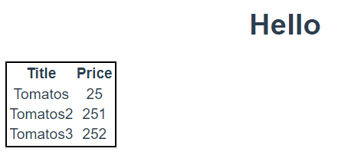

|  |  |
| --- | --- |
|  | <template>      <div>          <h1>{{message}}</h1>          <table class="table-list">              <thead>                  <tr>                      <th>Title</th>                      <th>Price</th>                  </tr>              </thead>              <tbody>                  <tr v-for="prod in productsList" :key="prod.id">                      <td>{{prod.title}}</td>                      <td>{{prod.price}}</td>                  </tr>              </tbody>          </table>      </div>  </template>  <script>  const message='Hello'      export default {          name:'TableList',          props: {              productsList: {                  type: Array,                  default: () => []              },          },          data() {              return {                  message              }          },      }  </script>  <style lang="css" scoped>  .table-list{      border: 2px solid black;  }  </style> |
|  | <template>    <div id="app">      <!-- 3.Використовуємо компонент, як новий тег -->    <table-list :products-list="productList"/>    </div>  </template>  <script>  //1. Імпортуємо файл  import TableList from "./components/TableList";  export default {    name: 'App',    components: {    //2.Реєстрація    TableList    },    data() {      return {        productList: [         {           id:1,           title:'Tomatos',           price:25         },         {           id:2,           title:'Tomatos2',           price:251         },         {           id:3,           title:'Tomatos3',           price:252         },          ]      }    },  }  </script>  <style>  #app {    font-family: Avenir, Helvetica, Arial, sans-serif;    -webkit-font-smoothing: antialiased;    -moz-osx-font-smoothing: grayscale;    text-align: center;    color: #2c3e50;    margin-top: 60px;  }  </style> |

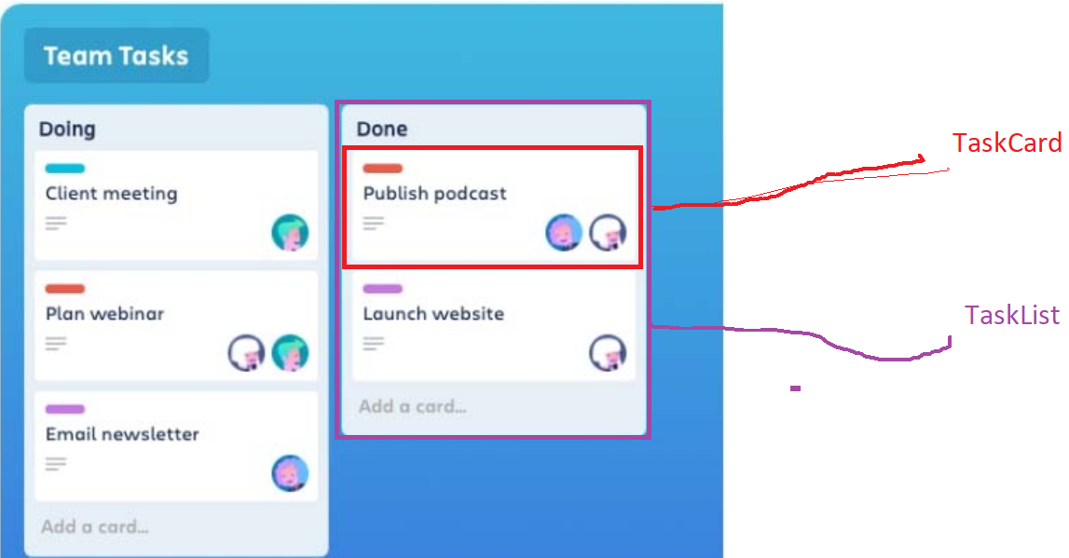

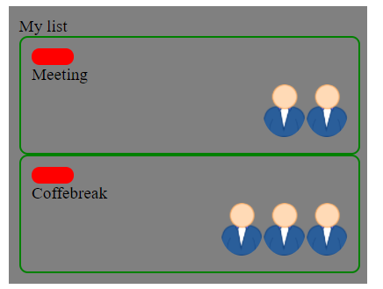

|  |  |
| --- | --- |
|  | <template>  <div class="container">  <div>      <div class="tag">      </div>      <div class="title">          {{title}}      </div>      <div class="img-container">          <img          v-for="(user,ind) in users" :key="ind"           :src="user.photo" :alt="user.name"           :title="user.name"           class="user-photo"           >      </div>  </div>      </div>  </template>  <script>      export default {          name: 'TaskCard',          props: {              category: {                  type: Number,                  default: 0              },              title:{                  type: String,                  default: 'nulltitle'              },              users: {                  type: Array,                  default: () => []              },            },      }  </script>  <style lang="css" scoped>  .container{      border-radius: 8px;      border:2px solid green;      width: 300px;      padding: 10px;  }  .tag{    border-radius: 8px;    width: 40px;    height: 16px;    background-color: red;  }  .user-photo{      border-radius: 50%;      height: 50px;  }  .img-container{      text-align: right;  }  </style> |
|  | <template>      <div class="main-container">          <div>{{title}}</div>          <div class="tasks-container">              <task-card              v-for="task in tasksList" :key="task.id"                :category="task.category"                :title="task.title"                :users="task.users"              />          </div>      </div>  </template>  <script>  //1  import TaskCard from "./components/TaskCard";      export default {          name:'TaskViewer',          components: {              //2              TaskCard          },          props: {              title: {                  type: String,                  default: 'Tasks list'              },              tasksList:{                  type:Array,                  default:()=>[]              }          },      }  </script>  <style lang="css" scoped>  .main-container{      width: 320px;      padding: 10px;      background-color: grey;  }  </style> |
|  | <template>    <div>      <!-- 3.Використовуємо компонент, як новий тег -->     <tasks-viewer      title="My list"      :tasks-list="tasksList"/>    </div>  </template>  <script>  //1. Імпортуємо файл  import TasksViewer from "./components/TasksViewer";  export default {    name: 'App',    components: {    //2.Реєстрація    TasksViewer    },    data() {      return {        tasksList: [         {           id:1,           category:1,           title:'Meeting',           users:[             {               name:'Ivan',               photo:'https://upload.wikimedia.org/wikipedia/commons/thumb/5/50/User_icon-cp.svg/1200px-User_icon-cp.svg.png'             },             {               name:'Petro',               photo:'https://upload.wikimedia.org/wikipedia/commons/thumb/5/50/User_icon-cp.svg/1200px-User_icon-cp.svg.png'             },           ]         },         {           id:2,           category:2,           title:'Coffebreak',           users:[             {               name:'Ivan',               photo:'https://upload.wikimedia.org/wikipedia/commons/thumb/5/50/User_icon-cp.svg/1200px-User_icon-cp.svg.png'             },             {               name:'Petro',               photo:'https://upload.wikimedia.org/wikipedia/commons/thumb/5/50/User_icon-cp.svg/1200px-User_icon-cp.svg.png'             },            {               name:'Sidor',               photo:'https://upload.wikimedia.org/wikipedia/commons/thumb/5/50/User_icon-cp.svg/1200px-User_icon-cp.svg.png'             },           ]         },          ]      }    },  }  </script>  <style>  #app {    font-family: Avenir, Helvetica, Arial, sans-serif;    -webkit-font-smoothing: antialiased;    -moz-osx-font-smoothing: grayscale;    text-align: center;    color: #2c3e50;    margin-top: 60px;  }  </style> |

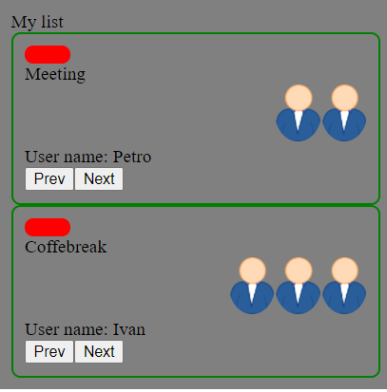

|  |  |
| --- | --- |
|  | <template>  <div class="container">  <div>      <div class="tag">      </div>      <div class="title">          {{title}}      </div>      <div class="img-container">          <img          v-for="(user,ind) in users" :key="ind"           :src="user.photo" :alt="user.name"           :title="user.name"           class="user-photo"           >      </div>      <div>          User name: {{currentUser.name}}      </div>      <div>          <button @click="onPrevClick">Prev</button>          <button  @click="onNextClick">Next</button>      </div>  </div>      </div>  </template>  <script>      export default {          name: 'TaskCard',          props: {              category: {                  type: Number,                  default: 0              },              title:{                  type: String,                  default: 'nulltitle'              },              users: {                  type: Array,                  default: () => []              },            },          data() {              return {                  currentUserIndex:0              }          },          computed: {              currentUser() {                  return this.users[this.currentUserIndex]              }          },          methods: {              onPrevClick() {                  this.currentUserIndex--                  if(this.currentUserIndex<0)                      this.currentUserIndex=this.users.length-1              },              onNextClick(){                  this.currentUserIndex++                  if(this.currentUserIndex>=this.users.length)                      this.currentUserIndex=0              }          },      }  </script>  <style lang="css" scoped>  .container{      border-radius: 8px;      border:2px solid green;      width: 300px;      padding: 10px;  }  .tag{    border-radius: 8px;    width: 40px;    height: 16px;    background-color: red;  }  .user-photo{      border-radius: 50%;      height: 50px;  }  .img-container{      text-align: right;  }  </style> |