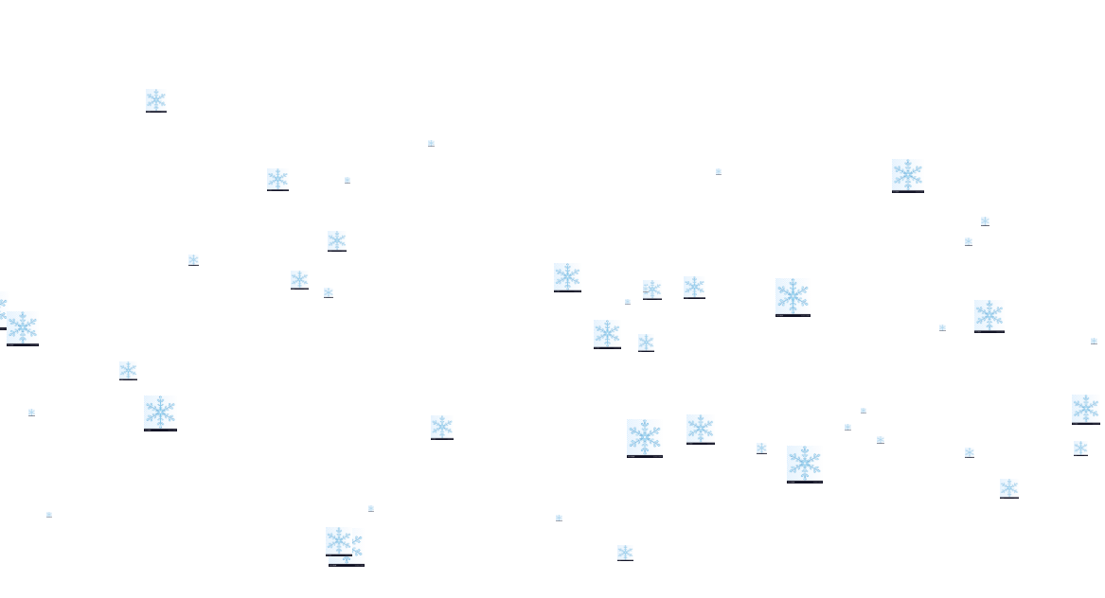
<!DOCTYPE html>
<html lang="en">
<head>
<meta charset="UTF-8" />
<meta name="viewport" content="width=device-width, initial-scale=1.0" />
<meta http-equiv="X-UA-Compatible" content="ie=edge" />
<title>Document</title>
<script>
class SnowFlake {
constructor(imgPath,min = 10, max = 500) {
this.min = min;
this.max = max;
this.imgPath=imgPath
this.setInitParams();
}
getRandomNum(min,max) {
return Math.floor(
min + Math.random() * (max - min + 1)
);
}
setInitParams = () => {
this.left = this.getRandomNum(this.min,this.max);
this.top = this.getRandomNum(10,400);
this.interval = this.getRandomNum(50,100)
this.width=this.getRandomNum(5,30)
};
move = () => {
this.top += 3;
if (this.top > 500) this.setInitParams();
this.left += this.getRandomNum(-10,10) ;
if (this.left > this.max) this.left=this.max;
if (this.left <this.min ) this.left=this.min;
this.width += this.getRandomNum(-10,10) ;
if (this.width > 30) this.width=30;
if (this.width <5 ) this.width=5;

this.setNewPosition();
};
setNewPosition = () => {
this.img.style.top = this.top + "px";
this.img.style.left = this.left + "px";
this.img.style.width = this.width+ "px";
};
startMove = () => {
setInterval(this.move, this.interval);
};
render() {
this.img = document.createElement("img");
this.img.setAttribute(
"src",
this.imgPath
);
this.img.style.position = "absolute";

this.setNewPosition();
return this.img;
}
}
//-------------
window.onload = function() {
for (let i = 0; i < 50; i++) {
const sn = new SnowFlake("https://cdn4.vectorstock.com/i/1000x1000/52/58/transparent-snowflake-vector-5465258.jpg",1,1000);
document.body.appendChild(sn.render());
sn.startMove();
}
};
</script>
</head>
<body></body>
</html>

