

The Homes for Ukraine Data Platform - User Guide

Version: 11.0

Date of Release: 03/04/23

[Version Control 6](#_Toc130905352)

[The Homes for Ukraine Data Platform (HfU) 8](#_Toc130905353)

[Data Statement 9](#_Toc130905354)

[Summary of roles 9](#_Toc130905355)

[Overview of the system windows, tabs and navigation 13](#_Toc130905356)

[Key things to remember 13](#_Toc130905357)

[Menus 14](#_Toc130905358)

[Navigation 15](#_Toc130905359)

[Main navigation panel 15](#_Toc130905360)

[Navigation Buttons 15](#_Toc130905361)

[System Views 16](#_Toc130905362)

[Individual records 17](#_Toc130905363)

[Applicant 17](#_Toc130905364)

[Household 19](#_Toc130905365)

[Sponsor 21](#_Toc130905366)

[Sponsor Household 22](#_Toc130905367)

[Using the system 23](#_Toc130905368)

[Searching for a record within your local authority 23](#_Toc130905369)

[Searching for a record outside of your local authority 24](#_Toc130905370)

[Welcome Centre Checks 26](#_Toc130905371)

[Initial ‘Check in’ Check 26](#_Toc130905372)

[2nd Stage Checks 27](#_Toc130905373)

[3rd and Final checks prior 27](#_Toc130905374)

[Sponsor/Host Checks 28](#_Toc130905375)

[Bulk updates to checks 29](#_Toc130905376)

[Using Case Notes 30](#_Toc130905377)

[Tips for adding information into the Case Notes and Activities 31](#_Toc130905378)

[Adding a Complex Case flag 31](#_Toc130905379)

[Updating the Case Notes and Activities Check boxes 32](#_Toc130905380)

[Locked Case Notes and Activities Check Boxes 34](#_Toc130905381)

[Updating the Applicant Checks box 35](#_Toc130905382)

[Updating / Creating a Housing Need 36](#_Toc130905383)

[Updating an existing Housing Need 36](#_Toc130905384)

[Creating a new Housing Need 37](#_Toc130905385)

[Creating/Closing a Placement Record 40](#_Toc130905386)

[Closing a placement record 40](#_Toc130905387)

[Creating a new placement record 41](#_Toc130905388)

[Updating an existing Placement Tracking 44](#_Toc130905389)

[Creating a historical Placement Tracking 46](#_Toc130905390)

[Changing Journey Status 48](#_Toc130905391)

[Updating multiple records with the same journey status 49](#_Toc130905392)

[Handling No Shows 50](#_Toc130905393)

[Making changes to Household Groups 52](#_Toc130905394)

[Changing lead applicant status 52](#_Toc130905395)

[Removing an applicant to a new household 53](#_Toc130905396)

[Adding an applicant to a household group 54](#_Toc130905397)

[Using the Health Board Tab 56](#_Toc130905398)

[Re-matching / Re-assignments 57](#_Toc130905399)

[Identifying a suitable host 57](#_Toc130905400)

[Re-match within the individual local authority boundary 58](#_Toc130905401)

[Re-assignment across local authority boundaries but wholly within Wales 58](#_Toc130905402)

[Cross Border Re-assignment across UK national borders (either Scheme) 59](#_Toc130905403)

[If the person is leaving Wales 59](#_Toc130905404)

[If the person is moving into Wales with advanced notice 60](#_Toc130905405)

[If the person has moved into Wales and we find out retrospectively 61](#_Toc130905406)

[Repatriation 63](#_Toc130905407)

[When a person is leaving for repatriation 63](#_Toc130905408)

[If a person returns from repatriation 64](#_Toc130905409)

[If the household record is assigned to your local authority 64](#_Toc130905410)

[If the household record is not assigned to your local authority 65](#_Toc130905411)

[Using the Sponsor Section 66](#_Toc130905412)

[Adding a New Sponsor/Host 66](#_Toc130905413)

[Adding Host Addresses 67](#_Toc130905414)

[Hosts with multiple addresses 68](#_Toc130905415)

[Linking a household record and a Sponsor/ host record 69](#_Toc130905416)

[Adding the Sponsor/host Details to your household record 69](#_Toc130905417)

[Replacing an existing Host / Sponsor 71](#_Toc130905418)

[Removing a Host/Sponsor when the household is a No Show 72](#_Toc130905419)

[Recording additional sponsor household members 73](#_Toc130905420)

[Handling Duplicate Applicant Records 74](#_Toc130905421)

[Rejected / Withdrawn Sponsors/Hosts 74](#_Toc130905422)

[Duplicate Hosts with no approved applicants attached 75](#_Toc130905423)

[Updating Sponsor Communication Preferences 77](#_Toc130905424)

[Creating personalised System Views and Reports 78](#_Toc130905425)

[Editing filters 78](#_Toc130905426)

[Editing columns 79](#_Toc130905427)

[Add columns to your system view 79](#_Toc130905428)

[Change the order of columns on your system view 79](#_Toc130905429)

[Remove columns from your system view 80](#_Toc130905430)

[Saving your own system view 80](#_Toc130905431)

[Deleting your own system view 81](#_Toc130905432)

[Extracting information from the Ukraine data platform to replicate Objective Connect 84](#_Toc130905433)

[Escalating any Data platform related issues or functionality requests 87](#_Toc130905434)

[How will service incidents relating to the Data Platform be handled? 87](#_Toc130905435)

[Homes for Ukraine Data Platform FAQ 87](#_Toc130905436)

[Contact Details 87](#_Toc130905437)

[Annex 1 - Summary of processes within each Scheme 88](#_Toc130905438)

[Super Sponsor scheme 88](#_Toc130905439)

[How the process works - In summary 89](#_Toc130905440)

[How the process works - In Detail 90](#_Toc130905441)

[Individual Sponsor Scheme (Homes for Ukraine) 99](#_Toc130905442)

[Sponsor 104](#_Toc130905443)

[Annex 2 – Status Reasons and Explanations 108](#_Toc130905444)

[Annex 3 – Logging incidents and incident categories 110](#_Toc130905445)

# Version Control

|  |  |  |
| --- | --- | --- |
| **Version** | **Date** | **Key changes made** |
| V1 | 07/07/2022 |  |
| V2 | 20/07/2022 | Amended error in email address in Annex 2 |
| V3 | 27/07/2022 | Added:  Re-matching process  Completion of Annex 1 (IS and Sponsor)  Using the Sponsor section |
| V4 | 29/07/2022 | Edits and clarifications made to the Accessing the Live Data Platform sections. |
| V5 | 23/09/2022 | Added:  Adding a complex case flag, bulk updates to checks, extracting information from the Ukraine data platform to replicate Objective Connect, Handling Duplicate Applicant Records. |
| V6 | 21/10/2022 | Added: Searching for records outside a local authority |
| V7 | 10/11/2022 | Added:  Definitions of a host and sponsor. Managing repatriation within the system; Recording No-Shows; Using the Health Board Info Tab; Using the Journey Tracking table. Annex 2 – Status Journey Reasons and Explanations  Updated:  Using the Search function; Navigation Button Change to access the Info and Training Hub; Searching for records outside a local authority; Screen shots to mirror changes in the platform. Saving and deleting a System View. |
| V8 | 14/12/2022 | Added: Status Reasons for Sponsor/Host records.  Cross Border Re-assignment – if a person has moved into Wales and we find out retrospectively  Updated: Creating a New Housing Need Record; Re-matching; Re-match within the individual LA boundary; Re-assignment across Local Authority boundaries but wholly within Wales; Cross Border Re- assignment ; if a person is moving to Wales – advanced notice |
| V9 | 24/01/23 | Added: Hosts with multiple addresses; replacing and existing host/sponsor; rejected or withdrawn sponsor/host; duplicate hosts with no approved applicants attached    Updated: Creating/closing a placement record; Creating a new placement record; Removing an applicant to a new household; adding an applicant to a household group; Re-assignment across local authority boundaries but wholly within wales; linking a household record and a sponsor record; adding sponsor/host details to your household record; Annex 1 – sponsor    Removed: Using the sponsor section – creating a household placement tracking |
| V10 | 22/02/23 | Added: Sponsor/ host checks; Updating the case notes and activities check boxes; Locked case notes and activities check boxes; updating sponsor communication preferences    Updated: Cross Border Re- assignment across UK national borders (either scheme); if a person is leaving Wales; if a person is moving to Wales with advanced notice; if a person has moved into Wales and we find out retrospectively |
| V11 | 03/04/23 | Added: Updating an existing placement tracking ; creating a historic placement tracking ; Removing a host/sponsor when the household is a no show    Updated: Creating / Closing a placement Record; Closing a placement record; Closing a placement record; Handling no shows; Re-assignment across local authority boundaries but wholly within Wales; Cross Border Re- assignment across UK national borders (either scheme); Repatriation |

# The Homes for Ukraine Data Platform (HfU)

Prior to the development of the HfU data platform, there was no single source of truth or way of viewing the full journey progress (via Super Sponsor or Individual Sponsor Schemes) of people from Ukraine seeking sanctuary in Wales. The Data Platform facilitates secure access to an up to date, single source of data to those providing support to Ukrainian citizens coming into Wales.

It will help provide an overview of all those entering Wales so that we can easily monitor and support individuals, as well as enable accurate reporting to Welsh Ministers and UK Government.

We believe this will bring about the following benefits:

* **Centralised and simplified data**: we can gather information on all Ukrainians coming into Wales, using a common set of journey status codes to ensure that we all have the right information at the right time to support them through their journey, and improve information available to staff involved in this work.
* **Safe and secure**: information can be split down by LA, so an individuals’ data and case notes can be controlled by LAs and transferred if they move from one LA to another.
* **Cross-agency**: Each touchpoint to support those in need is recorded. This aids decision making and service/support allocation locally and at Health Board level.
* **Ease of Reporting**: the requirement to report to receive the appropriate funding streams will be much easier with less effort for Local Authorities as Welsh Government will be able to run reports at a national level instead.

This training guide will assist all users requiring access to the data platform, to be able to navigate and update the platform. As future iterations of the data platform are released, this guide will continue to be updated and shared. They will include individuals accessing the system from:

* Welsh Government
* Digital Health and Care Wales
* Contact Centre (hosted by Cardiff Local Authority)
* Local Authorities in Wales (including LA staff working in Welcome Centres)
* Local Health Boards in Wales

## Data Statement

The Ukraine Data Platform has been developed by the Welsh Government to support the delivery of services to Ukrainian citizens and sponsors resident in Wales under the Welsh Government super-sponsorship, and Homes for Ukraine individual sponsorship schemes only. The data platform contains personal identifiable data. Data disclosure agreements are in place and are regularly reviewed.

The Welsh Government, local authorities and NHS health boards are all independent data controllers for the data they will access through the platform. Cardiff Council, in its role as the Contact Centre, operates as a Processor under the Welsh Government's instruction.

By accessing the data platform, you are confirming that you have a valid business reason to access the data and that it will only be used for the agreed purposes.

# Summary of roles

**Welsh Government**

The Welsh Government has multiple responsibilities:

* Defining the policies that support the Homes for Ukraine scheme in Wales.
* Receiving and processing the UK Gov data onto platform.
* Producing the reports and statistics required by Senedd ministers and UK Government.
* All system security matters.
* Developing the platform, to help with workload processing.

In terms of the platform the Welsh Government are the product and service owners.

**Local Authorities**

Numerous local authority services will be required by individuals and groups that have travelled from Ukraine, including housing provision (where an individual has arrived through the Super Sponsor Scheme) and facilitating conversations between hosts and those looking for accommodation and checks of accommodation (through Individual Sponsor Scheme). They also provide access to statutory services such as education and social services. The system will facilitate improved data sharing between approved organisations to ensure individuals receive the services and housing that meet their needs.

**Contact Centres**

Operating from Cardiff Council, but providing a service to the whole of Wales, a team of 70+ staff are responsible for initiating travel of Ukrainians to Wales. They prepare households for their journey, capture individual needs, capture housing need, allocate them a space at a Welcome Centre, track them in transit and coordinate transport to welcome centres where they are supported by local authority staff. They have access to the data of all applicants until they arrive at the Welcome Centre. The Contact Centre do not liaise or input data for anyone coming through the individual route.

**Arrival Hubs**

Under the Super Sponsor scheme, Arrival Hubs liaise with the Contact Centre to ensure Ukrainians travelling to Welcome Centres are guided to their onward transport. In Wales, the arrival hubs are Holyhead and Pembroke Dock Ports, Cardiff Airport and Wrexham and Cardiff Central stations.

**Welcome Centres**

Operated mainly by local authorities with support from local providers (hoteliers/third sector organisations), these centres provide temporary accommodation to new arrivals through the Super Sponsor Scheme and connection with any support they require to access medical care, education and financial assistance. The Welcome Centres also coordinate the transfer of new arrivals when suitable permanent accommodation is found. Welcome Centres do not house individuals that have arrived through the Individual Sponsor Route.

**Local Health Boards**

Operating through Public Health Wales and the Local Authorities, the Local Health Boards provide medical support for those arriving from the Ukraine. In some cases, the NHS will be in contact with applicants and/or medical staff before the person arrives in the UK to ensure the right level of support and care is in-place for their arrival.

**Accessing the Live Data Platform**

Registering for an account

Before you can access the HfU Data Platform, you need to have registered for access.

To register for an account:

* Contact your local Ukraine Data Platform Data Champion with details of your Microsoft 365 account.
* Your Data Champion will consider your request and if approved, will request an account be set up for you using your Microsoft 365 account details.
* Once your account has been set up, you will receive a notification from the Welsh Government that your account is ready to be accessed.

If you are unsure whether you have an account set up, please check with your Local Data Champion before trying to access the system.

**Please Note**:

* The Welsh Government will only accept requests for new accounts that come via your Data Champion
* Before setting up a new Data Champion / user, the Welsh Government will require confirmation from the requesting Data Champion that they have trained the new champion(s) and that they have full knowledge of how to use the platform and obtain support.
* You **will not** receive a username and password – please follow the instructions below to access the system for the first time.

Accessing the Live System for the first time

You can access the Live system using the following information

1. Open a browser and paste the following URL into the address bar and click return: <https://homesforukrainedataplatform.crm11.dynamics.com/>
2. You will be asked to log in with your Microsoft 365 account details
3. Once prompted you will need to use Microsoft Authenticate to verify you as a user. If you are not currently using Microsoft Authenticate, please see below for further information on downloading and using the application.
4. When the Platform opens, a Home Screen may appear. Select ‘Homes for Ukraine’ app.

If you experience problems logging in, please refer to Annex 2 (Logging Incidents).

**Important**:

* Do not share your login details to the system or authenticate another user on their behalf.
* Do not use the live system to deliver any training.  Training should be done in the Test System [https://org616cc293.crm11.dynamics.com/](https://eur01.safelinks.protection.outlook.com/?url=https%3A%2F%2Forg616cc293.crm11.dynamics.com%2F&data=05%7C01%7Csarah.lilley%40gov.wales%7Ccb5eb379b767493a522c08da59a82cd5%7Ca2cc36c592804ae78887d06dab89216b%7C0%7C0%7C637920876084543335%7CUnknown%7CTWFpbGZsb3d8eyJWIjoiMC4wLjAwMDAiLCJQIjoiV2luMzIiLCJBTiI6Ik1haWwiLCJXVCI6Mn0%3D%7C3000%7C%7C%7C&sdata=rE3ldzO%2BXhwAL6WDrdHOQRbPAY%2FbtqNyuV29YsM2DyU%3D&reserved=0)
* To help differentiate between the Live (Prod) and Dev systems, the banners are different colours.

Live Platform - Purple

Test Platform - Orange

Using Multi-Factor Authentication (MFA)

Multi-factor authentication is a process in which users are prompted for an additional form of identification during sign-in. The additional form of identification is usually a code or biometric login through their mobile phone.

A second form of identification makes it harder for attackers to obtain or duplicate your log in details. It is therefore mandatory that MFA is used to access the platform.  You can use either a personal phone, work phone or tablet to authenticate your access to the data platform.

You can do this in two ways:

1. **Download the Microsoft Authenticator app**. The app plays no other role on your phone than helping you log into the platform when you require access. [Click here to find our detailed instructions on how to use the Microsoft Authenticator app to access the Homes for Ukraine data platform.](https://docs.google.com/document/d/17_jZ9VpIRT7EFVxx53YgwMVlLAayXwNU/edit?usp=sharing&ouid=112052873182991728520&rtpof=true&sd=true)
2. **Use Microsoft Authenticator to request a code** sent by SMS text message to your phone. If you prefer this method, [click here to follow the alternative guide to use Microsoft Authenticate SMS text message to authenticate your access.](https://docs.google.com/document/d/1ggB6NAKJxEzQb2od48AHaEkDKH5qzIbG/edit?usp=sharing&ouid=112052873182991728520&rtpof=true&sd=true)

# Overview of the system windows, tabs and navigation

## Key things to remember

* The system includes details of those travelling on Super Sponsor and Individual Sponsor Scheme
* The data/fields you can see will depend on your security settings so you may not be able to access everything that we train on when you log into the system.
  + Local authority staff (including those that work in welcome centres) will only see data for those allocated to their local authority area. This applies to applicants of both the individual and super sponsor schemes
* Anything blue and underlined indicates that it can be clicked to take you to another set of information
* Where there is a red asterisk (\*) next to a field, this is a mandatory field
* You may see navigation arrows which enable you to go straight to the record of a linked individual
* You can filter on a lot of information on the ‘Applicants’ screen
* You must save any changes to records before moving to a different screen

## Menus

The menus on the left of the screen display the data in the system in the following ways:

**People menu**

|  |  |
| --- | --- |
|  | The **Applicants** section lists all individuals that have been granted rights to travel either within the Super Sponsor or individual route.  The **Households** section lists all groups travelling together. A Household ID and a FAM ID are the same thing.  The **Sponsors** section lists all individuals that have offered to house an individual or family from Ukraine through the Individual Sponsor Scheme.  The **Sponsor Household** section details the individuals that are living in a sponsor's home at the time of application. i.e. the son/daughter of someone who has been accepted as a sponsor.  **Search Applicants...** section enables you to search for a record to identify the record owner I.e. another local authority or cross border. |

**Placements menu**

|  |  |
| --- | --- |
|  | The **Applications** section lists the applicants by application number.  The **Housing Needs** section summarises the housing needs of an individual.  The **Accommodations** section is a list of all the Welcome Centres and Temporary Accommodations for the Super Sponsor route.  The **Host Addresses** section shows data on all addresses of properties offered to house individuals through the Homes for Ukraine Individual Route scheme.  The **Placement Tracking** section lists all of the placements that have been entered on the system. |

## Navigation

Hovering over each icon will give you a tooltip label, but below is a summary of navigation menus, as well as some of the tools you will need to use the system.

### Main navigation panel

From the main navigation panel, you can access the different system sections.



### Navigation Buttons

|  |  |
| --- | --- |
| **Button** | **Purpose** |
|  | **Go Back**  To return to the previous screen or tab. |
|  | **Save**  To save the current record. |
|  | **Save & Close**  To save the current record and return to the previous screen or tab. |
|  | **Refresh**  To refresh the current screen or record. |
|  | **Export to Excel**  To export the current view, based on the columns available. |
|  | **Help** Will take you straight to the Ukraine Data Platform User Documentation and Information Hub. |

## System Views

Click on the screen title (for example, All Applicants on the Applicants screen) to display a drop-down of different system views. Selecting a system view will alter the columns and filters visible for that screen, depending on the use case. You can then [filter these views further](#_Editing_filters) and [add additional columns](#_Editing_columns) to create your own personalised view if you wish, which you can then save.

Some system views have already been created which will be a helpful starting point.

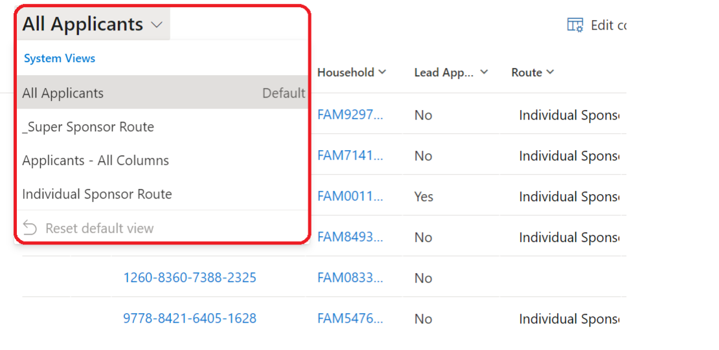

**Filters**

You can filter the current screen by selecting the Edit filters button 

You can read more in-depth guidance on filtering under the [Editing filters section of this guide](#_Editing_filters).

**Columns**

You can edit the columns visible on your system view by selecting the Edit columns button 

You can read more about adding, moving and removing columns under the [Editing columns section of this guide](#_Editing_columns).

# Individual records

## Applicant

Each applicant has their own record on the system which captures information relating to their application and journey to sanctuary in Wales.

To access an individual applicant record:

1. [Applicants section](#_Menus), double-click on the applicant’s name. This will open a new screen, titled with the applicant’s name. You can then see different overviews for the individual by clicking through the various tabs.

Images shows the tabs on the applicant screen. These are 
Summary
Personal Details
Case Notes and Activities
Placement Trackings
Health Board Info
Related which drops down to audit history

|  |  |
| --- | --- |
| **Tab Name** | **Summary of Tab** |
| **Summary** | Provides an overview of the individual record.  The Person Information section includes:   * whether this person is their household’s **lead applicant** (usually an adult or English speaker in the group for communication purposes) * the individual’s **relationship** to the lead applicant (if not lead applicant) * their **sponsor scheme** and **journey status** * their Household ID   **Case notes** and record activities such as meetings, tasks, and any other actions taken to capture information relevant to that individual’s journey are also featured here.  **Checks** and services offered can be quickly updated here and are used for filtering data |
| **Personal Details** | Gives a more in-depth record of the applicant’s **phone** and **email** details plus details of their **sponsor/host** (where applicable). |
| **Case Notes and Activities** | Summarises all **case notes** raised for an applicant. Case notes may include notes on travel information, checks outstanding at a welcome centre or notes on changes to the makeup of their household group. |
| **Placement Tracking** | Lists all **current and previous placements**. This includes records of when an applicant stays in temporary accommodation or welcome centres as well as their move to permanent accommodation. |
| **Health Board Info** | Provides additional information for Local Health Boards relating to their registered medical practice. |
| **Related** | Provides access to Audit History for those that have permission. It provides a time stamped record detailing all changes made to an individual’s record. |

## Household

A household group is a group of individuals that have travelled together to the UK and wish to move into accommodation together. Households can encompass both related and non-related individuals. Any information related to their requirements as a group is captured under their Household ID. Household IDs start with FAM (if created before data is imported into the system) or WG (if changes are made to Household Group after data import) and are followed by numbers.

To access a household record:

1. From either the [Households section](#_Menus) or an individual’s record, left-click on the Household ID. This will open a new screen, titled with the Household ID. You can then see different overviews for the household by clicking through the various tabs.

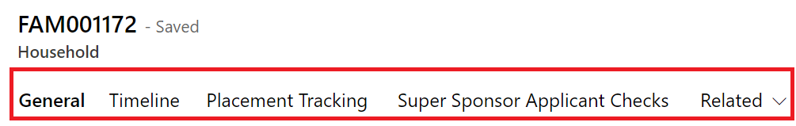

|  |  |
| --- | --- |
| **Tab name** | **Summary of Tab** |
| **General** | This tab gives an overview of the household details, including a list of the **individuals within the household**. In this tab you can also make edits to the makeup of the household (**adding** or **removing household** **members** and **assigning lead applicant** status). You can also make a **household note**, for example, you can make a note if someone is in hospital but needs to be considered as being part of the household because they will join the family when they are released. |
| **Timeline** | Here you will find a **summary of case notes** and **changes** made to the household record. This includes details of who made the changes and when the change was made. |
| **Placement Tracking** | This Tab provides a summary of the placement tracking records for the household which you can easily access and amend. You can also create new placement tracking records. |
| **Individual or Super Sponsor Applicant Checks** | Shows the checks required depending on the sponsor route the applicant is travelling under. For Super Sponsor these include medical screening and interim payment. For Individual Sponsor these include welfare visit and interim payment. |
| **Related** | Provides access to Audit History for those that have permission. It provides a time stamped record detailing all changes made to a household record. |

## Sponsor

The Sponsor screen provides details of the sponsor. This includes details of the sponsor’s contact preferences as well as any case notes or activities relating to the individual.

To access an individual Sponsor record:

1. Double-click on the sponsor’s name from the [Sponsors section](#_Menus). This will open a new screen, titled with the sponsor’s name. You can then see different overviews for the sponsor by clicking through the various tabs.

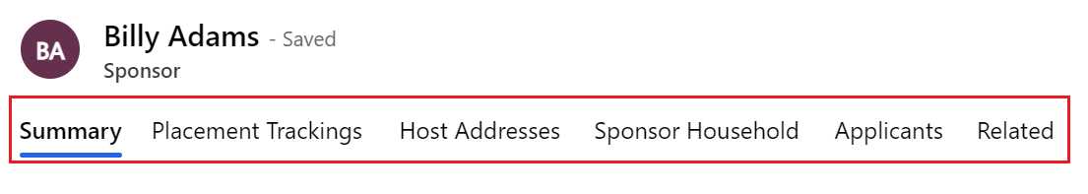

|  |  |
| --- | --- |
| **Tab name** | **Summary of Tab** |
| **Summary** | The Summary Tab section includes:   * overview of personal details of the sponsor * their **contact details** and **address**. * their **sponsor host status**   You can also add **Case Notes and Activities** against the record and will be able to **record checks.** |
| **Placement Tracking** | Will show placement tracking for individuals who will be housed with the Sponsor. |
| **Host Addresses** | List all the available addresses in which a Sponsor has been approved to house applicants who have applied via the Individual Sponsor Route. |
| **Sponsor Household** | Shows individuals that live with Sponsor at the time of application. |
| **Applicants** | Shows individuals who have listed them as a host on their individual sponsor scheme application. |
| **Related** | The options within this tab are Audit History and Applications. |

## Sponsor Household

The Sponsor Household screen allows you to see who else from the sponsor’s family is living in a sponsor’s accommodation at the point of application. For example a sponsor’s child or partner.

To see an individual Sponsor Household record:

1. Double-click on the individual’s name from the [Sponsor Household section](#_Menus). This will open a new screen, titled New Sponsor Household e. You can then see different details of the individuals within a sponsor’s household.

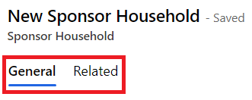

|  |  |
| --- | --- |
| **Tab name** | **Summary of Tab** |
| **General** | The General tab gives a brief overview of **all individuals that live in the sponsor’s household**. |
| **Related** | Provides access to Audit History for those that have permission. It provides a time stamped record detailing all changes made to a sponsor household’s record. |

# Using the system

## Searching for a record within your local authority

1. Click on Applicant Screen if searching for an individual, or Household section if you are searching for a FAM ID reference.
2. Enter a search term into the search tool and press enter. For example, you may want to search for an applicant using their last name.



1. This will filter the table to show the relevant results.

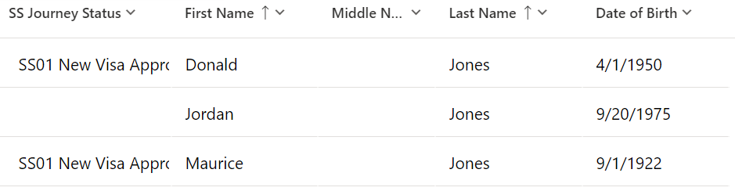

You can also search for a sponsor or applicant across the whole system.

1. Search for sponsors and applicants by entering their name into the search bar and pressing enter or clicking the search icon.



1. Your search results will then display in different tab: Contacts (Applicants), Sponsors and Applications.

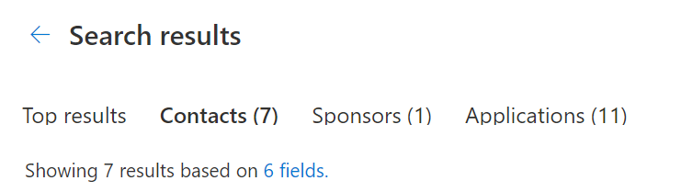

1. You can click on the record to access further information.
2. If you need to filter the information further, open the Filter pane by clicking on which runs vertically down the right side of your screen.
3. If you wish to do an advanced search, you can click on the ‘Search for rows in a table using advanced filters’ option.

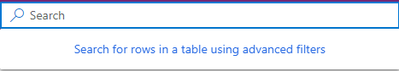

## Searching for a record outside of your local authority

The ‘out of area search’ function has been developed to enable you to find basic information about any record within the platform, regardless of which local authority the record is assigned to.

To access the out of area search, you need to:

1. Open the Homes for Ukraine Data Platform using your normal log in details and authentication processes.
2. Click on **Search Applicants from other LA’s** which is listed under People in the left-hand navigation bar.

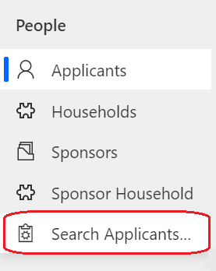

1. Once the search screen has opened you will find two options in the left-hand navigation.

**Applicants** carry out standard household and individual level searches as detailed in the user guide. These are limited to those in your defined area.

**Applicant Search** Enables you to search by name to identify records which match the search criteria irrelevant of which Local Authority ‘owns’ the record.

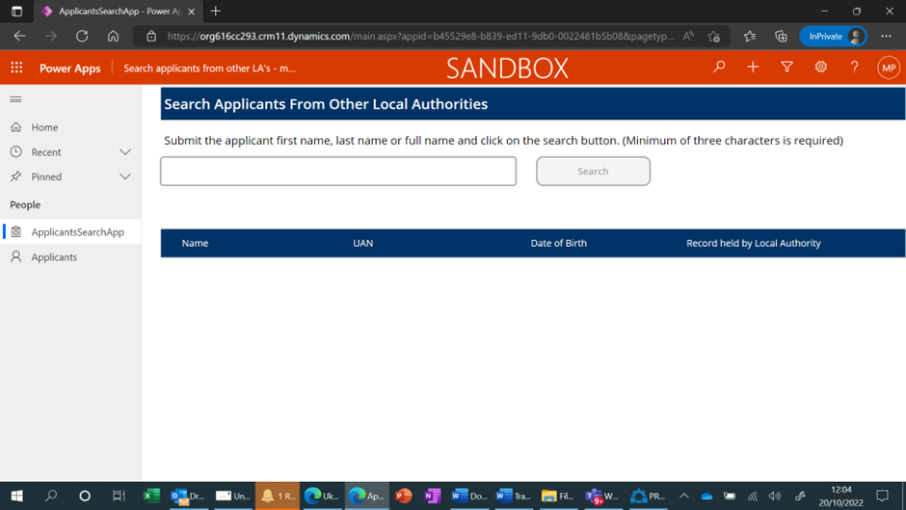

1. Type full or part of the person’s name in the search box using a minimum of 3 characters. This search does not use wildcard characters and will return a maximum of 200 lines of data.

**Please Note:** You are still unable to access records that sit outside of your local authority, but you can use the information provided to contact the owning local authority and discuss any appropriate action. A list of Data Champions can be provided.

## Welcome Centre Checks

When a person or household group arrives at a Welcome Centre, there are several checks that need to take place before they are ready to be matched to suitable accommodation. These are grouped into three checklists.

1. Initial Check in
2. 2nd Stage checks (usually relatively close to the initial checking in)
3. 3rd and Final check

There are 2 places to update an individual’s record to show the checks that have taken place.

1. Case Notes and Activities
2. Check Box

Both are under the Summary tab within an individual's record.

**Please note**:

Once the checks are finalised, we will build these into the system, however this is the best way to update records in the interim.

### Initial ‘Check in’ Check

Ideally completed as soon as an individual reaches the contact centre or emergency accommodation the initial checks list focus on immediate health requirements and getting them settled.

Check list items are:

1. Meet any immediate needs (medical, essential supplies). *If any medical needs, contact local healthcare team or 111 if further advice needed.*
2. Offer Covid test *(not compulsory but advised). If positive, alert healthcare worker.*
3. Allocate room.
4. Provide a Welcome Centre information pack and tour of facilities.

After this check you will need to [create a placement record](#_Creating_a_new) which will include the room allocated during this initial check.

### 2nd Stage Checks

During the 2nd you will need to create another case note or several case notes to cover the process of offering these aspects of health and financial support. Not all delivery partners will have access to the system, so consider how you will share information with them. [Using excel to export the data may be a useful option](#_Navigation_Buttons).

1. Book individual/family health appointment with health team.
2. Refer for DWP support.
3. Refer to casework team if immediate financial support is required.
4. Offer new mobile SIM card if required.

To do so, follow the steps below to create a new case note. Again, you may want to copy the checklist (numbered 5 – 8) to indicate which checks have been carried out.

**Please note**: if a new SIM card is provided, ensure the number is added to the “Preferred number” field within Person Information in the Summary tab.

### 3rd and Final checks prior

The following checks will need to be completed before an applicant can be considered for matching to available accommodation through the Super Sponsor Scheme.

1. Assistance offered to open a bank account.
2. Offer ESOL language classes.
3. Arrange attendance at cultural briefing session.
4. Adults: refer to Working Wales for employment/ training support.
5. Children: Arrange immediate education and early years provision.
6. Signpost to biometric data registration with Home Office.
7. Check accommodation needs haven’t changed.

[Create a case note](#_Using_Case_Notes) to record that these checks have been completed and change the checks box as appropriate.

At this point you will also need to check that the accommodation needs of the household have not changed.

When these checks/services have been offered or provided, you can [change the journey status](#_Changing_Journey_Status) from SS07 – SS08 Welcome Centre Ready for Move On. That will then enable local authorities to assess the housing need of individuals in the Welcome Centre who have had checks completed against available accommodation.

## Sponsor/Host Checks

The sponsor/Host and their property should be checked prior to arrival, or very shortly after, a person or household are matched to them. Three of checks below can used to track when a check has been carried out, the two checks with padlocks will be provided the DLUHC data feeds.

The checks should be toggled on the data platform once completed and include:

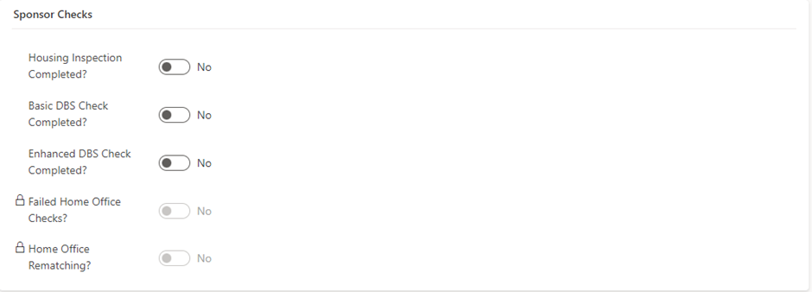

**Housing Inspection Check** – to ensure the property is suitable and meets the correct criteria to host applicants.

**Basic DBS Check Completed** – to ensure that the Basic DBS check has been completed and passed.

**Enhanced DBS Check Completed** – to ensure that the Enhanced DBS check (if required) has been completed and passed.

As part of the application process, a sponsor may be rejected by the home office if they fail their **PNC (Police National Computer services) Check**. This will be recorded in the data platform under a locked field and will be read only for information only. It will be the Home Office’s responsibility to rematch the applicant to a suitable sponsor for their application, this will also show in the sponsor checks section under **Home Office Rematching** as a read only checkbox for information only.

## Bulk updates to checks

There is a table within each household record which lists the members of the household and which checks they have undergone in the Welcome Centre. When several members of a household group have each undergone the same checks (such as having a family health appointment booked or welfare visit completed), you can quickly update these checks in a single location to save time.

You can also use this table to see which members of a merged household (a reunited family for example) have had checks and which individuals have not.

To update all the records at the same time:

1. Click on the Household ID for the person or group you wish to update.

2. Click on the Super Sponsor / Individual Sponsor Applicant Checks button in the top menu (depending on which sponsorship scheme the person is on).

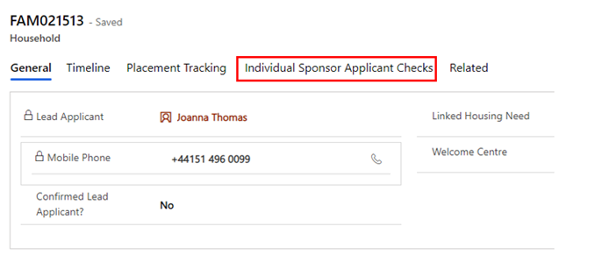

3. Use the dropdown menu to change the status of the check from No to Yes once completed, ensuring you click the save button at the top of the page or as indicated below when you have completed your updates:

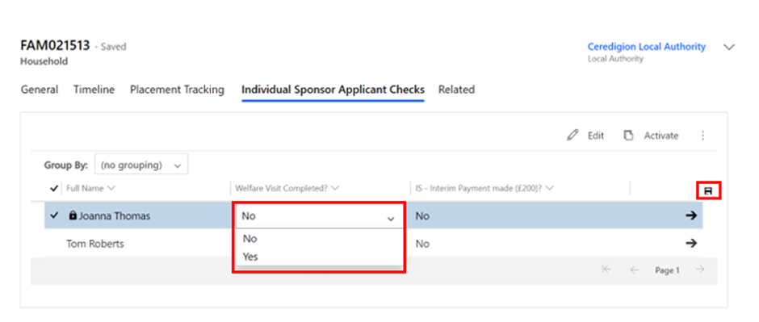

## Using Case Notes

You will need to create a case note to record any checks which have been completed and add any additional information. To do this:

1. Change your system view and filter this view further if you prefer. You can read more about changing system views under the [System Views section](#_System_Views) of this guide.
2. Double-click on the name of the applicant whose record you wish to update. This will take you to the [individual Applicant screen](#_Applicant).
3. On the Summary tab, under Case Notes and Activities, you can add case notes. This should be done for each person arriving.
4. Click Enter a note.



1. Add a title for your case note and add details in the main text box. In this case, you may want to simply copy the checklist above (numbered 1 – 4), to indicate that these are the checks that have been carried out.

For ease of filtering and future reference please add the following in the title of the case note:

* The name of the Welcome Centre and your initials, for example Ty Magor WC – SL. You will see the Contact Centre will have added WNSU CC + initials to their records.

or

* If you are working within a Local Authority, please insert your Local Authority name and your initials, for example, Conwy CC – SL.

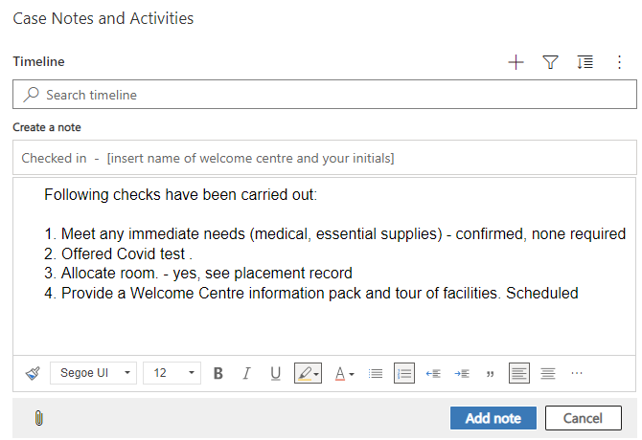

1. To add your note, click the Add note button.
2. To discard your note, click the Cancel button.

### Tips for adding information into the Case Notes and Activities

* Provide as much detail as possible BUT do not include any health/sensitive information. For example, you could say a medical check has been booked/completed but not information about the outcome.
* Do not delete a record unless it has been added in error. You can annotate it has been completed or if a task or appointment mark as complete using to tick icon which appears when you hover over a record.
* You can create a Task, but you are not able to assign tasks to other team members.
* You are only able to update your own case notes.
* The system is not designed for document upload.

## Adding a Complex Case flag

A complex case flag can be applied to individual applicants’ records. This is used when an applicant may have a complex health or personal circumstance which may mean they should be supported differently.

A complex case flag creates a pop-up message that appears whenever the applicant’s record is accessed to notify the platform user of the complex case.

It is vital that the privacy of the applicant is protected. Therefore, any information outlining their circumstances must be held on local systems. A case note should be added to the platform identifying the person or team to speak to for further information.

To add a complex case note:

1. Open the applicant’s record on the Summary section.

2. Under Case Notes and Activities, click Yes on the Complex Case dropdown menu.

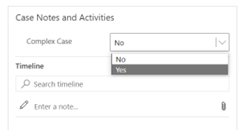

3. Add a case note on the timeline with details on who to contact in the local authority for further information on handling the case appropriately.

After a complex case note has been created, a pop up will show every time the person’s record is accessed.

## Updating the Case Notes and Activities Check boxes

**No Non-essential Communications**

An applicant may make contact to state they don’t want to receive any communication, however it is necessary that essential communications are still carried out. This means they should only receive information from Welsh Government regarding their current sponsor/hosting position. Restricting their communication preferences to essential communication only means they will stop receiving updates regarding things such as Ukrainian National holiday updates/ information on local Ukrainian events etc.

To action this request in the UDP:

1. Go into the Applicant record, on the summary tab
2. Locate the No Non-essential Communications check under Case Notes and Activities
3. Toggle this to YES

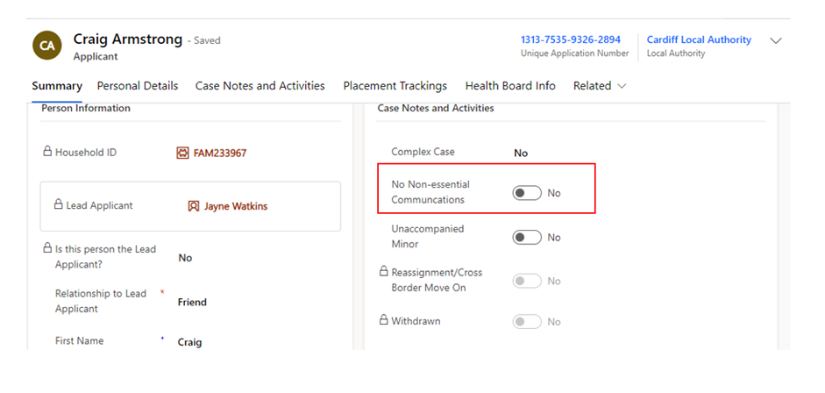

Please note: you will need to click the dotted lines once for the toggle to appear and then you can click this again to toggle over to YES

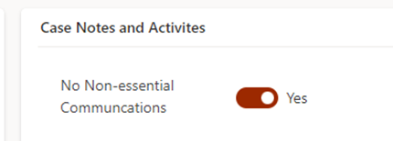

**Unaccompanied Minor**

There may be occasions when a minor (child under the age of 16) will travel to hosted/initial accommodation without the accompany of an adult. There may also be occasions where Ukrainian parents repatriate and leave their child unaccompanied with the host/sponsor. It is very important we capture these cases within the data platform to ensure we identify these individuals.

To action this within the UDP:

1. Go into the Applicant record, on the summary tab
2. Locate the Unaccompanied Minor check under Case Notes and Activities
3. Toggle this to YES

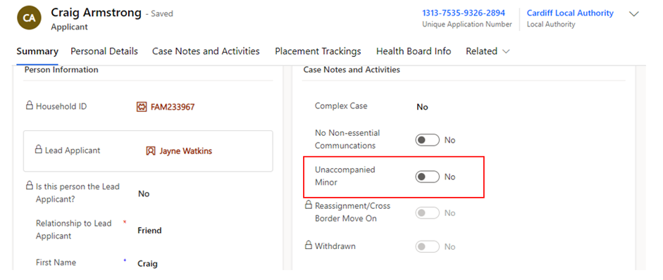

Please note: you will need to click the dotted lines once for the toggle to appear and then you can click this again to toggle over to YES

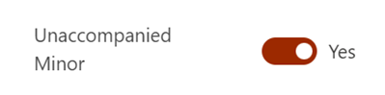

## Locked Case Notes and Activities Check Boxes

These are locked fields within the system that are updated through DLUHC data flows. They are read only records and serve for information purposes only.

|  |  |
| --- | --- |
| Check | Explanation |
| Re-assignment/ Cross Border Move on | If toggled, this will indicate that the individual has either been re-assigned from another UK Nation following the Rematching / Reassignment Process. |
| Withdrawn | If toggled to yes, this will indicate the applicant has withdrawn this application for a visa – this can either be due to no longer needing the visa or due to there being multiple visa’s applied for. |

## Updating the Applicant Checks box

To ensure reports can be accurately extracted by a range of organisations please ensure you update the checks box. The checkboxes are split into Super Sponsor Checks and Individual Sponsor Checks.

1. Click the  boxes to switch between yes and no. A blue box indicates the check has taken place.

**Please note**:

The checkboxes are continuing to be developed so they accurately record the range of checks required for individuals, determined by the scheme they are travelling under.

## Updating / Creating a Housing Need

Housing needs will initially be created by:

* The Contact Centre for applicants coming through the Super Sponsor scheme
* The appropriate Local Authority for applicants coming through the Individual Sponsor scheme

If a person joins or leaves a household ID group, you must:

* Update the linked housing need requirement for the existing household
* Create a new linked housing need for the person that has been moved (if they are not joining another group).

Every Household ID should have a linked housing need which helps Local Authority colleagues when matching individuals to suitable accommodation whether that be super sponsor scheme households or individuals travelling on the individual scheme needing to be re-housed.

### Updating an existing Housing Need

1. Go to the [Applicants section](#_Menus) and double-click on the name of an applicant to get to their [individual applicant screen](#_Applicant).
2. On the Summary tab, click on the Household ID (FAM# or WG#).

1. On the Household screen click on the Linked Housing Need.



1. Make changes to the fields as required. Those marked with a red asterisk (\*) are mandatory.
2. Once you have made the required changes, make sure to save by clicking the Save button or Save & Close button.

### Creating a new Housing Need

1. Search for the applicant(s) in the [Applicant section](#_Menus).
2. Once you have found the applicant, click on the Household ID (FAM# or WG#).



This will take you to the Household section.

1. On the General tab, double click on the Linked Housing Need field and select New Housing Need.

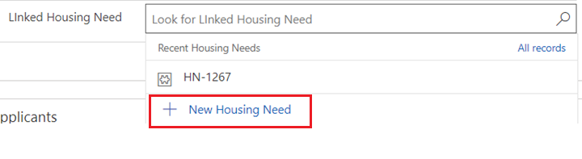

1. Complete the fields as required. Those marked with a red asterisk (\*) are mandatory.
2. Once you have made the required changes, make sure to save by clicking the Save button. This will assign the Housing Need record with a unique reference Code (HN--#####).
3. Unfortunately, the Housing Need Record does not automatically link to the Household record so you will need to:
   1. Copy the Housing Need reference code (you can highlight, right click and copy). Return to the Household Record (General Tab).and paste the Housing Need reference into the Linked Housing Need Field.

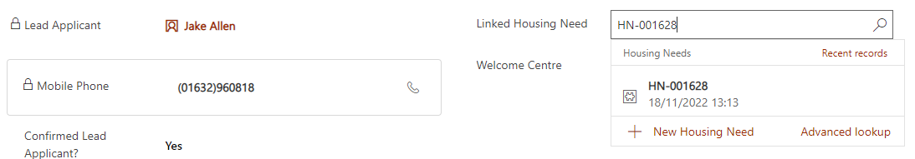

* 1. Click Save & Close.

**Deleting an orphaned Housing Need record**

When you [merge households](#_Adding_an_applicant), you will also update the main household housing need. The person that has joined the new household will now have an orphaned housing need record which will need to be deleted. Only a limited number of platform users can delete records, so if you have a housing need which needs to be deleted, please email [WNSManagement@cardiff.gov.uk](mailto:WNSManagement@cardiff.gov.uk) with the Housing Needs reference (H-N – xxxx) that needs to be deleted.

## Creating/Closing a Placement Record

Whenever a household is moved, you will need to create a new placement record. This creates a history of their placements including start and end dates and reasons for moving.

Creating and closing placement records is equally applicable irrelevant of the Scheme.

Creating a new placement tracking will force the closure of the previous placement tracking, so it is really important that the dates are entered correctly.

If you only need to move one person in the household (for example someone needs to be moved to hospital) they will need to be split from the family group. You can find instructions on how to do that under the [removing an applicant to a household section](#_Removing_an_applicant).

IMPORTANT : **Before creating a placement tracking for a sponsor/host placement** you must first [assign](https://ukc-word-edit.officeapps.live.com/we/wordeditorframe.aspx?ui=en%2DUS&rs=en%2DUS&wopisrc=https%3A%2F%2Fwales365uk-my.sharepoint.com%2Fpersonal%2Fwilliam_rees_gov_wales%2F_vti_bin%2Fwopi.ashx%2Ffiles%2Fc59e3a17a9424215bb556aa4bbce1305&wdenableroaming=1&mscc=1&wdodb=1&hid=793A4167-5CE7-4D74-BBB2-25556DCBE103&wdorigin=Sharing&jsapi=1&jsapiver=v1&newsession=1&corrid=3d3a93bd-a7b7-4c5d-91b0-a79a3a76f106&usid=3d3a93bd-a7b7-4c5d-91b0-a79a3a76f106&sftc=1&cac=1&mtf=1&sfp=1&instantedit=1&wopicomplete=1&wdredirectionreason=Unified_SingleFlush&rct=Normal&ctp=LeastProtected#_Adding_a_New) / [replace](https://ukc-word-edit.officeapps.live.com/we/wordeditorframe.aspx?ui=en%2DUS&rs=en%2DUS&wopisrc=https%3A%2F%2Fwales365uk-my.sharepoint.com%2Fpersonal%2Fwilliam_rees_gov_wales%2F_vti_bin%2Fwopi.ashx%2Ffiles%2Fc59e3a17a9424215bb556aa4bbce1305&wdenableroaming=1&mscc=1&wdodb=1&hid=793A4167-5CE7-4D74-BBB2-25556DCBE103&wdorigin=Sharing&jsapi=1&jsapiver=v1&newsession=1&corrid=3d3a93bd-a7b7-4c5d-91b0-a79a3a76f106&usid=3d3a93bd-a7b7-4c5d-91b0-a79a3a76f106&sftc=1&cac=1&mtf=1&sfp=1&instantedit=1&wopicomplete=1&wdredirectionreason=Unified_SingleFlush&rct=Normal&ctp=LeastProtected#_Replacing_an_existing) a host within the household section

### Closing a placement record

You do not need to close a placement record before you create a new record detailing their next placement. When you create a new placement tracking, this will automatically close the previous. You must update the move on reason before you create a new placement tracking, to do so:

1. Click on the Household ID number (either FAM ID or WG ID) from an Applicant Summary record.
2. Go to the Placement Tracking's tab.

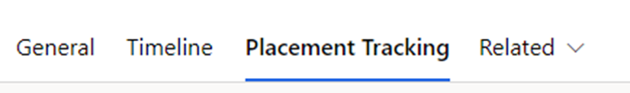

1. Click on the record you wish to close.
2. Add the move on reason (using the drop down).
3. Click Save or Save and Close.

### Creating a new placement record

1. Click on the Household ID number (either FAM ID or WG ID) from an Applicant Summary record.
2. Go to the Placement Tracking's tab



1. Click the New Placement Tracking button 
2. On the New Placement Tracking form, complete the fields as follows:

|  |  |
| --- | --- |
| **Form criteria** | **Content to enter** |
| Applicant | (Already completed) |
| Placement Type | Welcome Centre / Temporary Accommodation / Hospital /Move on Accommodation / sponsor/host etc |
| Date started | Date when person arrived at their accommodation i.e welcome centre |
| Date Allocated | Date when Contact Centre allocated space in Welcome Centre (if known / applicable) or Local Authority allocated space for other accommodation |
| Date ended | Leave blank (until person leaves) |
| Allocated Welcome Centre | Name of WC/emergency accommodation (hotel) from pre-populated list |
| Address | Room number, wing etc in WC or address of other accommodation such as emergency accommodation / hospital |
| Local Authority | Your LA |
| Host Sponsor | Leave blank until person is moved out of WC to permanent accommodation |
| Move on reason | Leave blank |
| Application | Leave blank |

1. Once you have completed all relevant fields, click the Save or Save & Close buttons.

When creating a placement tracking once the placement type has been selected as ‘sponsor / host’ the host information will auto populate onto the right-hand side of the placement tracking from the household page.

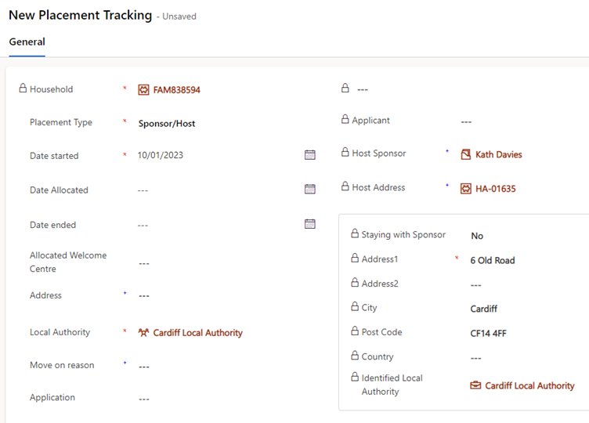

This will allow you to copy and paste information over to the free text address box if required.

If you are creating a placement tracking for any other option other than ‘sponsor/host’ for example ‘move on accommodation’ this will not pull through the host details into the placement tracking. It is important that you consider the below placement reasons and when to use them within a placement tracking record:

|  |  |  |  |
| --- | --- | --- | --- |
| Placement Type | Reason for Placement Type | Additional Reasons | Additional Reasons 2 |
| Hospital | When someone has left their accommodation to be hospitalised |  |  |
| Move on accommodation | When someone has left hosted accommodation to become self-supported | When someone has left one local authority to be hosted at another |  |
| Repatriation | When someone has left the UK entirely to return to Ukraine |  |  |
| Sponsor/Host | When someone is matched with a host - usually for the first time on the individual scheme | When someone is new to the local authority having moved from another LA in Wales to live with a chosen host |  |
| Temporary Accommodation | When someone arrives unexpected and is housed in initial accommodation (welcome centre) until a suitable host can be found | When someone needs to leave host address due to relationship breakdown and is moved to initial accommodation (welcome centre) | When someone needs to leave host address due to relationship breakdown and is moved to another host temporarily |
| Welcome Centre | When a person on the super sponsor scheme is housed in initial accommodation (welcome centre) |  |  |
| Temporarily Left | When a person has left their hosted accommodation for a short, temporary period for a holiday etc.  There will be a known return date and the case should be kept with the LA. |  |  |

When a new placement tracking record is created for anything other than ‘sponsor/host’ – the host details will automatically be removed from the Household page. You do not need to remove the host prior to ending the current placement tracking record as the creation of the new placement tracking will end the current sponsor/host placement tracking and remove that link to the host on the household.

## Updating an existing Placement Tracking

If you identify that need to make a change / update a placement tracking that you have created on the household page, it will be possible to do this, but you may be limited to what you can change. Once a placement tracking has been updated, all changes will filter through to the linked applicant and sponsor placement tracking’s. We refer to this as the ‘Parent / Child’ relationship between placement tracking’s (the parent being the household PT and the child being the applicant PT)

To update the start date of a placement tracking:

1. Go into the household placement tracking.
2. Select the PT you would like edit and click edit (you can also just double click on the record)

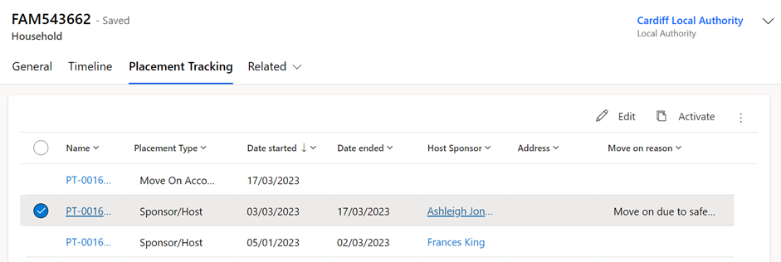

1. Once in the PT you can update any of the fields to add or remove information.

1. You can amend the start date to any date later than the original date set, unless this is the first ever PT created for the household.

1. Click save and close.

1. The changes will reflect on the applicant and sponsor PTs.

Please Note:

1. If this is the first PT ever created for the household the start date can be altered to any date.
2. If there is a previous PT created before the one you wish to edit – you will only be able to update the start date to a later date, anything before the original date will throw up an error due to this being linked to the end date of the previous PT.

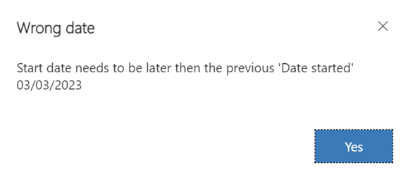

1. The end date of any PT will always be locked and you will not be able to update it – it is very important that when creating a new PT, the date selected is correct as this will impact the end date if the previous placement tracking.

## Creating a historical Placement Tracking

There may be a requirement to create historical placement tracking record for the period of time where applicants had arrived into Wales but the UDP was not yet set up.

The ability to add a historic placement tracking will allow the Local Authority to create placement tracking’s with dates created prior to the first placement tracking for the household. It will be the LAs responsibility to input any historic placement tracking’s for households who remain within the same Local Authority. For households that no longer live in the same Local Authority as their original placement – it will be the responsibility of the Contact Centre to input historical placement tracking’s on these records, due to them having access to all Welsh LA data. The contact centre will liaise with the previous LA to ensure the information inputted is correct.

**IMPORTANT: when inputting multiple historic placement tracking’s, it’s really important that you start by creating the most recent historic placement first and then work your way back to the first placement. As the end date is locked you need to work backwards from newest to oldest placements.**

To create a historic placement tracking:

1. Go into the household record and select placement tracking’s.
2. Referring to the screenshot below, to create a historic placement tracking the date needs to precede the start date of the first placement tracking – in this example it would need to be a date prior to 04/01/23.

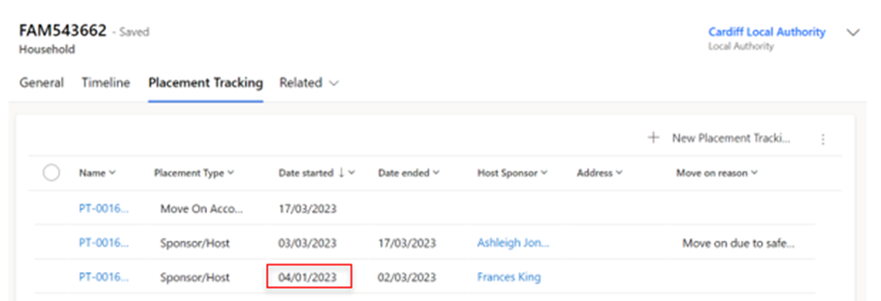

1. Select new placement tracking and complete all fields, the placement type selected should reflect what the placement type was at the time of the historic placement.
2. When you input the start date you will get a warning message that you are about to create a historic placement tracking.

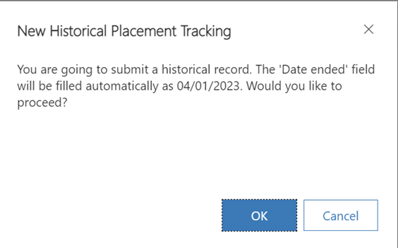

1. Select ok and create the placement tracking inputting all relevant information:

* 1. if the placement was for a Welcome Centre you need to ensure you input the correct welcome centre into the allocated welcome centre field.
  2. if the placement was for a sponsor/host you need to ensure you link the host and host address relevant to that placement.

1. Save and close the PT.

Please note: there is no system functionality behind historic placement tracking’s so this will not link the welcome centre or sponsor/host and will also not move the record (if the previous placement was in another LA).

## Changing Journey Status

To change an applicant’s Journey Status:

1. Go to the Applicants screen and double-click on the name of the applicant whose status you wish to update.
2. From the Summary tab, under Person Information, select the Journey Status dropdown.



1. Select the correct stage on the journey status.
2. Once you have updated the applicant’s status, make sure to save using either the Save or Save and Close buttons.

You are also able to update a whole household journey status, by following the [instructions on updating multiple records](#_Updating_multiple_records) with the same information.

**Please note**: the stages available on the Journey Status are dependent on the applicant’s route. You may need to check whether the applicant’s is travelling under the Super Sponsor or Individual Sponsor route before changing the applicant’s Journey Status, to ensure you update the correct codes.

Annex 1 shows the Journey Statuses and definitions.

## Updating multiple records with the same journey status

There will be some instances, such as updating a journey status, where it is better to update multiple records of the same household. Particularly when moving from SS07 – SS08 and SS08 – SS09.

To update multiple records with the same information:

1. Double-click on the Applicant Household ID (FAM# or WG#).
2. You can then select multiple applicants from the same household using the check box against each record.
3. Once you have selected the required applicants, click the Edit button just above the table. This will open the Edit menu:

1. You can then update the SS Journey Status or any other appropriate fields for the multiple applicants.

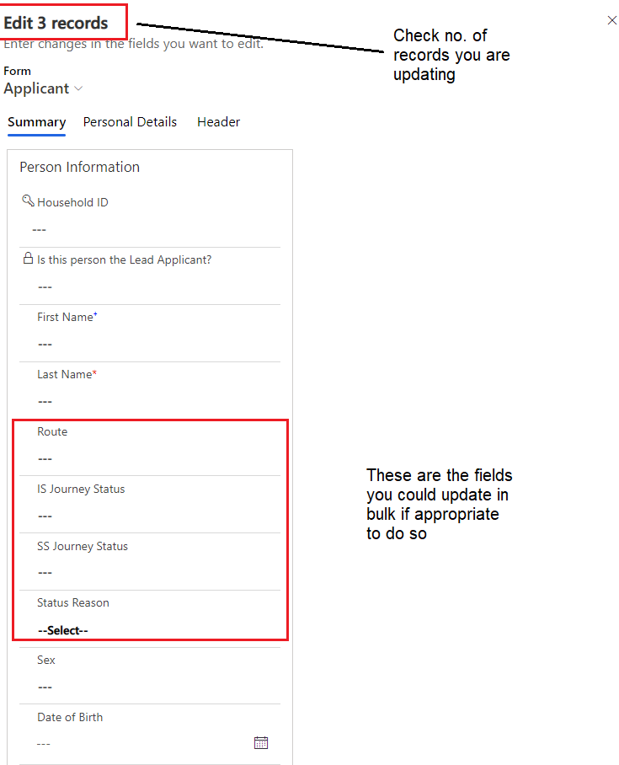

1. Make sure to click the Save button once you have made your changes.

## Handling No Shows

There will be instances where households do not arrive when anticipated. It may be because they have travelled elsewhere, decided not to travel or are waiting for family members to get their travel documentation. In those situations, they are classed as No Shows. It is recommended that you:

1. Change the Journey Status to one of the following (depending on sponsor route and understanding):

* IS21 - No Show – Known
* IS22 – No Show – Unknown
* SS05D – No Show – Known
* SS05E – No show – unknown

1. Add a journey status reason – relevant examples include Case completed; Not Travelling or Move to another scheme.
2. Where reasons are known, you can provide additional information in the case notes.

There are no placement records required where an individual has not shown.

Updating the Journey Status for these scenarios is essential as this allows for functionality to remove the host link on the household page.

If there are safeguarding concerns, please refer to your local safeguarding policies.

## Making changes to Household Groups

There may be circumstances when it is necessary to either add or remove a person to a household, or to change the lead applicant of the group. This section explains that process.

It is vital that when editing household groups, any housing requirements associated with those groups are also amended to reflect the change.

If you change a lead applicant, you must reset the relationships between the applicants in the group.

All edits to the makeup of a household are done using this Action table in the household record:

If you remove an applicant to a new household, their Household ID will start with a WG rather than FAM. This shows the changes were made in the data platform.

### Changing lead applicant status

To change the lead applicant status of an applicant you need to:

1. Go to the Household section and click on a Household ID (FAM# or WG#).

This will take you to the individual household screen. From here, on the Action dropdown, select Set Lead Applicant.

1. On the Applicant field, search for the applicant you want to set as the household lead.

1. You can then add further information in the Action Comment field.
2. Once you have set the new lead applicant for the household, save your changes by clicking the Save button or the Save and Close button.

### Removing an applicant to a new household

If you are breaking a household group apart for whatever reason, you need to ensure:

* The person moving is not the lead applicant. If they are, you will need to reassign the lead applicant role, as set out above.
* If a person is joining another existing household group, they need to be removed from their existing household before you can add them to a different household. Once removed from the initial household, they will be given a new household ID beginning with WG. They can then be [linked to a new household](#_Removing_an_applicant).
  1. Search for an applicant within the household you wish to edit either through the Applicants or Households menu.

1. Double-click on a member of the household and click on the blue Household ID at the top of the summary screen.
2. Halfway down the page, under Applicants, click on the Action drop-down:



1. From the list of actions, select Remove Applicant to new Household.
2. On the Applicant field, type in the applicant you want to remove to a new household.

1. Add any comments relevant to the removal of the household member (do not capture any personal data here).

1. Click Save or Save and Close.
2. Once you have completed these steps, you must edit the linked housing need record for the existing household to reflect the change in accommodation requirements.
3. The host linked to the original household will also be removed from the locked sponsor field within applicant page.
4. A case note will be automatically generated which will show the household ID they were in and their new WG ID reference.

### Adding an applicant to a household group

To add an applicant to an existing household group you need to:

1. Search for an applicant within the household you wish to edit.
2. Double-click to open their record.
3. Click on the blue Household ID at the top of the summary screen.

1. Halfway down the page, under Applicants, click on the Action drop-down:



1. From the list of actions, select Add Applicant. This will reveal two new fields: Applicant and Action Comment.
2. Click in the Applicant box and type in the name of the person you wish to add to the group.

1. Add an Action Comment to capture any additional information on why this action was required.
2. Click the Save or Save and Close button to complete the action. In the list of household members below, the new applicant will be listed in the table.
3. You will need to edit the new household member’s relationship to the lead applicant. In the table, click the dropdown under the ‘Relationship to Lead Applicant’ field.

1. Select the appropriate relationship and save your changes by clicking the small disk icon on the right-hand side of the table.
2. The host linked to the new household will automatically link to the new added applicant and will appear on the locked sponsor section of the applicant page.
3. A case note will be automatically generated which will show the household ID they were in and their new household ID reference.
4. You will now need to [amend the Household Housing Needs record](bookmark://_Updating_an_existing) and email [WNSManagement@cardiff.gov.uk](mailto:WNSManagement@cardiff.gov.uk) requesting deletion of the now orphaned housing need record, for the person that has just joined the family. For example, Maurice Jones.

**Please note**:

* It is imperative that each household has a lead applicant. It will usually be included with the contact centre information, but if not, a lead applicant will need to be identified for each household.
* If the person separating from the house is the lead applicant, you will need to reassign the lead applicant role before you are able to move them from the household. You can read more about reassigning the lead applicant for a household under the [Changing lead](#_f1nhaesql5mg) [applicant status section](#_Changing_lead_applicant) of this guide.
* The new household created will have a WG reference rather than a FAM reference as the changes have been made within the system.
* You must [update the linked housing need](#_Updating_an_existing) of the original household from which the applicant has been removed.

# Using the Health Board Tab

The Health Board tab has been added for use by Local Health Boards. Local Authority based users of the system do not need to complete fields in this tab but may refer to it for information if necessary.

The three fields contained within the Tab are:

|  |  |
| --- | --- |
| NHS Number | The NHS number assigned to the applicant on the NHS system. |
| Registered at Medical Practice | The medical practice code for the surgery they have registered with. |
| Medical Practice Post Code | The postcode of the surgery to which they have been registered. |

To update a field:

1. Click in the field you wish to update and add the necessary information.
2. Click Save  or Save & Close  buttons in the top toolbar of the system.

If you wish to report on these fields, you can add them to personalised views following instructions in the [Creating Personalised Views](#_Creating_personalised_System) section of the Guide.

You may also wish to [add a case note](#_Using_Case_Notes ) against the individual’s record. Please note that sensitive and medical information should not be included in the case notes. These should be added on your usual NHS systems.

# Re-matching / Re-assignments

There will be times where households need to be re-matched to alternative accommodation. This may be for several reasons including the scheduled end of a placement; placement breakdown; and movement to be closer to friends or family – amongst other reasons.

Re-matching process is the same for individuals, irrelevant of the scheme through which they travelled to Wales.

The process for re-matching will depend on the nature of the re-match in question. Depending on the scenario, some elements of ‘rematching’ will be referred to as Re-assignment. There are broadly four categories:

1. Re-match within the individual local authority boundary
2. Re-assignment across local authority boundaries but wholly within Wales
3. Cross Border Re-assignment across UK national borders (e.g., from a local authority in Wales to a local authority in England – or vice versa)
4. Re-match from a super sponsor route to a host across a UK national boundary.

## Identifying a suitable host

If you are aware of a household (individual/family/group) that requires re-matching you will need to identify a host (either via the Ukrainian themselves, through the Expression of Interest data previously shared, or via other means)

There are two possible ways to identify a possible host:

1. Review existing sponsors that are/have hosted individuals through the Homes for Ukraine Sponsor Scheme. This can be done within the data platform.
2. Review those that have offered accommodation through the Super Sponsor Scheme. This will need to be done outside of the data platform using the Expressions of Interest shared through the Ukraine Offer Tracker spreadsheet. Access and further guidance on the [Offer Tracker Spreadsheet is available here.](https://eur01.safelinks.protection.outlook.com/?url=https%3A%2F%2Fsecure.objectiveconnect.co.uk%2Flogin&data=05%7C01%7CSarah.Lilley%40gov.wales%7C5188c88010944180a59108da6e4d9d90%7Ca2cc36c592804ae78887d06dab89216b%7C0%7C0%7C637943576870226169%7CUnknown%7CTWFpbGZsb3d8eyJWIjoiMC4wLjAwMDAiLCJQIjoiV2luMzIiLCJBTiI6Ik1haWwiLCJXVCI6Mn0%3D%7C3000%7C%7C%7C&sdata=0VA07uBBVe9%2FChZtintEkk5Gsm7TeOZGkBB6rhlvvyw%3D&reserved=0) You will require access to the to the URD - URD - Onward Accommodation workspace within Objective Connect to access both the spreadsheet and guidance.

## Re-match within the individual local authority boundary

If you can facilitate a local re-match, there is no need for another local authority’s agreement nor notification to the UK GovernmentIf you are able to-match with a sponsor of another Ukrainian household who has travelled under the Homes for Ukraine Scheme, you will find their details in the system and will need to link the records of both the Sponsor and the household that requires re-matching.

If you have found a suitable host from the EoI data generated through the Super Sponsor Scheme, you will need to undertake the following steps on the data platform to record the re-match and ensure appropriate property, DBS and safeguarding checks are completed for the new host and where necessary other family members living with them.

1. Ensure you have changed the allocation status on the Ukraine Offer Tracker Spreadsheet.
2. Within the Home for Ukraine Data Platform, you will need to
   1. [Add a New Host](#_Adding_a_New) within the Sponsor section of the data platform
   2. [Add the host property address](#_Adding_Host_Addresses)
   3. [Link the host to the applicant.](#_Linking_an_applicant)
   4. [Create a new tracking placement record,](#_Create_a_Household)

## Re-assignment across local authority boundaries but wholly within Wales

The key difference between matching and this process is the need for local authorities to get the agreement of the onward destination local authority before processing the transfer on the Ukraine Data Platform. The Ukraine Data Platform does not permit full access to all records for every local authority. Only the records of those linked to an area can be viewed by the relevant local authority. Therefore, if a visa holder moves to a new local authority a re-assignment process must take place to ensure data transfers appropriately.

You will also need to export any data required about the specific Ukrainian household moving out of their area to ensure you do not lose access to the information before transferring records to the new local authority.

Once the re-match has been agreed between both local authorities, **the original local authority** (where a household is already placed) will need to:

1. [Create a system view](https://ukc-word-edit.officeapps.live.com/we/wordeditorframe.aspx?ui=en%2DUS&rs=en%2DUS&wopisrc=https%3A%2F%2Fwales365uk-my.sharepoint.com%2Fpersonal%2Fwilliam_rees_gov_wales%2F_vti_bin%2Fwopi.ashx%2Ffiles%2Fc59e3a17a9424215bb556aa4bbce1305&wdenableroaming=1&mscc=1&wdodb=1&hid=793A4167-5CE7-4D74-BBB2-25556DCBE103&wdorigin=Sharing&jsapi=1&jsapiver=v1&newsession=1&corrid=3d3a93bd-a7b7-4c5d-91b0-a79a3a76f106&usid=3d3a93bd-a7b7-4c5d-91b0-a79a3a76f106&sftc=1&cac=1&mtf=1&sfp=1&instantedit=1&wopicomplete=1&wdredirectionreason=Unified_SingleFlush&rct=Normal&ctp=LeastProtected#_Creating_personalised_System) of the names within the household transferring and all required fields and export the data to Excel.
2. Complete the Move on Reason and placement end date for the current placement tracking.
3. To assign them to the new local authority, [create a new household placement tracking record](https://ukc-word-edit.officeapps.live.com/we/wordeditorframe.aspx?ui=en%2DUS&rs=en%2DUS&wopisrc=https%3A%2F%2Fwales365uk-my.sharepoint.com%2Fpersonal%2Fwilliam_rees_gov_wales%2F_vti_bin%2Fwopi.ashx%2Ffiles%2Fc59e3a17a9424215bb556aa4bbce1305&wdenableroaming=1&mscc=1&wdodb=1&hid=793A4167-5CE7-4D74-BBB2-25556DCBE103&wdorigin=Sharing&jsapi=1&jsapiver=v1&newsession=1&corrid=3d3a93bd-a7b7-4c5d-91b0-a79a3a76f106&usid=3d3a93bd-a7b7-4c5d-91b0-a79a3a76f106&sftc=1&cac=1&mtf=1&sfp=1&instantedit=1&wopicomplete=1&wdredirectionreason=Unified_SingleFlush&rct=Normal&ctp=LeastProtected#_Creating_a_new).
   1. Ensure the move on reason is set to ‘move on accommodation’.
   2. Detail the name and address of the new host within the address field, if known.
   3. Assign it to the new local authority by adding them into the ‘Local Authority’ field within the placement tracking form.
4. Save the placement tracking record. **At this point the current host will automatically remove from the household page, the current PT will end, and all information will transfer over to the new local authority and you will lose access to the record(s).**
5. Inform the new local authority the records have been transferred across.

The **new local authority needs to:**

1. [Add a New Host](https://ukc-word-edit.officeapps.live.com/we/wordeditorframe.aspx?ui=en%2DUS&rs=en%2DUS&wopisrc=https%3A%2F%2Fwales365uk-my.sharepoint.com%2Fpersonal%2Fwilliam_rees_gov_wales%2F_vti_bin%2Fwopi.ashx%2Ffiles%2Fc59e3a17a9424215bb556aa4bbce1305&wdenableroaming=1&mscc=1&wdodb=1&hid=793A4167-5CE7-4D74-BBB2-25556DCBE103&wdorigin=Sharing&jsapi=1&jsapiver=v1&newsession=1&corrid=3d3a93bd-a7b7-4c5d-91b0-a79a3a76f106&usid=3d3a93bd-a7b7-4c5d-91b0-a79a3a76f106&sftc=1&cac=1&mtf=1&sfp=1&instantedit=1&wopicomplete=1&wdredirectionreason=Unified_SingleFlush&rct=Normal&ctp=LeastProtected#_Adding_a_New) within the Sponsor section of the data platform.
2. [Add the host property address](https://ukc-word-edit.officeapps.live.com/we/wordeditorframe.aspx?ui=en%2DUS&rs=en%2DUS&wopisrc=https%3A%2F%2Fwales365uk-my.sharepoint.com%2Fpersonal%2Fwilliam_rees_gov_wales%2F_vti_bin%2Fwopi.ashx%2Ffiles%2Fc59e3a17a9424215bb556aa4bbce1305&wdenableroaming=1&mscc=1&wdodb=1&hid=793A4167-5CE7-4D74-BBB2-25556DCBE103&wdorigin=Sharing&jsapi=1&jsapiver=v1&newsession=1&corrid=3d3a93bd-a7b7-4c5d-91b0-a79a3a76f106&usid=3d3a93bd-a7b7-4c5d-91b0-a79a3a76f106&sftc=1&cac=1&mtf=1&sfp=1&instantedit=1&wopicomplete=1&wdredirectionreason=Unified_SingleFlush&rct=Normal&ctp=LeastProtected#_Adding_Host_Addresses).
3. Completing necessary checks on the host updating [Case Notes and Check boxes](https://ukc-word-edit.officeapps.live.com/we/wordeditorframe.aspx?ui=en%2DUS&rs=en%2DUS&wopisrc=https%3A%2F%2Fwales365uk-my.sharepoint.com%2Fpersonal%2Fwilliam_rees_gov_wales%2F_vti_bin%2Fwopi.ashx%2Ffiles%2Fc59e3a17a9424215bb556aa4bbce1305&wdenableroaming=1&mscc=1&wdodb=1&hid=793A4167-5CE7-4D74-BBB2-25556DCBE103&wdorigin=Sharing&jsapi=1&jsapiver=v1&newsession=1&corrid=3d3a93bd-a7b7-4c5d-91b0-a79a3a76f106&usid=3d3a93bd-a7b7-4c5d-91b0-a79a3a76f106&sftc=1&cac=1&mtf=1&sfp=1&instantedit=1&wopicomplete=1&wdredirectionreason=Unified_SingleFlush&rct=Normal&ctp=LeastProtected#_Using_Case_Notes) during the process.
4. [Add the host into the household record](https://ukc-word-edit.officeapps.live.com/we/wordeditorframe.aspx?ui=en%2DUS&rs=en%2DUS&wopisrc=https%3A%2F%2Fwales365uk-my.sharepoint.com%2Fpersonal%2Fwilliam_rees_gov_wales%2F_vti_bin%2Fwopi.ashx%2Ffiles%2Fc59e3a17a9424215bb556aa4bbce1305&wdenableroaming=1&mscc=1&wdodb=1&hid=793A4167-5CE7-4D74-BBB2-25556DCBE103&wdorigin=Sharing&jsapi=1&jsapiver=v1&newsession=1&corrid=3d3a93bd-a7b7-4c5d-91b0-a79a3a76f106&usid=3d3a93bd-a7b7-4c5d-91b0-a79a3a76f106&sftc=1&cac=1&mtf=1&sfp=1&instantedit=1&wopicomplete=1&wdredirectionreason=Unified_SingleFlush&rct=Normal&ctp=LeastProtected#_Linking_an_applicant) using the Host field.
5. Open a new placement under the relevant placement type for the same day (this will not override the previous placement tracking date).
6. If the placement type ‘sponsor/host’ is selected, then the new host will pull through into the right-hand side of the placement tracking.
7. Once the host has confirmed the move has taken place, complete the finance section of the host record.

## Cross Border Re-assignment across UK national borders (either Scheme)

Where a Ukrainian wishes to move from or to Wales, to another country within the UK and agreement has been reached between both local authorities, the way to capture that within the system is straight forward. The process of recording this in the data platform is the same, irrelevant of the scheme they are transferring from.

### If the person is leaving Wales

1. Establish the location within the UK where the Ukrainian has identified the new host
2. Contact the Case Management Team [casemanagementteam@cardiff.gov.uk](mailto:casemanagementteam@cardiff.gov.uk) with all relevant details of the transfer request
3. The Case Management Team will contact the onward Local Authority and submit the request via Foundry, if accepted they will confirm back to the Welsh Local Authority once Foundry has been updated
4. Ensure the [case notes](https://ukc-word-edit.officeapps.live.com/we/wordeditorframe.aspx?ui=en%2DUS&rs=en%2DUS&wopisrc=https%3A%2F%2Fwales365uk-my.sharepoint.com%2Fpersonal%2Fwilliam_rees_gov_wales%2F_vti_bin%2Fwopi.ashx%2Ffiles%2Fc59e3a17a9424215bb556aa4bbce1305&wdenableroaming=1&mscc=1&wdodb=1&hid=612B83F9-5789-4D21-8B22-717B331565EA&wdorigin=Sharing&jsapi=1&jsapiver=v1&newsession=1&corrid=9c2e8108-4ea5-447d-9308-043ab1673fb1&usid=9c2e8108-4ea5-447d-9308-043ab1673fb1&sftc=1&cac=1&mtf=1&sfp=1&instantedit=1&wopicomplete=1&wdredirectionreason=Unified_SingleFlush&rct=Normal&ctp=LeastProtected#_Using_Case_Notes) record that the onward destination local authority has agreed to the transfer.
5. Update the move on reason of the household’s existing placement.
6. [Create a new placement record](https://ukc-word-edit.officeapps.live.com/we/wordeditorframe.aspx?ui=en%2DUS&rs=en%2DUS&wopisrc=https%3A%2F%2Fwales365uk-my.sharepoint.com%2Fpersonal%2Fwilliam_rees_gov_wales%2F_vti_bin%2Fwopi.ashx%2Ffiles%2Fc59e3a17a9424215bb556aa4bbce1305&wdenableroaming=1&mscc=1&wdodb=1&hid=612B83F9-5789-4D21-8B22-717B331565EA&wdorigin=Sharing&jsapi=1&jsapiver=v1&newsession=1&corrid=9c2e8108-4ea5-447d-9308-043ab1673fb1&usid=9c2e8108-4ea5-447d-9308-043ab1673fb1&sftc=1&cac=1&mtf=1&sfp=1&instantedit=1&wopicomplete=1&wdredirectionreason=Unified_SingleFlush&rct=Normal&ctp=LeastProtected#_Creating_a_new) providing their new cross border address and date of transfer. If this is not possible, add the country to which they are moving to.
7. Select either (England), (Northern Ireland) or (Outside of UK) within the Local Authority mandatory field.

**Scotland does not currently use Foundry so this process will not be applicable to those who are requesting to leave the country to live in Scotland.**

Selecting (England), (Northern Ireland), or (Outside of UK) ensures you can correctly assign an individual when they have moved outside of Wales and remove the records from your local authority view. However, it will not transfer records out of the data platform to cross border systems. Updating cross border systems such as Foundry will be completed separately by the case management team.

Once the Data has been passed to the receiving LA, Within the applicant summary page under case notes and activities, once the data has arrived onto the Data Platform, the Reassignment/Cross Border Move on will be toggled to YES. This is a locked field and is for information purposes only to show those individuals who have been reassigned across UK Nations.

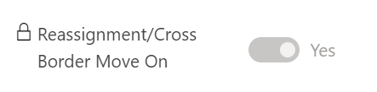

### If the person is moving into Wales with advanced notice

These are requests sent for re-assignment to Wales via Foundry with notice prior to any travel arrangements being made.

When a local authority from outside of Wales sends a re-assignment request to Wales via Foundry, the Case Management Team will receive and discuss the request with the relevant Welsh Local Authority. If the Welsh Local Authority accepts the process will be as follows:

1. The Case Management Team will accept the request on Foundry and gain access to the data
2. The data will flow into the Ukraine Data Platform – please note there may be a time lag
3. Within the data platform, you will need to:
   1. [Add a New Host](https://ukc-word-edit.officeapps.live.com/we/wordeditorframe.aspx?ui=en%2DUS&rs=en%2DUS&wopisrc=https%3A%2F%2Fwales365uk-my.sharepoint.com%2Fpersonal%2Fwilliam_rees_gov_wales%2F_vti_bin%2Fwopi.ashx%2Ffiles%2Fc59e3a17a9424215bb556aa4bbce1305&wdenableroaming=1&mscc=1&wdodb=1&hid=612B83F9-5789-4D21-8B22-717B331565EA&wdorigin=Sharing&jsapi=1&jsapiver=v1&newsession=1&corrid=9c2e8108-4ea5-447d-9308-043ab1673fb1&usid=9c2e8108-4ea5-447d-9308-043ab1673fb1&sftc=1&cac=1&mtf=1&sfp=1&instantedit=1&wopicomplete=1&wdredirectionreason=Unified_SingleFlush&rct=Normal&ctp=LeastProtected#_Adding_a_New) within the Sponsor section of the data platform
   2. [Add the host property address](https://ukc-word-edit.officeapps.live.com/we/wordeditorframe.aspx?ui=en%2DUS&rs=en%2DUS&wopisrc=https%3A%2F%2Fwales365uk-my.sharepoint.com%2Fpersonal%2Fwilliam_rees_gov_wales%2F_vti_bin%2Fwopi.ashx%2Ffiles%2Fc59e3a17a9424215bb556aa4bbce1305&wdenableroaming=1&mscc=1&wdodb=1&hid=612B83F9-5789-4D21-8B22-717B331565EA&wdorigin=Sharing&jsapi=1&jsapiver=v1&newsession=1&corrid=9c2e8108-4ea5-447d-9308-043ab1673fb1&usid=9c2e8108-4ea5-447d-9308-043ab1673fb1&sftc=1&cac=1&mtf=1&sfp=1&instantedit=1&wopicomplete=1&wdredirectionreason=Unified_SingleFlush&rct=Normal&ctp=LeastProtected#_Adding_Host_Addresses)
   3. Update the [Case Notes and Check boxes](https://ukc-word-edit.officeapps.live.com/we/wordeditorframe.aspx?ui=en%2DUS&rs=en%2DUS&wopisrc=https%3A%2F%2Fwales365uk-my.sharepoint.com%2Fpersonal%2Fwilliam_rees_gov_wales%2F_vti_bin%2Fwopi.ashx%2Ffiles%2Fc59e3a17a9424215bb556aa4bbce1305&wdenableroaming=1&mscc=1&wdodb=1&hid=612B83F9-5789-4D21-8B22-717B331565EA&wdorigin=Sharing&jsapi=1&jsapiver=v1&newsession=1&corrid=9c2e8108-4ea5-447d-9308-043ab1673fb1&usid=9c2e8108-4ea5-447d-9308-043ab1673fb1&sftc=1&cac=1&mtf=1&sfp=1&instantedit=1&wopicomplete=1&wdredirectionreason=Unified_SingleFlush&rct=Normal&ctp=LeastProtected#_Using_Case_Notes) to record non sensitive info regarding outcomes of checks and any other information necessary.
   4. Once the applicant records are visible, you will need to [create a new household placement tracking record](https://ukc-word-edit.officeapps.live.com/we/wordeditorframe.aspx?ui=en%2DUS&rs=en%2DUS&wopisrc=https%3A%2F%2Fwales365uk-my.sharepoint.com%2Fpersonal%2Fwilliam_rees_gov_wales%2F_vti_bin%2Fwopi.ashx%2Ffiles%2Fc59e3a17a9424215bb556aa4bbce1305&wdenableroaming=1&mscc=1&wdodb=1&hid=612B83F9-5789-4D21-8B22-717B331565EA&wdorigin=Sharing&jsapi=1&jsapiver=v1&newsession=1&corrid=9c2e8108-4ea5-447d-9308-043ab1673fb1&usid=9c2e8108-4ea5-447d-9308-043ab1673fb1&sftc=1&cac=1&mtf=1&sfp=1&instantedit=1&wopicomplete=1&wdredirectionreason=Unified_SingleFlush&rct=Normal&ctp=LeastProtected#_Create_a_Household), linking the host to the applicant within the Host Sponsor field in the placement tracking form.
   5. Ensure the [case notes](https://ukc-word-edit.officeapps.live.com/we/wordeditorframe.aspx?ui=en%2DUS&rs=en%2DUS&wopisrc=https%3A%2F%2Fwales365uk-my.sharepoint.com%2Fpersonal%2Fwilliam_rees_gov_wales%2F_vti_bin%2Fwopi.ashx%2Ffiles%2Fc59e3a17a9424215bb556aa4bbce1305&wdenableroaming=1&mscc=1&wdodb=1&hid=612B83F9-5789-4D21-8B22-717B331565EA&wdorigin=Sharing&jsapi=1&jsapiver=v1&newsession=1&corrid=9c2e8108-4ea5-447d-9308-043ab1673fb1&usid=9c2e8108-4ea5-447d-9308-043ab1673fb1&sftc=1&cac=1&mtf=1&sfp=1&instantedit=1&wopicomplete=1&wdredirectionreason=Unified_SingleFlush&rct=Normal&ctp=LeastProtected#_Using_Case_Notes) record the transfer has been agreed and include any information received from the Case Management Team

Within the applicant summary page under case notes and activities, once the data has arrived onto the Data Platform, the Reassignment/Cross Border Move on will be toggled to YES. This is a locked field and is for information purposes only to show those individuals who have been reassigned across UK Nations.

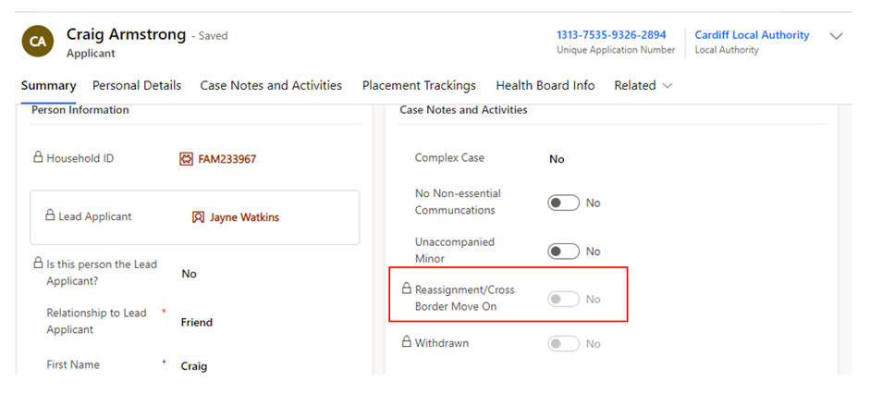

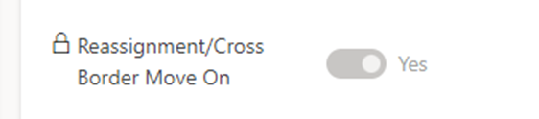

### If the person has moved into Wales and we find out retrospectively

These are instances where a Local Authority has identified that a Ukrainian has already arrived in Wales with no advance notice of travel. The receiving Welsh Local Authority will need to follow the below process:

1. Contact the Case Management Team [casemanagementteam@cardiff.gov.uk](mailto:casemanagementteam@cardiff.gov.uk) and ask them to raise a re-assignment request on Foundry
2. The Case Management Team will contact the original Local Authority and if the request is accepted will arrange for the information to be sent over
3. The data will flow into the Ukraine Data Platform – please note there may be a time lag
4. Within the data platform, you will need to:
5. [Add a New Host](https://ukc-word-edit.officeapps.live.com/we/wordeditorframe.aspx?ui=en%2DUS&rs=en%2DUS&wopisrc=https%3A%2F%2Fwales365uk-my.sharepoint.com%2Fpersonal%2Fwilliam_rees_gov_wales%2F_vti_bin%2Fwopi.ashx%2Ffiles%2Fc59e3a17a9424215bb556aa4bbce1305&wdenableroaming=1&mscc=1&wdodb=1&hid=612B83F9-5789-4D21-8B22-717B331565EA&wdorigin=Sharing&jsapi=1&jsapiver=v1&newsession=1&corrid=9c2e8108-4ea5-447d-9308-043ab1673fb1&usid=9c2e8108-4ea5-447d-9308-043ab1673fb1&sftc=1&cac=1&mtf=1&sfp=1&instantedit=1&wopicomplete=1&wdredirectionreason=Unified_SingleFlush&rct=Normal&ctp=LeastProtected#_Adding_a_New) within the Sponsor section of the data platform

1. [Add the host property address](https://ukc-word-edit.officeapps.live.com/we/wordeditorframe.aspx?ui=en%2DUS&rs=en%2DUS&wopisrc=https%3A%2F%2Fwales365uk-my.sharepoint.com%2Fpersonal%2Fwilliam_rees_gov_wales%2F_vti_bin%2Fwopi.ashx%2Ffiles%2Fc59e3a17a9424215bb556aa4bbce1305&wdenableroaming=1&mscc=1&wdodb=1&hid=612B83F9-5789-4D21-8B22-717B331565EA&wdorigin=Sharing&jsapi=1&jsapiver=v1&newsession=1&corrid=9c2e8108-4ea5-447d-9308-043ab1673fb1&usid=9c2e8108-4ea5-447d-9308-043ab1673fb1&sftc=1&cac=1&mtf=1&sfp=1&instantedit=1&wopicomplete=1&wdredirectionreason=Unified_SingleFlush&rct=Normal&ctp=LeastProtected" \l "_Adding_Host_Addresses)
2. Update the [Case Notes and Check boxes](https://ukc-word-edit.officeapps.live.com/we/wordeditorframe.aspx?ui=en%2DUS&rs=en%2DUS&wopisrc=https%3A%2F%2Fwales365uk-my.sharepoint.com%2Fpersonal%2Fwilliam_rees_gov_wales%2F_vti_bin%2Fwopi.ashx%2Ffiles%2Fc59e3a17a9424215bb556aa4bbce1305&wdenableroaming=1&mscc=1&wdodb=1&hid=612B83F9-5789-4D21-8B22-717B331565EA&wdorigin=Sharing&jsapi=1&jsapiver=v1&newsession=1&corrid=9c2e8108-4ea5-447d-9308-043ab1673fb1&usid=9c2e8108-4ea5-447d-9308-043ab1673fb1&sftc=1&cac=1&mtf=1&sfp=1&instantedit=1&wopicomplete=1&wdredirectionreason=Unified_SingleFlush&rct=Normal&ctp=LeastProtected#_Using_Case_Notes) to record non sensitive info regarding outcomes of checks and any other information necessary.
3. Once the applicant records are visible, you will need to [create a new household placement tracking record](https://ukc-word-edit.officeapps.live.com/we/wordeditorframe.aspx?ui=en%2DUS&rs=en%2DUS&wopisrc=https%3A%2F%2Fwales365uk-my.sharepoint.com%2Fpersonal%2Fwilliam_rees_gov_wales%2F_vti_bin%2Fwopi.ashx%2Ffiles%2Fc59e3a17a9424215bb556aa4bbce1305&wdenableroaming=1&mscc=1&wdodb=1&hid=612B83F9-5789-4D21-8B22-717B331565EA&wdorigin=Sharing&jsapi=1&jsapiver=v1&newsession=1&corrid=9c2e8108-4ea5-447d-9308-043ab1673fb1&usid=9c2e8108-4ea5-447d-9308-043ab1673fb1&sftc=1&cac=1&mtf=1&sfp=1&instantedit=1&wopicomplete=1&wdredirectionreason=Unified_SingleFlush&rct=Normal&ctp=LeastProtected#_Create_a_Household), linking the host to the applicant within the Host Sponsor field in the placement tracking form.
4. Ensure the [case notes](https://ukc-word-edit.officeapps.live.com/we/wordeditorframe.aspx?ui=en%2DUS&rs=en%2DUS&wopisrc=https%3A%2F%2Fwales365uk-my.sharepoint.com%2Fpersonal%2Fwilliam_rees_gov_wales%2F_vti_bin%2Fwopi.ashx%2Ffiles%2Fc59e3a17a9424215bb556aa4bbce1305&wdenableroaming=1&mscc=1&wdodb=1&hid=612B83F9-5789-4D21-8B22-717B331565EA&wdorigin=Sharing&jsapi=1&jsapiver=v1&newsession=1&corrid=9c2e8108-4ea5-447d-9308-043ab1673fb1&usid=9c2e8108-4ea5-447d-9308-043ab1673fb1&sftc=1&cac=1&mtf=1&sfp=1&instantedit=1&wopicomplete=1&wdredirectionreason=Unified_SingleFlush&rct=Normal&ctp=LeastProtected#_Using_Case_Notes) record the transfer has been agreed and include any information received from the Case Management Team

Within the applicant summary page under case notes and activities, once the data has arrived onto the Data Platform, the Reassignment/Cross Border Move on will be toggled to YES. This is a locked field and is for information purposes only to show those individuals who have been reassigned across UK Nations.





# Repatriation

There will be times when a Ukrainian household chooses to return to the Ukraine to live or visit for an extended period. When a household leaves their accommodation for more than 2 weeks, local authorities can reallocate their accommodation to another family in need. Due to the volatile nature within Ukraine, families that had repatriated without plans to come back may choose to return to Wales.

Ideally a family will inform you of their decision in advance, but you may not know this has happened until they return, seeking accommodation.

It is important that placement tracking records show the individual has left the UK and returned for funding purposes and you may therefore need to complete these retrospectively.

## When a person is leaving for repatriation

When a household (either individual or group) repatriate you will need to:

1. Confirm with the household group that they are returning to the Ukraine.
2. Once they have left, update their status to
   1. SS10 Move On for Super Sponsor Scheme
   2. IS05 Move On for Individual Sponsor Scheme.
   3. Status reason for either scheme can be set to ‘Repatriation’.
3. Update the move on reason on their current placement record. Depending on the scheme they arrived under, this could be a placement record for a host or welcome centre.
4. Create a new placement tracking record including:
   1. Placement Type – Repatriation
   2. Address – if you know the country they have returned to, you can add it here
   3. Local Authority - ‘Outside of the UK’
   4. Move on Reason – no need to add anything here.
5. If the person is at a Welcome Centre, email the Contact Centre ([wnsadmin@cardiff.gov.uk](mailto:wnsadmin@cardiff.gov.uk)) with the FAM/WG reference number to note that they have left the UK for repatriation reasons and the number of rooms that can be released.
6. Access the household record via the FAM ID and remove the Welcome Centre from the Household ID Page.  
     
   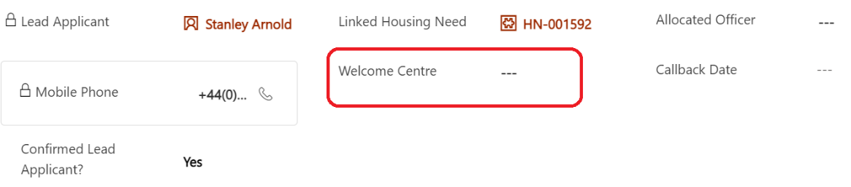
7. If the person is with a host, you can remove the links to the host address and make necessary changes to host record.

## If a person returns from repatriation

If a household returns from repatriation, they will need to contact the local authority to say they have returned. They may or may not have returned to their original local authority area.

1. Check your records to see whether the household record is assigned to your local authority. If the record isn’t assigned to your local authority, use the ‘[searching outside of your local authority’](#_Searching_for_a) steps to identify the record owner.

### If the household record is assigned to your local authority

1. Check whether a placement at the welcome centre or original host is still available.  
   1. **If yes,** refer to point C below.
   2. **If no**, new accommodation will need to be found.
      1. You can follow the [re-matching process](#_Re-matching) to find them suitable accommodation. In the short term, this may include emergency accommodation.
   3. update the placement tracking records. If you were unaware the household had left, you will need to
      1. update the original placement record if relevant
      2. [create a new placement record](#_Creating_a_new) for repatriation. This is important for funding purposes.
   4. Once the household is assigned to ‘(outside of UK)’ in the repatriation placement tracking record, it will disappear from your view. Email the Contact Centre ([wnsadmin@cardiff.gov.uk](mailto:wnsadmin@cardiff.gov.uk)) with the FAM/WG household reference and ask them to re-assign the household record.
   5. The Contact Centre will close the repatriation placement record and start a new placement tracking record to assign it back to the local authority.
   6. Once the household record is returned, complete the placement tracking record with required details.
2. [Update case notes](#_Using_Case_Notes) as needed.
3. Update [Journey Status](#_Changing_Journey_Status ) to ‘IS03 - Moved to Accommodation or SS10 – Moved on or SS07 if returned to Welcome Centre accommodation.

### If the household record is not assigned to your local authority

If the household records are not assigned to your local authority it means that either a repatriation tracking record has been completed and is assigned to ‘(outside of UK)’ or the original local authority did not update their placement tracking records.

1. If the household record is assigned to another local authority, please make direct contact with their Data Champion and request that the placement tracking records reflect that they have repatriated. This will ensure the records are transferred to ‘(outside of UK)’.
2. If / once the household is assigned to ‘(outside of UK)’, email the Contact Centre ([wnsadmin@cardiff.gov.uk](mailto:wnsadmin@cardiff.gov.uk)) with the FAM/WG household reference and ask them to locate the household record. The Contact Centre will create a new placement tracking record to assign it to your local authority, this will close the original repatriation placement record.
   1. You will need to consider the available accommodation and whether the household has resided in the county previously and whether that placement (Welcome Centre or Host/Sponsor) is still available.
   2. **If the previous placement is available, you can complete the placement tracking record.**
   3. **If the household is a new arrival to your local authority or the placement is no longer available**, new accommodation will need to be found. You can follow the [re-matching process](#_Re-matching) to find them suitable accommodation. In the short term, this may include emergency accommodation. Once accommodation has been identified you can complete the new placement tracking record.

# Using the Sponsor Section

**Definitions:**

A Sponsor is the person who sponsor’s the visa for the individual. For Super Sponsor that is the Welsh Government but for Individual Sponsor Scheme, that would be the host providing them with accommodation.

A Host is the person providing accommodation for the household(s).

An individual can be both sponsor and host.

## Adding a New Sponsor/Host

1. Click on the [Sponsor section](#_Sponsor) in left hand navigation.

1. Click New at the top of the screen to open a blank sponsor record.

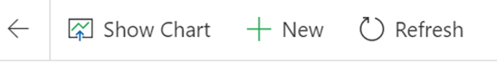

1. Complete the fields within the Summary Tab noting the following:
   1. Within the ‘Type’ field, select host to reflect that it is someone who has offered accommodation through Expression of Interest (EoI) as part of the Super Sponsor Scheme. In the unlikely event you need to create a new record for someone offering accommodation through the Homes for Ukraine Scheme, you would select Sponsor.
   2. Address refers to the home that the host lives in, rather than the address of the accommodation being offered.
   3. It is really important that you include contact details for the host including both telephone number and email address.
   4. Once checks are completed and the host is active and receiving their monthly contribution, you will be able to add their finance system reference and other details within this section for reference. It will not link directly to your local finance systems.
2. Update [Case Notes and Activities](#_Using_Case_Notes) as appropriate.
3. Click Save.

## Adding Host Addresses

A host address is the address of accommodation being offered to house Ukrainians travelling to Wales. A host can have multiple addresses depending on when the number of properties being offered. The host may or may not live at the address.

To add a host address you need to:

1. Click on the [Sponsor section](#_Sponsor) in left hand navigation and find the sponsor record required.
2. Open the Sponsor record.
3. Click on the Host Addresses Tab and click on New Host Address

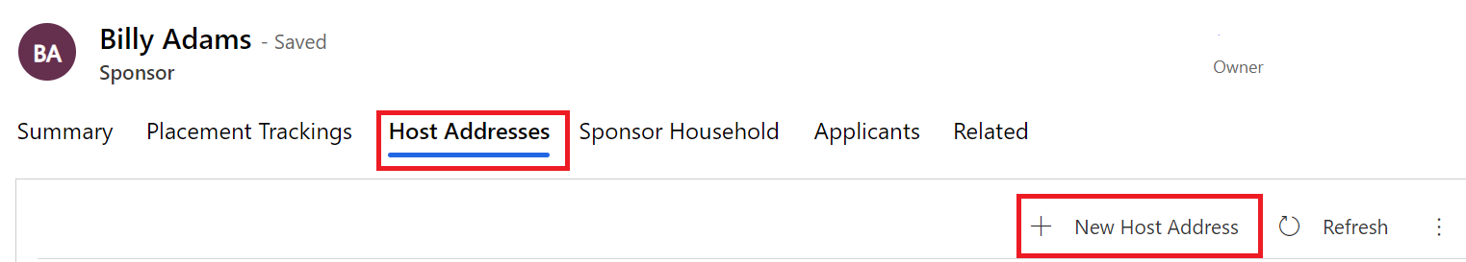

1. Complete the form, considering the following:
   1. Address fields are for the accommodation that is being offered which may not necessarily be the address at which the host live.
   2. Staying with Sponsor field indicates whether the property is the main residence of the sponsor and their family e.g. someone would be allocated a room in the sponsors/host house rather than accommodation separately owned by the sponsor/host.
2. Save the record.
3. You now need to assign the sponsor and host address records to ensure everyone in your local authority group can access the records. Click Assign in the top navigation of the data platform.



1. Assign to User or Team and then hit enter to browse your local authority.

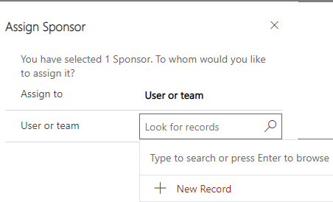

To check, this has happened correctly, you can check the host address to ensure the host local authority has changed as well as the ‘owner’ in the top right corner of the record. This may take a little while to filter through so refresh after 20-30 seconds.

## Hosts with multiple addresses

If a host has multiple addresses, then these need to be added separately for each property in the [host addresses tab](https://ukc-word-edit.officeapps.live.com/we/wordeditorframe.aspx?ui=en%2DUS&rs=en%2DUS&wopisrc=https%3A%2F%2Fwales365uk-my.sharepoint.com%2Fpersonal%2Fwilliam_rees_gov_wales%2F_vti_bin%2Fwopi.ashx%2Ffiles%2Fc59e3a17a9424215bb556aa4bbce1305&wdenableroaming=1&mscc=1&wdodb=1&hid=793A4167-5CE7-4D74-BBB2-25556DCBE103&wdorigin=Sharing&jsapi=1&jsapiver=v1&newsession=1&corrid=3d3a93bd-a7b7-4c5d-91b0-a79a3a76f106&usid=3d3a93bd-a7b7-4c5d-91b0-a79a3a76f106&sftc=1&cac=1&mtf=1&sfp=1&instantedit=1&wopicomplete=1&wdredirectionreason=Unified_SingleFlush&rct=Normal&ctp=LeastProtected#_Adding_Host_Addresses). Each address for the host will show as available individually until they are linked to an applicant.

When a host is linked to the applicant on the household page, you will be able to search all available addresses for that host.

If a host has more than one family staying in the same property:

1. The address will need to be [added onto the address section](https://ukc-word-edit.officeapps.live.com/we/wordeditorframe.aspx?ui=en%2DUS&rs=en%2DUS&wopisrc=https%3A%2F%2Fwales365uk-my.sharepoint.com%2Fpersonal%2Fwilliam_rees_gov_wales%2F_vti_bin%2Fwopi.ashx%2Ffiles%2Fc59e3a17a9424215bb556aa4bbce1305&wdenableroaming=1&mscc=1&wdodb=1&hid=793A4167-5CE7-4D74-BBB2-25556DCBE103&wdorigin=Sharing&jsapi=1&jsapiver=v1&newsession=1&corrid=3d3a93bd-a7b7-4c5d-91b0-a79a3a76f106&usid=3d3a93bd-a7b7-4c5d-91b0-a79a3a76f106&sftc=1&cac=1&mtf=1&sfp=1&instantedit=1&wopicomplete=1&wdredirectionreason=Unified_SingleFlush&rct=Normal&ctp=LeastProtected#_Adding_Host_Addresses) multiple times
2. Each address will require a different annotation to show it’s a different part of the house/ building – e.g. Flat 1 / Flat 2:

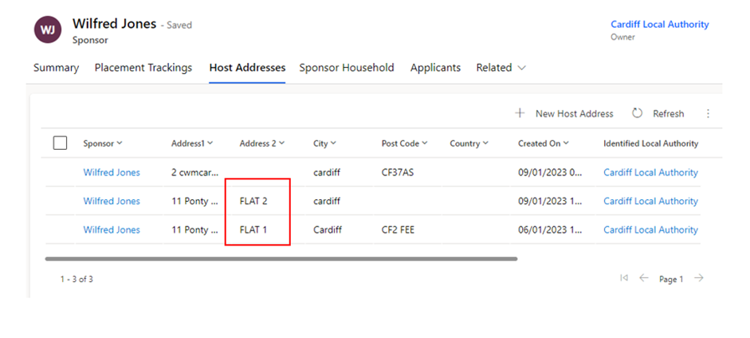

## Linking a household record and a Sponsor/ host record

When linking a sponsor to a household there are two steps to follow.

1. Within the household page, you need to input the sponsor /host into the host field
2. Create a Household Placement Tracking record

### Adding the Sponsor/host Details to your household record

To open a household record:

1. Search for an applicant within the household you wish to edit either through the Applicants or Households menu.
2. Double-click on a member of the household and click on the blue Household ID at the top of the summary screen.
3. Click in the Host Field to add the name of your sponsor. You can either type the name or press return to bring up a full list.

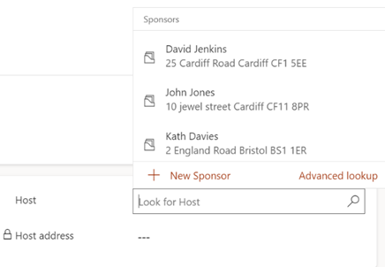

If you have multiple sponsors with the same name, click on the drop-down arrow next to their name to see further details.

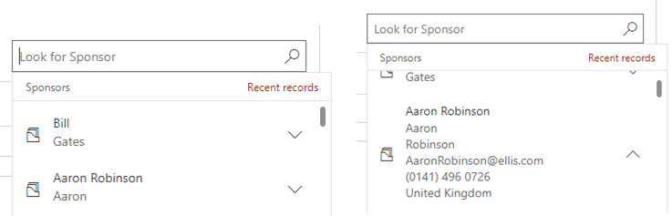

1. Click in the host address field to select the appropriate address. It will only lisyt those associated with the sponsor that are currently unavailable.

If you select the wrong address, you can easily delete and select the right address or check the HA reference in the host address tab within the Sponsor section of the platform.

1. Click Save or Save and Close - if you check the ‘sponsor’ section on the personal details tab of the applicant page – you will see this has now pulled through the new sponsor – this field will be locked with no option to update

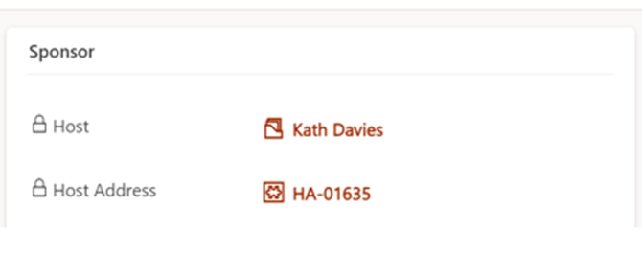

## Replacing an existing Host / Sponsor

On some occasions you will need to replace an existing host/sponsor with another within the current local authority.

If the host is being replaced:

1. Firstly, you must delete the current host out of the host / host address field on the household page.
2. When searching the replacement host’s name in the host box, only available hosts will show (those that don’t have an applicant attached to their record).

Hosts with multiple properties will show as available if they have any available properties – only the available properties will show in the host address list.

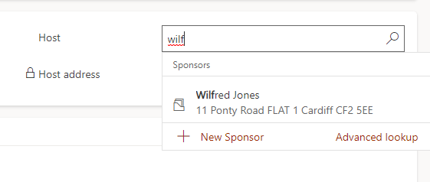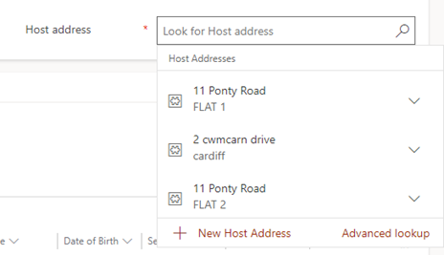

IMPORTANT: when changing / updating a host on the record you must update the host on the household field **first** and then create a placement tracking for the new placement

As the host section on the household page is mandatory you can only replace a host with an alternative host unless the applicant is moving to move on accommodation (self-supporting).

To remove a host completely (because the person is moving to self-supporting within the LA for instance) you need to create a placement tracking with a dropdown of any scenario other than sponsor/host:

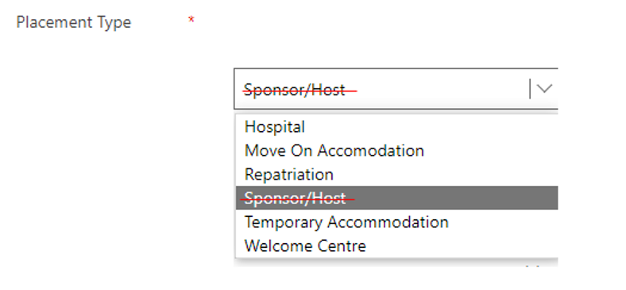

Once a placement tracking has been created with one of the above dropdowns, the host will be automatically removed from the household page and the host section will no longer be a mandatory field.

## Removing a Host/Sponsor when the household is a No Show

There will be occasions where a household has decided either not to travel to Wales, has decided not to use this Visa or has travelled to another part of the UK on a separate Homes for Ukraine Visa. There may also be a situation where the household/applicant are uncontactable with no confirmed arrival date.

On these occasions, there may be a host still linked to the household page, which is a result of a flow that was run in release 4.0. As the host / host address field is mandatory on the household page and you cannot create a placement tracking for someone who hasn’t arrived, it’s important that the IS Journey Status is reflective of the situation to enable the deletion of the data in these mandatory fields.

The system has functionality that when ALL members of a household group are set to No show / uncontactable it will remove the mandatory restrictions behind the host/ host address section of the household page.

When a household (multiple applicants or single applicants) are no shows, you should:

1. Set the IS Journey Status to one of 3 options: IS21, IS22, IS23.

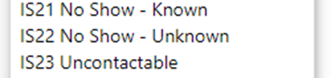

1. Ensure that this is set for ALL members of the household.
2. Go into the household page and delete the host / host address.
3. Click save.

The host/host address fields will now be empty, the link between sponsor/host and applicant will be removed and the sponsor/host will now become available.

Please note: if not all members of the household are no show’s then you will need to split the household [removing the no show applicants](https://ukc-word-edit.officeapps.live.com/we/wordeditorframe.aspx?ui=en%2DUS&rs=en%2DUS&wopisrc=https%3A%2F%2Fwales365uk-my.sharepoint.com%2Fpersonal%2Fwilliam_rees_gov_wales%2F_vti_bin%2Fwopi.ashx%2Ffiles%2Fc59e3a17a9424215bb556aa4bbce1305&wdenableroaming=1&mscc=1&wdodb=1&hid=95B3DB3E-2F02-4707-9F0F-F638D695D67D&wdorigin=Sharing.ServerTransfer&jsapi=1&jsapiver=v1&newsession=1&corrid=1f7d13a1-127e-42c8-8eba-c26bd9aa8e23&usid=1f7d13a1-127e-42c8-8eba-c26bd9aa8e23&sftc=1&cac=1&mtf=1&sfp=1&instantedit=1&wopicomplete=1&wdredirectionreason=Unified_SingleFlush&rct=Normal&ctp=LeastProtected#_Removing_an_applicant) into their own household group.

## Recording additional sponsor household members

A sponsor household member is a person that is living with the applicant at the time the application to be a sponsor is made. For example, a child or partner.

Understanding who lives with the sponsor in their home, will help to ensure the appropriate checks are undertaken.

To add a sponsor household member, you need to:

1. Click on [Sponsor Household](#_Sponsor_Household) section in the left hand navigation.
2. Click  in the top application navigation bar.
3. Add the name of the sponsor. Click into the Sponsor field and the most recent record you have opened will show in the drop down. Otherwise you can hit return for a full list of start to type their name for a short list of options to show.

1. Complete the remainder of the fields.
2. Click Save or Save & Close.

## Handling Duplicate Applicant Records

Many Ukrainians have applied on several visa schemes in order to seek sanctuary in Wales and the UK. If they have had a visa approved for more than one scheme, the data in the platform may reflect this, appearing as duplicate records.

It may be clear to you which sponsorship scheme a person is travelling on, for example if they arrive at a Welcome Centre (super sponsor) or if they have their own sponsor (individual sponsor). If it is not clear, you can ask the individual to confirm which scheme they are travelling on, or you can ask to check their application number on any emails or documentation they have brought with them.

When you have established which application is the duplicate, take the following steps to mark out the duplicate record and separate it from any existing household groups:

1. Make a note of the application number of the duplicate record. In the true record, add a case note and include the duplicate application number for future reference.

2. Open the applicant’s duplicate record on the Summary section.

3. Under SS or IS Journey Status, select SS11/IS100 Duplicate Record.

4. Under status reason, select Move to another Visa Scheme.

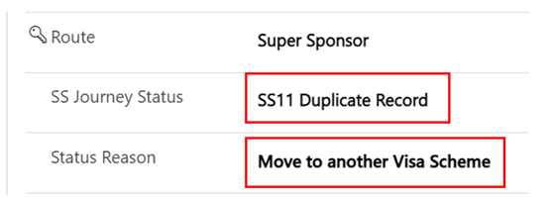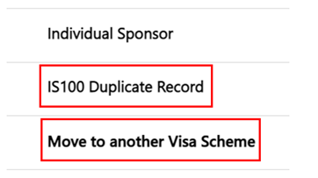

5. Remove the duplicate applicant from any household group they are in using the [Removing an Applicant to a New Household](https://docs.google.com/document/d/1uxeZJ00RrfxDTBaj9mGiYg-WLZQl72mh/edit#heading=h.32hioqz) guide.

6. Ensure the linked housing needs record reflects the correct number of people and their requirements using the [Updating an existing housing needs record](https://docs.google.com/document/d/1uxeZJ00RrfxDTBaj9mGiYg-WLZQl72mh/edit#heading=h.qsh70q) guide.

7. To remove these duplicates from your system or personalised Views, filter the SS or IS journey status column to ensure SS11 / IS100 is not included.

## Rejected / Withdrawn Sponsors/Hosts

There may be occasions where a sponsor/host wishes to withdraw their interest in hosting or is rejected as a result of failed checks, such as local government/ property checks.

If a host expresses that they wish to ‘withdraw’ from the scheme or is ‘rejected’ as a result of failed checks the record will need to be set to the correct sponsor journey status in order for the system to deactivate their records.

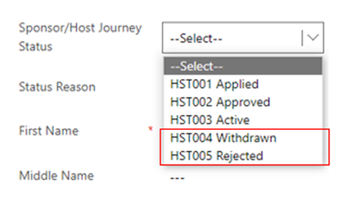

Once selected the system will automatically deactivate these records to prevent them from showing up on the active sponsors list.

* You will still have the ability to create case notes on the record once deactivated.
* If you need to access a withdrawn / rejected sponsor record – you can locate these via the inactive sponsor’s view:

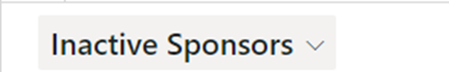

## Duplicate Hosts with no approved applicants attached

From time to time you may come across an additional host record. These will usually have no linked applicants or PTs attached

It will normally show an application linked with no applicant name which suggests that the applicant has not yet been approved.

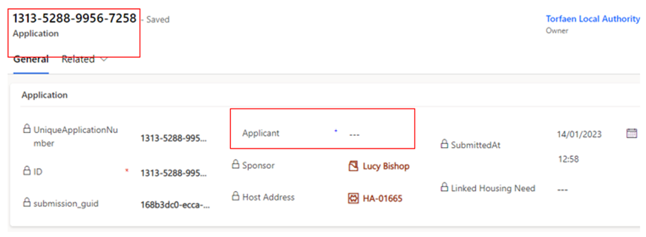

To avoid having multiple records in the system for hosts/sponsors you can

deactivate these by selecting their sponsor/host journey status to HST006 – Duplicate.

The record will be automatically de activated.

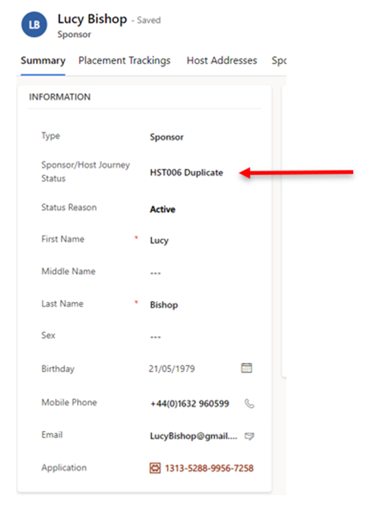

If you need to access a Deactivated sponsor record – you can locate these via the inactive sponsors view:

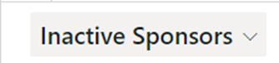

## 

## Updating Sponsor Communication Preferences

A sponsor/host may make contact to state they don’t want to receive any communication, however it is necessary that essential communications are still carried out. This means they should only receive information from Welsh Government regarding their current sponsor/hosting position. Restricting their communication preferences to essential communication only means they will stop receiving updates regarding things such as Ukrainian National holiday updates/ information on local Ukrainian events etc.

To action this request in the UDP:

1. Go into the Sponsor record, on the summary tab
2. Locate the No Non-essential Communications check under Case Notes and Activities
3. Toggle this to YES

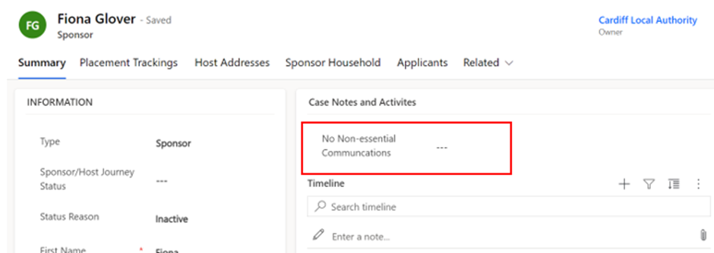

Please note: you will need to click the dotted lines once for the toggle to appear and then you can click this again to toggle over to YES

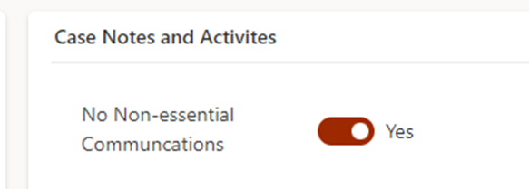

# Creating personalised System Views and Reports

## Editing filters

To add a new filter:

1. Select the [Edit filters button](#_Navigation_Buttons) on the appropriate screen.
2. Click the Add drop-down and choose to filter by Row, Group or Related Entity.

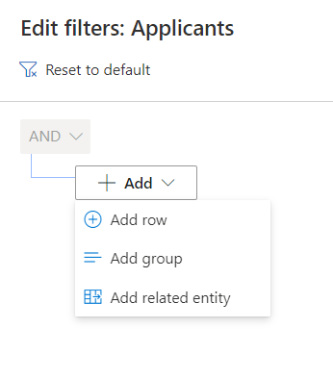

1. Choose the row, group or entity you want to filter by (for example, Last Name) and specify the criteria.
2. Add more rows, groups or entities to filter by, or delete as applicable.
3. Check the checkbox at the start of each row before attempting to apply your filters.

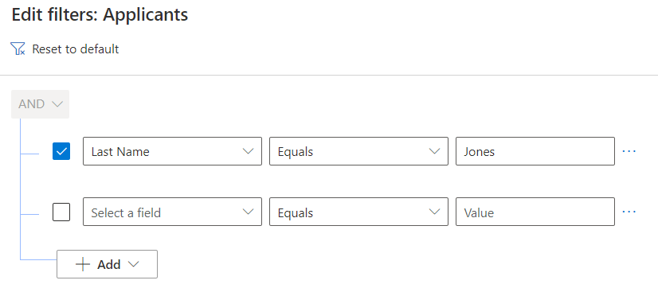

1. Click the Apply button . This will filter the selection on your screen.

## Editing columns

On the Edit columns panel, you can add additional columns to your system view, change the order of columns and remove columns from your system view.

### Add columns to your system view

1. To add a new column to your system view:
2. Click the Edit columns button 
3. From the Edit columns panel, click the Add columns button This will reveal additional columns which can be added to your system view.
4. Scroll through the list of columns or use the search tool to find the column you are looking for.
5. Left-click on the columns you want to add. Once you have added all columns required, click the close button to return to the Edit columns panel.
6. To apply your changes and see the new columns on your system view, click the Apply button on the Edit columns panel.
7. To discard your changes click the Cancel button .

### 

### Change the order of columns on your system view

To change the order in which columns appear on your system view:

1. Click the Edit columns button .
2. From the Edit columns panel hover over any column (your cursor should appear as four arrows intersecting).
3. Click and drag the column into the required order.
4. To apply your changes and see the new columns on your system view, click the Apply button on the Edit columns panel.
5. To discard your changes click the Cancel button .

### Remove columns from your system view

To remove a column from your system view:

1. Click the Edit columns button 
2. From the Edit columns panel hover over any column.
3. Click on the options button  that appears beside the column name.
4. Click the Remove button to remove the column from your system view.
5. To apply your changes and see the new columns on your system view, click the Apply button on the Edit columns panel.
6. To discard your changes click the Cancel button .

### Saving your own system view

Once you have added/removed columns and filtered information, you can save your view. This is helpful if it is a view that you will use frequently.

1. Once you have changed your filters/columns as necessary, click on the arrow next to the system view title, such as All Applicants
2. A drop-down menu will open.

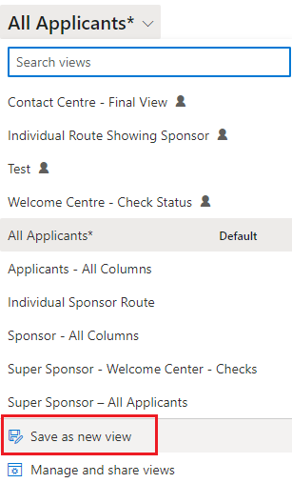

1. Click Save as a new view

### Deleting your own system view

If you no longer require a saved view, you can delete them from your ‘MyView’ list.

1. Click on the System View drop down arrow.
2. Select Manage and share views.

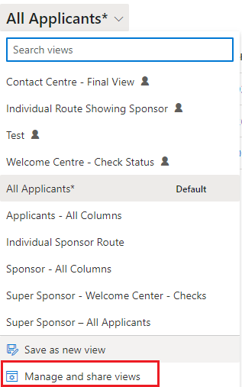

1. A new window will open.
2. Select the view you wish to manage and click on the 3 dots to the right of the name.

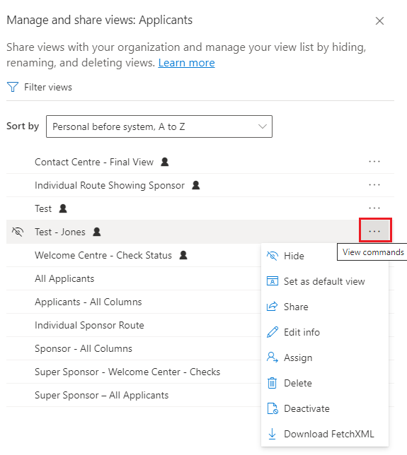

1. Select the option you wish to choose. Options include:

|  |  |
| --- | --- |
| Hide | Hide from View. If you have a view that you have hidden it will give you the option to ‘show’. |
| Set as default view | Set as your default view when you open the data platform. |
| Share | Share the view with colleagues. |
| Edit Info | Change name and description of the selected view. |
| Assign View | Assign the view to a group or individual. |
| Delete | Will permanently remove the view. |

# Extracting information from the Ukraine data platform to replicate Objective Connect

Responses to our platform user survey showed that many local authorities used the Objective Connect data for internal reporting.

To help you continue to feed your own internal reporting systems, we have developed a set of templates within the platform which you can use to extract information that you previously received via Objective Connect.

The available templates are all found within the **Applications section** of the system and are accessed through pre-set views. A set of views are available which correspond to the Excel templates which you can use to extract the information.

The table below shows:

**Objective Connect Data Sheet**: the name of the data sheet you have previously received via Objective Connect

**UDP View**: the data platform view that you must access to see the data arranged in the same way as Objective Connect

**UDP Excel template**: the name of the related Excel template which enables you to extract the data.

|  |  |  |
| --- | --- | --- |
| **Objective Connect Data Sheet** | **UDP View** | **UDP Excel template** |
| Approved Applications | Application Main Applicant - OC | ApprovedApplicants-OC |
| Sponsor | Application Sponsor - OC | Sponsor-OC |
| Sponsor Hosting Address | SponsorHostingAddress - OC | SponsorHostAddress-OC |
| UK Arrivals | UK Arrivals - OC | UK Arrivals-OC |

Note: In downloading the templates, you **must** click ‘Download Excel Template’ and **not** ‘View in Excel Online’. Using the download template option removes the risk of editing system data in the Excel Online version.

For the templates to mimic the layout of data on Objective Connect, formulas have been used to ensure the data sits in the correct columns. If you wish to manipulate the data once downloaded, it is recommended you **save your own version of the download** to remove the formulas.

**How to access and extract the data:**

1. To access all the templates, click on the **Applications** section of the platform (under Placements in the left-hand menu). Under the Views, select the relevant view with **OC** in the title.

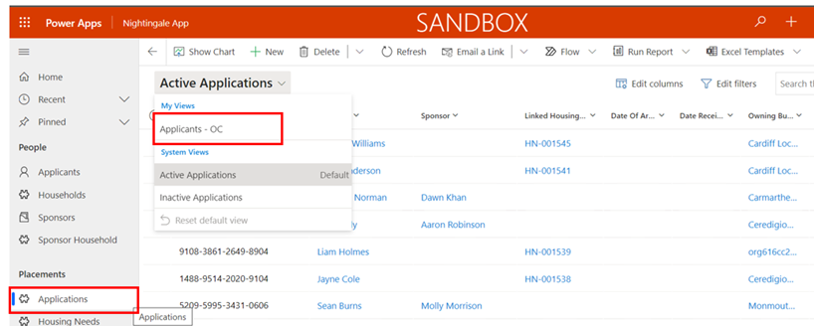

2. If you are accessing the templates for the first time, you need to create a connection between your view and the templates. To do this:

* Click on **Excel Templates**, and then click **View All My Templates**. You do not need to repeat this step again in future.
* After you click View All My Templates, simply click the Back arrow button to return to the view you selected.

If you are unable to see Excel Templates listed after ‘Run Report’, in the system menu, click on the **three dots** for further options.

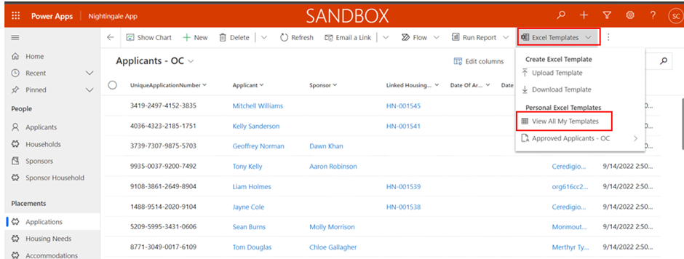

3. When you have the view you wish to export on your screen, click on **Excel Templates** in the top menu, and click the arrow next to the Template – in this case Approved Applicants – OC:

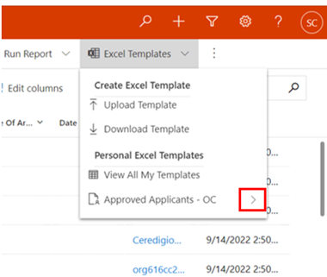

4. You must then click the **Download** **Approved Applicants – OC**:

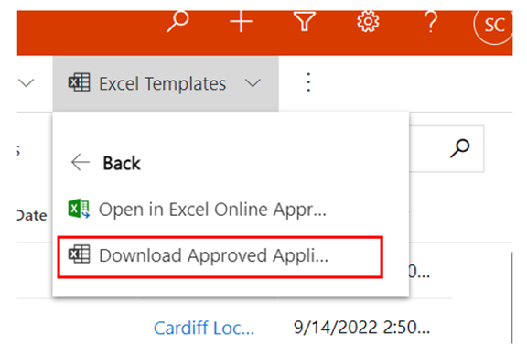

5. The downloaded content will appear in your Downloads folder on your computer for you to use in your internal reporting.

Please remember the note above in relation to the formulas and save a copy of your own for editing. The pop-up message which appears on the screen can be ignored. The upload function has been disabled on the platform.

# Escalating any Data platform related issues or functionality requests

## How will service incidents relating to the Data Platform be handled?

A service model has been developed and agreed with colleagues from Digital Health and Care Wales. User incidents will be triaged by your organisation’s local IT service desk in the first instance, before a call is routed to the Data Platform service desk.

Please speak with your local champion before contacting your IT service desk.

**Annex 3** provides further information about the Service Model and who to contact.

## Homes for Ukraine Data Platform FAQ

All of our documentation (including FAQS), training videos and User Guides are available via this link. - <https://ukrainedataplatform.github.io/documentation/>.

## Contact Details

For any feedback on the system, please email [UkraineResponseQueries@gov.wales](mailto:ukraineresponsequeries@gov.wales)

# Annex 1 - Summary of processes within each Scheme

## Super Sponsor scheme

Each step of the process involves checks and updates to the data platform to ensure arrivals from Ukraine are safely guided to accommodation in Wales. This step-by-step process outlines what needs to be done within the data platform and who is responsible for it.

### How the process works - In summary

|  |  |  |
| --- | --- | --- |
| **Journey Status** | **Primary responsibility** | **Key System updates required** |
| SS01 - SS05 | **Contact Centre** | Update all fields as necessary and create initial housing record  Status Changes |
| SS05 | **Contact Centre** | CC to complete arrival hub details and make them aware of ETA and other info  Arrival Hub to phone through confirmation of contact and Contact Centre to update records  Status Change |
| SS07 | **Contact Centre** | Checks undertaken by Welcome Centre and system updated through Case Notes and Check box  Placement record created  Housing Need checked and updated if required  Status Change |
| SS08 | **Welcome Centre** | Status Change |
| SS09 | **Welcome Centre / Local Authority** | Accommodation is allocated but individual is still in welcome centre.  Update status notes |
| SS10 | **Welcome Centre / Local Authority** | Change Status  Close Welcome Centre placement record  Create a new placement record for their permanent accommodation |

### How the process works - In Detail

|  |  |  |  |  |
| --- | --- | --- | --- | --- |
| **Step of process** | **What is happening here** | **What needs to take place on data platform?** | **Who is doing something on the data platform to capture this?** | **Checklist to move to next status** |
| SS01  Visa approved – initial contact to be made to start journey to Wales if all necessary factors are in place. | An individual with an approved visa for the Super sponsor route is identified on system.  If contact is made, the following things are checked to ensure they are ready to begin their journey to Wales:  a) individual and all linked people on application all have permission letters to travel  b) contact numbers and email address are up to date.  c) If pets being brought into UK and whether they have arranged appropriate checks and APHA licence has been granted.  d) housing requirements for applicant and linked people captured  e) any additional support required during travel  f) any location preferred (not guaranteed)  g) notes on travel arrangements such as dates and arrival location | Search data for individuals and linked people with SS01 status  Record that necessary checks have taken place in a case note.  Identify and update records of all linked people with SS01 status and confirm they are ready to travel.  If not all members of group are ready to travel, set a reminder task to recontact to check when all are ready to travel.  Open a case note on the system to record any details of travel arrangements (times/place of arrival). | Contact Centre | SS01 to SS02 checklist  Recorded if interpreter needed, language specified, and details of LL Pin provided  Confirmed that the citizen has received their permission to travel letter  Confirmed if the citizen is bringing pets and if so, has arranged appropriate checks and obtained an APHA licence  Linked all family members to the lead applicant and confirmed any vulnerabilities in the group  Queried any covid symptoms and given basic advice on travel  Confirmed citizen has made travel arrangements to the UK/ Wales, including method of travel and ETA  Ensure all has been recorded in the timeline notes  Has a follow up email with all details been sent to citizen |
| SS02  Ready for Welcome Centre (WC) Allocation    SS03  WC Allocated | Three interlinked steps in the process which is done once the separate WC availability list is provided to CC each day. Individuals/households | Search by SS02 status to present list of those to be allocated.  Look at housing requirements and cross reference with list of availability provided by WCs.  Update availability list and add name of WC to individual/group’s records.  Change Status to SS03 once the WC is allocated.  Access contact number on system and contact applicants to notify them of a space being reserved and they can commence their travel.  Open a case note on the system to record any details of travel arrangements (times/place of arrival). | Contact Centre |  |
| SS04  Applicant informed of WC Arrangements | Once SS04 status is reached and the applicants have a space in a WC reserved, they can start their travel to Wales.  No guarantees are made to house people to others they may know, but consideration will be given if suitable accommodation can be found or in cases of vulnerable individuals travelling together. Some WCs are only suitable for individuals, some only for families, some only for over 18s. One is able to house people with pets.    Applicants confirm that they are travelling to UK. Contact Centre gathers information about flights/trains/ferries to track the applicants. CC regularly checks in with applicants throughout their journey to check their welfare and that journey is progressing as planned. |  |  | **SS04 – SS05 checklist**    Has clear details of WC been provided to the citizen  Are details of the citizens travel arrangements provided  Confirmed that citizen has started / will start travelling to UK  Has a note at the top of the timeline been added under title EXPECTED ARRIVAL DATE/ TIME |
| SS05 - In Transit  SS05B – Hospital admission  SS05C Temporary accommodation pending medical discharge.  SS05D – No Show – Known  SS05E – No Show - Unknown | Applicants have confirmed that they are on their way to UK. They will be in regular contact with the Contact Centre during their journey to ensure they are reaching their Welcome Centre destination.  Contact Centre may liaise with any arrival hubs to ask them to make sure the applicants get on the correct transport. Contact Centre remains in touch with applicant along journey until they are in care of Welcome Centre staff. | Access any existing case notes outlining travel arrangements to check where applicants are on their journey. Contact them when they reach a change in trip (e.g. from plane to train) to provide assistance and update notes to show leg of journey has been completed. | Contact Centre    Arrival Hub ( to phone through info to contact centre when contact has been made) | Confirmed that citizen has started travelling to UK  If not started travel, confirmed date and time due to travel – notes in timeline  Confirmed with citizen if they are travelling to another UK port and planned the best route for them to get to Wales  Contacted first Arrival hub (if applicable) with details of citizens ETA and instructions of next steps  Contacted WC to inform of ETA to them  Confirmed with citizen the planned route and where to go at arrival hub  Liaised with Arrival Hub and Welcome Centre if any taxi’s need booking  Checked in with citizen throughout journey  Confirmed citizen has reached Welcome Centre    **Change SS status to SS07 once tracking is completed** |

|  |  |  |  |  |
| --- | --- | --- | --- | --- |
| SS07  Housed in WC | Applicants have been supported by the Contact Centre to reach their allocated Welcome Centre. The Welcome Centre may need to arrange last step transport to take the new arrival from the nearest transport hub to the centre.  At Welcome Centre, new arrivals are allocated a room, have immediate needs met and arrangements are made for local authority services appointments.  Once new arrivals have settled into the Welcome Centre, this step ensures local authority services are notified of a need for support and new arrivals are signposted to national services such as universal credit support. | Allocate a room/rooms.    Find new arrivals on system    Create a case note to confirmation that arrival checklist is complete.    Check housing need is correct on the system    Create placement record including room number details for new arrival.    Create case note for health appointment time, date and location. Add ‘complete’ to case note when appointment has taken place.    If new SIM card provided, add new contact number to system. | Welcome Centre (if have direct access) or LA liaison if direct access isn’t available. | **Checklist on arrival:**  Meet any immediate needs (medical, essential supplies). If any medical needs, contact healthcare team or 111 if further advice needed.  Offer Covid test (not compulsory but advised). If positive, alert healthcare worker.  Allocate room.  Provide a Welcome Centre information pack and tour of facilities.    **Secondary checklist once rooms allocated:**  Book individual/family health appointment with health team.  Refer for DWP support.  Refer to casework team if immediate financial support is required.  Offer new mobile SIM card if required.    **Final Checklist before status change**  Assistance offered to open a bank account.  Offer ESOL language classes.  Arrange attendance at cultural briefing session.  Adults: refer to Working Wales for employment/ training support  Children: Arrange immediate education and early years provision  Signpost to biometric data registration with Home Office  Check accommodation needs haven’t changed.    Can move status from SS07 – SS08: |
| SS08  In WC ready to be moved on | Once all checks have been completed, the Welcome Centre new arrivals to move into for the duration of their visa, they will leave the welcome centre. | Create a case note to confirm that the checklist has been offered and add any relevant notes.    Change status from SS07 to SS08 once all is complete. | Local authority |  |
| SS09  Move on accommodation allocated | Permanent accommodation has been identified and allocated to the family, but the family have not yet moved from the Welcome Centre | Link Sponsor record to household | Local authority |  |
| SS10  Moved On | Family have left the Welcome Centre and moved into their accommodation or repatriated to another country / back to the Ukraine |  |  | Close the placement record for welcome centre  Open new placement record and record details of new address on system.  When household leave the Welcome Centre, change their status to SS10.  Add a status reason (not mandatory) |

## Individual Sponsor Scheme (Homes for Ukraine)

Each step of the process involves checks and updates to the data platform to ensure arrivals from Ukraine are safely guided to accommodation in Wales, through the Individual Sponsor Scheme.

|  |  |  |  |  |
| --- | --- | --- | --- | --- |
| **Step of process** | **What is happening here** | **What needs to take place on data platform?** | **Who is doing something on the data platform to capture this?** | **Checklist to move to next status** |
| IS01  Visa & Host Approved | The applicant has successfully applied for a visa under the Homes for Ukraine scheme and has found their own host.  At this stage, the Host has undergone preliminary checks approved by Home Office for a visa to be approved. Further local authority checks may still deem the host as unsuitable. Host statuses can be found below for further reference | Data provided from UK Government is shared with Welsh Government and added to the system.  The records of hosts and new arrivals will be linked together on the system.  Local authorities to complete supplementary Property and DBS checks and update case notes and toggle switches as necessary. See HST002. | Welsh Government  Local authority |  |
| IS02  Placed with host family | The host/sponsor has made arrangements for the applicant to travel to their initial home.  A welfare visit should be arranged to check the new arrival has settled with any support needs identified. | Open a new placement tracking to capture the details of when the new hosting arrangement began.  Create a case note to capture that a welfare visit has been made.  To commence financial support, record on system the day of month for payments run/ payment eligible date.  Update applicant check “Emergency Paid Issued” and add a case note with details | Local authority | Change status from IS01-IS02 when the sponsor contacts local authority to notify them of applicant’s arrival.  It is anticipated that this status will remain in place unless there is a reason to end the placement. |
| IS03  Moved to Accommodation | This is a temporary journey status, used in instances where an applicant is moved to accommodation that is not provided by their original host/sponsor.  This may happen when the duration of an offer comes to an end or if the relationship between the host/sponsor has broken down. They may also wish to move to join other family members housed elsewhere. | Once a new host has been found, commence DBS and safeguarding checks on the host and anyone living in the host property. Also undertake a property assessment.  Update Case notes and toggle switches as appropriate.    Close the placement tracking with the original host and note the reason for the placement ending.  Open a new placement tracking with the details of their new placement and linking them to their new host.  Change status to IS03 during that process. Once individual has moved into the new placement, change status back to IS02. | Local authority |  |
| IS04  Rematching Needed | This is a temporary status for when a household has requested a re-match to alternative accommodation. This may be within Wales or across UK borders.  Rematching may occur for the same reasons as above.  This status may precede IS03 as an individual may be rematched before they move into an alternative placement. | This will vary based on the category of re-match. Please see Pg 39-42 of the User Guide for specific guidance based on the category.     Types of activity on the platform include:   * Add new Sponsor record and Sponsor Address details if they are not on the platform. * Use Case Notes to record any necessary checks * Link Household and Sponsor. | Local Authority |  |
| IS05 Move On | Use this status where an individual has moved from their original sponsor accommodation into:   * their own accommodation * have chosen to repatriate to Ukraine * Have moved to alternative hosted accomodation either within Wales or across border. | * Close their open placement tracking record. * Open a new placement tracking record with as much information on where they are gone * Update Case Notes as required. | Local Authority |  |

**Additional Status Codes**

IS21 – No Show – Known Where an individual/family have not shown up as expected, but the reason is known.

IS22 – No Show – Unknown Where an individual / family have not shown up as expected, and there is no known reason.

IS 23 – Uncontactable Where a local authority has tried to contact an applicant multiple times but has failed to reach them.

IS99 – On Hold That travel and/ or move to a host is on hold. This may be due to waiting for all families of a household to receive their visas prior to travel, for example.

IS100 – Duplicate The applicant has more than one record on the Data Platform and this is a duplicate.

## Sponsor

As sponsors/hosts are identified through the checks and updates to the data platform to ensure arrivals from Ukraine are safely guided to accommodation in Wales, through the Individual Sponsor Scheme.

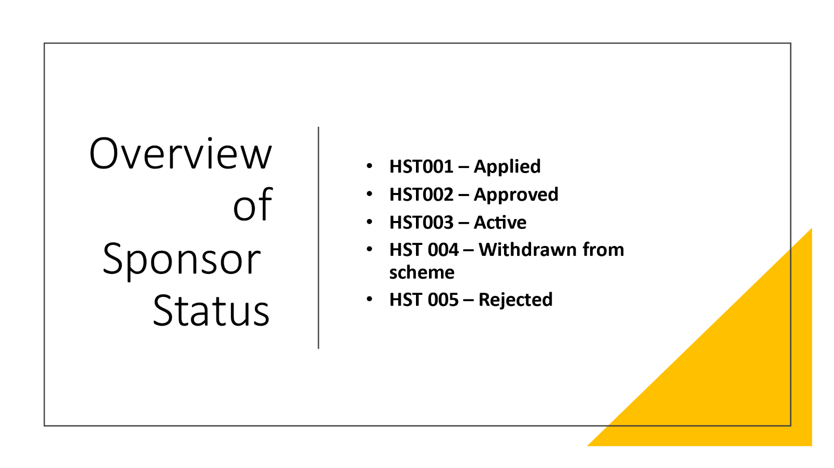

|  |  |  |  |  |
| --- | --- | --- | --- | --- |
| **Step of process** | **What is happening here** | **What needs to take place on data platform?** | **Who is doing something on the data platform to capture this?** | **Checklist to move to next status** |
| **HST001**  **Applied** | A host has been named on an application and/or they have applied to be a host. | A record for both the host/sponsor and new arrival is created on the system and their records linked together to create the connection between the two entities. | Welsh Government data team |  |
| **HST002**  **Approved** | Checks are made by local authorities take place to ensure the suitability of hosts and their accommodation.  A welfare visit is made to ensure the new arrival and host are settled in the arrangement and any necessary support is offered.  Finance details to commence payments will also need to be captured on local systems. | A note should state that DBS checks (either basic or enhanced) and safeguarding checks have commenced and that a housing inspection has also taken place.  (No sensitive or personal data should be captured in the system.)  An additional note to capture that a welfare visit has been made should also go on the system. | Local authority | 1. To move from HST001-HST002: 2. DBS check is passed. 3. Safeguarding checks have been completed and assessed. 4. Housing inspection is passed.   If all checks are passed, update host/sponsor’s status to HST002.  Once their applicant arrives, they will change to HST003 (as they become active hosts). |
| **HST003**  **Active** | The new arrival(s) moves into the Host/sponsor’s accommodation  The host will welcome their new arrivals and support them to liaise with local wraparound support services. | When new arrivals move in, update the status of the host to HST003.  Payment arrangements (details captured on local systems) are put in place to provide financial support to the host and to the new arrival.  Local authority will log on the system that an emergency £200 payment has been provided to the new arrival.  Create a case note noting Emergency Payment Issued with details of who processed/ authorised the payment and when. Capture whether payment to new arrival made by cash or pre-payment card. | Local authority | Host status remains at HST003 for the duration of the agreed hosting arrangement. |
| **HST004**  **Withdrawn** | The host/sponsor no longer wishes to offer their property to house individuals/families under either scheme | Change the status and add a case note to the system with any relevant (non-sensitive) information. | Local authority | 1. Set Sponsor/host journey status to HST004 - Withdrawn  2. The host record will now become inactive and appear in the inactive sponsors list |
| **HST005**  **Rejected** | Sponsor has not successfully completed their checks. Application has been rejected | Update the case notes with when checks were commenced to capture that the checks were not completed/passed.  Notify external systems (JIRA) of withdrawal of offer to prevent applicant from travelling.  If the new arrival is already here, undertake rematching process to find a new host.  The status can then be updated to HST005. | Local authority | 1. Set Sponsor/host journey status to HST004 - Withdrawn  2. The host record will now become inactive and appear in the inactive sponsors list |
| **HST006- Duplicate** | Sponsor record is duplicated due to applicant visa not yet being approved | Update the case notes to explain that sponsor/host record is linked to application that has not yet been approved    The status can be updated to HST006 - Duplicate | Local authority | 1. Set Sponsor/host journey status to HST006 – Duplicate  2. The host record will now become inactive and appear in the inactive sponsors list |

### Annex 2 – Status Reasons and Explanations

Whilst journey status reasons are not mandatory fields, it does help to provide additional ‘at a glance’ context for colleagues accessing the record. Here is a list of the Individual and Super Sponsor Scheme journey status reasons and a brief explanation.

Users of the system will need to make a judgement on a case-by-case basis as to which status reason is applicable for a particular record at a point in time.

|  |  |
| --- | --- |
| **Status for Applicants** | **Explanation** |
| Active | The case is active and progressing as expected. |
| Case Completed | The individual has either moved out of a welcome centre and into hosted accommodation (if on Super Sponsor Scheme) or have moved out to more permanent accommodation (if on individual sponsor route). |
| Confirmation Call Required | A call is required to confirm travel arrangements. |
| Family Visas Pending | Individual is awaiting visas for other family members who are travelling as part of the household. |
| Move to another Visa Scheme | Individual has applied and been issued visas under multiple schemes and has switched the one they wish to travel under. |
| Not Travelling | Individual has chosen not to travel. |
| Other Call Back Required | A call back is required to discuss something relating to their journey or their stay. |
| Pet Service Pending | Awaiting confirmation that Pet transportation and quarantine housing has been arranged in the UK. |
| Travel Date Pending | Awaiting travel details. |
| Uncontactable | Multiple attempts to contact an individual (or lead contact if a child) have been unsuccessful. |
| Visa Confirmation Pending | Waiting for permission to travel documentation. |
| Self-Supporting | Individual has moved into self-funded accommodation and are no longer reliant on Local Authority services provided to Ukrainians on their arrival into the UK under either the IS or SS Scheme |
| Repatriation | They have returned to their home country and have not communicated plans regarding their return. |
| Support Ended | Individual no longer requires support. This status reason can be used if the person has died whilst in the UK. Please provide additional clarification as to reason in the case note. |

|  |  |
| --- | --- |
| **Status Reasons for Sponsor/Host** | **Explanation** |
| Active | The record is active and in use. |
| Duplicate Record | There are multiple records for the same sponsor/Host. Mark up all bar one as duplicate |
| Adverse Checks | An individual has failed a check against the Police National Computer (PNC) or the Home Office Warnings Index (Central Gov). Used in conjunction with rejected status code when appropriate |
| InActive | The record is no longer active. Used in conjunction with rejected or withdrawn status codes. |

# Annex 3 – Logging incidents and incident categories

This document sets out the agreed Service Model to be adopted by all local authorities and health boards when seeking assistance on the system to ensure DHCW can provide a timely response to queries.

The sort of incidents we are anticipating can be categorised into the following:

|  |  |  |
| --- | --- | --- |
| **Incident** | **Possible Cause** | **Action** |
| User unable to access the system | Either:   1. New account required 2. Local infrastructure issue (e.g. unable to access the internet) 3. Account set-up issue | 1. New user request, see below 2. Contact local IT service desk to see if there are issues which would be stopping the user accessing UDP. If there are no local issues either the local UDP champion or the local IT service desk should email ([service.desk@wales.nhs.uk](mailto:service.desk@wales.nhs.uk)) the DHCW NSD with the details. Email Subject should be “HFU Access issue” 3. If there are no local issues either the local UDP champion or the local IT service desk should email ([service.desk@wales.nhs.uk](mailto:service.desk@wales.nhs.uk)) the DHCW NSD with the details. **Email Subject should be “HFU Access issue”** |
| User requires access to the system for operational need. | System account request | The local UDP champion should:   1. Check that user has a Microsoft 365 account, if they do not then they should arrange with local IT. 2. Local USP champion should email ([NationOfSanctuarySurvey@Gov.Wales](mailto:NationOfSanctuarySurvey@Gov.Wales)) the Welsh Government UDP service team with the user’s name and 365 email details. **Email Subject should be “HFU User Request**” Accounts will be set up within approximately 72 hours. |
| Multiple users unable to access the system | Either:   1. Local infrastructure issue (e.g. unable to access the internet) 2. HFU infrastructure issue | 1. Contact local service desk to see if there are any issues which would be stopping the user accessing UDP. If there are no local issues either the local UDP champion or the local IT service desk should email ([service.desk@wales.nhs.uk](mailto:service.desk@wales.nhs.uk)) the DHCW NSD with the details. Email Subject should be “HFU Access issue” 2. If there are no local issues either the local UDP champion or the local IT service desk should email ([service.desk@wales.nhs.uk](mailto:service.desk@wales.nhs.uk)) the DHCW NSD with the details. Email Subject should be “HFU Access issue” |
| Data not saved after data entry or amendment | Possible user error – failure to use Save button. | Local UDP champion to review the users’ actions. If the Local UDP champion is content that the user is using the system correctly then they should email ([service.desk@wales.nhs.uk](mailto:service.desk@wales.nhs.uk)) the DHCW NSD with the details. Email Subject should be “HFU application issue” |
| User(s) notice data inaccuracies or anomalies | Possible data load issues | The Local UDP champion or local service desk should email data@gov.wales with the details. Email Subject should be “HFU data issue” |
| Application issues | System fault | The Local UDP champion or local service desk should email ([service.desk@wales.nhs.uk](mailto:service.desk@wales.nhs.uk)) the DHCW NSD with the details. Email Subject should be “HFU application issue” |
| User cannot see some or all of the expected data | User permissions issue | The Local UDP champion or local IT service desk should email ([service.desk@wales.nhs.uk](mailto:service.desk@wales.nhs.uk)) the DHCW NSD with the details. Email Subject should be “HFU user permissions issue” |
| MFA issue | MFA fault. | The Local UDP champion or local IT service desk should email ([service.desk@wales.nhs.uk](mailto:service.desk@wales.nhs.uk)) the DHCW NSD with the details. Email Subject should be “HFU MFA issue” |
| Application performance | System fault | Contact local IT service desk to see if there are any local issues which would be causing the system to run slowly (e.g. network issues).    If no local issues the Local UDP champion or local IT service desk should email ([service.desk@wales.nhs.uk](mailto:service.desk@wales.nhs.uk)) the DHCW NSD with the details. Email subject should be “HFU application performance issue” |
| User identifies opportunity to improve the system | System change request | The opportunity should be discussed with the local UDP champion first.  Local UDP Champion should email ([NationOfSanctuarySurvey@Gov.Wales](mailto:NationOfSanctuarySurvey@Gov.Wales)) Welsh Government with the suggestion. Email Subject should be “HFU application change request” |
| Deletion of User from the system | If user, no longer requires access to the system or has left the local organisation then we need to be informed from a security perspective.    Please note periodic reports will be run to show user inactivity. | The local UDP champion should email ([service.desk@wales.nhs.uk](mailto:service.desk@wales.nhs.uk)) the DHCW NSD with the details. Email Subject should be “HFU Deletion Request” |

***Note: Local UDP champion may also be called Local UDP super-user***

**National Service Desk Contact Details:**

To log a call with the National Service Desk use email address ([service.desk@wales.nhs.uk](mailto:service.desk@wales.nhs.uk)) ensuring that the Subject/Title line contains “HFU” (case sensitive). All further correspondence regarding an incident should be via the contact link in the ServicePoint confirmation email.

The following information will be expected to be presented in the email:

* Originating Service Desk or UDP Champion details (Organisation and Name)
* Brief description of the incident
* Full description of the incident
* Username
* User contact details
* Phone
* Email
* Office location
* Work location
* What has currently been done to resolve the incident

Please note the NSD will expect you to have carried out the following checks prior to contacting them, if these initial checks have not been carried out your request for assistance will be rejected. Checks include:

* Correct browser
* Network checks
* Ensuring no local IT issues are causing the issue