Computer programming

Final Project

Report

I.E.S. San Vicente
San Vicente del Raspeig (Alicante)
2017/2018

Teachers:
José Ignacio Cabanes / Ignacio Iborra

Student:
Miguel García Gil

1. Introduction
Project name
Street Fighters

Made by
Miguel García Gil

Short description of the project
This is a martial arts game based in the famous game called Street Fighter. You will be able to fight with a friend with a character and win the game.

2. Functionality of the project
After entering the program, a welcome screen will we displayed, where the user can choose between:

• Play against the computer.
• Play against another player.
• Quit the game.

If the user chooses a game against the computer, a character selector screen is displayed and you can choose a character to play. After the character is chosen, a countdown starts from 3 and then you can start the fight. If the life of the character or the machine reaches zero, the game is won or lost.

If play against another player is chosen, a character selector screen is displayed again and you can choose a character to play and so on.

Before quitting the game, the scoreboard will be saved, and it will be retrieved in the next session.

The images for the pieces and the background screen are read from file at the beginning of the game.

3. Screen prototype
The game screen will look like this:

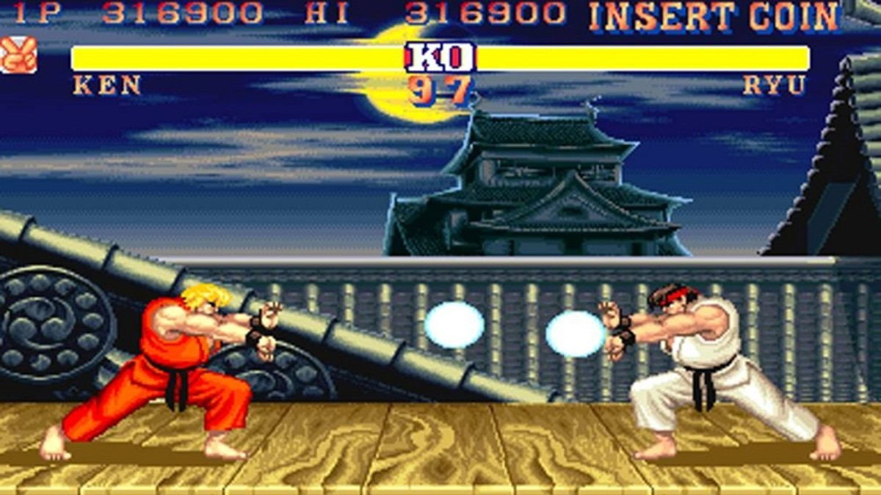

4.Analysis

4a. Requisites
Requisite | Date achieved
The program will allow a player to play a "StreetFighter " against other player (and the program will "judge") who has won
The program will allow a player to select a character to play with.
The game will start showing an intro screen
The intro screen will allow he user to enter a Credits screen, which will display data about the programmer
The game can be paused pressing "P", and then returned by pressing any other key
The game will use SDL graphics library, and the images will be optimized.
The program will allow a player to play Demo mode.

4b. Basic pseudocode

Program body:
Display welcome screen
Wait for user to press a key
If key = ESC, quit program
If key = 1, start one player game
…

One player game:
Display level selection screen
Wait for user to press a key
If key = ESC, return
…

…

4c. Classes diagram
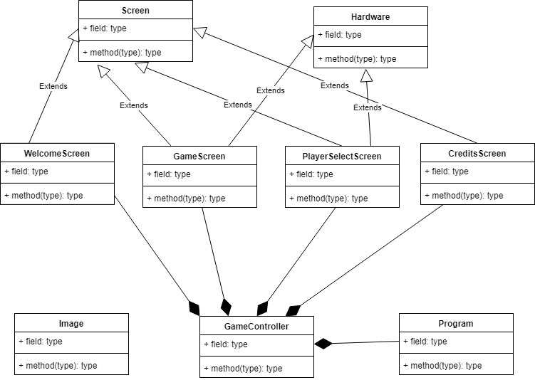

5. Initial planning and expected deliveries

5a. Expected deliveries
- Version 1: Implement the skeleton of the classes, show the character and make it move.
- Version 2: Developing select screen class (but you can only chose between two characters by the moment)
- Version 4: Intro sequence and menu screen with music.
- Version 5: Animation of simple movement sequences (punch, kick).
- Version 6: Animation of complex movement sequences (jump, somersault, etc).
- Version 7: Defensive sequences
- Version 8: Each collision subtracts X% of energy, according to distance and if the other player defends himself or not.
- Version 8: 2 player mode (2 blocks of keys).
- Version 9: Single player mode, with several levels of difficulty, for example:

- * Level 1: attack and defense at random

- * Level 2: random attack, preventive defense

- * Level 3: optimized attack according to type of adversary, defense according to actions of adversary
- Version 10: Victory animations
- Version 11: Training mode
- Version 12: Gamepad / joystick support
- Version 13: Demo mode.
- Version 14: Introduction of improvements and correction of failures.
- Version 15: Pray to approve.
(…) Note: You must plan 15 deliveries. Each one of them will correspond to 1 hour of work in the classroom.

5b. Real deliveries
- Version 1 (May 14): Tried to move the character on screen but not achieved. Improved different classes
- Version 2 (May 15): Developing PlayerSelectScreen class.
- Version 3 (May 16): Finishing PlayerSelectScreen class and making some improvements.
- Version 4 (May 17): Intro sequence implemented, added Font class and updated Hardware to better write texts. Started the implementation of menu class with the ability to change and select between screens.
- Version 5 (May 18): Animation of simple movements (kick and punch).

6. File formats

6a. Plain files format
The scores table is saved to a text file, which contains the name of a player in one line, and the corresponding score in the following line, and so on, to complete the 10 highest scores, as in this example:

John
125
Peter
116
…

6b. Entity-Relationship Diagram (If needed)
(…)

7. Problems found and solutions
I preferred not to use the SDL library directly, which I found difficult to learn, so I have used the classes "Hardware", "GraphicsElement" and "Font" that we had used previously in class games (...)

Although in the level 3 (hard) I check the next three movements, sometimes the computer makes foolish moves, but always in the first column. I have not found where the bug is, but I think the problem may lie in this portion of code, in which I check each column versus the previous one: (...)

I noticed that if I take the game to another computer which has not the DotNet Framework installed in it, the program closes without any error or warning message (...)

(…)

8. Improvements or restrictions to the starting design
I have had time enough to include the effect of animation when the pieces fall (…)

I have not been able to implement (…) because of (…)

9. Screenshots of the final project
(…)

10. Source code of the final project
(…)

