SF16Functional Testing: Final Test

|  |  |
| --- | --- |
| Your name and group ID: | Date: |
| Василюк Владислав 753502 | 03.12.2020 |

## Introduction to the project

Imagine that you were assigned to a new project as a tester where domain area – finance. You and your test team lead Victor is located in Minsk. The rest team – in India, China (development) and USA (business analyst, customers and supervisors).

This is a small mobile project developed for Blackberry platform. After login to application you are redirected to the Home screen (please see the screenshot of the Home screen below):

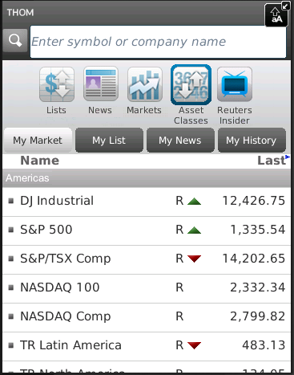

Main horizontal menu with icons

Search bar

Financial content of the Home screen

Customer of the project (named Brian) wants to implement a new feature for this project. Brian was working with business analyst John on requirements for this feature.

So, your task is:

1. Review the requirements for the new feature provided by John.
2. In case of any questions you need to write email to John with request to clarify your questions.
3. Provide estimations for test activities for this feature by email to your test lead Victor.
4. Write test cases for the feature for smoke test.
5. Review provided screens with the implemented feature.
6. Find and submit bugs in case of any.
7. (*optional task) Send test results and your decisions about quality of the feature to Victor.

**Below you will find requirements for the feature and templates for emails, test cases, bug reports and so on, please fill in only those templates that you think reasonable in scope of this feature. Also you can write any additional information that you want.**

## Requirements for the new feature

**User story #045**

**Summary**: As a user I want to access my Profile from the Home screen

**Priority**: Major

**Description**:

* Profile menu icon exists in the Home screen.
* Profile menu icon is positioned on the list of menu icons in the Home screen between Asset Classes and Reuters Insider icons.
* Profile view is displayed when Profile icon is selected.
* The Profile view must have header section (with name, company, location, thought of the day and photo).
* If photo is not available then default image is used.
* The rest of the person’s detail fields can be scrolled, only lines where user has added information are shown.
* Text size must not be too small.

## Clarification letter for business analyst regarding the feature #045:

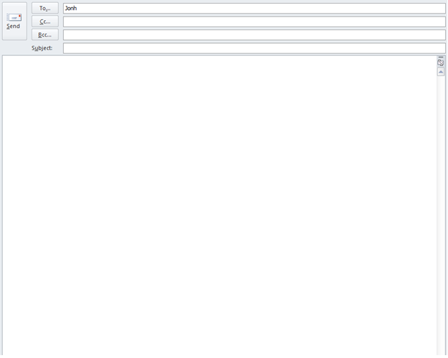

Uladzislau Vasiliuk

Requirement clarifications for feature #045

Dear John,  
I want to clarify some points about the feature #045. These points are:

1. Which font size should be used in Profile view?
2. What is thought of the day?
3. Which fields in Profile view are required and which are optional?
4. What text should we display in name, company, location fields if input is not provided?
5. What image should be used by default in photo?
6. Can you tell more specific about “rest of person’s details” fields?
7. What is the exact size of the text?

I look forward to discussing the details and next steps!

With gratitude,

Uladzislau Vasiliuk.

## Test estimations for the feature #045 to the test team lead Victor:

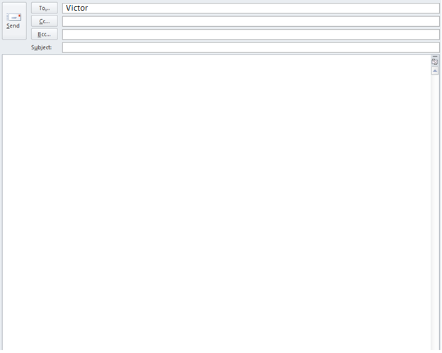

Uladzislau Vasiliuk

Test estimations for feature #045

Dear Victor,  
I attached below table with approximate test estimations for the feature #045

|  |  |
| --- | --- |
| **Activity** | **Required time** |
| Requirements study | 0.25 hours |
| Sending feedback | 0.25 hours |
| Smoke test | 2 hours |
| Functional test | 2 hours |
| Bug report | 2.5 hours |
| **Total effort** | **7 hours** |

Warm regards,  
Uladzislau Vasiliuk.

## Test cases for the feature #045:

|  |  |  |  |  |  |  |
| --- | --- | --- | --- | --- | --- | --- |
| **No** | **Req. No.** | **Module** | **Test Description** | **Expected Results** | **Passed /Failed** | **Comments** |
| 1 | 3 | Home Screen | **Existing of Profile menu icon**  Preparations: The test application  must be installed on your device,  the application icon must be  placed on the desktop.  1. Click (or touch) on the application  icon on the desktop. | 1) Profile menu icon exists in the Home screen. | **Passed** |  |
| **No** | **Req. No.** | **Module** | **Test Description** | **Expected Results** | **Passed /Failed** | **Comments** |
| 2 | 3 | Home Screen | **Positioning of Profile menu icon**  Preparations: The test application  must be running. | 1) Profile menu icon is positioned on the list of menu icons in the Home screen between Asset Classes and Reuters Insider icons | **Failed** |  |
| **No** | **Req. No.** | **Module** | **Test Description** | **Expected Results** | **Passed /Failed** | **Comments** |
| 3 | 1 | Profile View | **Profile header fields appearing**  Preparations: The test application  must be running.  1. Click (or touch) Profile menu icon | 1) Name, company, location, thought of the day fields appear in header of Profile view.  2) Photo or default image appears | **Failed** |  |
| **No** | **Req. No.** | **Module** | **Test Description** | **Expected Results** | **Passed /Failed** | **Comments** |
| 4 | 1 | Profile View | **Rest fields of Profile header scrolling**  Preparations: The test application  must be running. Profile menu must be selected.  Profile view must be running.  1) Scroll rest of the person’s detail fields | 1) The rest of the person’s detail fields can be scrolled 2) Only lines where user has added information are shown. | **Failed** |  |
| **No** | **Req. No.** | **Module** | **Test Description** | **Expected Results** | **Passed /Failed** | **Comments** |
| 5 | 1 | Profile View | **Entering big text**  Preparations: The test application  must be running. Profile menu must be selected.  Profile view must be running.  1) Enter text with size 100 000 into the field name. | 1) It should be impossible to enter big text. | **Failed** |  |

## The feature #045 is ready for testing:

So, developers have finished implementation the feature #045. You received notification that the build with feature #045 was released and ready for testing. The build was successfully installed. Victor asked you to test the feature. You open the application -> login -> and see the Home screen provided below:

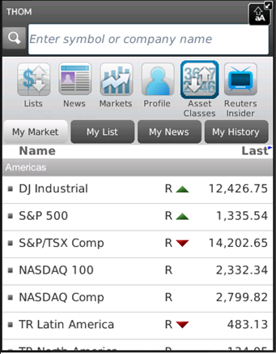

Upon clicking Profile icon in the main horizontal menu the next screen is opened:

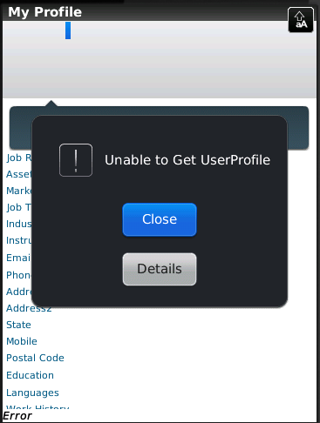

## Templates for bug reports:

|  |  |
| --- | --- |
| **Bug ID** | 1 |
| **Summary** | Profile screen doesn’t work. |
| **Description** | After clicking Profile menu icon Profile View opens with error: “Unable to ger UserProfile” and buttons “Cancel” and “Details”. |
| **Severity** | Major |
| **Priority** | High |
| **Steps to reproduce** | 1. Launch app  2. Tap (or click) Profile menu icon on Home Screen |
| **Bug ID** | 2 |
| **Summary** | The Profile menu icon is positioned in wrong place |
| **Description** | The Profile menu icon exists in Home screen between icons Market and Asset Classes |
| **Severity** | Low |
| **Priority** | Low |
| **Steps to reproduce** | 1. Launch app |

## Test results to the test team lead:



Uladzislau Vasiliuk

Results for feature #045

Dear Victor,  
I’ve tested build of application with feature #045. I have faced 2 errors (1 – major, 1 – low).  
First error blocks work of all changes in feature.

This build need fixing and can’t be released.

Warm regards,  
Uladzislau Vasiliuk.