3.1 Query: db.restaurants.find({borough: "Queens", cuisine: "Chinese"}).count()

Result: 728

3.2 Query: db.restaurants.find({}, {_id: 1}).sort({"grades.score": -1}).limit(1)

Result: { "_id" : ObjectId("5c0d9e64464d476a2554f0ae") }

3.3 Query: db.restaurants.updateMany({borough: "Manhattan"}, {$push: {grades: {"date": ISODate(), "grade": "A", "score": 7}}})

Result: { "acknowledged" : true, "matchedCount" : 10259, "modifiedCount" : 10259 }

3.4 Query: db.restaurants.find ({"grades.8.score": {$lt: 7}}, {_id: 0, name: 1} )

Result: { "name" : "Silver Krust West Indian Restaurant" }

{ "name" : "Pure Food" }

3.5 Query: db.restaurants.find({cuisine: "Seafood", grades: {$elemMatch: {grade: "B", date: {$gte: new ISODate("2014-02-01T00:00:00.000Z"), $lte: new ISODate("2014-03-01T00:00:00.000Z")}} } }, {borough: 1} )

Result: { "_id" : ObjectId("5c0d9e65464d476a255524ba"), "borough" : "Bronx" }

{ "_id" : ObjectId("5c0d9e65464d476a25552732"), "borough" : "Manhattan" }

4.1 Query: db.restaurants.createIndex({name: 1})

Result: {

"createdCollectionAutomatically" : false,

"numIndexesBefore" : 1,

"numIndexesAfter" : 2,

"ok" : 1

}

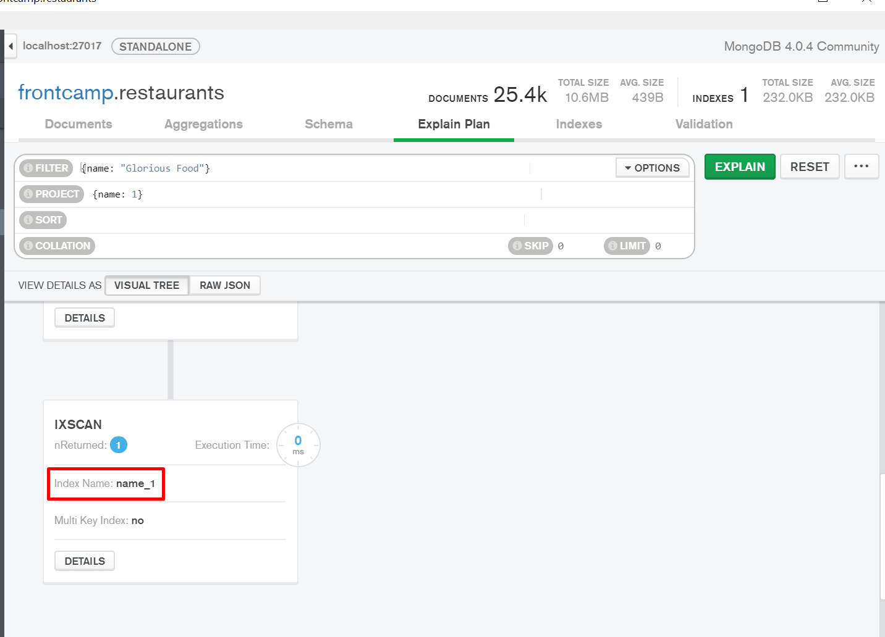

4.2 Query: db.restaurants.dropIndex("name_1")

Result: { "nIndexesWas" : 2, "ok" : 1 }

4.3 Query: db.restaurants.createIndex({restaurant_id: 1, borough: 1})

Result:

{

"createdCollectionAutomatically" : false,

"numIndexesBefore" : 1,

"numIndexesAfter" : 2,

"ok" : 1

}

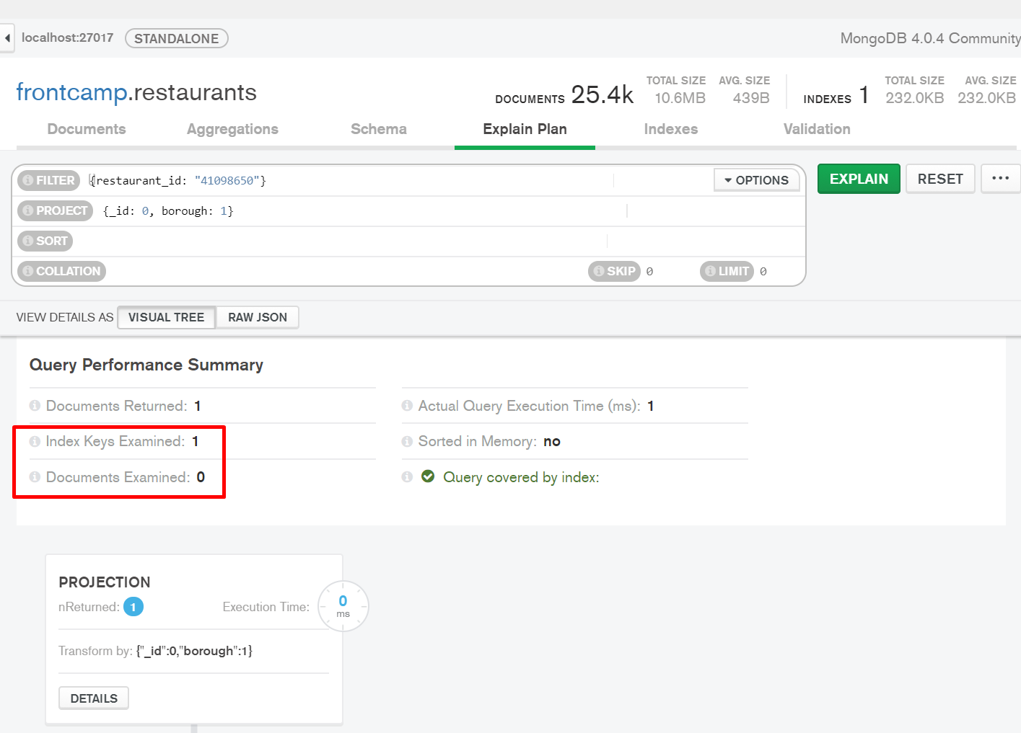

4.4 Query: db.restaurants.createIndex({cuisine: 1}, { partialFilterExpression: {borough: "Staten Island"}})

Result:

{

"createdCollectionAutomatically" : false,

"numIndexesBefore" : 2,

"numIndexesAfter" : 3,

"ok" : 1

}

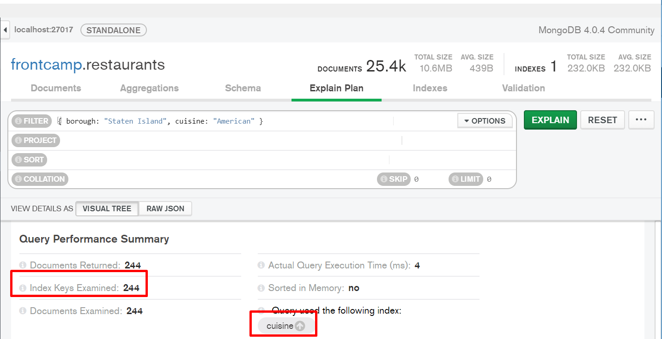

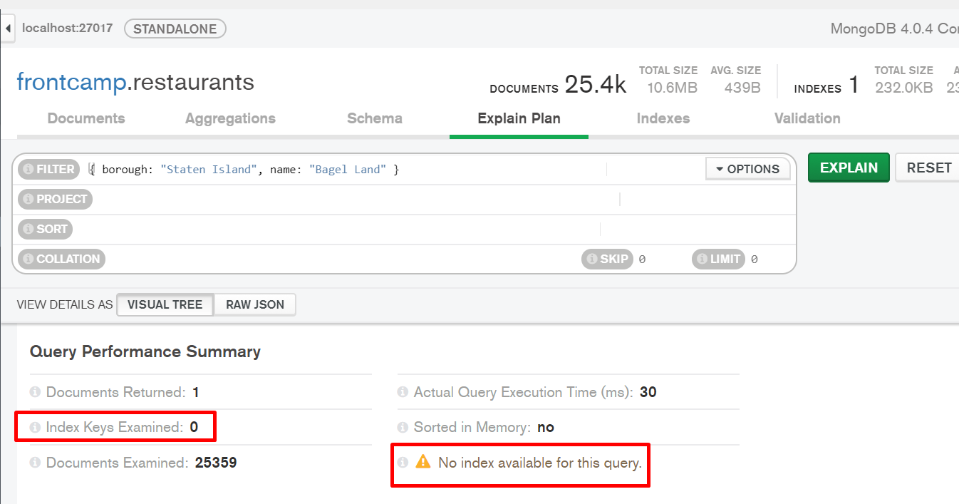

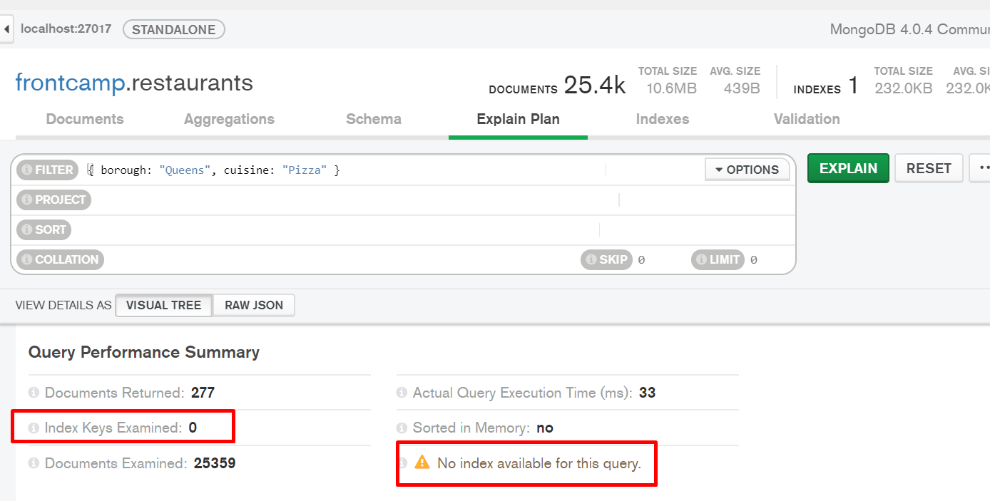

4.5 Query: db.restaurants.createIndex({"grades.8.score": 1, name: 1, })

Result:

{

"createdCollectionAutomatically" : false,

"numIndexesBefore" : 3,

"numIndexesAfter" : 4,

"ok" : 1

}

