HYBRID AUTOMATION FRAMEWORK

-Framework is created using different set of tools to automate any application

Project Details
In this project,we are going to automate a bank domain with different features using a hybrid framework.

Tools used in this project:

1.Coding is done in java
2.Install Eclipse IDE
2.Using Maven to create a project
3.Using selenium to automate
4.Execution
---->Using TestNG to write test cases and execute
---->you can use pom.xml to execute
----->Without eclipse you can run in cmd
5.Using Jenkins for continuous integration
6.Using GitHUB to maintain the repository
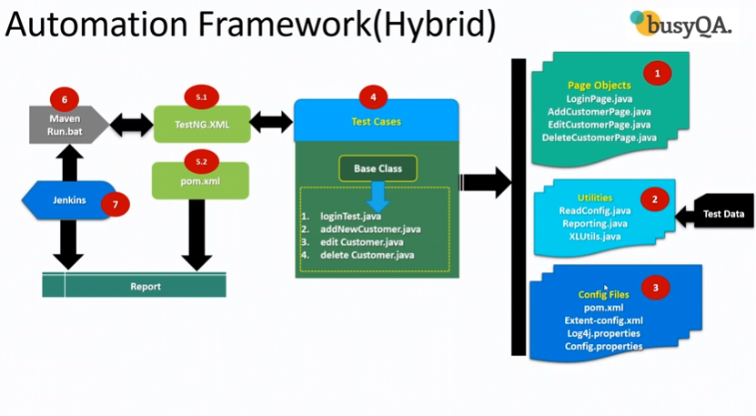

Three phases in automation:

1.Implementation
-Page Objects
-Utilities
-Config files
-Test cases
-Base class
2.Execution
3.Maintanence

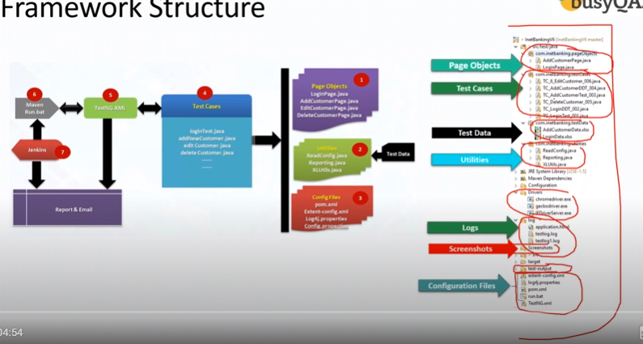

Phase 1: Implementation
- Create a Maven Project
- Update POM.xml
- Create Page Objects
- Create Base class
- Create Test cases
- Create Data Driven test case
- Add logs to test case
- Read common values from properties file
- Run test cases on desired browser
- Add extent report

Phase 2 : Execution
Phase 3: Maintanence
Project structure
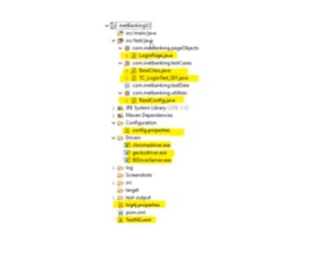

URL of the application
https://demo.guru99.com/v4
Username and password
-Email--->keerthana@gmail.com
User ID : | mngr383924
Password : | ymubEja

Steps for creating framework for each web page
1.Create a page object class in the page objects package for the web page
→Initiate the driver
-->Locate all the web elements in that page
-->Define action or methods for each web element located
2.Create the base class for that web page
--->@Before class
-setup method()--->Deifne system.property,pre-requisites
--->@Test
-steps for the test
--->@AfterClass
-Exiting steps like quit,close()
---->Here the before class and after class will be repeating for all the test cases,so we can remove them from the test case and add them in the base class and then extend the base class in the test class.So base class can be extended in all the test case class.
---->Base class can be created under test cases package
--->In the base class,define
1.Environmental variables
2.Setup method--->@Beforeclass--->Define logger
3.TearDown method--->@Afterclass

3.Create Test case for that web page
--->Extend the base class for all the test case classes
--->Define only @test method only in the test case class
--->Pass logger messages after every action done in the web page
--->Import the action methods from the page object class of that corresponding web page and call for the methods by creating an object
4.Create Log files using logger
--->Import the log4.jar files
--->create log4.j properties file and copy the default code in the file
--->Then define the logger in the setup and test class method
--->After executing the test case,you can see the log folder
5.Create properties file---config.properties
---->Instead of adding the environmental variables in base class,we can define all the variables in properties file
---->Read all the data from properties file into base class
--->Create config.properties file in configuration folder
--->Create utility class--->Readconfig.java
--->The utility class helps in reading the data from the properties file
--->create a method for each variable in the properties file
--->using getproperty(“”) read the values
--->Each method will return the value of the variable
--->Modify the code in base class so the test case class can access the
Readconfig class
--->Now create object for the readconfig class in the base class and call all the methods in the read config file
--->config--->readconfig--->base class--->test case
6.Run Test case on specified browser
---->Create a TestNG.Xml file in the project
---->In the TestNG file,<parameters> tag pass the browser nam and value like chrome
---->Mention the @Parameters(“browser”) before @BeforeClass
---->Now run the testNg.xml as testNG suite,the browser will be choosen

7.Extent Report
1.extent-config.xml-copy the default template
2.extent report jar files-add it in the pom.xml if it is a maven project ,if not then import external jars in the project
3.Create listener class under utilities package—reporting.java
---In listener class,add the following default methods
--->onTestPass
--->onTestSkipped
--->onTestFail
--->onTestSuccess
--->onStart
--->onFinish
--->Add the required code part

4.Create a connection between listener class and the project in TestNG.xml
5.Declare the listener call in the testng.xml,so that particular class in executed and extent report is generated

8.Create Data Driven Test case
---->Apache poi jars
--->xls file
--->Create ExcelUTILS.java--->under utilities package
--->@Data provider annotation
--->In ExcelUtils.java
-create user define methods for
1.getRowcount
2.getCellcount
3.getcelldata
4.setcelldata
---->create an .xlsx file with positive and negative test data
---->Create a data driven test case
-Extends base class-->contains afetr and before test methods
-create a @Test method
-create a @DataProvider method
-In this method pass the exceel file and store the data
-use the methods from excelutilities file
--->Create page object class-webelement locators and action methods
---->Add the test case class in testng.xml and execute

-Create a @DataProvider method
-In this method pass the exceel file and store the data in 2 d array using for loop

9.Adding new test case
---->everything is ready,so just create a new test case

