System Administration & Maintenance

Employee Self Service

System

**Member:**

**A (SURNAME, FIRSTNAME MIDDLE NAME)**

**B (SURNAME, FIRSTNAME MIDDLE NAME)**

**C (SURNAME, FIRSTNAME MIDDLE NAME)**

**D (SURNAME, FIRSTNAME MIDDLE NAME)**

Course & Section: **BSIT - SECTION** Professor: **Patrick David B. Lim, LPT** Submitted: **M/D/Y**

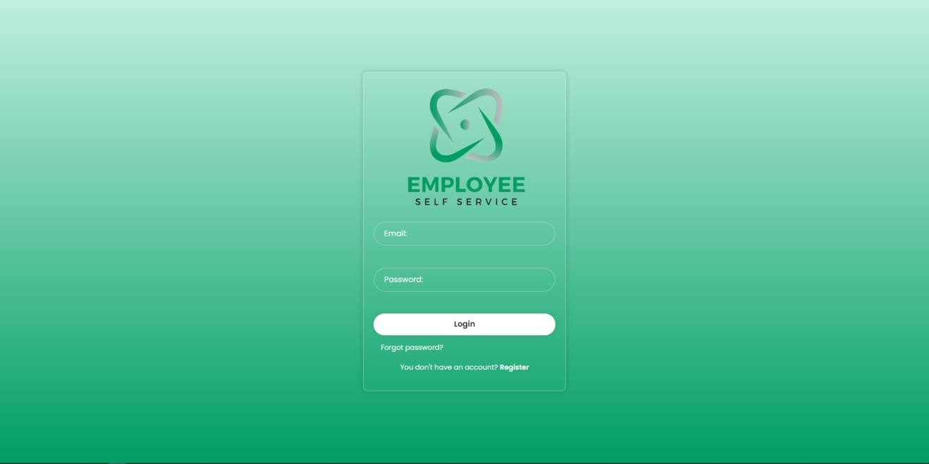

# Login UI

Purpose: Authenticates users and controls access to the system Components:

Username/Email field Password field

Login button

"Forgot password" link "Register" button for new users

Functionality:

Validates user credentials against database Creates session upon successful login

Redirects to appropriate dashboard (admin/employee)

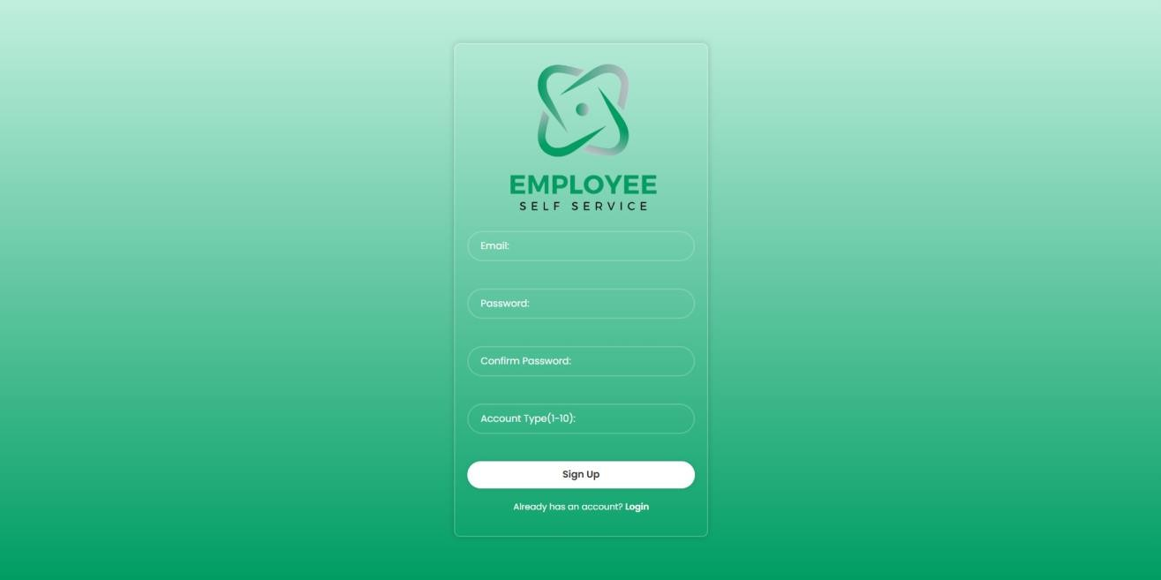

# Register Button

Purpose: Allows new users to create accounts Components:

Registration form with fields (name, email, password, account type) Sign in button

Link to login page

Functionality:

Validates input data

Checks for existing accounts Hashes password before storage Creates new user record in database

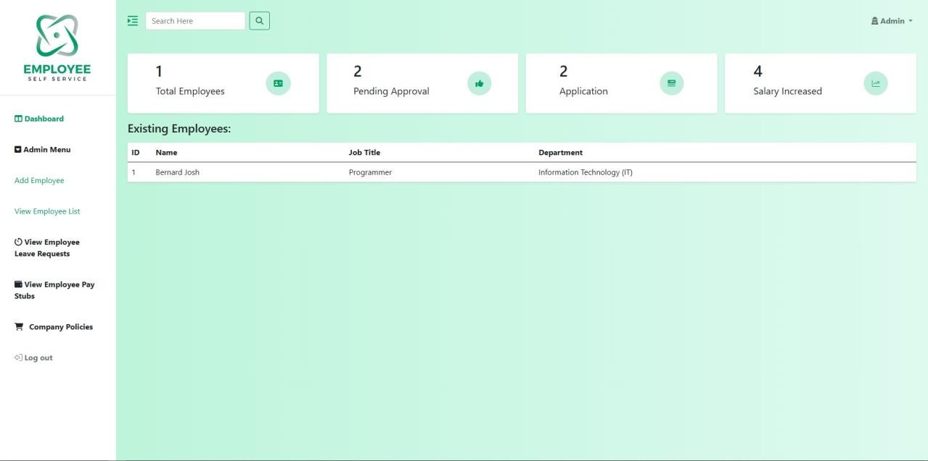

# Admin Dashboard

Purpose: Central control panel for administrators Components:

Summary dashboard showing: (total employees, pending leave requests, job interview applications, and employees with salary increases.)

Quick access menu Recent activity log

Navigation to all admin functions

Functionality:

Displays system overview

Provides access to all admin features Shows alerts/notifications

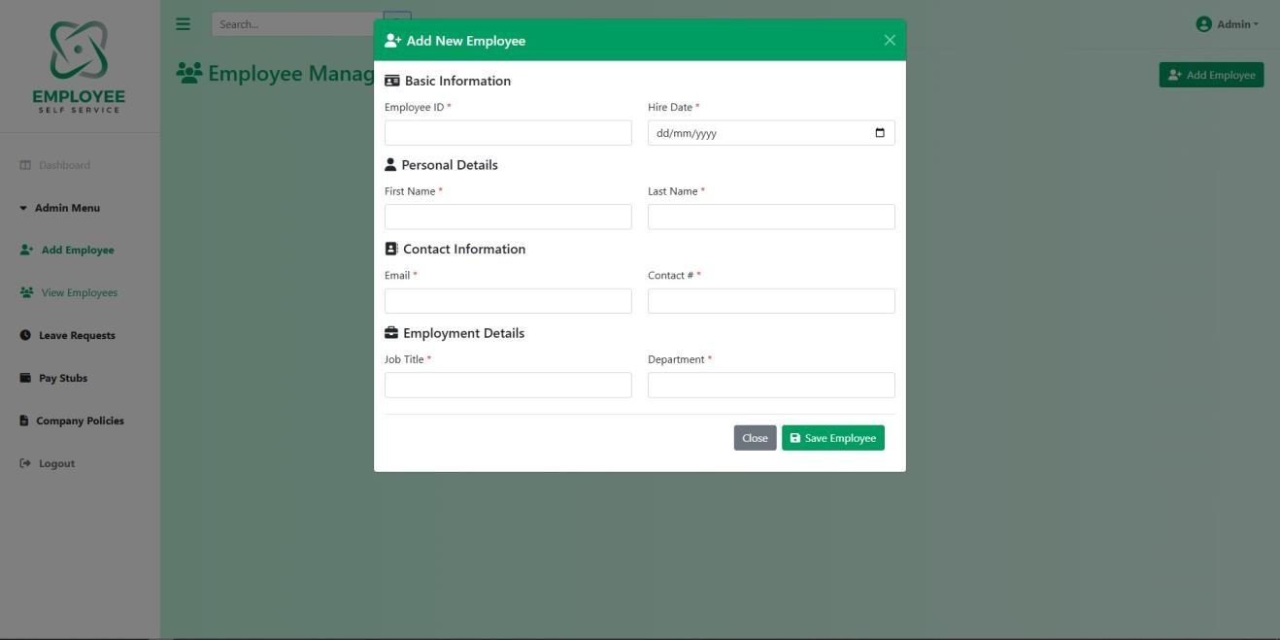

# Add Employee

Purpose: Create new employee records Components:

Form with employee details Save/Cancel buttons

Input validation

Functionality:

Collects employee information (name, contact, position, etc.) Validates data formats

Inserts new record into database Returns success/error message

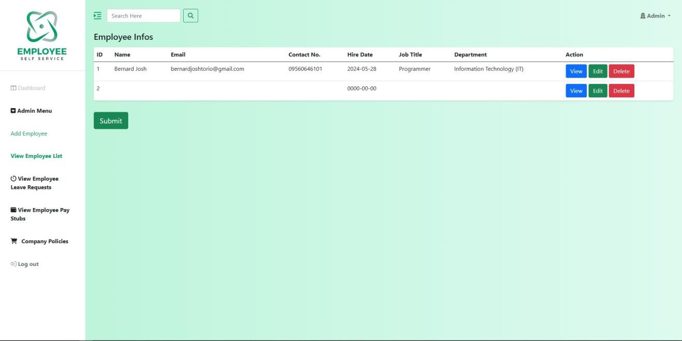

# View Employee List

Purpose: Display all employee records Components:

Search/filter controls Pagination

Data table with employee information Action buttons (View/Edit/Delete)

Functionality:

Retrieves employee data from database Supports sorting and filtering

Displays in tabular format Links to detailed actions

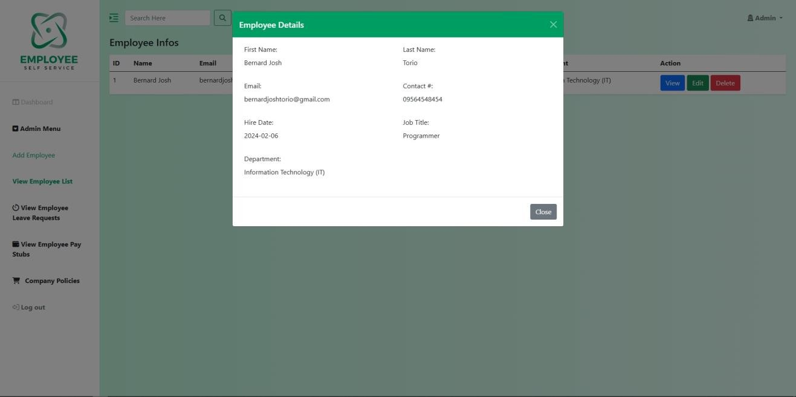

# View Button

Purpose: Show detailed employee information Components:

Modal or separate view page Employee details display Close/Back button

Functionality:

Fetches complete employee record Displays in read-only format

May include additional info (documents, history)

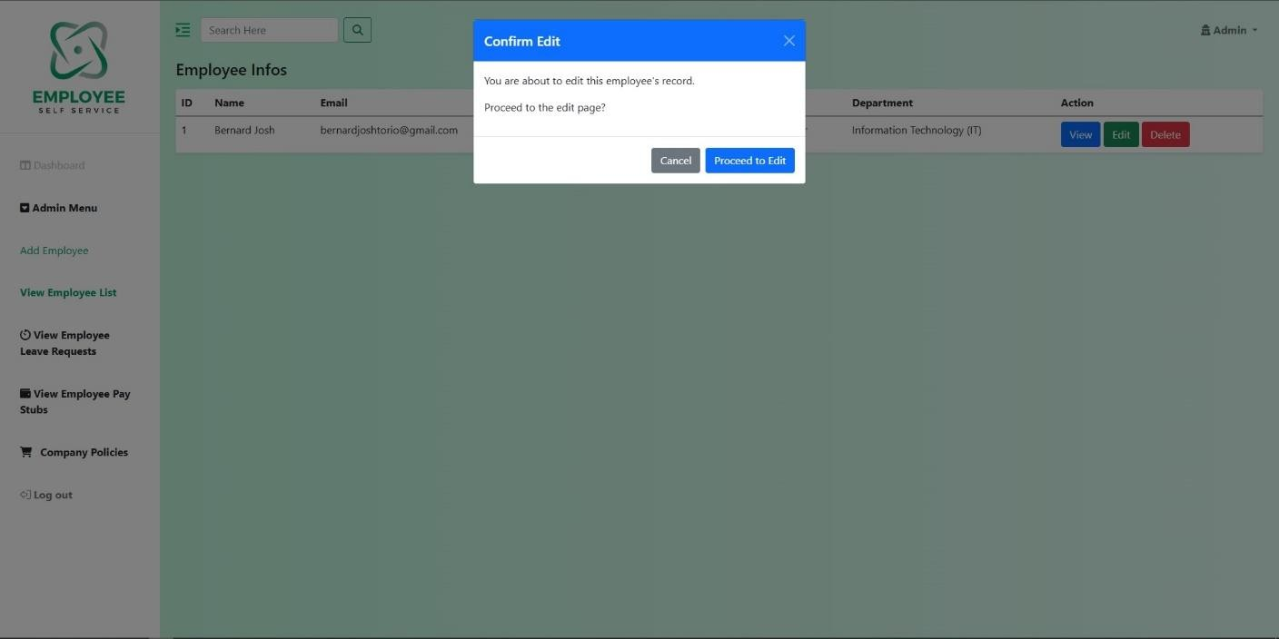

# Delete Button

Purpose: Remove employee records Components:

Confirmation dialog Success/error message

Functionality:

Verifies deletion request Removes record from database May archive instead of delete Updates related records if needed

# Maintenance

Preventive Maintenance:

Corrective Maintenance:

Checked by:

**Score:**

**Score:**

**Score:**