**Project title:**

- University Management System

**Subject:**

(Comp337)- Database Management System

**Done by:**

Kudaibergen Stalbekov 164137

Ularbek Abdyrazakov 174167

**Introduction**

EUL is an acronym for European University of Lefke, it was founded by theCyprus Science Foundation and officially started its academic activities in 1990 asa State Foundation University. The University and all its respective departmentsare accredited with the Turkish Republic’s Higher Education Council (Board) sinceits first day of establishment.

The University campus is located on hill in one of the island’s richest naturalcorners, overlooking the local landscape and with a full view of the blue waters ofthe Mediterranean. With its quiet and tranquil setting, it offers students an idealenvironment to pursue their academic studies.Currently, the institution has about 13,000 students (and still growing); with a total number of 600 staffs.

The traditional view of software development takes an algorithmic perspective. In this approach, the main building block of all software is the procedure or function. This view leads developers to focus on issues of control and the decomposition of larger algorithms into smaller ones. There is nothing inherently evil about such a point of view except that it tends to yield brittle systems. As requirements change and the system grows, systems built on algorithmic focus turn out to be very hard to maintain.

The contemporary view of software development takes an object-oriented perspective.In this approach , the main building block of all software systems is the object or class.Simply put, an object is a thing, generally drawn from the vocabulary of the problem space or the solution space ; a class is a description of a set of common objects. Every object has identity, state ,and behavior.

**Objective of the project:**

Objective of the project is solution for simplifying the entry process. It provides user simple and friendly interface. The main objectives of University Management Sysgtem are folowings:

* Easy adding of student and instructor information
* Increase high throughputs
* Decrease overheads
* Minimization redundancy
* Make data more secure
* Easy searching information about student or instructor

**Scope:**

This project deals with the various functioning in University management process. The main idea is to implement a proper process to system .In our existing system contains a many operations as we mantioned above: registration, student search and etc. All these activity takeout manually by administrator(Course coordinator).

In our model, it deals with the Operations in system. For example, when students fill the registration form the record is stored in the database. And display the details of student is perform by retrieving information from database table.

**System Analysis**

The main function of the analysis phase is to look carefully at the requested features with an eye towards the issue that each may create in the actual coding. This phase is the time during which reasonably deliverable thoughts of each team member can decide.

**Functional Requirements:**

In our project we have 3 types of users:

1) Faculty coordinator

2) Instructor

3) Student

Therefore we have different type of functional requirements for each of them.

1)Faculty coordinator requirements:

✓ Login to the system

✓ Add new course

✓ Add new teacher

✓ Add new student

✓ Assign courses to instructors (teaching)

✓ Assign instructors to students (advisors)

2) Instructor requirements:

✓ Login to the system

✓ See and update his/her details

✓ See the courses assigned to him/her

✓ See course details (course info, list of students registered, etc.)

✓ Register students to the courses

3) Student requirements:

✓ Login to the system

✓ See and update his/her details

✓ See the courses he/she is registered to

✓ See the other students registered in his/her class

**Application Design and Backend**

Form designing:

a) Login page: Consist of Sudent ,Instructor and Faculty coordinator part. The user should choose one of them for entering to the system using special ID and PASSWORD:

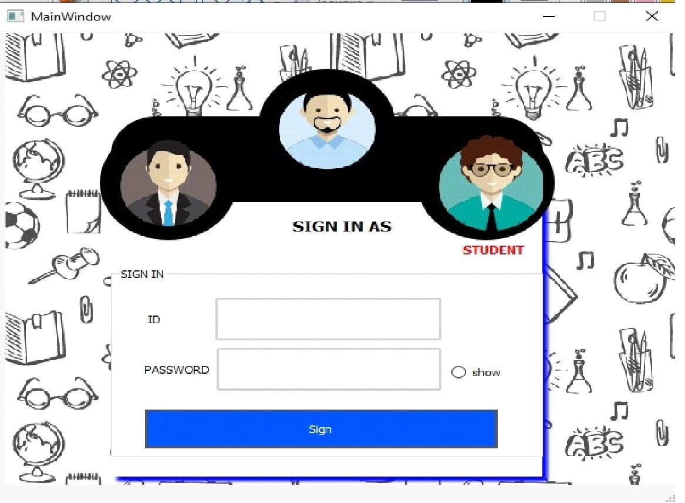

As you see on the right bottom we have a radio button "SHOW" whose function is showing the hidden password to make sure that you entered it right. Here is coding part of this button:

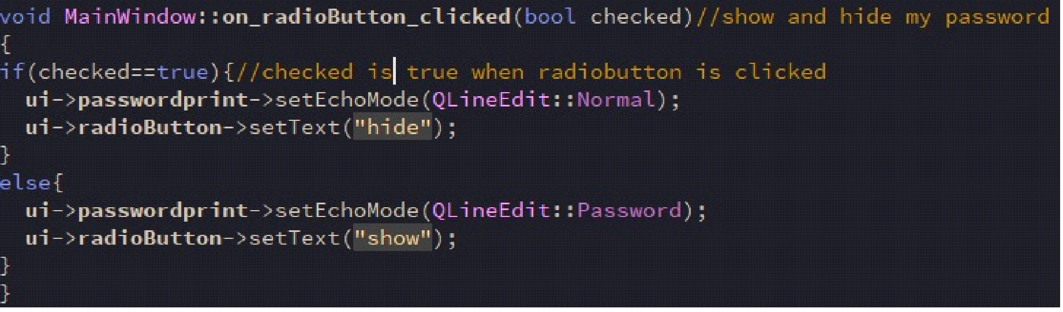

As we mentioned before user should choose who is he and after it signs, this backend code for "SIGN" button:

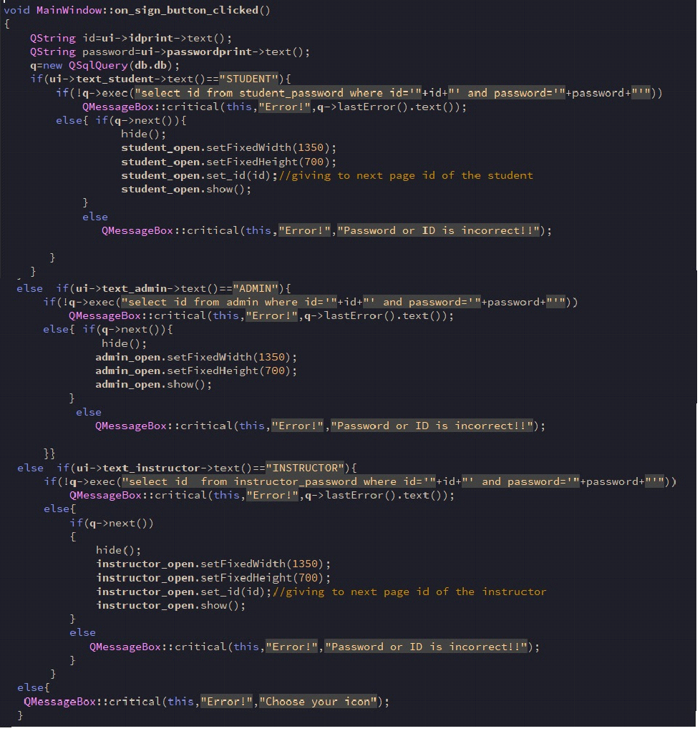

Let's sign in to instructor GUI:

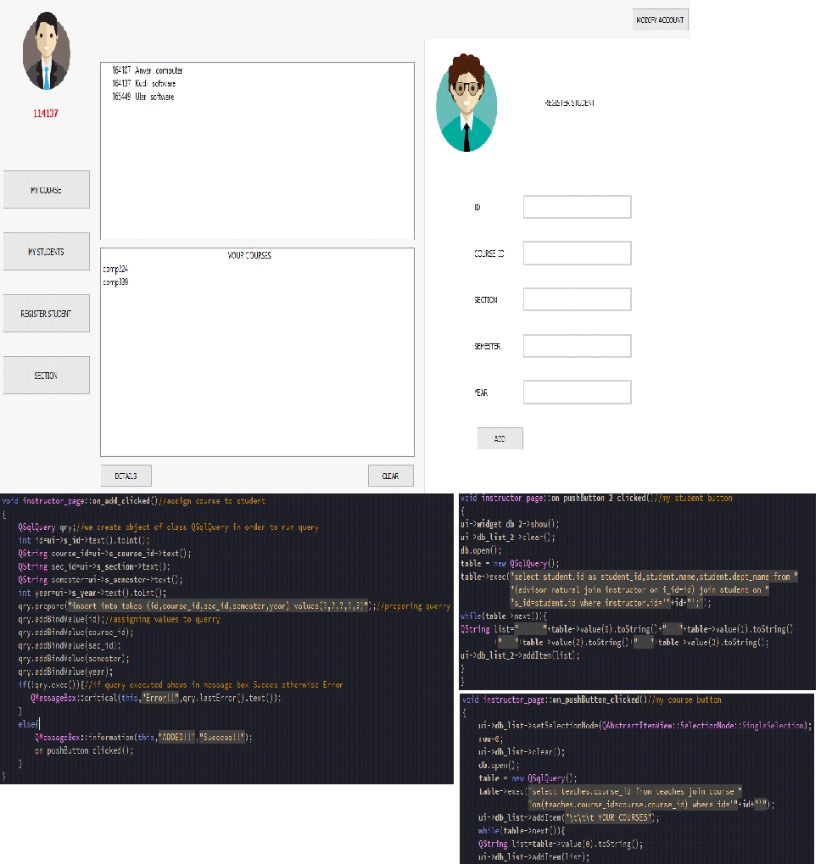

The UI above is appears when instructor clicks "REGISTER STUDENT" ,"MY COURSE" and "MY STUDENT" buttons also we add the coding part of this buttons, and if user will choose the "MODIFY ACCOUNT" on window will appears this one:

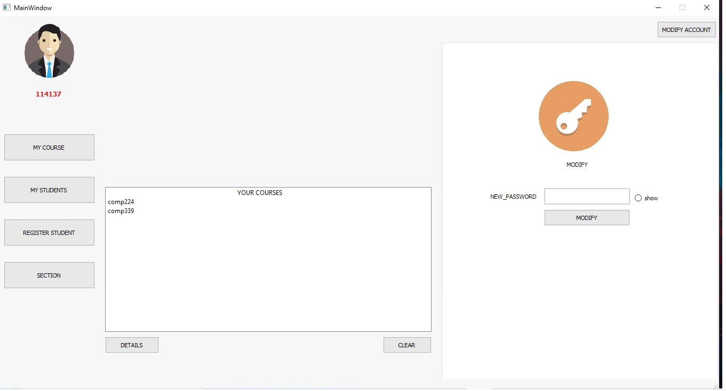

This backend code is for "MODIFY"button

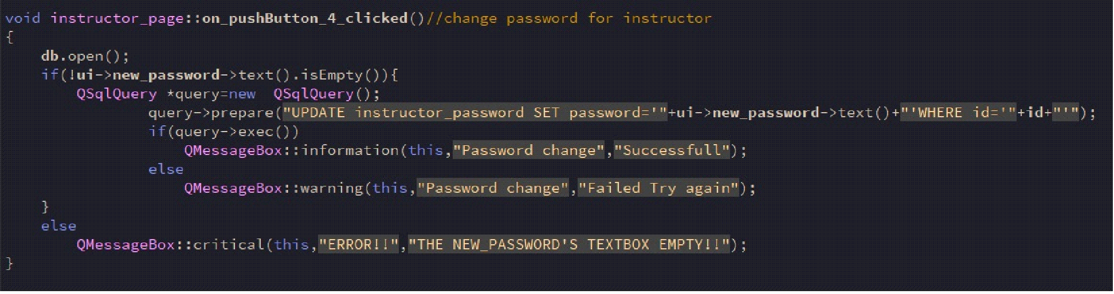

As you can see above ,there is also a "DETAILS" button which shows the detailed information about course:

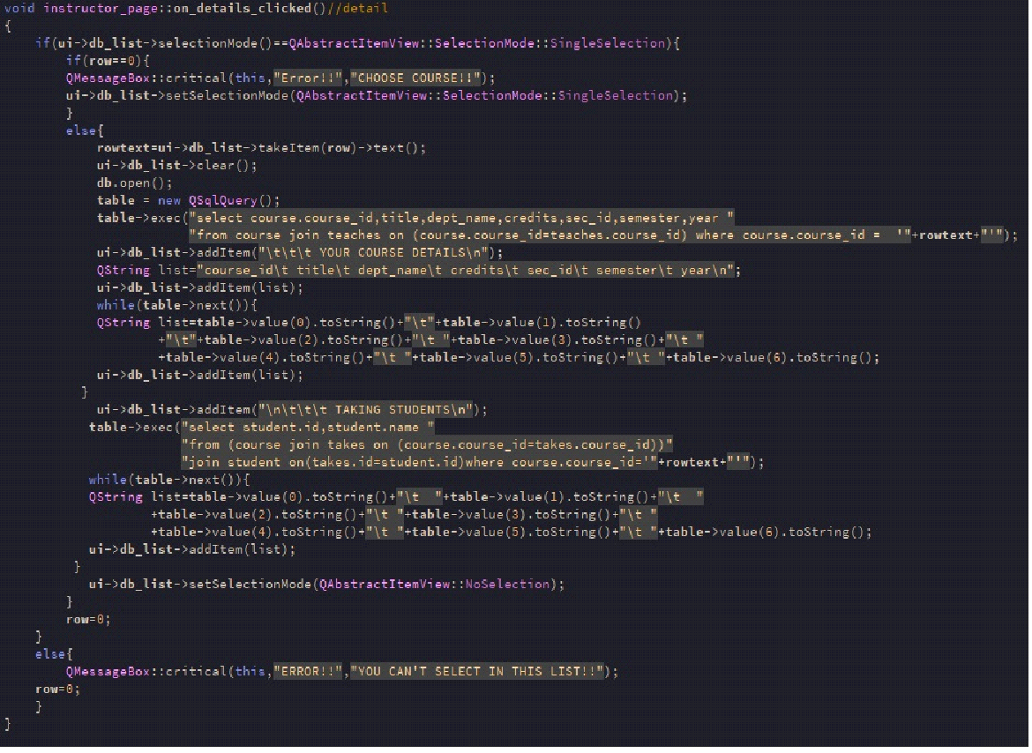

Now we understand what instructor does:

- Registers students,

- Modifies account info

- Checks teaching courses and their details

And this is Student UI window: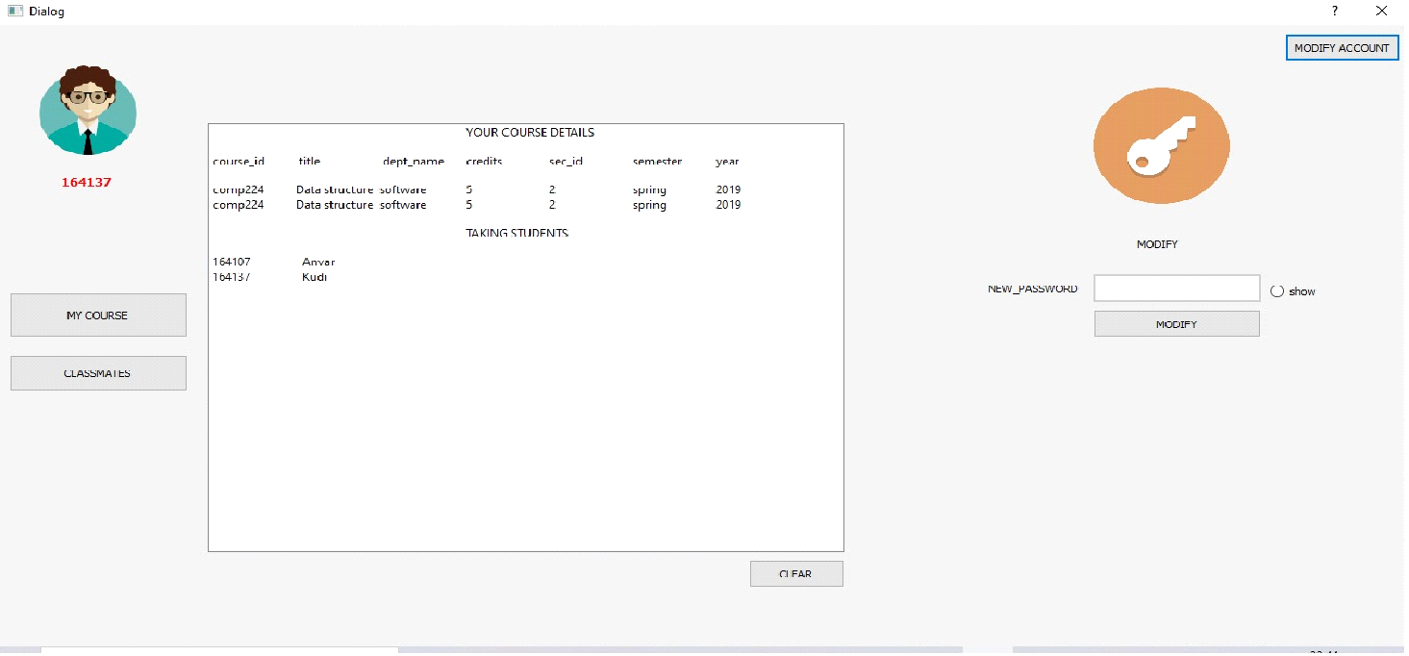

The window above will appear when user press the "MODIFY" ,"MY COURSE" and "CLASSMATES" buttons.

Student can modify his account or check which course he is taking and also can see which other students takes the exact course.

This is the coding part of "classmates" button

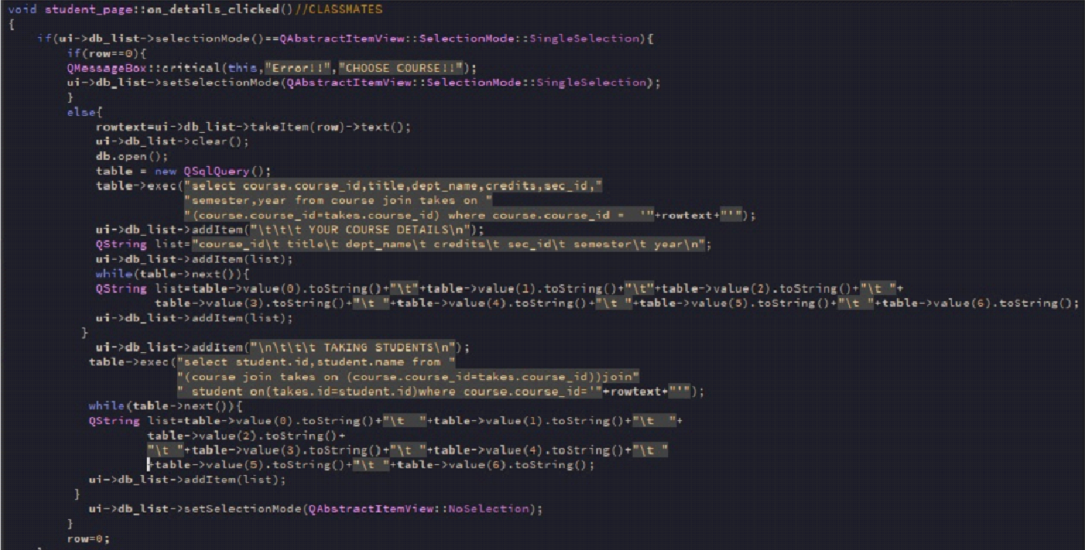

and this backend part of "MODIFY" button:

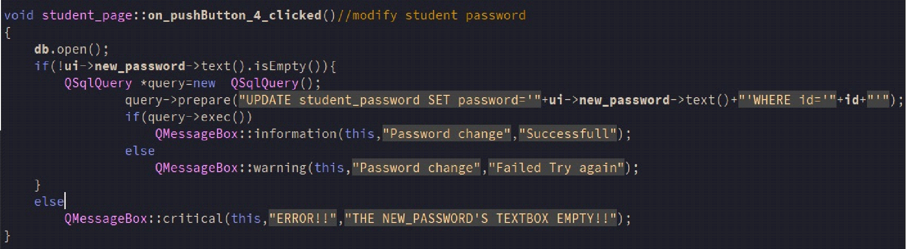

This one for "MY COURSE" button: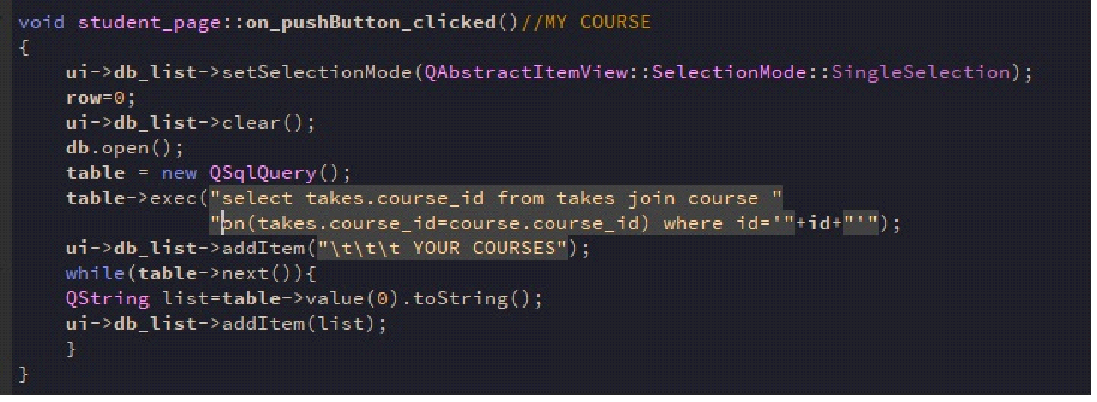

Now , the last UI is for "Faculty Coordinator" :

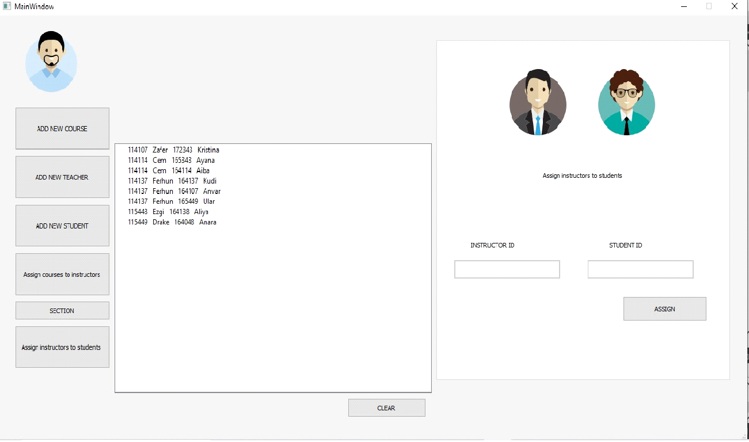

Faculty coordinator can add new courses, add new teacher or student, also assigning students to their advisor(instructor) as above.

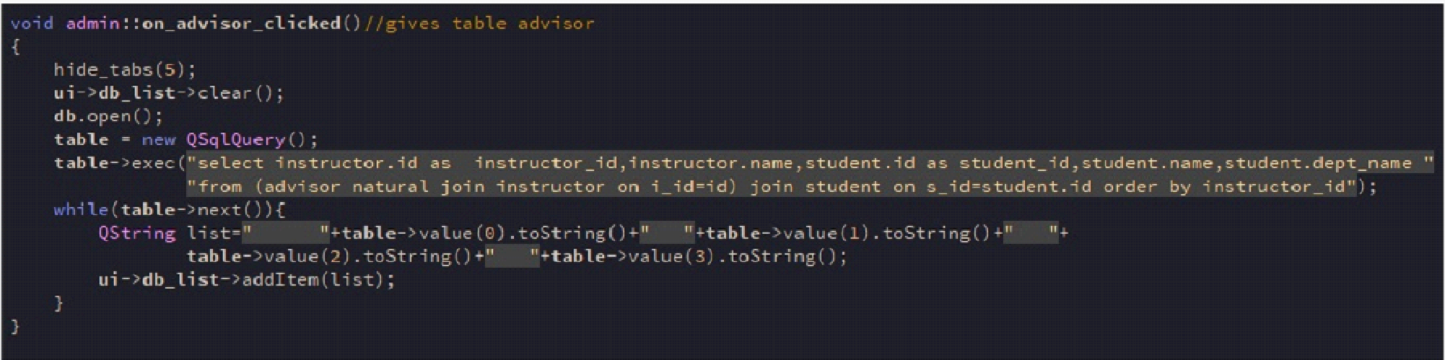 This code for "ADD NEW COURSE " button:

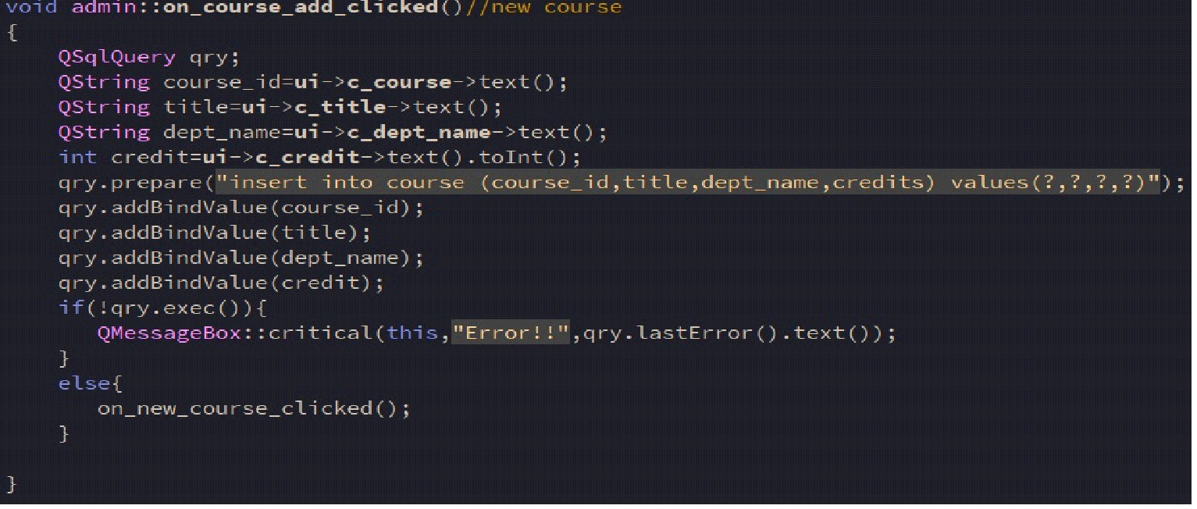

Code for "ADD NEW TEACHER" button:

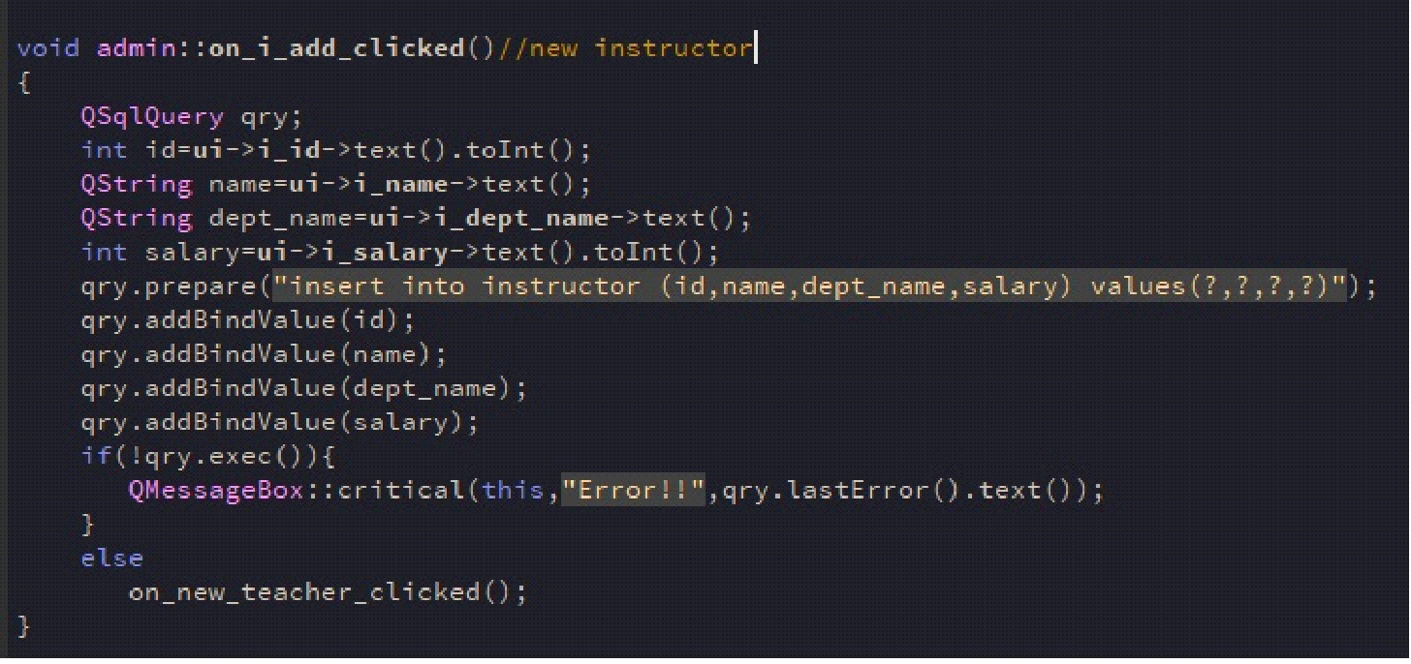

And this code for "ADD NEW STUDENT" button:

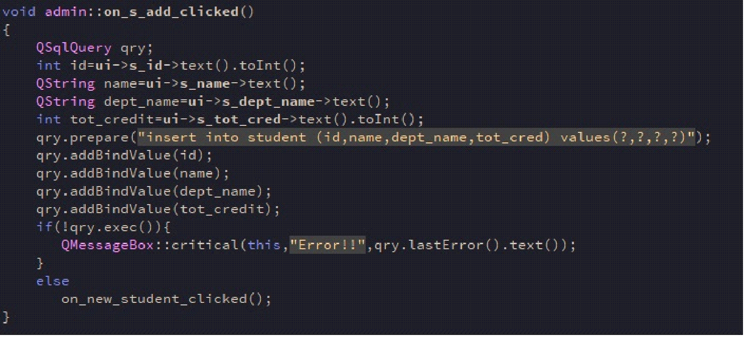

And this code for "ASSIGN COURSE TO INSTRUCTOR " button:

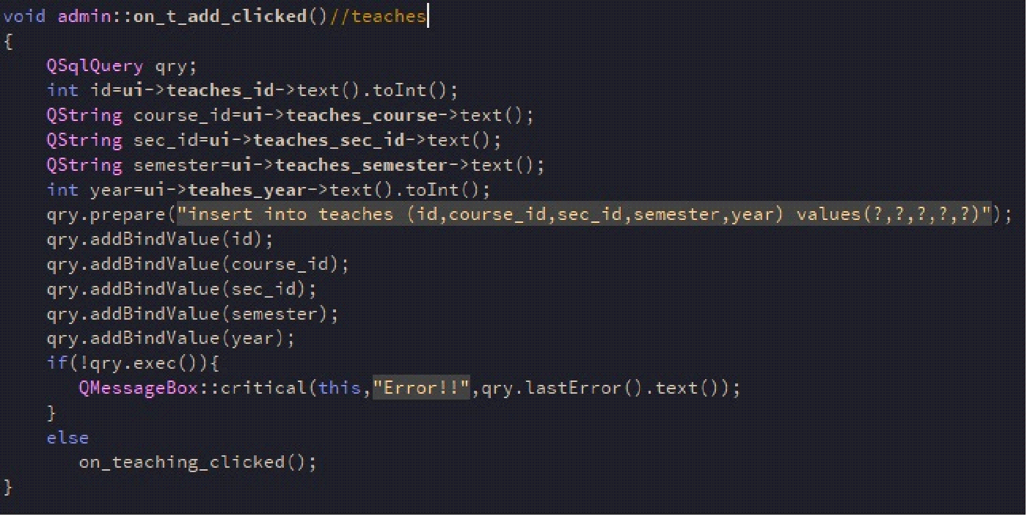

This code is for that situation when "ASSIGN" is clicked:

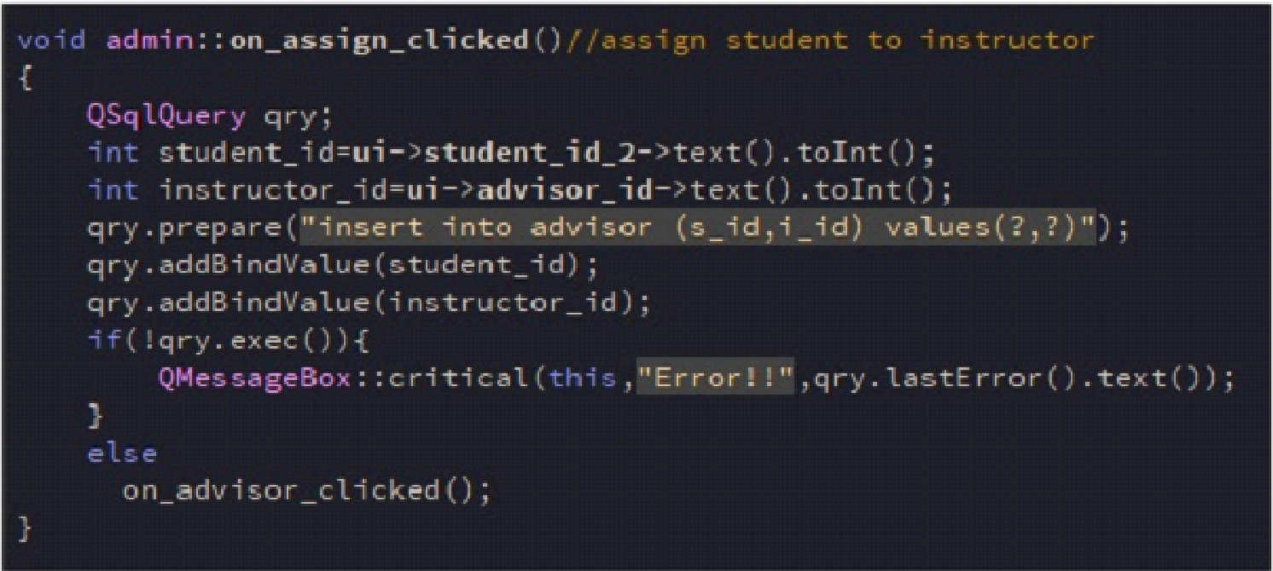

And as a last one ,it's code of how we connect our app to database:

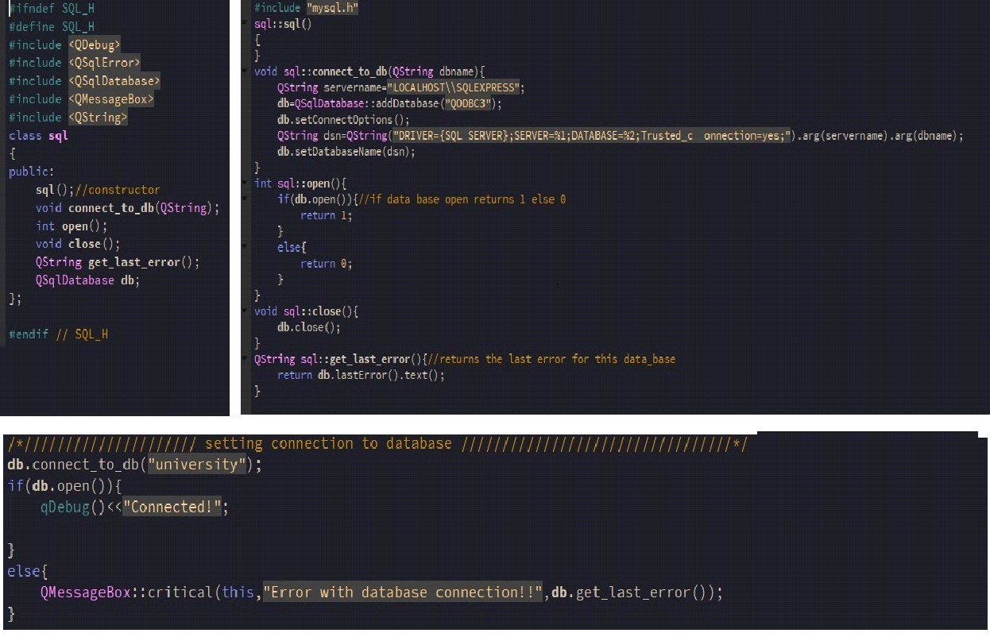

**E-R - DIAGRAM**

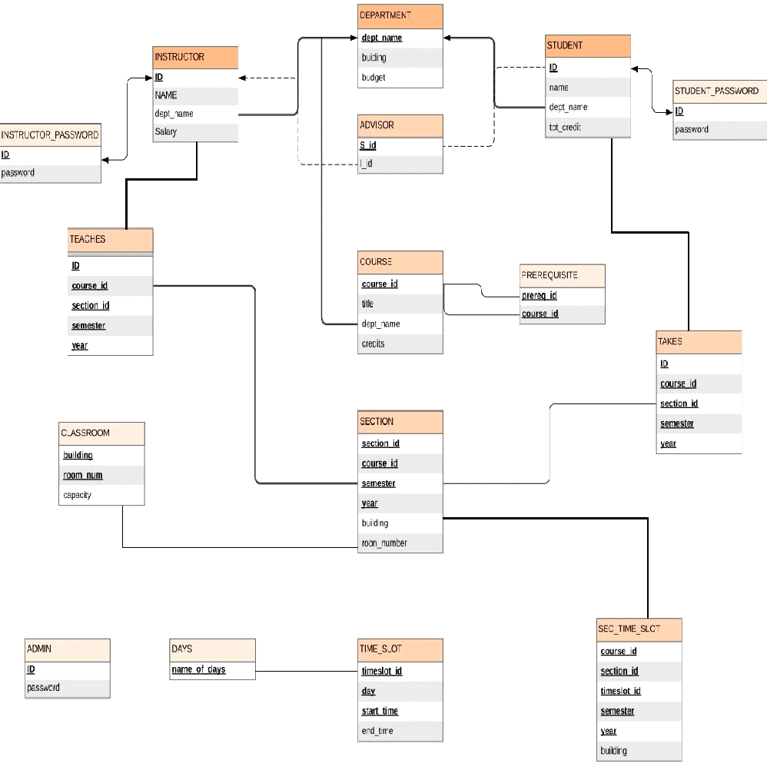

**CONCLUSION**

The project entitled as **University Management System** is the system that deals with the issues related to a particular institution.

* This project is successfully implemented with all the features mentioned in system requirements specification.
* The application provides appropriate information to users according to the chosen service.
* The project is designed keeping in view the day to day problems faced by a college.
* Deployment of our application will certainly help the college to reduce unnecessary wastage of time in personally going to each department for some information.

Awareness and right information about any college is essential for both the development of student as well as faculty. So this serves the right purpose in achieving the desired requirements of both the communities.