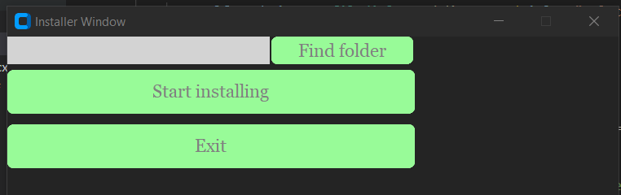

Оберемо папку

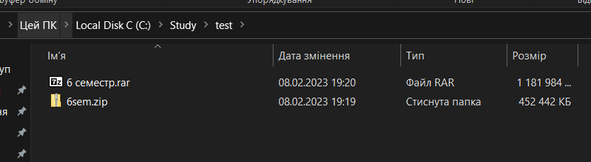

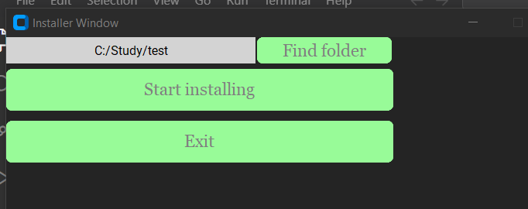

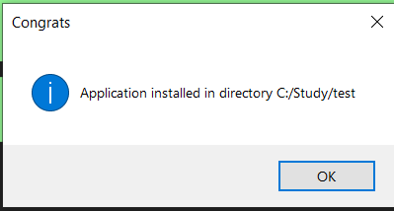

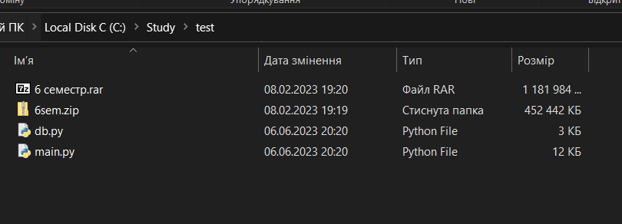

Вивела зібрані дані для наочності

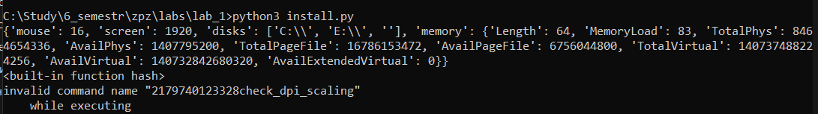

Якщо не обрати папку

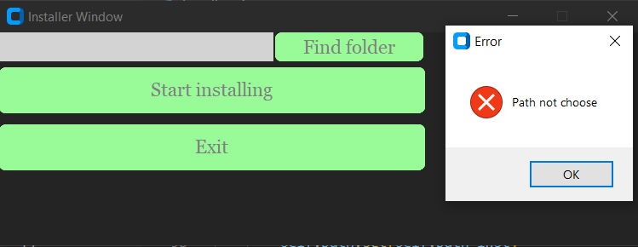

Тепер запустимо змінений код до 1шої лаби

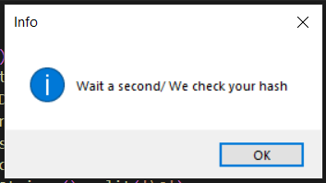

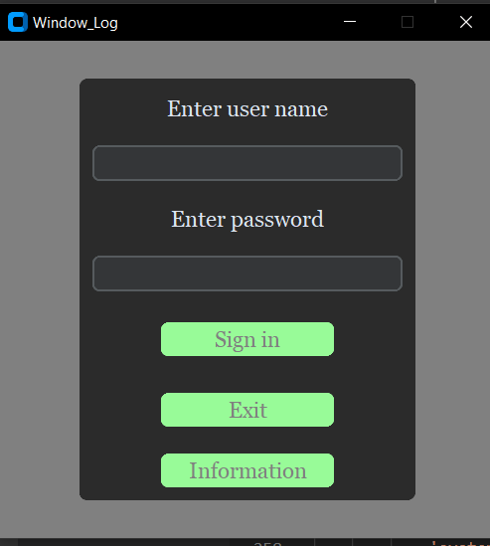

Install.py

import zipfile

import hashlib

import json

import win32api

import tkinter

import winreg

from tkinter import filedialog,messagebox

import customtkinter as ctk

import win32.lib.win32con as win32con

import platform

import pyautogui

APP = "AppLab2.zip"

class INSTALLER(ctk.CTk):

    screen_width, _ = pyautogui.size()

    print(screen_width)

    def GetInfoUser(self):

        info = {

        'username': win32api.GetUserName(),

        'computername': win32api.GetComputerName(),

        'windowsdir': win32api.GetWindowsDirectory(),

        'systemdir': win32api.GetSystemDirectory(),

        'mouse': win32api.GetSystemMetrics(win32con.SM_CMOUSEBUTTONS),

        'screen': win32api.GetSystemMetrics(win32con.SM_CXSCREEN),

        'disks': win32api.GetLogicalDriveStrings().split('\0'),

        'memory': win32api.GlobalMemoryStatusEx()[0]

        }

        return info

    def setRegKey(self, value):

        # key = winreg.CreateKey(winreg.HKEY_CURRENT_USER, "SOFTWARE\\MuzychkaSkrypka")

        # winreg.SetValueEx(key, sign, 0, winreg.REG_SZ,value)

        key = winreg.CreateKey(winreg.HKEY_CURRENT_USER, "SOFTWARE\\MuzychkaSkrypka")

        winreg.SetValueEx(key, "HashValue", 0, winreg.REG_SZ, value)

        winreg.CloseKey(key)

    def __init__(self):

        super().__init__()

        self.title ('Installer Window')

        self.geometry("800x400")

        self.resizable(False,False)

        self.path = tkinter.StringVar()

        self.find_folder = ctk.CTkButton(master=self, font=("Georgia", 18), text = "Find folder", text_color="gray",  fg_color="palegreen", command = self.ShowFolder)

        self.find_folder.grid(row = 1, column =5)

        self.start_install = ctk.CTkButton(master=self, font=("Georgia", 18), text="Start installing", text_color="gray",  fg_color="palegreen", command=self.Install,width=400)

        self.start_install.grid(column = 4,ipady=10,columnspan=2,pady = 5)

        self.label_path = ctk.CTkLabel(master = self, width=250, fg_color="lightgray", textvariable= self.path, text_color="black")

        self.label_path.grid(row = 1,columnspan = 4, column =1,ipadx = 5)

        self.end_button = ctk.CTkButton(master=self, font=("Georgia", 18), text="Exit", text_color="gray",  fg_color="palegreen", command=self.exit_but, width=400)

        self.end_button.grid(row = 4, column = 4,ipady=10,columnspan=2,pady = 5)

    def exit_but(self):

        self.destroy()

    def ShowFolder(self):

        self.path_inst = filedialog.askdirectory(title ="Select Folder")

        self.path.set(self.path_inst)

    def Install(self):

        dir = self.path.get()

        if not dir:

            tkinter.messagebox.showerror(title="Error", icon = "error", message = "Path not choose")

            return

        info = self.GetInfoUser()

        # generated_hash = hashlib.md5(json.dumps(info).encode()).hexdigest()

        print(info)

        print(hash)

        json_info = json.dumps(info).encode('utf-8')

        # hash_object = hashlib.sha256(json_info)

        hash_object = hashlib.md5(json_info)

        hash_hex = hash_object.hexdigest()

        self.setRegKey(hash_hex)

        # self.setRegKey("Signature", generated_hash)

        zip = zipfile.ZipFile(APP)

        try:

            zip.extractall(dir)

            zip.close()

            self.destroy()

            messagebox.showinfo(title="Congrats", message = f"Application installed in directory {dir}")

        except Exception:

            tkinter.messagebox.showerror(title="Error",message ="Something went wrong")

if __name__ == "__main__":

    Installer = INSTALLER()

    Installer.mainloop()

Та додала код до main.py

class HashCheck():

        def __init__(self):

            tkinter.messagebox.showinfo(title="Info", message="Wait a second/ We check your hash")

        def GetInfoUser(self):

            info_hash = {

                'username': win32api.GetUserName(),

                'computername': win32api.GetComputerName(),

                'windowsdir': win32api.GetWindowsDirectory(),

                'systemdir': win32api.GetSystemDirectory(),

                'mouse': win32api.GetSystemMetrics(win32con.SM_CMOUSEBUTTONS),

                # 'screen': win32api.GetSystemMetrics(win32con.SM_CXSCREEN),

                'disks': win32api.GetLogicalDriveStrings().split('\0'),

                # 'memory': win32api.GlobalMemoryStatusEx()[0]

            }

            return info_hash

        def getRegKey(self, sign):

            key = winreg.OpenKey(winreg.HKEY_CURRENT_USER,"SOFTWARE\\MuzychkaSkrypka")

            value = winreg.QueryValueEx(key,sign)[0]

            return value

        def Hash_Check(self):

            info = self.GetInfoUser()

            print(info)

            json_info = json.dumps(info).encode('utf-8')

            hash_object = hashlib.md5(json_info)

            hash_now = hash_object.hexdigest()

            # hash_now = hashlib.md5(json.dumps(info).encode()).hexdigest()

            cool_hash = self.getRegKey("HashValue")

            print(hash_now)

            print(cool_hash)

            if (hash_now == cool_hash):

                return True

            else:

                return False

hash_TF = HashCheck()

hash_TF.Hash_Check()

if hash_TF:

    DataBase = db.Data()

    DataBase.file_init()

    logWin = Window_Log()

    logWin.mainloop()

else:

  tkinter.messagebox.showinfo(title="Error", message="Your hash is incorrect")