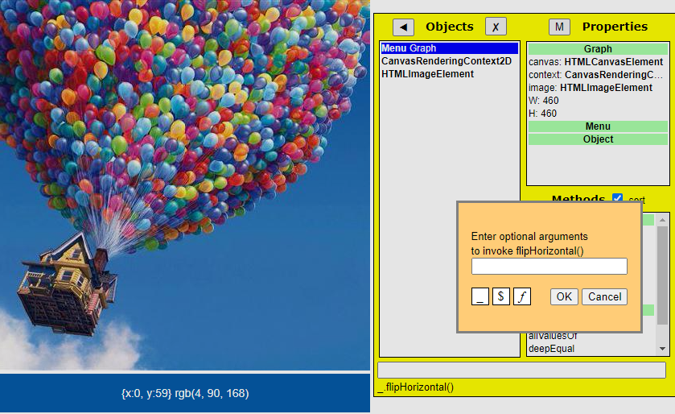

flipHorizontal() {

var imgWidth = img.width;

var imgHeight = img.height;

var imgData = this.context.getImageData(0, 0, imgWidth, imgHeight);

for (let i = 0; i < imgData.height; i++) {

for (let j = 0; j < imgData.width / 2; j++) {

var index = ((i \* imgData.width) + j) \* 4;

var mirrorIndex = (((i + 1) \* imgData.width) - (j + 1)) \* 4;

for (let k = 0; k < 4; k++) {

var temp = imgData.data[index + k];

imgData.data[index + k] = imgData.data[mirrorIndex + k];

imgData.data[mirrorIndex + k] = temp;

}

}

}

this.context.putImageData(imgData, 0, 0, 0, 0, imgData.width, imgData.height);

}

}