# AI-Generated Report

## Distribution Chart Summary

The credit rating distribution weighted by exposure reveals several notable patterns across employment status groups. Employed individuals consistently account for the highest exposure across all credit rating categories, with a particularly pronounced dominance in the best credit ratings (1 and 2). This suggests that the largest share of exposure is concentrated among those with stable employment and higher credit quality.  
  
Self-employed individuals, while showing substantial exposure, have a more even distribution across the credit rating spectrum, with their exposure peaking at mid-level credit ratings (2 to 5). This indicates a broader risk profile within this group, as their exposure does not decline as sharply with worsening credit ratings compared to the employed segment.  
  
Pensioners display a moderate but steady exposure across all credit ratings, with a slight increase in the mid-range (3 to 5). This pattern may reflect a relatively stable but risk-averse lending approach to this demographic.  
  
Unemployed individuals consistently represent the lowest exposure in every credit rating category, and their exposure drops off sharply as credit ratings worsen. This highlights a clear risk aversion in extending credit to this group, especially at lower credit ratings.  
  
Overall, the distribution of exposure by credit rating and employment status underscores a strong preference for allocating credit exposure to employed individuals with higher credit ratings, while exposure to self-employed and unemployed groups is either more evenly spread or significantly limited, respectively. This weighted distribution suggests a cautious approach to credit risk, with employment status playing a critical role in exposure decisions.

## Distribution Chart

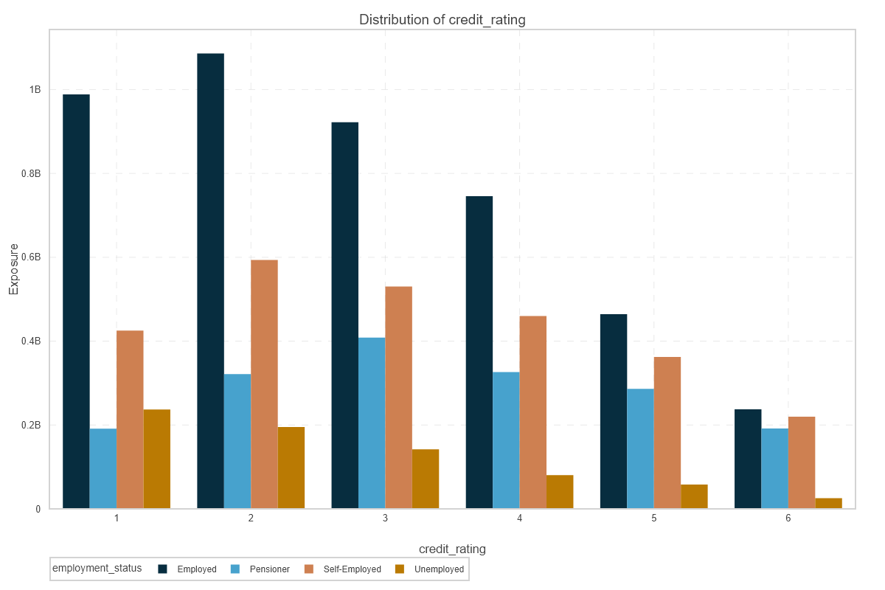

## Discriminatory Power Chart Summary

The chart tracking discriminatory power, as measured by somers_d, over time reveals a notable pattern. From mid-2020 through mid-2022, there is a steady and consistent increase in somers_d values, indicating an improvement in the model’s ability to distinguish between outcomes. This upward trend peaks around mid-2022, suggesting a period of optimal discriminatory power.  
  
However, what stands out is the sharp decline in somers_d after this peak, with values dropping significantly by early 2023. This reversal is particularly striking given the previous period of stability and growth. The confidence interval, represented by the shaded region, also widens considerably during this decline, highlighting increased uncertainty or variability in the model’s performance during this later period.  
  
Overall, the outputs suggest that while discriminatory power improved steadily for two years, there is a surprising and abrupt deterioration in performance after mid-2022. This anomaly warrants further investigation to identify potential causes, such as changes in data quality, population characteristics, or model drift, to ensure the reliability of discriminatory power metrics over time.

## Discriminatory Power Chart

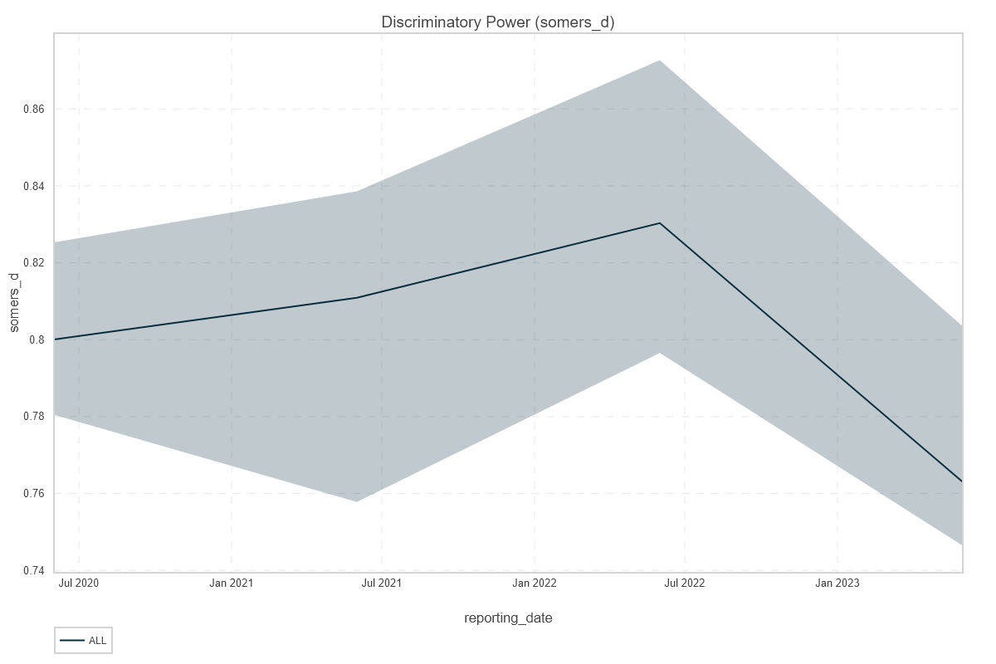

## Migration Matrix Chart Summary

The migration matrix plot provides a clear visualization of rating class movement between 2021 and 2022. The most prominent pattern is the strong diagonal dominance, indicating that the majority of entities remained in the same rating class year-over-year. This stability is particularly evident in the highest and lowest rating classes, where the largest counts are concentrated.  
  
A notable anomaly appears in the transition from rating class 3 in 2021 to class 5 in 2022, where a small but distinct cluster is highlighted in red. This suggests an unusual spike in downgrades directly from a mid-tier to the lowest rating class, which is not mirrored in the other classes and may warrant further investigation.  
  
Additionally, the migration matrix plot reveals that upward movement (upgrades) is less frequent than downward movement (downgrades), especially for entities starting in the lower rating classes. The off-diagonal elements, while generally smaller, show that most migrations occur between adjacent classes, with very few entities skipping multiple classes in a single year.  
  
Overall, the migration matrix plot underscores both the general stability of rating assignments and the presence of isolated but significant rating transitions, particularly abrupt downgrades, which could have implications for risk management and portfolio monitoring.

## Migration Matrix Chart

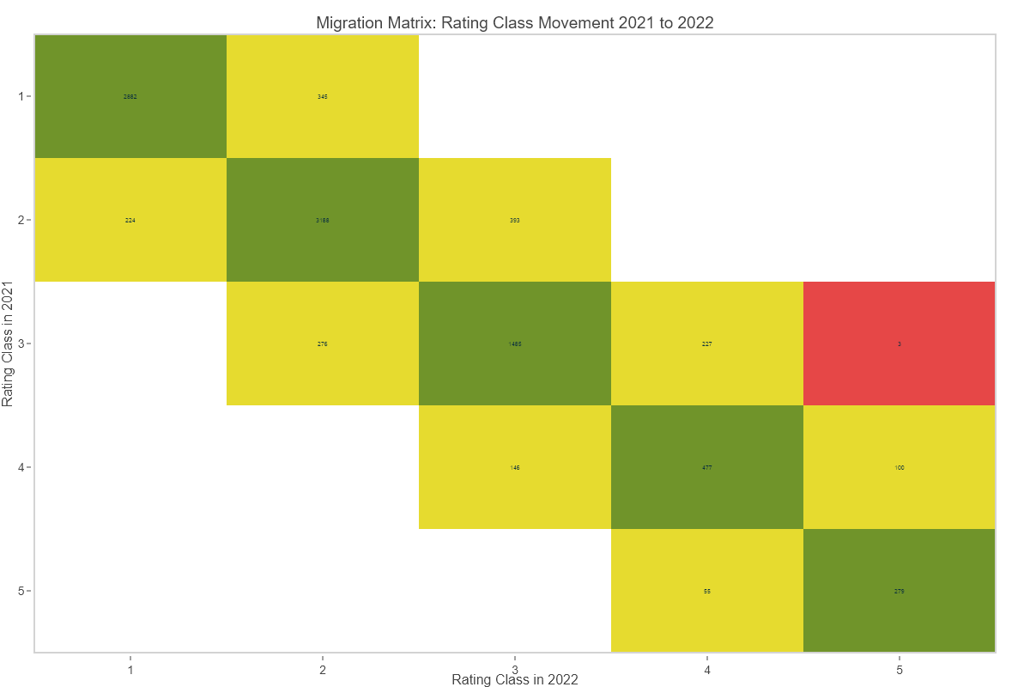

## PSI Chart Summary

The outputs from the PSI chart highlight a strong similarity between the distributions of unique counts in the new sample and the old sample across all rating classes. The Population Stability Index (PSI) value of 0.0158 is notably low, indicating minimal shift or drift between the two distributions. This suggests that the underlying population characteristics have remained stable over time.  
  
A closer look at the chart reveals that the largest differences between the new and old sample distributions occur at the lower and higher ends of the rating class spectrum. Specifically, the new sample shows a slightly higher relative population in rating classes 1 and 2, while the old sample has marginally higher proportions in classes 3, 4, and 5. However, these differences are minor and do not indicate any significant anomaly or trend.  
  
Overall, the PSI output confirms that the unique counts in the new sample closely mirror those in the old sample, with no surprising deviations. This stability is a positive indicator for ongoing monitoring and suggests that the process generating these distributions remains consistent.

## PSI Chart

