# Name: Course & Year: BSSE - 2 Schedule: W: 10 AM – 1 PM Group Number: GROUP 4 Date of Experimentation: 10/02/2024 Instructor’s Signature:

**LABORATORY EXPERIMENT NO. 8**

SHORT CIRCUIT

# Objectives:

1. To understand what a Short Circuit is.
2. To determine how a Short Circuit affects the voltages in a circuit.
3. To determine how a Short Circuit affects the currents flowing in a circuit.

# Equipments:

1. VOM (either Analog or Digital) including probes
2. Four (4) pieces of Carbon Composition Resistors of different values
3. Connecting Wires of size # 22 or # 20, solid conductor
4. Trainer Kit or DC Voltage Source / Power Supply with variable voltage output

# Procedure for Experimentation with the Data and Results of Computations:

1. Choose four (4) resistors of different color combinations. Assign resistor numbers from 1 to 4. On Table 1, interpret the color-coding and write the equivalent Ohmic values and the tolerances of each resistor.
2. Using either an Analog or Digital Ohmmeter, measure the resistances and write the readings in the spaces provided on Table 1.

*Ohmic*  *Ohmmeter*

*Ohmic*

1. Compute for the percentage differences: *%Diff*



 *100%* .

|  |  |  |  |  |
| --- | --- | --- | --- | --- |
| **Table 1 - The Ohmic Value and Ohmmeter Readings** | | | | |
| **Resistor** | **Ohmic (Numerical) Value** | **Tolerance** | **Ohmmeter Reading** | **% Difference (Ohmic & VOM)** |
| **R1** |  |  |  |  |
| **R2** |  |  |  |  |
| **R3** |  |  |  |  |
| **R4** |  |  |  |  |

1. Connect the circuit shown on the diagram on the breadboard using the four (4) resistors (arrange the resistors in the circuit according to the sequence used on Table 1). Make sure the wires and resistors are inserted properly. After connecting, have your work checked by the instructor.

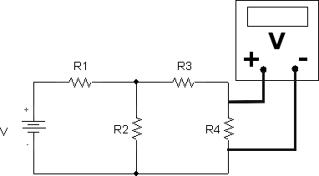

1. Power up or switch on the power supply using the Source Voltage specified by the instructor, as indicated on the Voltmeter. Place the reading in the space for Source Voltage in the Table provided. (Make an effort to maintain this Source Voltage in all the succeeding circuits with one resistor shorted at a time.)
2. Use the voltmeter function of the VOM to measure the Voltage across each resistor. Place the readings in the spaces for Measured Voltage on the Table provided.
3. Switch off the power supply.
4. Use the formula: *I*  *V*

*R* to solve for the Measured Current through each resistor

wherein Measured Current = Measured Voltage / Ohmmeter Reading of the Resistance.

Such that,

*I1*  *V1*

*R1* ,

*I 2*  *V2*

*R 2* , and etc. Place the results in the spaces for

Measured Current on the Table provided.

1. Remove the wires that connect the Source Voltage to the resistors in series-parallel on the breadboard. Measure the Total Resistance by placing the red probe (of the VOM) on the leg of the resistor where the positive terminal of the Source Voltage was connected with; while the black probe (of the VOM) must be placed on the leg of the resistor where the negative or ground terminal of the Source Voltage was connected with. Place the result in the space for Total Resistance on the Table provided.

|  |  |  |  |  |  |
| --- | --- | --- | --- | --- | --- |
| **Table 2 – Complete Circuit (Figure 2)** | | | | | |
| **Source Voltage, V Total =** | | | **Total Resistance, R Total =** | | |
| **Voltages** | **V1** | **V2** | | **V3** | **V4** |
| **Theoretical** |  |  | |  |  |
| **Measured** |  |  | |  |  |
| **% Difference** |  |  | |  |  |
| **Currents** | **I1** | **I2** | | **I3** | **I4** |
| **Theoretical** |  |  | |  |  |
| **Measured** |  |  | |  |  |
| **% Difference** |  |  | |  |  |

1. Remove Resistor R1 from the circuit on the breadboard. Replace it with a short- circuiting wire. Refer to the next Figure/Circuit Diagram for the circuit connection. Repeat Procedures #5 to #9. Results must be written on Table 3.

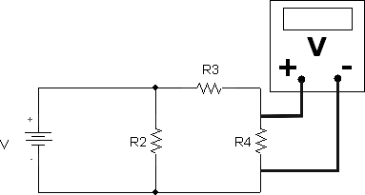

|  |  |  |  |  |  |
| --- | --- | --- | --- | --- | --- |
| **Table 3 – R1 Shorted** | | | | | |
| **Source Voltage, V Total =** | | | **Total Resistance, R Total =** | | |
| **Voltages** | **V1** | **V2** | | **V3** | **V4** |
| **Theoretical** |  |  | |  |  |
| **Measured** |  |  | |  |  |
| **% Difference** |  |  | |  |  |
| **Currents** | **I1** | **I2** | | **I3** | **I4** |
| **Theoretical** |  |  | |  |  |
| **Measured** |  |  | |  |  |
| **% Difference** |  |  | |  |  |

1. Remove the short-circuiting wire and return Resistor R1 to its original placement in the circuit on the breadboard. Then, remove resistor R2 from the circuit and replace it with the short-circuiting wire. Refer to the next Figure/Circuit Diagram for the circuit connection. Repeat Procedures #5 to #9. Results must be written on Table 4.

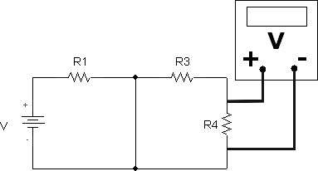

|  |  |  |  |  |  |
| --- | --- | --- | --- | --- | --- |
| **Table 4 – R2 Shorted** | | | | | |
| **Source Voltage, V Total =** | | | **Total Resistance, R Total =** | | |
| **Voltages** | **V1** | **V2** | | **V3** | **V4** |
| **Theoretical** |  |  | |  |  |
| **Measured** |  |  | |  |  |
| **% Difference** |  |  | |  |  |
| **Currents** | **I1** | **I2** | | **I3** | **I4** |
| **Theoretical** |  |  | |  |  |
| **Measured** |  |  | |  |  |
| **% Difference** |  |  | |  |  |

1. Remove the short-circuiting wire and return Resistor R2 to its original placement in the circuit on the breadboard. Then, remove Resistor R3 from the circuit and replace it with the short-circuiting wire. Refer to the next Figure/Circuit Diagram for the circuit connection. Repeat Procedures #5 to #9. Results must be written on Table 5.

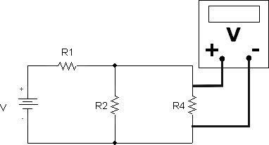

|  |  |  |  |  |  |
| --- | --- | --- | --- | --- | --- |
| **Table 5 – R3 Shorted** | | | | | |
| **Source Voltage, V Total =** | | | **Total Resistance, R Total =** | | |
| **Voltages** | **V1** | **V2** | | **V3** | **V4** |
| **Theoretical** |  |  | |  |  |
| **Measured** |  |  | |  |  |
| **% Difference** |  |  | |  |  |
| **Currents** | **I1** | **I2** | | **I3** | **I4** |
| **Theoretical** |  |  | |  |  |
| **Measured** |  |  | |  |  |
| **% Difference** |  |  | |  |  |

1. Remove the short-circuiting wire and return Resistor R3 to its original placement in the circuit on the breadboard. Then, remove Resistor R4 from the circuit and replace it with the short-circuiting wire. Refer to the next Figure/Circuit Diagram for the circuit connection. Repeat Procedures #5 to #9. Results must be written on Table 6.

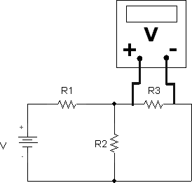

|  |  |  |  |  |  |
| --- | --- | --- | --- | --- | --- |
| **Table 6 – R4 Shorted** | | | | | |
| **Source Voltage, V Total =** | | | **Total Resistance, R Total =** | | |
| **Voltages** | **V1** | **V2** | | **V3** | **V4** |
| **Theoretical** |  |  | |  |  |
| **Measured** |  |  | |  |  |
| **% Difference** |  |  | |  |  |
| **Currents** | **I1** | **I2** | | **I3** | **I4** |
| **Theoretical** |  |  | |  |  |
| **Measured** |  |  | |  |  |
| **% Difference** |  |  | |  |  |

1. Use the Ohmmeter readings of each resistor on Table 1 and the Source Voltage from each respective Table (Tables 2 to 6) to obtain the Theoretical values needed on Tables 2 to 6.
2. Compute for the percentage differences on Tables 2 to 6:

*Theoretical*  *Measured*

*Theoretical*

*%Diff*



 *100%* .

1. Show details of the calculations/computations on the back pages of this Laboratory Experiment Report.

# Analysis and Observations:

1. What is a Short Circuit?
2. Compare the results shown on Table 2 to the results shown on Tables 3 to 6. What have you observed?
3. What happened to the circuit (including the effects on the Voltages and Currents) when R1 was shorted?
4. What happened to the circuit (including the effects on the Voltages and Currents) when R2 was shorted?
5. What happened to the circuit (including the effects on the Voltages and Currents) when R3 was shorted?
6. What happened to the circuit (including the effects on the Voltages and Currents) when R4 was shorted?
7. What are the problems you encountered while conducting this experiment?

**Conclusion:**