Curriculum VITAE 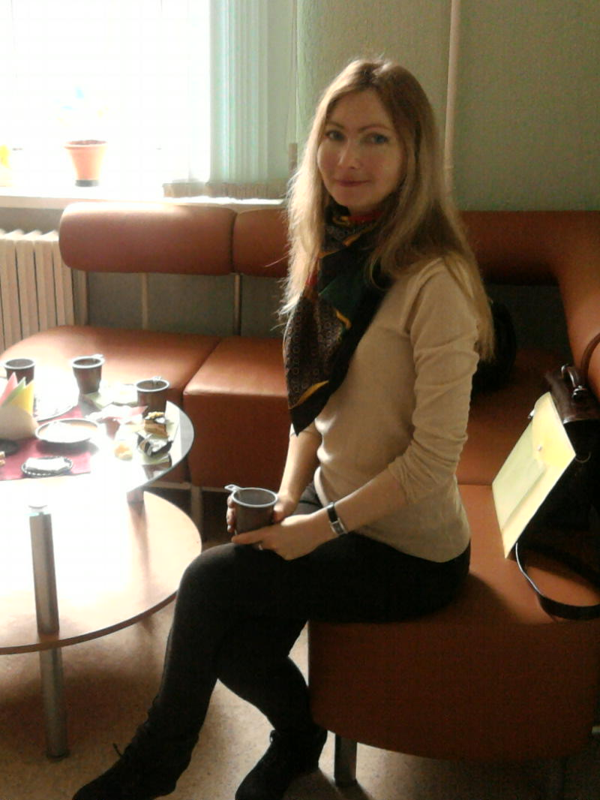

|  |
| --- |
| **Personal information** |

|  |  |  |
| --- | --- | --- |
| **Name** |  | YULIYA SHAMSHUR |
| **Address (1)** |  | Parkovaya street 32-33,211440 Novopolotsk, Belarus |
| **Address (2)** |  |  |
| **Telephone** |  | + 375445539215 |
| **Date of Birth** |  | 09/07/1979 |
| **E-mail** |  | yuliyashamshur@mail.ru |
| **Nationality** |  | BELORUSSIAN |
|  |  |  |

|  |  |  |
| --- | --- | --- |
| **Work experience** |  |  |
|  |  |  |
| **Period** |  | **09.2001-TILL 09.2009** |
| **Employer** |  | **School for specialization in German and English languages** |
| **Department** |  | **Foreign languages** |
| **Job** |  | TEACHER |
| **Responsibilities** |  | **MANAGING AND TEACHING GERMAN AND ENGLISH AS FOREIGN LANGUAGE, HANDLING MORE THAN 35 STUDENTS AND MANAGING STRICT DEADLINES FOR EXAMS, PREPARING STUDENTS FOR IELTS, TOEFL CERTIFICATE FORM A1/A2,B1/B2,C1,USING MODERN METHODS OF TEACHING, ORGANIZATION PRIVATE LESSONS AND PRIVATE METHODOLOGICAL TECHNOLOGY, TUTORING AND CLASS SUPERVISING, USING COMPUTER AND MULTIMEDIA TECHNOLOGIES** |
| **Period 10.2009-TILL 08.2010** | | |
| **Employer RBSM, Bugibba, Malta** | | |
| **Job** Teacher of English and home parent | | |
| **Responsibilities** Managing and Teaching English, taking care of students including pre school students. | | |
| **Period 08.2010-TILL 01.2011** | | |
| **Employer Hanskollen Ski centre** , **Norway**  **Responsibilities Receptionist** | | |
| **Period 20.02.2011-TILL present** | | |
| **Employer Gymnasium #1 Novopolotsk** | | |
| **Responsibilities Teacher of English, Head Teacher of English Department** | | |

|  |
| --- |
| **Education and training** |

**EDUCATION**

|  |  |  |
| --- | --- | --- |
| **Period** |  | **1996-2001** |
| **UNIVERSITY** |  | POLOTSK STATE UNIVERSITY |
|  |  |  |
| **Qualification** |  | TEACHER OF GERMAN AND ENGLISH |
| **Diploma** |  | UNIVERSITY GRADUATION CERTIFICATE |

|  |
| --- |
| **Personal skills**  **and competences** |

|  |  |  |
| --- | --- | --- |
| **Mother Language** |  | RUSSIAN,BELORUSSIAN |

|  |
| --- |
| **Other languages** |

|  |  |  |
| --- | --- | --- |
| **Language** |  | GERMAN,ENGLISH,CZECH,SERBIAN,FRENCH,NORWEGEAN |
| **• Reading skills** |  | ADVANCED |
| **• Writing skills** |  | GERMAN-ADVANCED(INTERPRETING SKILLS), ENGLISH-ADVANCED, OTHER-MEDIUM |
| **• Verbal skills** |  | ENGLISH-ADVANCED |

|  |  |  |
| --- | --- | --- |
| **Organizational and Social skills**  **and competences** |  | SOCIABLE  PATIENT  HARD WORKING  ABLE TO WORK AND TAKE DECISIONS UNDER STRESSFUL CIRCUMSTANCES  CAPABLE OF TAKING AN FOLLOWING DIRECTIONS AS INSTRUCTED BY SUPERIORS  ORGANIZED |

|  |  |  |
| --- | --- | --- |
| **Additional information** |  | **2009** GERMAN TEACHERS GENERAL CONFERENCE JENA/WEIMAR (GERMANY),  REPRESENTED MY COUNTRY AS S MEMBER IN THE GENERAL GERMAN TEACHERS CONFERENCE  **2010-2011** COURSE IN NORWEGIAN  **2013 Certificate in Computer Science**  **2014** Building Teaching Skills Through the Interactive Web’ online course with the University of Oregon’s American English Institute, a program of the Department of Linguistics  **2014 Shaping the Way We Teach English, online course with the University of Oregon**  2017 Courses for techers of German, Munic, Germany  2018 Conference in Fribourge Switzerland  2019 Conference in Bremen Germany |

INTERESTS: TRAVELLING, SPORTS, CHESS