Home
Header: Welcome
Paragraph: Since 1981, the Matsuyama–Sacramento Sister City Corporation (MSSCC) has been a vibrant community built on cultural exchange and international friendship. Founded by dedicated citizens, we connect Sacramento, California and Matsuyama, Japan through programs that immerse participants in each city’s unique traditions—creating lasting relationships, lifelong memories, and a stronger global community.
Image:
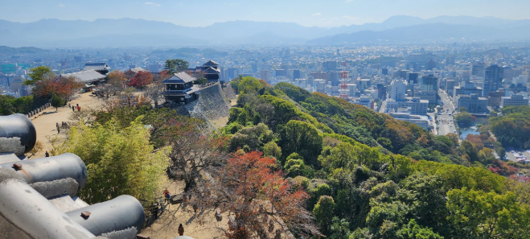
Caption: View from Matsuyama Castle overlooking the Ehime Prefecture, Japan.
Header: Mission
Paragraph: To strengthen international relations between Matsuyama and Sacramento by sharing our diversity and commonality through business, civic, cultural, and educational activities.
Image:
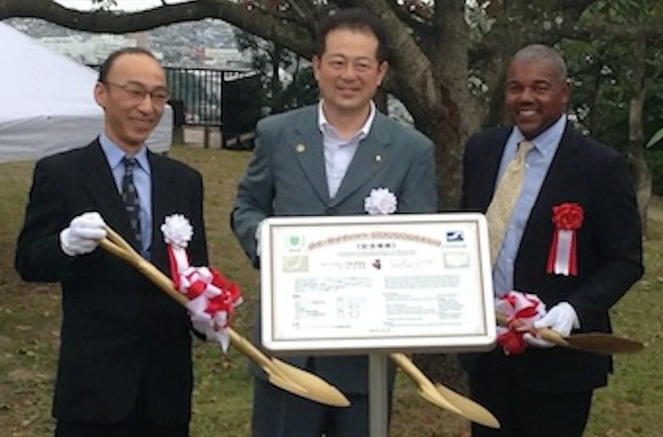
Caption: Groundbreaking to memorialize the planting of almond trees at Matsuyama City Park, Japan. Matsuyama Mayor Katsuhito Noshi, and Sacramento Councilmember Rick Jennings.
Header: Support
Paragraph: By supporting our organization through membership and donations, you help uphold values essential in today’s interconnected world: mutual understanding, respect, and global citizenship. Through educational programs, cultural events, and exchange opportunities, we celebrate our enduring friendship with Matsuyama while providing life-changing experiences for those eager to represent our region abroad.
Image:
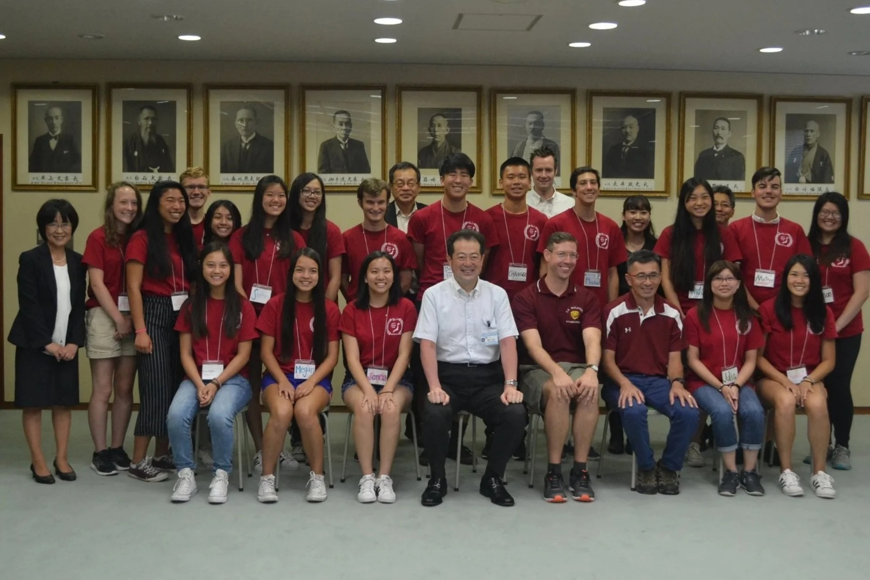
Caption: Assembly of students greeting the Mayor of Matsuyama
As a small nonprofit, MSSCC relies on generous donations to sustain student exchange programs and cultural activities. Your support helps elementary, junior high, and high school students experience the rich traditions of both Japan and the U.S., fostering lifelong cross-cultural understanding.
MSSCC is a non-profit organization established in 1981. Your sponsorship may be tax-deductible. Please consult with your tax advisor as to the deductibility of your sponsorship. MSSCC’s Tax ID is 94-2831119.

About | Board
Header: History
Paragraph: Since 1981, when Sacramento Mayor Phil Isenberg, Matsuyama Mayor Tokio Nakamura, and dedicated citizens from both countries came together under President Eisenhower’s People to People Program, our sister city partnership has brought the people of Sacramento and Matsuyama closer than ever. Over the years, students, professionals, community leaders, and families have crossed the Pacific—building friendships, fostering understanding, and creating lifelong memories between our two great cities.
Image:
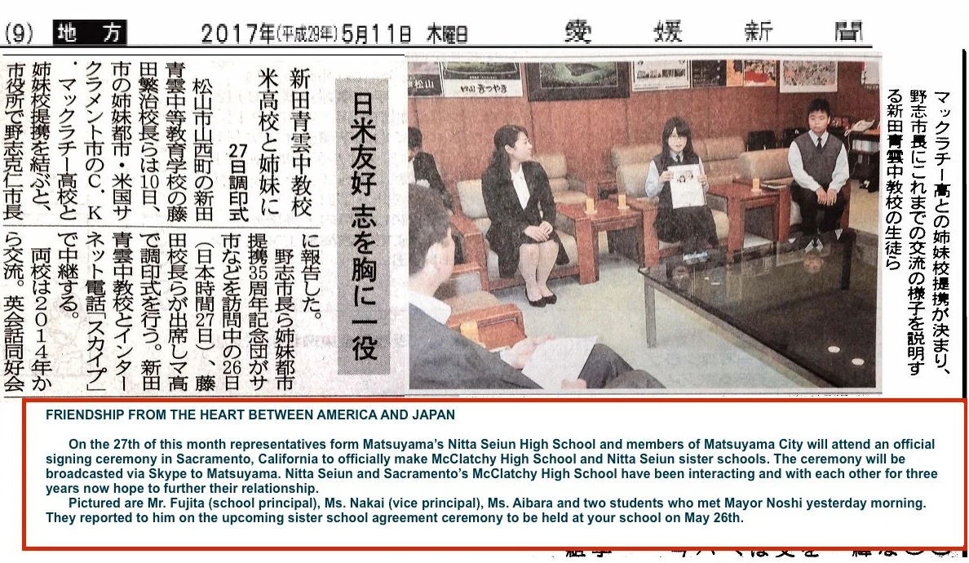
Caption:
Header: The Corporation
Image:
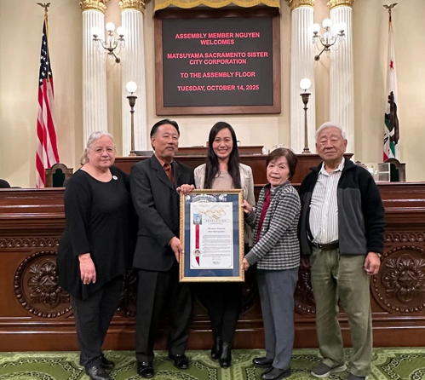
Caption:
Paragraph: The Corporation is led by a volunteer Board of fifteen Directors, including five Officers. Directors serve staggered three-year terms, while Officers are elected annually. There are no term limits for either role.
Subheader: Ex-Officio Members
Paragraph: The Mayor of Sacramento, the President of the Sacramento Camellia Society, the President of the Sacramento City Unified School District, and representatives from California’s 6th and 7th Congressional Districts.
Subheader: Special Honorary Members
Paragraph: Former Sacramento Mayor Heather Fargo.
Subheader: In Memoriam
Paragraph: We honor the lasting legacy of our founding and institutional members, whose vision and dedication helped shape the foundation of our organization. Hiroko Ninomiya of Japan, Sacramento attorney Virginia S. Mueller, former MSSCC President Ralph T. Sugimoto, Jr., and former Sacramento Mayor Anne Rudin.

Membership
Header: Membership
Paragraph: Whether you're a student, parent, educator, businessperson, or simply a global citizen at heart, your involvement helps carry forward a legacy of unity, respect, and shared learning between our two cities.
Ready to be part of something inspiring? Join us today by selecting your membership category and completing the online form. Prefer paper? Click below to download a printable version.
Header: Benefits
Paragraph: By becoming a member, you show your support for our sister city and exchange programs—helping to create meaningful connections across cultures, inspiring young minds, and spreading goodwill around the world. It feels good to be part of something that brings people together and makes a lasting difference.

As a member, you will:
- Receive regular updates on local cultural events, fundraisers, community activities, and invitations to special celebrations.
- Have the opportunity to join an official travel delegation to our sister city, Matsuyama—often alongside elected officials, board members, educators, business professionals, and friends of the sister city.
Header: The Delegation Experience
Paragraph: Your journey begins with several days in Matsuyama, featuring official meetings with city leaders, a formal welcome celebration, and visits to cultural landmarks and local shopping districts.
The adventure continues as you travel by bus, train, ferry, or bullet train to experience the rich diversity of Japan—from historic small towns and vibrant cities to serene countryside, sacred shrines and temples, bustling businesses, renowned shopping destinations, and unforgettable dining experiences.

Support
Header: Every Donation Counts
Paragraph: Investing in this partnership means investing in a future where knowledge and cultural appreciation bring people together. Your support ensures that this connection continues to thrive for generations to come.
Philanthropic donations play a vital role in sustaining our mission, ensuring that every dollar directly supports meaningful programs and contributes to the long-term strength and growth of our organization.
Your sponsorship may be tax-deductible. Please consult with your tax advisor as to the deductibility of your sponsorship.
MSSCC’s Tax ID is 94-2831119.
To donate by check contact us at matsacsistercitycorp.1@gmail.com.

Header: Sponsorship
Paragraph: Corporate sponsorships not only elevate the impact of our mission but also provide essential overhead support that ensures the sustainability and operational strength of our organization. By partnering with us, sponsors play a key role in expanding our reach, enhancing program quality, and fostering long-term community engagement. We’d love the opportunity to discuss how a larger corporate donation could impact our growth.
Current Sponsorship Needs
- $500 Annual Website Sponsor receives their logo on every page of the website (1 available) for a year.
- $1000 Delegation Welcome Dinner Sponsor TIER I receives their logo on the event program and banner.
- $2500 Delegation Welcome Dinner Sponsor TIER I + receives preferred seating at event.
Please reach out to us at matsacsistercitycorp.1@gmail.com to donate by check, or use the “SPONSOR” button below to select or customize your sponsorship.

Programs | Events
Header: Program and Events
Paragraph: Connection, exchange, and friendship are at the heart of our sister city mission. Through active participation in community events and cultural festivals, we offer engaging booth experiences that showcase Japan’s rich heritage and the value of international friendship.
Our outreach extends to student cultural exchanges and reciprocal friendship trips between Sacramento and Matsuyama, creating life-changing opportunities for participants to immerse themselves in each other’s traditions, language, and way of life. These experiences foster cross-cultural understanding, global awareness, and meaningful connections that last a lifetime.
Header: Student Exchange Programs
Paragraph: MSSCC works to facilitate the sister school programs by providing administrative and exchange support between the Sacramento and Matsuyama sister city corporations, the teachers of the sister schools, and with Matsuyama education and business professionals.

Subheader: Matsuyama and Sakura Elementary Schools
Paragraph: Sister schools formed in 2004. In a cultural exchange, students participate in holiday card and gift exchange, pen pal writing, and in virtual meetings to share information about their schools, cities, and everyday living.

Subheader: Orchard and Wake Elementary Schools
Paragraph: Sister schools formed in 2017. In a cultural exchange, students participate in holiday card and gift exchange, pen pal writing, virtual meetings to share information about their schools, cities, and everyday living.

Subheader: C.K. McClatchy High and Nitta Seiun Secondary Education Schools
Paragraph: C.K. McClatchy High School has been an official sister school with Nitta Seiun Secondary Education School since 2017. Every summer, McClatchy students participate in a biannual exchange program where they stay with host families, attend classes at Nitta Seiun, and explore local points of interest. In addition, students take part in pen pal writing and virtual meetings throughout the year. Conversely, every March, Nitta Seiun students visit California for two weeks, staying with host families and attending school at McClatchy.

Subheader: Rosemont High and Matsuyama Nishi Secondary Education Schools
Paragraph: The official sister school agreement is in progress. Since 2017, students take part in pen pal writing and virtual meeting exchanges throughout the year.

Partners
Header: Connecting with the Community
Paragraph: Partners are the foundation of the Matsuyama-Sacramento Sister City Corporation, helping to strengthen cultural connections and educational exchanges between our communities. Their support ensures that we continue fostering mutual understanding, global citizenship, and meaningful opportunities for individuals to engage with and represent our region abroad.

