Group : Team 8
Subject : Machine Learning
Assignment : 6 ( Team Assignment)

- Try changing the combination and values of hyperparameters for the example mentioned in the provided reference link and explain the impact that it has. https://scikitlearn.org/stable/auto_examples/ensemble/plot_gradient_boosting_regression. html#sphx-glr-auto-examples-ensemble-plot-gradient-boosting-regression-py

Ans: This Link leads to the gradient boosting regression page that produces a prediction model from many weak earning models.
In the code part of parameters, it is given as a dictionary variable. So, we can add additional keys (model partition) and values (the different parameters) to run the model, and then use a line plotting to compare the results.
Before Tuning:
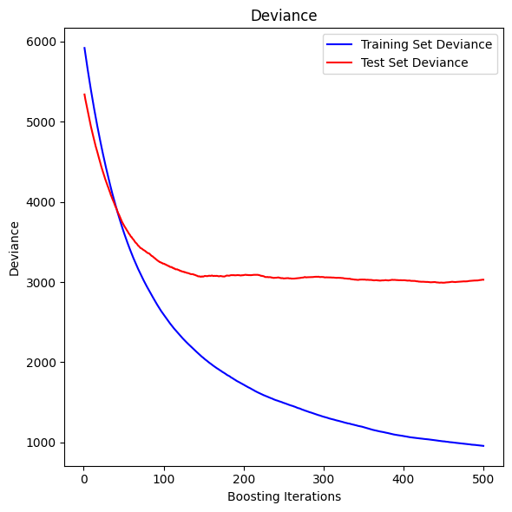
After Tuning:
Parameters: {
"A: Faster Learning": {
"n_estimators": 100,
"learning_rate": 0.1,
"max_depth": 3,
"min_samples_split": 5,
"loss": "squared_error",
},
"B: Deeper Trees": {
"n_estimators": 300,
"learning_rate": 0.05,
"max_depth": 6,
"min_samples_split": 5,
"loss": "squared_error",
},
"C: More Regularization": {
"n_estimators": 500,
"learning_rate": 0.01,
"max_depth": 3,
"min_samples_split": 10,
"loss": "squared_error",
}

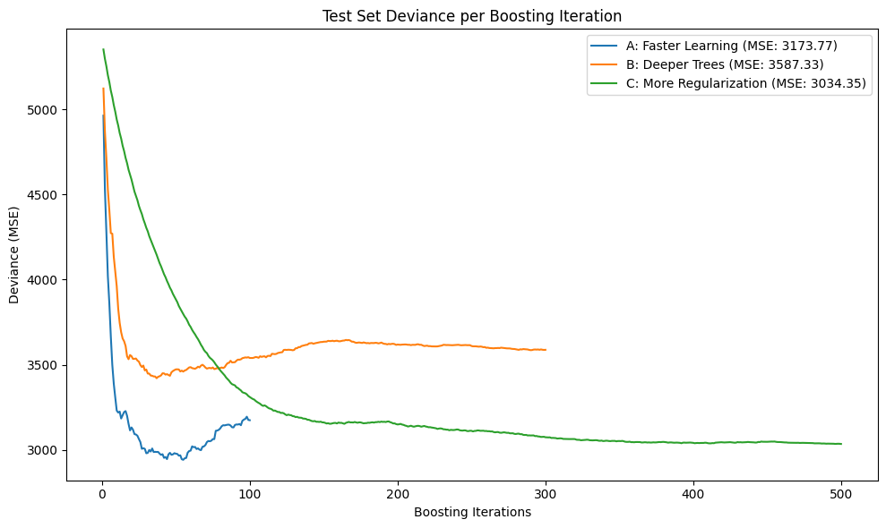

Configuration Parameters:
A: Faster Learning, Leads to Faster Convergence, But Higher Risk of Overfitting
B: Deeper Trees, Leads to slight Overfitting (Depending on the data), Test Error Stagnates Much Earlier.
C: High Regularization, Much Better in Generalization Compared to A and B, Balanced Decline in Error.

Impact:
- Learning Rate: Lower Values Like in (C) guide the model to learn slowly and avoid risking overfitting. However, Bigger values like in (A), if not balanced, may lead to worse resulting generalization.
- Estimators Numbers: Big number of estimators tend to provide more time for the refining process, particularly when the learning rate is slow. Although fewer estimators quicken the model learning speed, it is more aggressive and rigid to the given data and overfits.
- Tree Depth: the deeper the trees, the greater the capacity, as such will be a greater risk of overfitting. Shallower trees work just right with bosting due to reduced variance.
- Minimum samples split: a higher sample split adds regularization, making trees simpler and more generalized.
These are some basic fine tunings, we can also play around with subsample, max_features and more hyper parameter values to get a much more optimized version.

Q2). Try different values of cross val predict, cv for the example mentioned in the provided reference link and explain the impact that it has.
https://scikit learn.org/stable/auto_examples/model_selection/plot_cv_predict.html#sphx glr-auto-examples-model-selection-plot-cv-predict-py
Ans:-
https://colab.research.google.com/drive/1b0QL_5rzgUPJaDby--WnUMoBhi54kNw6?usp=sharing

Q3). Write a Python script that computes the MAE, MSE, RMSE, R-squared, and adjusted R-squared metrics for a given dataset. Analyze the resulting metric values to determine whether the model performed well or not.

Ans:-

Given Data:
Actual values: 19, 30, 89, 38, 46, 77, 65, 54, 45
Predicted values: 20, 26, 80, 40, 46, 74, 68, 54, 38

Step 1: Mean Absolute Error (MAE)
Formula:
MAE = (1/n) * Σ|y - ŷ|
Calculation:
MAE = (1/9) * (1 + 4 + 9 + 2 + 0 + 3 + 3 + 0 + 7) = 29 / 9 ≈ 3.22

Step 2: Mean Squared Error (MSE)
Formula:
MSE = (1/n) * Σ(y - ŷ)^2
Calculation:
MSE = (1/9) * (1 + 16 + 81 + 4 + 0 + 9 + 9 + 0 + 49) = 169 / 9 ≈ 18.78

Step 3: Root Mean Squared Error (RMSE)
Formula:
RMSE = √MSE
Calculation:
RMSE = √18.78 ≈ 4.33

Step 4: R-squared (R²)
Formula:
R² = 1 - Σ(y - ŷ)^2 / Σ(y - ȳ)^2
Result:
R² ≈ 0.958

Step 5: Adjusted R-squared
Formula:
Adjusted R² = 1 - (1 - R²) * (n - 1) / (n - p - 1)
Calculation:
Adjusted R² = 1 - (1 - 0.958) * (8 / 7) ≈ 0.952

Summary of Results:
Metric | Value
Mean Absolute Error | 3.22
Mean Squared Error | 18.78
Root MSE | 4.33
R-squared (R²) | 0.958
Adjusted R² | 0.952

Conclusion:
The model’s predictions are very close to the actual values.
The low MAE and RMSE indicate small prediction errors.
The high R² value (95.8%) shows the model explains most of the variance in the actual data.
Adjusted R² confirms the model's validity, considering the number of predictors.
The model performs very well and provides reliable predictions based on this evaluation.

Q.4. What is the difference between Ridge regression and Lasso regression? How do these two regularization techniques help in preventing overfitting in a regression model? Additional - Can you provide an example where Ridge regression may be more appropriate to use than Lasso regression, and vice versa?
Regularization techniques such as Lasso Regression (L1 regularization) and Ridge Regression (L2 regularization) add penalty terms to the loss function to stop overfitting in linear models. They take different approaches to managing features and resolving multicollinearity, even though both lower coefficients to lessen model complexity.
Key Differences Between Ridge and Lasso Regression
1. Type of Regularization Penalty
- Ridge Regression uses L2 regularization, adding a penalty equal to the sum of the squared coefficients to the loss function. This encourages the model to keep the coefficients small but does not set any of them exactly to zero.
- Lasso Regression uses L1 regularization, adding a penalty equal to the sum of the absolute values of the coefficients. This can shrink some coefficients all the way to zero, effectively removing those features from the model.
2. Feature Selection
- Ridge Regression does not perform feature selection. All predictors remain in the model, although their coefficients may be significantly reduced in magnitude.
- Lasso Regression performs automatic feature selection by setting some coefficients exactly to zero, thus eliminating less important predictors from the model.
3. Model Interpretability
- Ridge Regression results in a model that includes all features, which can make interpretation harder when there are many predictors.
- Lasso Regression leads to a simpler, more interpretable model, especially in high-dimensional settings, since it retains only the most significant features.
4. Handling Multicollinearity
- Ridge Regression is particularly effective when predictors are highly correlated (multicollinearity). It distributes the coefficient shrinkage more evenly and retains all variables.
- Lasso Regression may arbitrarily select one variable from a group of correlated predictors and set the others to zero, which can make its feature selection less stable in such cases.
5. Suitability
- Ridge Regression is best used when all predictors are believed to be relevant and the goal is to reduce overfitting without eliminating variables. It is suitable for situations with many predictors and multicollinearity.
- Lasso Regression is preferred when only a subset of predictors is expected to be important, and the goal is both regularization and variable selection, such as in high-dimensional data where many features may be irrelevant.
6. Effect on Coefficients
- Ridge Regression shrinks all coefficients towards zero but does not make any of them exactly zero.
- Lasso Regression can shrink some coefficients to exactly zero, removing those predictors from the model.

- Ridge Regression: Reduces overfitting by shrinking coefficients toward zero without eliminating any predictors. This balances the bias-variance tradeoff by lowering variance while introducing controlled bias. For example, in datasets with many correlated predictors (e.g., housing prices with size, bedrooms, and location), Ridge preserves all variables but limits their influence.
- Lasso Regression: Prevents overfitting by forcing some coefficients to zero, performing automatic feature selection. This simplifies models in high-dimensional datasets (e.g., genomics with thousands of genes), retaining only the most impactful predictors. The L1 penalty’s sparsity-inducing property makes it ideal when many variables are irrelevant

Example Use Cases
Ridge Regression is preferable when:
- All predictors contribute meaningfully to the outcome (e.g., economic indicators in GDP prediction).
- Multicollinearity exists among variables (e.g., height and weight in health studies).
Lasso Regression is preferable when:
- Only a subset of features matters (e.g., identifying key genetic markers from DNA data).
- Creating interpretable models with fewer variables (e.g., marketing campaigns targeting specific demographics).
For instance, Ridge would outperform Lasso in predicting airline ticket prices where fuel costs, demand, and distance all play roles. Conversely, Lasso would excel in text classification by selecting a subset of impactful keywords from thousands of tokens. Both methods require tuning the regularization parameter (λ) via cross-validation to optimize performance.

- How does Gradient Descent, Stochastic Gradient Descent, Mini-Batch Gradient Descent differ in terms of their approach to optimizing the objective function? How does the choice of learning rate affect the convergence of these algorithms to the global or local minima? Is it always the case that the loss function will be decreasing after a parameter update while applying/performing the Stochastic Gradient Descent (SGD) optimizer on a complete data set (no mini batches)? Justify your answer.

Ans:

Gradient Descent Uses entire Dataset to compute gradient of loss function. Gives accurate gradient estimate and smooth convergence, but is very slow for larger datasets and requires high memory use.
Stochastic Gradient descent uses only one data point t a time to compute gradient. So, it is fast and efficient memory wise. It can escape local minima due to noisy updates, but for the same may not converge smoothly, and will fluctuate around the minimum.
Mini-Batch gradient descent uses small subset of data. So, it balances the efficiency & accuracy, while running faster than gradient boosting, and smoother than stochastic gradient descent.

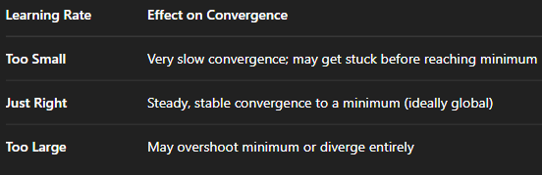
Since Gradient Descent uses full dataset, learning rate is too large, so it diverges. If we make it small, the convergence takes a long time.
In Stochastic GD, Due to noisy Gradients, High learning rate amplifies the noise, causing it to bounce around and if too small, it might never escape the local minima because of smaller steps.
Mini-Batch GD can handle moderately large learning rate well but still at risk of over shooting on the axis.

For the last question, NO, in SGD, the loss function will not always decrease after each parameter update, due to the following reasons:
- Noisy Gradient Estimations: SGD uses one data point at a time, so each update is based on a rough approximation of true gradient. Thus, it might either increase or decrease unpredictably as it moves closer to the actual average.
- Local loss landscape: the given data point might lie in an area of loss surface that causes a temporary uphill update.
- Learning rate size: a large learning rate amplifies this effect such that the step might be too big and cause overshooting.
- SGD loss Curve Behaviour: SGD loss curve is jagged, meaning it is a culmination of ups and downs.
So, the loss function tends to decrease on an average, but it will not always decrease after every update in SGD.

