

School of Science and Technology

Explainable AI (XAI) for Cardiovascular Disease Prediction
By
Ullas Umesh
N1221317

Supervisor
Dr. Jun He

A MSc Thesis submitted in partial fulfilment of the requirements of Department of Computer Science
Nottingham Trent University

for the degree of Master of Science in
Data Science

August 2025

Declaration

I hereby declare that I have independently authored this thesis and have only utilized the sources and resources explicitly cited. All quoted or paraphrased material from these sources is clearly indicated.
By submitting this work, I acknowledge my awareness of the University's expectations regarding proofreading, and I confirm my adherence to them.

Ullas Umesh


28th August 2025

Acknowledgement

I would like to extend my sincere thanks to my supervisor, Dr. Jun He. His invaluable guidance, expertise, insightful feedback, and unwavering support have been instrumental in shaping the direction of this thesis, and his constant support has made this journey both educational and fulfilling.
I am also grateful to my friends Jyothika, Adeeb, Chandana and Vidhyan for their support and companionship. Their encouragement and belief in my abilities have been a source of strength during the more challenging moments of this journey. Their friendship has been a source of joy and inspiration, and I am fortunate to have them by my side.
Finally, I would like to thank my family for their unconditional love and support, which has been a constant source of strength throughout my academic endeavours.
This thesis would not have been possible without the contributions and support of all these individuals, and I am deeply appreciative of their roles in my academic journey.

Abstract

Table of contents

Declaration 1
Acknowledgement 2
Abstract 3
List of Figures 6
List of Tables 8
Chapter 1: Introduction…………………………………………..……………….11
1.1 Background of the Study…………………………………………………………………………11
1.2 Problem Statement………………………………………………………………………………….14
1.3 Aim and Objectives…………………………………………………………………………….……14
1.4 Significance and Limitations…………………………………………………………………...15
1.4.1 Significance of the Study………………………………………………………………….15
1.4.2 Limitations of the Study…………………………………………………………………..15
1.5 Research Questions………………………………………………………………………………….16
1.6 Structure Overview………………………………………………………………………………….17
Chapter 2: Literature Review 18
2.1 Comprehensive Overview of Breast Cancer……………………………………………18
2.2 Epidemiology and Prevalence………………………………………………………………….19
2.3 Diagnostic Approaches in Breast Cancer…………………………………………………20
2.4 Dataset Selection and Relevance…………………………………………………….………21
2.4.1 Comparative Analysis of Dataset Selection……………………………….….22
2.5 Machine Learning Techniques for Breast Cancer…………………………………….23
2.6 Role of XAI………………………………………………………………………………………………..24
2.6.1 XAI Techniques……………………………………………………………………………….25
2.7 Critical Analysis and Evaluation………………………………………………………………..27
Chapter 3: Research Methodology 31
3.1 Introduction to Novel Approach……………………………………………………………….31
3.2 CRISP-DM Framework………………………………………………………………………………32
3.2.1 Business Understanding…………………………………………………………………33
3.2.2 Data Understanding……………………………………………………………………….33
3.2.2.1 Dataset Overview………………………………………………………………34
3.2.2.2 Info and Describe Functions……………………………………………..34
3.2.2.3 Correlation Analysis…………………………………………………………..34
3.2.3 Data Preparation…………………………………………………………………………...35
3.2.3.1 Data Cleaning…………………………………………………………………….36
3.2.3.2 Encoding Categorical Features………………………………………….36
3.2.4 Modelling…………………………………………………………………………………………37
3.2.4.1 Overview of Machine learning Models……………………………….37
3.2.5 Evaluation……………………………………………………………………………………….41
3.2.5.1 Terminology of Evaluation Metrics……………………………………42
3.2.6 Report Writing…………………………………………………………………………………41
3.3 Professional, Social, Ethical and Legal Issues (PSEL)…………………………...44
Chapter 4: Implementation: EDA and Data Preparation 47
4.1 Exploratory Data Analysis………………………………………………………………………..47
4.1.1 Outlier Detection and Handling……………………………………………………..48
4.1.2 Feature Scaling……………………….……………………………………………………..50
4.1.3 Feature Selection using RFE….………………………………………………………51
4.1.4 Feature Engineering……………………………………………………………………….52
4.1.5 Class Balancing………………………………………………………………………………53
4.2 Data Splitting: Training and Testing sets……………………………………………….54
Chapter 5: Implementation: Machine Learning Prediction 56
5.1 Support Vector Machine Learning (SVM)………………………………………………..56
5.1.1 Model Configuration and Parameters Used…………………………………….56
5.1.2 Parameters of SVM Model……………………………………………………………….57
5.1.3 Model Implementation…………………………………………………………………….57
5.2 Random Forest Model…………………………….………………………………………………..58
5.2.1 Model Configuration and Parameters Used…………………………………….58
5.2.2 Parameters of RF Model………………………………………………………………….58
5.2.3 Model Implementation…………………………………………………………………….59
5.3 Multi-Layer Perceptron (MLP)………………..………………………………………………..60
5.4 Extreme Gradient Boosting (XGBoost)………………………………….………………..62
5.5 CatBoost Model …………………………………….…………………………………………………64
5.6 Stacking Classifier……………………………………………………………………………………65
5.7 SHAP Feature Importance Analysis…………………………………………………………67
5.8 LIME Analysis……………………………………………………………………………………………70
5.9 Partial Dependence Plot for Stacking Classifier………………………………………71
Chapter 6: Evaluation and Results 73
6.1 Evaluation Metrics Performance of Predictive Models…………………………….73
6.1.1 Support Vector Machine………………………………………………………………..73
6.1.2 Random Forest……………………………………………………………………….……..75
6.1.3 Multi-Layer Perceptron……………………………..…………………………………..76
6.1.4 XGBoost….………………………………………………………………………………………77
6.1.5 CatBoost…………………………………………………………………………………….…..78
6.1.6 Stacking Classifier…………………………………….……………………………………79
Chapter 7: Evaluation and Results: XAI Techniques 81
7.1 Explanation of Obtained ML Models by XAI Techniques……………….…………81
7.1.1 SHAP on Predictive Models……………………………………….…………………..81
7.1.1.1 XGBoost Model………………………………………………………….……………..81
7.1.1.2 CatBoost Model…………………………………………………………….………….83
7.1.2 LIME on SVM Model………………………………………………………………………..86
7.1.3 PDP Analysis on Stacking Classifier……………………………………………...87
7.1.3.1 Single Feature………………………………………………………………………..87
7.1.3.2 Multiple Feature………………………………………………………………….….88
7.1.3.3 Interaction Plot……………………………………………………………………….89
Chapter 8: Discussion and Conclusion 90
8.1 Discussion and key findings…………………………………………………………………….90
8.2 Comparative Analysis of ML Models………………………………………………………..90
8.3 Limitations and Recommendations………………………………………………………….91
8.4 Conclusion………………………………………………………………………………………………..93
References 94
Appendix………………………………………………………………………………………………………….99
Project Risk……………………………………………………………………………………..………………99
Gannt Chart……………………………..………………………………………………….……………….100

List of Figures

Figure 1: Breast Cancer Statistics (American Cancer Society 2024) 10
Figure 2: Why XAI Matters (DataCamp n.d.) 12
Figure 3: Causes and Risk factors of Breast Cancer (Jabbar 2021) 18
Figure 4: Different types of ML Algorithms (Sharma, A. 2019) 22
Figure 5: Explainable AI in Healthcare (Reddy 2022) 23
Figure 6: CRISP-DM Life cycle (dslytics 2017) 30
Figure 7: Correlation heatmap 33
Figure 8: Distribution of Target Variable 35
Figure 9: Summary of Dataset columns and Data types 44
Figure 10: Boxplot of features before outlier removal 46
Figure 11: Boxplot of features after outlier removal 46
Figure 12: Feature selection after RFE 48
Figure 13: Pair plot of Original vs. Polynomial Features 50
Figure 14: Target Variable – Pre and Post-Balancing 51
Figure 15: Python code snippet of SVM Model 55
Figure 16: Python code snippet of Random Forest model 57
Figure 17: Python Code snippet of MLP model 59
Figure 18: Python code snippet of XGBoost Model 61
Figure 19: Python code snippet of Catboost Model 62
Figure 20: SHAP Code snippet for XGBoost Model 66
Figure 21: SHAP code snippet for Catboost model 66
Figure 22: Stacking Classifier with 3 base models 77
Figure 23: SHAP Summary Plot for XGBoost Model 80
Figure 24: SHAP Dependence Plot for XGBoost Model 80
Figure 25: Waterfall Plot for XGBoost Model 81
Figure 26: SHAP Summary Plot for CatBoost Model 82
Figure 27: Dependence Plot for CatBoost Model 83
Figure 28: Interactive Plot for CatBoost Model 83
Figure 29: LIME for Benign vs Malignant Prediction 84
Figure 30: Partial Dependence Plot for Multiple Features 86
Figure 31: PDP for Interaction 87

List of Tables

Table 1: Comparision of Accuracy in different ML Models 26
Table 2:Summary Statistics 45
Table 3: Parameters for SVM Model 53
Table 4: Parameters for RF Model 55
Table 5: Parameters for MLP Model 57
Table 6: Parameters for XGBoost Model 59
Table 7: Parameters for CatBoost Model 61
Table 8: Parameters for Stacking Classifier 62
Table 9: SHAP Parameters for XGBoost Model 64
Table 10: SHAP Parameters for CatBoost Model 65
Table 11: Classification Report for SVM Model 70
Table 12: Classification Report for Random Forest 71
Table 13: Classification Report for MLP Model 72
Table 14: Classification Report for XGBoost Model 74
Table 15: Classification Report for Catboost Model 74
Table 16: Classification Report for Stacking Classifier 76
Table 17: Model Performance Summary 87

Chapter 1: Introduction

- Background of the Study
Breast cancer is a major health concern worldwide, characterized by the uncontrolled growth of abnormal cells in the breast tissue. It is one of the leading causes of cancer-related deaths, predominantly affecting women, though men can also develop the disease. Breast cancer is generally classified into two main categories: Benign (Non-Cancerous) and Malignant (Cancerous). Benign breast tumors do not spread beyond the breast tissue and are not life-threatening, although they may require treatment (Orrantia-Borunda, et al. 2022). Malignant breast tumors, on the other hand, can invade nearby tissues and spread to other parts of the body, forming secondary tumors or metastases. This spread of cancer cells can lead to the formation of lumps and other symptoms.
The complexity of breast cancer arises from its biological diversity and the numerous risk factors influencing its onset, including age, genetics, lifestyle, and environmental factors. Globally, breast cancer represents approximately 30% of all new female cancer cases annually, highlighting the urgency of effective prevention, early detection, and treatment strategies
In the United States, the American Cancer Society's estimates for 2024 (Siegel, Giaquinto and Jemal 2024) indicate that about 313,510 new cases of invasive breast cancer will be diagnosed in women, along with approximately 56,500 new cases of ductal carcinoma in situ (DCIS). Tragically, around 42,250 women are expected to die from breast cancer this year. The average woman in the U.S. has about a 13% (1 in 8) lifetime risk of developing breast cancer, while the likelihood of dying from the disease is approximately 1 in 40, or 2.5% (Ahmad 2019). These statistics underscore the persistent challenge posed by breast cancer, which remains the second leading cause of cancer death in women.
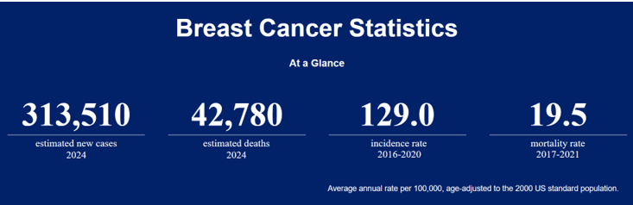
Figure 1: Breast Cancer Statistics (American Cancer Society 2024)
Traditional breast cancer detection methods, such as mammography, clinical breast exams, and biopsies, have proven effective in reducing mortality rates by enabling early diagnosis. However, these methods have certain limitations. They can produce false positives, exposing patients to unnecessary anxiety and additional procedures, involve radiation risks, and may be less accessible in resource-limited settings (Siegel, et al. 2023). These challenges have spurred interest in developing advanced techniques that leverage the power of Artificial Intelligence (AI) and Machine Learning (ML) to improve diagnostic accuracy.
The emergence of Artificial Intelligence (AI) and Machine Learning (ML) advanced predictive modelling in breast cancer detection (Javaid, et al. 2022) by analysing vast amount of data , such as medical imaging, genetic information, and patient demographics, to identify patterns and provide comprehensive risk assessments that may not be obvious through traditional methods. While these models hold promise for earlier detection and better outcomes, they often function as "black boxes"—their decision-making processes are opaque, raising concerns in clinical settings where understanding and explaining diagnoses is crucial for building trust among healthcare professionals and patients (Gerlings, Jensen and Shollo 2022).

To address these challenges, Explainable Artificial Intelligence (XAI) has emerged as a promising solution. XAI techniques, such as SHAP (SHapley Additive exPlanations) and LIME (Local Interpretable Model-agnostic Explanations), aim to make AI/ML models more transparent and interpretable. SHAP explains model predictions by attributing contributions of individual features helping clinicians understand how specific factors influence the outcome. LIME generates locally interpretable models that can mimic complex "black box" predictions in a simpler and more understandable manner. By providing this level of transparency, XAI helps bridge the gap between high-accuracy AI predictions and the interpretability needed in healthcare settings (Korica, Gayar and Pang 2021).
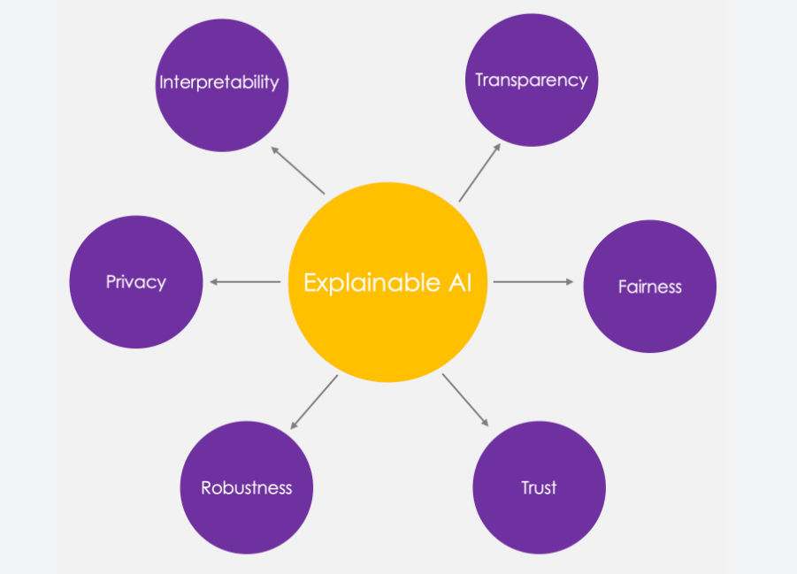
Figure 2: Why XAI Matters(DataCamp n.d.)

The integration of XAI into breast cancer diagnostics has the potential to revolutionize medical practice by combining the accuracy of AI with the interpretability that clinicians and patients need. Moving forward, research into XAI could pave the way for more transparent, reliable, and personalized diagnostic tools, thereby enhancing early detection efforts and improving patient outcomes in the fight against breast cancer.

- Problem Statement
The problem addressed by this research is the need for machine learning models that accurately predict breast cancer risk while being interpretable and transparent. Current models often act as "black boxes," limiting trust and understanding. This research aims to develop explainable models that classify breast cancer as benign or malignant with high accuracy while providing clear insights into the factors influencing these predictions. The Wisconsin Diagnostic Breast Cancer dataset will be used to ensure the models are both accurate and interpretable.
  - Aim and Objectives
The aim of this research is to develop and evaluate Explainable Artificial Intelligence (XAI) algorithms, including SHAP, LIME, and Partial Dependence Plot, applied to machine learning models such as Support Vector Machine (SVM), Random Forest, Multilayer Perceptron (MLP), XG-Boost, and CatBoost. Additionally, the research will implement a stacking classifier, an ensemble technique that combines the three most accurate models using a meta-learner. The effectiveness of these models will be measured using performance metrics such as accuracy, sensitivity, specificity, and interpretability.
Objectives:
- To conduct a comprehensive literature review on existing XAI techniques for breast cancer risk prediction, identifying the strengths, limitations, and challenges of current approaches.
- To Measure the performance of the developed XAI models using various metrics like accuracy, sensitivity, specificity, precision and compare them with the existing models.
- To Utilize the Wisconsin Diagnostic breast cancer dataset for developing predictive models focusing on SVM, Random Forest, MLP, XGBoost, Catboost models and implementing a stacking classifier by combining the three best-performing models with a meta-learner.
- To apply XAI techniques including SHapley Additive exPlanations (SHAP), Local Interpretable Model-agnostic Explanations (LIME), and Partial dependence plots to enhance the transparency and interpretability ensuring the decision-making process is understandable and clinically actionable.
- The study will follow a structured research timeline, ensuring the literature review, model development, XAI implementation and evaluation are completed within the designated timeframe.

  - Significance and Limitations
    - Significance

This study is significant as it aims to enhance breast cancer diagnosis by developing accurate and interpretable machine learning models using XAI techniques like SHAP, LIME, and Partial Dependence Plots. By prioritizing transparency and interpretability in AI models, this research addresses a key gap in current clinical practice, ensuring healthcare professionals can understand and trust AI-driven predictions. The study's outcomes could lead to more reliable AI tools that are actionable in clinical settings, ultimately improving early detection and patient outcomes.

1.4.2 Limitations of the study

The study seeks to integrate explainable artificial intelligence (XAI) with machine learning for breast cancer prediction. However, several limitations must be noted:
- Data Imbalance: The dataset contains an imbalance between benign and malignant cases, which may bias model predictions. To mitigate this, data balancing techniques like oversampling the minority class and under sampling the majority classes were applied. Future research could explore advanced data augmentation techniques or more diverse datasets to further mitigate this issue.
- Computational Complexity: The use of ensemble methods and XAI techniques increases computational complexity. Despite optimizing model training, practical implementation might still face obstacles.
- Generalizability: The models developed are specifically for breast cancer prediction and may not generalize to other types of cancers. Future research could adapt these models to a wider range of cancer types.

  - Research Questions

RQ1: How can Explainable AI (XAI) techniques be integrated with machine learning models to enhance the interpretability of breast cancer predictions without reducing accuracy?
RQ2: Which Machine learning model (e.g., SVM, Random Forest, XGBoost) provides the best performance in predicting breast cancer outcomes using the WDBC dataset?
RQ3: How effective are ensemble methods, like stacking classifiers, in combining multiple machine learning models to achieve higher accuracy in breast cancer predictions compared to individual models?
RQ4: Do XAI techniques like SHAP and LIME improve clinicians' understanding and acceptance of AI-driven breast cancer predictions?

  - Structure Overview

Chapter 1 introduces the challenges in breast cancer diagnosis, emphasizing the need for accurate, interpretable machine learning models. It outlines the research aims and objectives using SMART methodology and discusses the study's significance and limitations.
Chapter 2 critically examines previous studies, highlighting their strengths, limitations, and identifying gaps on breast cancer diagnosis.
Chapter 3 describes the novel approach following the CRISP-DM framework. PSEL considerations ensure ethical standards and data protection throughout the research.
Chapter 4 covers exploratory data analysis like feature scaling, feature selection using RFE, feature engineering.
Chapter 5 implements five machine learning models and an ensemble stacking technique. It introduces a stacking classifier with a meta-learner and splits the data.
Chapter 6 evaluates the Machine learning models prediction using metrics like accuracy, sensitivity, specificity, and precision.
Chapter 7 discusses the explanation of obtained models like XGBoost, Catboost, SVM by applying XAI techniques.
Chapter 8 summarizes the key findings, comparative analysis and evaluates different models. It concludes with insightful recommendations for future research and ongoing development in Explainable AI within healthcare considering ethical implications.

Chapter 2: Literature Review

This chapter provides a comprehensive review of existing research on breast cancer prediction using machine learning (ML) and Explainable Artificial Intelligence (XAI) techniques. As breast cancer remains a major global health challenge, the application of ML models has shown significant promise in enhancing the accuracy and efficiency of early detection and diagnosis. However, the "black box" (Zednik 2021) nature of many ML models poses challenges in clinical settings, where transparency and interpretability are essential for gaining the trust of healthcare professionals and patients.
The chapter concludes by identifying key gaps in the existing literature and proposing novel research questions and hypotheses. These aim to address the challenges identified in previous studies and contribute to the advancement of interpretable and clinically actionable predictive models in breast cancer care.

- Comprehensive Overview of Breast Cancer
Breast cancer is a leading cause of cancer-related morbidity and mortality among women globally. It originates primarily in the milk ducts or lobules of the breast tissue and is characterized by the uncontrolled growth of malignant cells. The development of breast cancer is a multifaceted process influenced by various factors, including genetic predispositions, hormonal influences, and environmental exposures. Age is a significant risk factor, with the likelihood of developing breast cancer increasing markedly with advancing age. Early and accurate prediction is crucial for timely intervention and ultimately improving patient survival rates (P. Sathiyanarayanan, et al. 2019).
Traditional predictive models for breast cancer often lack transparency and interpretability, which limits their clinical utility. In recent years, advancements in artificial intelligence (AI), particularly machine learning (ML) and deep learning, have demonstrated significant potential in improving the detection and diagnosis of breast cancer.
XAI aims to make the decision-making processes of AI and ML models more transparent and interpretable, allowing clinicians and patients to understand the factors driving the model's predictions. By providing clear explanations for model outputs, XAI enhances trust and confidence in AI-driven decisions, making these technologies more viable for clinical use (Duval 2019).

- Epidemiology and Prevalence
Breast cancer remains the most prevalent cancer among women globally, accounting for about 30% of all new cancer diagnoses. In 2020, over 2.3 million new cases were reported worldwide. Recent data from the World Health Organization (WHO) indicates that these numbers have continued to rise, with an estimated 2.4 million new cases in 2022, and projections suggesting that this figure may reach or exceed 2.5 million by 2024. The incidence remains highest in developed regions such as North America and Western Europe, where robust screening programs and lifestyle factors contribute to higher detection rates. In contrast, regions like Asia and Africa, which have historically reported lower incidence rates, are experiencing significant increases due to urbanization, changes in lifestyle, and improved diagnostic capabilities.
Several risk factors (Sun, et al. 2017) contribute to the development of breast cancer, including age, genetic mutations, and lifestyle choices. Women over 50 are at higher risk and those with BRCA1 and BRCA2 genes, have up to a 70% chance of developing breast cancer by age 70. Lifestyle factors, like obesity, physical inactivity, and alcohol consumption, contribute to risk, while protective factors such as breastfeeding and regular physical activity offer some mitigation.

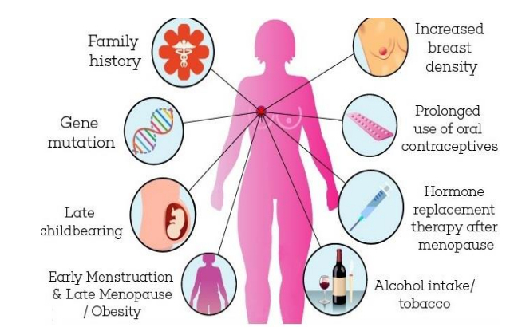
Figure 3 : Causes and Risk factors of Breast Cancer (Jabbar 2021)
The public health impact of breast cancer has remained profound over the years, particularly in low- and middle-income countries where early detection and access to treatment are still limited. In 2020, over 685,000 women died from breast cancer globally (Fuentes, et al. 2024). By 2023, this number had risen slightly, reflecting ongoing challenges in these regions despite global efforts to improve healthcare access. The economic burden, including medical costs and lost productivity, is also increasing. Public health initiatives are crucial for raising awareness, improving early detection, and promoting preventive measures to reduce the global burden of breast cancer.
- Diagnostic Approaches in Breast Cancer
Breast cancer diagnosis traditionally relies on a combination of imaging techniques and biopsies, each contributing uniquely to the detection and characterization of breast tumors.
- Mammography is the primary screening tool, particularly effective in detecting early-stage breast cancer in women over 50. However, its sensitivity decreases in women with dense breast tissue, leading to potential false negatives.
- Ultrasound used as a complementary tool to differentiate between solid tumors and cysts, particularly when mammography results are inconclusive.
- MRI is employed for high-risk patients and provides detailed images, particularly useful for detecting multifocal or multicentric disease, though it is more expensive and prone to false positives.
- Biopsies is essential for confirming a diagnosis through histopathological analysis. Fine-needle aspiration (FNA) is a commonly used method.

Emerging technologies like Molecular Imaging and Liquid Biopsies are gaining attention for their potential to enhance early detection (Abdelrahman, et al. 2021). Molecular imaging techniques, such as PET-CT, offer insights into tumour metabolism and behavior, which are not visible through conventional imaging. Liquid biopsies, which analyse circulating tumour DNA in blood samples, offer a non-invasive option for early detection and monitoring treatment response. These technologies, though promising, require further validation for routine clinical use.
Despite advances, these diagnostic methods have limitations. Mammography, while widespread, misses about 20% of cancers, especially in dense breast tissue. MRI’s high sensitivity leads to a higher rate of false positives, resulting in unnecessary biopsies. Liquid biopsies, although less invasive, are still in the early stages of clinical application and face challenges in sensitivity and interpretation.

- Dataset Selection and Relevance

The Wisconsin Diagnostic Breast Cancer (WDBC) dataset is a widely recognized resource used for developing machine learning models to predict breast cancer outcomes. It contains 569instances, each described by 32 features derived from fine needle aspirates (FNA) of breast masses. These features capture key characteristics of the cell nuclei, such as radius, texture, smoothness, compactness, and concavity, which are crucial for distinguishing between benign and malignant tumors. The dataset is labelled, with 357 cases classified as benign and 212 as malignant, making it an ideal for binary classification tasks in machine learning.
Clinical Relevance: The WDBC dataset's clinical relevance lies in its detailed and structured representation of cell morphology, which closely aligns with diagnostic practices in pathology. The features extracted from FNA samples are commonly used in clinical settings to evaluate breast masses, making the dataset not only a powerful tool for research but also directly applicable to real-world diagnostic processes. This relevance ensures that machine learning models developed using the WDBC dataset can provide insights that are meaningful and actionable in clinical practice.
Challenges Addressed: The dataset helps tackle key diagnostic challenges, such as differentiating between benign and malignant tumors, where traditional methods might struggle. The detailed features enable models to detect subtle patterns and improve diagnostic accuracy, potentially reducing misdiagnoses.

    - Comparative Analysis with Other Datasets

The SEER (Surveillance, Epidemiology, and End Results) dataset maintained by National Cancer Institute, offers extensive data on cancer incidence and survival across the United States, with a broad focus that includes demographic details and long-term outcomes. While SEER is ideal for epidemiological studies and assessing treatment efficacy, it lacks the specific cell-level detail needed for fine-tuned predictive modeling of breast cancer at the cellular level.
The Original Wisconsin Breast Cancer dataset derived from University of Wisconsin. It includes 699 instances with 9 attributes, all of which are based on features extracted from FNA images. Although this dataset has been widely used for educational purposes and simpler classification tasks, it is less detailed than the WDBC dataset, making it less suitable for advanced machine learning models that require a richer feature set to achieve higher predictive accuracy.

The WDBC dataset was selected for its detailed features and clinical relevance. The 32 features provide a comprehensive representation of cell morphology, essential for developing robust machine learning models that can accurately classify breast tumors. Compared to the SEER dataset, which is more suited for population-level analysis, and the original Wisconsin Breast Cancer dataset, which has fewer features, the WDBC dataset is better equipped to address the specific diagnostic challenges targeted in this research.
By leveraging the WDBC dataset, this research aims to develop models that not only improve accuracy in distinguishing between benign and malignant tumors but also provide insights that can be readily applied in clinical settings.

  - Machine Learning Techniques for Breast Cancer
Machine learning has become a transformative technology in the healthcare, offering the potential to significantly enhance the accuracy of breast cancer diagnosis. In the context of breast cancer, ML models have shown remarkable potential in analysing vast amounts of medical data, identifying patterns, and making predictions that can significantly aid in early detection and diagnosis.
The primary strength of ML lies in its ability to handle high-dimensional data and uncover relationships that may not be immediately apparent to human clinicians. However, one of the key challenges in the application of ML in healthcare is ensuring that these models are not only accurate but also interpretable and transparent. This is where the integration of Explainable AI (XAI) becomes crucial, as it allows healthcare providers to understand the reasoning behind a model's prediction, thereby fostering trust and enabling better clinical decision-making.
In this research, several ML models are employed to predict breast cancer outcomes using the Wisconsin Diagnostic Breast Cancer (WDBC) dataset.
Support Vector Machines (SVM) are utilized for their ability to create a clear margin between different classes, making them effective in distinguishing between benign and malignant tumors.
Random Forest is chosen for its robustness and ability to handle large datasets with numerous variables, reducing the risk of overfitting by aggregating predictions from multiple decision trees.
Multilayer Perceptron (MLP) is used for its capability to model complex non-linear relationships, making it particularly suitable for capturing intricate patterns in the data.
XGBoost and CatBoost, both gradient boosting algorithms, are included for their efficiency and accuracy in handling imbalanced datasets, which is often a challenge in medical data.
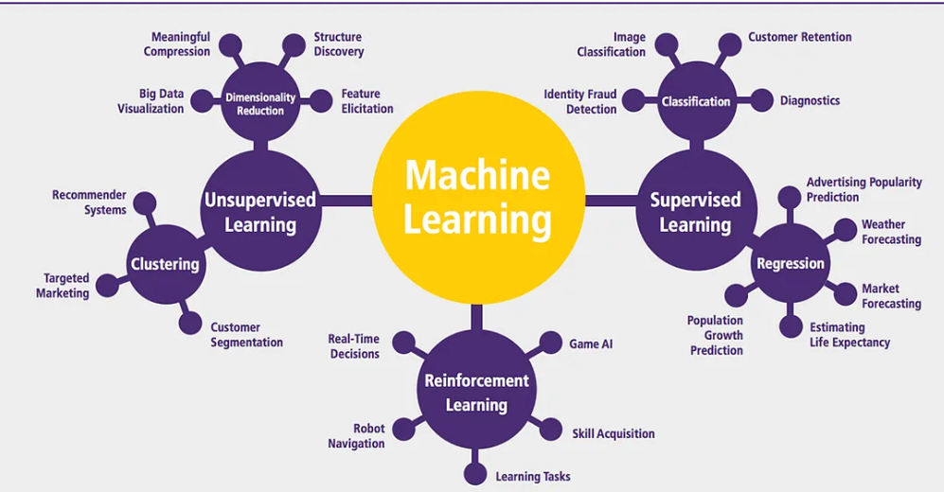
Figure 4: Different types of ML Algorithms (Sharma, A. 2019)

  - Role of XAI
This literature review examines the role of explainable artificial intelligence (XAI) in breast cancer prediction, highlighting its potential to enhance model interpretability and transparency while maintaining or improving accuracy. By analysing diverse medical data, such as mammograms and genomic information, AI and machine learning techniques can effectively identify patterns and predict breast cancer risk, aiding early detection and diagnosis. XAI techniques provide clear explanations for these predictions, fostering trust and confidence among clinicians and patients.
In healthcare, explainability (Adelodun, et al. 2023) allows healthcare professionals to comprehend how and why a model arrived at a particular diagnosis or prediction, thereby fostering trust and confidence in the technology. It also enables clinicians to validate the AI’s recommendations against their own medical knowledge and experience, ensuring that the AI supports, rather than undermines, clinical decision-making.
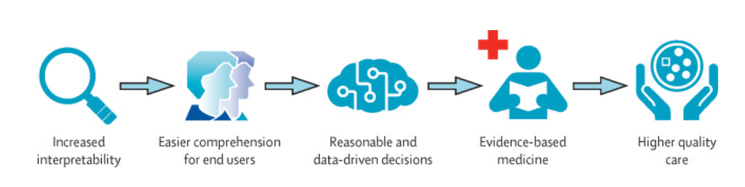
Figure 5: Explainable AI in Healthcare (Reddy 2022)

Moreover, explainability is significant in ensuring ethical AI use in healthcare. By making AI decisions transparent, XAI helps to identify and mitigate potential biases, reducing the risk of unfair treatment outcomes. It also supports informed consent, where patients are more likely to accept AI-assisted decisions if they understand the reasoning behind them (Vermeire, et al. 2021).
By combining these ML models with XAI techniques, this research aims to develop a reliable and interpretable tool for breast cancer prediction, addressing the need for transparency in AI-driven healthcare solutions. The application of these models to the WDBC dataset not only leverages its rich feature set but also aims to improve diagnostic accuracy, ultimately contributing to better patient care.

    - XAI Techniques
XAI techniques offer valuable insights into the decision-making process of models, allowing clinicians to comprehend the factors influencing breast cancer risk. This understanding supports more informed decision-making and the development of personalized treatment plans.
Explainable AI (XAI) techniques can be broadly categorized into two main types: Model-specific and Model-agnostic. These categories determine how the techniques interact with machine learning models to provide interpretability and transparency.
- Model-Specific Technique:
They are designed to work with specific types of machine learning models. These techniques leverage the internal structure and properties of the models to provide explanations.
Feature Importance in Tree-Based Models: In tree-based models such as Random Forests and XGBoost, feature importance is determined by evaluating how much each feature reduces impurity at each split. These contributions are then aggregated across all trees in the ensemble, offering a measure of each feature's influence on the predictions.
SHapley Additive exPlanations (SHAP) for Tree Models: Although SHAP is generally model-agnostic, there is a highly efficient implementation of SHAP specifically for tree-based models (TreeSHAP). It takes advantage of the tree structure to calculate SHAP values, which represent the contribution of each feature to a particular prediction.
- Model-Agnostic Technique:
They are flexible and can be applied to any machine learning model, regardless of its type. These techniques treat the model as a black box and provide explanations without needing to understand its internal workings.
Local Interpretable Model-agnostic Explanations (LIME): It is a popular model-agnostic technique that approximates the model locally around a prediction with an interpretable model, such as linear regression. It can be applied to any model, whether it's a neural network, decision tree, or SVM, making it highly versatile.
Partial Dependence Plots (PDP): They illustrate the relationship between a single feature and the predicted outcome while averaging the influence of other features. This model-agnostic technique can be applied to any machine learning model, helping to understand the effect of individual features.
Permutation Importance: This method evaluates feature significance by observing the change in the model's performance when feature values are randomly shuffled. It is applicable to any model and helps in understanding the overall importance of features.
Anchors: They explain individual predictions by identifying the minimal conditions (anchors) that guarantee a specific prediction. These conditions provide insight into the decision-making process of any machine learning model.

  - Critical Analysis and Evaluation

This section critically examines existing research on breast cancer prediction using machine learning and Explainable Artificial Intelligence (XAI) techniques. The aim is to evaluate the methodologies, findings, and limitations of these studies while identifying key areas for further research. Additionally, this analysis will highlight how the current study addresses these gaps and advances the field.
In 2019, (Shravya, Pravalika and Subhani 2019) compared several Machine learning models, including Logistic Regression, K-Nearest Neighbors (KNN), and Support Vector Machines (SVM), using the UCI Breast Cancer Dataset. Their findings revealed that SVM was the most effective model achieving an accuracy of 92.7%. The use of PCA for dimensionality reduction enhanced model efficiency without compromising accuracy. While the study makes valuable contributions, the selection of tested algorithms is relatively narrow, limiting the scope of the analysis. The inclusion of more advanced algorithms such as ensemble methods could potentially improve accuracy and model robustness. Addressing these gaps could significantly advance the study, providing more robust and adaptable solutions for breast cancer detection in practice.

Reference | Model Name | Accuracy
(Shravya, Pravalika and Subhani 2019) | Support Vector Machine (SVM) | 92.7%
 | K-Nearest Neighbors (KNN) | 92.23%
 | Logistic Regression | 92.10%
(Islam, et al. 2020a) | Support Vector Machine (SVM) | 97.14%
 | K-Nearest Neighbors (KNN) | 97.14%
 | Random Forest (RF) | 95.71%
 | Artificial Neural Networks (ANN) | 98.57%
 | Logistic Regression | 95.71%
(Kabiraj, et al. 2020) | XG Boost | 73.63%
 | Random Forest | 74.73%
(Khater, et al. 2023) | K-Nearest Neighbors (KNN) | 97.70%
 | XGBoost | 98.20%
(M. S. Yarabarla, L. K. Ravi and A. Sivasangari 2019) | Random Forest (RF) | 73.15%
 | K-Nearest Neighbors (KNN) | 71.40%
 | Support Vector Machine (SVM) | 71.40%
 | Gradient Boosting | 73.15%
(Jain, et al. 2024) | SVM with Radial Basis Function | 94.80%
(Chaurasiya and Rajak 2023) | Support Vector Machine (SVM) | 92.13%
 | Random Forest (RF) | 91.92%
 | K-Nearest Neighbors (KNN) | 95.10%
 | Logistic Regression | 92.10%
(Wankhade, et al. 2023) | Support Vector Machine (SVM) | 97.50%
 | Naïve bayes | 95.10%
 | Random Forest (RF) | 96.50%
(Rabiei, et al. 2022) | Gradient Boosting Trees (GBT) | 74%
 | Random Forest (RF) | 80%
 | Multi-Layer Perceptron (MLP) | 73%

Table 1: Comparison of Accuracy in different ML Models

(M. S. Yarabarla, L. K. Ravi and A. Sivasangari 2019) have utilized the Random Forest classifier for breast cancer identification and prediction, capitalizing on its high accuracy in distinguishing between benign and malignant cases. The Random Forest algorithm, which integrates both classification and regression techniques, enhances predictive performance by aggregating multiple decision trees. This ensemble approach leverages the strengths of individual trees to improve overall accuracy and reliability in diagnosing breast cancer.
(Islam, et al. 2020b) has applied various supervised learning techniques to the Wisconsin dataset, with Artificial Neural Networks (ANN) achieving the highest accuracy of 98.57%. (Kabiraj, et al. 2020) developed accurate ML models for classifying breast cancer using support vector, Random Forest, KNN classification and XG-boost. The authors depicted that KNN achieves the best accuracy of 97.70% and Precision of 98.2 % when compared with other models. The study tests the hypothesis that the bare nuclei feature in the Wisconsin breast cancer dataset and the area's worst feature in the Wisconsin diagnostic breast cancer dataset are the most important factors in determining breast cancer malignancy.
(Jain, et al. 2024) developed the ensemble approach of support vector machine with Radial basis function which achieved an accuracy of 94.80%. (Chaurasiya and Rajak 2023) developed a multi-feature fusion model and found that the Random Forest classifier outperformed Support Vector Machine, KNN, and Logistic Regression, achieving 95% accuracy and 90.9% precision. They concluded that feature selection played a significant role in improving recognition accuracy.
Khater et al. (2023) successfully developed machine learning models for breast cancer classification, employing Support Vector Machines, Random Forest, K-Nearest Neighbors (KNN), XGBoost and suing XAI techniques like SHAP and permutation feature importance. Their findings revealed that the KNN model outperformed the others, achieving an accuracy of 97.70% and a precision of 98.2%. The study further examined the hypothesis that the bare nuclei feature in the Wisconsin Breast Cancer dataset, along with the area's worst feature in the WDBC dataset, are the most significant factors in identifying breast cancer malignancy.
Wankhade et al. (2023) addresses different types of datasets and machine learning techniques including SVM, naïve bayes and random forests. SVM achieved the highest accuracy with 97.50%. The authors suggest that future work should focus on leveraging large datasets and integrating additional features, such as breast cancer stage identification, to further improve predictive performance.
Rabiei et al. (2022) explores various models for predicting breast cancer, using demographic, laboratory and mammographic features emphasizing the importance of integrating multiple risk factors to improve model performance. The Random Forest achieved highest accuracy. The research highlights the need for multi-center studies with larger datasets and the inclusion of genetic factors to enhance predictive accuracy and improve breast cancer prognosis.
This research aims to address these gaps by developing a novel stacking classifier that combines the strengths of multiple ML models, employing advanced techniques for class balancing, and integrating XAI methods that are both interpretable and clinically actionable.

Chapter 3: Research Methodology

- Introduction to Novel Approach

Building on the gaps identified in Chapter 2, this research introduces a novel approaching advanced Machine learning (ML) models with ensemble techniques and Explainable AI (XAI) methods. While existing studies focus on individual machine learning (ML) models, this research explores the combination of multiple models with ensemble techniques and XAI to enhance both accuracy and interpretability.
This research employs five advanced ML models - Support Vector Machine (SVM), Multilayer Perceptron (MLP), Random Forest (RF), XGBoost, and CatBoost leveraging their individual strengths to create robust predictive models.
A key innovation is the use of a stacking classifier, an ensemble method that leverages a meta-learner to combine the predictions of the three best-performing models based on accuracy. This technique aims to improve prediction accuracy by capturing diverse patterns and reducing overfitting.
To address the "black box" nature of these models and enhance clinical applicability, this research integrates XAI techniques—SHAP (SHapley Additive exPlanations), LIME (Local Interpretable Model-agnostic Explanations), and Partial Dependence Plots (PDP). These post-hoc explanation methods provide transparency in the decision-making process, enabling healthcare professionals to understand and trust model predictions, making them actionable in clinical settings. By addressing these gaps, this research aims to enhance predictive accuracy and contribute to the development of reliable and interpretable AI models for healthcare.

- CRISP-DM Framework

This research applies the CRISP-DM (Cross-Industry Standard Process for Data Mining) methodology, integrating the SMART criteria to ensure that each phase is Specific, Measurable, Achievable, Relevant, and Time-bound. The CRISP-DM framework, with its six key stages—Business Understanding, Data Understanding, Data Preparation, Modeling, Evaluation, and Deployment guides the project to achieve accurate and interpretable breast cancer predictions using the Wisconsin Diagnostic Breast Cancer (WDBC) dataset (Schröer, Kruse and Gómez 2021).
By leveraging the structured and iterative nature of CRISP-DM, this research ensures that the data mining process remains flexible and adaptable, allowing for continuous refinement of models based on evaluation outcomes and evolving project goals.
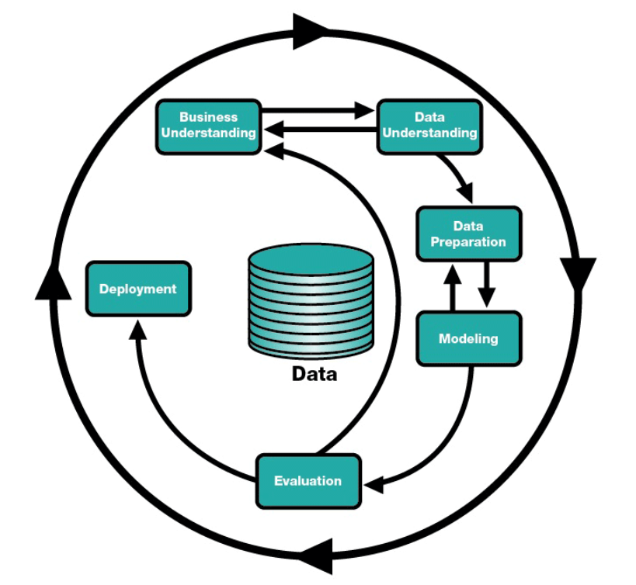
Figure 6: CRISP-DM Life cycle(dslytics 2017)

    - Business Understanding

The first phase of the CRISP-DM methodology focuses on defining the project's objectives of breast cancer prediction using the Wisconsin Diagnostic Breast Cancer (WDBC) dataset. The primary goal is to enhance early detection and diagnosis by reducing misclassification and improving patient outcomes. To achieve this, the research incorporates Explainable AI (XAI) techniques alongside traditional machine learning models, providing transparency in decision-making.

    - Data Understanding

This phase involves gaining a deep understanding of Wisconsin diagnostic breast cancer (WDBC) dataset, which serves as the foundation for the model. A detailed exploratory data analysis (EDA) is conducted to identify key patterns, relationships, and anomalies within the data. This includes analysing the distribution of features, identifying correlations, and understanding the distribution of benign versus malignant cases. The insights gained from this analysis guide subsequent data preparation steps and model development, ensuring that the models are built on a solid understanding of the data.

3.2.2.1 Dataset Overview

The Wisconsin Diagnostic Breast Cancer (WDBC) dataset, provided by Dr. William H. Wolberg at the University of Wisconsin-Madison, has become a widely used resource in the fields of machine learning and medical research.
The WDBC dataset comprises 569 patient cases and 32 columns. It includes 30 numerical features (float64) derived from FNA images, essential for classifying tumors. It also contains an integer column (int32) for diagnosis (benign or malignant) and a string column (string) likely used for patient IDs or other categorical information. The outcome variable indicates whether the tumor is benign or malignant, making it a binary classification problem.
Justification: The WDBC dataset was chosen for this research due to its relevance and focus on diagnostic accuracy, making it ideal for developing robust models aimed at early detection and accurate classification of breast cancer. Its comprehensive feature set allows for the development of complex models while ensuring that the findings are both clinically relevant and comparable to existing studies in the field.

3.2.2.2 Info and Describe Functions

The ‘info()’ function reveals the dataset's structure showing 569 entries across 32 columns with 30 numerical features (float64), one integer column (int64) for patient ID, and one object column for the diagnosis (benign or malignant).
The ‘describe()’ function provides detailed statistics, such as mean and standard deviation, which help understand data distribution and guide further preprocessing steps.

3.2.2.3 Correlation Analysis

The correlation matrix is calculated using Pearson’s correlation coefficient, which measures the linear relationship between two features. A value closer to 1 signifies a strong positive correlation, value closer to -1 indicates a strong negative correlation, and values near 0 imply no linear relationship.
A heatmap of the correlation matrix is plotted to visually depict the correlations between all pairs of features. In the heatmap, high positive correlations are shown in red, while high negative correlations are shown in blue.
Features like radius_mean, perimeter_mean, and area_mean are strongly correlated with each other and with the diagnosis, indicating their importance in distinguishing between benign and malignant tumors. This analysis helps in understanding feature relationships, guiding feature selection, and avoiding multicollinearity in the modeling process.
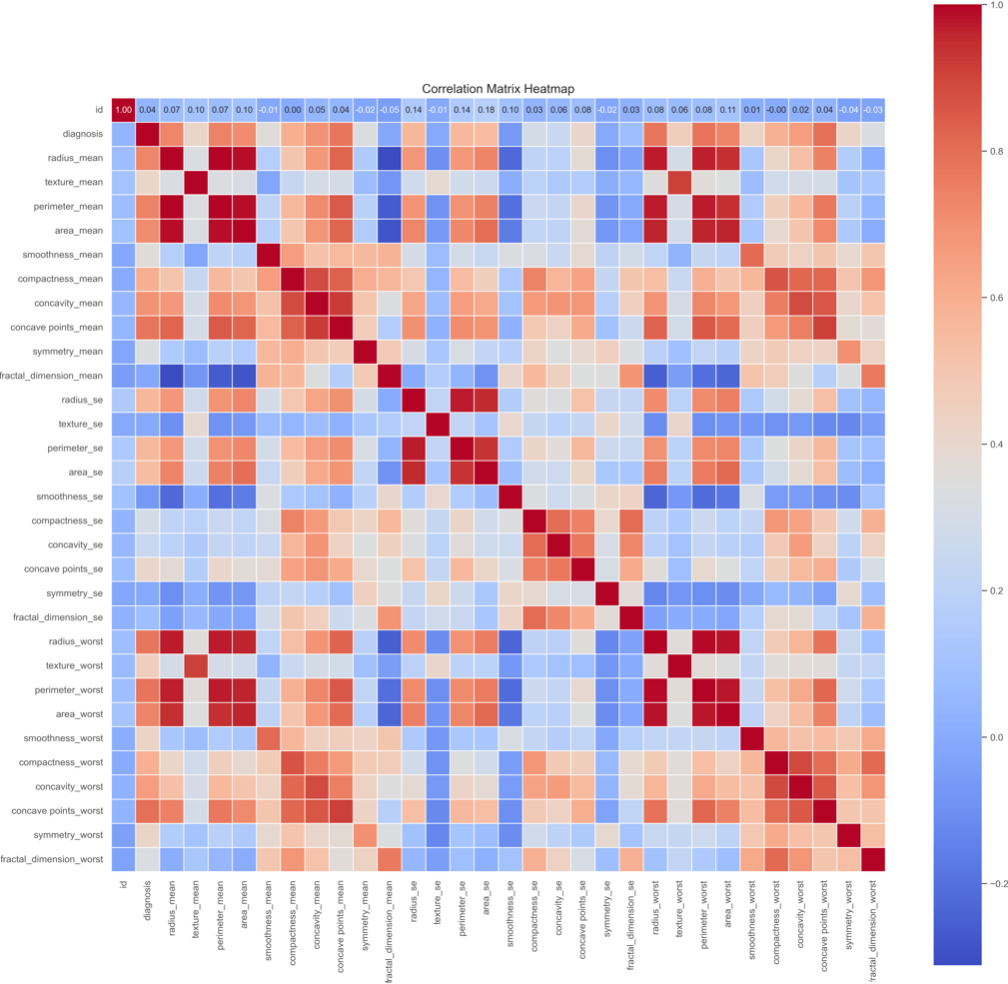
Figure 7: Correlation heatmap

    - Data Preparation

This step involves pre-processing the raw data to optimize it for modeling. This includes scaling features for uniformity, selecting key features with Recursive Feature Elimination (RFE), and applying polynomial feature engineering to enhance model performance. Data balancing techniques, like oversampling the minority class and under sampling the majority class, are also employed to ensure unbiased and balanced model predictions. After pre-processing, the data is split into training, validation, and test sets to ensure robust model evaluation.

      - Data Cleaning
The essential steps undertaken to prepare the dataset for analysis, ensuring its integrity and suitability for machine learning models.
- Removal of Irrelevant Columns: The ‘id’ column, which serves as an identifier had no predictive value, was removed from the dataset. This reduction in extraneous data helps focus the analysis on the features directly relevant to breast cancer prediction.
- Checking for Duplicates: To maintain data quality, the dataset was checked for duplicate entries. The analysis confirmed that there were no duplicates, ensuring that each record was unique and contributes valuable insights for the study.
- Handling Missing Values: A thorough check confirmed that the WDBC dataset contains no missing values, ensuring its reliability for analysis and model accuracy.

      - Encoding Categorical Features

In the data preprocessing stage, it is essential to convert categorical features into numerical values that machine learning models can interpret. In the Wisconsin Diagnostic Breast Cancer (WDBC) dataset, the diagnosis column represents the target variable, where 'M' stands for malignant tumors, and 'B' represents benign tumors.
It is converted into numerical values by simple mapping technique for model training. The 'M' value was mapped to 1, indicating a malignant tumor, and the 'B' value was mapped to 0, indicating a benign tumor. This simple yet essential step allows machine learning models to effectively process and distinguish between malignant and benign cases during training.
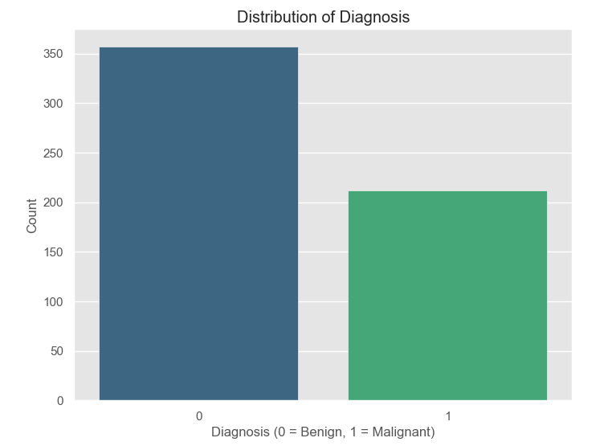
Figure 8: Distribution of Target Variable

    - Modelling

In this phase, five machine learning models such as SVM, MLP, Random Forest, XGBoost, and CatBoost are developed. The research introduces a stacking classifier that combines the top three models using a meta-learner, enhancing accuracy and reducing overfitting. Post-hoc explanations are provided through XAI techniques such as SHAP, LIME, and PDP, improving the interpretability of the models and aligning with the project’s goal of creating accurate and transparent predictive models.

3.2.4.1 Support Vector Machine:
Support Vector Machine is a powerful supervised machine learning algorithm widely used for classification tasks. The main goal is to find the optimal hyperplane that separates the data points of different classes in a feature space by maximizing the margin between the nearest points of each class, known as support vectors.
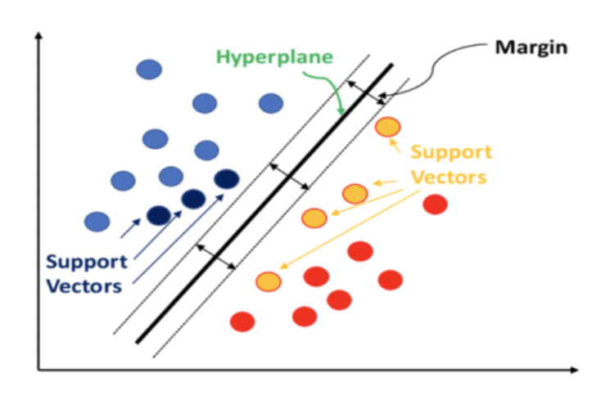
The basic formula for linear SVM classifier is as follows:
$$\hat{y}=\left\{\begin{aligned}1:w^{T}x+b≥0 \\ 0:w^{T}x+b<0\end{aligned}\right.$$

3.2.4.2 Random Forest
Random Forest is an ensemble learning method that operates by constructing a multitude of decision trees during training and outputting the class that is the mode of the classes of the individual trees. It is well-suited for classification tasks like breast cancer prediction due to its robustness against overfitting and its ability to handle large datasets with high dimensionality.
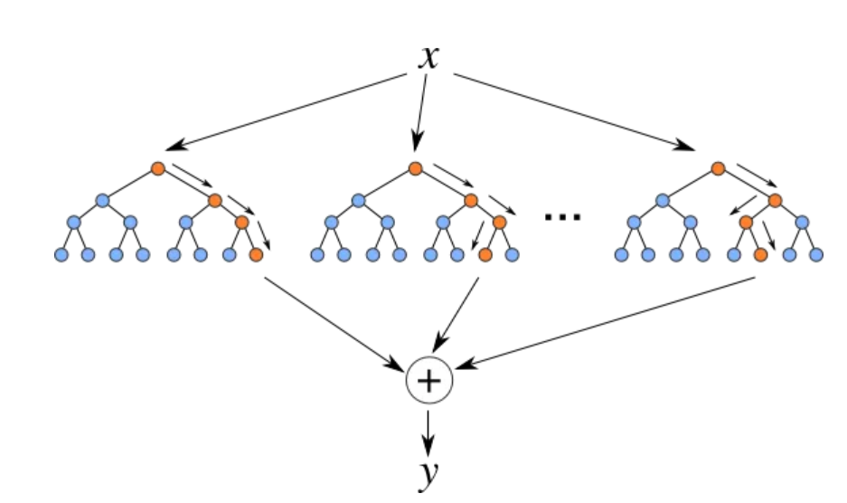

3.2.4.3 Multi-Layer Perceptron (MLP)

A Multilayer Perceptron (MLP) is a feedforward artificial neural network frequently used for classification tasks. It comprises an input layer, one or more hidden layers, and an output layer, with each neuron fully connected to the neurons in the next layer. MLP excels at capturing complex non-linear relationships, making it highly suitable for applications such as breast cancer prediction.
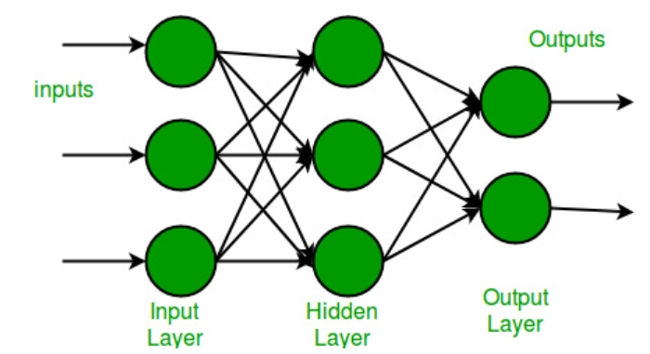
The final layer produces the output, which in this case is the probability of the input belonging to a particular class (benign or malignant).

3.2.4.4 Extreme Gradient Boosting (XGBoost)
XGBoost is a high-performance implementation of the gradient boosting framework, designed for speed and efficiency. It excels at modeling complex relationships and is ideal for tasks like breast cancer prediction, where accuracy is critical. XGBoost builds an ensemble of decision trees, with each tree correcting the errors of the previous ones.

3.2.4.5 CatBoost
CatBoost also known as Categorical Boosting, is an open-source library created by Yandex. It is tailored for tasks like regression and classification, particularly when handling with a large number of independent features. The model is constructed iteratively, beginning with a basic model and progressively enhancing it by adding new models that correct the errors made by previous ones.

3.2.4.6 Ensemble Methods
Ensemble methods are effective machine learning techniques that enhance performance by combining multiple models. The core idea is that by merging predictions from several models, the overall result becomes more reliable and less prone to errors than any individual model. These methods help reduce overfitting, improve generalization, and enhance predictive accuracy. Common ensemble techniques include bagging, boosting, and stacking, each employing a distinct strategy for model combination.

3.2.4.7 SHAP
It is a unified framework for interpreting predictions by assigning each feature an importance value for a particular prediction. SHAP values (Marcílio and Eler 2020) are based on cooperative game theory, specifically the Shapley value, which fairly distributes the "payout" (prediction) among the "players" (features) based on their contribution to the outcome.
The Shapley value for a feature is calculated as:

$$ϕ_{j}=\sum_{S⊆N}{\frac{\left|s\right|!\left(\left|N\right|-\left|s\right|-1\right)!}{\left|N\right|}\left[f\left(s∪\left\{j\right\}\right)-f\left(S\right)\right]}$$

3.2.4.7 LIME
It is a model-agnostic technique that approximates the behavior of complex models locally by fitting simple interpretable models around each prediction. It provides an explanation by highlighting the key features that influence a particular prediction, allowing users to understand why a model made a specific decision.
The formula for the LIME explanation model is:
$$L\left(f_{, }g,π_{x}\right)=\sum_{i}{Π_{x}\left(x_{i}\right){\left(f\left(x_{i}\right)-g\left(x_{i}\right)\right)}^{2}}$$

3.2.4.9 Partial Dependence Plot (PDP)

It illustrates the relationship between one or two features and the predicted outcome of a machine learning model, averaging out the effects of all other features. PDPs help to understand the marginal effect of selected features on the prediction, making it easier to interpret the model’s behavior.
The Partial dependence function for a set of features S is defined as:
$${\hat{f}}_{s}\left(x_{s}\right)=E_{x_{c}}\left[\hat{f}\left(x_{s},x_{c}\right)\right]$$

    - Evaluation
In the evaluation phase, the models' performance is assessed using a variety of metrics, including accuracy, precision, recall, F1-score, AUC, ROC curves, and confusion matrices. Post-hoc explanations are provided through Explainable AI (XAI) techniques like SHAP, LIME, and Partial Dependence Plots (PDP), which offer transparency by highlighting the impact of individual features on model predictions. It also compares the models based on their performance metrics and feature importance, ensuring that the chosen models not only achieve high accuracy but also provide reliable and interpretable results for healthcare professionals.

3.2.5.1 Terminology of Evaluation Metrics
Evaluation metrics provide a comprehensive understanding of the model's performance, balancing between how many cases were correctly identified and how many were missed or incorrectly identified. The use of these metrics ensures that the models not only perform well in terms of overall accuracy but also offer reliable predictions that are crucial for clinical decision-making.
- Accuracy

It is the ratio of correctly predicted instances to the total instances in the dataset. It provides an overall measure of how well the model is performing.
$$Accuracy=\frac{TP+TN}{TP+TN+FP+FN}$$
- TP = True Positives (correctly predicted positive cases)
- TN = True Negatives (correctly predicted negatives cases)
- FP = False Positives (incorrectly predicted as positive)
- FN = False Negatives (incorrectly predicted as negatives)
- Precision

It is the ratio of correctly predicted positive observations to the total predicted positives. It answers the question: "How many of the predicted positive cases were actually positive?"
$$Precision=\frac{TP}{TP+FP}$$
- Recall (Sensitivity or True Positive Rate)

It is the ratio of correctly predicted positive observations to all observations in the actual class. It answers the question: "How many of the actual positive cases were correctly predicted?"
$$Recall \left(Sensitivity\right)=\frac{TP}{TP+FN}$$

- Specificity (True Negative Rate)

It is the ratio of correctly predicted positive observations to all observations in the actual class. It answers the question: "How many of the actual positive cases were correctly predicted?"
$$Specificity =\frac{TN}{TN+FP}$$
- F1-Score
It is the harmonic mean of Precision and Recall, providing a balance between the two. It is particularly useful when the classes are imbalanced.
$$F1-Score=2 X\frac{Precision×Recall}{Precision+Recall}$$
- Area Under the ROC Curve (AUC-ROC)
The AUC-ROC is a measure of the model's ability to distinguish between classes. The ROC curve plots the True Positive Rate (Recall) against the False Positive Rate (1 - Specificity) at various threshold settings.
- Confusion Matrix
A Confusion Matrix is a table used to describe the performance of a classification model on a set of test data for which the true values are known. It is structured as:
 | Predicted Positive | Predicted Negative
Actual Positive | TP | FN
Actual Negative | FP | TN

The confusion matrix further breaks down the model's predictions, helping to visualize the balance between true positives, true negatives, false positives, and false negatives, which is critical in a healthcare context where the cost of misclassification can be high.
    - Report Writing
In this final stage, a comprehensive report is being prepared, summarizing the methodology, data analysis, development of ML and XAI models, and evaluation results. The report is set for completion by August 30th, 2024.

- Professional, Social, Legal and Ethical Issues
This section addresses the Professional, Social, Legal, and Ethical (PSEL) considerations integral to the responsible development and deployment of AI models in healthcare, particularly in sensitive areas such as breast cancer prediction.

Professional Issues:

The integration of AI models into healthcare, especially in critical applications like breast cancer diagnosis, necessitates that healthcare professionals are proficient in understanding and interpreting AI model predictions. These tools must enhance clinical judgment without replacing it. The accuracy and reliability of these models are critical as these tools must support clinical decision-making. XAI techniques like SHAP and LIME offer transparency, allowing clinicians to understand the factors driving the model’s predictions, which is essential for maintaining professional standards in patient care.
Furthermore, the rigorous validation of these models before deployment ensures that they perform consistently and reliably across different demographic and clinical settings, thereby supporting the professionalism required in healthcare.

Social Considerations:

AI-driven healthcare solutions carry significant social implications, particularly concerning equitable access to advanced diagnostic tools. There is a risk that if these tools are not made accessible to all socio-economic groups, they could exacerbate existing disparities in healthcare. This research aims to address this issue by leveraging Explainable AI (XAI) techniques to make machine learning models more transparent and understandable. By enhancing the interpretability of AI models, this research seeks to build trust among patients and clinicians, promoting the responsible and equitable use of AI tools. Ensuring that AI-driven diagnostics contribute to reducing healthcare inequalities, rather than widening the gap, is crucial in the pursuit of socially responsible healthcare innovation(Secinaro, et al. 2021). This involves not only the development of accessible AI tools but also the creation of supportive infrastructure and education that allows all segments of society to benefit from these advancements.

Legal Considerations:

Legal issues are critical in the deployment of AI in healthcare, especially concerning data privacy and regulatory compliance. The use of the Wisconsin Diagnostic Breast Cancer (WDBC) dataset in this research complies with data protection laws like GDPR (General Data Protection Regulation) and HIPAA (Health Insurance Portability and Accountability Act), as the dataset is anonymized.
However, beyond data protection, the application of AI models in clinical settings introduces additional legal complexities, especially regarding accountability for AI-driven decisions. AI models must be deployed with human oversight to mitigate legal risks and ensure that decisions made using AI tools are aligned with legal and ethical standards. The use of XAI techniques like SHAP and LIME provides a safeguard by making AI decisions transparent, which is critical for legal accountability.
Ethical Considerations:

Ethics in AI encompasses considerations fairness, transparency, and accountability. This research ensures that the AI models are free from bias, particularly in how they handle data related to different demographic groups. The use of XAI techniques contributes to ethical AI by making the decision-making process transparent, allowing both clinicians and patients to understand and trust the AI's predictions. Furthermore, this research considers the broader ethical implications of AI in healthcare, including its impact on patient autonomy and the potential displacement of healthcare jobs, emphasizing the need for a balanced approach that benefits both healthcare providers and patients.

Chapter 4: Implementation: EDA and Data Preparation

  - Exploratory Data Analysis
Exploratory Data Analysis (EDA) is a crucial step in the data pre-processing phase, allowing us to gain an initial understanding of the dataset's structure and key characteristics.
Summary Statistics: It provides a comprehensive overview of dataset’s features including central tendencies (mean, median), dispersion (standard deviation) and the range. It helps to identify patterns, outliers and anomalies within the data. For example, features like radius_mean, texture_mean, and area_mean provide crucial information about the typical tumor measurements.
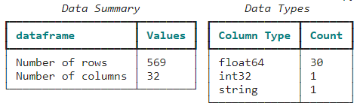
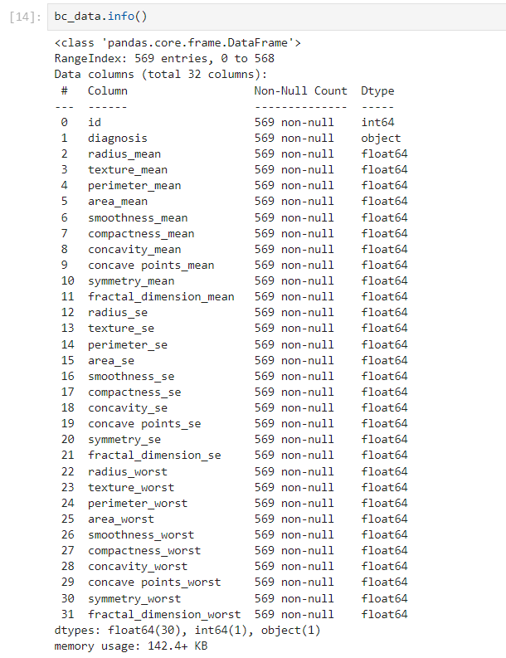
Figure 9: Summary of Dataset columns and Data types

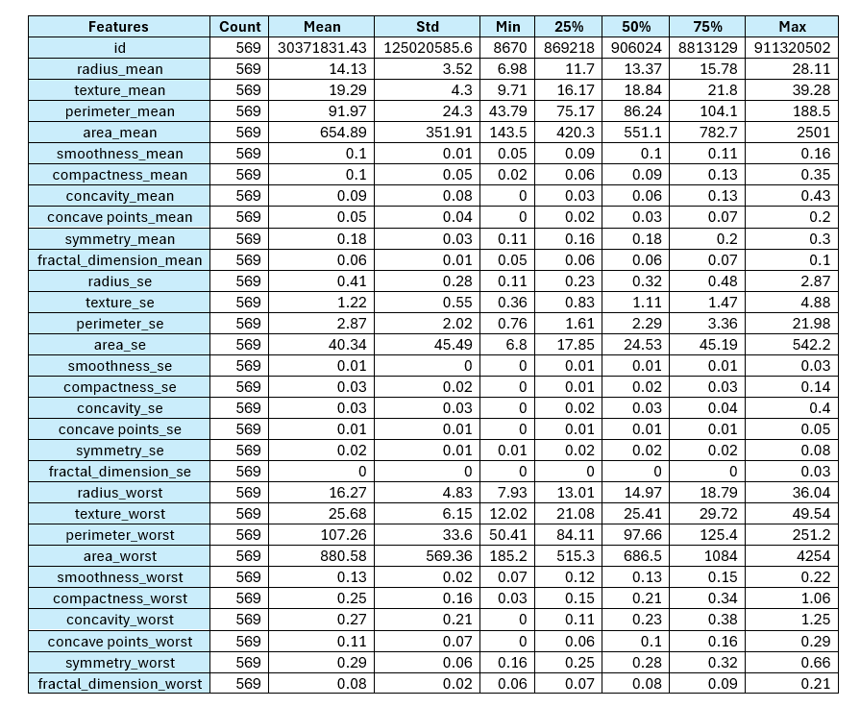
Table 2: Summary Statistics

    - Outlier Detection and Handling
Outliers can significantly distort the performance of machine learning models, leading to biased or inaccurate predictions. Therefore, detecting and handling outliers (Boukerche, Zheng and Alfandi 2020) is a critical step in the data preprocessing phase.
In this research, the Isolation Forest algorithm was utilized to detect and remove outliers from the dataset. This algorithm excels at detecting anomalies by randomly selecting features and split values, then calculating an anomaly score based on the path length from the root to the terminating node; shorter paths signify anomalies.
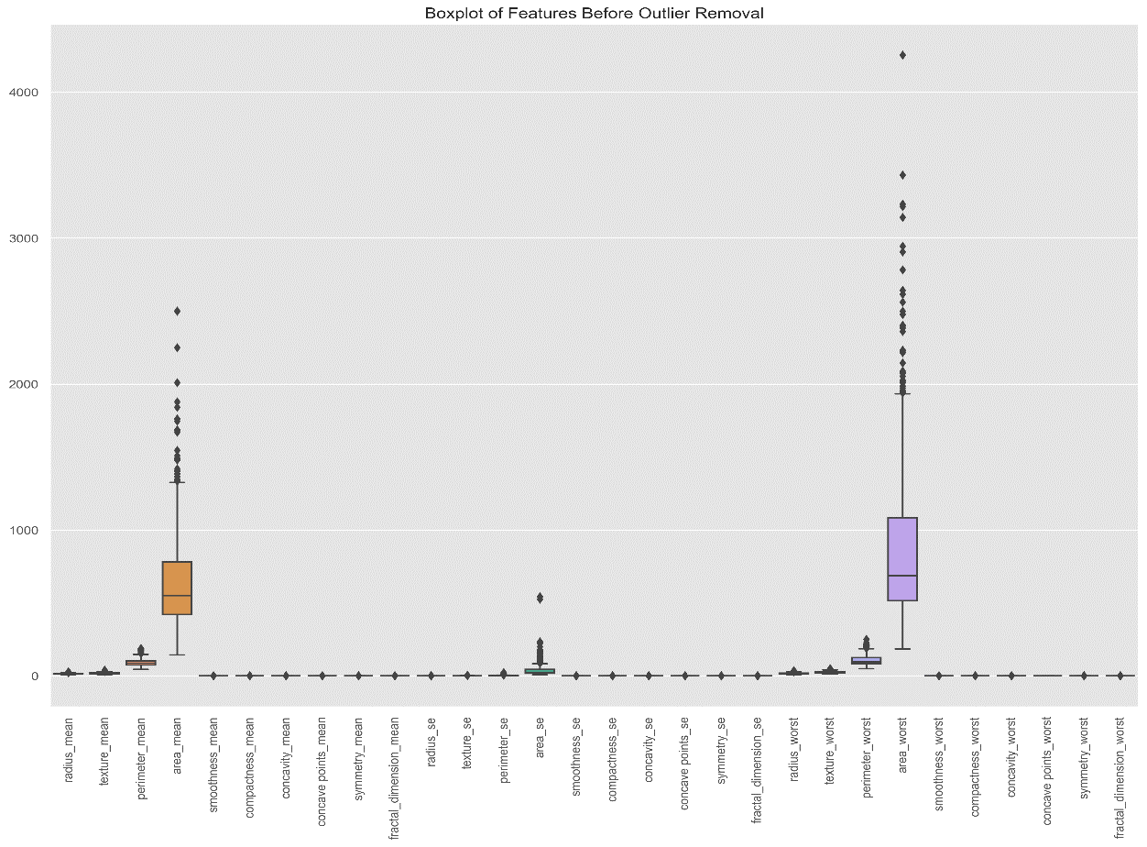
Figure 10: Boxplot of features before outlier removal

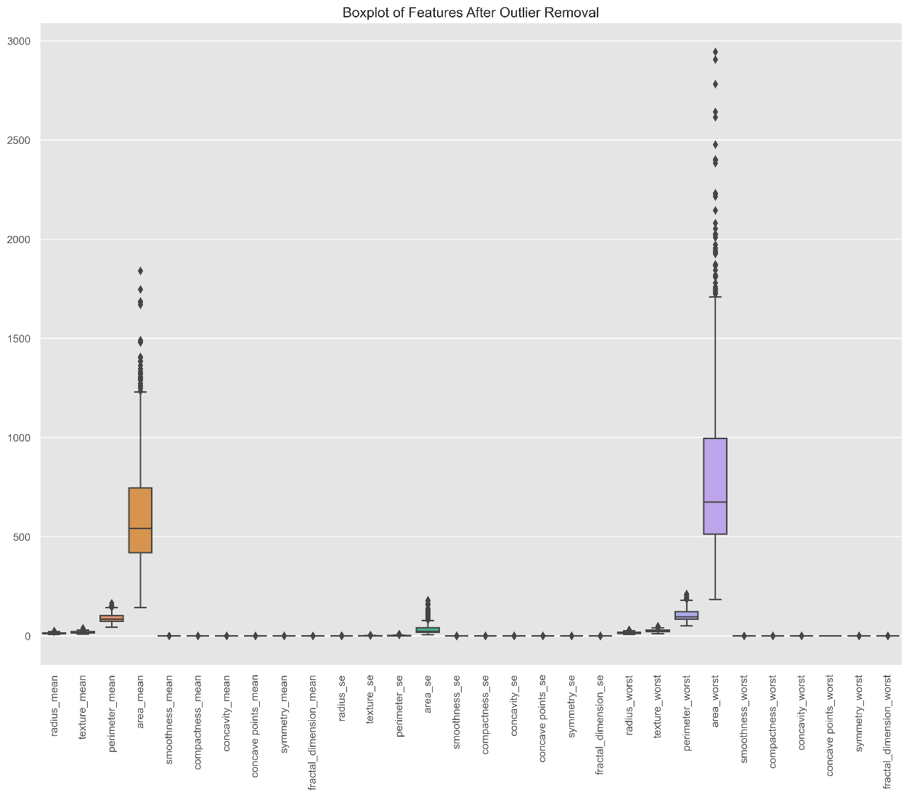
Figure 11: Boxplot of features after outlier removal

After applying the Isolation Forest algorithm, the second boxplot (Figure 11) shows the distribution of these features post outlier removal. A noticeable decrease in outliers for area_mean, perimeter_mean, area_worst, and perimeter_worst confirms a cleaner dataset.
The Isolation Forest algorithm, effective for high-dimensional data, proves efficient and scalable, making it ideal for complex medical datasets. This refined dataset, with reduced outlier influence, sets a solid foundation for the subsequent modeling phases, contributing to the creation of a highly reliable and accurate breast cancer prediction model.

    - Feature Scaling
Feature scaling is a crucial pre-processing step in machine learning particularly for algorithms sensitive to the magnitude of input data, such as Support Vector Machines (SVM). In this project, the StandardScaler from the scikit-learn library was used for this purpose.
The StandardScaler (Sharma, V. 2022) transforms the data by removing the mean and scaling it to unit variance, which is essential for achieving optimal model performance. All features, except the target variable ‘diagnosis’, were scaled using the StandardScaler, normalizing them to a mean of 0 and a standard deviation of 1. The scaled features were then converted back into a DataFrame, preserving the original dataset structure while optimizing the model's learning process.
The formula for standard scaling is:
$$Z=\frac{X-μ}{σ}$$
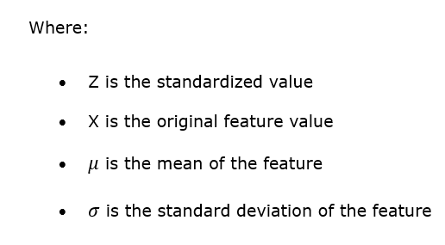
    - Feature Selection using RFE
Feature selection plays a key role in improving model performance by reducing dimensionality and emphasizing the most relevant features (Dhal and Azad 2022). In this project, Recursive Feature Elimination (RFE) combined with a Random Forest classifier was used to identify the top 10 crucial features for predicting breast cancer.
Recursive Feature Elimination (RFE) works by recursively removing the least important features, retraining the model, and re-evaluating feature importance until the top 10 most relevant features are identified. This method was chosen for its ability to enhance model interpretability while maintaining predictive accuracy. RFE iteratively evaluates the model's performance by ranking features based on their importance to the model's accuracy.
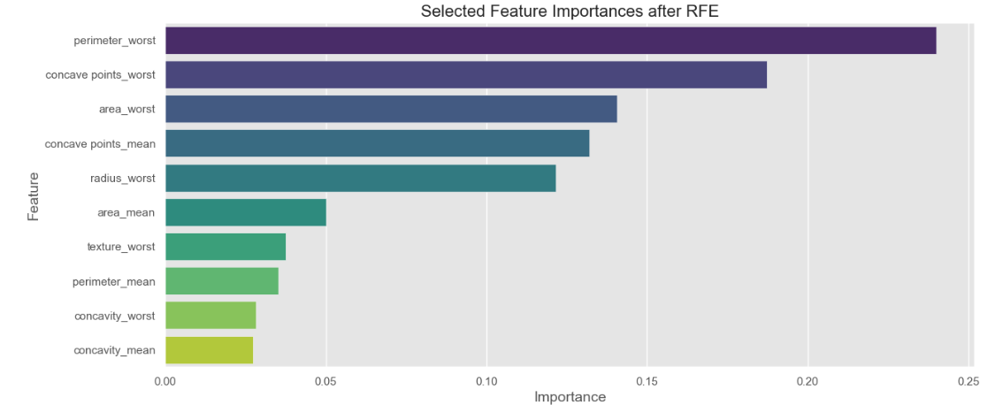
Figure 12: Feature selection after RFE

The Random Forest classifier, known for its robustness against overfitting and its ability to capture nonlinear relationships, was chosen as the estimator for RFE. Its inherent feature importance metrics provide a reliable basis for iterative feature elimination.
- The selected features identified in Figure 12 hold the highest importance scores, making them critical indicators in distinguishing between benign and malignant breast tumors.
- The horizontal bar plot (Figure 12) serves as a visual confirmation of the significance of these features, where Perimeter_worst stands out as the most influential feature, providing a clear indication of the importance of shape-related attributes in breast cancer classification.
- By reducing the dimensionality and focusing on the most significant features, this selection process not only enhances the model's predictive accuracy but also improves its interpretability, making it more applicable in clinical settings.

    - Feature Engineering
Feature engineering plays a key role in enhancing the predictive capability of machine learning models by creating new features that capture more complex patterns within the data. In this study, polynomial feature engineering was used to introduce non-linear relationships among the top features identified by Recursive Feature Elimination (RFE).
By generating polynomial features, especially squared terms, the model gains an expanded feature space that captures more complex interactions within the data.(Zheng and Casari 2018).
- The Pair plot (Figure 13) vividly illustrates the impact of polynomial features, such as perimeter_worst^2 and area_worst^2, in enhancing the separation between benign and malignant cases.
- This clearer distinction between classes, compared to the original features, highlights the value of these engineered features in capturing non-linear relationships in the data.
- As a result, the polynomial features contribute significantly to improving the model's accuracy but also to making the decision-making process more transparent, which is vital in clinical settings where model interpretability is essential.
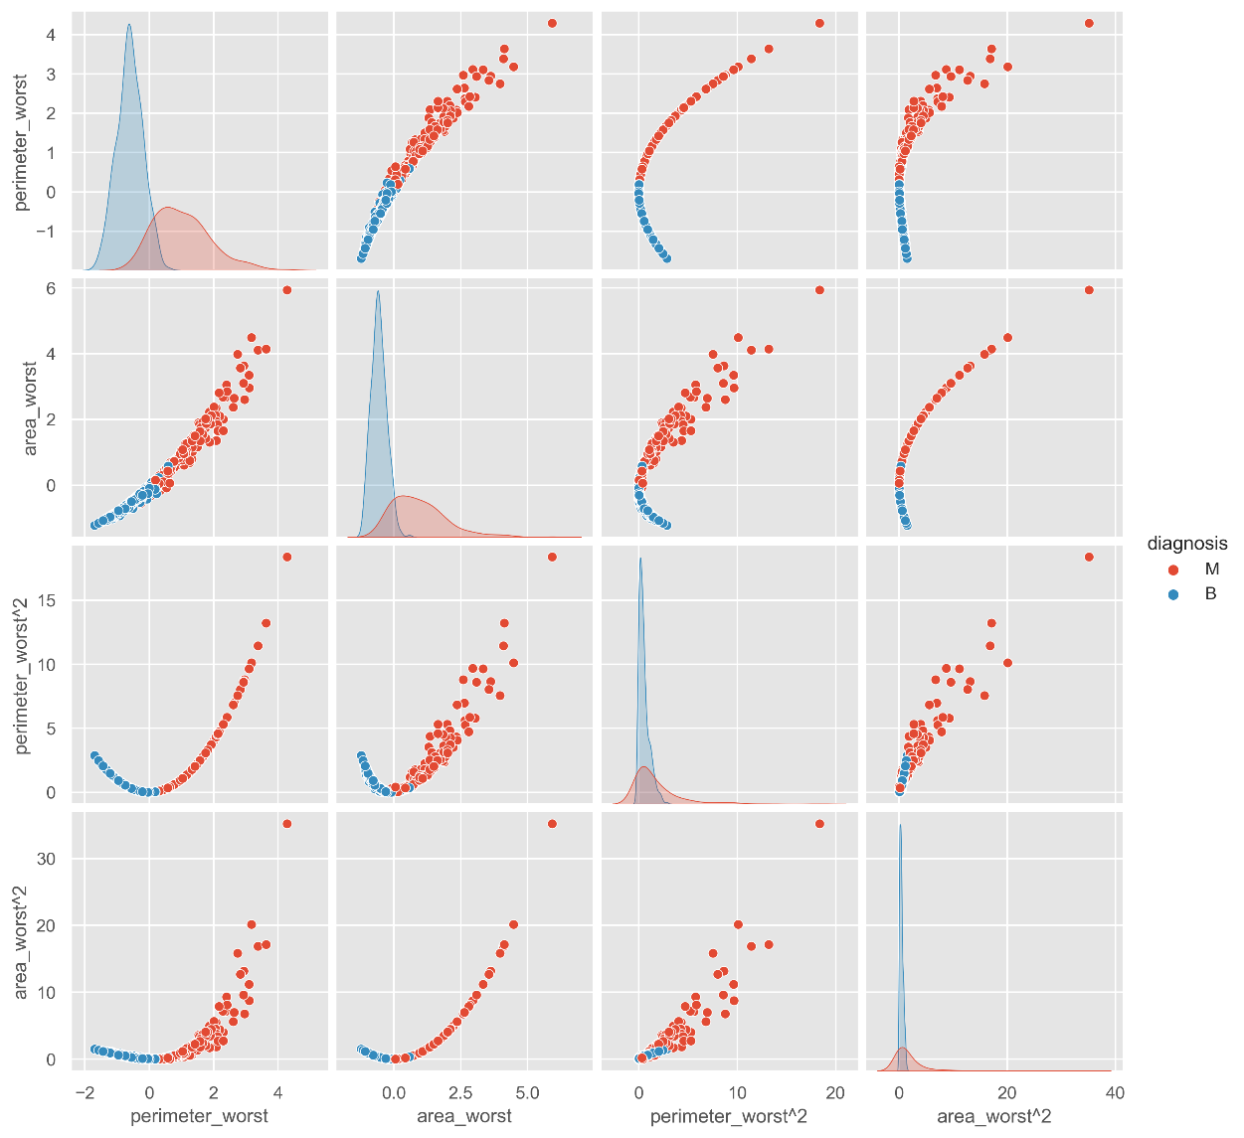
Figure 13: Pair plot of Original vs. Polynomial Features

    - Class Balancing
Class imbalance is a common issue in medical diagnosis datasets, where benign cases often outnumber malignant ones. To address this, techniques such as oversampling (Junsomboon and Phienthrakul 2017) were employed. The minority class (malignant cases) was oversampled to match the number of instances in the majority class (benign cases). This was achieved using the resampling method, which creates synthetic samples by randomly replicating instances from the minority class. By increasing the representation of malignant cases, the model becomes more sensitive to the characteristics of the minority class, improving its ability to detect malignant tumors.
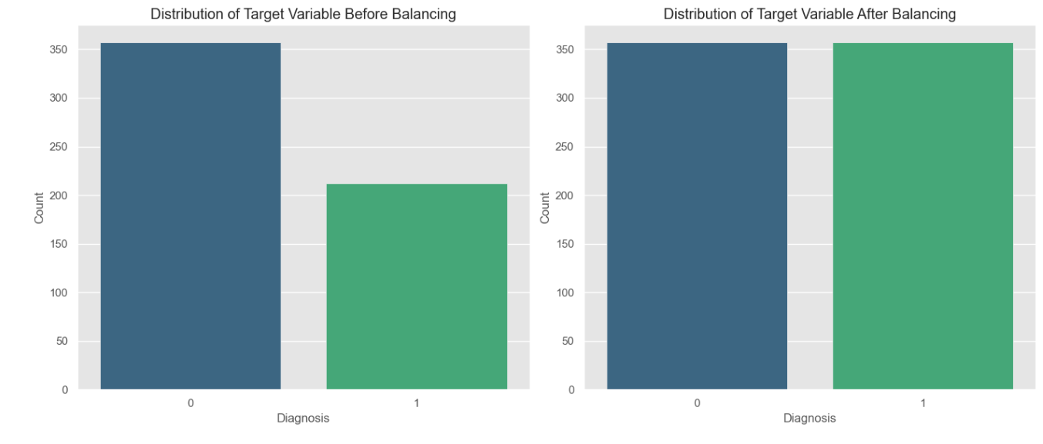
Figure 14: Target Variable – Pre and Post-Balancing

After balancing the dataset, the features and target variable were split into training and testing sets to ensure that the model is trained on a balanced dataset. The distribution of the target variable before and after balancing is illustrated in the Figure 14, which show a more even distribution of benign and malignant cases after applying the oversampling technique.
By addressing the class imbalance, the model is expected to perform better in detecting malignant cases, thereby contributing to a more reliable and effective breast cancer prediction model. This process helps in enhancing the model's accuracy and generalizability.

  - Data Splitting: Training and Testing Sets

The first step in the implementation phase was to split dataset into training and testing sets, ensuring the model’s ability to generalize to unseen data. Using the ‘train_test_split’ function from the ‘sklearn.model_selection’ library the dataset was divided with 70% for training (499 samples) and 30% for testing (215 samples). Each sample contains 65 features.
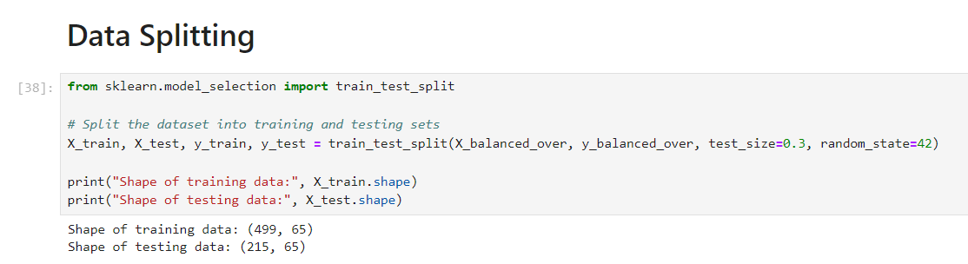

A stratified split was applied to maintain a balanced distribution of benign and malignant cases across both sets. The consistent random state guarantees reproducibility, supporting accurate model validation and performance assessment for breast cancer prediction.

Chapter 5: Implementation: Machine Learning Prediction

5.1 Support Vector Machine
5.1.1 Model Configuration and Python Libraries Used:
SVM was chosen for its effectiveness in binary classification tasks, making it an excellent choice for distinguishing between benign and malignant breast tumors using the Wisconsin Diagnostic Breast Cancer (WDBC) dataset.
The scikit-learn (sklearn) library was used extensively for this project due to its comprehensive suite of machine learning tools (Cervantes, et al. 2020). It details how the SVM model was implemented using the SVC class for binary classification, the use of GridSearchCV for hyperparameter tuning, and evaluation with metrics such as classification_report, accuracy_score, and confusion_matrix used to assess the model’s performance.
5.1.2 Parameters of SVM Model:
A grid search methodology was applied to identify the optimal combination of hyperparameters that would maximize the model’s classification performance. It mentions the key parameters considered and their roles in the model's success.
The key parameters considered are:
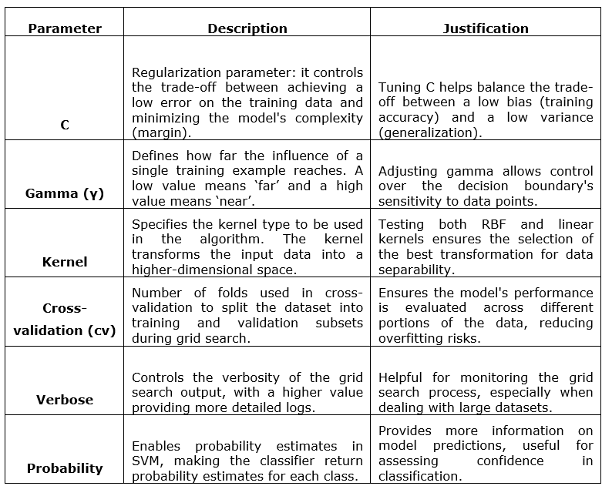
Table 1: Parameters for SVM Model

5.1.3 Model Implementation:
The model implementation involved setting up a grid search over the defined hyperparameter space (C, gamma, and kernel) with cross-validation to ensure the model's robustness across different subsets of the data. The best hyperparameters were then selected based on the highest cross-validation accuracy. The final model was evaluated on both training and testing datasets to measure its performance, with a focus on its generalization ability as indicated by the test accuracy.
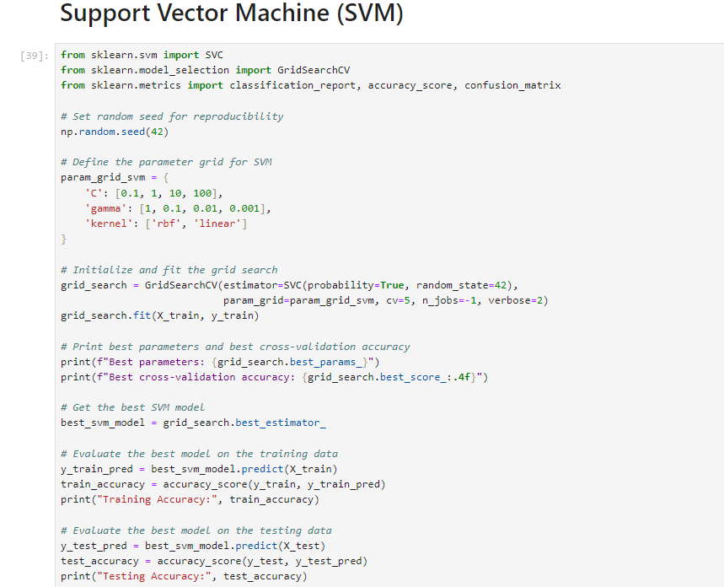
Figure 15: Python code snippet of SVM Model

  - Random Forest
    - Model Configuration and Parameters Used:
The Random Forest algorithm was chosen due to its robustness and effectiveness in handling high-dimensional data, making it particularly suitable for complex dataset. The scikit-learn (sklearn) library was extensively used in this project, and RandomForestClassifier was employed to create the model, benefiting from its ensemble learning approach to improve classification accuracy (Genuer, et al. 2020). GridSearchCV was used to perform an exhaustive search over the hyperparameter space, ensuring the model was optimized through cross-validation. Evaluation metrics such as accuracy_score, classification_report, and confusion_matrix is utilized to assess the model’s performance.
    - Parameters of Random Forest Model:
In Random Forest, several key parameters optimize model performance. n_estimators control the number of trees, where more trees improve accuracy but increase training time. max_features dictate the number of features considered for each split, balancing between generalization and accuracy. max_depth limits tree depth to prevent overfitting, while min_samples_split and min_samples_leaf ensure splits and leaf nodes have sufficient data for reliability. Bootstrap sampling enhances model robustness, and cross-validation (cv) helps avoid overfitting by ensuring consistent evaluation. Finally, verbose manages the detail level in training logs for easier progress tracking.
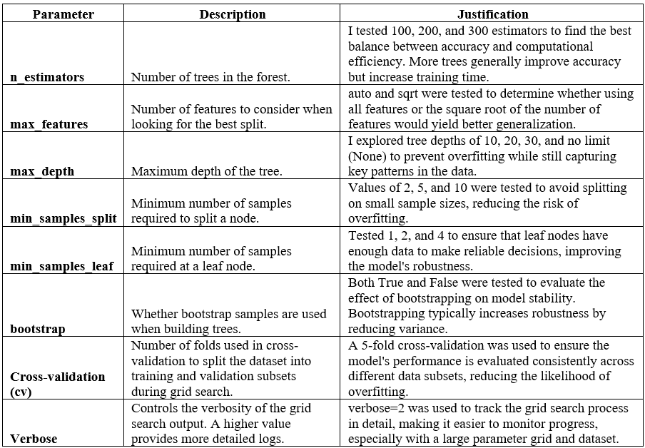
Table 2: Parameters for RF Model

    - Model Implementation:
The model implementation used a grid search with cross-validation to explore various combinations of hyperparameters, including n_estimators, max_features, max_depth, min_samples_split, min_samples_leaf, and bootstrap. The goal was to identify the optimal settings based on the highest cross-validation accuracy. The selected model was then evaluated on both training and testing datasets to assess its performance, particularly its ability to generalize, as reflected in the test accuracy.
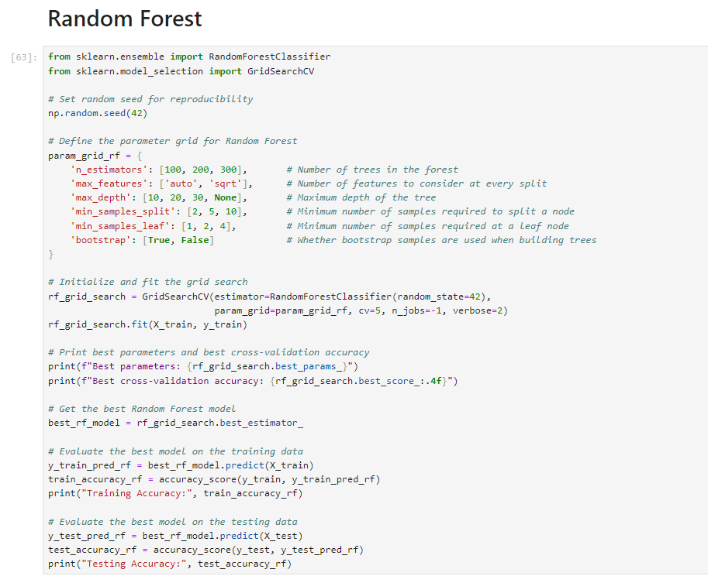
Figure 16: Python code snippet of Random Forest model

  - Multi-Layer Perceptron (MLP)
    - Model Configuration and Python Libraries Used:
The ‘MLPClassifier’ was employed to create the neural network model, which benefits from multiple layers and various activation functions to capture intricate patterns in the data. ‘GridSearchCV’ was used to perform an exhaustive search over the hyperparameter space to optimize model performance through cross-validation.
    - Parameters of MLP Model:
A grid search methodology was applied to identify the optimal combination of hyperparameters that would maximize the MLP model’s classification performance. Hyperparameter tuning was conducted using grid search with cross-validation to find the best combination of hidden_layer_sizes, activation, solver, alpha, and learning_rate parameters, enhancing the model’s overall performance. The key parameters considered are:
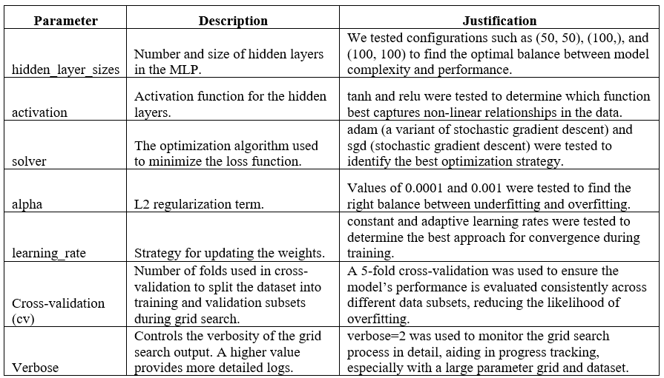
Table 3: Parameters for MLP Model

    - Model Implementation
The model implementation utilized grid search with cross-validation to explore different combinations of `hidden_layer_sizes`, `activation`, `solver`, `alpha`, and `learning_rate` to find the optimal configuration. The best hyperparameters were selected based on cross-validation accuracy, and the final model was evaluated on both training and testing datasets to assess its performance and generalization ability.

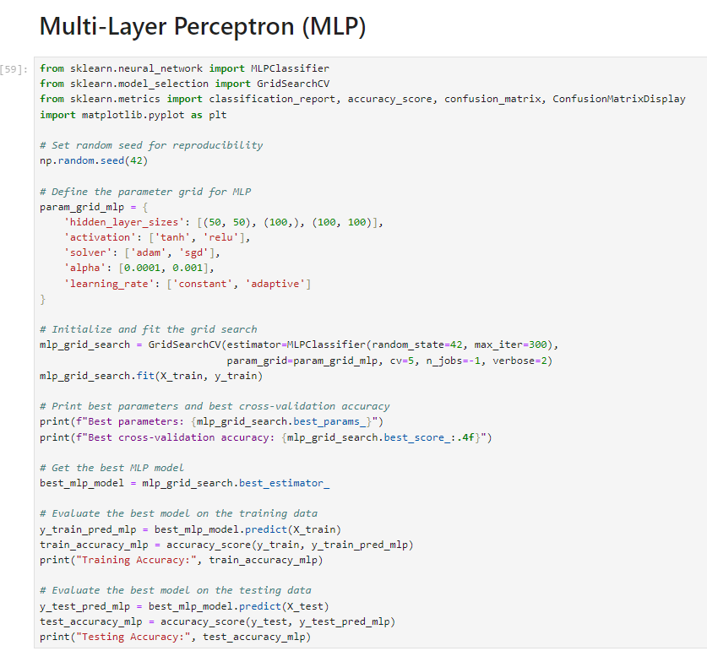
Figure 17: Python Code snippet of MLP model

  - Extreme Gradient Boosting (XGBoost)
    - Model Configuration and Python Libraries Used:
The XGBoost library was utilized to implement the XGBoost model, known for its high performance in classification tasks. The scikit-learn (sklearn) library was also used, particularly GridSearchCV, to perform an exhaustive search over the hyperparameter space, ensuring optimal model performance through cross-validation. Evaluation metrics, including accuracy_score and ROC-AUC analysis, were used to assess the model’s predictive performance.
    - Parameters of XGBoost Model:
A grid search methodology was applied to find the optimal combination of hyperparameters that would enhance the XGBoost model’s performance. Hyperparameter tuning was conducted using grid search with cross-validation to explore different values for learning_rate, max_depth, n_estimators, subsample along with the fixed parameter’s objective and eval_metric. The key parameters considered are:
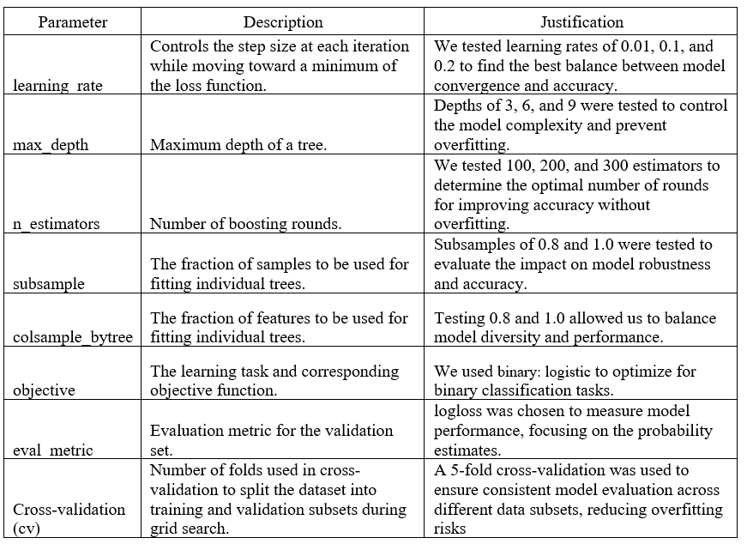
Table 4: Parameters for XGBoost Model

    - Model Implementation:
The model implementation involved using grid search with cross-validation to optimize hyperparameters such as learning_rate, max_depth, n_estimators, subsample, and colsample_bytree. The best hyperparameters were selected based on cross-validation accuracy, and the final model was evaluated on both training and testing datasets to assess its accuracy and generalization ability. Additionally, ROC-AUC analysis was conducted to evaluate the model's discriminative power.

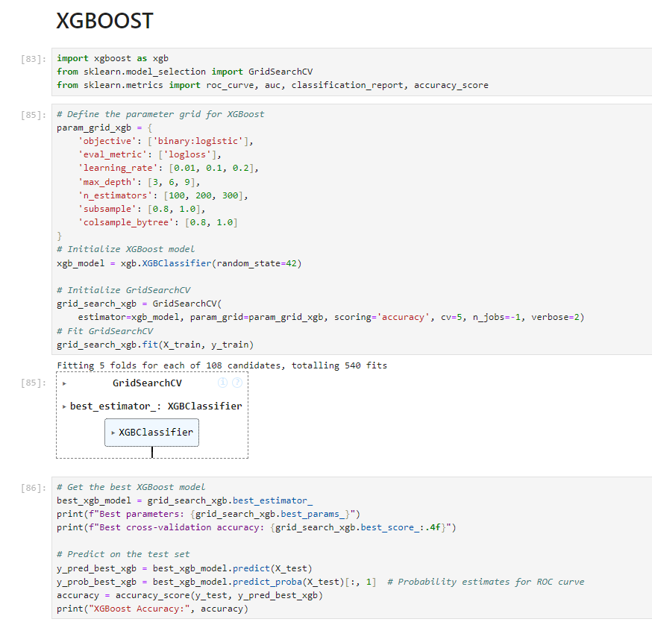
Figure 18: Python code snippet of XGBoost Model

  - CatBoost Model
    - Model Configuration and Python Libraries Used:
The catboost library was used to implement the CatBoost model, which is known for its fast-training time and excellent performance in classification tasks. The model was trained directly on the dataset with default settings, leveraging CatBoost’s internal optimizations. The scikit-learn (sklearn) library was employed for evaluating the model’s performance using metrics such as classification_report, accuracy_score, and confusion_matrix.
    - Parameters of CatBoost Model:
The CatBoost model was configured using its default settings, with random state fixed for reproducibility. While CatBoost is robust with minimal tuning, further hyperparameter optimization can be conducted depending on the dataset characteristics. The key parameters considered in this implementation are:
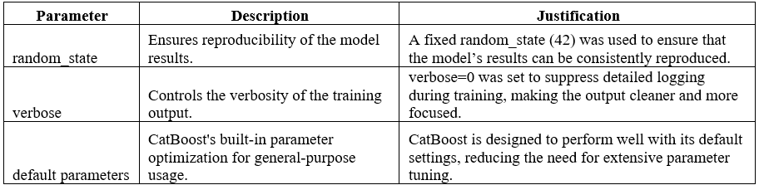
Table 5: Parameters for CatBoost Model

    - Model Implementation:
The CatBoost model was trained on the dataset without extensive hyperparameter tuning, benefiting from its ability to deliver high performance out-of-the-box.
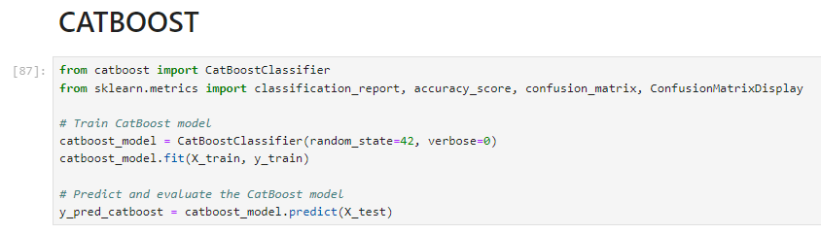
Figure 19: Python code snippet of Catboost Model

  - Stacking Classifier

The stacking classifier, also known as stacked generalization, (Sharma, S. R., Singh and Kaur 2023) was chosen for this project due to its ability to combine multiple machine learning models in a way that optimizes their collective performance. This approach allows for the integration of different models, each with its unique strengths, into a unified model that leverages the best aspects of each base learner.
5.6.1 Model Configuration and Python Libraries Used:
A Stacking Classifier was chosen to combine the strengths of multiple individual models, enhancing the overall predictive performance by leveraging the diverse learning approaches of each base model.
The base models included an MLP (Multi-Layer Perceptron), XGBoost, and CatBoost, each known for their strong performance in classification tasks. The Stacking Classifier was trained using cross-validation to ensure robustness and generalization across different subsets of the data.
    - Parameters of Stacking Classifier:
The stacking classifier was configured with three base models: MLP, XGBoost, and CatBoost. These models were selected based on their strong individual performance and complementary strengths. The Logistic Regression model served as the meta-learner. Cross-validation (cv=5) was applied to the stacking process to ensure the model’s performance was consistently evaluated.
The key components considered in this implementation are:
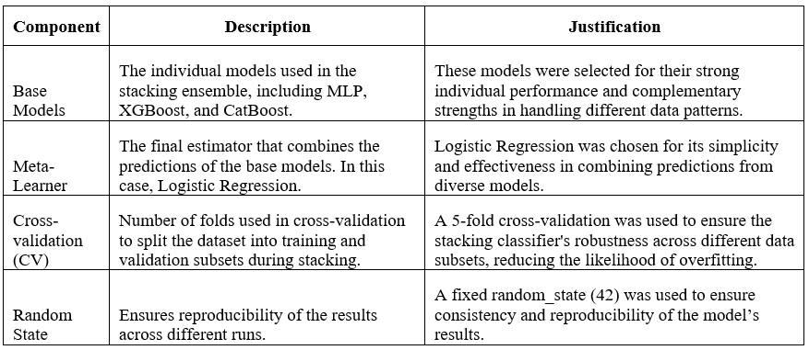
Table 6: Parameters for Stacking Classifier

    - Model Implementation:
The Stacking Classifier was implemented by first defining the base models (MLP, XGBoost, and CatBoost) and the meta-learner (Logistic Regression). The model was trained using a 5-fold cross-validation to ensure robust performance across different data splits. The final model was evaluated on the test dataset, with performance metrics including accuracy, sensitivity (recall), and specificity (true negative rate) calculated to assess its predictive capabilities.
  - SHAP Feature Importance Analysis
SHAP values were computed for XGBoost, and CatBoost models. These models were selected for SHAP analysis due to their ensemble nature and the complexity of their decision-making processes, which can benefit from a detailed feature importance explanation.
5.7.1 SHAP for XGBoost
To understand the contribution of individual features to the predictions made by the XGBoost model, SHAP (SHapley Additive exPlanations) was utilized. SHAP values provide a unified measure of feature importance, indicating how much each feature contributes to the prediction relative to the baseline model. The ‘shap.Explainer’ was used to compute SHAP values on the test set, and several plots were generated to visualize the impact of each feature.
5.7.1.1 SHAP Parameters and Implementation for XGBoost:
- Explainer Initialization: The SHAP explainer was initialized using the trained XGBoost model and the training data. This setup allows for accurate computation of SHAP values that reflect the model’s decision-making process.
- Summary and Dependence Plots: The summary plot was generated to provide a global view of feature importance, while dependence plots were created to explore the relationship between specific features, such as perimeter_worst, and the model’s output. These visualizations help in understanding both the individual and combined effects of features.
- Force and Waterfall Plots: To gain insights into individual predictions, force and waterfall plots were used. These plots break down how each feature contributes to the final prediction, offering a detailed view of the model’s behavior on a case-by-case basis.
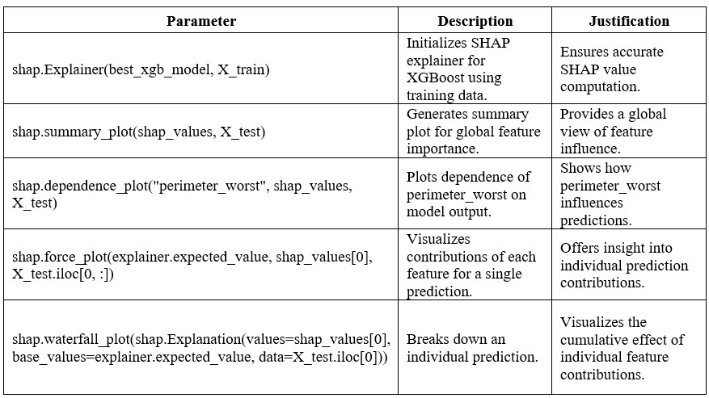
Table 7: SHAP Parameters for XGBoost Model
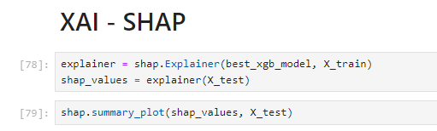
Figure 20: SHAP Code snippet for XGBoost Model

    - SHAP For CATBOOST
      - SHAP Parameters and Implementation for CatBoost:
- TreeExplainer Initialization: SHAP’s TreeExplainer was used to compute SHAP values for the CatBoost model, leveraging its optimization for tree-based models.
- Summary and Dependence Plots: Like the XGBoost model, a summary plot was generated for CatBoost to assess global feature importance, and a dependence plot for area_worst was created to examine feature interactions and impacts on predictions.
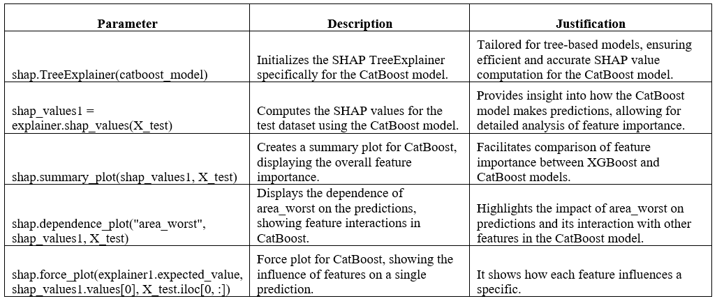
Table 8: SHAP Parameters for CatBoost Model

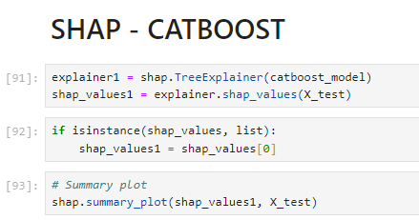
Figure 21: SHAP code snippet for Catboost model

  - LIME Feature Importance Analysis
LIME (Local Interpretable Model-agnostic Explanations) was applied to provide interpretability for the SVM, MLP, and Stacking Classifier models. LIME is particularly useful for understanding individual predictions by approximating the model locally with an interpretable model, thus offering insights into why a model made a particular prediction.
    - LIME for SVM
- Explainer Initialization: The LIME explainer was initialized using the training data for the SVM model. This step is crucial for allowing LIME to approximate the SVM model locally and generate explanations for specific predictions.
- Explanation Generation: LIME was used to explain individual predictions by generating interpretable models around the prediction. This provided insights into which features were most influential in the SVM model’s decisions for specific instances.
    - LIME for MLP
- Explainer Setup: Similar to the SVM model, the LIME explainer was initialized using the training data for the MLP model. Given the non-linear nature of MLP, useful in breaking down complex predictions into understandable components.
- Interpretability: LIME helped to visualize how the MLP model used individual features to arrive at a prediction, making it easier to understand the model's behavior on a case-by-case basis.
    - LIME for Stacking Classifier
- Explainer Configuration: The LIME explainer was configured for the Stacking Classifier model, which combines the predictions of multiple base models. LIME was essential in dissecting the ensemble’s predictions to understand how each base model’s contributions influenced the final prediction.
- Feature Contribution: LIME explanations provided a clear view of how different features impacted the stacking classifier’s decisions, offering insights into the model’s overall decision-making process.
  - Partial Dependence Plots for Stacking Classifier

PDPs are particularly useful for interpreting complex models, such as ensemble models, by showing how the predicted outcome changes as a single feature or a pair of features varies, while all other features are held constant.
5.9.1 PDP for Single Feature
The Partial Dependence Plot for a single feature was generated using the PartialDependenceDisplay.from_estimator method. This plot helps to isolate the effect of one feature on the model’s output, providing a clear understanding of whether the relationship between the feature and the prediction is linear, monotonic, or more complex.
5.9.1.1 Implementation
- Method Used: PartialDependenceDisplay.from_estimator(stacking_clf, X_train, [0], feature_names=X_train.columns)
- Feature Examined: The feature indexed as 0 in the training data.
Interpretation: For instance, if the plot shows a positive slope, it indicates that as the feature value increases, the likelihood of a positive prediction also increases. This kind of insight is crucial for identifying key predictors in the model.
    - PDP for Multiple Feature
By examining the combined effects of multiple features, this plot allows for a deeper understanding of how these features work together to affect the outcome, which is particularly important in complex models like the Stacking Classifier.

      - Implementation
- Method Used: PartialDependenceDisplay.from_estimator(stacking_clf, X_train, [0, 1, 2], feature_names=X_train.columns)
- Features Examined: The features indexed as 0, 1, and 2 in the training data.
If two features have strong combined effects on the prediction, this can indicate interaction effects that are important to consider in the overall model interpretation.
    - Interaction Plot
An interaction plot was generated to examine the joint impact of two features (e.g., feature_0 and feature_1) on the model’s predictions (Greenwell 2017). They are particularly insightful because they can reveal whether the effect of one feature on the prediction depends on the value of another feature.
- By plotting PDPs, this research demonstrates the direct and combined impacts of individual features on the final prediction made by the Stacking Classifier.
- This can help in refining the model further or in understanding the underlying data patterns more effectively.

Chapter 6: Evaluation and Results: Machine Learning Models

This Chapter delves into the analysis of the performance and interpretability of the machine learning (ML) models developed in this research. It presents a comprehensive evaluation of the models through established performance metrics and analyses the impact of Explainable AI (XAI) techniques applied to these models.
  - Evaluation Metrics Performance of Predictive Models
- Support Vector Machine (SVM)
The Support Vector Machine (SVM) model was meticulously fine-tuned, resulting in optimal hyperparameters of C: 100, Gamma: 1, and a Linear Kernel. The SVM achieved an accuracy of 93.95% on the test dataset.
The classification report, as shown in Table 9 , highlights the model's precision, recall, and F1-score across both benign and malignant classes. Precision ensures that when the model predicts malignancy, it is highly likely to be correct, reducing the risk of unnecessary treatments.
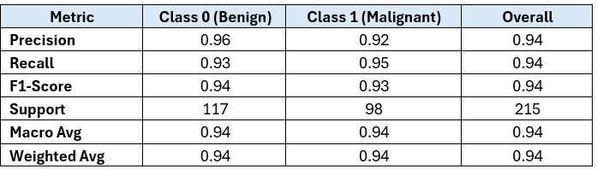
Table 9: Classification Report for SVM Model
.
The confusion matrix shown below for the SVM model demonstrates its effectiveness in distinguishing between benign and malignant tumors. The model successfully identified 109 benign, 93 malignant cases, 8 false positives, and 5 false negatives. The low false negatives are particularly important in medical diagnostics, as it minimizes the risk of missing malignant tumors.

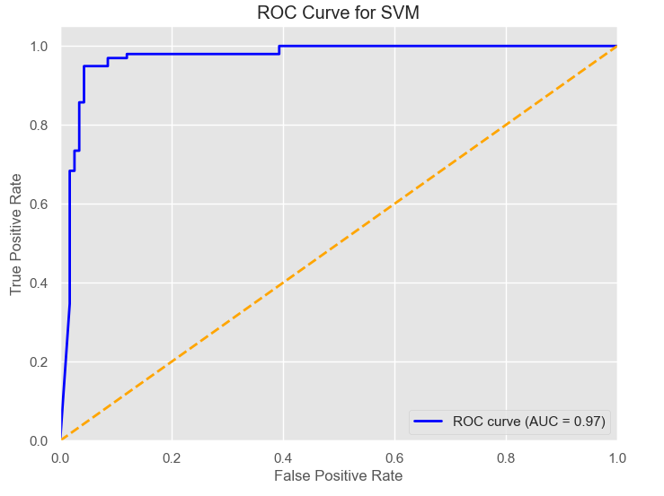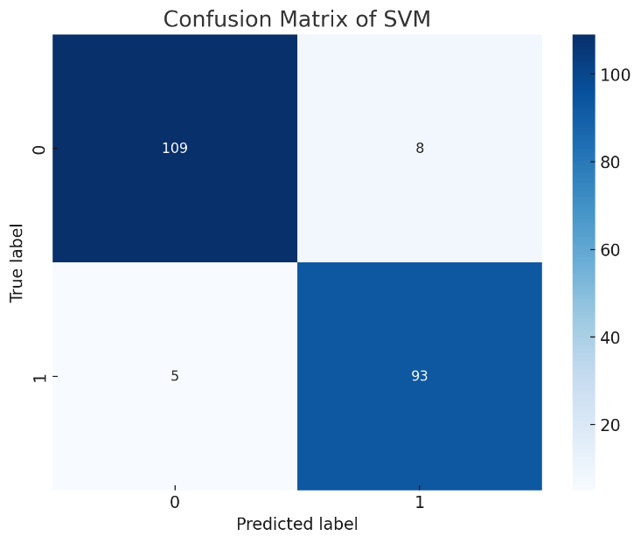

    - Random Forest (RF)
The Random Forest model was carefully trained and evaluated to predict breast cancer using the Wisconsin Diagnostic Breast Cancer (WDBC) dataset. This ensemble method, known for its robustness against overfitting and ability to handle high-dimensional data, achieved an accuracy of 95.81% on the test dataset.

The Classification report illustrated in Table 10 highlights the model's strong performance in distinguishing between benign and malignant tumors. It shows a high precision of 92% for malignant tumors, meaning most predicted positives are correct. The recall is at 95%, indicating the model effectively identifies most malignant cases. The F1-scores, balancing precision and recall, are similarly robust at 0.94 for benign and 0.93 for malignant tumors.
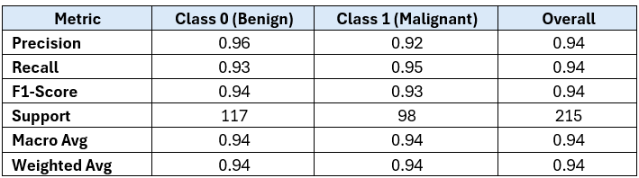
Table 10: Classification Report for Random Forest
The confusion matrix for the Random Forest model, depicted in Figure 15, that the model accurately classified most cases, with 112 true negatives and 93 true positives.

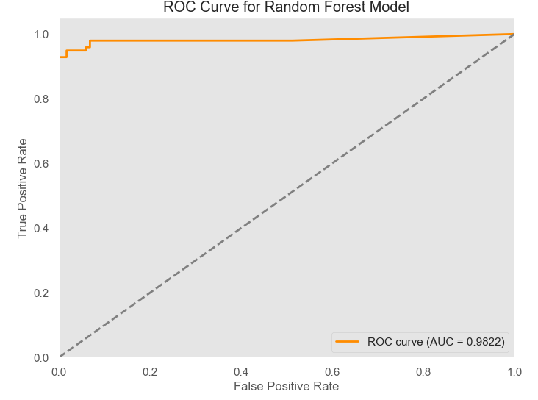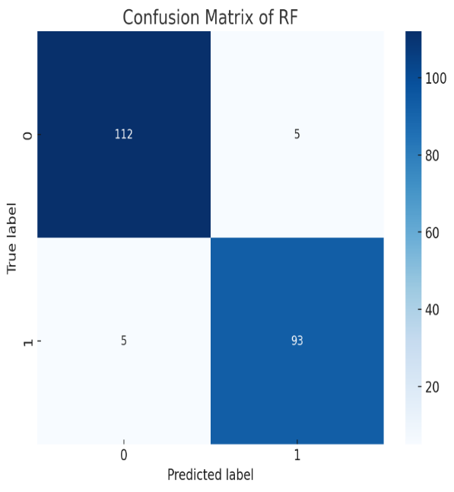

    - Multi-Layer Perceptron (MLP)
The MLP model was trained and evaluated on the test dataset, achieving an accuracy of approximately 95.35%. The model’s performance is detailed in the classification report, which shows precision, recall, and F1-scores of 0.96 for benign (Class 0) and 0.95 for malignant (Class 1) tumors. The model exhibits strong sensitivity (recall) of 94.9% for malignant cases and a high specificity of 95.7% for benign cases.
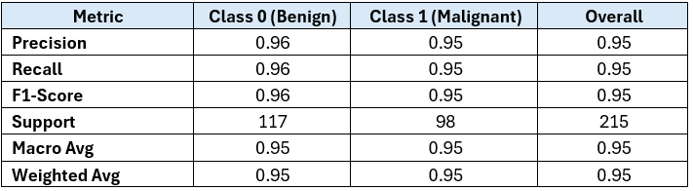
Table 11: Classification Report for MLP Model

The confusion matrix for the MLP model indicates that the model correctly identified 112 benign cases and 93 malignant cases. However, it made 5 errors in both false positives (benign predicted as malignant) and false negatives (malignant predicted as benign).

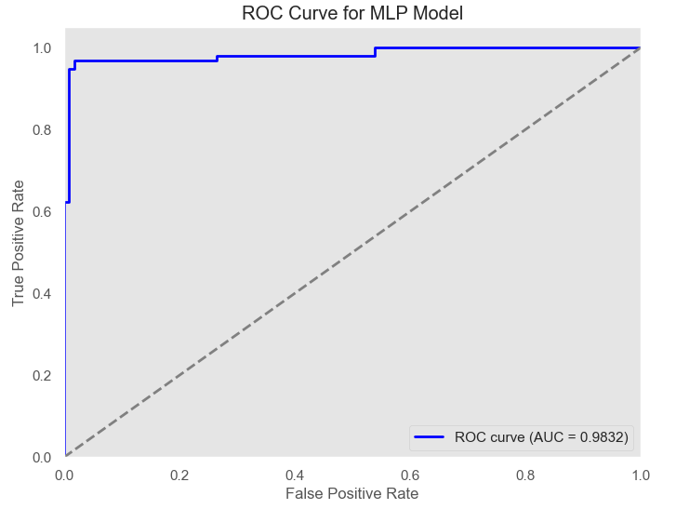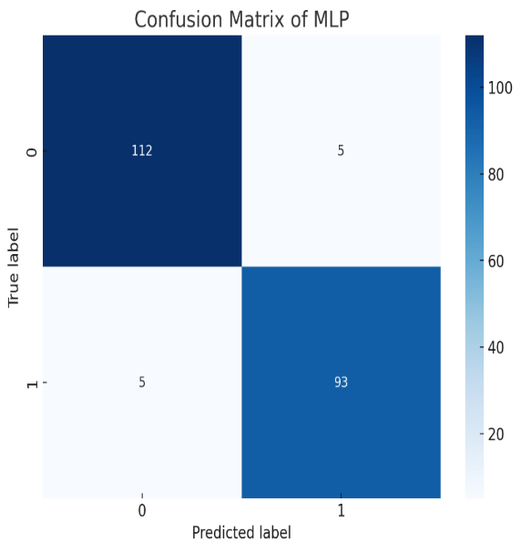

Overall, the MLP model demonstrates robust performance with minimal misclassifications, like other models like SVM and Random Forest.

    - XGBoost

The classification report for the XGBoost model demonstrates excellent predictive performance across both classes and achieved accuracy of 96.27%. With a precision of 97% for benign cases and 96% for malignant cases, the model accurately identifies instances belonging to each category. Similarly, the recall rates of 97% for benign and 96% for malignant indicate that the model effectively captures most true cases without missing significant instances.
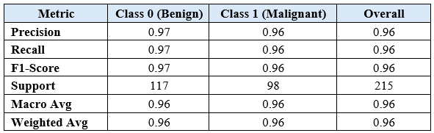
Table 12: Classification Report for XGBoost Model

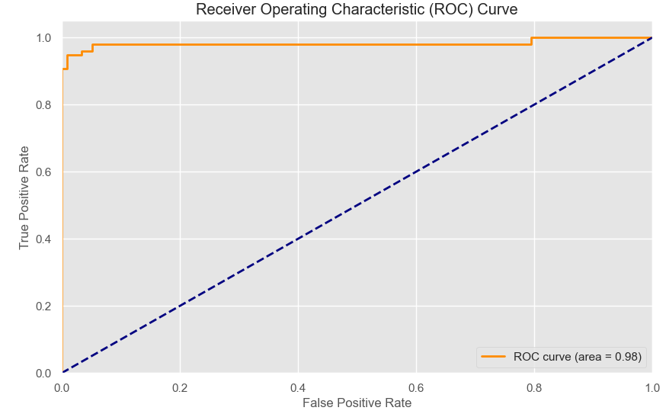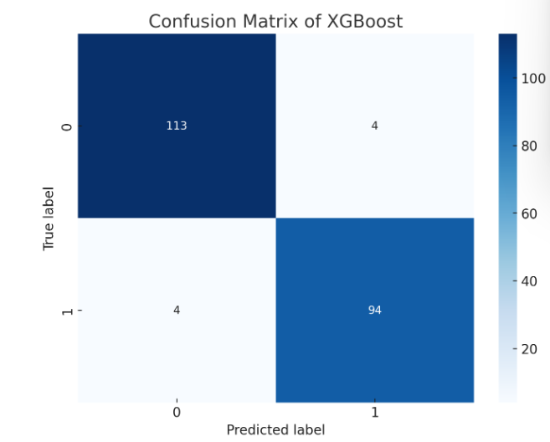

    - CatBoost
The CatBoost model demonstrates strong performance, achieving an overall accuracy of 96.27%. The precision, recall, and F1-scores for both benign (Class 0) and malignant (Class 1) tumors are consistently high, indicating the model’s effectiveness in correctly classifying both types of cases.
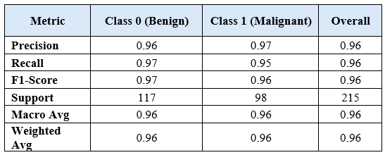
Table 13: Classification Report for Catboost Model

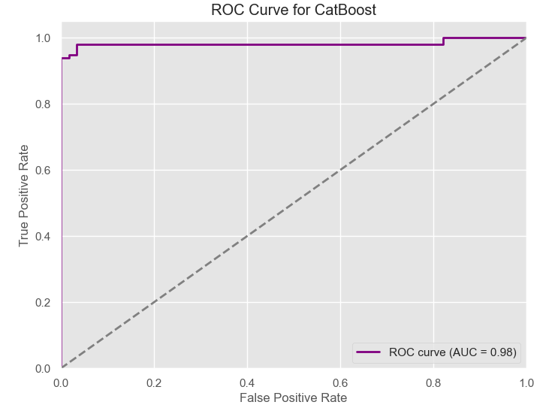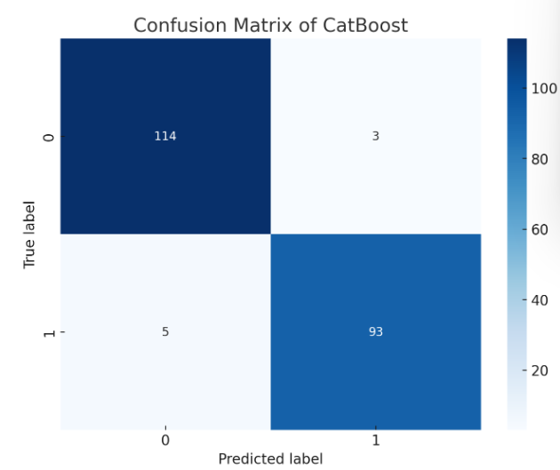

The ROC curve for CatBoost shows excellent model performance, with an AUC of 0.98, indicating a high ability to correctly distinguish between classes with minimal false positives.

    - Stacking Classifier
The stacking classifier used in this implementation is composed of three base models: MLPClassifier, XGBClassifier, and CatBoostClassifier. These base models are combined using a final meta-learner, which in this case is a Logistic Regression model.
Base models were selected as they achieved the highest accuracy among five models. The predictions are combined using meta-learner which combines the output of the base models that maximizes the overall predictive performance.
The stacking classifier was trained on the training dataset, and the model was evaluated on the test set. During training, each base model is trained on the full training data, and their predictions are used as input features for the meta-learner. After training, the model was evaluated using various metrics, including accuracy, precision, recall, F1-score, sensitivity, specificity, and the confusion matrix. It achieved an accuracy of 96.74%.

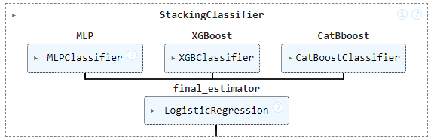
Figure 22: Stacking Classifier with 3 base models

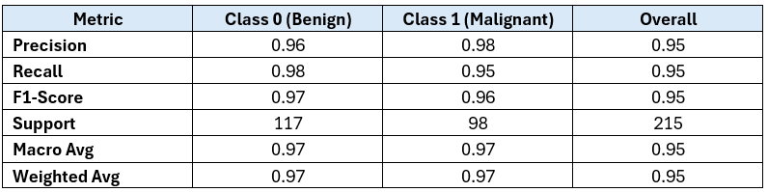

Table 14: Classification Report for Stacking Classifier

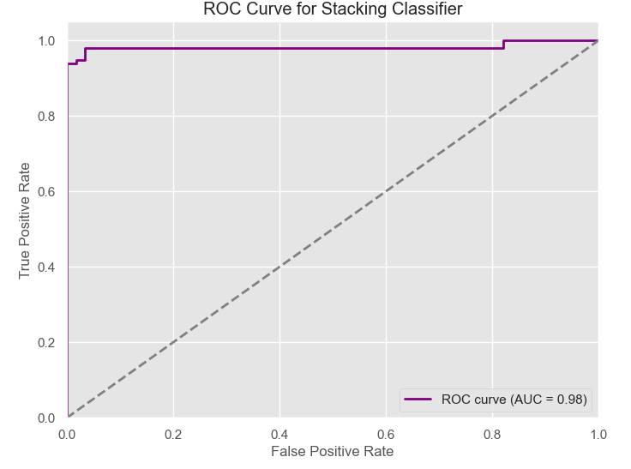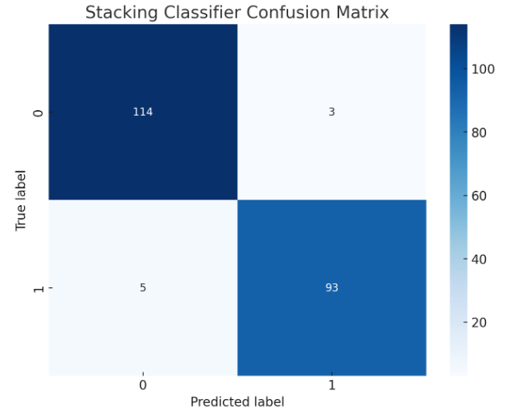
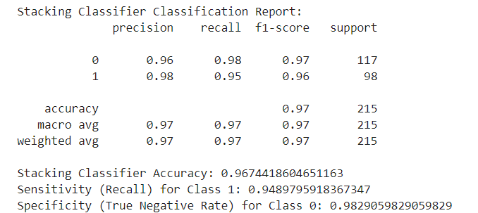

The model correctly identified 114 benign cases (true negatives) and 93 malignant cases (true positives), with only 3 benign cases misclassified as malignant (false positives) and 5 malignant cases misclassified as benign (false negatives).
The curve shows a high level of performance with an AUC (Area Under the Curve) value of 0.98, indicating that the model has excellent discriminative ability.
Overall, the Stacking Classifier, by leveraging the complementary strengths of MLP, XGBoost, and CatBoost, along with a Logistic Regression meta-learner, proves to be a highly effective ensemble approach.

Chapter 7: Evaluation and Results: XAI Techniques

  - Explanation of Obtained ML Models by XAI Techniques
7.1.1 SHAP on Predictive Models
In this research, SHAP is implemented on two predictive models that is XGBoost and Catboost. The SHAP summary plot shows the global importance of features, with the features ranked in descending order of their importance (from top to bottom).
      - SHAP Analysis for XGBoost Model

- perimeter_worst, area_worst, and concave points_worst are the most influential features in the model.
- For ‘perimeter_worst’, higher values (red) lead to a higher SHAP value, indicating an increased likelihood of predicting the positive class likely malignant in a cancer detection model.
- This dependence plot illustrates how SHAP value for ‘perimeter_worst’ changes as the value of perimeter_worst changes.
- The interaction with ‘area_mean concavity_mean’ is also shown, where higher values of ‘area_mean concavity_mean’ (red) further increase the SHAP value.
- The Waterfall plot breaks down the prediction of an individual instance, showing the cumulative impact of each feature. The most significant negative contributors in this instance are ‘perimeter_worst’, concave points_worst, and area_worst as shown in figure 25.
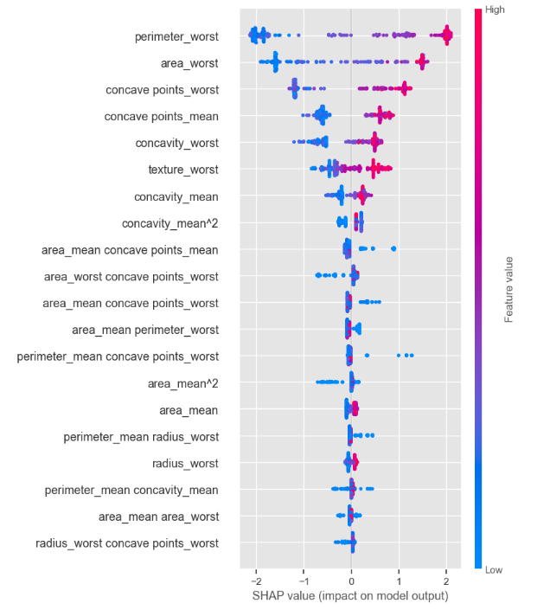
Figure 23: SHAP Summary Plot for XGBoost Model

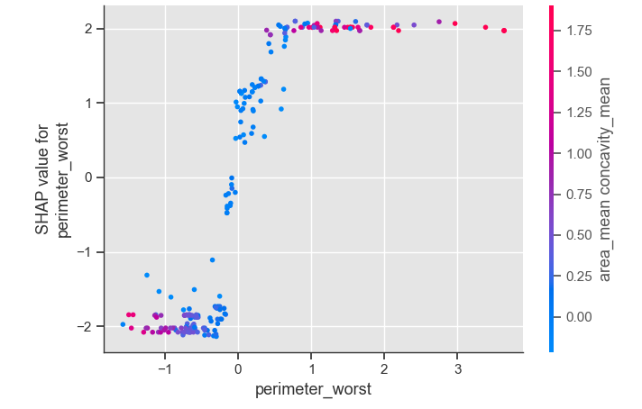
Figure 24: SHAP Dependence Plot for XGBoost Model

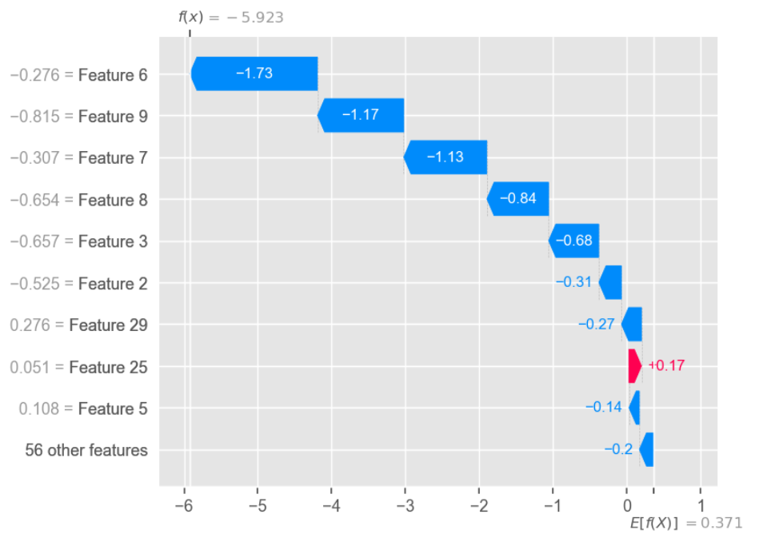
Figure 25: Waterfall Plot for XGBoost Model

The XGBoost model identified top five features ‘perimeter_worst’, ‘area_worst’, ‘concave points_worst’, ‘concave points_mean’, and ‘concavity_worst’ as having the highest SHAP values, highlighting their significant contribution to predicting the likelihood of a tumor being malignant.
Identifying these features as key predictors enhances the XGBoost model's interpretability and aligns with clinical practices used to assess tumor malignancy. This strengthens the model's role in supporting clinical decisions, aiding in early cancer detection, and improving treatment planning.

7.1.1.2 SHAP Analysis for CatBoost Model:

The SHAP analysis for the CatBoost model explains how individual features contribute to the model’s predictions and how these features interact with each other. The below figures offer insights into both global feature importance and specific feature interactions that drive the model's decisions.

- Top Features: perimeter_worst, area_worst, and concave points_worst emerge as the most influential features.
- The SHAP Dependence Plot shows how the SHAP value for area_worst (tumor size) increases with its value, indicating larger tumors are linked to higher malignancy predictions. It also highlights interactions with ‘concavity_worst’ emphasizing the strong relationship between tumor size and malignant diagnosis.
- The SHAP Interaction Plot highlights how feature pairs, like ‘area_worst’ with ‘perimeter_worst and ‘concave points_mean’ with ‘radius_worst’, interact to significantly influence the model's predictions.
- This shows that the model accounts for both individual features and their combined effects on outcomes.
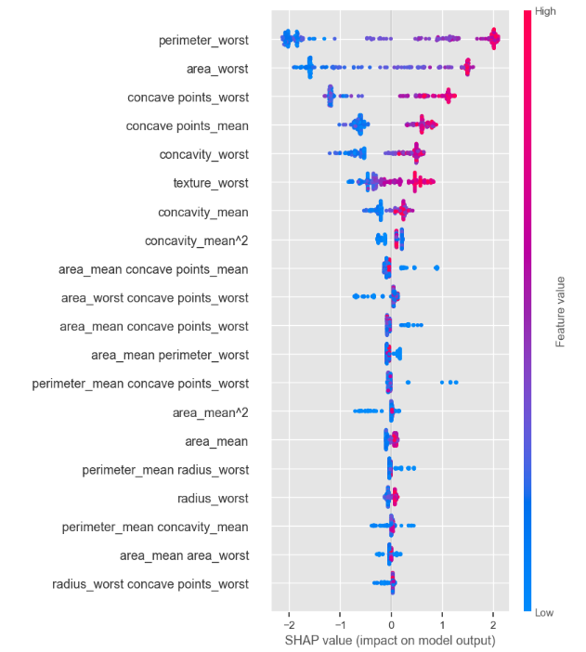
Figure 26: SHAP Summary Plot for CatBoost Model
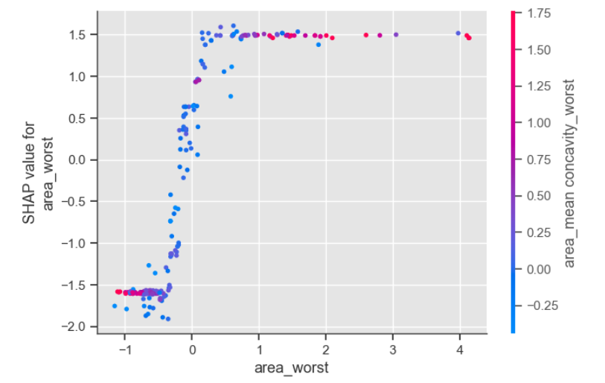
Figure 27: Dependence Plot for CatBoost Model

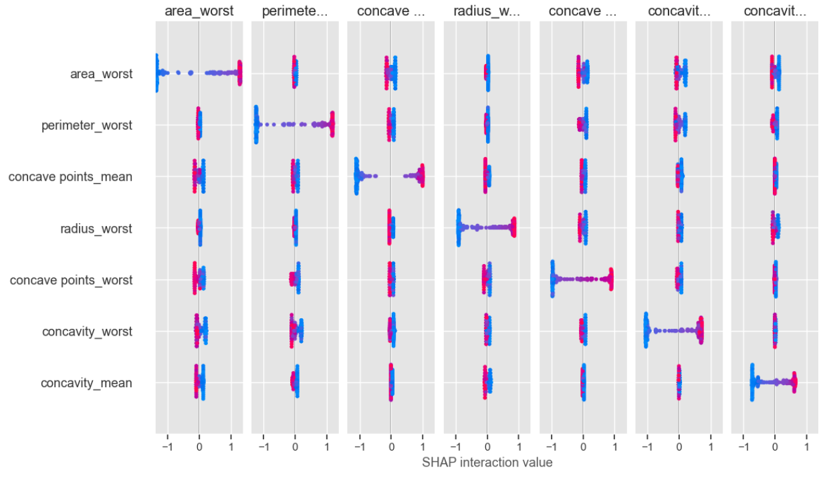
Figure 28: Interactive Plot for CatBoost Model

The SHAP analysis of the CatBoost model confirms the critical role of specific tumor characteristics—namely size (perimeter_worst, area_worst) and boundary irregularities (concave points_worst, concavity_worst)—in predicting malignancy.

    - LIME Analysis on Predictive Models
7.1.2.1 LIME for Support Vector Machine (SVM)

Lime focuses on how individual features contribute to the prediction for a specific instance. The features are ranked based on their contribution to pushing the prediction towards the malignant class (red bars) or away from it (green bars). These features suggest that certain combinations of tumor area and concave points, when within specific thresholds, increase the likelihood of malignancy.

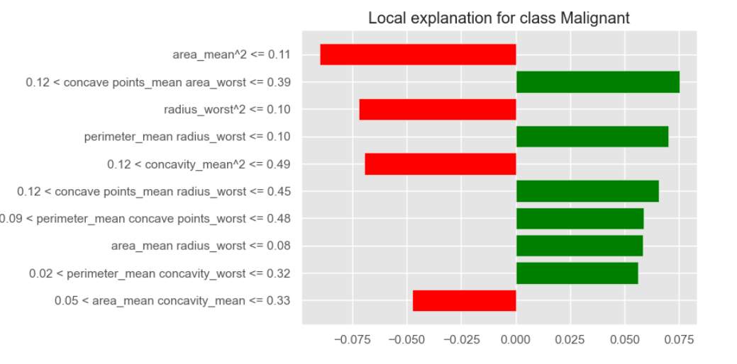
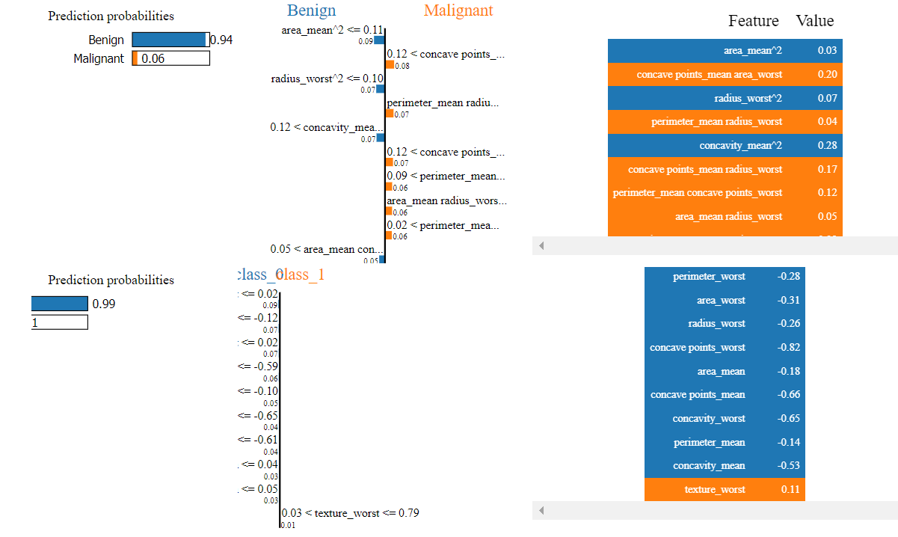

Figure 29: LIME for Benign vs Malignant Prediction
The LIME analysis for the SVM model provides valuable insights into how individual features influence the prediction of tumor malignancy. The local explanations reveal that certain measurements, particularly those related to tumor size and shape, play crucial roles in the model’s decisions.
- For Malignant Predictions: Features like area_mean^2 and concave points_mean area_worst are influential, suggesting that larger and more irregular tumors are more likely to be classified as malignant.
- For Benign Predictions: Smaller and less irregular features, such as radius_worst^2 and perimeter_mean radius_worst, significantly push the prediction towards benign.
The ability to visualize how different features contribute to the prediction probability helps in understanding and validating the model’s outputs, which is crucial for its application in medical diagnostics.

    - PDP Analysis on Stacking Classifier
      - PDP for a Single Feature:

The plot indicates a positive monotonic relationship between concavity_mean and the model's output. As concavity_mean increases, the predicted probability also increases.
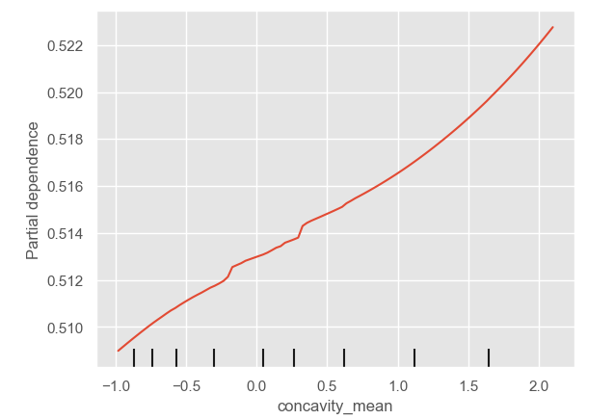

7.3.2 PDP for Multiple Features:

The three PDPs for multiple features: perimeter_worst, concave points_mean, and area_worst. Each plot visualizes the relationship between these features and the model's prediction, individually.
- The PDP for perimeter_worst suggests that as the tumor perimeter increases, the likelihood of malignancy also increases significantly.
- ‘Concave points_mean’ also shows a positive correlation with the model's output.
- The plot for area_worst also shows a strong positive relationship, where an increase in tumor area leads to a higher probability of malignancy. The sharp rise in the curve suggests that area is a critical factor in determining the malignancy of a tumor.
- This interaction plot effectively highlights how the combined effect of perimeter_worst and concave points_mean influences the model's predictions.

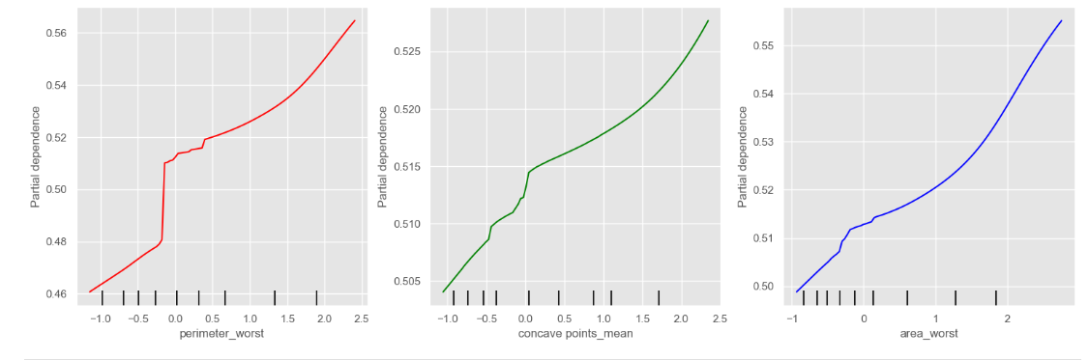
Figure 30: Partial Dependence Plot for Multiple Features
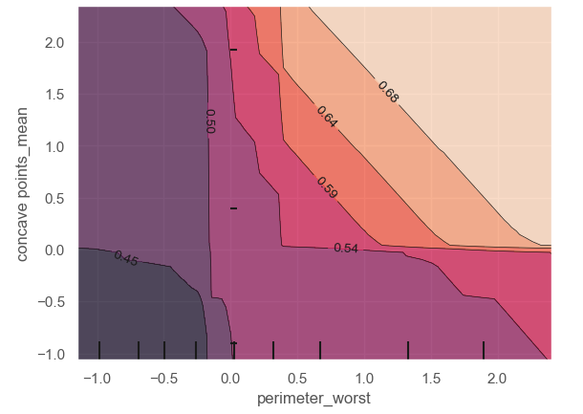

Figure 31: PDP for Interaction Plot

The PDP analysis for the Stacking Classifier reveals that the features concavity_mean, perimeter_worst, concave points_mean, and area_worst all have a significant positive impact on the predicted probability of malignancy. The clear, monotonic relationships observed in these plots indicate that as these feature values increase, the likelihood of the model predicting a malignant tumor also increases. These observations are consistent with clinical expectations and further validate the use of these features in the diagnostic process for breast cancer.

Chapter 8: Discussion and Conclusion

- Discussion of key findings
The research aimed to develop accurate and interpretable machine learning models for breast cancer classification, focusing on techniques such as SHAP (SHapley Additive exPlanations), LIME (Local Interpretable Model-agnostic Explanations), Partial dependence plots (PDP), ROC curve analysis, and accuracy metrics.
- The results confirmed that XAI techniques such as SHAP, LIME successfully enhanced the interpretability of the models without significantly compromising accuracy, supporting Hypothesis 1.
- XGBoost and Catboost outperformed superior performance compared to other models enhanced with XAI techniques, supporting Hypothesis 2.
- The stacking classifier, which combined MLP, XGBoost, and CatBoost, achieved the highest accuracy at 96.74%, validating Hypothesis 3 with ROC curves indicating excellent discriminative power.

- Comparative Analysis of ML Models

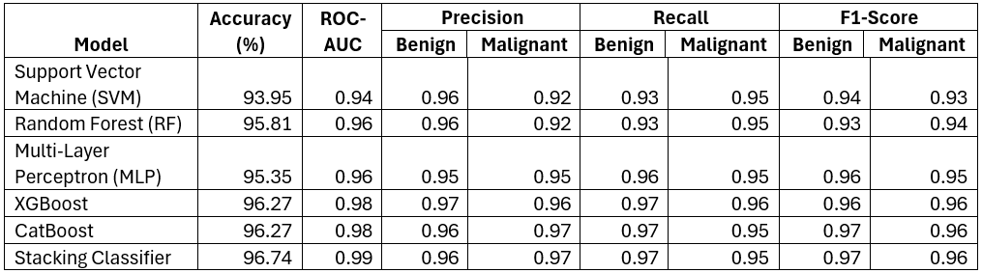
Table 15: Model Performance Summary

This above table presents a comparative analysis of various machine learning models used for breast cancer classification, highlighting their performance across multiple metrics. The stacking classifier emerges as the top performer, achieving the highest accuracy (96.74%) and ROC-AUC (0.99), indicating its superior ability to distinguish between benign and malignant cases.
Each model's precision, recall, and F1-Score for both benign and malignant predictions are also detailed, with the stacking classifier showing balanced and consistently high scores across all metrics. This analysis underscores the effectiveness of combining models to leverage their strengths, resulting in more accurate and reliable diagnostic predictions. These results demonstrate that the stacking approach, particularly when integrated with interpretability techniques, holds significant promise for clinical application in breast cancer diagnosis.

- Limitations and Recommendations

This study demonstrates the potential of machine learning models, enhanced by Explainable AI (XAI) techniques, to transform breast cancer diagnostics. With high accuracy and tools like SHAP, LIME, and Partial Dependence Plots offering transparency, these advancements represent a significant step forward in reliable and interpretable AI-driven healthcare.
However, despite these successes, the study faced certain limitations that suggest areas for further improvement:

Data Limitations: The current study focused on a specific dataset, the Wisconsin Diagnostic Breast Cancer (WDBC) dataset. Expanding the dataset in future research could enhance the model's robustness and ensure consistent performance across varied clinical environments.

To build on the success of this study and address its limitations, the following recommendations are proposed:
- Real-Time Interpretability: Future research should focus on implementing real-time interpretability within clinical decision support systems. This approach will ensure that AI-generated explanations are immediately available and easily understood during clinical workflows, enabling healthcare professionals to make swift, informed decisions without compromising on transparency.
- User-friendly Interfaces: Developing intuitive interfaces that integrate AI models with XAI techniques is crucial for enhancing adoption among clinicians. These tools should present clear, actionable insights, facilitating the practical application of AI-driven predictions in routine clinical practice.

- Conclusion

This research has successfully demonstrated the potential of integrating Explainable Artificial Intelligence (XAI) techniques with advanced machine learning models for breast cancer classification. The primary goal of developing models that are both accurate and interpretable was effectively achieved. By integrating XAI methods such as SHAP, LIME, and Partial Dependence Plots (PDP), the study provided transparency into the models' decision-making processes, making them more applicable and trustworthy in a clinical setting.
The stacking classifier, which leveraged the strengths of MLP, XGBoost, and CatBoost, proved to be the most effective, achieving the highest accuracy and ROC-AUC values. This highlights the value of ensemble techniques in enhancing predictive performance. Despite the successes, the study also identified some limitations, particularly the reliance on a single dataset (WDBC), which may limit the generalizability of the findings. Future research should address this by validating the models on more diverse datasets and exploring their application in real-time clinical environments.
In conclusion, this study contributes significantly to the advancement of AI in healthcare by showing that it is possible to develop models that are both highly accurate and transparent. The findings underscore the critical role of explainability in making AI-driven tools actionable and reliable for clinicians. Moving forward, continued efforts to refine these models and expand their applicability across different clinical settings will be essential for maximizing their impact in improving patient care.

References
ABDELRAHMAN, L., et al., 2021. Convolutional neural networks for breast cancer detection in mammography: A survey. Computers in Biology and Medicine, 131, 104248.
ADELODUN, A.B., et al., 2023, Explainable artificial intelligence with scaling techniques to classify breast cancer images. In: Explainable artificial intelligence with scaling techniques to classify breast cancer images. Explainable Machine Learning for Multimedia Based Healthcare Applications. Springer, 2023, pp. 99–137.
AHMAD, A., 2019. Breast cancer statistics: recent trends. Breast Cancer Metastasis and Drug Resistance: Challenges and Progress, , 1–7.
AMERICAN CANCER SOCIETY, 2024. Breast Cancer Statistics [online]. . Available at: https://cancerstatisticscenter.cancer.org/types/breast [Accessed 27 August 2024].
BOUKERCHE, A., ZHENG, L. and ALFANDI, O., 2020. Outlier detection: Methods, models, and classification. ACM Computing Surveys (CSUR), 53 (3), 1–37.
CERVANTES, J., et al., 2020. A comprehensive survey on support vector machine classification: Applications, challenges and trends. Neurocomputing, 408, 189–215.
CHAURASIYA, S. and RAJAK, R., 2023. Comparative Analysis of Machine Learning Algorithms in Breast Cancer Classification. Wireless Personal Communications, 131 (2), 763–772.
DATACAMP, n.d. Explainable AI: Understanding and Trusting Machine Learning Models [online]. . Available at: https://www.datacamp.com/tutorial/explainable-ai-understanding-and-trusting-machine-learning-models?dc_referrer=https%3A%2F%2Fwww.google.com%2F [Accessed 25 August 2024].
DHAL, P. and AZAD, C., 2022. A comprehensive survey on feature selection in the various fields of machine learning. Applied Intelligence, 52 (4), 4543–4581.
DSLYTICS, 2017. CRISP-DM [online]. . Available at: https://dslytics.wordpress.com/2017/11/15/crisp-dm/ [Accessed 21 August 2024].
DUVAL, A., 2019. Explainable artificial intelligence (XAI). MA4K9 Scholarly Report, Mathematics Institute, the University of Warwick, 4.
FUENTES, J.D.B., et al., 2024. Global stage distribution of breast cancer at diagnosis: a systematic review and meta-analysis. JAMA Oncology, .
GENUER, R., et al., 2020. Random forests. Springer.
GERLINGS, J., JENSEN, M.S. and SHOLLO, A., 2022. Explainable AI, but explainable to whom? An exploratory case study of xAI in healthcare. Handbook of Artificial Intelligence in Healthcare: Vol 2: Practicalities and Prospects, , 169–198.
GREENWELL, B.M., 2017. pdp: An R package for constructing partial dependence plots. R J., 9 (1), 421.
ISLAM, M.M., et al., 2020a. Breast cancer prediction: a comparative study using machine learning techniques. SN Computer Science, 1, 1–14.
ISLAM, M.M., et al., 2020b. Breast cancer prediction: a comparative study using machine learning techniques. SN Computer Science, 1, 1–14.
JABBAR, M.A., 2021. Breast cancer data classification using ensemble machine learning. Engineering & Applied Science Research, 48 (1).
JAIN, R., et al., 2024. Radial Basis Function Integrated with Support Vector Machine Model for Breast Cancer Detection. In: 2024 2nd International Conference on Artificial Intelligence and Machine Learning Applications Theme: Healthcare and Internet of Things (AIMLA), IEEE, pp. 1–5.
JAVAID, M., et al., 2022. Significance of machine learning in healthcare: Features, pillars and applications. International Journal of Intelligent Networks, 3, 58–73.
JUNSOMBOON, N. and PHIENTHRAKUL, T., 2017. Combining over-sampling and under-sampling techniques for imbalance dataset. In: Proceedings of the 9th international conference on machine learning and computing, pp. 243–247.
KABIRAJ, S., et al., 2020. Breast cancer risk prediction using XGBoost and random forest algorithm. In: 2020 11th international conference on computing, communication and networking technologies (ICCCNT), IEEE, pp. 1–4.
KHATER, T., et al., 2023. An Explainable Artificial Intelligence Model for the Classification of Breast Cancer. IEEE Access, .
KORICA, P., GAYAR, N.E. and PANG, W., 2021. Explainable artificial intelligence in healthcare: Opportunities, gaps and challenges and a novel way to look at the problem space. In: International Conference on Intelligent Data Engineering and Automated Learning, Springer, pp. 333–342.
M. S. YARABARLA, L. K. RAVI and A. SIVASANGARI, 2019. Breast Cancer Prediction via Machine Learning. In: 2019 3rd International Conference on Trends in Electronics and Informatics (ICOEI), pp. 121–124.
ORRANTIA-BORUNDA, E., et al., 2022. Subtypes of breast cancer. Breast Cancer [Internet], .
P. SATHIYANARAYANAN, et al., 2019. Identification of Breast Cancer Using The Decision Tree Algorithm. In: 2019 IEEE International Conference on System, Computation, Automation and Networking (ICSCAN), pp. 1–6.
RABIEI, R., et al., 2022. Prediction of breast cancer using machine learning approaches. Journal of Biomedical Physics & Engineering, 12 (3), 297.
REDDY, S., 2022. Explainability and artificial intelligence in medicine. The Lancet Digital Health, 4 (4), e214–e215.
SCHRÖER, C., KRUSE, F. and GÓMEZ, J.M., 2021. A systematic literature review on applying CRISP-DM process model. Procedia Computer Science, 181, 526–534.
SECINARO, S., et al., 2021. The role of artificial intelligence in healthcare: a structured literature review. BMC Medical Informatics and Decision Making, 21, 1–23.
SHARMA, A., 2019. Guide for Machine Learning: Types of Machine Learning Algorithms [online]. . Available at: https://medium.com/@akshatsharma0610/guide-for-machine-learning-types-of-machine-learning-algorithms-44a822bfc40c [Accessed 28 August 2024].
SHARMA, S.R., SINGH, B. and KAUR, M., 2023. A novel approach of ensemble methods using the stacked generalization for high-dimensional datasets. IETE Journal of Research, 69 (10), 6802–6817.
SHARMA, V., 2022. A study on data scaling methods for machine learning. International Journal for Global Academic & Scientific Research, 1 (1), 31–42.
SHRAVYA, C., PRAVALIKA, K. and SUBHANI, S., 2019. Prediction of breast cancer using supervised machine learning techniques. International Journal of Innovative Technology and Exploring Engineering (IJITEE), 8 (6), 1106–1110.
SIEGEL, R.L., GIAQUINTO, A.N. and JEMAL, A., 2024. Cancer statistics, 2024. CA: A Cancer Journal for Clinicians, 74 (1).
SIEGEL, R.L., et al., 2023. Cancer statistics, 2023. Ca Cancer J Clin, 73 (1), 17–48.
SUN, Y., et al., 2017. Risk factors and preventions of breast cancer. International Journal of Biological Sciences, 13 (11), 1387.
VERMEIRE, T., et al., 2021. How to choose an explainability method? Towards a methodical implementation of XAI in practice. In: Joint European Conference on Machine Learning and Knowledge Discovery in Databases, Springer, pp. 521–533.
WANKHADE, Y., et al., 2023. Machine learning approach for breast cancer prediction: A review. In: 2023 2nd International Conference on Applied Artificial Intelligence and Computing (ICAAIC), IEEE, pp. 566–570.
ZEDNIK, C., 2021. Solving the black box problem: A normative framework for explainable artificial intelligence. Philosophy & Technology, 34 (2), 265–288.
ZHENG, A. and CASARI, A., 2018. Feature engineering for machine learning: principles and techniques for data scientists. " O'Reilly Media, Inc.".

Risk ID | Risk Type | Risk Description | Probability | Impact | Severity | Mitigation | Contingency Plan
R1 | Data Availability | Insufficient data can limit our ability to build an effective model. | Low | High | Medium | Explore multiple sources to gather relevant data (Kaggle, data.world). Develop backup plans when primary data sources are unavailable. | Regular backups of project data to secure cloud storage (e.g., Azure, GoogleColab)
R2 | Data Quality | Insufficient data can limit our ability to build an effective model. | Medium | High | High | Regularly assess the quality of project data to identify inconsistencies, inaccuracies, or missing values. | Engage with data science community for insights and datasets.
R3 | Technical Issues | Laptop Malfunction or loss of data due to software or hardware issues. | Low | Medium | High | Ensure regular backups of data, code, and written project. Keep spare hardware components (e.g., hard drives, USB drives). | Engage technical support or NTU IT team for prompt resolution.
R4 | Model Performance | Model may underperform, leading to lower accuracy than expected. | Medium | High | High | Ensure appropriate model choice, rigorous validation, feature engineering, regular evaluation, robust testing and ensemble methods for robust predictions. | Continuously monitor model's performance against data. Collaborate with tutor, NTU staff, and online resources for code review and method validation.
R5 | Model Complexity | Simplify complex models for better understanding by creators and audiences. | Low | Medium | Medium | Ensure model selection with tutor's advice, aiming for both accuracy and interpretability. Clearly define and communicate limitations, validate regularly, and seek user feedback for improvements. | simplify model with tutor guidance, consider alternatives, provide user training, enhance documentation, conduct peer reviews, and iteratively refine based on feedback.
R6 | Ethical Consideration | Consider privacy and ethics in data use, model outputs, and recommendations to ensure responsible decision-making | Medium | High | Medium | Ensure the data source is from open-source, prioritize privacy, and maintain transparency. | If the dataset is not private, anonymize when appropriate. Keep project secure until submission to ensure privacy and confidentiality.

Appendix
Project Risk

Gantt Chart
