LensS Collections Intelligence
Product and Demo Guide

Decision intelligence for collections on the Databricks Data Intelligence Platform, built by the Concentrix Data & Analytics Practice

Item | Detail
Product version | v1.9.1 · October 2026
The application | Command Center · Explorer · Assistant · Observability
Use cases covered | UC1 Collections Performance Management & Forecasting · UC3 Collections Policy & Strategy Effectiveness
Demo data | Synthetic collections portfolio, 20,000 accounts, Indian rupees (₹), snapshot 15 September 2026; no real customer data
Recommended demo length | 20 minutes plus questions (section 9)
Contents
1. About this guide 3
How to use it 3
2. Solution overview 4
The business problem 4
What LensS does 4
Use cases in scope 4
Why it is different 4
3. Architecture 6
Components and why they were chosen 6
Security and access model 7
4. Data foundation 8
The demo dataset 8
Layered data design (medallion architecture) 8
Metric views 9
Certified and Command Center views 9
Business rules captured as data 9
5. The AI and its safeguards 10
The LensS query engine (Genie) 10
How a question is answered 10
One assistant, whichever path answers 10
Safeguards 11
6. The LensS application 12
6.1 Command Center: one story in five chapters 12
6.2 Explorer 16
6.3 Assistant 18
6.4 Observability 19
7. Deployment and operations 21
8. Before the demo 22
Checklist 22
Presenter tips 22
9. Demo script (20 minutes) 23
Scene by scene 23
Tailor to the room 24
10. Safe questions 25
11. Demo boundaries 26
12. Questions and answers 27
Appendix A. Key figures (sample data, 15 September 2026) 28
Appendix B. Glossary 29

1. About this guide
This guide explains what LensS Collections Intelligence is, how it is built and why, what every part of the application shows, and how to demonstrate it to clients: a timed script, safe questions, prepared answers and the boundaries to respect. It describes version 1.9.1.

How to use it
If you need to… | Go to
Explain the product in two minutes | 2. Solution overview
Explain how it is built and why it can be trusted | 3. Architecture, 4. Data foundation, 5. The AI and its safeguards
Know what each screen shows and how each figure is calculated | 6. The application
Deploy or update it | 7. Deployment and operations
Prepare and run a client demo | 8. Before the demo, 9. Demo script, 10. Safe questions
Stay within what the data supports and answer questions | 11. Boundaries, 12. Questions and answers
Look up a figure or term live | Appendix A (key figures), Appendix B (glossary)

Presenter golden rules
Lead with the decision, not the technology. Each chapter of the Command Center answers a question a collections leader asks every morning.
Show the evidence once per scene. Open "View accounts" or the SQL behind an answer: traceability is the strongest differentiator.
Say once, early, that the data is a sample portfolio, not any client's data.
Stay inside the boundaries in section 11: no forecasts, no causal uplift claims, no prices or timelines in the room.

2. Solution overview

The business problem
Collections leaders need fast, trustworthy answers every day: are we going to hit target, where is the gap, why are we behind, which customers should we call today, and are our contact policies too aggressive? Today those answers come from dashboards, spreadsheets and ad-hoc analysis, often with different numbers for the same measure, and AI assistants can't be trusted with the figures.

What LensS does
LensS turns governed collections data into decisions: where the business stands, why, where the money is and who to call today, plus an AI assistant whose every answer is checked, explained and audited.
Part of the app | What the user gets
Command Center | One page that reads as a story in five chapters: are we on track, how healthy is the book, what is holding us back, where is the money, what to do this week. Each chapter opens with its answer in one sentence, and every figure opens the exact accounts behind it.
Explorer | Self-service drill-down: filters, KPIs compared with the whole portfolio, diagnostic charts, and the accounts behind any chart item, with CSV export.
Assistant | Plain-language questions. Quick answer (about 20 seconds), Deep analysis (multi-step, 1–3 minutes) or Auto. It remembers the conversation, explains the platform itself, and shows charts, the SQL and a quality score with every answer.
Observability | Every question traced end to end, answer quality and faithfulness, performance, drift, guardrails, evaluations and Responsible AI.

Use cases in scope
Use case | Business objective | Typical questions
UC1 Collections Performance Management & Forecasting | Know whether the monthly target will be achieved, what drives performance, and which actions maximise recoveries. | Progress vs target · month-end outlook · shortfall · root causes · accounts for immediate intervention · recovery opportunity
UC3 Collections Policy & Strategy Effectiveness | Improve policies with data: which strategies, channels and segments work, fairly compared. | Underperforming segments · strategy and channel effectiveness like-for-like · over-contact risk · vulnerable and disputed customers

Out of scope
UC2 (agency performance and allocation) and UC4 (workforce and capacity) are on the wider roadmap but not configured. The assistant says so if asked.

Why it is different
- Decisions, not reports. The Command Center ends in a prioritised, fair work plan, and every number opens its account list.
- No AI in the figures. Every Command Center and Explorer figure is governed SQL on certified views; AI is used only to answer questions, and each answer shows its SQL.
- Trust you can show an auditor. Guardrails screen every question and answer, a judge scores faithfulness to the data, and every step is logged.
- One assistant. Auto picks the right depth, conversation memory makes follow-ups work, and questions about the platform itself are answered too.
- Runs where the data lives. Built on Databricks: Unity Catalog, Genie, model serving, Lakebase and Databricks Apps, deployed by one command into a client's own workspace.

3. Architecture
LensS is built entirely on the Databricks Data Intelligence Platform. Data flows through governed layers in Unity Catalog into a curated semantic layer; the LensS query engine (a Genie space) answers questions against that layer; a trust layer of served models screens, routes and scores; and the LensS web app, hosted on Databricks Apps, brings it together.
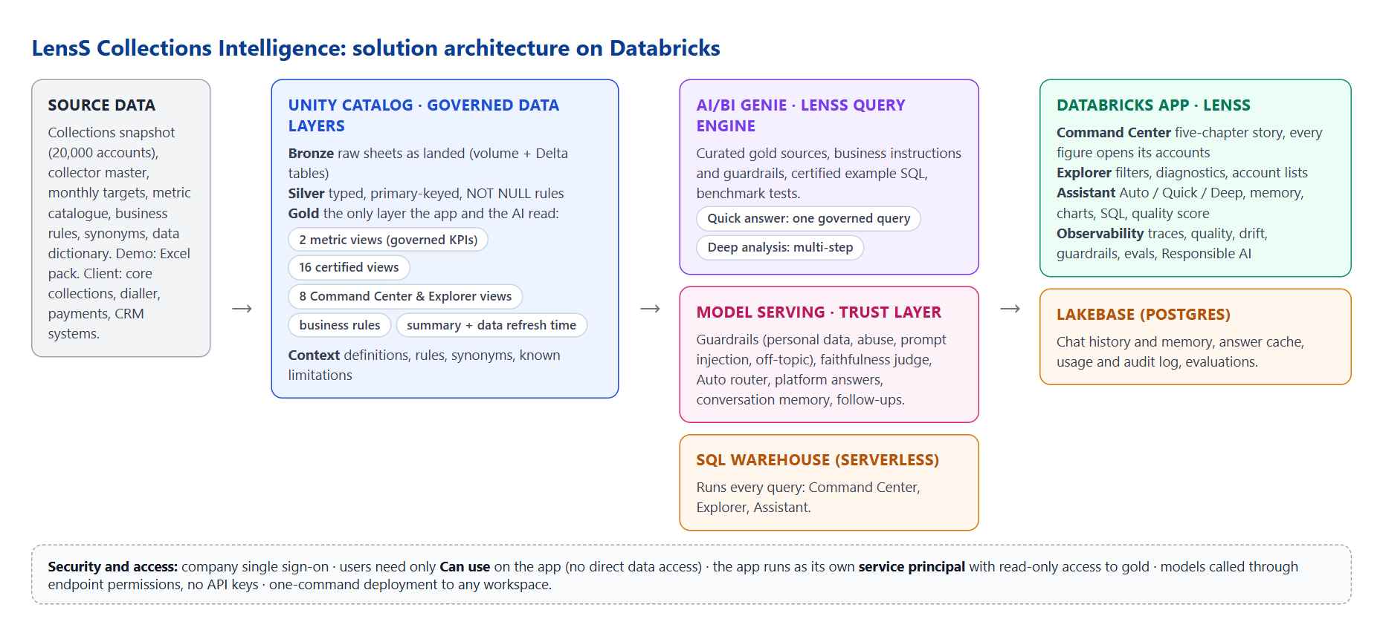
Figure 1. Solution architecture

Components and why they were chosen
Layer | Component | Role in LensS | Why
Governance | Unity Catalog | Bronze, silver, gold and context schemas; all permissions | One place for access control, lineage and audit
Storage | Volume + Delta tables | The raw workbook and one table per sheet | Governed landing zone; reproducible loads with row-count checks
Semantic layer | Metric views | Two governed KPI models (performance vs target; collections funnel) | KPIs defined once; no double counting
Semantic layer | Certified and Command Center views | 16 certified views and 8 Command Center and Explorer views | Approved logic shared by the dashboards and the AI
AI | Genie (LensS query engine) | Curated sources, instructions, certified examples, benchmarks; Chat and Agent modes | Natural language to governed SQL; multi-step analysis
AI | Model serving | Guardrails, faithfulness judge, Auto router, platform answers, conversation memory, follow-ups, empty-result notes | Each feature switchable per deployment; no API keys
Compute | Serverless SQL warehouse | Runs every query from every tab | Starts in seconds; scales with users
Application | Databricks Apps | Hosts the LensS web app (Node.js, AppKit) | Single sign-on built in; the app has its own identity
Operational data | Lakebase (Postgres) | Chat history and memory, answer cache, usage and audit log, evaluations | Fast transactional reads and writes; Databricks OAuth
Deployment | Deploy script + Databricks CLI | Creates or updates everything with one command | Repeatable and portable across workspaces

Security and access model
- Users sign in with company single sign-on and need only Can use on the app. They get no direct access to tables, the warehouse, the Genie space or Lakebase.
- The app runs as its own service principal with read-only access to the gold layer, run access to the Genie space, use of the warehouse, query access to the model endpoints, and read/write on its own Lakebase tables.
- No personal data. The data holds account and customer tokens only. Guardrails mask personal data in questions before they reach the engine and in answers before they are shown.
- Everything is auditable. Who asked what, the checks, the SQL, rows, timings, scores and ratings are logged per question and visible in Observability.

4. Data foundation

The demo dataset
A synthetic but realistic collections portfolio designed to exercise the full question set. No real customer data is used; identifiers are synthetic tokens.
Dataset | Grain | Volume | Content
Fact_Collections_Snapshot | One row per account per snapshot date | 20,000 accounts · 15 Sep 2026 (19,035 past due) | Product, arrears stage, balances, month-to-date recovery and cost, contact attempts, right-party contact, promises, broken promises, cure and roll flags, strategy, preferred channel and language, vulnerability, dispute, and model scores (payment propensity, non-payment risk, recovery opportunity, primary non-payment driver)
Dim_Collector | One row per collector | 80 collectors | Team, region, specialisation, status
Fact_Targets | Month × product × arrears stage | 30 rows | Monthly target, eligible balance, daily target
Context sheets | Reference | 8 sheets | Metric catalogue, business rules, synonyms, query catalogue, data dictionary, model requirements, acceptance tests, README
Products: Credit Card, Personal Loan, Auto Loan, Mortgage, SME Loan. Arrears stages: 1–30, 31–60, 61–90, 91–180 and 180+ days past due (DPD). Channels: Voice, WhatsApp, SMS, Email, Digital Self-Cure, Field.

Layered data design (medallion architecture)
Layer | Schema | What it holds | Why it matters
Bronze | lenss_collections_bronze | Source sheets landed exactly as received, plus the raw file in a governed volume | Full traceability to the source
Silver | lenss_collections_silver | Typed, cleaned tables with a primary key and NOT NULL rules | Reliable joins; the engine understands relationships
Gold | lenss_collections_gold | 2 metric views, 16 certified views, 8 Command Center and Explorer views, business-rules configuration, executive summary and data refresh time | The only layer the app and the AI read
Context | lenss_collections_context | Metric definitions, rules, synonyms, known limitations, demo question sequence | Business knowledge captured as governed data

Metric views
A metric view defines business measures once, with the dimensions they can be sliced by. Any tool asks for a measure by name and gets the same governed calculation: rates are always sum of numerators over sum of denominators, and targets are aggregated at their own grain before joining, which prevents double counting.
Metric view | Purpose | Example measures
mv_performance_targets | Performance against the monthly target | Collections, target, achievement %, target gap, outstanding balance
mv_collections_funnel | The collections funnel and strategy effectiveness | Contact and right-party contact rates, promise conversion, promises kept and broken, cure, roll forward and back, cost to collect, high-risk accounts, recovery opportunity

Certified and Command Center views
Sixteen certified views hold the approved logic for the key business questions (for example progress vs target, shortfall contribution, non-payment drivers, the immediate-intervention list with its recommended action, over-contact risk, like-for-like strategy comparison, recommended channel and the collector scorecard). Eight Command Center and Explorer views add the KPIs, risk snapshot, target outlook, action queues, channel and region views, and the account-level Explorer base that every account list reads.

Business rules captured as data
Rule | Setting
Population (accounts in collections) | DPD > 0 and outstanding balance > 0, on the snapshot date
High-risk account (R07) | Non-payment risk ≥ 0.70
Priority account / immediate intervention (R08) | Non-payment risk ≥ 0.70 and payment propensity ≥ 0.25
Kept / broken promise | Kept when at least 90% of the promised amount was paid by the due date; only promises already due can be broken
Cured account | At least 90% of the outstanding balance recovered
Over-contact risk | Groups of 30+ accounts averaging 4.5+ contact attempts this month
Minimum volume | At least 30 accounts before ranking or recommending on a segment (50 for channel recommendations)

5. The AI and its safeguards

The LensS query engine (Genie)
Element | In LensS | Purpose
Curated sources | Gold metric views, certified views and the business-rules configuration | The engine sees only governed, analysis-ready data
Instructions | Scope, calculation rules and prohibitions | Business knowledge and guardrails in the engine itself
Certified examples | Question-and-SQL pairs for the common questions | Teaches the approved way to answer
Benchmarks | Test questions with expected answers, including refusal tests | Measures accuracy after every change

 | Quick answer | Deep analysis
Best for | "What", "how much", "which" | "Why" and "what should we do"
How it works | One governed SQL query and a narrative answer | Plans, runs several queries, reasons between steps, builds charts, writes a report
Typical time | About 20 seconds | 1–3 minutes

How a question is answered
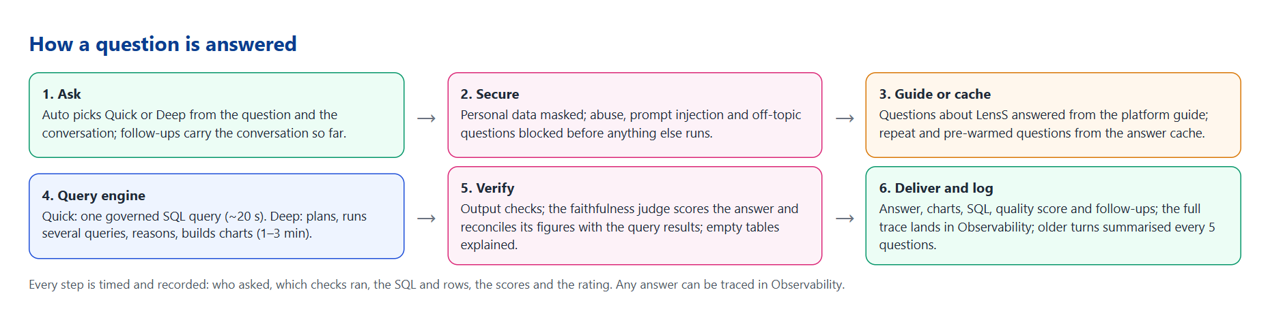
Figure 2. How a question is answered

One assistant, whichever path answers
- Auto (the default) picks Quick or Deep with a small model or a word rule. It reads the conversation: a short follow-up to a deep analysis stays deep, and a "why" after a quick answer can go deeper.
- Conversation memory. Every follow-up carries the conversation so far: a summary of older turns plus the recent questions and answers, across both modes and including cached and platform answers. Older turns are summarised every 5 questions.
- Questions about LensS itself ("What is LensS?", "How do I filter in the Explorer?") are answered from a written platform guide; data questions go to the engine as usual. Switchable per deployment.
- Empty tables are never shown. A result with no rows is replaced by a one-line reason.

Safeguards
Safeguard | What it does
Input guardrails | Personal data masked (email, phone, card, Aadhaar, PAN and more); abuse and prompt injection blocked; off-topic questions caught by a classifier
Engine instructions | In scope only; no causal uplift claims; no probability of hitting target or forecasts beyond the month; no personal data; disputes and vulnerable customers routed to support
Output checks | Personal data and profanity removed; forecast, causal and probability wording flagged
Faithfulness judge | Every figure in an answer checked against the query results, plus scores for faithfulness, relevance, completeness and safety; weak answers show a warning
Feedback loop | 👍/👎 with reasons; complaints reviewed in Observability and turned into evaluation cases
Evaluations | A suite of ground-truth, red-team and policy cases, with run history

6. The LensS application
Four tabs. The Command Center loads first (its data is prepared when the app starts and drawn top to bottom); the Explorer and Observability then load in the background, so every tab opens instantly.

6.1 Command Center: one story in five chapters
Each chapter answers one question and opens with its answer in one sentence written from the certified figures; each figure appears once. A story bar under the banner jumps between chapters. KPI definitions (in the banner and at the foot of the page) explains every figure.

Chapter 1 · Are we on track?
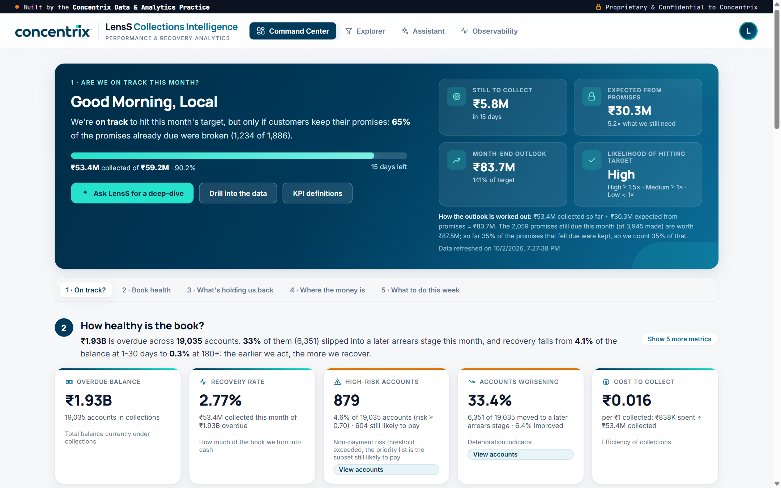
Figure 3. Chapter 1: the verdict, progress and month-end outlook
- Verdict: "We're on track to hit this month's target, but only if customers keep their promises: 65% of the promises already due were broken (1,234 of 1,886)." It reads "within reach" or "at risk" when the outlook is weaker.
- Progress: ₹53.4M collected of ₹59.2M (90.2%), 15 days left.
- Tiles: still to collect ₹5.8M; expected from promises ₹30.3M (5.2× what we still need); month-end outlook ₹83.7M (141% of target); likelihood High.
- How the outlook is worked out (shown under the tiles): "₹53.4M collected so far + ₹30.3M expected from promises = ₹83.7M. The 2,059 promises still due this month (of 3,945 made) are worth ₹87.5M; so far 35% of the promises that fell due were kept, so we count 35% of that." Likelihood is High at ≥ 1.5× coverage, Medium at 1–1.5×, Low below 1×. Data refreshed on shows when the data was last loaded.

Chapter 2 · How healthy is the book?
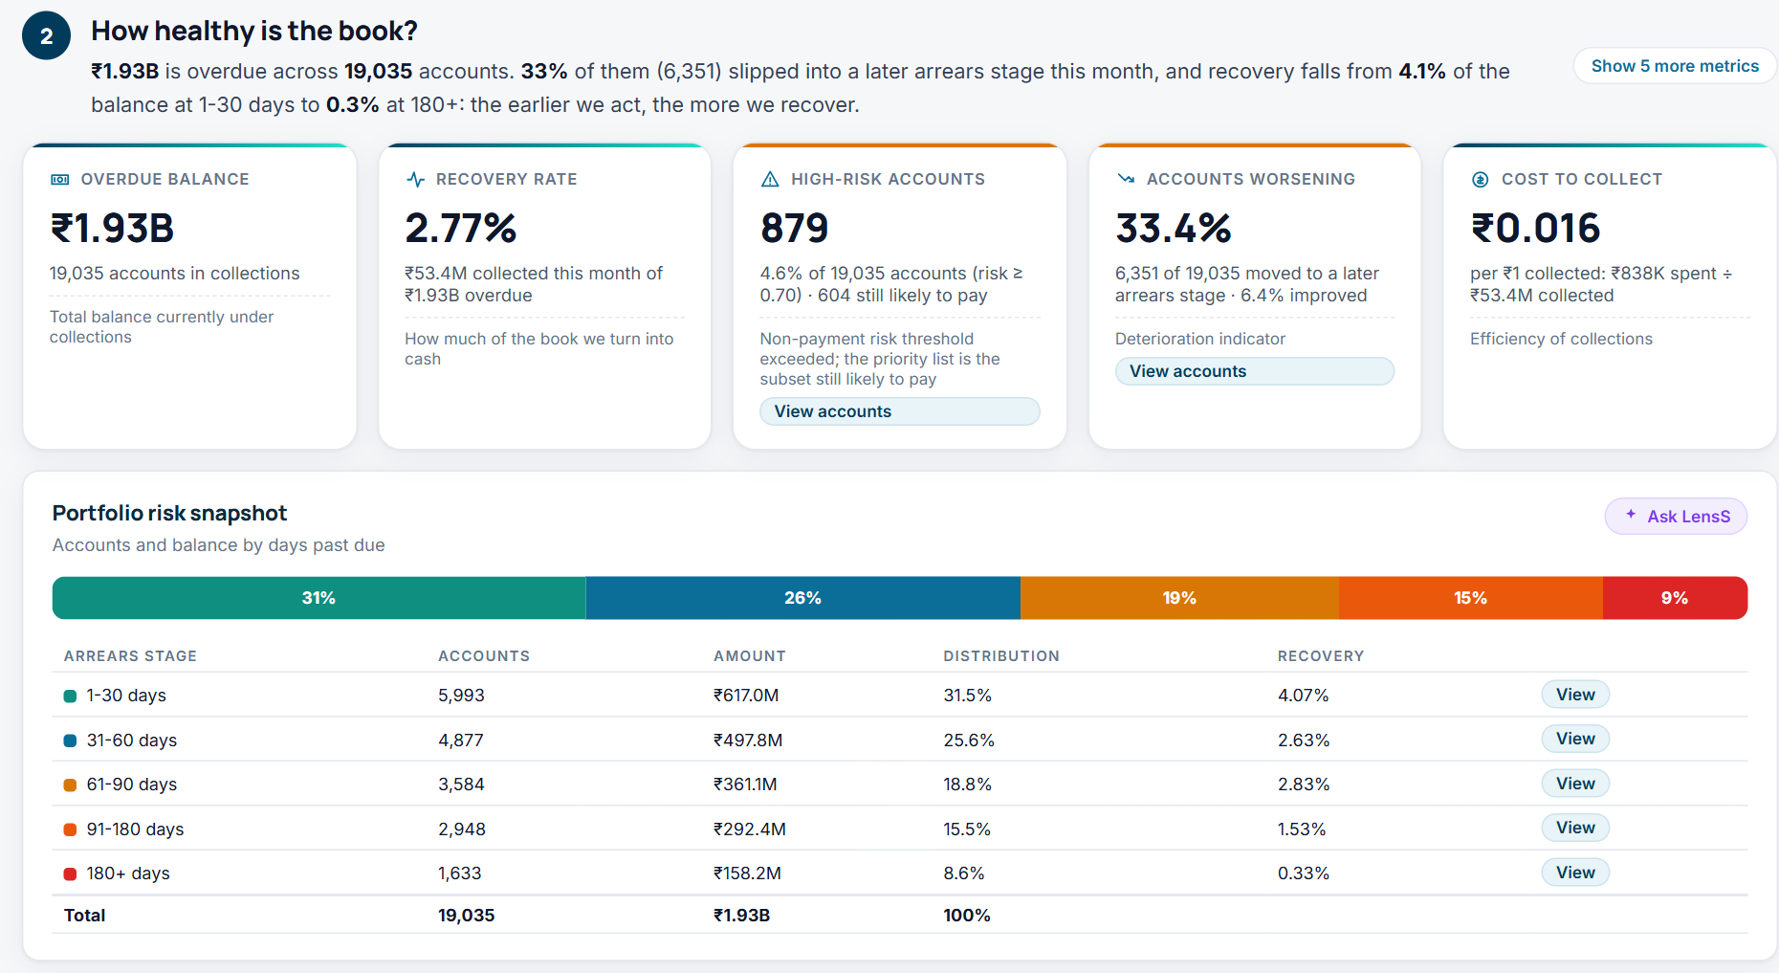
Figure 4. Chapter 2: vital signs and the arrears-stage snapshot
- Overdue balance ₹1.93B across 19,035 accounts; recovery rate 2.77% (₹53.4M collected of ₹1.93B); 879 high-risk accounts (4.6% of 19,035; 604 still likely to pay); 33.4% of accounts worsened this month (6,351 of 19,035; 6.4% improved); cost to collect ₹0.016 per ₹1 (₹838K spent ÷ ₹53.4M collected).
- Every rate says what it is out of ("X of Y"), so nobody has to look elsewhere for the base.
- Show 5 more metrics: customers reached 47.4% (8,563 of 18,074 we tried), agreed to pay 46.1% (3,945 of 8,563), promises honoured 34.6% (652 of 1,886), amount promised, contact attempts per customer 4.5 (calls, SMS, WhatsApp and email, answered or not).
- Risk snapshot: accounts, balance and recovery by arrears stage; recovery falls from 4.1% at 1–30 days to 0.3% at 180+.

Chapter 3 · What is holding us back?
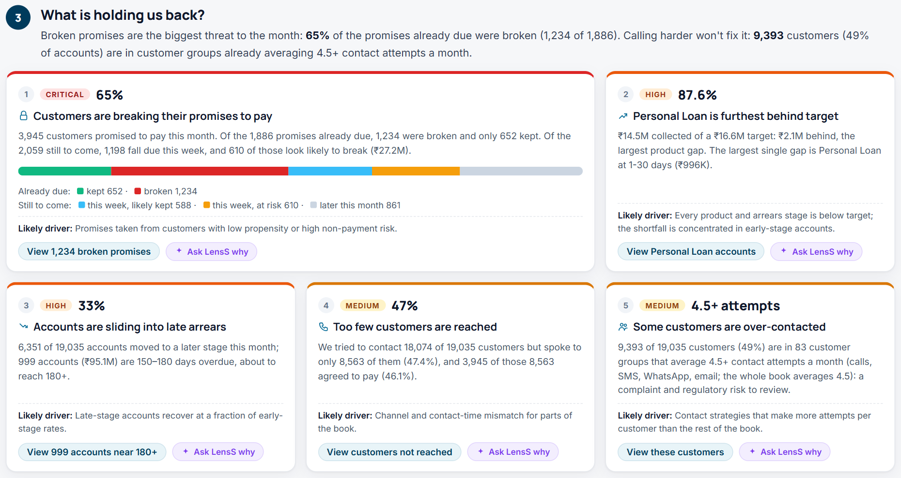
Figure 5. Chapter 3: five issues ranked by risk and money
# | Severity | Issue | Figures
1 | Critical | Customers are breaking their promises to pay | 3,945 customers promised to pay this month. Of the 1,886 already due, 1,234 were broken and 652 kept. Of the 2,059 still to come, 1,198 fall due this week and 610 look likely to break (₹27.2M). A bar shows the five parts
2 | High | Personal Loan is furthest behind target | 87.6% of target, ₹2.1M behind; largest single gap Personal Loan at 1–30 days (₹996K)
3 | High | Accounts are sliding into late arrears | 33% worsened; 999 accounts (₹95.1M) at 150–180 days
4 | Medium | Too few customers are reached | We tried to contact 18,074 of 19,035 customers but spoke to only 8,563 (47.4%); 3,945 of those agreed to pay (46.1%)
5 | Medium | Some customers are over-contacted (headline "4.5+ attempts") | 9,393 of 19,035 customers (49%) are in 83 groups averaging 4.5+ contact attempts a month; the whole book averages 4.5
Each issue has its likely driver, View accounts and Ask LensS why (a deep analysis). Issues 4 and 5 do not contradict each other: issue 5 counts contact attempts (answered or not), issue 4 counts customers actually spoken to. We try about 4.5 times per customer but reach fewer than half, so the answer is the right channel at the right time, not more calls. The 4.5 cut-off was set during the build, because the data pack's sample rule (6+) finds nothing in this data.

Chapter 4 · Where is the money?
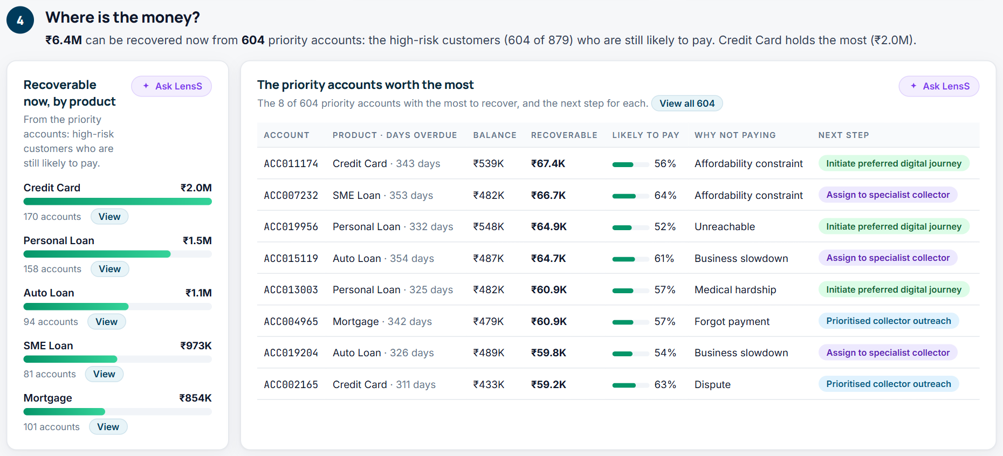
Figure 6. Chapter 4: recoverable now, and the priority accounts worth the most
- ₹6.4M can be recovered now from 604 priority accounts: high-risk customers still likely to pay. Credit Card holds the most (₹2.0M).
- The 8 priority accounts worth the most, with why they aren't paying and the next step for each; View all 604.

Chapter 5 · What should we do this week?
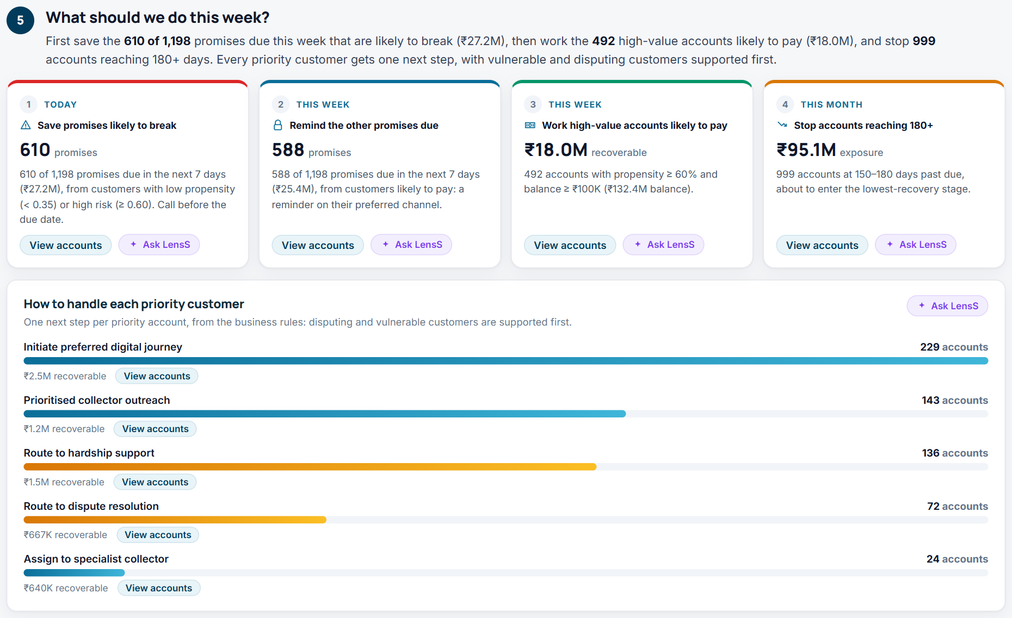
Figure 7. Chapter 5: the work queues and how to handle each priority customer
# | When | Queue | Size | Rule
1 | Today | Save promises likely to break | 610 · ₹27.2M | Due in 7 days; propensity < 0.35 or risk ≥ 0.60
2 | This week | Remind the other promises due | 588 · ₹25.4M | Due in 7 days, likely to be kept
3 | This week | Work high-value accounts likely to pay | 492 · ₹18.0M recoverable | Propensity ≥ 0.60 and balance ≥ ₹100K
4 | This month | Stop accounts reaching 180+ | 999 · ₹95.1M exposure | 150–180 days past due
How to handle each priority customer: one next step per account from the intervention rule in the data pack, checked in order: dispute → dispute resolution (72); vulnerable → hardship support (136); broken promise with propensity ≥ 0.35 → immediate follow-up; not reached and prefers a digital channel → digital journey (229); risk ≥ 0.80 and balance ≥ ₹50K → specialist collector (24); otherwise prioritised outreach (143).

View accounts
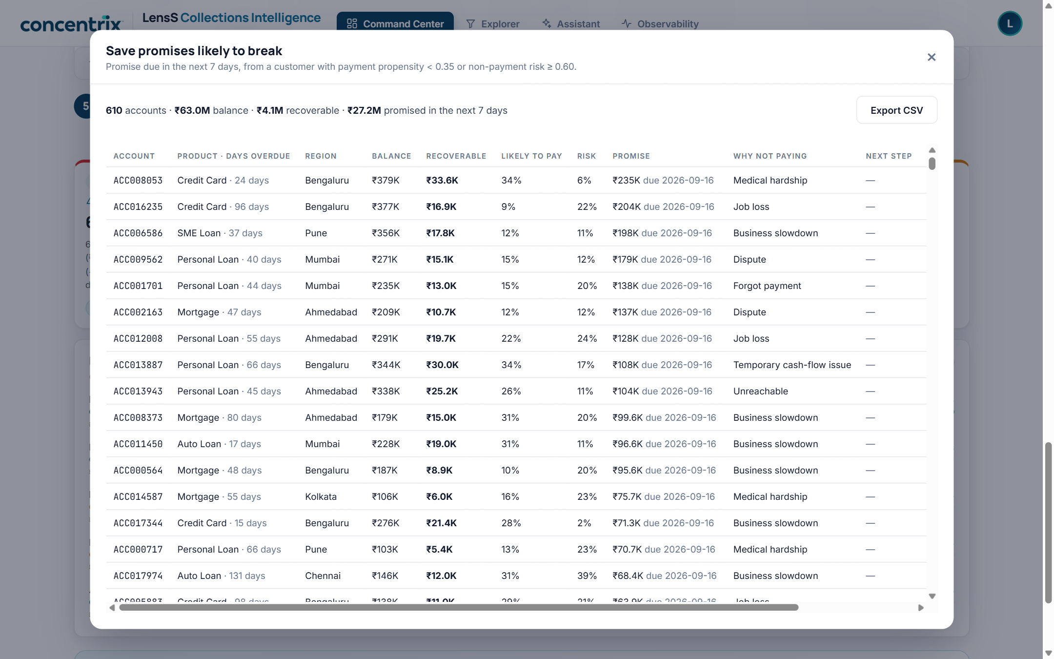
Figure 8. Every figure opens its accounts: here, the 610 promises likely to break
Every card, issue, queue, stage, product and next step has View accounts: the exact accounts behind the number (same rule, same count), with balance, recoverable amount, likelihood to pay, risk, promise, reason for non-payment, next step and collector, plus totals and Export CSV. Lists over 1,000 accounts show and export the first 1,000.

6.2 Explorer
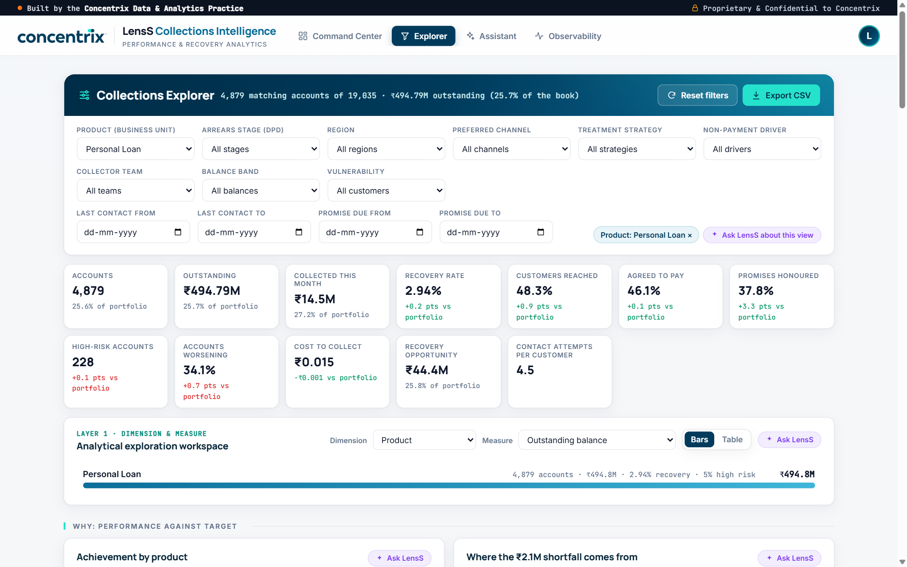
Figure 9. Explorer filtered to Personal Loan: each KPI compared with the portfolio
- Filters: product, arrears stage, region, preferred channel, treatment strategy, non-payment driver, collector team, balance band, vulnerability, last-contact and promise-due dates.
- 12 KPI tiles for the filtered slice, with the share of the portfolio or the difference in points, green when better and red when worse. With no filters, the Explorer reconciles exactly to the Command Center.
- Workspace: any dimension × measure, as bars (portfolio average marked) or a table; click a bar to filter.
- Diagnostic panels: achievement by product, where the shortfall comes from, a product × stage heatmap, non-payment drivers, treatment strategies (observational), the funnel from arrears to payment, channel effectiveness, best channel per stage, regions and collectors. Every item has View; heatmap cells are clickable.
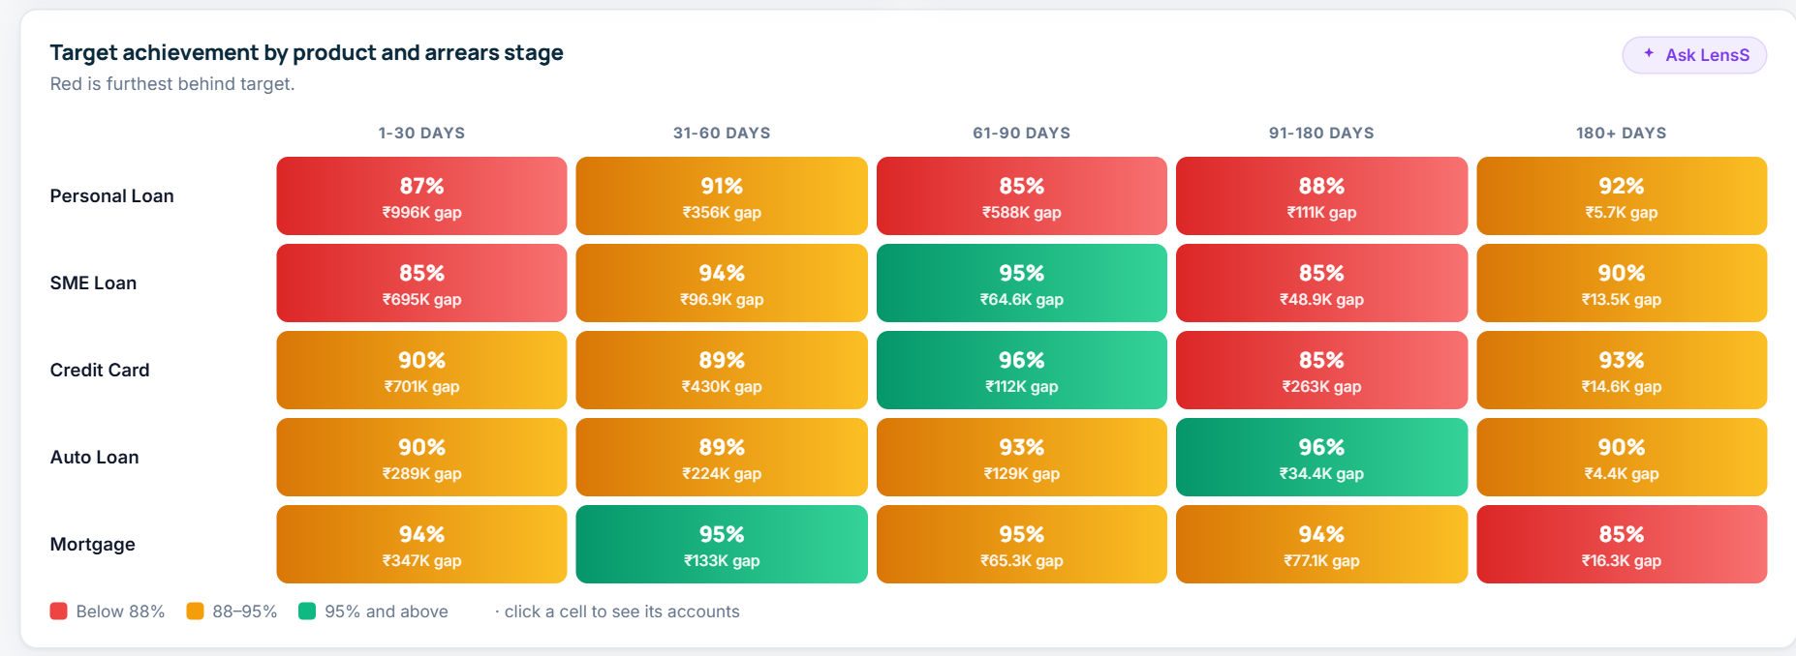
Figure 10. Target achievement by product and arrears stage; click a cell to see its accounts
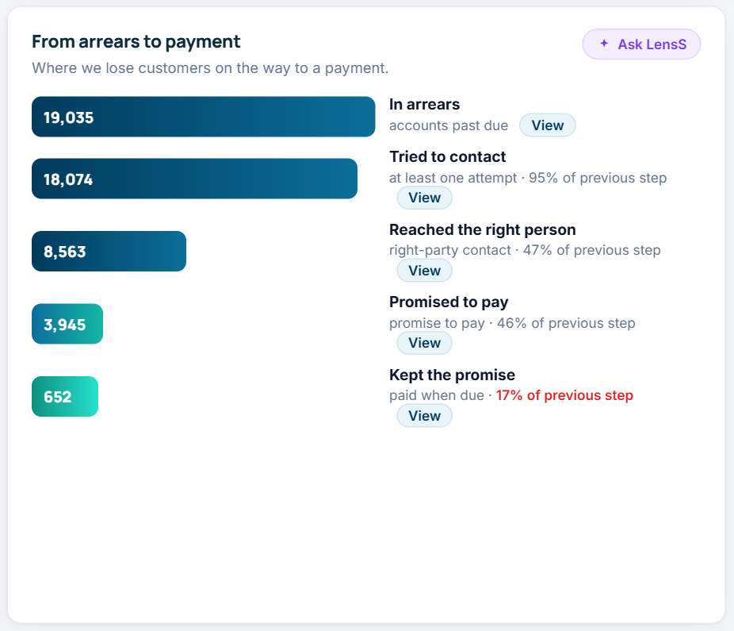
Figure 11. From arrears to payment, with the accounts at each step
- Accounts behind the numbers: the 500 with the most recovery opportunity in the current filters, with search, sort and Export CSV.

6.3 Assistant
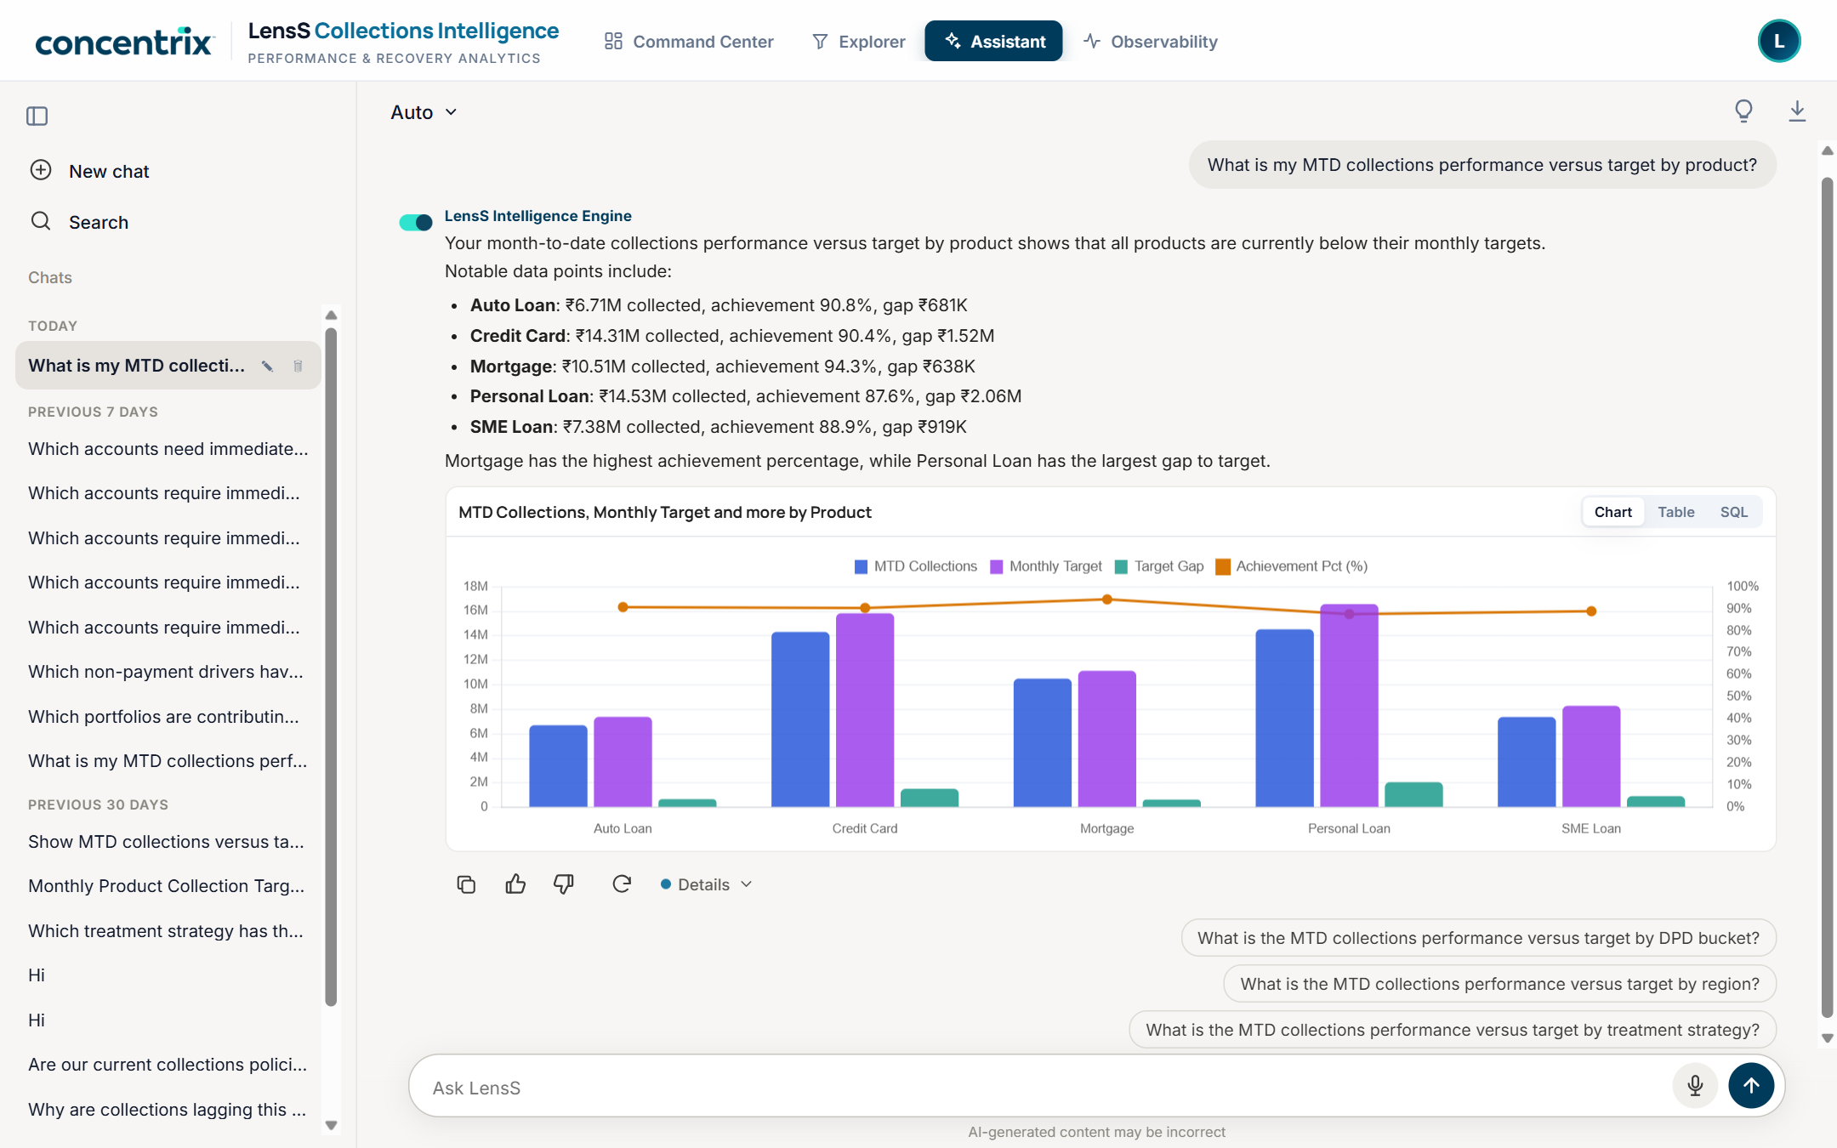
Figure 12. A quick answer with its chart (Chart / Table / SQL), actions and suggested follow-ups
- Modes: Auto (default), Quick answer, Deep analysis. Deep analyses show their progress and can run while the user works elsewhere; a notification says when the answer is ready.
- Under each answer: copy, 👍/👎, regenerate and Details: the quality score, data sources, safety checks and how the answer was made, including the SQL.
- Help to start: quick-start prompts and a categorised question library (executive, diagnostic, operational, risk and conduct, strategy). Suggested questions are pre-answered after each data refresh, so they return in seconds.
- Conversation: private chat history per user, named from the first question, with search, rename, delete and PDF export.

6.4 Observability
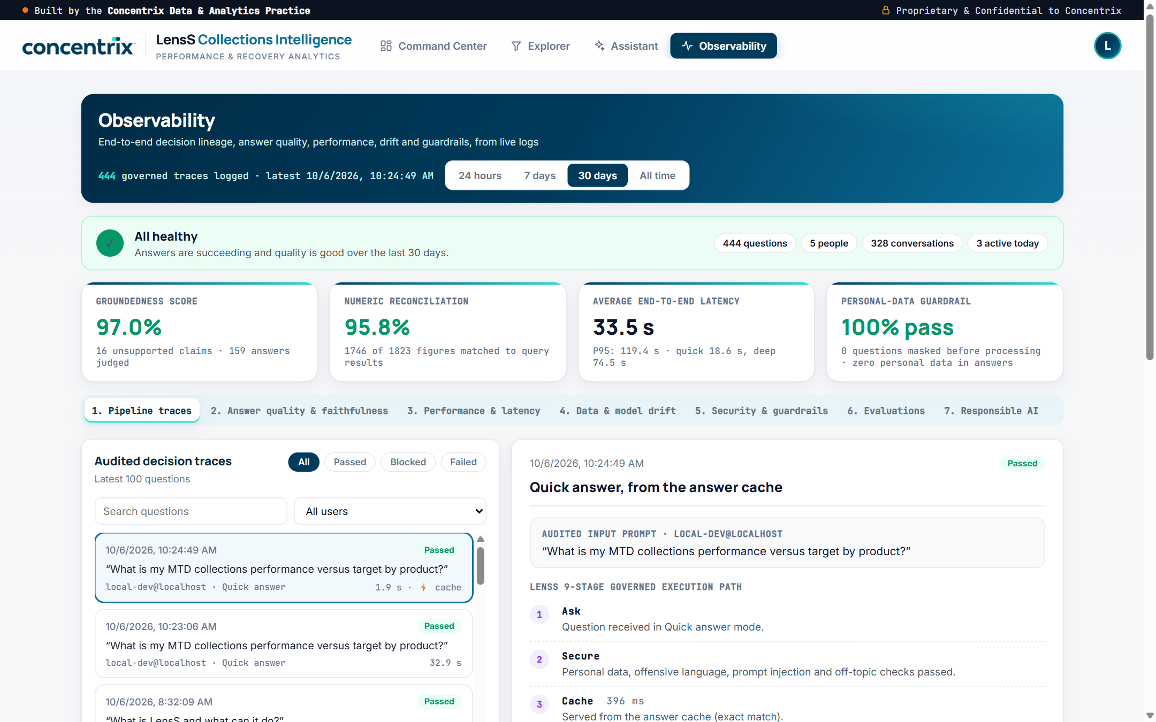
Figure 13. Observability: health, headline measures and a governed decision trace
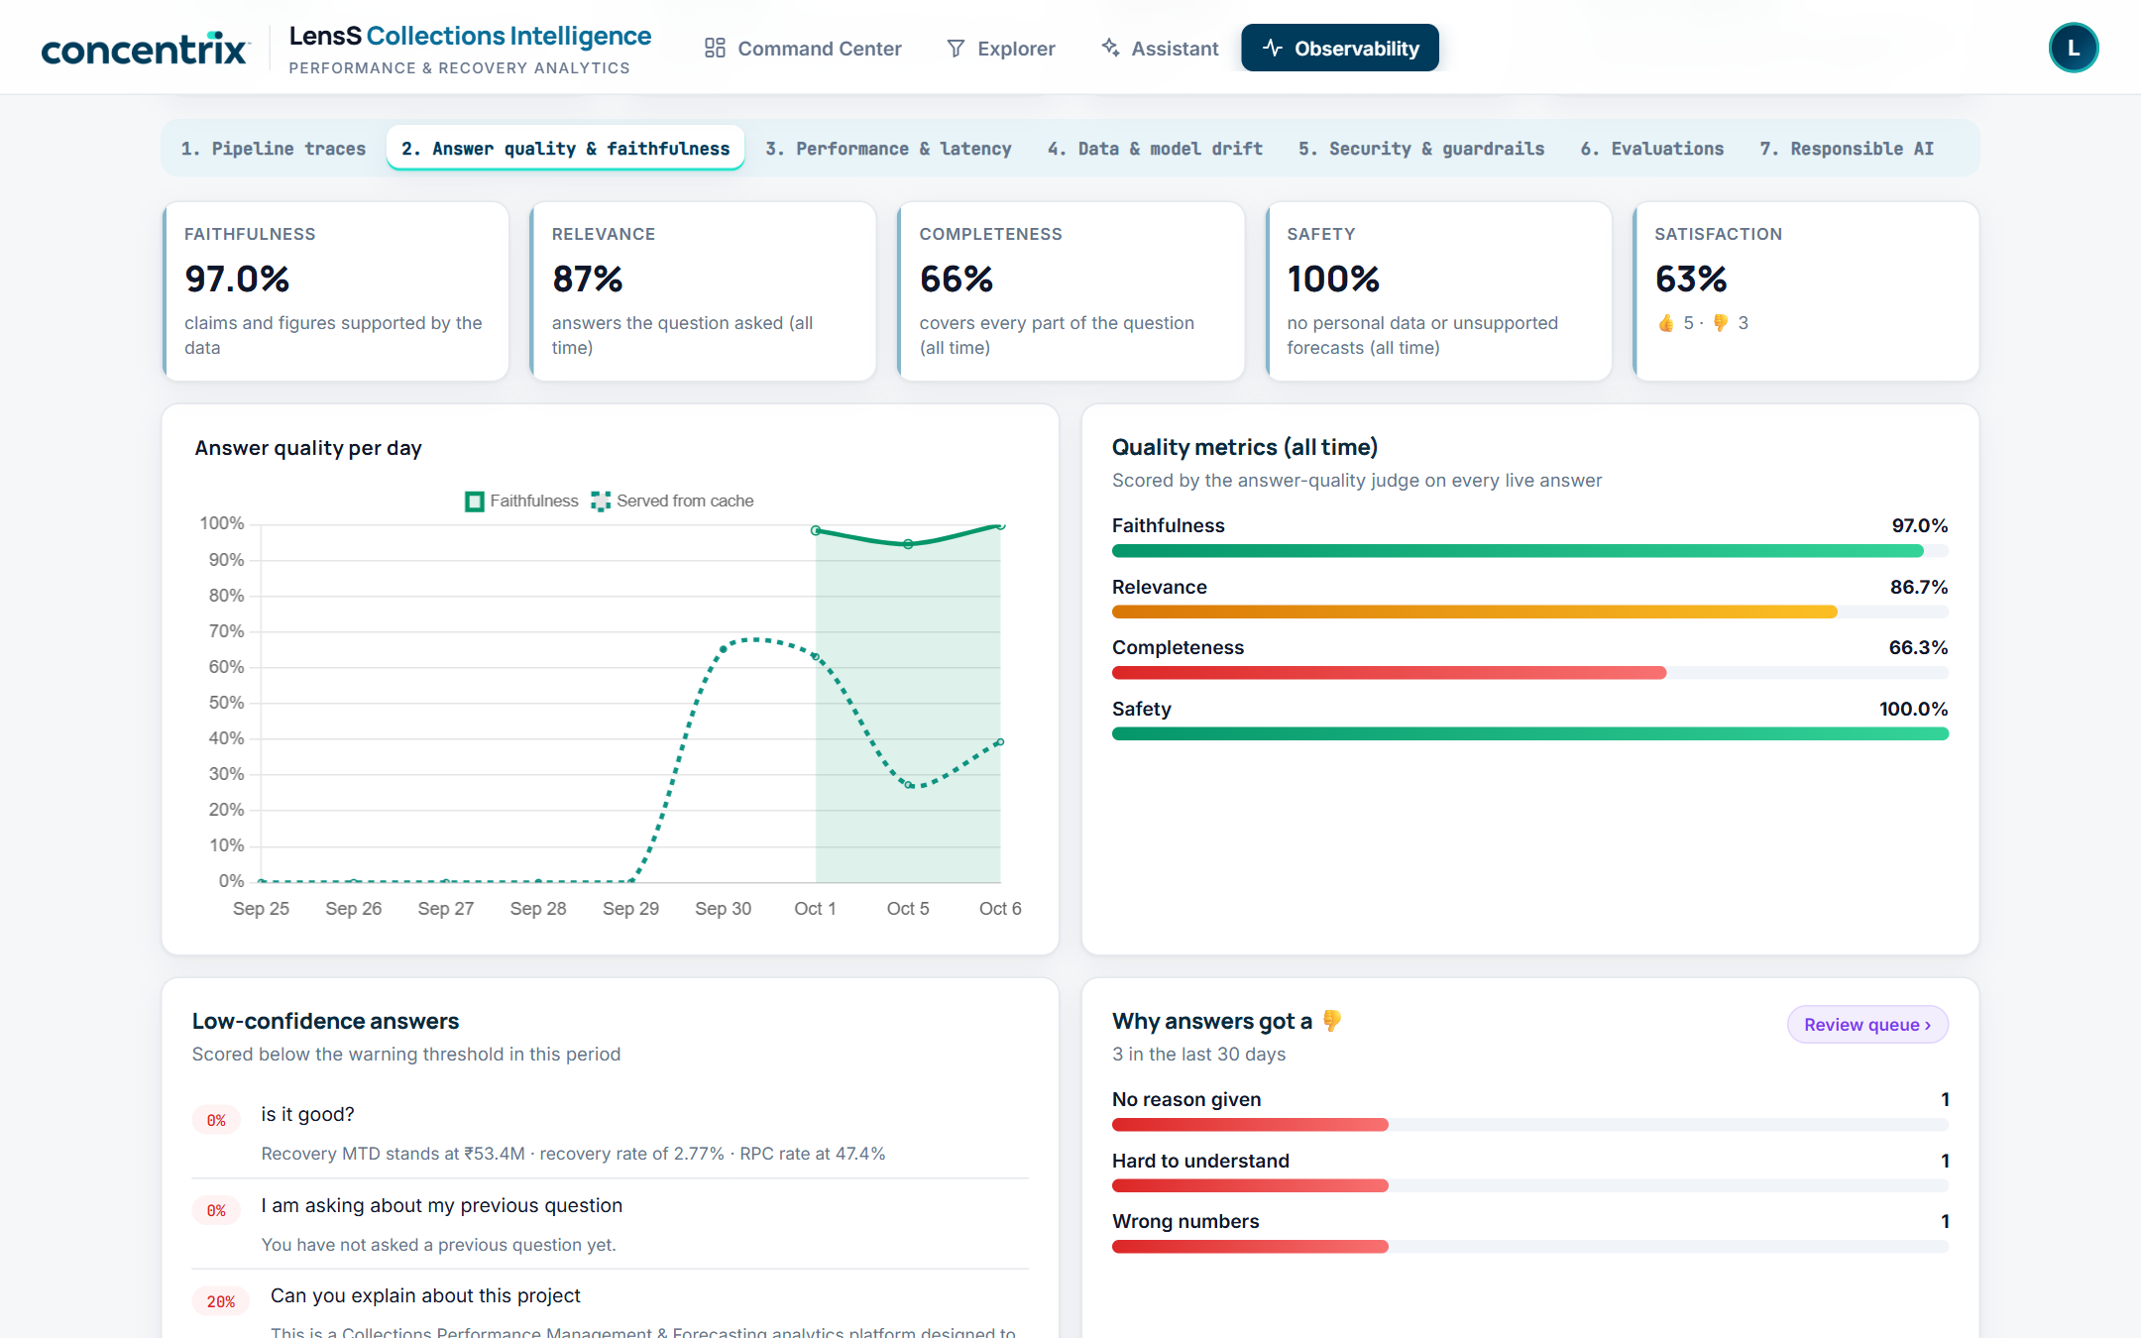
Figure 14. Answer quality and faithfulness
Area | What it shows
1. Pipeline traces | Every question as a governed path (ask, secure, cache, plan, retrieve, verify, synthesise, deliver, log) with timings and SQL
2. Answer quality & faithfulness | Faithfulness, relevance, completeness, safety, satisfaction; low-confidence answers; reasons for 👎; the feedback review queue
3. Performance & latency | Answer times by mode and where the time goes
4. Data & model drift | Quality and usage trends over time
5. Security & guardrails | What the guardrails masked or blocked
6. Evaluations | Run the evaluation suite and compare runs
7. Responsible AI | Purpose, models and what each is used for, data, protections and limits

7. Deployment and operations
One automated, repeatable command creates or updates every component in a workspace. Each step is safe to re-run, and steps can be run on their own.
Step | What it does
schemas | Creates the four schemas and the raw-files volume
ingest | Uploads the workbook and lands every sheet as a table, verifying row counts
context | Creates the governance and context tables
transform | Builds silver, the business-rules configuration, metric views and certified views
views | Builds the Command Center and Explorer views
summary | Writes the executive summary and the data refresh time
genie | Creates or updates the query engine (sources, instructions, examples, benchmarks)
lakebase | Creates or upgrades the app database (chat history, memory, cache, logs, evaluations)
app | Creates or updates the app, its resources and permissions, and deploys the code
smoke | End-to-end test of the deployed app as a non-admin identity (27 checks)
Situation |  | Run
App code changed |  | --only app
A release with view, summary or database changes |  | --only lakebase,views,summary,genie,app
New data in the workbook |  | --only ingest,transform,views,summary,app
A new workspace |  | Everything (no --only)
- Configuration per workspace: one config file each; every AI feature (semantic cache, guardrails, judge, follow-ups, Auto, platform questions, memory, evaluations) can be switched on or off.
- Caching: Command Center results are kept until the data changes; the 10 suggested questions are pre-answered after each data or engine change; repeat questions are answered from the cache, with Refresh to ask again live.
- Testing: each release is checked with the deployed smoke test (27 checks) and a click-through of every screen; the results are recorded in the change log.
Full instructions: SETUP_GUIDE.md and README.md in the project repository.

8. Before the demo

Checklist
- Deploy the latest version the day before and check the deploy log ends with the app URL and no errors.
- Confirm the suggested questions are pre-answered: the app's logs show "pre-warm finished: 10/10 answered".
- Open the app 10 minutes early so the warehouse is warm; click through all four tabs once.
- Check the numbers match Appendix A (₹53.4M, ₹59.2M, 610, 604). If they differ, use the screen.
- Start a fresh chat, and clear rehearsal chats from the history.
- Browser: zoom 100%, notifications allowed for the app, other tabs closed.
- Have a backup: screenshots of each chapter and one completed deep analysis.

Presenter tips
- Read each chapter's first sentence, then point at one figure and open its accounts.
- Start a deep analysis early (chapter 3) so it is ready by the Assistant scene.
- Address each role in the room once: collections, finance, risk, data, operations (section 9).

9. Demo script (20 minutes)
Time | Segment | What the room should take away
00:00 | Opening | Leaders get reports, not decisions, and can't trust AI on their numbers
02:00 | Command Center, chapters 1–5 | From "are we on track?" to "who do we call today", every number traceable to accounts
10:00 | Explorer | Anyone can slice the portfolio, without writing a query
13:00 | Assistant | Plain-language questions, real analysis, with the working shown
17:00 | Observability | Every AI answer traced, scored, guarded and auditable
19:00 | Close | A pilot on their own portfolio is the next step

Scene by scene
Scene | Say | Do
Opening | "Every collections leader starts the day with five questions. LensS answers them on one page, in order, and lets you ask anything else, with AI you can audit." | Command Center, top of the page
1 · On track? | "We're on track, but only if customers keep their promises: 65% of promises already due were broken." | Point at the outlook tiles and how the outlook is calculated
2 · Book health | "₹1.93B overdue; a third of accounts slipped this month; recovery falls from 4% to 0.3% as debt ages." | View accounts on High-risk accounts; mention Export CSV
3 · Holding us back | "Broken promises are critical, and over 9,000 customers are already over-contacted, so calling harder isn't the answer." | Hover, then click Ask LensS why on the critical issue (it runs in the background)
4 · The money | "₹6.4M recoverable now from 604 priority accounts; here are the eight worth the most." | Point at the accounts and their next steps
5 · This week | "Save 610 promises today, remind 588, work 492 high-value accounts, stop 999 reaching 180+, with vulnerable customers supported first." | View accounts on Today: the call list
Explorer | "The Command Center says what; the Explorer finds where." | Filter Personal Loan; click a red heatmap cell; View on "Kept the promise"; Reset
Assistant | "Just ask; Auto picks the depth." | Open the analysis from scene 3; show Details and the SQL; ask "Which of those should we fix first?"
Observability | "This is what your risk team will ask about." | Open the trace of the last question; answer quality; guardrails; Responsible AI
Close | "Where you stand, why, where the money is and who to call today, all traceable. Next step: a pilot on your portfolio." | Agree next steps; take commercials offline

Tailor to the room
Who | Cares about | Show
Head of collections / COO | Target, productivity | Chapter 5 queues and account lists; next step per customer
CFO / finance | Cash, outlook, cost | Chapter 1 outlook; cost to collect by stage (late stage 13× more)
Risk / compliance | Conduct, vulnerable customers, audit | Over-contact issue; hardship and dispute routing; Observability
CIO / CDO | Architecture, governance, security | Certified views, SQL behind answers, Responsible AI, Databricks
Operations managers | Who to call, which channel | Explorer: best channel per stage, collectors, View on any segment

10. Safe questions
These ten are pre-answered after every data refresh, so they return in seconds. Type them exactly or click them from the Assistant's suggestions.
Mode | Question
Quick | What is my MTD collections performance versus target by product?
Quick | Which accounts require immediate intervention?
Quick | Which portfolios are contributing most to the shortfall?
Quick | Which channel should we use for each DPD bucket?
Quick | Which non-payment drivers have the lowest recovery rate?
Deep | Why are collections lagging this month and what should we do about it?
Deep | Are our current collections policies too aggressive? Look at over-contact risk, complaints and vulnerable customers.
Deep | Where is the biggest recovery opportunity and which channel should we use for each segment?
Deep | Why are so many promises to pay being broken, and which segments should we prioritise to fix it?
Deep | Which channels and contact times work best for reaching customers, and how should we change our contact strategy?
Good live follow-ups in the same chat: "Which of those should we fix first?", "And for Mumbai?", "Explain that in one paragraph for my CFO." Platform questions: "What is LensS?", "How do I filter by region in the Explorer?"

11. Demo boundaries
Say these, not more
Forecasts: the outlook is this month's sum (collected so far + the promises still due × the share being kept). With one snapshot there is no history to forecast from, and LensS says so if asked.
Strategy uplift: comparisons are like-for-like but observational. Proving causal uplift needs a randomised champion/challenger test.
Data: a synthetic sample portfolio with one month-to-date snapshot, in Indian rupees. Cost-to-collect levels use demo cost assumptions; compare segments, not the absolute level.
Commercials: no prices, timelines or named reference clients in the room; take them offline with the account lead.
KPIs: computed by certified SQL, never by AI; the AI explains and answers questions.

12. Questions and answers

Is the AI making up these numbers?
No. The Command Center and Explorer are SQL on certified views. In the Assistant, each answer shows its SQL, and a faithfulness judge checks its figures against the query results (Observability → Answer quality).

Does our data leave our environment?
LensS is built on Databricks and designed to be deployed in the client's own workspace: Unity Catalog for data, Genie for questions, Databricks-served models for the checks, Lakebase for chat history and Databricks Apps for the interface. Confirm specific security or residency requirements with the solution architect.

What about personal data?
The data holds account and customer tokens only. Guardrails mask personal data in questions and answers, and a request for names or phone numbers is refused (this is part of the automated test suite).

Why 879 high-risk but only 604 priority accounts?
The 604 are the high-risk accounts still likely to pay (propensity ≥ 0.25), so they are worth intervening on now.

Why is the target ₹59.2M when ₹1.93B is overdue?
The target is what we aim to collect this month, set per product and arrears stage, about 3% of the overdue book; it is highest for early-stage accounts (4.6% of balance at 1–30 days) and smallest at 180+ (0.4%).

Why is cost to collect only ₹0.016?
It is collection cost ÷ collected (₹838K ÷ ₹53.4M), and the sample data uses demo cost assumptions. The pattern is the point: late-stage debt costs 13 times more to collect than early-stage debt.

Where do the next steps come from?
From the intervention rule in the data pack's business rules and sample SQL, using raw account fields. Disputes and vulnerability are checked first; thresholds are configurable, and because the rule lives in one certified view, a change applies everywhere.

Can it forecast next month or prove which strategy works?
Not from one snapshot, and not without a controlled test; LensS states both limits rather than inventing numbers. Monthly loads and a champion/challenger design unlock both.

What if an answer is wrong?
Each answer carries a quality score and its SQL; users rate answers; low scores and 👎 appear in Observability for review and can become evaluation cases. Suggested questions are refreshed whenever the data changes.

How long to set up on our data, and what does it cost?
It depends on the data model and environment; scope it in a short discovery, and take commercials offline with the account lead.

Does it only work for collections?
Collections is the first use case built. The pattern (certified views, a story-led command center, a governed assistant with full observability) is general; applying it elsewhere is a discussion for discovery.

Appendix A. Key figures (sample data, 15 September 2026)
Measure | Value
Collected this month / monthly target | ₹53.4M / ₹59.2M · 90.2% achieved · ₹5.8M to go · 15 days left
Expected from promises / outlook | ₹30.3M (5.2× the gap) / ₹83.7M, 141% of target · likelihood High
Overdue balance / accounts | ₹1.93B / 19,035 accounts in collections (20,000 in the file)
Recovery rate | 2.77% of the overdue balance this month
High-risk / priority accounts | 879 / 604, with ₹6.4M recoverable now
Accounts worsening / improving | 33.4% (6,351) / 6.4% (1,211)
Contact funnel | 18,074 tried → 8,563 reached (47.4%) → 3,945 promised (46.1%) → 652 kept · 4.5 contact attempts per customer on average
Promises this month | 3,945 made · 1,886 already due (652 kept, 1,234 broken, 65%) · 2,059 still to come (₹87.5M): 1,198 due this week (₹52.6M; 610 likely to break, ₹27.2M; 588 likely kept), 861 later
Cost to collect | ₹0.016 per ₹1 (₹838K spent); 1–30 days ₹0.010, 180+ ₹0.132
Target by stage | 1–30 ₹28.2M · 31–60 ₹14.3M · 61–90 ₹11.2M · 91–180 ₹5.0M · 180+ ₹0.6M
Product gaps | Personal Loan 87.6% (₹2.1M behind) … Mortgage 94.3%; largest single gap Personal Loan 1–30 days (₹996K)
Recovery by stage | 4.07% at 1–30 days → 0.33% at 180+
Over-contact | 9,393 customers in 83 groups at 4.5+ contacts a month
Work queues | Save 610 (₹27.2M) · remind 588 (₹25.4M) · high value 492 (₹18.0M) · near 180+ 999 (₹95.1M)
Next steps for priority accounts | Digital journey 229 · prioritised outreach 143 · hardship support 136 · dispute resolution 72 · specialist collector 24
Recoverable by product | Credit Card ₹2.0M · Personal Loan ₹1.5M · Auto Loan ₹1.1M · SME Loan ₹973K · Mortgage ₹854K

Appendix B. Glossary
Term | Meaning
DPD / arrears stage | Days past due; accounts are grouped into 1–30, 31–60, 61–90, 91–180 and 180+
MTD | Month to date, up to the snapshot date
RPC (right-party contact) | Contact made with the actual customer
PTP (promise to pay) | A customer's commitment to pay; broken when it fell due and wasn't kept
Payment propensity / non-payment risk | Model scores from 0 to 1 that come with the data
Incremental recovery opportunity | Extra ₹ expected if we intervene (a field in the data)
Roll forward / roll back | Moving to a later / earlier arrears stage
Cost to collect | Collection cost ÷ amount collected (₹ per ₹1)
Priority account | Non-payment risk ≥ 0.70 and payment propensity ≥ 0.25
Specialist collector | An experienced collector for the hardest, highest-value cases (risk ≥ 0.80, balance ≥ ₹50K)
Metric view / certified view | Governed definitions of measures / approved SQL for key questions, in Unity Catalog
Genie (LensS query engine) | The Databricks AI/BI configuration that turns questions into governed SQL
Faithfulness | How far an answer's claims and figures are supported by the query results
Service principal | A non-human identity; the app uses its own, with least privilege
Lakebase | Databricks-managed Postgres, used for chat history, memory, cache and logs

