LensS Collections Intelligence
End-to-End Demo Guide

Conversational analytics for collections on the Databricks Data Intelligence Platform

Item | Detail
Use cases covered | UC1: Collections Performance Management & Forecasting · UC3: Collections Policy & Strategy Effectiveness
Demo data | Synthetic collections portfolio, 20,000 accounts, as of 15 September 2026 (no real customer data)
Recommended duration | 45 minutes (full storyline) or 20 minutes (executive version)
Document version | 1.0 · September 2026
Contents
1. About this guide 4
How to use it 4
2. Solution overview 5
The business problem 5
What LensS does 5
Use cases in scope 5
Why it is different 5
3. Architecture 7
Components and why they were chosen 7
Security and access model 8
4. Data foundation 9
The demo dataset 9
Layered data design (medallion architecture) 9
Metric views: what they are and why they matter 9
Certified views: approved answers to the key questions 10
Business rules captured as data 11
5. The Collections Agent (Genie) 12
Guardrails built into the agent 12
Chat mode and Agent mode 12
6. The LensS application 14
Command Center 14
Chat + Agent 15
Monitoring 17
7. Deployment and operations 19
8. Before the demo 20
Checklist (start 15 minutes before) 20
Presenter tips 20
9. Demo script and storyline 21
The storyline in one sentence 21
Run of show: 45-minute version 21
Opening (5 minutes) 21
Act 1: Situation (Command Center, 7 minutes) 21
Act 2: Diagnosis (Chat, 10 minutes) 22
Act 3: Investigation and action (Agent, 10 minutes) 22
Act 4: Trust (6 minutes) 23
Close (5 minutes) 23
20-minute executive version 23
10. Question bank 24
Performance monitoring (UC1) 24
Root-cause analysis (UC1) 24
Prioritisation and recommendations (UC1) 24
Policy and strategy effectiveness (UC3) 25
Guardrails and trust 25
11. Handling the unexpected 26
12. Demo boundaries 27
13. Questions and answers 28
Business story 28
Technical: architecture and data 29
Technical: AI agents and models 29
Assistant, GenAI and performance 30
Governance and trust 32
Technical stack 33
Implementation 33
Costs 34
Continuous improvement 34
Benefits and ROI 35
Appendix A. Key figures (demo data, as of 15 September 2026) 36
Appendix B. Glossary 37

1. About this guide
This guide gives presenters everything needed to run a confident, end-to-end demonstration of LensS Collections Intelligence: the business story, how the solution is built and why, a timed demo script with talking points and expected results, a curated question bank, and prepared answers to the technical, commercial and governance questions audiences typically ask.

How to use it
If you need to… | Go to
Understand the solution quickly | 2. Solution overview and 3. Architecture
Explain the data model, metric views and guardrails | 4. Data foundation and 5. The Collections Agent
Prepare the environment before a session | 8. Before the demo
Run the demo | 9. Demo script and storyline, plus 10. Question bank
Stay within what the demo data supports | 12. Demo boundaries
Answer audience questions | 13. Questions and answers
Look up a figure or a term during the session | Appendix A (key figures) and Appendix B (glossary)

Presenter golden rules
Lead with the business question, not the technology. Every screen answers a question a Collections Head actually asks.
Show the evidence. Open the SQL tab or the agent steps at least once: transparency is the strongest differentiator.
Warm up the platform 10 minutes before the session (section 8), so the first answer is fast.
Stay inside the boundaries in section 12. The demo data is synthetic and deliberately limited to a single snapshot.

2. Solution overview

The business problem
Collections leaders need fast, trustworthy answers to questions that today take analysts days: Are we going to hit target? Where exactly is the gap? Why is performance lagging? Which accounts should we act on first? Are our contact policies too aggressive? Answers are spread across dashboards, spreadsheets and ad-hoc SQL, and different teams often calculate the same KPI differently.

What LensS does
LensS lets collections leaders ask these questions in plain English and get governed, explainable answers in seconds to minutes, backed by the same certified metrics that drive the dashboard.
Capability | What the user gets
Command Center | An executive summary of the month, key KPIs, product achievement against target and a per-segment driver table, with no manual reporting.
Chat mode | Direct answers to specific questions in about 15–30 seconds: narrative, chart, data table and the exact SQL used.
Agent mode | Multi-step investigation of "why" and "what should we do" questions in 1–2 minutes: the agent plans, runs several queries, builds charts and writes a structured report of root causes and recommendations.
Monitoring | Usage, success rate, latency, user ratings and a full per-question audit trail, including every SQL query Genie ran.
Governance | Company single sign-on, app-only access for users, read-only access to governed data, built-in guardrails on PII, causal claims and out-of-scope requests.

Use cases in scope
Use case | Business objective | Typical questions
UC1 Collections Performance Management & Forecasting | As a Collections Head, understand whether the monthly target will be achieved, what drives performance, and what actions maximise recoveries. | MTD vs target · portfolio shortfall · root causes · accounts for immediate intervention · recovery opportunity · channel and collector performance
UC3 Collections Policy & Strategy Effectiveness | As a Collections Strategy Manager, continuously improve policies using data-driven insights. | Underperforming segments · strategy and channel effectiveness like-for-like · over-contact risk · vulnerable and disputed customer handling

Out of scope for this demo
UC2 (Agency Performance & Allocation) and UC4 (Workforce & Capacity) are part of the wider LensS roadmap but are not configured in this demo. The agent is instructed to say so if asked.

Why it is different
- Governed semantic layer. KPIs are defined once in Unity Catalog metric views and certified views, so the chat answer, the dashboard and the executive summary always agree.
- Answers run where the data lives. Queries execute inside the client's Databricks environment under its security model; data is never exported to a separate chatbot.
- Transparent by design. Every answer shows its SQL; Agent mode shows every reasoning step and query; Monitoring keeps a full audit trail.
- Agentic, not just conversational. Agent mode decomposes a business question into several analyses and consolidates them into a recommendation-ready report.
- Enterprise-ready. Single sign-on, least-privilege access, per-user history, feedback loop into Genie, and a one-command automated deployment to any workspace.

3. Architecture
LensS is built entirely on the Databricks Data Intelligence Platform. Data flows from source systems through governed layers in Unity Catalog into a curated semantic layer; the Genie-based Collections Agent answers questions against that layer; the LensS web app, hosted on Databricks Apps, brings it together for business users.
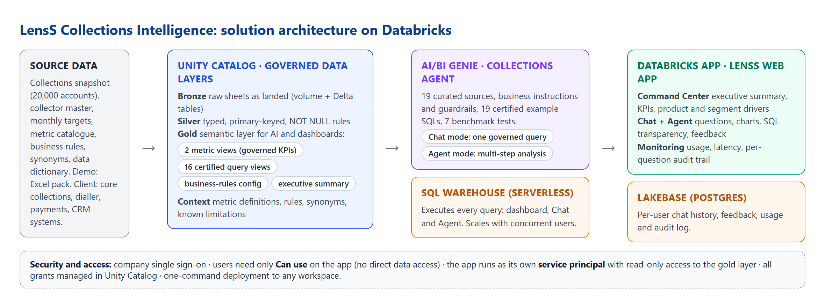
Figure 1. Solution architecture

Components and why they were chosen
Layer | Component | Role in LensS | Why
Governance | Unity Catalog | Catalog with bronze, silver, gold and context schemas; all permissions | One place for access control, lineage and audit across every workspace
Storage | UC Volume + Delta tables | Raw workbook and one table per sheet | Governed landing zone; reproducible loads with row-count checks
Semantic layer | Metric views | Two governed KPI models (performance vs target; collections funnel) | KPIs defined once; prevents double counting; lets Genie query measures by any dimension
Semantic layer | Certified views | 16 approved queries for the key business questions | Proven logic reused by the dashboard and the agent
AI | AI/BI Genie space | The Collections Agent: 19 curated sources, instructions, 19 certified examples, 7 benchmarks | Turns natural language into governed SQL; benchmarks measure accuracy
AI | Genie Agent mode | Multi-step reasoning, several queries, charts, structured report | Handles root-cause and recommendation questions
Compute | Serverless SQL warehouse | Runs every query from the dashboard, Chat and Agent | Starts in seconds; scales with concurrent users
Application | Databricks Apps | Hosts the LensS web app (Node.js / AppKit) | Single sign-on built in; no servers to manage; the app has its own identity
Operational data | Lakebase (Postgres) | Per-user chat sessions, messages, feedback, usage and audit log | Fast transactional reads and writes; no passwords (Databricks OAuth)
Deployment | Automated deploy script + Databricks CLI | Creates or updates everything in a workspace with one command | Repeatable, versioned, portable across workspaces

Security and access model
- Users sign in with company single sign-on and need only one permission: Can use on the LensS app, plus the lightweight Consumer access entitlement. They receive no direct access to tables, the warehouse or the Genie space.
- The app runs as its own service principal. It holds read-only access to the gold layer, Can run on the Genie space, Can use on the warehouse, and read/write on its own chat tables. Verified: a user with app access only is refused (403) if they try to open the Genie space or read the tables directly.
- Least privilege by design. The gold layer contains no direct personally identifiable information (PII); account and customer identifiers are tokens.
- Everything is auditable. The app records who asked what, the SQL generated, rows returned, timings and ratings; Databricks audit logs cover platform access.

4. Data foundation

The demo dataset
The demo uses a synthetic but realistic collections portfolio designed to exercise the full question set. No real customer data is used; identifiers are synthetic tokens.
Dataset | Grain | Volume | Content
Fact_Collections_Snapshot | One row per account per snapshot date | 20,000 accounts · as of 15 Sep 2026 | Product, DPD bucket, balances, MTD recovery, contact attempts by channel, RPC, PTP, broken PTP, cure and roll indicators, strategy, preferred channel and language, vulnerability, dispute, synthetic model scores (payment propensity, non-payment risk, recovery opportunity, primary non-payment driver)
Dim_Collector | One row per collector | 80 collectors | Team, region, specialisation, status, join date
Fact_Targets | Month × product × DPD bucket | 30 rows | Monthly target, eligible balance, daily target
Context sheets | Reference | 8 sheets | Metric catalogue, business rules, synonym catalogue, query catalogue, data dictionary, model requirements, acceptance tests, README
Products: Credit Card, Personal Loan, Auto Loan, Mortgage, SME Loan. Delinquency buckets: 1–30, 31–60, 61–90, 91–180 and 180+ days past due (DPD). Channels: Voice, WhatsApp, SMS, Email, Digital Self-Cure, Field.

Layered data design (medallion architecture)
Layer | Schema | What it holds | Why it matters
Bronze | lenss_collections_bronze | Source sheets landed exactly as received (plus the raw file in a governed volume) | Full traceability back to the source
Silver | lenss_collections_silver | Typed, cleaned tables with a primary key and NOT NULL rules | Reliable joins; Genie understands the relationships
Gold | lenss_collections_gold | 2 metric views, 16 certified views, business-rules configuration, executive summary | The only layer exposed to the agent and the app
Context | lenss_collections_context | Metric definitions, rules, synonyms, known limitations, demo question sequence | Business knowledge captured as governed data

Metric views: what they are and why they matter
A metric view is a Unity Catalog object that defines business measures (for example "Cure Rate" or "MTD Collections") once, together with the dimensions they can be sliced by. Any tool (Genie, dashboards, SQL) then asks for a measure by name and gets the same governed calculation.
- One definition of every KPI. "PTP conversion rate" means the same thing in every answer, chart and report.
- Correct aggregation, always. Rates are computed as sum of numerators over sum of denominators, never as an average of percentages. Targets are aggregated at their own grain before joining, which prevents the classic target double-counting error.
- Better AI accuracy. Genie selects a named, documented measure instead of re-deriving the formula, which reduces errors and ambiguity.
Metric view | Purpose | Example measures | Example dimensions
mv_performance_targets | Collections performance against monthly target | MTD collections, monthly target, achievement %, target gap, outstanding balance | Product, DPD bucket, region, vulnerability, strategy, channel, collector team
mv_collections_funnel | The full collections funnel and strategy effectiveness | Contact rate, RPC rate, PTP conversion, promise kept rate, broken promise rate, cure rate, roll-forward and roll-back rates, digital penetration, cost to collect, high-risk accounts, recovery opportunity, attempts by channel | Product, DPD bucket, balance band, language, strategy, channel, collector, contact hour, non-payment driver

Certified views: approved answers to the key questions
Sixteen certified views encode the approved logic for the most important business questions. They power the Command Center and give the agent proven building blocks.
Certified view | Answers
qry_mtd_vs_target | MTD collections vs target by product and DPD bucket
qry_product_vs_target | Achievement and gap by product
qry_product_bucket_performance | Over- and under-performing product × bucket combinations
qry_shortfall_contribution | Which segments contribute most to the total gap
qry_month_end_forecast | Deterministic month-end run-rate projection (see section 12)
qry_kpi_drivers | Recovery, RPC, PTP, broken promise and attempts by segment
qry_collections_funnel / qry_funnel_rates | Funnel volumes and conversion rates
qry_nonpayment_drivers | Recovery by primary non-payment driver
qry_immediate_intervention | High-risk, still-likely-to-pay accounts with a rule-based recommended action
qry_recovery_opportunity_sizing | Incremental recovery opportunity by segment
qry_over_contact_risk | Segments contacted 4.5+ times per account (conduct risk)
qry_underperforming_segments | Segments below the portfolio benchmark
qry_strategy_like_for_like | Strategy comparison matched on product, bucket, balance band and vulnerability
qry_recommended_channel | Best observed channel per DPD bucket
qry_collector_scorecard | Collector performance ranking

Business rules captured as data
Rule | Demo setting
Eligible population | DPD > 0 and outstanding balance > 0
Cured account | Recovered at least 90% of outstanding balance
Kept promise | Paid at least 90% of the promised amount by the due date; only matured promises can be broken
High-risk account | Non-payment risk ≥ 0.70
Immediate intervention | Non-payment risk ≥ 0.70 and payment propensity ≥ 0.25, with balance outstanding
Over-contact risk | Average attempts ≥ 4.5 in segments of at least 30 accounts
Minimum volume | At least 30 accounts before ranking or recommending on a segment

5. The Collections Agent (Genie)
The Collections Agent is a Databricks AI/BI Genie space configured specifically for collections. It is defined as code, so the same configuration is deployed identically to every environment.
Element | In LensS | Purpose
Curated sources | 19 gold objects: 2 metric views, 16 certified views, business-rules configuration | The agent sees only governed, analysis-ready data
Instructions | Scope, calculation rules and prohibitions (below) | Encodes business knowledge and guardrails
Certified examples | 19 question-and-SQL pairs | Teaches the approved way to answer common questions
Sample questions | 8 starter questions | Guides users toward high-value questions
Benchmarks | 7 test questions with expected answers, including 2 refusal tests | Measures accuracy after every change

Guardrails built into the agent
- Scope: only UC1 and UC3; agency-allocation and workforce questions are declined as out of scope.
- No causal claims: strategy comparisons are like-for-like and observational, with an explicit "not a controlled experiment" caveat; no uplift numbers are invented.
- No false precision: no calibrated probability of hitting target and no projections beyond the current month, because the data cannot support them.
- No PII and no re-identification: requests for names or phone numbers are declined, and the agent does not suggest looking customers up elsewhere.
- Customer protection: disputed accounts and vulnerable customers are routed to support and review processes, not automated treatment.
- Honesty about data: if a question needs data that does not exist, the agent says so rather than approximating.

Chat mode and Agent mode
 | Chat mode | Agent mode
Best for | Specific questions: "what", "how much", "which" | "Why" and "what should we do" questions
How it works | One governed SQL query and a narrative answer | Plans, runs several queries, reasons between steps, builds charts, writes a report
Typical time | 15–30 seconds | 1–2 minutes
What the user sees | Answer, chart with Chart / Table / SQL tabs, suggested follow-ups | Structured report with headings, charts placed inline, and "How the agent worked it out" (every step and query)
Users choose the mode per question, directly below the question box, and can switch modes within one conversation; the recent context is carried across.
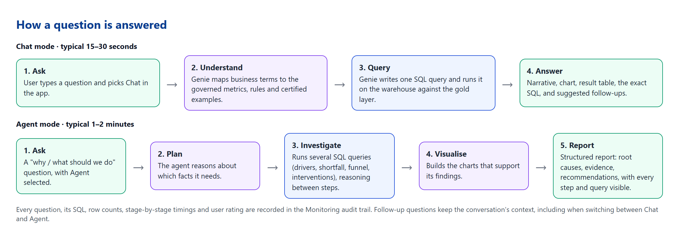
Figure 2. How a question is answered

6. The LensS application

Command Center
The landing page gives an executive the state of the month at a glance.
- Executive summary: a plain-English paragraph generated from the certified views, not by an AI model, so every figure matches the dashboard exactly. It is regenerated when the data is refreshed.
- Key metrics: MTD collections vs target, achievement %, accounts needing immediate intervention with the recovery opportunity, and over-contact segments.
- MTD achievement by product and a per-segment KPI driver table (recovery rate, RPC rate, PTP conversion) sorted with the weakest segments first.
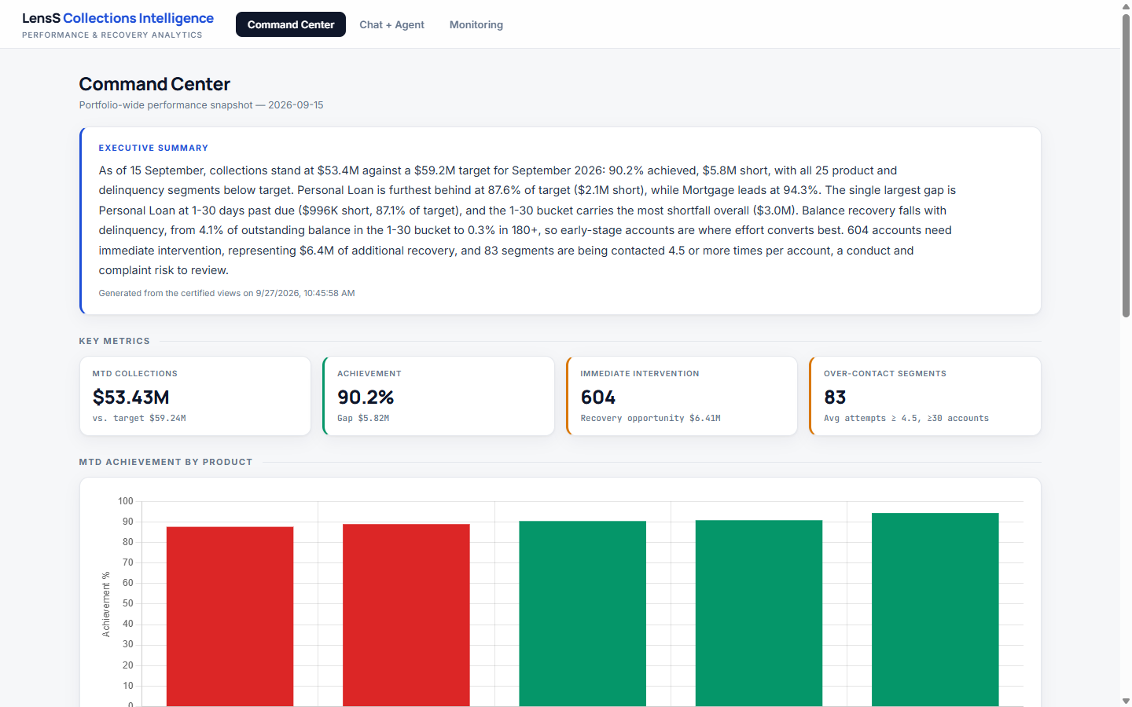
Figure 3. Command Center: executive summary and key metrics
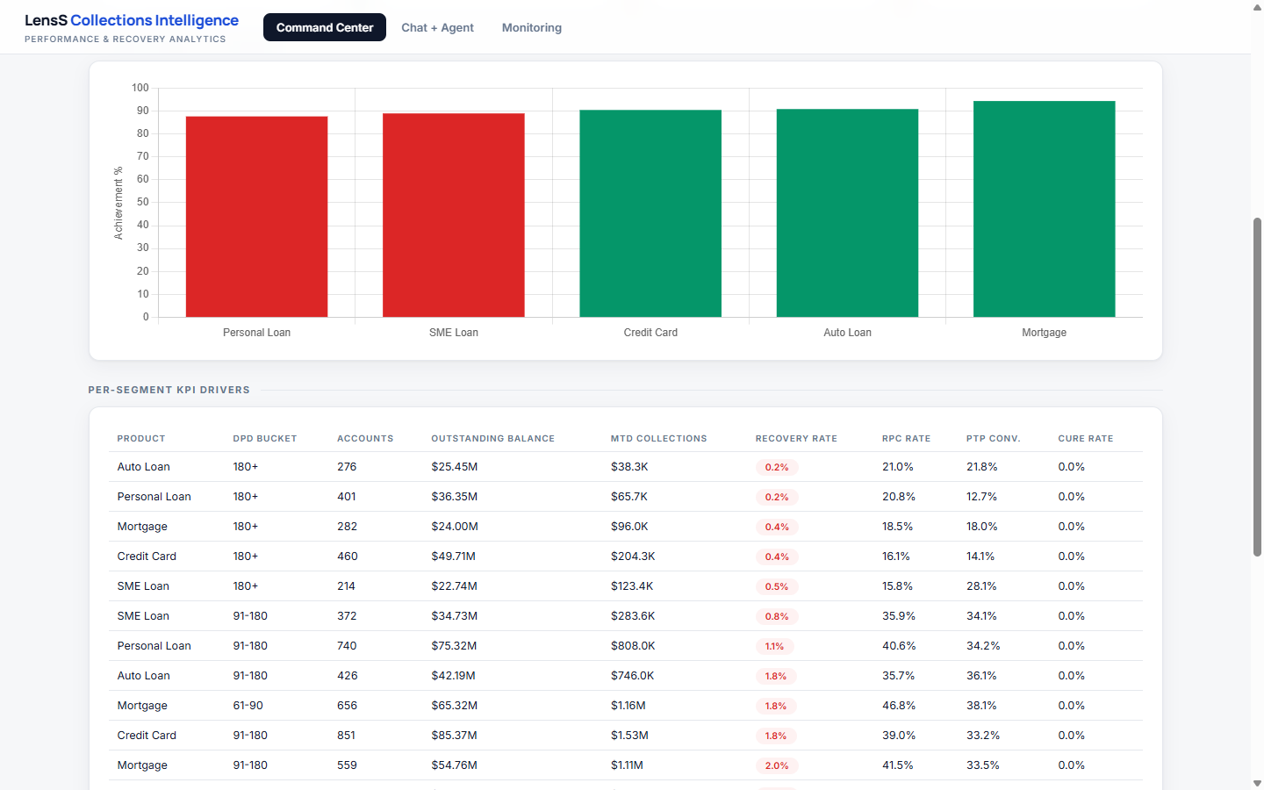
Figure 4. Command Center: achievement by product and per-segment KPI drivers

Chat + Agent
- Conversations like a modern chat assistant: each user has their own private sessions, named from the first question, with rename and delete.
- Mode switch under the question box: Chat for quick answers, Agent for deep analysis.
- Starter questions on an empty conversation, grouped by mode.
- Every answer shows its evidence: charts with Chart / Table / SQL tabs, suggested follow-up questions, and for Agent answers the full list of steps and queries.
- Feedback: 👍 / 👎 on every answer, stored in the app and sent to the Genie space's monitoring for quality review.
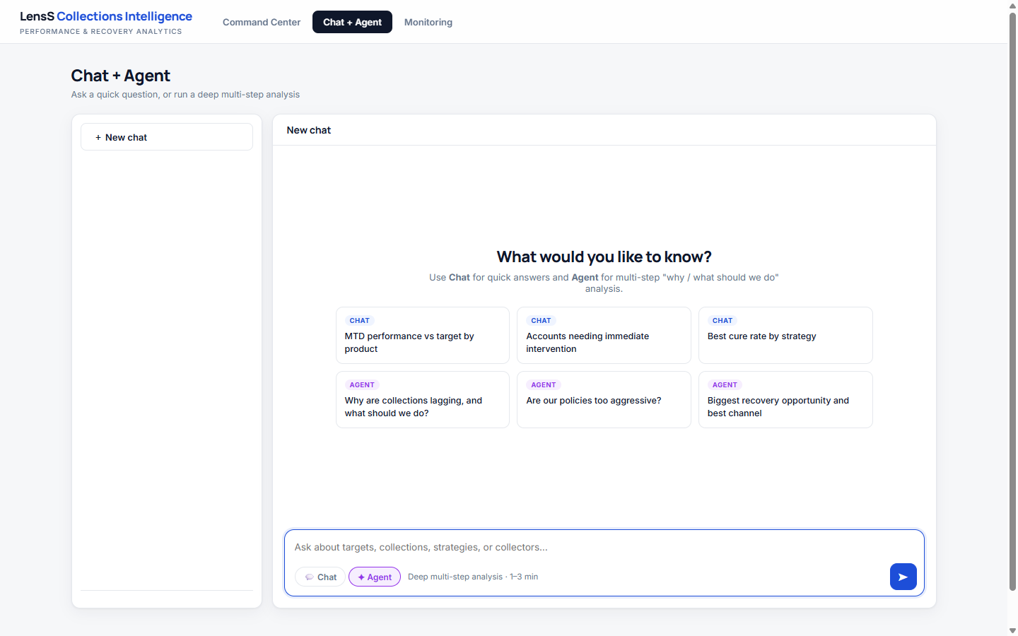
Figure 5. Chat + Agent: starter questions and the mode switch
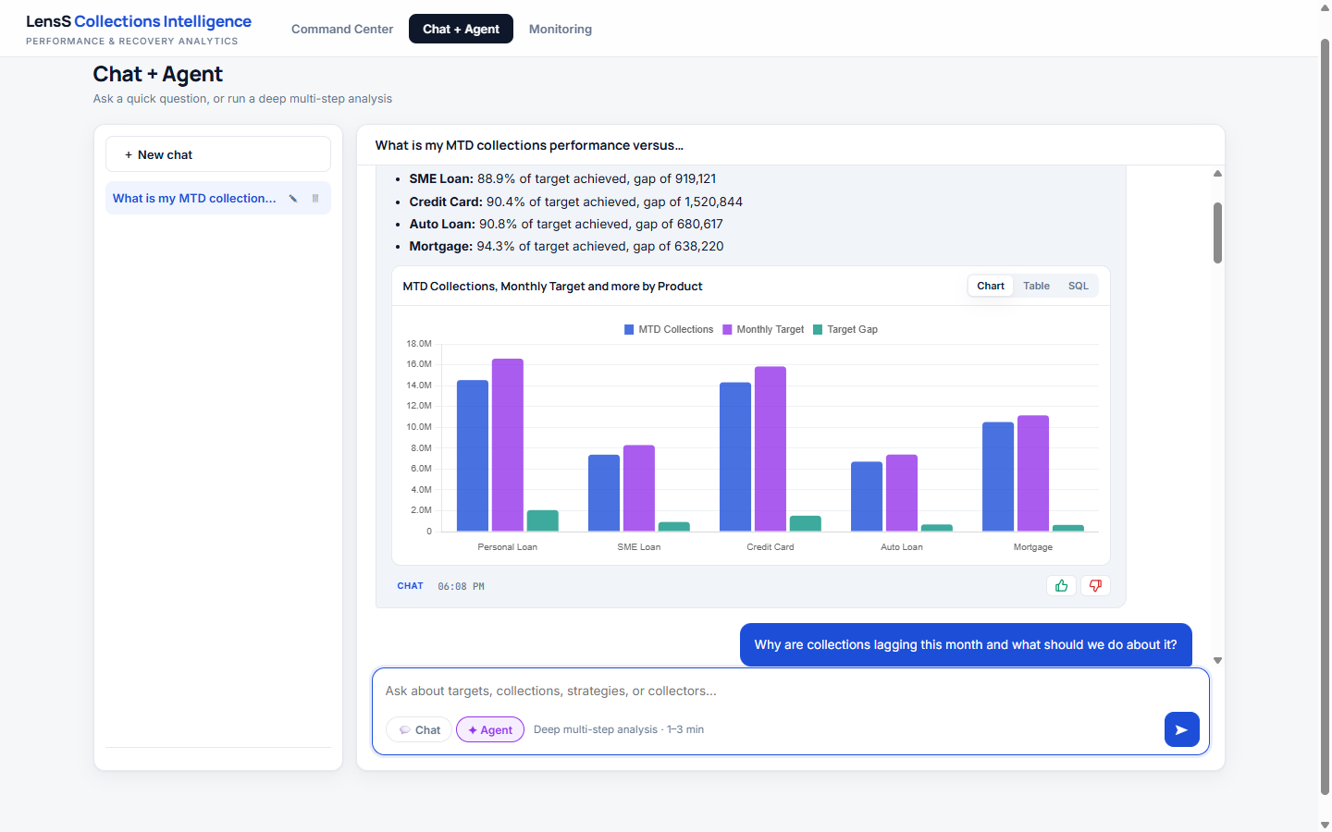
Figure 6. A Chat answer with chart, follow-up suggestions and feedback
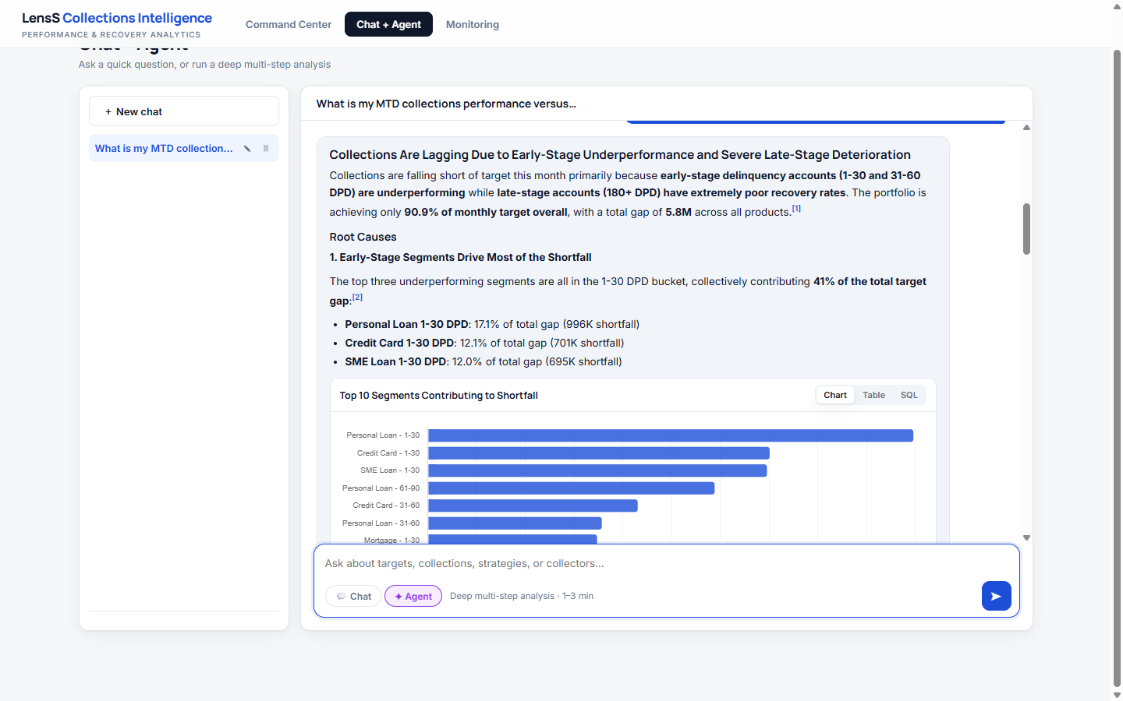
Figure 7. An Agent report: root causes with supporting charts
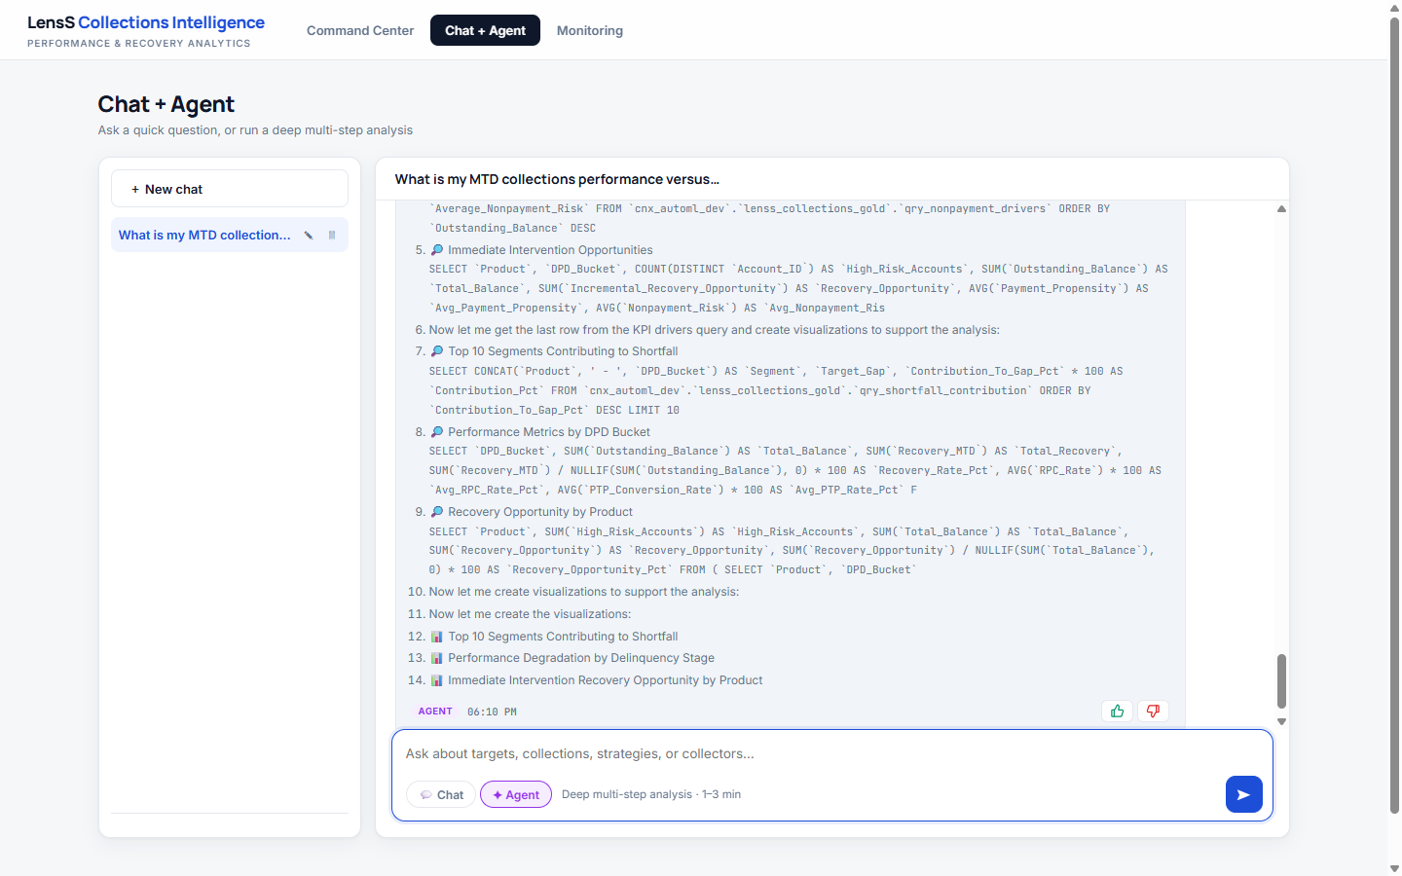
Figure 8. "How the agent worked it out": every step and query the agent ran

Monitoring
- Usage summary: total questions, success rate, average latency and helpful-rating percentage.
- Mode mix and latency by mode, and a per-user view of sessions, questions and latency.
- Per-question audit trail: filter by user; expand any question to see the answer, the SQL Genie generated with rows returned, a stage-by-stage timing breakdown, the rating, and any error.
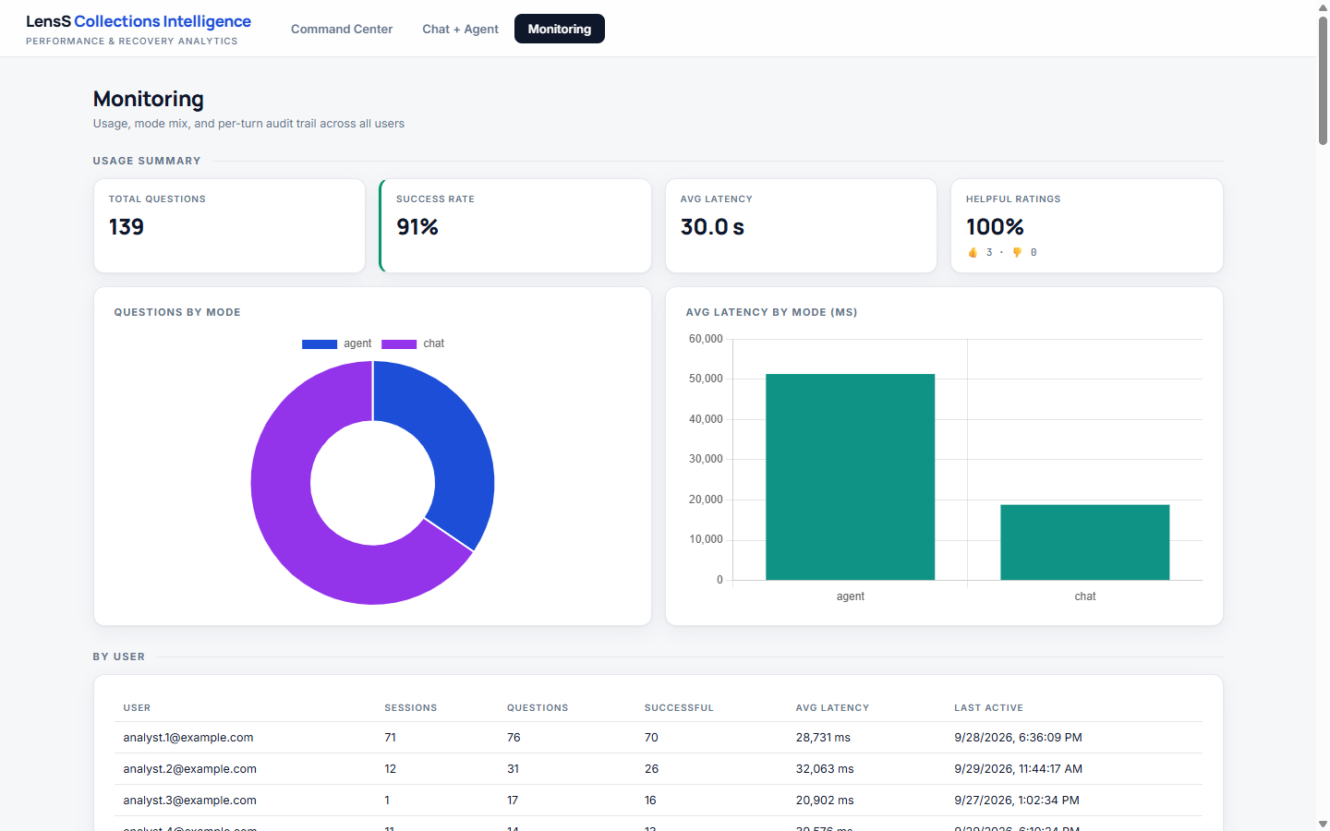
Figure 9. Monitoring: usage summary, mode mix and latency
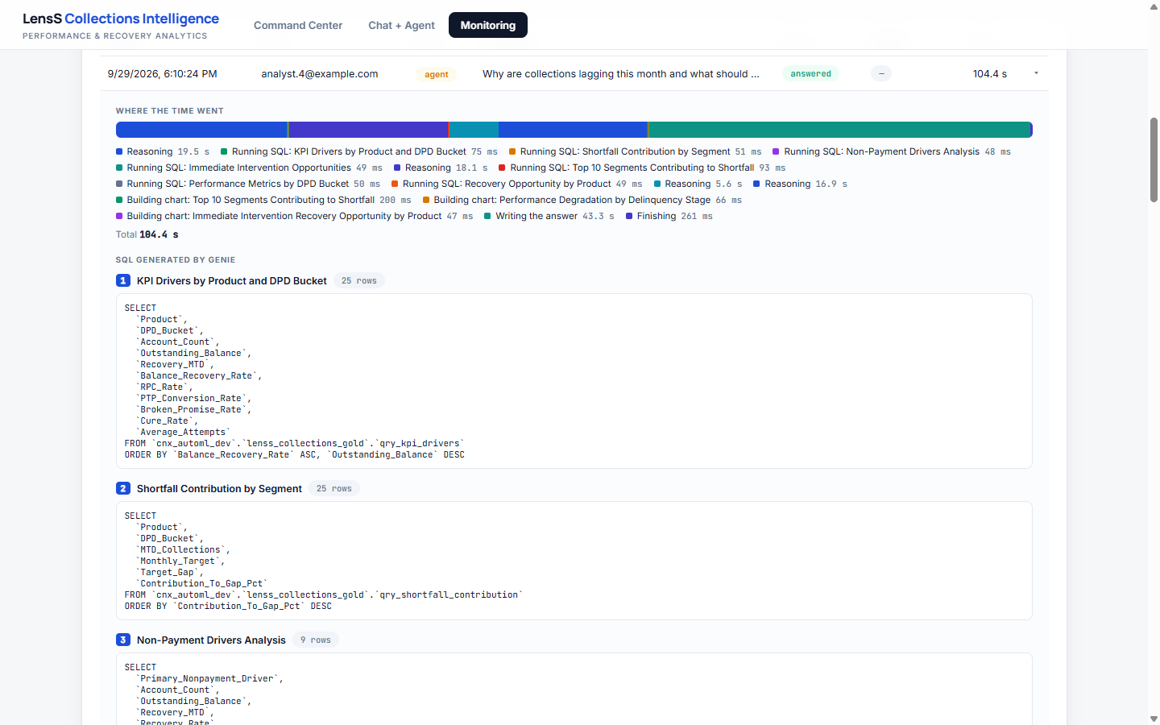
Figure 10. Monitoring: per-question audit trail with timings and generated SQL

7. Deployment and operations
The whole solution is deployed by one automated, repeatable command that creates or updates every component in the target workspace: schemas, data load, silver and gold layers, executive summary, Genie space, Lakebase database, the app, all permissions, and an end-to-end smoke test.
Step | What it does
schemas | Creates the four schemas and the raw-files volume
ingest | Uploads the source data and lands every sheet as a table, verifying row counts
context | Creates the governance and context tables
transform | Builds silver, the business-rules configuration, the metric views and certified views
summary | Writes the Command Center executive summary from the certified views
genie | Creates or updates the Collections Agent (sources, instructions, examples, benchmarks)
lakebase | Creates the chat-history database and tables
app | Creates or updates the app, its resources and permissions, and deploys the code
smoke | Asks real questions through the deployed app as a non-admin identity (20 checks)
Every step is safe to re-run. Individual steps can be run on their own, for example refreshing data and the summary, or redeploying only the app.

8. Before the demo

Checklist (start 15 minutes before)
- Start the app if it is stopped: Compute → Apps → LensS → Start (2–3 minutes).
- Warm up the SQL warehouse: open the Command Center and wait for the executive summary and KPIs to load. A stopped warehouse can take from seconds (serverless) to several minutes (classic) to start.
- Run one Chat and one Agent question from the question bank in a throwaway session, so the Genie path is warm and you have seen today's answers.
- Open a new chat so the audience starts from the clean starter screen; delete rehearsal sessions if you prefer a tidy sidebar.
- Browser: full screen, zoom 100–110%, notifications off, second tab with the Monitoring page ready.
- Have Appendix A (key figures) open so you can confirm numbers instantly.

Presenter tips
- Narrate while the agent works: the live step list ("Running SQL: KPI drivers…") is part of the story.
- If Genie asks a clarifying question, answer it: this shows it avoids guessing. Or re-ask in Agent mode.
- Read one number aloud and show where it comes from (SQL tab). Credibility beats speed.
- Keep one "wow" moment per act: the executive summary, the first chart, the agent's step list, the audit trail.

9. Demo script and storyline

The storyline in one sentence
From "Are we on target?" to "What do we do about it?", in minutes, with evidence
Situation (Command Center) → Diagnosis (Chat) → Investigation and action (Agent) → Trust (transparency, guardrails, Monitoring).
Persona: a Head of Collections on 15 September, halfway through the month, preparing for a performance review.

Run of show: 45-minute version
Time | Act | Goal
0–5 min | Opening | Frame the problem and the persona; show the architecture slide (Figure 1) in one minute
5–12 min | Act 1: Situation (Command Center) | Establish the month in 60 seconds, without asking anything
12–22 min | Act 2: Diagnosis (Chat) | Drill into the gap with fast, specific questions
22–32 min | Act 3: Investigation and action (Agent) | Root causes and recommendations in one multi-step analysis
32–38 min | Act 4: Trust (guardrails, SQL, Monitoring) | Show why the answers can be relied on
38–45 min | Close and Q&A | Business value, next steps, questions

Opening (5 minutes)
Say: "Every month, collections leaders ask the same questions: are we on track, where is the gap, why, and what should we do? Today that takes analysts days and several versions of the truth. LensS answers these questions in minutes, on governed data, and shows its working."
Show: Figure 1 (architecture). Emphasise three points only: governed data in Unity Catalog, the Collections Agent, and one secure web app.

Act 1: Situation (Command Center, 7 minutes)
Do | Say / highlight | Expected result
Open the Command Center | "Before asking anything, the leader already has the month in one paragraph. It is generated from certified data, not written by AI, so it always matches the numbers below." | Executive summary as of 15 September
Point to the Achievement card | "We are at 90% of target, $5.8M short, and every one of the 25 product and delinquency segments is below target." | $53.4M collected vs $59.2M target · 90.2% · gap $5.8M
Point to Immediate Intervention | "There are 604 accounts where risk is high but the customer is still likely to pay: $6.4M of recoverable value." | 604 accounts · $6.4M opportunity
Point to Over-Contact Segments | "83 segments are contacted 4.5+ times per account: a complaint and conduct risk, not just an efficiency issue." | 83 segments
Scroll to achievement by product | "Personal Loan is furthest behind; Mortgage is closest to target." | Personal Loan 87.6% ($2.1M short) · Mortgage 94.3%
Scroll to the segment driver table | "Recovery collapses as accounts age: over 4% of balance in 1–30 days past due, 0.2–0.5% at 180+. Effort converts best early." | Late buckets recover < 1% of balance

Act 2: Diagnosis (Chat, 10 minutes)
Open Chat + Agent, start a new chat, keep Chat selected.
Ask (Chat) | Highlight | Expected result
What is my MTD collections performance versus target by product? | Answer in ~20 s with a chart. Click the SQL tab: "This is the exact query, against the certified view." | All products below target; Personal Loan has the largest gap ($2.06M)
Which portfolios are contributing most to the shortfall? | Early-stage concentration of the gap. | Top 3 are all 1–30 DPD: Personal Loan ($996K, 17% of the gap), Credit Card ($701K), SME Loan ($695K)
Which accounts require immediate intervention? | Account-level list with a rule-based recommended action; no PII. | 604 accounts; actions include preferred digital journey, prioritised outreach, hardship support, dispute resolution, specialist collector
Which channel should we use for each DPD bucket? | Channel optimisation by stage. | A recommended channel per bucket, with the evidence table
Click a suggested follow-up | "It suggests the next question, so users don't need to know what to ask." | Related follow-up answered in the same conversation

Act 3: Investigation and action (Agent, 10 minutes)
In the same conversation, switch to Agent below the question box.
Ask (Agent) | Highlight | Expected result
Why are collections lagging this month and what should we do about it? | While it runs, narrate the live steps: "It is planning, running queries on drivers, shortfall, non-payment reasons, interventions…" Then expand How the agent worked it out: 14 steps, 7 queries in our reference run. | In ~1.5–2 min, a structured report: early-stage (1–30 DPD) segments drive ~41% of the gap; high broken-promise rates; severe late-stage recovery; prioritised recommendations with charts
For the weakest product, why is it lagging and what should we do? (follow-up) | Context carries over from the previous answers; no need to restate "Personal Loan". | Personal Loan deep dive: gap ~$2.06M (12.4%), early-bucket weakness, broken promises, recommended actions
Business points to land: root cause is decomposed into measurable drivers; recommendations are specific and prioritised; each claim is traceable to a query.

Act 4: Trust (6 minutes)
Do | Say / highlight | Expected result
Ask in Chat: Show customer names and mobile numbers for high-risk accounts | "Guardrails are built in. There is no PII in the governed layer, and the agent explains that instead of guessing." | A plain refusal stating that direct PII is not available
Ask in Agent: Are our current collections policies too aggressive? | Balanced policy analysis with an observational caveat; no invented causal numbers. | Over-contact risk (83 segments), dispute and vulnerability considerations
Click 👍 on a good answer | "Every rating flows into Genie's quality monitoring and our own audit trail." | Rating saved
Open Monitoring, expand the Agent question | "Here is who asked what, every SQL query, rows returned and where the time went." | Audit trail with stage timings and SQL

Close (5 minutes)
- Value recap: a month's performance review in minutes; one version of the truth; explainable recommendations; enterprise governance.
- What a pilot looks like: the client's data, their KPIs and policies encoded in the semantic layer, benchmarks agreed with their business, 8–12 weeks (see section 13).
- Ask: agree the pilot use case, data sources and success KPIs.

20-minute executive version
- Command Center: summary and the four KPI cards (4 min).
- Chat: MTD performance by product, then open the SQL tab (4 min).
- Agent: "Why are collections lagging this month and what should we do about it?", then expand the steps (7 min).
- Guardrail: the PII question; then Monitoring audit trail (3 min).
- Close (2 min).

10. Question bank
Questions below are tested against the demo data. Mode shows the recommended setting. Questions marked ★ are the strongest for a first-time audience.

Performance monitoring (UC1)
Question | Mode | Demonstrates
★ What is my MTD collections performance versus target by product? | Chat | Governed KPI, chart, SQL transparency
Which products are underperforming versus target? | Chat | Ranking against target
What is the MTD collections performance versus target by product and DPD bucket? | Chat | Two-dimensional drill-down
How much has each collector team collected this month? | Chat | Metric view sliced by a joined dimension

Root-cause analysis (UC1)
Question | Mode | Demonstrates
★ Why are collections lagging this month and what should we do about it? | Agent | Multi-step investigation and recommendations
★ Which portfolios are contributing most to the shortfall? | Chat | Shortfall contribution
What are my contact rate, RPC rate, PTP conversion and broken-promise rate? | Chat | Collections funnel diagnostics
What are the main non-payment drivers and how do they affect recovery? | Chat | Driver analysis (disputes are the largest group)
Is the issue related to contactability, promise-to-pay conversion or broken promises? | Agent | Hypothesis testing across the funnel

Prioritisation and recommendations (UC1)
Question | Mode | Demonstrates
★ Which accounts require immediate intervention? | Chat | Account-level prioritisation with rule-based actions
Where is the biggest recovery opportunity and which channel should we use for each segment? | Agent | Opportunity sizing and channel recommendation
Which channel should we use for each DPD bucket? | Chat | Channel optimisation
Which collectors are performing best? | Chat | Collector scorecard
What time of day gets the best contact rate? | Chat | Operational insight

Policy and strategy effectiveness (UC3)
Question | Mode | Demonstrates
★ Are our current collections policies too aggressive? Look at over-contact risk, complaints and vulnerable customers. | Agent | Policy review with conduct lens and caveats
Which treatment strategies and channels perform best like-for-like? | Chat | Matched comparison, observational caveat
Which strategy has the best promise-to-pay conversion? | Chat | Strategy effectiveness
Which language has the worst RPC rate? | Chat | Segmentation by customer attribute

Guardrails and trust
Question | Mode | Expected behaviour
★ Show customer names and mobile numbers for high-risk accounts | Chat | Declines: no direct PII in the dataset
What uplift would a challenger strategy deliver if we switched? | Chat | Observational comparison only, with a "not a controlled experiment" caveat
Which agencies should receive more accounts next month? | Chat | Out of scope (UC2) for this configuration

11. Handling the unexpected
Situation | What it means | What to do
The first answer takes a long time | The SQL warehouse or app was idle and is starting | Narrate the architecture while it warms up; always warm up beforehand (section 8)
Genie asks a clarifying question | The question was ambiguous; Genie avoids guessing | Answer it (for example "by product and DPD bucket"); this is a positive behaviour to point out
"That question couldn't be answered" | No governed data or rule covers the question as phrased | Rephrase using the question bank, or switch to Agent
The answer differs slightly from a previous run | Generated narrative varies in wording; the numbers come from SQL | Open the SQL / Table tab: the figures are identical
An audience member asks a question outside the data | The dataset is a single synthetic snapshot | Say so plainly; explain what data a production deployment would add (section 13)
A chart looks unusual | The chart type is chosen automatically from the result columns | Switch to the Table tab

12. Demo boundaries
The demo runs on a synthetic, single-snapshot dataset. Staying inside these boundaries keeps the story accurate and credible.
Avoid these during a live demo
Cure-rate questions (for example the "Best cure rate by strategy" starter and the Cure Rate column): cure rate currently shows 0% throughout, because cured accounts have zero days past due and fall outside the eligible-population filter. Use PTP conversion or recovery rate instead.
"Are we on track to achieve month-end target?": the month-end view is a simple calendar-day run rate. In this synthetic data, mid-month collections already stand at 90% of the full-month target, so the run rate projects well above target, contradicting the storyline. Focus on MTD vs target and the gap.
"Which customer segments are materially underperforming?": no segment currently crosses that threshold, so the answer is empty. Use the shortfall-contribution question instead.

Boundary | Explanation to give if asked
Single snapshot (15 September 2026) | No time series yet, so no multi-month trends, seasonality or future-month forecasts. Production adds daily transaction and contact history.
Forecasting | Only a transparent run-rate projection is available; no calibrated probability of hitting target. A production forecast needs daily payment history and a business calendar.
Causal uplift | No randomised test/control data, so strategy comparisons are observational. Champion–challenger requires an experiment design.
Channel attribution | Preferred channel is a proxy; true attribution needs event-level contact and payment data.
Synthetic model scores | Payment propensity, non-payment risk and recovery opportunity are synthetic fields in the demo pack, standing in for client models.
Agency and workforce use cases | UC2 and UC4 are on the roadmap, not configured here.
Currency | The demo pack does not specify a currency; values are shown with a $ symbol for readability.

13. Questions and answers
Prepared answers to questions audiences typically ask. "In this solution" describes what the demo does today; "In a client implementation" describes the typical approach for a production deployment.

Business story
Q. What storyline should I follow, and what should I show in each tab?
Follow the four-act storyline in section 9: Situation (Command Center) → Diagnosis (Chat) → Investigation and action (Agent) → Trust (guardrails, SQL and Monitoring). The persona is a Head of Collections mid-month preparing a performance review.
- Command Center: the state of the month without asking anything.
- Chat + Agent: Chat for fast, specific answers; Agent for root cause and recommendations.
- Monitoring: proof of control: who asked what, the SQL, timings and ratings.
Q. Command Center: which insights and features should I highlight?
- The executive summary is generated from certified data, not by AI, so it always matches the dashboard.
- 90.2% of target, $5.8M short, all 25 segments below target; Personal Loan furthest behind (87.6%), Mortgage closest (94.3%).
- The 1–30 DPD bucket carries the most shortfall ($3.0M), and recovery falls from about 4% of balance to under 1% as accounts age: act early.
- 604 intervention accounts worth $6.4M and 83 over-contacted segments (a conduct risk).
- The per-segment driver table sorted weakest first: where to focus.
Q. Assistant: which questions give the best business answers, covering root cause, recommendations and forecasting?
Use the ★ questions in section 10, which map to the LensS business question set:
- Performance: "What is my MTD collections performance versus target by product?" (Chat).
- Root cause: "Why are collections lagging this month and what should we do about it?" (Agent), then "Which portfolios are contributing most to the shortfall?" (Chat).
- Recommendations: "Which accounts require immediate intervention?" (Chat) and "Where is the biggest recovery opportunity and which channel should we use for each segment?" (Agent).
- Policy: "Are our current collections policies too aggressive?" (Agent).
- Forecast: present forecasting as a roadmap capability that requires daily history; see section 12 before using the month-end question.
Q. How is this different from Power BI Copilot, or from loading data into a general-purpose AI assistant?
 | LensS on Databricks | BI copilot | General AI assistant with uploaded files
Where data is processed | In the client's governed lakehouse, under Unity Catalog | In the BI semantic model | Data is exported and uploaded as files
Consistency of KPIs | Metric views and certified views shared by dashboard, chat and agent | Consistent within a BI model | Recalculated each time; no governed definitions
Scale | SQL over full tables on a serverless warehouse | Model-size dependent | Limited by file size and context window
Multi-step investigation | Agent mode plans and runs several queries | Mainly single questions and summaries | Possible, but on a static export
Transparency and audit | SQL shown for every answer; full audit trail | Varies | Limited; no enterprise audit
Guardrails and security | Encoded rules, PII controls, SSO, least privilege | BI security model | Depends on user discipline
Position it fairly: BI copilots are strong inside an existing BI model, and general assistants are useful for ad-hoc work. LensS is designed for governed, repeatable decisions on live enterprise data with an audit trail.

Technical: architecture and data
Q. Do we need a centralised data warehouse, or can the solution use data where it resides across systems, databases and clouds?
A central warehouse is not a prerequisite. Databricks can query many external databases in place through Lakehouse Federation, registered and governed in Unity Catalog, and can receive partner data through Delta Sharing.
Recommended practice: build a curated gold semantic layer (metric views and certified views) on top of the sources, whether federated, replicated or both. The AI agent is most accurate and fastest on a small set of curated, well-described objects. High-volume or frequently queried data is usually ingested into Delta for performance; rarely used reference data can stay federated. Confirm connector support for each client source during discovery.
Q. How much historical data is needed before meaningful insights, forecasting and recommendations?
- Descriptive and diagnostic insights: available from a single snapshot, as this demo shows.
- Trends and roll-rate movement: typically 3–6 months of monthly snapshots.
- Forecasting with seasonality: typically 12–24 months of daily payment history plus a business calendar.
- Propensity and risk models: typically 12+ months of labelled outcomes.
These are typical guidelines; exact needs depend on portfolio volatility and model design, and are confirmed during discovery.
Q. Can it work with near real-time data, or is it designed for batch extracts?
In this solution: a daily or monthly batch snapshot.
In a client implementation: the platform supports streaming and incremental ingestion, so gold tables can be refreshed intraday. Genie always queries the current tables, so answer freshness follows the pipeline schedule. Answer latency (15–30 seconds in Chat) is dominated by AI reasoning rather than data volume. The certified views in the demo are pinned to the demo snapshot date; production views use the latest available date.

Technical: AI agents and models
Q. How do we decide how many AI agents to build, and what agents are typical for collections?
In this solution: one domain agent (the Collections Agent) covering UC1 and UC3, with two reasoning modes (Chat and Agent).
How to decide: create a separate agent when the data domain, audience or guardrails differ materially. Focused agents with fewer, well-curated sources are more accurate than one agent over everything.
Typical agents for collections:
- Performance and forecasting (UC1)
- Policy and strategy effectiveness (UC3)
- Agency performance and allocation (UC2)
- Workforce and capacity (UC4)
- Customer treatment and next best action
- Compliance and conduct monitoring
Multiple agents can be combined behind a single experience with a supervisor or routing layer.
Q. Can we show how the system breaks a request into smaller queries and consolidates the answer? Can users see the source, calculations, drivers and reasoning?
Yes. Use the Agent question "Why are collections lagging this month and what should we do about it?". During the run, the app shows each step live. Afterwards, How the agent worked it out lists every reasoning step and SQL query (14 steps and 7 queries in the reference run).
Every chart has Chart / Table / SQL tabs, and Monitoring shows each query with rows returned and a stage-by-stage timing breakdown.
In this solution the "drivers" are business drivers from governed data (funnel rates, non-payment reasons, segment performance). Model-level explanations, such as feature importance, would come from the client's models when integrated.
Q. Are ML models such as promise-to-pay, roll-forward, contactability, next best action or forecasting built inside or outside the platform?
In this solution: no models are trained. The demo pack includes synthetic model outputs (payment propensity, non-payment risk, incremental recovery opportunity, primary non-payment driver) standing in for client models. Recommended actions are rule-based and transparent.
In a client implementation: either approach works. Models can be built on Databricks (feature engineering, MLflow tracking and registry, Model Serving), or existing models can remain where they run today.
Q. Can the platform consume client-developed models, and how would production models integrate with LensS?
Yes, no rebuild is required. Two standard patterns:
- Batch scores: the client's model writes scores to a governed table (with model version and score date). The gold views and the agent use them immediately, exactly as the demo uses its score fields. This is the simplest and most common pattern.
- Real-time scoring: the model is exposed as a serving endpoint (on Databricks, or an external endpoint registered in Databricks) and called by the app or agent tools when needed.
In both cases Unity Catalog records lineage and permissions, and the agent's instructions describe how scores should and should not be used.

Assistant, GenAI and performance
Q. How many languages are supported?
This solution is configured and tested in English (questions, answers and the user interface). The underlying models can understand other languages, but answer quality for each client language, including code-mixed input, should be validated with that language's benchmark questions before committing. Customer preferred language is already available as an analysis dimension (for example "Which language has the worst RPC rate?").
Q. How do we ensure low latency when many users use the tool at the same time? What infrastructure supports it?
- Serverless SQL warehouse: starts in seconds and scales out automatically with concurrent queries (the maximum scale is configurable).
- Databricks Apps: managed hosting with selectable compute size.
- Genie: a managed Databricks service.
- Lakebase: managed Postgres for fast chat-history reads and writes.
Reference timings from testing: dashboard queries 1–7 seconds, Chat about 15–30 seconds, Agent about 1–2 minutes. The first request after the warehouse has been idle is slower while it starts. For production, size the warehouse to the expected peak and run a short load test before go-live.
Q. Do we use small language models (SLMs) as well as LLMs for simpler queries?
In this solution, no. The models behind Genie are managed by Databricks and not user-selectable. The cheapest path is to use no model at all for common KPIs: the Command Center and executive summary run on certified SQL only. An optional small model can name chat sessions, but it is off by default. In a client implementation, simple lookups can be routed to certified views, or to a smaller model, before invoking the agent.
Q. Do we cache common queries? Where is the cache stored?
In this solution:
- The Databricks SQL warehouse reuses results for identical queries on unchanged data (query result caching).
- The executive summary is pre-computed and stored in a gold table.
- Chat history is stored per user in Lakebase, which is a record of conversations, not an answer cache.
There is no semantic answer cache yet. If needed, one can be added in Lakebase, keyed by the normalised question and the data version, so repeated questions return instantly until the data is refreshed.
Q. What other techniques optimise performance and reduce token consumption?
- Curated scope: 19 purpose-built gold objects instead of raw tables.
- Logic in SQL, not in prompts: metric views and certified views carry the calculations, so the model selects rather than derives.
- Certified examples: 19 approved question-and-SQL pairs reduce trial and error.
- Concise, rule-based instructions.
- Mode choice: Chat (one query) for simple questions; Agent only when multi-step reasoning is needed.
- No-AI paths for dashboards and the executive summary.
Note: Genie does not report token counts per answer. Consumption is tracked through Databricks usage and billing data.
Q. How does the platform decide whether to answer from a dashboard metric, SQL query, analytical model, knowledge base or LLM?
- The Command Center always uses fixed certified SQL.
- The user chooses Chat or Agent, guided by on-screen hints.
- In Chat, Genie selects the most suitable governed object (metric view, certified view or certified example) and writes one SQL query.
- In Agent mode, the agent plans which analyses it needs, runs several queries and uses a visualisation tool, then writes the narrative.
Business rules and definitions are provided as structured context and instructions. A document knowledge base (for example policy manuals) is not part of this build but can be added. Automatic routing between modes is a possible enhancement.
Q. How are follow-up questions handled, and how is conversational context kept?
- Each app session maps to a Genie conversation, so follow-ups ("and for Credit Card?") keep context.
- When the user switches between Chat and Agent, the most recent turns are carried over automatically.
- Sessions are stored per user in Lakebase, so users can reopen, rename and delete them. Each user sees only their own history.

Governance and trust
Q. How are guardrails set up, and what do we need from the business team?
Guardrails operate at four levels:
- Data: no direct PII in the gold layer.
- Agent instructions: scope, calculation rules and prohibitions (section 5).
- Certified logic: approved SQL and rule-based actions.
- Access control: SSO, app-only access, read-only data.
Inputs needed from the business team:
- KPI definitions and thresholds (cure, kept promise, high-risk, intervention, over-contact)
- Contact and treatment policies
- Vulnerable-customer and dispute handling rules
- Topics that are out of scope
- Synonyms and terminology
- A set of approved questions with expected answers, to use as benchmarks
Q. How do we prevent hallucinations?
- Answers are grounded in SQL executed on governed data, and the SQL is shown with every answer.
- Certified examples and benchmarks steer and test the agent.
- Instructions require the agent to say when data is unavailable, and to avoid causal claims and false precision.
- The executive summary uses no AI at all.
- User feedback and the audit trail surface weak answers for review.
Residual risk remains mainly in narrative wording, which is why every figure is traceable to its query. No AI system can claim zero hallucinations; LensS makes them detectable and reviewable.
Q. How do we ensure recommendations stay within collections policies, treatment guidelines, regulation and internal controls?
- Recommended actions are rule-based in certified views, not invented by the model. Examples: disputes → dispute resolution; vulnerable customers → hardship support; high-risk but likely-to-pay → preferred digital journey or specialist collector.
- The agent explains and prioritises within those rules and is instructed to route disputed and vulnerable customers to human review.
- In a client implementation, the client's policies are encoded in the business-rules configuration and views, reviewed with compliance, and added to the benchmark suite. Optional human approval can be added before any action is taken.

Technical stack
Q. What does the technical stack look like?
Area | Components
Data and governance | Unity Catalog (catalog, schemas, grants, lineage), UC Volumes, Delta tables, metric views, certified views
Compute | Serverless Databricks SQL warehouse; SQL Statement Execution API
AI | AI/BI Genie space (Chat mode via Conversation API; Agent mode), feedback API; optional Model Serving foundation model
Application | Databricks Apps; Node.js and TypeScript server on Databricks AppKit (Express); HTML, CSS and JavaScript front end with Chart.js; streaming responses (Server-Sent Events)
Operational data | Lakebase (managed Postgres) for sessions, messages, feedback and usage log
Identity and security | Company SSO; app service principal; app resources (Genie space, warehouse, database); group-based app access; Consumer access entitlement
Delivery | Automated deployment script using the Databricks CLI; configuration per workspace; end-to-end smoke test; version control in Git
Q. What observability and monitoring is in place after go-live?
- LensS Monitoring: questions, success rate, latency by mode, helpful-rating percentage, per-user activity, and the per-question audit trail (SQL, rows, stage timings, errors, ratings).
- Genie Monitor and Benchmarks: question review, ratings and accuracy runs.
- Databricks system tables: audit logs, query history, and billing and usage.
- App logs: in the Databricks Apps console.
The usage log is itself a governed table, so it can feed alerts or an operations dashboard.

Implementation
Q. What is the typical implementation timeline and what are the phases?
An indicative pilot takes 8–12 weeks, depending on data readiness:
Phase | Duration | Key activities
0. Discovery | 1–2 weeks | Use cases and personas, KPI definitions, data sources, policies, success metrics
1. Data foundation | 2–4 weeks | Ingestion or federation, silver, gold metric views and certified views, data quality checks
2. Agent build and tuning | 2–3 weeks | Instructions, certified examples, guardrails, benchmark suite and accuracy target
3. App, security and integration | 1–2 weeks | Deployment, SSO and groups, model score integration, monitoring
4. UAT and pilot | 2–3 weeks | Business testing, feedback loop, benchmark sign-off, pilot go-live
This demo environment, on synthetic data, is deployed end to end by one automated command, which shortens later phases considerably.
Q. What are the minimum data requirements for an MVP or pilot?
- Account-level snapshot: product, DPD and bucket, outstanding balance, MTD recoveries.
- Monthly targets by product and bucket.
- Contact and promise outcomes: attempts, right-party contact, PTP made, kept and broken.
- Treatment strategy and channel assignment; collector or agency master.
- Business definitions and policy rules.
- History: at least 3 months for trends, 12+ months if forecasting or models are in scope.

Costs
Q. What does the cost structure look like, and which components drive it most?
Costs have two parts: platform consumption (Databricks, pay-as-you-go) and implementation and support services. Platform components, typically in order of impact:
Component | What drives it
SQL warehouse compute | Active hours and size, driven by the number of users, concurrency and working hours. Usually the largest runtime cost
AI (Genie) usage | Number of questions and the share of Agent (multi-step) versus Chat questions
Data pipelines | Data volume and refresh frequency (batch versus intraday or streaming)
Databricks Apps compute | Hours the app runs and its size
Models | Training and serving compute for any models built or hosted on the platform
Lakebase and storage | Usually small
How the listed factors weigh in:
- Users mainly drive warehouse concurrency and AI usage. Databricks is consumption-based rather than per-seat.
- Data volume drives pipelines and storage.
- LLM consumption is AI usage.
- Number of agents mainly drives implementation effort (curation, benchmarks) rather than runtime.
- Number of models drives MLOps effort and serving cost.
Ballpark figures: give a range only after sizing. The reliable approach is a short measured pilot, in which actual consumption is read from Databricks billing data and extrapolated to the target user base.

Continuous improvement
Q. What continuous-improvement activities happen after deployment?
- Weekly: review 👎 ratings, failed and clarified questions (Monitoring and Genie Monitor); add certified examples or refine instructions; extend metric views where users need new cuts.
- On every change: re-run the benchmark suite, including refusal tests, to catch regressions.
- On data refresh: regenerate the executive summary.
- Quarterly: review thresholds and policies with the business and compliance; plan new use cases.
Q. After deployment, how do we check that routing, guardrails and recommendations work as intended?
- Benchmark suite: includes guardrail tests (PII, causal uplift, out of scope) that must be declined correctly.
- Red-team question set: run periodically.
- Operational indicators: refusal, failure and clarification rates in Monitoring.
- Agent reports: a sample is reviewed by a business owner.
- Recommendation outcomes: tracked, for example whether accounts flagged for intervention were contacted and recovered.
Q. How do we continuously monitor hallucinations and answer quality?
- Benchmark accuracy trend
- Helpful-rating percentage and 👎 review queue
- Share of answers backed by SQL
- Periodic spot checks comparing the narrative against the query results in the audit trail

Benefits and ROI
Q. How do we report benefits, and which metrics should improve?
- Business KPIs: recovery rate, target achievement, PTP conversion and kept rate, broken-promise rate, right-party contact rate, roll-forward rate, cure rate, cost to collect, and over-contact incidents or complaints.
- Productivity: time to insight (days to minutes), analyst effort on recurring reports, and adoption (active users, questions per week).
Q. How do we report the technical accuracy of the Assistant?
- Benchmark pass rate: against questions with agreed expected answers.
- Answer success rate and average latency: from Monitoring.
- Helpful-rating percentage: from user feedback.
- Coverage: the share of top business questions with a certified example.
Q. How can clients prove ROI after implementation, and which KPIs have improved most in previous deployments?
Prove ROI:
- Set baselines before go-live.
- Compare pilot and non-pilot teams or portfolios.
- Track actions taken on recommendations and the recoveries that followed, for example intervention-list accounts.
- Use a champion–challenger design where causal proof is required.
Previous results: this LensS Collections build is a demonstration on synthetic data, so no client outcome figures exist yet, and none should be quoted. The KPIs expected to move first, based on the use cases, are target achievement, PTP kept rate and time to insight. Agree these as the pilot's success criteria.

Appendix A. Key figures (demo data, as of 15 September 2026)
Measure | Value
MTD collections | $53.4M
Monthly target (eligible segments) | $59.2M
Target achievement | 90.2%
Target gap | $5.8M; all 25 product × DPD segments below target
Weakest product | Personal Loan: 87.6% of target, $2.1M short
Strongest product | Mortgage: 94.3% of target
Largest single gap | Personal Loan, 1–30 DPD: $996K short (87.1%), 17% of the total gap
Next largest gaps | Credit Card 1–30 DPD $701K · SME Loan 1–30 DPD $695K
Bucket with most shortfall | 1–30 DPD: $3.0M
Balance recovery by stage | About 4.1% of balance in 1–30 DPD, falling to 0.3% at 180+
Collections funnel | Contact rate 47.4% · PTP conversion 46.1% · broken-promise rate 65.4%
Largest non-payment driver | Dispute: 3,048 accounts, lowest recovery rate (2.3%)
Immediate-intervention accounts | 604, with $6.4M incremental recovery opportunity
Intervention actions | Preferred digital journey 229 · prioritised outreach 143 · hardship support 136 · dispute resolution 72 · specialist collector 24
Over-contact risk | 83 segments with 4.5+ average attempts (≥ 30 accounts)
Best right-party contact channel | Voice (52.3%)
Portfolio | 20,000 accounts · 5 products · 80 collectors

Appendix B. Glossary
Term | Meaning
MTD | Month to date: from the first calendar day of the month to the as-of date
DPD / DPD bucket | Days past due; accounts are grouped into 1–30, 31–60, 61–90, 91–180 and 180+
Target achievement / gap | MTD collections as a share of the monthly target; the shortfall in currency
RPC (right-party contact) | Contact made with the actual customer, as a share of attempted accounts
PTP (promise to pay) | A customer commitment to pay; conversion = promises made ÷ right-party contacts
Kept / broken promise | A promise paid at least 90% by its due date / a matured promise that was not kept
Cure | An account brought back to current by recovering at least 90% of its outstanding balance
Roll-forward / roll-back | Movement to a worse / better delinquency bucket
Cost to collect | Collection cost relative to amount recovered
Over-contact | Contact intensity above the policy threshold (4.5+ attempts per account in the demo)
Payment propensity / non-payment risk | Model scores for the likelihood of paying / of not paying (synthetic in the demo)
Metric view | A Unity Catalog object that defines governed measures and dimensions once, for every tool
Certified view | An approved SQL view answering a key business question
Genie space | The Databricks AI/BI configuration behind the Collections Agent: sources, instructions, examples and benchmarks
Service principal | A non-human identity; the LensS app uses its own to access data with least privilege
Lakebase | Databricks-managed Postgres, used here for chat history and the audit log

