DEMO GIVER GUIDE
Starting the app before a demo
A few clicks, then about 5 to 10 minutes of waiting. Do it before the audience joins.
Why the app may be off
- The app stops itself after 60 minutes without use, to save cost. Nothing is lost: data, chat history and settings stay.
- Start it at least 10 minutes before your demo. Starting takes about 5 to 10 minutes.

Before the demo day: check your access
- Workspace access. You can sign in to the workspace link in Step 1.
- Can Manage on the app. On the app page (Step 4) the Start button is there and clickable. With only Can Use, you can open a running app but not start it.
Missing either? Ask the app owner a day ahead: they add you from the app page with Share → Can Manage.
STEP 1 Open the Databricks workspace
Go to https://adb-7405607799560577.17.azuredatabricks.net/ and sign in with your work account.
STEP 2 Open Databricks Apps
Click the nine dots in the top-right corner (1), then Databricks Apps (2).
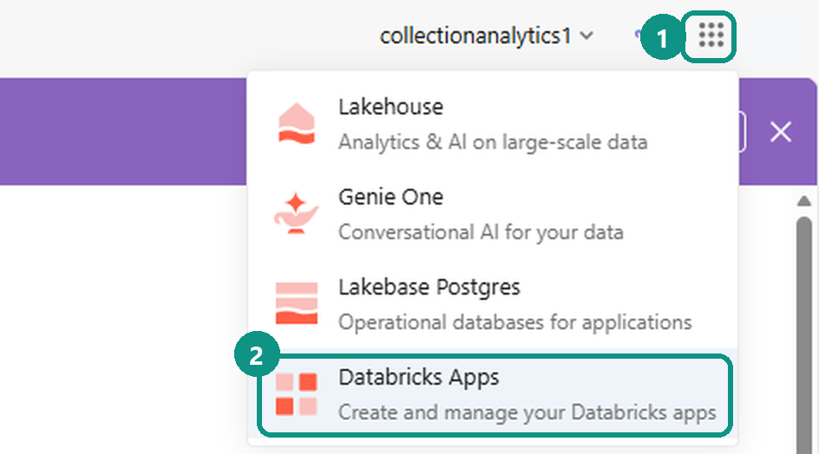
STEP 3 Find your app
The list shows only apps you created at first. Click Clear filters (3) to see every app, then click your app’s name (4).
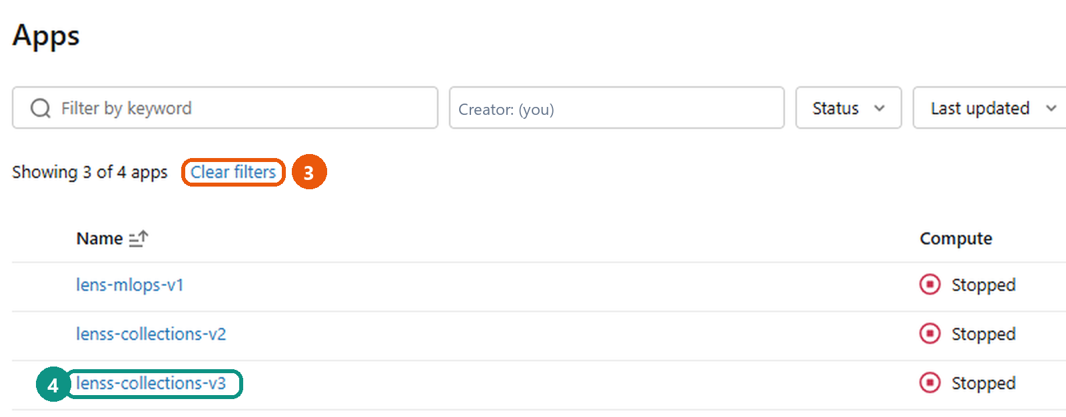
Product | App to open | Used for
LensS Collections Intelligence | lenss-collections-v3 | Collections demos
Lens MLOps | lens-mlops-v1 | Model monitoring demos
STEP 4 Start the app
On the app page, click Start (5) at the top right. Under App status (6) it says Unavailable and Stopped while it is off.
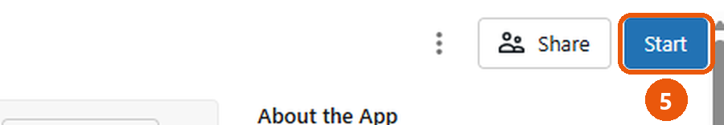
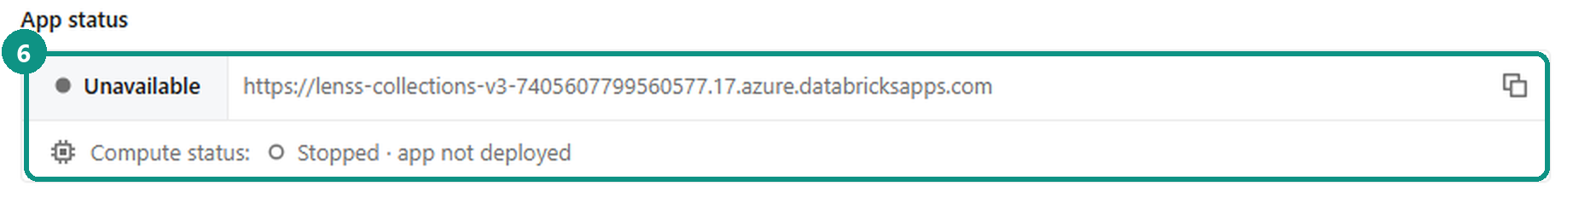
STEP 5 Wait until it is running, then open it
- Wait until App status (6) shows Running. This takes about 5 to 10 minutes; refresh the page to check.
- Click the app link in the App status box. The app opens in a new tab.
- Open the Command Center once before the demo, so the first screen your audience sees loads instantly.

After the demo
Nothing to do. The app stops on its own 60 minutes after the last use.

