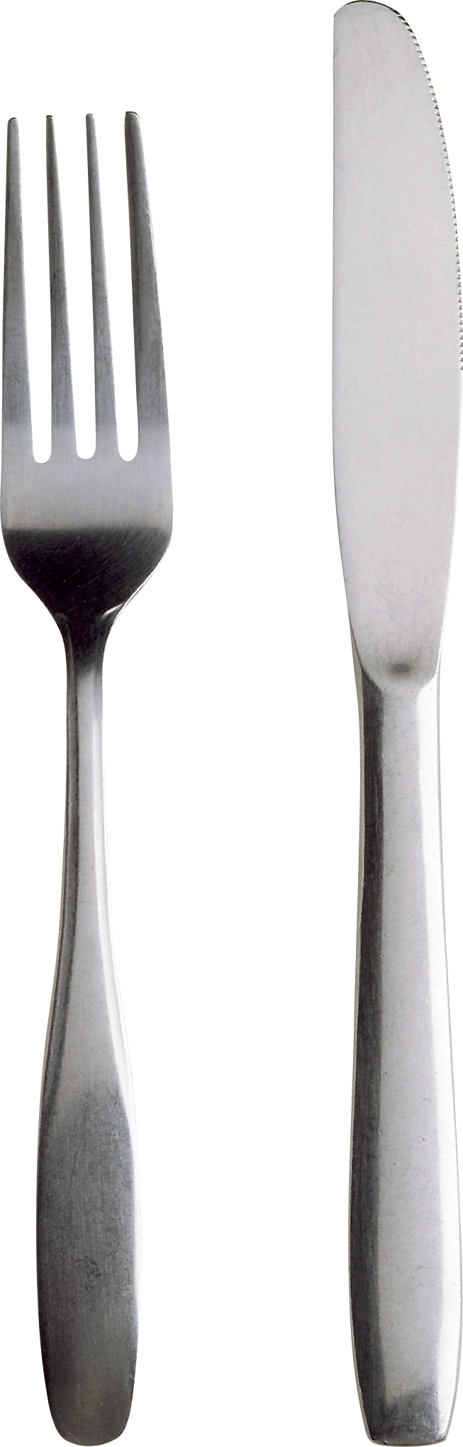Bon appetit  Ulmada Dmitri  Manger general  Tel.799xxxxx  Mun.Balti, str.Independentei, nr.1  e-mail:ulmadadmitri@gmail.com | 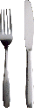    Bon appetit  Ulmada Dmitri  Manger general  Tel.799xxxxx  Mun.Balti, str.Independentei, nr.1  e-mail: ulmadadmitri@gmail.com
Bon apetit  Ulmada Dmitri  Manger general  Tel.799xxxxx  Mun.Balti, str.Independentei, nr.1  e-mail:novikovdanik@gmail.com | Bon appetit  Ulmada Dmitri  Manger general  Tel.799xxxxx  Mun.Balti, str.Independentei, nr.1  e-mail: ulmadadmitri@gmail.com
Bon appetit  Ulmada Dmitri  Manger general  Tel.799xxxxx  Mun.Balti, str.Independentei, nr.1  e-mail: ulmadadmitri@gmail.com | Bon appetit  Ulmada Dmitri  Manger general  Tel.1223455445  Mun.Balti, str.Independentei, nr.1  e-mail: ulmadadmitri@gmail.com
Bon appetit  Ulmada Dmitri  Manger general  Tel.799xxxxx  Mun.Balti, str.Independentei, nr.1  e-mail: ulmadadmitri@gmail.com | Bon appetit  Ulmada Dmitri  Manger general  Tel.799xxxxx  Mun.Balti, str.Independentei, nr.1  e-mail: ulmadadmitri@gmail.com
Bon appetit  Ulmada Dmitri  Manger general  Tel.799xxxxx  Mun.Balti, str.Independentei, nr.1  e-mail: ulmadadmitri@gmail.com | Bon appetit  Ulmada Dmitri  Manger general  Tel. 799xxxxx  Mun.Balti, str.Independentei, nr.1  e-mail: ulmadadmitri@gmail.com


Bon appetit
Meniu

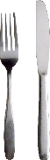


Denumire fel 1 Pret

Denumire fel 2 Pret

Denumire fel 3 Pret

Denumire fel 4 Pret

Denumire fel 5 Pret

Denumire fel 1 Pret

Denumire fel 2 Pret

Denumire fel 3 Pret

Denumire fel 4 Pret

Denumire fel 5 Pret

Bon appetit
Bon appetit

