For the Partial Fulfillment of the
Requirements of Software Engineering 2

SOFTWARE REQUIREMENTS SPECIFICATIONS

Presented by:

Group X

Bon, John Ulric
Cablao, John Randall
Junatas, Kenji
Lanzanas, Kiel Ethan
Quisayang, Canard Cyris
Yabut, Aleerah Marishka

Mar/18/2026

Presented to:

Renato V. Baisa, MBA,ITIL

- Introduction

  - (i) Purpose of this Document –
The purpose of this Software Requirements Specification (SRS) document is to establish a complete and unambiguous definition of the GMIK: Gather Mission, Interaction, and Koneksyon system. This document is submitted in partial fulfillment of the requirements for Software Engineering 2 and serves as the foundational reference for the development team, project stakeholders, and academic evaluators to ensure a shared understanding of what the system must deliver.

This document is necessary for the following reasons:

First, it formally translates the identified community problem—the absence of a secure, structured, and location-aware digital marketplace for peer-to-peer task exchange—into a precise set of software requirements. It bridges the gap between the observed operational failures in informal social media channels and the proposed technical solution, ensuring that every feature developed is directly traceable to a documented user need.

Second, it provides the development team with a definitive blueprint for implementation throughout the Software Engineering 2 project lifecycle. By specifying functional requirements, system behavior, external interfaces, performance benchmarks, and design constraints, this document eliminates ambiguity and serves as the single source of truth for all design, development, testing, and acceptance activities.

Third, it establishes the criteria for system validation and acceptance. Each requirement stated herein is verifiable through testing, demonstration, or inspection, allowing stakeholders to objectively assess whether the delivered GMIK Minimum Viable Product (MVP) satisfies its intended objectives.

Fourth, it manages stakeholder expectations by explicitly defining the boundaries of the MVP. The GMIK MVP is scoped exclusively for the Android platform. Features deliberately excluded from the current scope—including iOS support, in-app payment processing, automated dispute resolution, and full five-star ratings—are acknowledged within this document to maintain development focus and ensure timely delivery of a functional, testable software artifact within the academic timeline.

  - (ii) Scope of this document –
This Software Requirements Specification encompasses the complete definition of the GMIK system from conceptualization through delivery. It describes the overall working of the proposed software product and establishes the main objective of this document: to provide a clear, complete, and verifiable specification that enables the successful construction of the GMIK Minimum Viable Product (MVP) for the Android platform.

Value to Stakeholders:

For end-users (Droppers and Chasers), this document assures that the delivered system will directly address their pain points when exchanging services through informal channels. The requirements captured herein guarantee that users will have access to location-based task discovery, transparent task tracking, a foundational trust system through verified profiles and completion counters, and a manual payment ledger that records off-app settlements without handling sensitive financial data.

For system administrators and operations managers, this document defines the governance tools necessary to maintain platform health, including user management, content moderation, and system monitoring capabilities through a dedicated web dashboard.

For the development team, this document provides the complete technical specification required to build, integrate, and deploy the system. It includes:

- Functional Requirements: 21 distinct functional requirements categorized by subsystem.
- System Modeling: Use-Case Diagrams, Data Flow Diagrams (Level 0-2), Activity Diagrams, Component Diagrams, and Package Diagrams.
- Interface Requirements: Specifications for user interfaces, hardware interfaces, software interfaces, and communication interfaces.
- Performance Requirements: Defined benchmarks for response time, API latency, and concurrency capacity.
- Design Constraints: Platform limitations, technology stack decisions, and regulatory compliance requirements.
- Non-Functional Attributes: Security, reliability, usability, maintainability, and data privacy specifications.
- Preliminary Schedule and Budget: Overview of development timeline and cost estimation.

Development Time and Cost Overview:

The GMIK MVP development commenced in February 2026 and is targeted for completion by November 2026, following a \phased approach over approximately ten months. The project is organized into five main phases: Project Initiation and Planning, Core System and Backend Development, Feature Integration and Alpha Build, Testing and Pilot Launch, and Final Submission and Documentation.

Based on a detailed Work Breakdown Structure, the estimated total development effort is approximately 1,000 to 1,200 person-hours. This estimate accounts for backend development, frontend implementation, real-time chat and GPS integration, push notifications, testing, bug fixing, and UI/UX refinement.

The estimated MVP deployment cost ranges from ₱20,000 to ₱55,000, covering cloud infrastructure, Google Maps API (within free tier allowances), domain registration, SSL certificate, and contingency. Developer labor is rendered as sweat equity and is not reflected in the cash cost.

A complete Work Breakdown Structure, detailed effort estimation, and comprehensive cost breakdown are provided in Preliminary Schedule and Budget.

  - (iii) Overview –
GMIK: Gather Mission, Interaction, and Koneksyon is a hyperlocal, peer-to-peer task marketplace system designed to provide a secure, structured, and efficient digital alternative to informal social media channels currently used for community service exchange.

Product Summary:

The name GMIK is derived from the Filipino slang word "gimik," which colloquially refers to casual social gatherings, side activities, and friendly ventures. This linguistic choice intentionally reflects the system's core philosophy: to preserve the spirit of community collaboration and spontaneous assistance while elevating the experience through deliberate software engineering. GMIK transforms the uncertain, trust-dependent nature of Facebook Groups and X (Twitter) task posts into a reliable, verifiable, and location-aware digital marketplace.

GMIK enables users to participate in a two-sided service economy through two fluid, dynamic roles accessible from a single account:

- The Dropper: A user who posts a task request ("Gmik") requiring completion. The Dropper specifies the task title, description, category, suggested compensation, and preferred meeting or delivery location.
- The Chaser: A user who browses available tasks through a dynamic feed, filters by category and proximity, accepts tasks for execution, and updates the task through a transparent lifecycle: Posted → Accepted → In-Progress → Done.

Core Product Features:

- Smart Location Discovery. The system captures the user's real-time GPS location with explicit permission and automatically sorts the task feed based on calculated distance. Users can filter tasks within specific radii, ensuring that all connections are logistically feasible and time efficient.
- Structured Task Lifecycle. Every task follows a defined, user-controlled state machine. This eliminates the ambiguity prevalent in social media posts regarding whether a task has been claimed, is being worked on, or has been completed. Both parties always maintain full visibility of the task status.
- Foundational Trust and Accountability Framework. GMIK addresses the critical trust deficit in peer-to-peer marketplaces through layered accountability mechanisms:
  - Email Verification: All accounts must be verified, establishing identity integrity.
  - Completion Counters: User profiles publicly display the number of successfully completed tasks, providing observable reputation data.
  - Manual Payment Ledger: The system provides a dedicated interface for the Dropper to formally mark a task as "Payment Settled" after off-app settlement via cash, GCash, or Maya. This creates an immutable record of transactional integrity without handling sensitive financial data.
- Real-Time Coordination. Upon task acceptance, a dedicated in-app text channel is automatically activated between the matched Dropper and Chaser, enabling logistics coordination without exposing personal contact details. Real-time push notifications alert users to task acceptance, status changes, new messages, and new tasks posted within their preferred radius.
- Android Mobile Application. GMIK is built as a native Android application (React Native, API Level 29+), which is the exclusive mobile platform for the MVP. A responsive web application and iOS version are identified for future development phases.
- Administrative Governance. A secure web-based dashboard enables privileged users to manage user accounts, moderate reported content, review system activity logs, and monitor platform health metrics.

Target Deployment:

The GMIK MVP will be soft-launched in a controlled pilot environment at the conclusion of the development timeline (November 2026), targeting an initial user base of 30–50 concurrent users within the immediate academic community. This pilot deployment will validate core functionality, assess system performance under realistic load conditions, and gather preliminary feedback on user adoption and the effectiveness of the proposed trust and discovery models.

Product Context:

GMIK is a deliberate engineering response to a documented societal gap. By providing structure to informal service exchange, the system aims to reduce transaction friction, increase trust, and unlock economic productivity within local communities. This Software Requirements Specification document represents the complete technical foundation upon which that vision will be built, tested, and delivered.

- General description
This section describes the general functions of the GMIK system, including user objectives, user characteristics, core features, benefits, and the importance of the product. It also defines the features of the user community that distinguish GMIK as a digital community platform rather than merely a transaction marketplace.

General Functions of the Product:

GMIK is a hyperlocal, peer-to-peer task marketplace system for the Android platform that enables users to post and complete tasks within their immediate geographic community. The system's core functions include user registration and verification, task posting, task discovery, location-based sorting, task acceptance and status tracking, in-app messaging, real-time notifications, manual payment ledger, reputation tracking, and administrative moderation.

User Objectives:

Guests aim to evaluate the platform and determine whether to register. Droppers seek to efficiently find reliable, nearby individuals to complete their tasks with clear status visibility and payment tracking. Chasers aim to easily discover paid task opportunities within their immediate vicinity and build a public reputation through successful completions. Administrators and Operations Managers are focused on maintaining platform health, enforcing community standards, and ensuring a safe, trustworthy environment.

User Characteristics:

Guests are unauthenticated to visitors with basic technical proficiency and read-only access to public task listings. Registered Users are authenticated individuals with verified email addresses and moderate technical proficiency, capable of dynamically switching between Dropper and Chaser roles from a single account. Administrators are technical users with full system oversight and advanced proficiency, managing users, configurations, and system logs via a web dashboard. Operations Managers are privileged users responsible for content moderation and support, with intermediate proficiency and access to moderation panels and governance tools.

Core System Features:

The GMIK MVP delivers an Android mobile application built with React Native, supported by a cloud-hosted backend and database. Core features include email-based account verification, GPS-enabled proximity sorting and filtering, a structured task lifecycle with visible status updates, fluid dual-role functionality, real-time in-app chat and push notifications, public reputation counters based on completed tasks, a manual payment confirmation ledger, and a responsive web-based admin dashboard.

Benefits:

For Droppers, GMIK provides access to verified, nearby task executors, full visibility into task progress, a formal record of payment settlement, and reduced risk of fraud and miscommunication. For Chasers, the platform enables easy discovery of paid local tasks with transparent requirements and compensation, the ability to build a portable and observable reputation, and organized coordination tools. For the broader community, GMIK transforms unstructured, high-risk social media exchanges into a reliable digital marketplace, fosters local economic activity, and builds trust through accountability and transparency.

Importance of the Product:

GMIK directly addresses three critical failures inherent in informal social media channels used for task exchange: the Trust and Verification Gap, Transaction Invisibility, and Geospatial Inefficiency. As established in the problem statement, these failures leave users without means to assess counterparty reliability, maintain records of agreements, or efficiently discover nearby opportunities. GMIK resolves these gaps through verified identities, structured task tracking, and GPS-enabled hyperlocal matching.

Features of the User Community:

GMIK is designed as a digital community, not merely a transaction platform. The reciprocal role model allows any user to act as both Dropper and Chaser, reflecting the true nature of community assistance and encouraging sustained engagement. Public completion counters serve as observable social proof of reliability. Every task leaves a transparent audit trail, enabling community self-regulation and discouraging bad actors. The hyperlocal focus reinforces neighborhood and campus-level connections, fostering real-world relationships and repeat interactions. Finally, community-driven governance empowers users to flag violations, with Operations Managers acting as stewards to maintain platform standards.

- Functional Requirements
This section lists all functional requirements of the GMIK system. Each requirement is assigned to a unique identifier and is organized by functional area. The requirements are derived from the use‑case scenarios documented in the introduction and are supported by the process diagrams (Section 4.3) and data design (Section 4.1).

3.1 User Management
ID | Requirement | Related Diagrams
FR-1 | The system shall allow a Guest to register for a new account by providing a valid email address, a password, and a display name. | Client Flow via Registration  (Fig 4.3a)
FR-2 | The system shall send a verification email to the provided address upon registration. The account shall be activated only after the email link is clicked.
FR-3 | The system shall allow a verified user to log in by providing their registered email address and password. | Client Flow via Login (Fig 4.3c)
FR-4 | The system shall allow an authenticated user to view and edit their own profile, including display name and profile picture. | Profile wireframe  (Fig 4.4j)
FR-5 | The system shall allow an authenticated user to dynamically operate as a “Dropper” or “Chaser” within the marketplace interface.

3.2 Task Management
ID | Requirement | Related Diagrams
FR-6 | The system shall allow an authenticated user acting as a Dropper to create a new task (“Gmik”). A task shall include a title, description, category, suggested compensation, and a location. | Post wireframes  (Fig 4.4c-4.4e), ERD (Tasks table)
FR-7 | The system shall display a feed of available tasks to authenticated users. The feed shall be the default view for users in the “Chaser” role. | Browse wireframe  (Fig 4.4f)
FR-8 | The system shall allow users to filter the task feed by category, proximity (e.g., 1km, 5km), and urgency. The system shall also provide a keyword search function across task titles and descriptions.
FR-9 | The system shall allow any user (Guest or Registered) to select a task from the feed to view its complete details. | Task Details wireframe (Fig 4.4g)
FR-10 | The system shall allow an authenticated user acting as a Chaser to accept an available task. Upon acceptance, the task status shall change to “Accepted” and become unavailable to other Chasers. | Provider Flow  (Fig 4.3b, 4.3d), ERD (Task_Acceptance)
FR-11 | The system shall allow the assigned Chaser to update the status of an accepted task through the sequence: Accepted → In-Progress → Done.
FR-12 | The system shall allow the Dropper of a task marked “Done” to confirm completion, which finalizes the task record.

3.3 Location Services
ID | Requirement | Related Diagrams
FR-13 | The mobile application shall request and capture the user’s GPS location (with explicit permission) to determine proximity for filtering. | Network Diagram (Google Maps integration)
FR-14 | The system shall sort the task feed by default based on the calculated distance between the user’s location and the task location.

3.4 Communication & Coordination
ID | Requirement | Related Diagrams
FR-15 | The system shall provide a text-based chat channel that is automatically created and accessible only to the Dropper and Chaser of an accepted task. | Chat wireframes  (Fig 4.4h-4.4i), ERD (Messages table)
FR-16 | The system shall automatically generate and dispatch in-app notifications for the following events: task acceptance, task status change, new message received, and new task posted within the user’s preferred radius. | ERD  (Notifications table)

3.5 Payment & Trust
ID | Requirement | Related Diagrams
FR-17 | The system shall provide an interface for the Dropper to mark a completed task as “Payment Settled” after an off-app transaction (cash, GCash, Maya). This action shall be recorded in the task history. | ERD (Payments table)
FR-18 | The system shall calculate and publicly display on a user’s profile a count of tasks they have successfully completed. | Profile wireframe  (Fig 4.4j), ERD  (Users.completed_tasks_count)

3.6 Administration & Moderation
ID | Requirement | Related Diagrams
FR-19 | The system shall provide a web-based administrative interface for viewing a list of all users, disabling user accounts, and viewing user activity logs. | Network Diagram (Admin Dashboard)
FR-20 | The system shall provide an interface for Operations Managers to view tasks and user accounts reported by other users, and to remove or hide violating content.
FR-21 | The system shall provide an administrative dashboard displaying key metrics (e.g., total users, active tasks, completed tasks this week).

- Interface Requirements

This section describes the data design, deployment architecture, process flow, and user interface of the GMIK system.

- 4.1 Entity Relationship (Data Design)

The database schema for GMIK is captured in the Entity Relationship Diagram (ERD) shown in Figure 4.1. It defines the relationships between the core entities: Users, Tasks, Task Acceptance, Messages, and Payments.

Figure 4.1: GMIK Entity Relationship Diagram

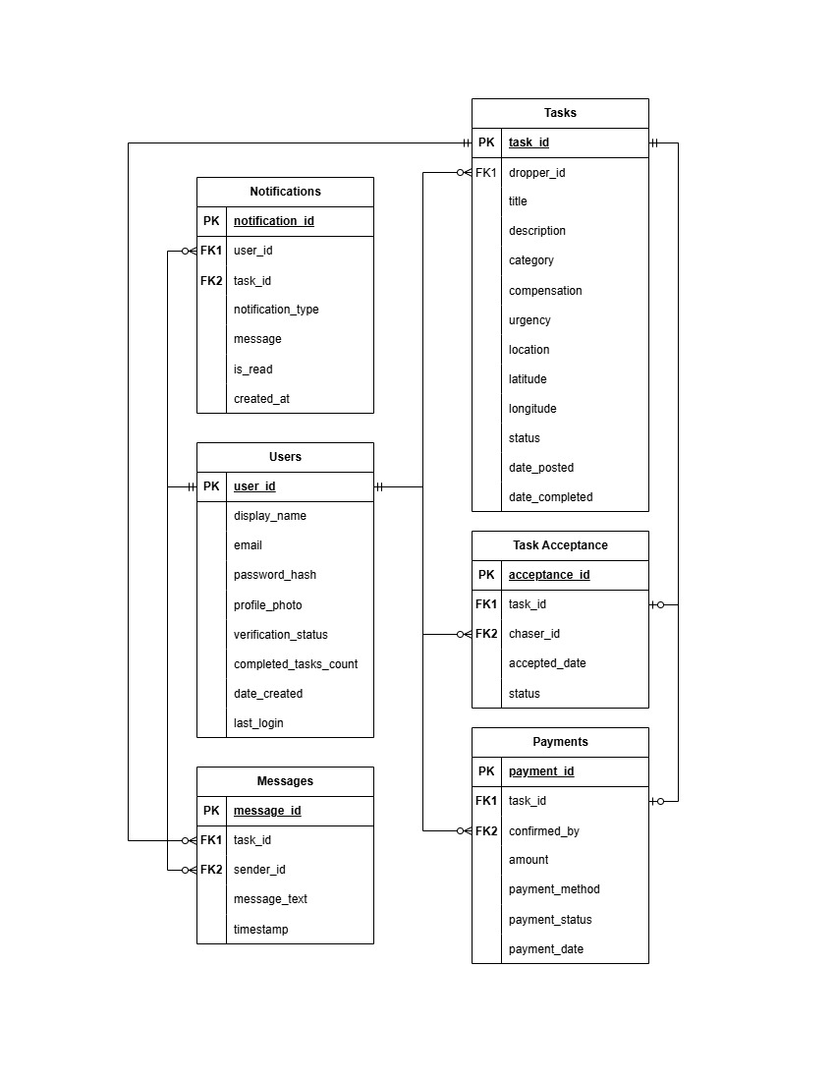
The ERD supports the following key relationships:

- Dropper Workflow (Users → Tasks)
- Connection: Users.user_id (PK) → Tasks.dropper_id (FK)
- Relationship: Mandatory One to Optional Many.
- Project Context: This defines the "Dropper" role in our system. A verified user can post multiple task requests ("Gmiks") to the marketplace. The relationship is mandatory on the user side because a task cannot exist without a creator, which ensures accountability and allows the system to build the user's public record of completed tasks.
- Chaser Workflow (Users → Task Acceptance)
- Connection: Users.user_id (PK) → Task_Acceptance.chaser_id (FK)
- Relationship: Mandatory One to Optional Many.
- Project Context: This defines the "Chaser" role. When a user browses the feed and accepts a task, this connection records exactly who is responsible for executing it. A single user can accept many different tasks over their lifetime on the app, but every acceptance record must point back to one specific verified user to maintain the system's foundational trust.
- Task Lifecycle (Tasks → Task Acceptance)
- Connection: Tasks.task_id (PK) → Task_Acceptance.task_id (FK)
- Relationship: Mandatory One to Optional One.
- Project Context: Our MVP supports a "linear, single-acceptance task model". A task starts in the "Posted" status with zero acceptances. Once a Chaser claims it, it receives exactly one acceptance record, changing its status and removing it from the public marketplace. It cannot have "many" acceptances because the scope explicitly excludes multi-person assignments or task bidding.
- In-App Coordination (Users & Tasks → Messages)
- Connections: * Users.user_id (PK) → Messages.sender_id (FK)
  - Tasks.task_id (PK) → Messages.task_id (FK)
- Relationship: Mandatory One to Optional Many (for both).
- Project Context: Upon task acceptance, the system activates a simple text-based chat interface between the Dropper and the Chaser. Every single message must know who sent it (the User) and which specific task they are talking about (the Task). Users and tasks start with zero messages, but can accumulate many as logistics are planned.
- Manual Payment Ledger (Users & Tasks → Payments)
- Connections:
  - Tasks.task_id (PK) → Payments.task_id (FK) (Mandatory One to Optional One)
  - Users.user_id (PK) → Payments.confirmed_by (FK) (Mandatory One to Optional Many)
- Project Context: Because GMIK does not process actual funds, it relies on a manual payment ledger. After an off-app transaction (like GCash or Maya) is completed, the Dropper manually marks the task as "Payment Settled".
  - A task exists for a while before getting exactly one payment confirmation.
  - The system must record exactly which user confirmed the settlement to maintain a transparent transactional record.
- Alert System (Users & Tasks → Notifications)
- Connections:
  - Users.user_id (PK) → Notifications.user_id (FK)
  - Tasks.task_id (PK) → Notifications.task_id (FK)
- Relationship: Mandatory One to Optional Many (for both).
- Project Context: GMIK features real-time in-app alerts for critical events like task acceptance, status changes, and new messages. To deliver these properly, the database must tie every single notification to the specific user receiving the alert, as well as the specific task that triggered it

These relationships implement the functional requirements for task posting acceptance, messaging, payment confirmation, and notifications as defined in Section 3.

- 4.2 Deployment/Setup Diagram (Interface Design)

The deployment architecture of GMIK is illustrated in Figure 4.2. It shows how the different components are deployed and communicate with each other.

Figure 4.2: GMIK Network Deployment Diagram

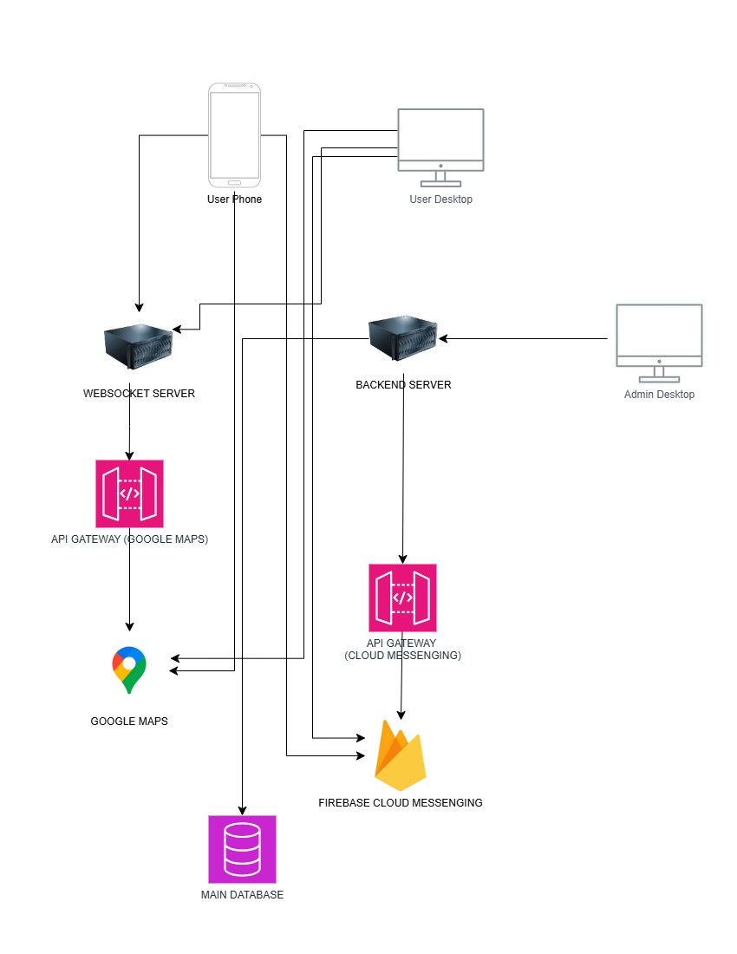

The diagram depicts the following components:

- User Devices: Android phones and desktop browsers (for the admin dashboard) connect to the backend server over HTTPS.
- Backend Server: A Node.js/Express.js server hosts the REST API and WebSocket server. It handles authentication, task management, messaging, and notifications.
- Database: A cloud-hosted PostgreSQL database stores all persistent data (users, tasks, messages, etc.).
- External APIs:
  - Google Maps Platform – used for geolocation, distance calculation, and map display.
  - Firebase Cloud Messaging (FCM) – delivers push notifications to Android devices.
- Admin Dashboard: A responsive web application, also served by the backend, provides administrative tools for user management, content moderation, and system monitoring.
All communication between clients and the server is encrypted via TLS 1.2+ to ensure data security.

- 4.3 Process Diagram (Architectural Design)

The system’s core workflows are captured in the process diagrams shown in Figures 4.3a through 4.3d. They illustrate the step-by-step interactions for both the Dropper (client) and Chaser (provider) during registration and login scenarios.

Figure 4.3a: Client Flow via Registration

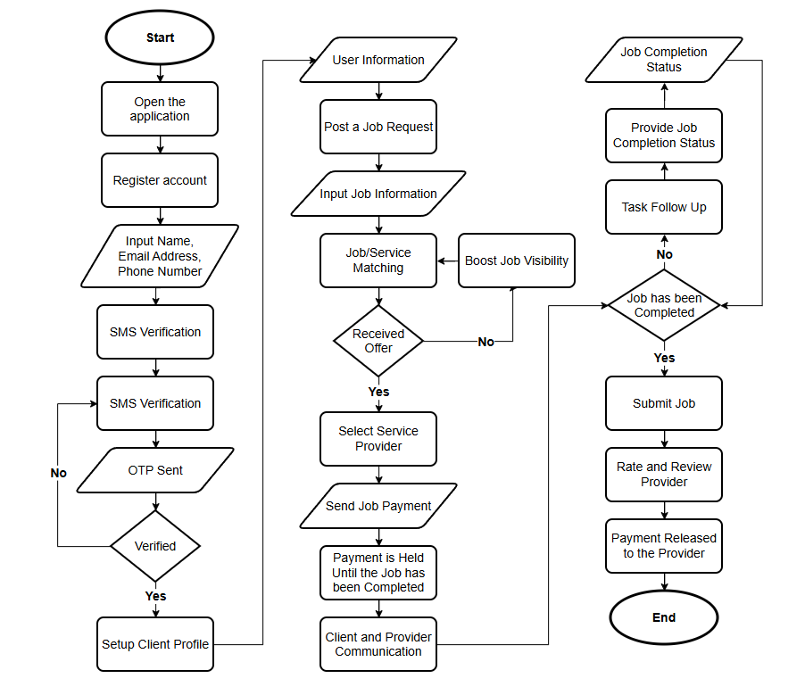

Figure 4.3b: Provider Flow via Registration
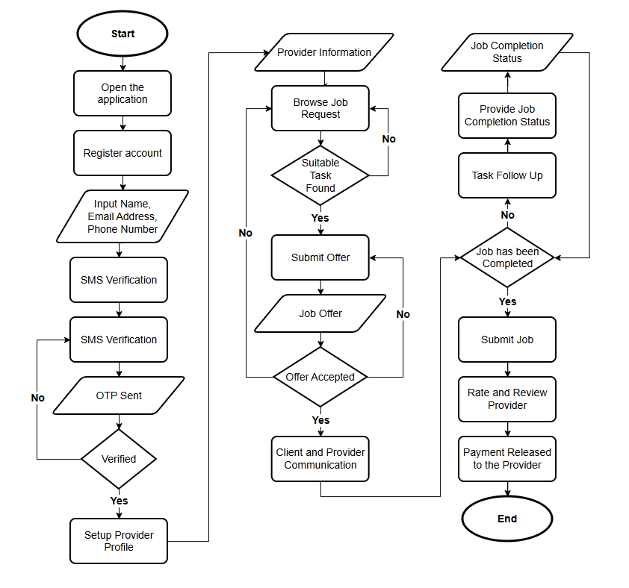

Figure 4.3c: Client Flow via Login

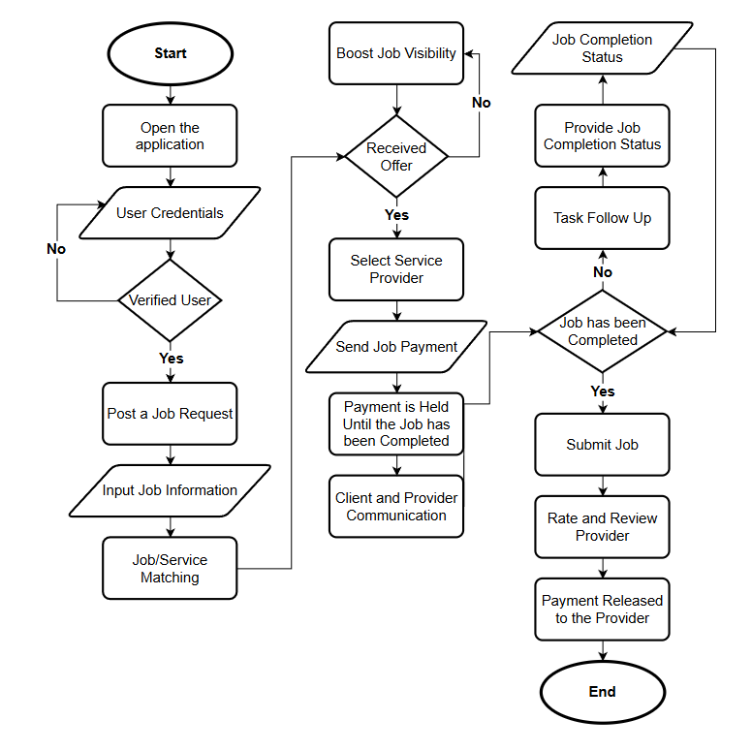

Figure 4.3d: Provider Flow via Login

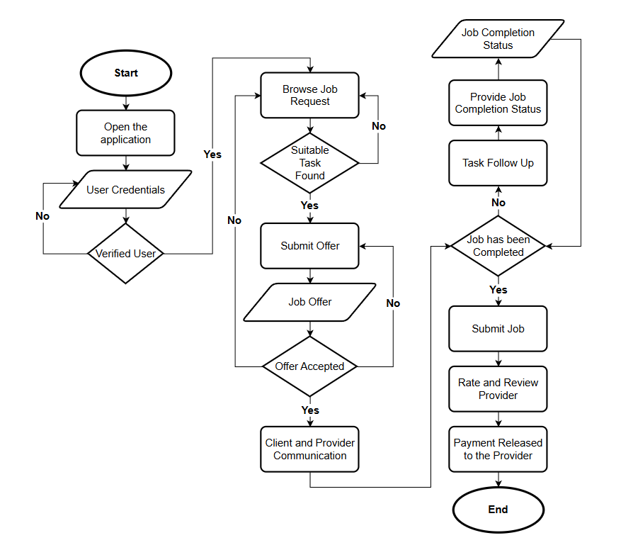
These diagrams detail the processes for:
- Account creation and SMS/OTP verification (email verification in the MVP).
- Posting a task (Dropper) and browsing/submitting offers (Chaser).
- Task matching, communication, completion, and payment release.

The flowcharts align with the functional requirements defined in Section 3, particularly those related to user registration, task posting, task acceptance, and payment confirmation.

- 4.4 Interface Diagram (Component‑level Design)

The low-fidelity wireframes in Figures 4.4a through 4.4j provide the visual design of the Android mobile application. These wireframes define the layout and user interaction flow for the main screens.

Login and Registration Screens
- Figure 4.4a: Login Screen – Allows existing users to enter credentials.


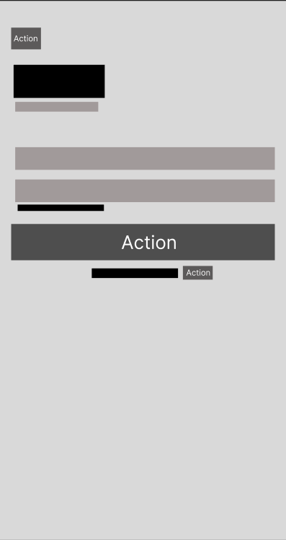
- Figure 4.4b: Registration Screen – Captures new user information.

Task Posting (Dropper) Workflow
- Figure 4.4c: Post – Title & Description – Fields for task title and description.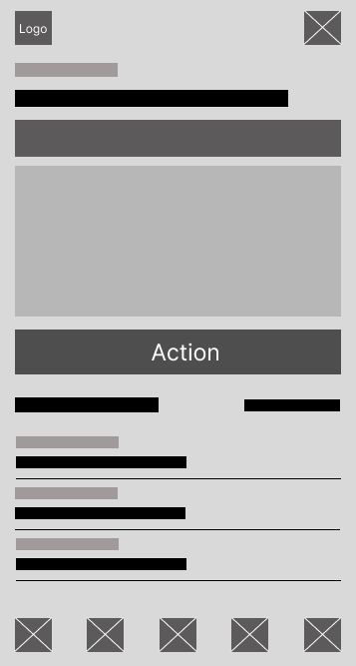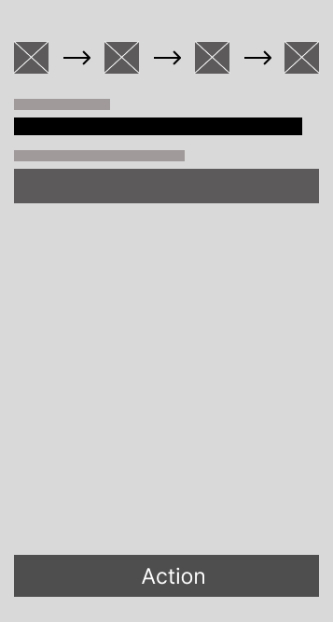

- Figure 4.4d: Post – Additional Details – Where, when, budget, and other options.
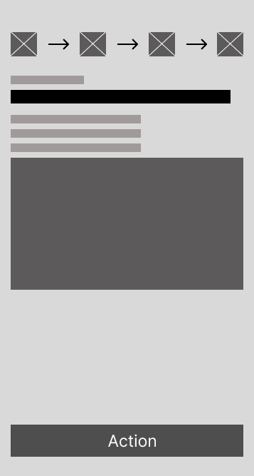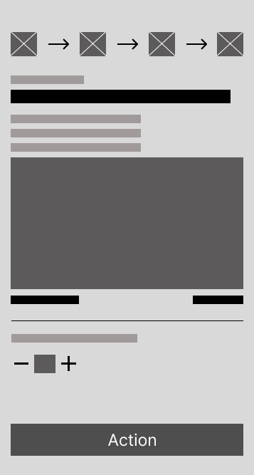

- Figure 4.4e: Post – Summary – Review before publishing.
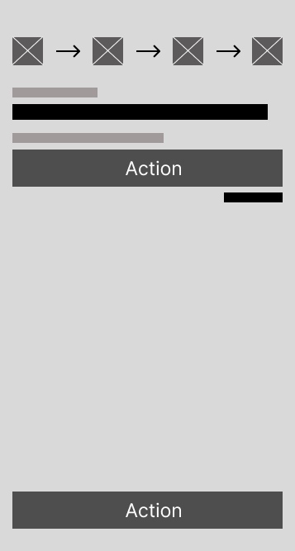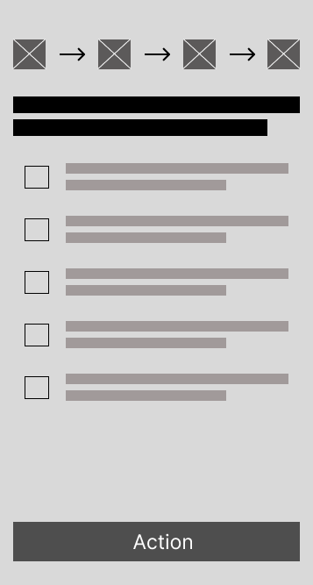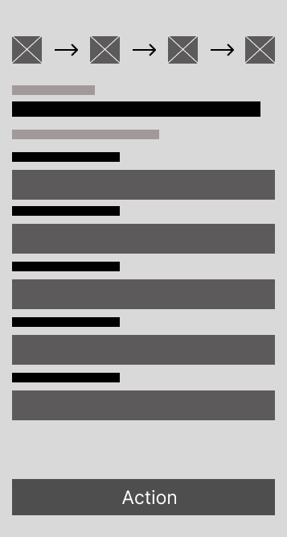
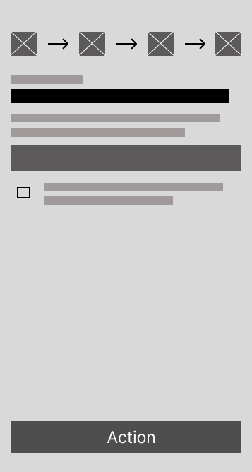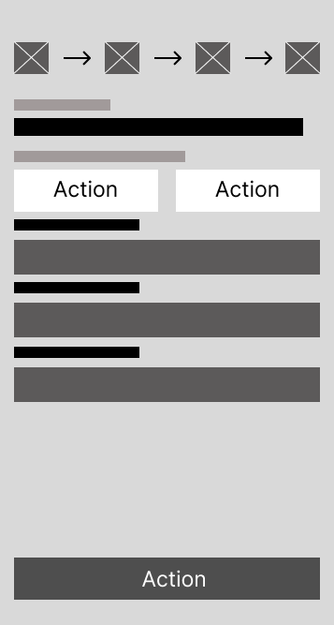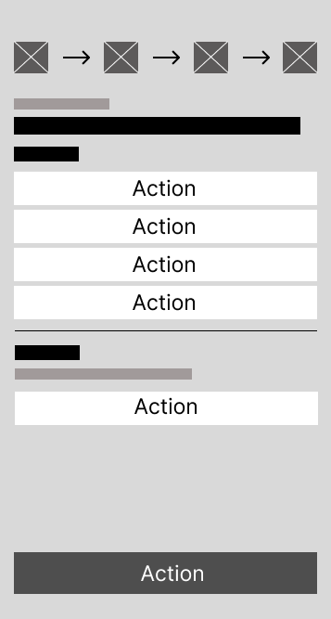

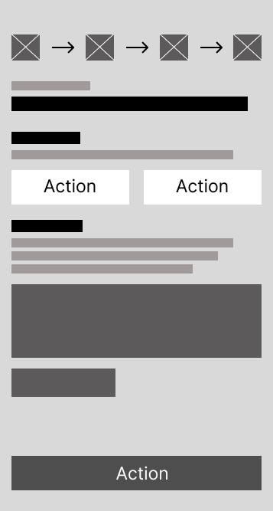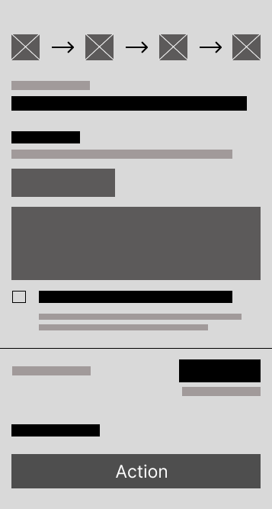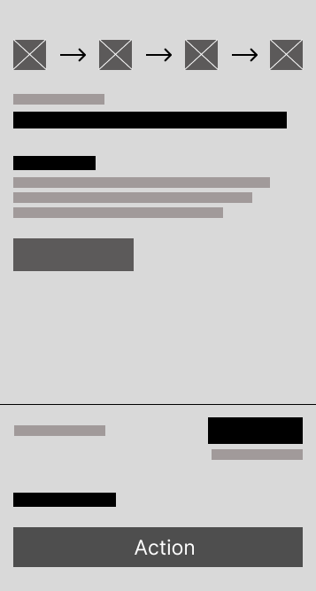
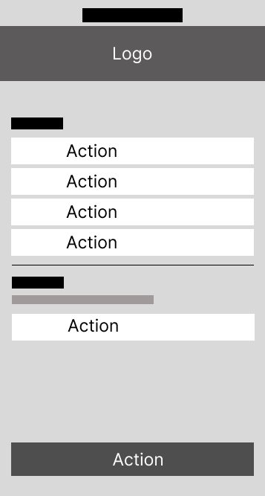

Task Discovery (Chaser) Workflow
- Figure 4.4f: Browse Feed – Lists available tasks with filters.
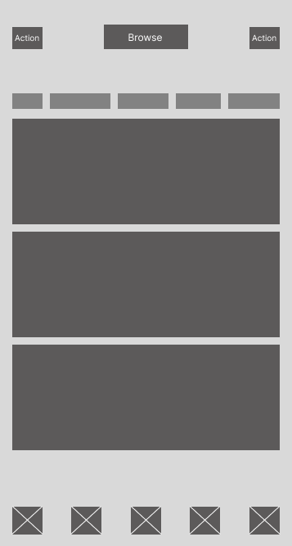

- Figure 4.4g: Task Details – Shows full task information and acceptance button.
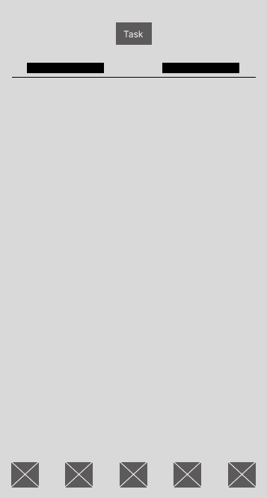
Coordination and Communication
- Figure 4.4h: Chat List – Shows active conversations.
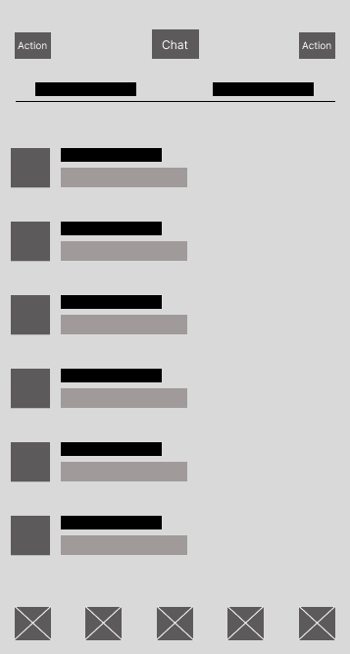

- Figure 4.4i: Chat Window – Real-time messaging interface.
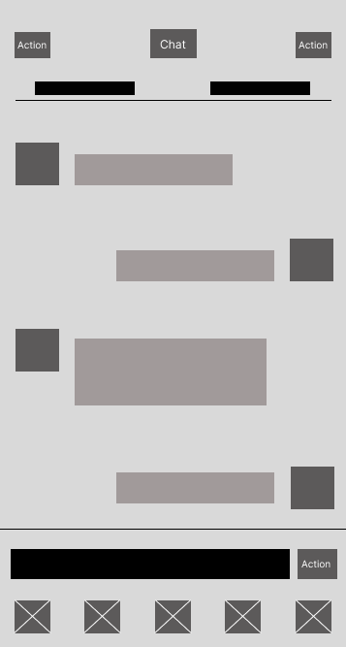

User Profile
- Figure 4.4j: Profile Screen – Displays user details, verification badge, and completed tasks count.
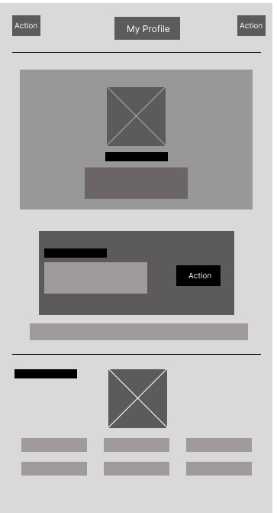
Each wireframe is designed to be intuitive and to follow Material Design guidelines, ensuring a consistent user experience on Android devices.
6. Design Constraints
This section describes the limitations imposed on the design and development of the GMIK Minimum Viable Product (MVP). These constraints are derived from the project scope, platform decisions, budget limitations, and academic timeline documented in the preceding sections.

Platform Constraint
The MVP is built for Android only. We're using React Native with API Level 29 or higher, but the app will not be available on iOS at launch. A web version for regular users is also off the table for now both are planned for future releases. We're also not optimizing tablets in this version. It'll work, but don't expect a tablet-specific experience.

Technology Stack Constraint
We're not experimenting with different technologies. The backend runs on Node.js with Express.js. The database is PostgreSQL hosted in the cloud. For location features, we're using Google Maps Platform. For push notifications, it's Firebase Cloud Messaging. Every bit of communication between the app and our servers must be encrypted with TLS 1.2 or higher. These decisions have already been made, and the team will stick to them.

Payment Processing Constraint
This is a hard rule: GMIK does not touch payments. When a Dropper and Chaser settle up, they do it outside the app cash, GCash, Maya, whatever works for them. The app only provides a way for the Dropper to mark the task as "Payment Settled" afterward. That means no credit card forms, no digital wallets, no escrow, and no automated dispute resolution. We're staying far away from the complexity of handling real financial transactions.

Trust and Reputation Constraint
You won't find five-star ratings in the MVP. That feature was deliberately cut from the current scope. Instead, trust is shown through completion counters a simple number on every user's profile showing how many tasks they've successfully finished. Account verification is also straightforward: just email confirmation. No ID uploads, no SMS codes, no "Sign in with Google" buttons. We're keeping the barrier to entry low while still establishing basic accountability.

Task Lifecycle Constraint
The task model follows a simple rule: one task, one Chaser. Once a task is accepted, it's off the marketplace. No bidding, no splitting tasks among multiple people, no complicated assignments. The status also moves in only one direction: from Posted to Accepted to In-Progress to Done. There's no going backward. If a task is marked Done, it stays Done. This keeps everything predictable for both parties.

Budget and Time Constraint
We started development in February 2026 and need to wrap up by November 2026, that's about ten months. The team expects to put in roughly 1,000 to 1,200 hours of work, and nobody is getting paid. This is sweat equity. The actual cash we need to spend on cloud hosting, Google Maps API (within free tier limits), domain registration, SSL certificate, and a little buffer for surprises is between P20,000 and P55,000. If something would push us beyond that, we either cut it or figure out another way.

Deployment Constraint
At launch, we're not aiming for millions of users. The MVP will soft-launch with just 30 to 50 people using it at the same time, all from our immediate academic community. That means we don't need to build for massive scale. No 99.9% uptime requirements, no automatic failover, no disaster recovery across multiple regions. Moderation is done manually by Operations Managers through the admin dashboard. No AI, no automated flagging—just real people reviewing reported content.

Data Privacy Constraint
Even though we're small, we still have to handle user data responsibly. The document calls out data privacy as a non-functional requirement, so we need to follow the rules. That means collecting only what we need, storing it securely, and being transparent about how it's used. The TLS encryption requirement already covers the security side, now we just need to make sure our practices match the law.

Excluded Features Constraint
Sometimes what you don't build is just as important as what you do. Here's what's explicitly not in the MVP iOS support, a web app for regular users, in-app payments, automated dispute resolution, five-star ratings, SMS verification, multi-person tasks, bidding, tablet layouts, and any kind of automated content moderation. These are all conscious cuts to keep the project on track and deliver something that actually works by November.

- Non-Functional Attributes

The GMIK system must satisfy a comprehensive set of non-functional requirements to ensure that the application operates efficiently, securely, and reliably while delivering a high-quality user experience. These attributes define how the system performs rather than what it does.

  - Security

- The system must ensure secure user authentication through verified accounts.
- All data communication must be protected using encrypted connections (HTTPS).
- User information such as passwords must be stored securely
- The system must prevent unauthorized access and protect against common security threats.
- Payment information is not stored, as all transactions are handled outside the system.

  - Performance

- The system should respond quickly to user actions such as loading tasks, posting, and messaging.
- Task feeds and user interfaces should load smoothly without noticeable delays.
- Real-time features like chat and notifications should function efficiently.
- The system should handle multiple users at the same time without slowing down.

  - Reliability

- The system must function consistently without frequent errors or crashes.
- Task data and user actions must be always saved accurately.
- The system should handle failures gracefully and recover without losing data.

  - Usability

- The application must be easy to use and understand for all users.
- The interface should follow a clear and consistent design.
- Users should be able to perform key actions (posting, accepting tasks) with minimal effort.
- Error messages and notifications must be clear and helpful.

  - Scalability

- The system should support future growth in users and data.
- It must be designed so additional features can be added later without major changes.

  - Maintainability

- The system should be easy to update, fix, and improve.
- The code structure must be organized and understandable for developers
- Future modifications should not disrupt existing features.

  - Portability

- The system should run on different Android devices with varying specifications.
- The use of React Native allows for possible expansion to other platforms in the future.

  - Compatibility

- The system must work properly with required external services such as maps and notifications.
- The admin dashboard should function on standard web browsers.

  - Data Integrity

- The system must ensure that all stored data is accurate and consistent.
- Task status and user information must always reflect the correct state.

  - Availability
- The system should be accessible whenever users need it, with minimal downtime.
- Any maintenance should be planned to avoid disrupting users.

- Preliminary Schedule & Budget

- Appendices

9.1 APPENDIX A: System Modeling Diagrams
Entity-Relationship Diagram (Data Design)
Figure 4.1

Network Deployment Diagram (Interface Design)
Figure 4.2

Process Diagram (Architectural Design)
Figure 4.3a: Client Flow via Registration
Figure 4.3b: Provider Flow via Registration
Figure 4.3c: Client Flow via Login
Figure 4.3d: Provider Flow via Login

Interface Diagrams (Component-level Design)
Figure 4.4a: Login Screen
Figure 4.4b: Registration Screen
Figure 4.4c: Post – Title & Description
Figure 4.4d: Post – Additional Details
Figure 4.4e: Post – Summary
Figure 4.4f: Browse Feed
Figure 4.4g: Task Details
Figure 4.4h: Chat List
Figure 4.4i: Chat Window
Figure 4.4j: Profile Screen

