- Interface Requirements

This section describes the data design, deployment architecture, process flow, and user interface of the GMIK system.

- 4.1 Entity Relationship (Data Design)

The database schema for GMIK is captured in the Entity Relationship Diagram (ERD) shown in Figure 4.1. It defines the relationships between the core entities: Users, Tasks, Task Acceptance, Messages, and Payments.

Figure 4.1: GMIK Entity Relationship Diagram

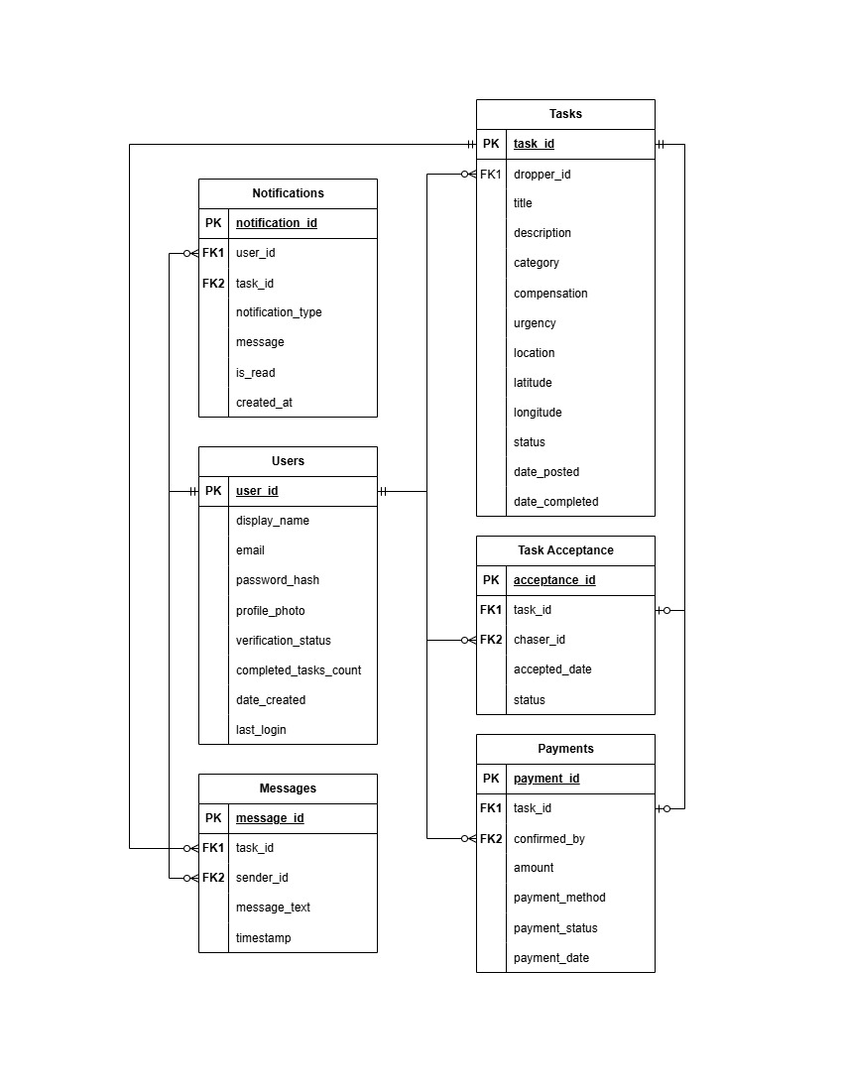
The ERD supports the following key relationships:

- Dropper Workflow (Users → Tasks)
- Connection: Users.user_id (PK) → Tasks.dropper_id (FK)
- Relationship: Mandatory One to Optional Many.
- Project Context: This defines the "Dropper" role in our system. A verified user can post multiple task requests ("Gmiks") to the marketplace. The relationship is mandatory on the user side because a task cannot exist without a creator, which ensures accountability and allows the system to build the user's public record of completed tasks.
- Chaser Workflow (Users → Task Acceptance)
- Connection: Users.user_id (PK) → Task_Acceptance.chaser_id (FK)
- Relationship: Mandatory One to Optional Many.
- Project Context: This defines the "Chaser" role. When a user browses the feed and accepts a task, this connection records exactly who is responsible for executing it. A single user can accept many different tasks over their lifetime on the app, but every acceptance record must point back to one specific verified user to maintain the system's foundational trust.
- Task Lifecycle (Tasks → Task Acceptance)
- Connection: Tasks.task_id (PK) → Task_Acceptance.task_id (FK)
- Relationship: Mandatory One to Optional One.
- Project Context: Our MVP supports a "linear, single-acceptance task model". A task starts in the "Posted" status with zero acceptances. Once a Chaser claims it, it receives exactly one acceptance record, changing its status and removing it from the public marketplace. It cannot have "many" acceptances because the scope explicitly excludes multi-person assignments or task bidding.
- In-App Coordination (Users & Tasks → Messages)
- Connections: * Users.user_id (PK) → Messages.sender_id (FK)
  - Tasks.task_id (PK) → Messages.task_id (FK)
- Relationship: Mandatory One to Optional Many (for both).
- Project Context: Upon task acceptance, the system activates a simple text-based chat interface between the Dropper and the Chaser. Every single message must know who sent it (the User) and which specific task they are talking about (the Task). Users and tasks start with zero messages, but can accumulate many as logistics are planned.
- Manual Payment Ledger (Users & Tasks → Payments)
- Connections:
  - Tasks.task_id (PK) → Payments.task_id (FK) (Mandatory One to Optional One)
  - Users.user_id (PK) → Payments.confirmed_by (FK) (Mandatory One to Optional Many)
- Project Context: Because GMIK does not process actual funds, it relies on a manual payment ledger. After an off-app transaction (like GCash or Maya) is completed, the Dropper manually marks the task as "Payment Settled".
  - A task exists for a while before getting exactly one payment confirmation.
  - The system must record exactly which user confirmed the settlement to maintain a transparent transactional record.
- Alert System (Users & Tasks → Notifications)
- Connections:
  - Users.user_id (PK) → Notifications.user_id (FK)
  - Tasks.task_id (PK) → Notifications.task_id (FK)
- Relationship: Mandatory One to Optional Many (for both).
- Project Context: GMIK features real-time in-app alerts for critical events like task acceptance, status changes, and new messages. To deliver these properly, the database must tie every single notification to the specific user receiving the alert, as well as the specific task that triggered it

These relationships implement the functional requirements for task posting acceptance, messaging, payment confirmation, and notifications as defined in Section 3.

- 4.2 Deployment/Setup Diagram (Interface Design)

The deployment architecture of GMIK is illustrated in Figure 4.2. It shows how the different components are deployed and communicate with each other.

Figure 4.2: GMIK Network Deployment Diagram

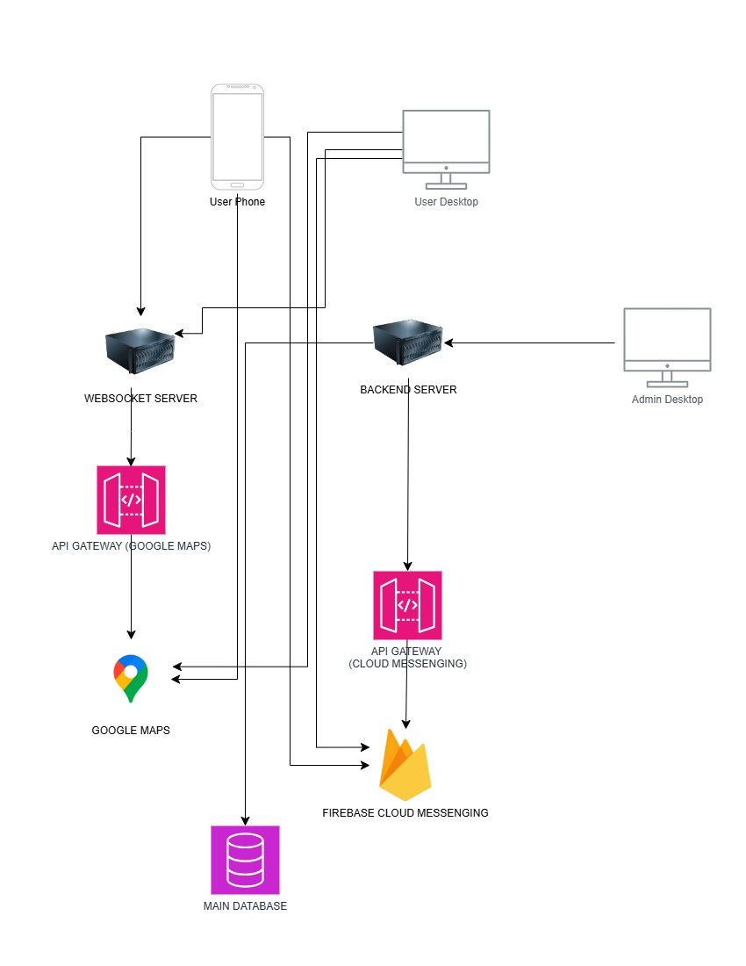

The diagram depicts the following components:

- User Devices: Android phones and desktop browsers (for the admin dashboard) connect to the backend server over HTTPS.
- Backend Server: A Node.js/Express.js server hosts the REST API and WebSocket server. It handles authentication, task management, messaging, and notifications.
- Database: A cloud-hosted PostgreSQL database stores all persistent data (users, tasks, messages, etc.).
- External APIs:
  - Google Maps Platform – used for geolocation, distance calculation, and map display.
  - Firebase Cloud Messaging (FCM) – delivers push notifications to Android devices.
- Admin Dashboard: A responsive web application, also served by the backend, provides administrative tools for user management, content moderation, and system monitoring.
All communication between clients and the server is encrypted via TLS 1.2+ to ensure data security.

- 4.3 Process Diagram (Architectural Design)

The system’s core workflows are captured in the process diagrams shown in Figures 4.3a through 4.3d. They illustrate the step-by-step interactions for both the Dropper (client) and Chaser (provider) during registration and login scenarios.

Figure 4.3a: Client Flow via Registration

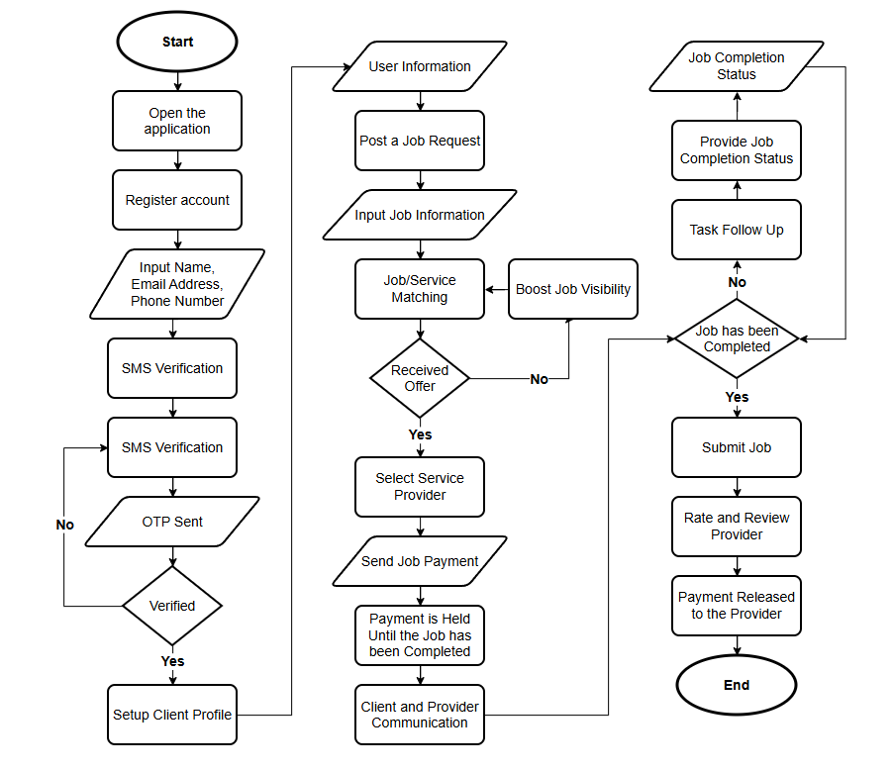

Figure 4.3b: Provider Flow via Registration
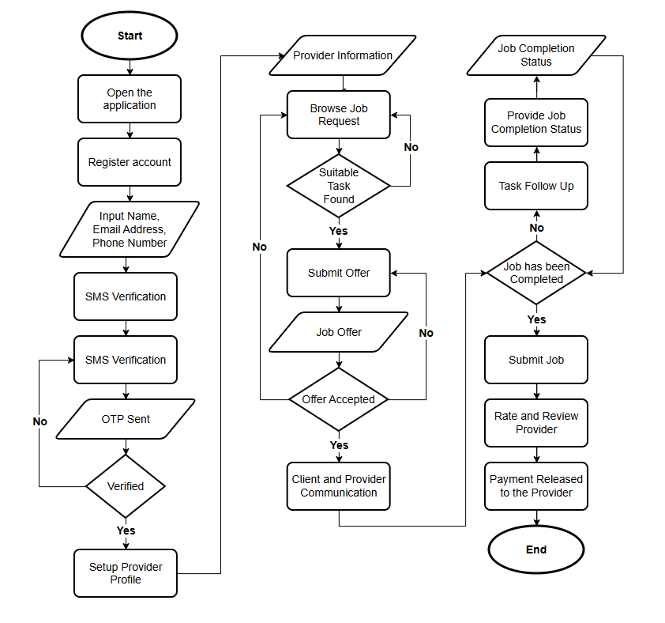

Figure 4.3c: Client Flow via Login

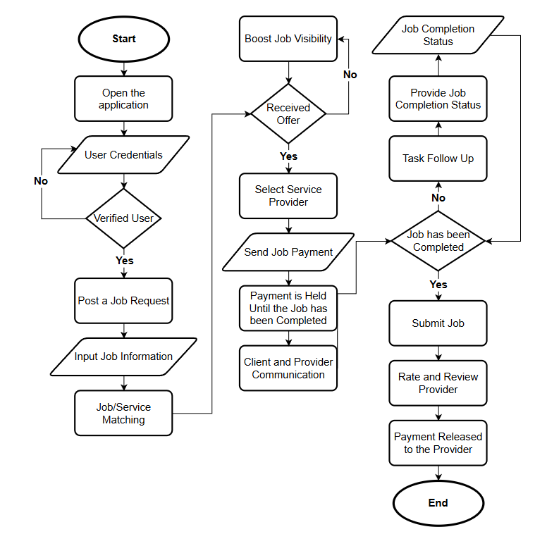

Figure 4.3d: Provider Flow via Login

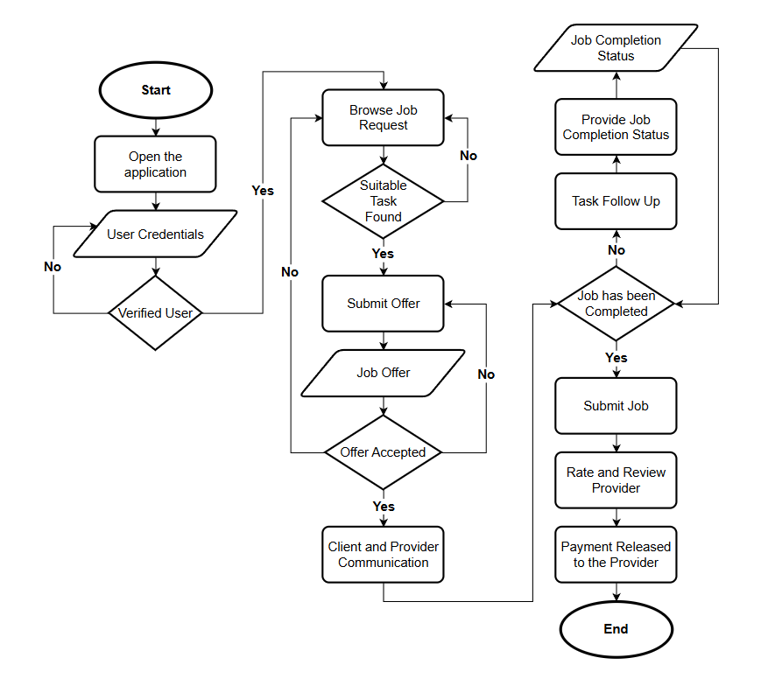
These diagrams detail the processes for:
- Account creation and SMS/OTP verification (email verification in the MVP).
- Posting a task (Dropper) and browsing/submitting offers (Chaser).
- Task matching, communication, completion, and payment release.

The flowcharts align with the functional requirements defined in Section 3, particularly those related to user registration, task posting, task acceptance, and payment confirmation.

- 4.4 Interface Diagram (Component‑level Design)

The low-fidelity wireframes in Figures 4.4a through 4.4j provide the visual design of the Android mobile application. These wireframes define the layout and user interaction flow for the main screens.

Login and Registration Screens
- Figure 4.4a: Login Screen – Allows existing users to enter credentials.
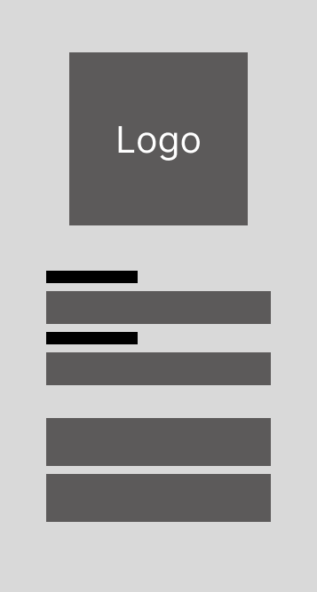

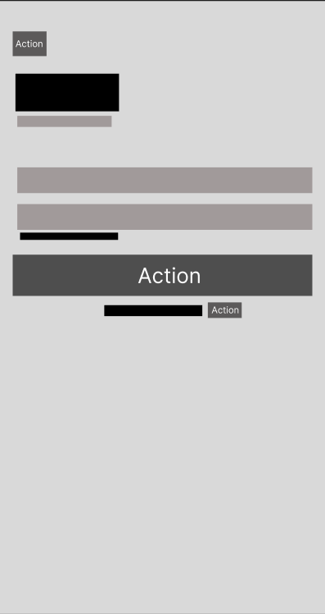
- Figure 4.4b: Registration Screen – Captures new user information.

Task Posting (Dropper) Workflow
- Figure 4.4c: Post – Title & Description – Fields for task title and description.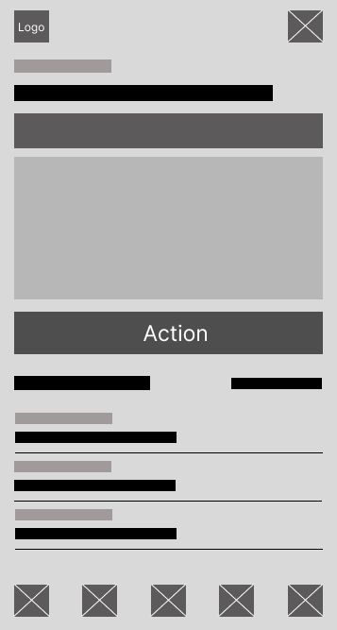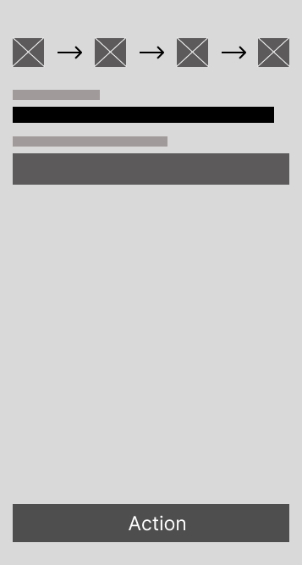

- Figure 4.4d: Post – Additional Details – Where, when, budget, and other options.
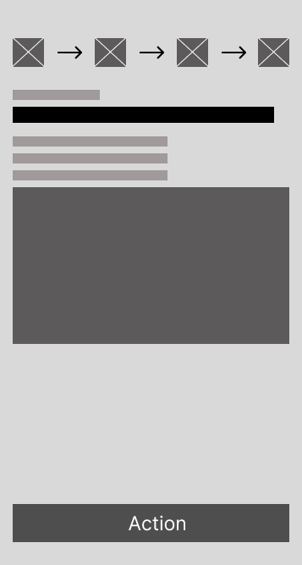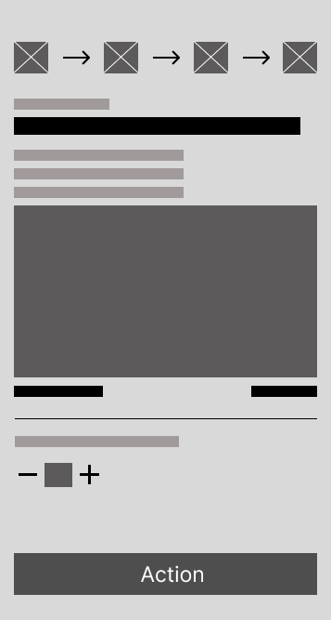

- Figure 4.4e: Post – Summary – Review before publishing.
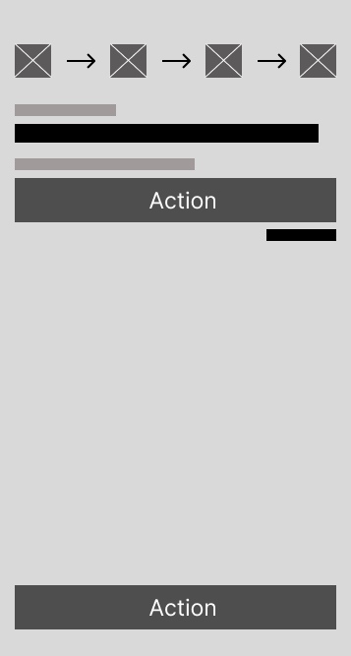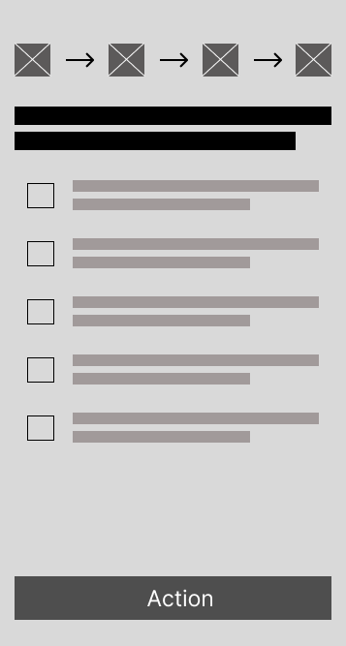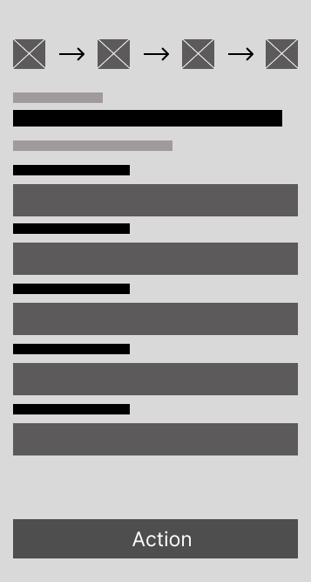
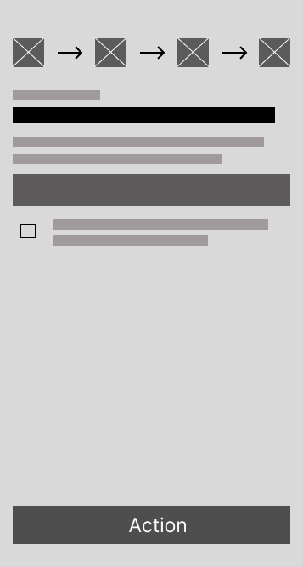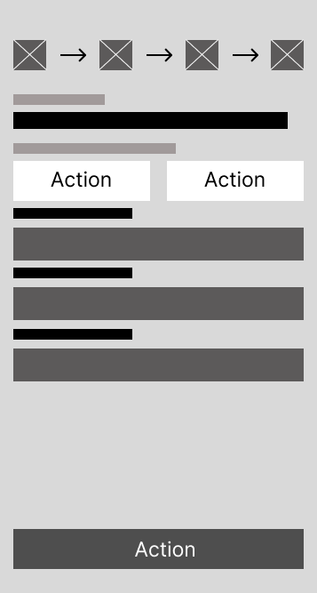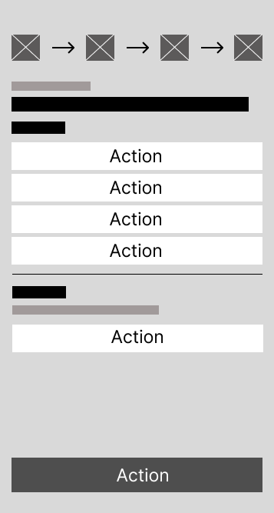

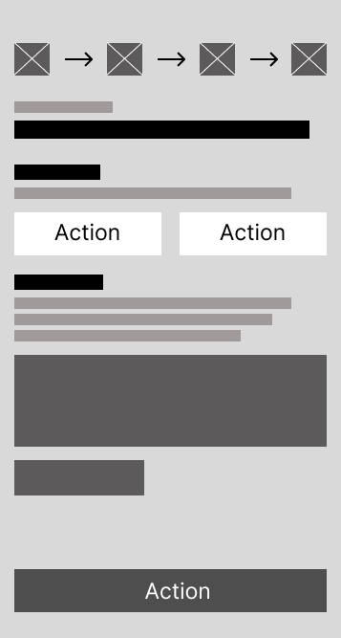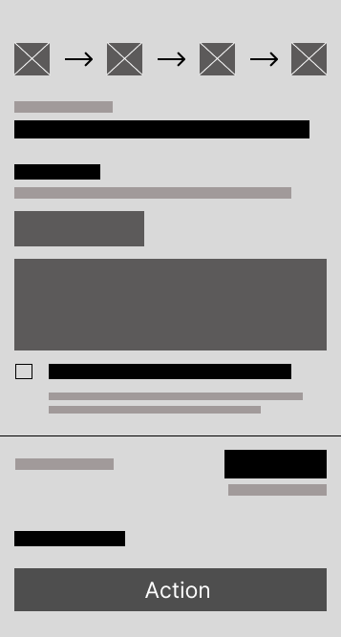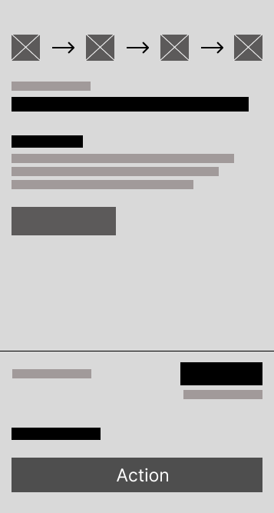
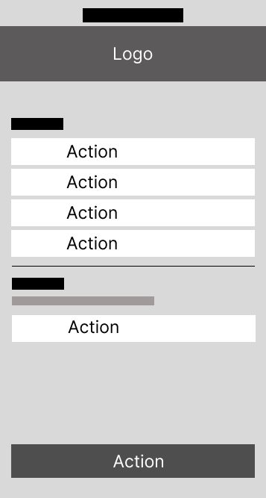

Task Discovery (Chaser) Workflow
- Figure 4.4f: Browse Feed – Lists available tasks with filters.
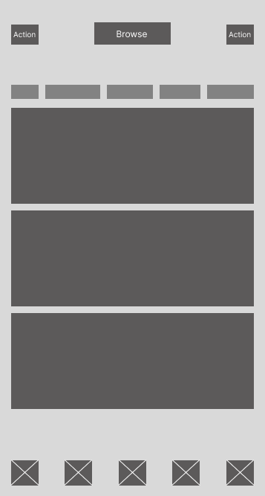
- Figure 4.4g: Task Details – Shows full task information and acceptance button.
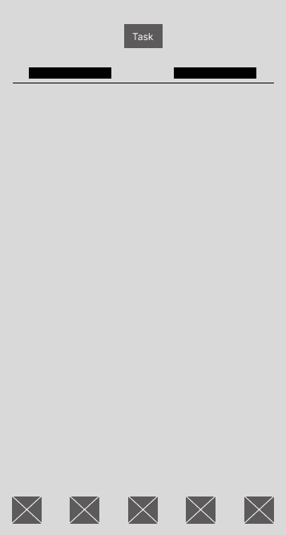
Coordination and Communication
- Figure 4.4h: Chat List – Shows active conversations.
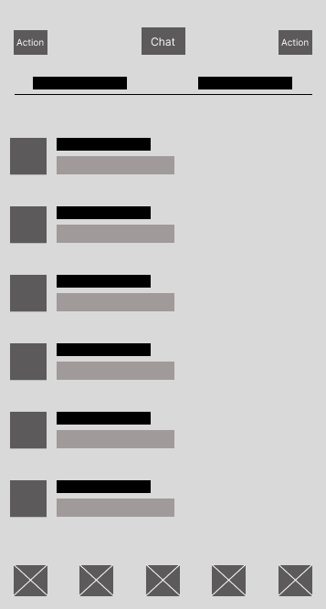

- Figure 4.4i: Chat Window – Real-time messaging interface.
