User Profile
- Figure 4.4j: Profile Screen – Displays user details, verification badge, and completed tasks count.
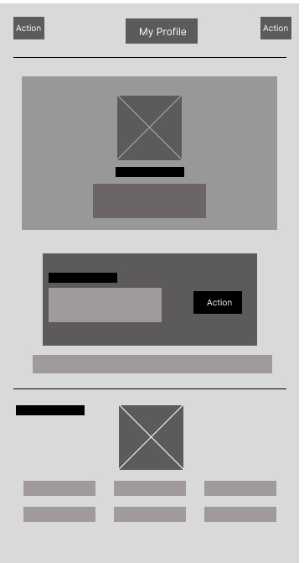
Each wireframe is designed to be intuitive and to follow Material Design guidelines, ensuring a consistent user experience on Android devices.
6. Design Constraints
This section describes the limitations imposed on the design and development of the GMIK Minimum Viable Product (MVP). These constraints are derived from the project scope, platform decisions, budget limitations, and academic timeline documented in the preceding sections.

Platform Constraint
The MVP is built for Android only. We're using React Native with API Level 29 or higher, but the app will not be available on iOS at launch. A web version for regular users is also off the table for now both are planned for future releases. We're also not optimizing tablets in this version. It'll work, but don't expect a tablet-specific experience.

Technology Stack Constraint
We're not experimenting with different technologies. The backend runs on Node.js with Express.js. The database is PostgreSQL hosted in the cloud. For location features, we're using Google Maps Platform. For push notifications, it's Firebase Cloud Messaging. Every bit of communication between the app and our servers must be encrypted with TLS 1.2 or higher. These decisions have already been made, and the team will stick to them.

Payment Processing Constraint
This is a hard rule: GMIK does not touch payments. When a Dropper and Chaser settle up, they do it outside the app cash, GCash, Maya, whatever works for them. The app only provides a way for the Dropper to mark the task as "Payment Settled" afterward. That means no credit card forms, no digital wallets, no escrow, and no automated dispute resolution. We're staying far away from the complexity of handling real financial transactions.

Trust and Reputation Constraint
You won't find five-star ratings in the MVP. That feature was deliberately cut from the current scope. Instead, trust is shown through completion counters a simple number on every user's profile showing how many tasks they've successfully finished. Account verification is also straightforward: just email confirmation. No ID uploads, no SMS codes, no "Sign in with Google" buttons. We're keeping the barrier to entry low while still establishing basic accountability.

Task Lifecycle Constraint
The task model follows a simple rule: one task, one Chaser. Once a task is accepted, it's off the marketplace. No bidding, no splitting tasks among multiple people, no complicated assignments. The status also moves in only one direction: from Posted to Accepted to In-Progress to Done. There's no going backward. If a task is marked Done, it stays Done. This keeps everything predictable for both parties.

Budget and Time Constraint
We started development in February 2026 and need to wrap up by November 2026, that's about ten months. The team expects to put in roughly 1,000 to 1,200 hours of work, and nobody is getting paid. This is sweat equity. The actual cash we need to spend on cloud hosting, Google Maps API (within free tier limits), domain registration, SSL certificate, and a little buffer for surprises is between P20,000 and P55,000. If something would push us beyond that, we either cut it or figure out another way.

Deployment Constraint
At launch, we're not aiming for millions of users. The MVP will soft-launch with just 30 to 50 people using it at the same time, all from our immediate academic community. That means we don't need to build for massive scale. No 99.9% uptime requirements, no automatic failover, no disaster recovery across multiple regions. Moderation is done manually by Operations Managers through the admin dashboard. No AI, no automated flagging—just real people reviewing reported content.

Data Privacy Constraint
Even though we're small, we still have to handle user data responsibly. The document calls out data privacy as a non-functional requirement, so we need to follow the rules. That means collecting only what we need, storing it securely, and being transparent about how it's used. The TLS encryption requirement already covers the security side, now we just need to make sure our practices match the law.

Excluded Features Constraint
Sometimes what you don't build is just as important as what you do. Here's what's explicitly not in the MVP iOS support, a web app for regular users, in-app payments, automated dispute resolution, five-star ratings, SMS verification, multi-person tasks, bidding, tablet layouts, and any kind of automated content moderation. These are all conscious cuts to keep the project on track and deliver something that actually works by November.

- Non-Functional Attributes

The GMIK system must satisfy a comprehensive set of non-functional requirements to ensure that the application operates efficiently, securely, and reliably while delivering a high-quality user experience. These attributes define how the system performs rather than what it does.

  - Security

- The system must ensure secure user authentication through verified accounts.
- All data communication must be protected using encrypted connections (HTTPS).
- User information such as passwords must be stored securely
- The system must prevent unauthorized access and protect against common security threats.
- Payment information is not stored, as all transactions are handled outside the system.

  - Performance

- The system should respond quickly to user actions such as loading tasks, posting, and messaging.
- Task feeds and user interfaces should load smoothly without noticeable delays.
- Real-time features like chat and notifications should function efficiently.
- The system should handle multiple users at the same time without slowing down.

  - Reliability

- The system must function consistently without frequent errors or crashes.
- Task data and user actions must be always saved accurately.
- The system should handle failures gracefully and recover without losing data.

  - Usability

- The application must be easy to use and understand for all users.
- The interface should follow a clear and consistent design.
- Users should be able to perform key actions (posting, accepting tasks) with minimal effort.
- Error messages and notifications must be clear and helpful.

  - Scalability

- The system should support future growth in users and data.
- It must be designed so additional features can be added later without major changes.

  - Maintainability

- The system should be easy to update, fix, and improve.
- The code structure must be organized and understandable for developers
- Future modifications should not disrupt existing features.

  - Portability

- The system should run on different Android devices with varying specifications.
- The use of React Native allows for possible expansion to other platforms in the future.

  - Compatibility

- The system must work properly with required external services such as maps and notifications.
- The admin dashboard should function on standard web browsers.

  - Data Integrity

- The system must ensure that all stored data is accurate and consistent.
- Task status and user information must always reflect the correct state.

  - Availability
- The system should be accessible whenever users need it, with minimal downtime.
- Any maintenance should be planned to avoid disrupting users.

