**GIS-Analyses using Free- and Open-Source-Software**

**Assignment 5**

**By C. Gawlas (3604077) and U. Lorenz (3600484)**

1. **Draw a workflow diagram**

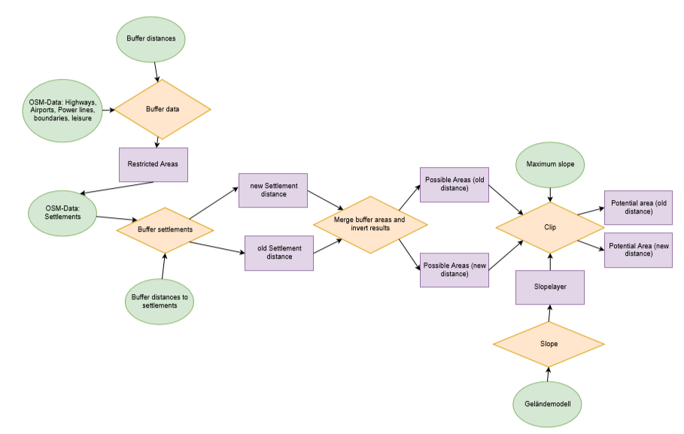

In this workflow a circle means that what it contains is an input parameter or data set. The yellow rhombs are processes and the rectancles are all kind of results gained by dataprocessing.

For our needs it is not necessary to differentiate which part of the analysis should be done with which tool because the whole analysis can either be done in QGIS or in GRASS GIS. It would be possible to combine these tools, but there is no need to do so. This is why the colour in our case is the same for every symbol

1. **Experimental implementation in GRASS GIS**

For an experimental implementation the data preprocessing is done with GRASS GIS. This includes to import the data, clip, set the region, merge files, load an extension and use the extension. This is all implemented in the Preprocessing_assignment5.py script which can be found in our repository (collaborator only Gawlas, Ludwig and Lorenz, otherwise not visible; <https://github.com/UlrikeLorenz/Final_Project_Group5/blob/master/Preprocessing_assignment5.py>). Data sources for the implementation are given as textfiles in the repository. Most of the data is gain from OSM by overpass-turbo.

For our purposes GRASS GIS is an option for the final project. It is possible to import all the files and do the preprocessing. The difficulties are the different coordinate systems. In our analysis most of the layers should be buffered with a value in the same unit as the projection gives. This means most of the layer would be buffered in degrees instead of meters. This is why it would be easier to do a part of the Project in QGIS which offers the opportunity to reproject files in the same environment. In GRASS GIS it is also possible, but more complicated because a new location is needed with a coordinate system in meters (UTM). There the files from another location in a coordinate system with degrees as unit can later be reprojected and imported to the new location to be able to buffer with meters as units. To work with the Elevation model both GRASS GIS and QGIS offer great opportunities so it is considered as equal.

BONUS

The bonus is implemented with an additional script available at <https://github.com/UlrikeLorenz/Final_Project_Group5/blob/master/Assignment5_Bonus/BONUS_script.py>. For the script data from overpass turbo and an layer with the stops is uploaded on the repository too.