# The Power Meter Device

## Hardware

### Strain Gages

Four CEA series, 350 Ohm strain gages are located on the crank arm of the bicycle, connected as a Wheatstone bridge, and supplied with 5 Volts. Two of the strain gages are placed on the upper side of the arm, while another two are located on the lower side. This arrangement eliminates temperature effects on the measurements, as well as prevents forces which are parallel to the arm to be measured.

### Amplification

Since the differential signal of the strain gages is too small, it needs to be amplified. This is achieved by using the instrumentation amplifier INA122, which takes a differential signal and outputs a single amplified signal. The gain of the amplifier is entirely dependent on a single external resistor; for this project the resistor has a value of 750 Ohms.

### Reed Switch

To measure the cadence, the reed switch of a cheap bicycle computer was used. This switch closes when located close to a magnet; it is connected together with a pull-down resistor to a port of the Genuino 101, so that when the reed switch passes the magnet, a high signal can be read by the Genuino.

The reed switch is mounted on the inner side of the crank wheel, while the magnet is mounted on the bicycle frame.

### Genuino 101

The Arduino/Genuino 101 is a development board which includes an Intel Curie module. This board is appropriate for use in this project since it includes an internal Bluetooth Low Energy (BLE) including a PCB antenna. As expected from a microcontroller, the Genuino 101 can be instructed to react to input and timer interruptions.

The Genuino 101 can be programmed using the Arduino IDE, although it needs the particular add-on that allows programming the Intel Curie module. Furthermore, the CurieBLE library allows for easy and fast development of programs that use the Bluetooth BLE module.

<https://www.arduino.cc/en/Main/ArduinoBoard101>

<https://www.arduino.cc/en/Reference/CurieBLE>

## Software

### Algorithm overview

The following figures show the flow chart for the main program, the timer (1 millisecond) interruption, as well as the reed switch interruption.

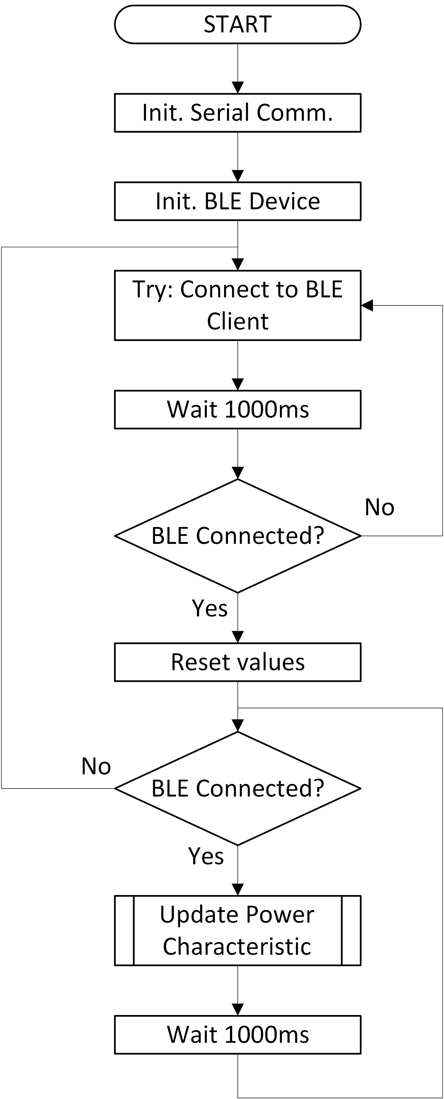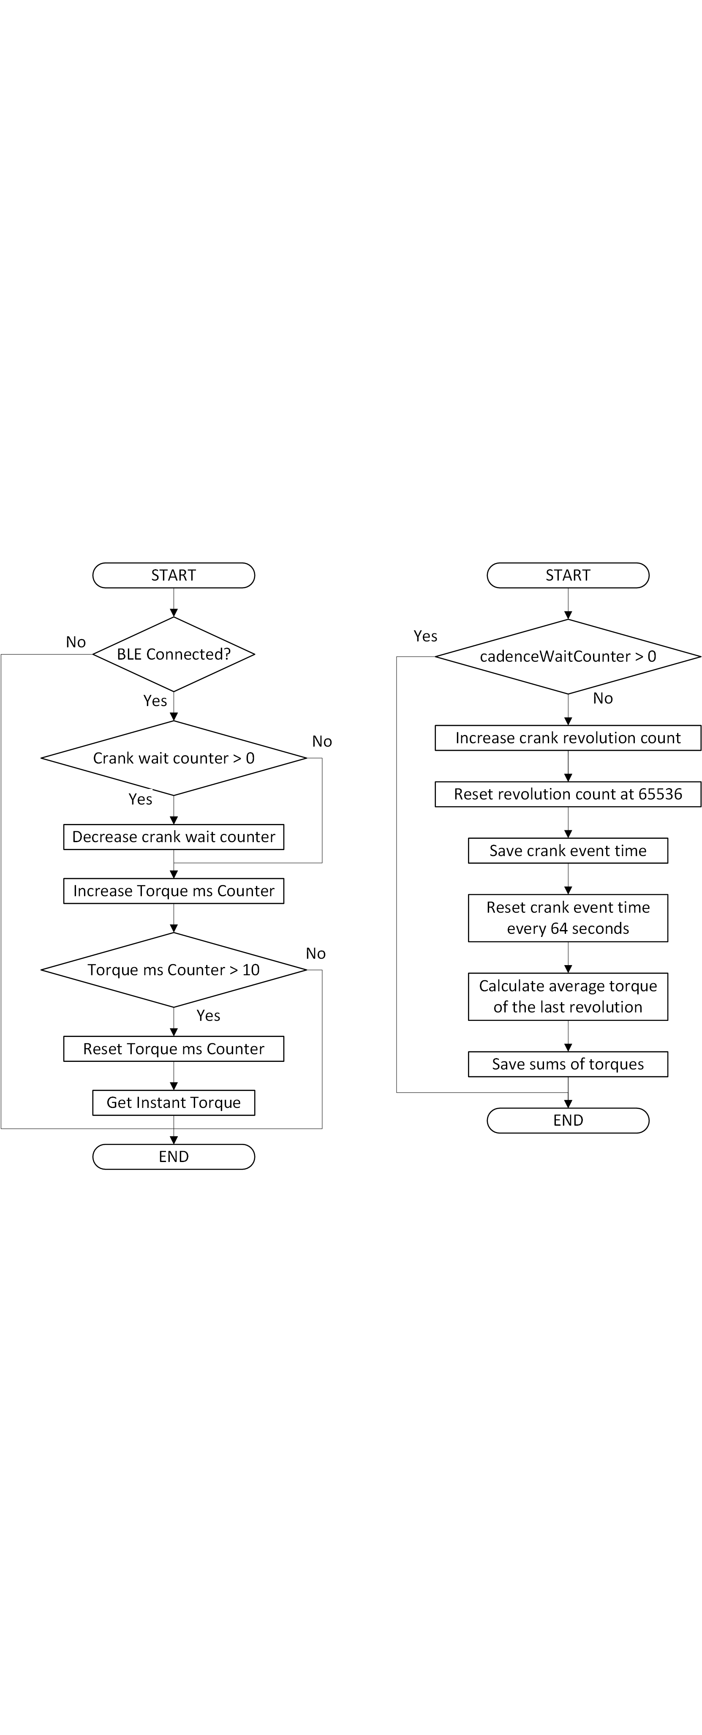

### Bluetooth Low Energy Services and Characteristics

Bluetooth Low Energy (also known as Bluetooth 4.0 or Bluetooth Smart) functions similar to a posting board, and its implementation is documented in the Bluetooth 4.0 specification. Services for different purposes exist already (including one for power meters); custom services may also be used.

Each service contains a number of so called characteristics, and each characteristic is made up of at least one value field (of different lengths and data types). All services and characteristics are identified by a UUID, which normally is written as a two bytes value.

Characteristics can (and must) be configured in at least one of three R/W configurations, following the specification. WRITE characteristics may be written by clients, READ characteristics need a request from the client, and NOTIFY characteristics work as push notifications, wherein the server informs the client when the value of the characteristic has changed, and send the new value.

For the power meter, the following service, characteristics, UUID and configurations where used.

|  |  |  |
| --- | --- | --- |
| **Name** | **UUID** | **Configuration** |
| Power Service | 0x1818 | ------ |
| Cycling Power Measurements Characteristic | 0x2A63 | Notify |
| Cycling Power Feature Characteristic | 0x2A65 | Read |
| Sensor Location Characteristic | 0x2A5D | Read |

### Torque Measurements

Strictly speaking, the signal that is measured by Genuino corresponds to the force applied to the pedal. This force is measured every 10 ms by means of a timer interruption; this force is multiplied by the crank length (17 cm) to get the torque of the crank. The average torque of each crank revolution is calculated, which multiplied by the cadence at that moment makes up the power at a certain time.

The sensitivity (Volts/Newton) of the strain gages and their amplification was calculated experimentally by adding known weights to the crank, and getting the voltage read by Genuino. The gotten measurements show a linear relation (as expected) between the force applied and the voltage appearing at the analog port.

Note that, for the calculations, it is necessary to estimate a force out of a voltage measurement. The results are as follows:

|  |  |  |
| --- | --- | --- |
| **Name** | **Value** | **Units** |
| Slope | 261.7427 | Newton/Volt |
| Offset | -181.948 | Newton |

### Cadence Measurements

Every crank revolution is detected with an interrupt; within this interview the count of the cumulative crank revolutions is increased, and the time of the last crank event is saved. The cadence itself is calculated right before updating the BLE values.

### Power Calculation

The power measurement characteristic is updated every second. Updating this characteristic implies the calculation of the average cadence and power since the last update. Once the new values have been calculated, all relevant characteristics are written by the server and may be sent to the clients.

The cadence is calculated by subtracting the current and old cumulative crank revolutions, and dividing this by the time difference between the current and old last crank events. The power is then calculated by multiplying the calculated cadence by the average torque of the last second. These values are then written to each of the characteristics; if the characteristic has more than one value field (or value fields longer than one byte), they are saved in an array in the order given by the Bluetooth 4.0 specification.