**Tech Bazaar**

C:\Users\Hp\AppData\Local\Temp\ksohtml16812\wps1.png

**Final Year Project – I**



**FYP Team**

Hamza Ahmad Bhutta 18F-0368

Fahad Usman 18F-0181

Sheroz Khalid 18F-0319

Project Supervisor: Mr. Masood Habib

Co-Supervisor: Dr. Umer Aftab

**Date**

**10/04/2022**

**Fall 2022**



### Department of Computer Science

FAST – National University of Computer & Emerging Sciences Chiniot-Faisalabad Campus

# Acknowledgement

This documentation consumed a lot of work, research, and dedication. It was not possible without help of our teachers and supervisors. We would like to extend our sincere gratitude to them.

We are thankful to FAST National University of Computer and Emerging Sciences for their financial and logistical support and for providing necessary guidance concerning project.

We are also grateful to both our supervisor Mr. Masood Habib for provision of expertise, and technical support. Without their superior knowledge and experience, the documentation would never have brought the quality outcomes, and thus their support has been essential.

We shall soon start the implementation of the project after the acceptance of documents.

# Intellectual Property Right Declaration

**This is to declare that the work under the:**

**Title: ADS carried out in partial fulfillment of the requirements of:**

**□BS FYP □MS Research Survey □MS Thesis □Course Project**

Is the sole property of the National University of Computer and Emerging Science, and is protected under the intellectual property right laws. It can only be considered/used for purposes like extension for further enhancement, product development, adoption for commercial/organizational usage, etc., with the permission of the University

This above statement applies to all students and faculty. Date: 26/6/22

Student 1

Name: Hamza Ahmad Bhutta

Signature: Hamza

Student 2

Name: Fahad Usman

Signature: Fahad

Student 3

Name: Sheroz Khalid

Signature: Sheroz

Supervisor (Faculty)

Name~~:~~ Mr. Masood Habib Signature:

Co-Supervisor (Faculty) Name: Mr. Umar Aftab

Signature:

# Tech Bazaar

This is to declare that the above publication produced under the:

#### Title: Tech Bazaar

Is the sole contribution of the author(s) and no part hereof has been reproduced on as it is basis (cut and paste) which can be considered as **Plagiarism.** All referenced parts have been used to argue the idea and have been cited properly. We will be responsible and liable for any consequence if violation of this declaration is determined.

Date: 26/6/22

Student 1

Name: Hamza Ahmad Bhutta

Signature: Hamza

Student 2

Name: Fahad Usman Signature: Fahad

Student 3

Name: Sheroz Khalid

Signature: Sheroz

Table of Contents

Department of Computer Science 1

Acknowledgement 1

Intellectual Property Right Declaration 2

Tech Bazaar 3

1: Document Version 9

1.1 : Introduction 1

1.1.1 : Purpose 1

1.1.2 : Objectives 1

1.1.3 : Scope 1

1.1.4 : Abbreviation, definition 1

1.1.5 : Intended Audience and Reading Suggestions 2

1.2 : Positioning: 2

1.2.1 : Business Opportunity: 2

1.2.2 : Problem Statement 3

1.2.3 : Product Position Statement: 4

1.3 : STAKEHOLDER AND USER DESCRIPTIONS 5

1.3.1 : Market Demographics: 5

1.3.2 : Stakeholder Summary: 5

1.3.3 : User Summary 6

1.3.4 : User Environment 6

1.3.5 : Stakeholder or User Needs 7

1.4 : Product Overview 8

1.4.1 : Product Perspective 8

1.5 : Dependencies and Constraints 8

1.5.1 Dependencies 8

1.5.2 Constraints 9

1.6 : Functional Requirements 9

1.7 : Other Non-Functional Requirements 11

1.7.1 Availability: 11

1.7.2. Reliability: 11

1.7.3. Testability: 11

1.7.4. Maintainability: 11

1.7.5 Accessibility: 11

3. Use Case 12

3.1 : System Use Case Diagram 12

3.2 : High level Use Cases 13

4.1 : Expanded Use Cases 15

4.1 : Operation Contracts 20

4.5.1: OC1: 20

4.5.2: OC2: 20

4.5.2: OC3: 21

4.0 Architecture Diagram: 22

4.1 Component Diagram: 23

4.2 Activity Diagram 24

4.3 Package Diagram: 26

4.3 Data Flow Diagram: 27

4.4 Schema Design: 28

4.5 System Sequence Diagram 29

4.1.1 Register: 29

4.1.2 Setup Shop: 30

4.1.3 Analyze Sales: 31

4.1.4 Pay in Installment 32

4.1.5 Wishlist: 33

5: Reference 34

**Figure 1 Use Case 12**

**Figure 2 Architecture Diagram**: **22**

**Figure 3 Component Diagram 23**

**Figure 4 Activity Diagram 24**

**Figure 5 Package Diagram 25**

**Figure 6 Data Flow Diagram 27**

**Figure 7 Schema Design 28**

**Figure 8 System Sequence Diagram 29**

**Table 1 Problem Statement 3**

**Table 2 Product Position Statement 4**

**Table 3 Stakeholder Summary 5**

**Table 4 User Summary 6**

**Table 5 Stakeholder per User Needs 7**

**Table 6 Summary of Capabilities 8**

# 1: Document Version

*Table 1- Version of Vision Document*

|  |  |  |  |
| --- | --- | --- | --- |
| **Version** | **Date** | **Description** | **Authors** |
| V1.0 | 05/01/2022 | Updated: problem statement  Updated:Funtional Requirement | Hamza Ahmad Bhutta  Fahad Usman  Sheroz Khalid |
| V1.1 | 14/04/2022 | Updated: UML diagrams | Hamza Ahmad Bhutta  Fahad Usman  Sheroz Khalid |

# Introduction

### : Purpose

The purpose of this document is to highlight, analyze and to have a better understanding of the high-level requirements of the system. It focuses on the capabilities needed by the stakeholders, and the targeted users, and why these needs exist. This will help us in identifying and reducing the potential risks of the system.

### : Objectives

* + - * People will get web based application for trading their merchandises.
      * Seller will be able to launch the marketing campaigns through appropriate channels.
      * Advertisement will become more easer for seller to handle with the help of software.
      * Sales analysis enable the seller to keep track of their growth and marketing campaign.
      * It will make easier for customer to get track of interested goods
      * Advertisements will be relevant to customer interests which will grow sales of goods.

### : Scope

This Document applies to TechBazaar, which is a business marketplace for retailers and Vendors. The application will help connect active Vendors who have good quality of goods to new customers and will help them in mutual benefits like growth in sales and finding goods at moderate price etc. The application will provide a medium for small scale business to promote their goods with the help of automated advertisement assisted with sales analytics and showing their promotions to interested customers through notifying system under considerable charges.

### : Abbreviation, definition

Following are the abbreviation and definitions used in the document:

* TechBazaar: The marketplace for Vendors and customers
* Customer: Person who wants to buy something.
* Stakeholders: People who are taking risks of loss for benefits.

### : Intended Audience and Reading Suggestions

The intended audience for the following document are developers and the users of the application. The main audience are:

* + - * **Development Team** will use this document to design and develop a web based application according to the customer requirements.
      * **Users** will use this document to learn about the features of the system and get information about how to use the system.
      * **Testers** will use this document before writing test cases because this will act as a contract between customer and contractor. Tester will validate user requirements.

The rest of the document contains the functional requirements, non-functional requirements, deployment info and dependencies.

# Positioning

Positioning tells us that how our application grows, and we can earn money through this application in the market, it defines business opportunity and defines the Problem statement that why we need to develop this application.

Details are given below:

### : Business Opportunity

A lot of opportunities will come if this application start to work in present modern era. New jobs will be created in Vendors stores. New and innovative products could be launched through this application, will be available. This application will assist in goods promotion across its relevant interested customers. It will assist in Vendor business growth with its modern techniques and tools. Not only Vendors get revenue from it but its development team and owner of this application will also be able to get their commission from its users. Automated advertisement assisted with analytics tools promises in the growth of business.

### : Problem Statement

*Table 1 Problem Statement*

|  |  |
| --- | --- |
| The problem of | People don’t have enough budget and traffic to create their own web based application for their businesses. They need an online application to establish their online store and emphasize their products in the market which are low on sales.Moreever buyers mostly don’t get satisfy about quality & courier method. For computer and electronic accessories specifically. |
| Affects | The retailers, Vendors and their customers. Local businesses that want to promote their goods and need a proper advertisement channels assisted with modern tools. |
| The impact of which is | Local brands not having a centralized platform for promotions and advertisements to influence their business growth. |
| A successful solution would be | The web application will provide a medium for small scale business to promote their goods with the help of automated advertisement assisted with sales analytics and showing their promotions to interested customers through notifying system under considerable charges. |

### : Product Position Statement:

*Table 2 Product Position Statement*

|  |  |
| --- | --- |
| For | 1. New brands, Vendors and retailers looking for the best solution for promotion, growth in business and profit. 2. Customers looking for goods at moderate price with considerable quality. |
| Who | Are looking for a centralized platform where their goods and products could be featured, and they could be sold right away on the basis of their categories. |
| TechBazaar | Is a web application based software solution. |
| That | 1. Provides a marketplace to the new brands, Vendors and retailers where they can promote their product, track and influence their growth in business and to increase profit. 2. Provide goods at moderate price with considerable quality. |
| Unlike | Platforms which don’t offer the functionality of analysis and marketing campaign. Don’t attract customers. |
| Our product | Provide a medium for small scale business to promote their goods with the help of automated advertisement assisted with sales analytics and showing their promotions to interested customers through notifying system under considerable charges. |

# : STAKEHOLDER AND USER DESCRIPTIONS

### : Market Demographics:

The target market segment includes the people who readily use their mobile phones and laptops. The users are expected to be connected to internet in order to reach application. To gain the attention of consumers we have to use platforms where consumers can easily access our application.

### : Stakeholder Summary:

*Table 3 Stakeholder Summary*

|  |  |  |
| --- | --- | --- |
| **Name** | **Description** | **Responsibilities** |
| FAST-CFD Faculty | Have copyrights of our Final Year Project | Provide resources and help to develop this application. |
| Mr. Masood Habib | Supervisor of the project. | Help the development team to develop the project. |
| Mr. Umar Aftab | Co-Supervisor of the project. | Help the development team to develop the project. |
| Hamza Ahmad Bhutta | Member (student) | Development of project. |
| Fahad Usman | Member (student) | Development of project |
| Sheroz Khalid | Member (student) | Development of project |

### : User Summary

*Table 4 User Summary*

|  |  |  |  |
| --- | --- | --- | --- |
| **Name** | **Description** | **Responsibilities** | **Stakeholder** |
| Vendor | High priority end user of the system. | 1. Launch campaigns to promote their products. 2. Approach the Customer the by using the search filter. | Self |
| Customer | High priority end user of the system. | 1. Send offer against the launched campaigns by the brands 2. Create order and deliver it after completion. | Self |

### : User Environment

In order to use **TechBazaar.com** system users are required to have internet availability

And Browser.

### : Stakeholder or User Needs

*Table 5 Stakeholder per User Needs*

|  |  |  |  |  |
| --- | --- | --- | --- | --- |
| Need | Priority | Concerns | Current Solution | Solution |
| Secured access | High | Privacy of user data. | None | Management of user access with unique username and  password. Also, implementation of md5. |
| Scalable | High | Security is a big concern with respect to data especially images of person can be stolen. Application can be used by kidnappers also. | None | Allow multiple users to access the application at the same time. |
| Easy-to-use | High | Users can easily use the application. | None. | Provide a user-friendly interface. |
| Flexible | Moderate to High | Each user may have a custom-made experience for itself. | None. | Users can switch between application modes according to their needs. |
| Responsive | Moderate | None | None | User upload response time will be kept minimum. |

# : Product Overview

This field is used to give overall view related to product. The information gives in this section must be accurate precise, specific and relate to the project, which describes the perspective and features of the product.

### : Product Perspective

This product will be a web-based application and need a browser with internet connection. To use this application user must registered first by using their active email or login through their social accounts (Facebook, Instagram, and Gmail). After that user can login to the system and access the functionality provided by the application.

# : Dependencies and Constraints

This section is defining the dependencies and constrains of the TechBazaar. Below is the detailed description.

### Dependencies

The default language of this application is English, It Requires laptop & smart phone.

This application depends on phone number verification by using email service and on network. Network on the user’s phone will be available everywhere a user may go so that emergency messages may be speedily delivered

### : Constraints

The constrains of our system are listed below:

#### Security

The image of user is encrypted so that no one steals the data and provides privacy to users by two-way authentication, first with phone number verification and the second one with login.

#### Usability

A lay man who knows how to use the internet can easily interact with the system. Language will simple to understand for layman. The bounce will be minimum so the user can easily move backward and forward. Through these effecs user interface will be easy to use.

#### Responsiveness

The response time of the system will be maximum 25 seconds. The system will load any of the page and in 20 to 25 seconds.

#### Maintainability

The system should be developed in such a way that it is extensible. It should be easy to incorporate new features requirements or accommodate a change in the existing requirements.

# : Functional Requirements

* Portals for both Sellers and customers.
* Sellers and customers should be able to login into their account.
* The Buyer can see products through ads & look into his/her desired products.
* Buyer can save his/.her desired items as wishlist to purchase later
* Ads shown to buyer on basis of wishlist.
* Email marketing would help to engage customer attraction
* Live chat and messenger option would provide easiness to customer
* Price wise commission system would implemented
* It provides return and refund policy.
* Ads will created automatically no admin person needed
* Sales will check by data analysis.
* Provides return and refund policy for customer satisfaction
* Notifies about wishlist base discount items
* Provides Payment methods
* The user will receive notification about any changes in order
* Product quality Negotiation before payment for customer satisfaction.
* Rating and reviews will collect to modify enhance system if needed.

# : Other Non-Functional Requirements

### Availability

The system should be always available. It should be ensured that there should be minimum or no downtime to ensure better user experience. The system should be reliable. It should yield correct results if a user performs searches for a person.

### Reliability

Our application will provide regular information and notifications about discounts and new products.

### Testability

The application should be testable. A separate test environment should be set up where testers and the Quality Assurance engineers can test the application for bugs and/or incomplete or missed requirements.

### Maintainability

The system should be maintainable. The system should be able to adapt new features. Previous functionality should not be disturbed in case of adding new functionality.

### 1.7.5 Accessibility

The system should be accessible to the Vendors and customers only at any location.

# Use Case

### : System Use Case Diagram

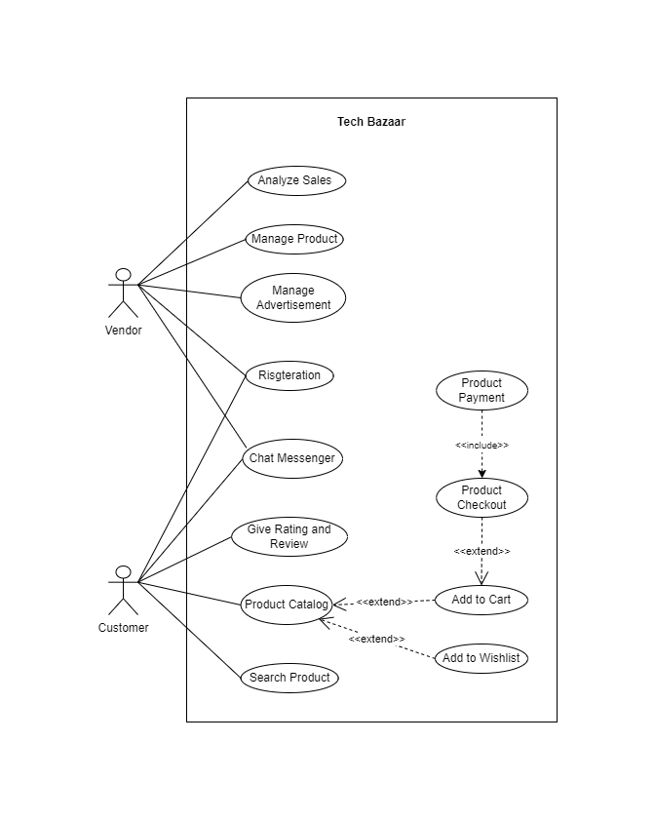

*Figure 1 Use Case*

### : High level Use Cases

#### : Register user

|  |  |
| --- | --- |
| Use case ID | UC-02 |
| Use case name | Register |
| Actor | Vendor, Customer |
| Type | Primary |
| Description | User will enter their details into the system. System validate customer’s details and saves into the database. |

#### : Product Catalog

|  |  |
| --- | --- |
| Use case ID | UC-02 |
| Use case name | Product Catalog |
| Actor | Customer |
| Type | Primary |
| Description | Users can view products/items on system. A web page containing all accessories will show to user. |

#### : Analyze Sales

|  |  |
| --- | --- |
| Use case ID | UC-03 |
| Use case name | Analyze sales |
| Actor | Vendor |
| Type | Primary |
| Description | To Analyze records of user’s sales and purchasing. To collect review about which products are more selling and which product makes less selling. |

#### : Confirm package

|  |  |
| --- | --- |
| Use case ID | UC-04 |
| Use case name | Confirm package |
| Actor | Vendor, Customer |
| Type | Primary |
| Description | Customer make payment receives his/her shipping system notifies product receive successfully points deduct from his/her wallet and package is confirm for both vendor and customer. |

#### : Setup advertisement

|  |  |
| --- | --- |
| Use case ID | UC-06 |
| Use case name | Setup advertisement |
| Actor | Vendor |
| Type | Primary |
| Description | Ads of products shown to both users .Ads also be shown on wishlist of customer. Ads will created automatically. |

#### : Product Checkout

|  |  |
| --- | --- |
| Use case ID | UC-07 |
| Use case name | Product Checkout |
| Actor | Customer |
| Type | Primary |
| Description | Select product quantity ,add shipping address and payment method. |

#### 3.2.7: Add in Wishlist

|  |  |
| --- | --- |
| Use case ID | UC-08 |
| Use case name | Add in wishlist |
| Actor | Customer |
| Type | Primary |
| Description | User can add his/her desire product in wishlist for later. |

### Expanded Use Cases

The features of our system are given below. These are the major features which has been described below

#### : Register user

|  |  |
| --- | --- |
| Use case name | Register user |
| Actor | Vendor, Customer |
| Type | Primary |
| Description | User will enter their details into the system. System validate details and saves into the database. |
| Pre-conditions | User is not registered before. User need to access system through web browser |
| Post-conditions | System creates a new account for the new user. |
| Noral flow | 1. User provide their details. 2. System save details. 3. System setup/displays product. 4. System shows the message after setup successfully. |
| Alternate Scenario | 1. If user details are invalid    1. Display the message of Invalid details.    2. Return to 1. |

#### : Manage Product

|  |  |
| --- | --- |
| Use case name | Manage Product |
| Actor | Vendor |
| Type | Primary |
| Description | Users can view products/items on system |
| Pre-conditions | Users must provide details. |
| Post-conditions | Users able to see products & perform activities |
| Normal flow | 1. Users give detail. 2. System save details 3. System display details of user. |
| Alternate Scenario | If details invalid make changes according to new detail. |

#### 4.1.3: Confirm package

|  |  |
| --- | --- |
| Use case name | Confirm Package |
| Actor | Customer, Vendor |
| Type | Primary |
| Description | Customer make payment receives his/her shipping system notifies points deduct from his/her wallet and vendor will receive his money when shipment received by customer verified by courier services. |
| Pre-conditions | Customer make payment regarding project points deduct from wallet |
| Post-conditions | Customer receive product system provide notification |
| Normal flow | 1. Customer make payment 2. Payment save on wallet 3. Customer receives shipment 4. Points deduct from wallet |
| Alternate Scenario | If customer not receive package points remain in wallet as before. |

#### 4.1.4: Add in Wishlist

|  |  |
| --- | --- |
| Use case name | Add in Wishlist |
| Actor | Customer |
| Type | Primary |
| Description | User can add his/her desire product in wishlist for later. |
| Pre-conditions | The user want to purchase product for later. |
| Post-conditions | System save user’s desire item in wishlist. |
| Normal flow | 1. User select the desired product 2. User save item in wishlist 3. System save activity in database. 4. System later show product to user when needed. |
| Alternate Scenario | N/A |

#### : Analyze Sales

|  |  |
| --- | --- |
| Use case name | Analyze Sales |
| Actor | Vendor |
| Type | Primary |
| Description | To Analyze records of user sailing purchasing to know which products don’t have enough sales. |
| Pre-conditions | Identify number of products |
| Post-conditions | Show ratio of sales purchasing of products |
| Normal flow | 1. Identify units sold. 2. Track performance is sailing purchasing. 3. Record all data. 4. Make ratio to analyze sales |
| Alternate Scenario | N/A |

#### : Pay in installments

|  |  |
| --- | --- |
| Use case name | Pay in installments |
| Actor | Customer |
| Type | Primary |
| Description | Customer paying a bill in small portions throughout a fixed period of time. |
| Pre-conditions | Customer chooses Pay in installments options. |
| Post-conditions | Customer will able to make payment in parts on base condition provided. |
| Normal flow | 1. Customer select installment options 2. System shows information regarding option he chooses 3. Customer makes payment in parts as per conditions |
| Alternate Scenario | If Customer fails to pay system give notification. |

# : Operation Contracts

## 4.5.1: OC1

|  |  |
| --- | --- |
| Name | Manage Product(list,ads,notifications) |
| Type | System |
| Responsibility | It is used for user to view product and perform other activities. |
| Cross Reference | Manage Product (UC-02) |
| Output | Display the filtered result of search. |
| Precondition | User must provide authenticate details |
| Post-condition | Users able to see products & perform activities |

## 4.5.2: OC2

|  |  |
| --- | --- |
| Name | Analyze (products) |
| Type | System |
| Responsibility | It allows the user to track ratio of sailings. |
| Cross Reference | Analyze Sales (UC-03) |
| Output | Display the filtered result of search. |
| Precondition | Track number of products. |

## 

## 4.5.3: OC3

|  |  |
| --- | --- |
| Name | View(Prices,Items,Information) |
| Type | System |
| Responsibility | It initiates user to. |
| Cross Reference | List Products (UC-04) |
| Output | Shows notification of start campaign. |
| Precondition | Must have Authenticate account |
| Post-condition | View all Products and details along it |

# 5.1: Architecture Diagram:

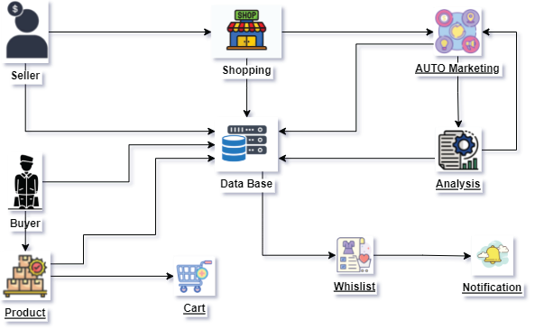

*Figure 2 Architecture Diagram*

# 5.2: Component Diagram:

# C:\Users\HAMZA\Downloads\WhatsApp Image 2022-04-13 at 11.52.45 PM (1).jpeg

*Figure 3 Component* *Diagram*

# 5.3: Activity Diagram

#### C:\Users\Fahad Usman\Downloads\WhatsApp Image 2022-06-24 at 12.31.07 PM.jpeg

*Figure 4 Activity Diagram*

# 5.4: Package Diagram:

# C:\Users\HAMZA\Downloads\package diagram FYP.drawio.png

*Figure 5 Package Diagram*

# 

# 5.5: Data Flow Diagram:

# C:\Users\HAMZA\Downloads\DFD diagram FYP.drawio.png

*Figure 6 Data Flow diagram*

# 5.6: System Sequence Diagram

### 5.6.1: Register:

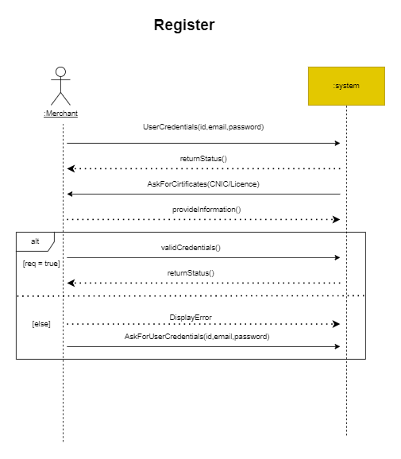

*Figure 7 Register SSD*

### 5.6.2: Manage Product:

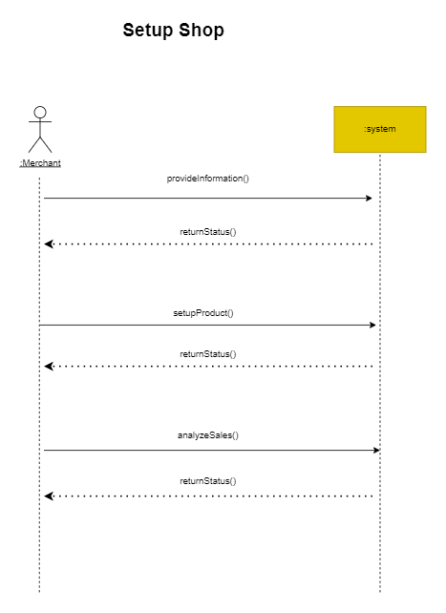

*Figure 8 Manage Product SSD*

### 5.6.3: Analyze Sales:

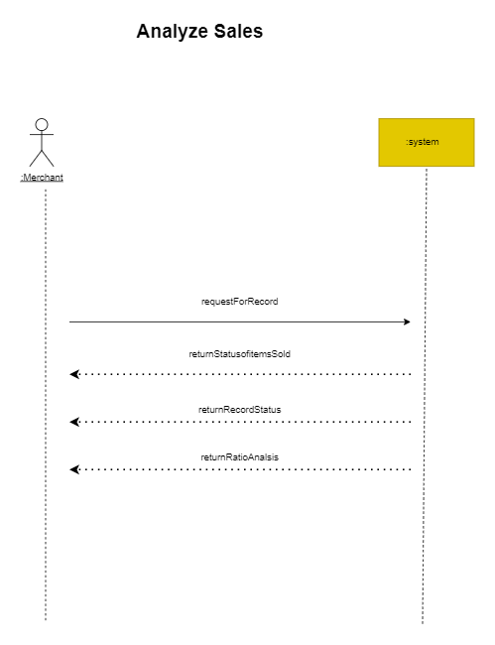

*Figure 9 Analyze Sale*

### 5.6.3: Wishlist:

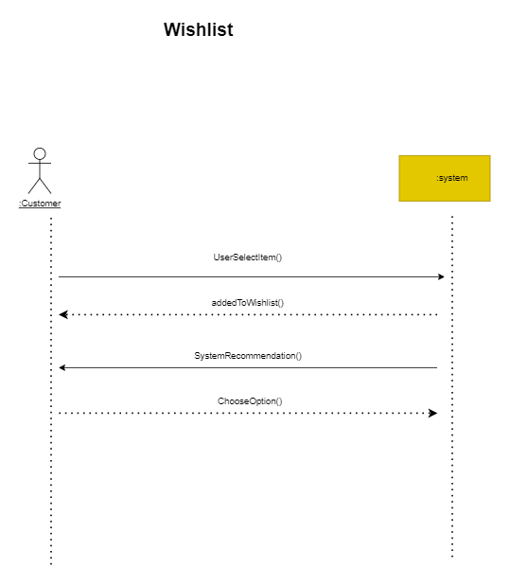

*Figure 10 Wishlist*

# 5: Reference

<https://www.javatpoint.com/>

<https://www.techopedia.com/>

<https://www.softwaretestinghelp.com/>

<https://walee.pk/>

<https://www.inbeat.co/>

<https://www.collabr8.ca/>

<https://www.wikipedia.org/>

https://www.webfx.com/blog/marketing/importance-of-digital-marketing/