**COMP9311 24T3: Assignment 1**

**Student ZID: z5518601**

**Name: Tianxiong Wu**

**Question 1. Suppose we are designing a database for a hospital. The hospital provides the following information, based on the provided information, please draw an ER diagram using the notations taught in the lecture. (8 marks)**

Entities: Doctors, Patients, Departments, Equipment, Prescriptions, Rooms

Relationships: Prescribe, Received, Work, Belongs, Have, Occupies

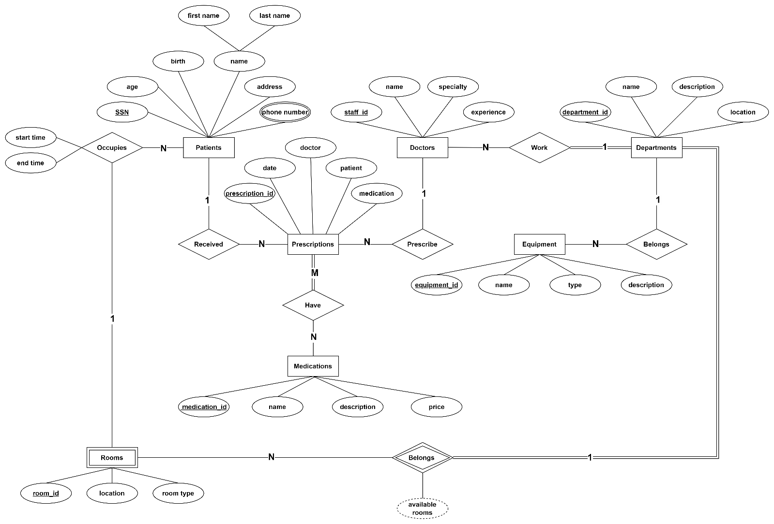

**Question 2. Convert the ER-diagram into a relational data model. Use the notations/model taught in the lecture. (6 marks)**

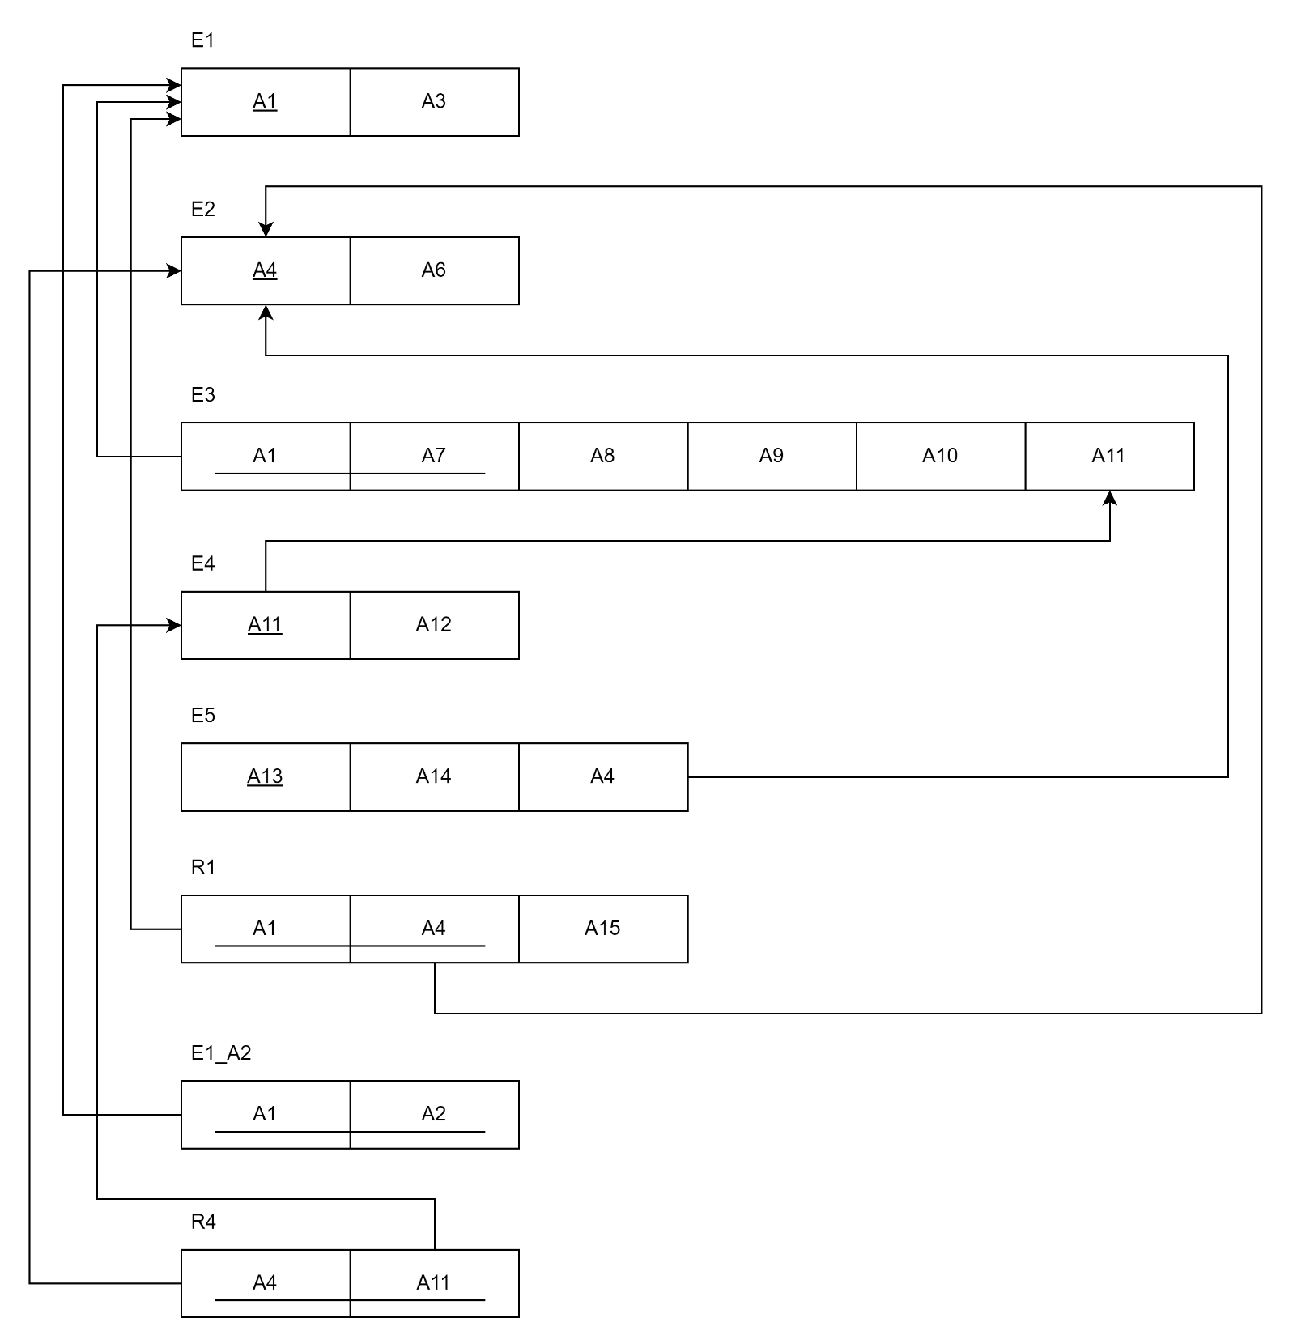

**Question 3. Given the following schema for the car sale database, write the relational algebra expressions for the queries with the operators/notations taught in the lecture. (10 marks)**

**• Customer (cusID, cusName, phone)**

**• Manufacturer (manuID, makName, foundedYear, country)**

**• Car (carID, manuID, model, year, bodyType, status (available/sold))**

**• Sale (carID, cusID, salpID, saleYear, salePrice)**

**• Salesperson (salpID, salpName, rating)**

**• Service (serID, carID, sYear, sCost)**

**Queries:**

**1. (2 marks) Find the names of customers who have purchased cars from more than two different manufacturers and whose total spending on these cars is higher than the average total spending of all customers.**

1. Average total spending of all customers:
$$R1→AVG\left(salePrice\right)(Sale)$$

2. Customers who have purchased cars from more than two different manufactures:
   1. Customers who purchased cars:
 ${R2→π}_{manuID,cusID}\left(Sale⋈Car⋈Manufacturer⋈Customer\right)$

  2. Customers who purchased cars from different manufactures:
 $R3→{π_{COUNT\left(manuID\right),cusID}\left(R2\right)}_{ }$

  3. Customers who purchased cars from more than two different manufactures:
$R4→σ_{COUNT\left(manuID\right)>2}(R3)$

3. Customer whose total spending is higher than the average:
$$R5→σ_{salePrice>R1}(Customer⋈Sale)$$

4. Result:

$$π_{cusName}(R4⋈R5)$$

**2. (2 marks) Find the names of manufacturers whose cars have never been serviced more than once in any given year and have only been sold by salespersons with a rating higher than 4.5.**

1. Cars have never been serviced more than once in any given year:
$${R1→π}_{COUNT(sYear),carID}(Service⋈Car)$$

$$R2→σ_{COUNT(sYear)≤1}(R1)$$

2. Sold by salespersons with a rating higher than 4.5:
$${R3→σ}_{rating>4.5}\left(Sale⋈Salesperson\right)$$

3. Result:

$$π_{makname}(R2⋈R3)$$

**3. (3 marks) Find the names of salespersons who have sold cars every year since they started working and have never sold a car with a sale price below the average sale price of all cars sold in that year. (You can assume the current year is 2024, and that the year the salesperson started working is the same as the year they sold**

**their first car.)**

1. Salesperson who have sold cars every year since they started working:
   1. Start Year:
 $$R1→π_{salpID,MIN(saleYear)}(Sale)$$

  2. Years Required for salesperson:
 $$R2→π_{salpID,2024-MIN(saleYear)} (R1 ⨝ Sale)$$

  3. Salesperson working years:
 $$R3→π_{salpID,COUNT(saleYear)}(Sale)$$

  4. Result:
$$R4→R2⋈_{COUNT(saleYear)=2024-MIN(saleYear)\#}R3$$

2. Average price of all cars sold in the year:
$${R5→γ}_{saleYear,AVG(salePrice),salpID}(Sale)$$

3. Salesperson who sold a car over the average price:
$${R6→π}_{salpID}(σ_{salePrice>AVG(salePrice)}(R5⋈Sale))$$

4. Result:

$$π_{salpName}(R4⋈R6⋈Salesperson)$$

**4. (3 marks) Find the ID of cars that have been serviced exactly once in their lifetime, and that service occurred at least three years after the car was sold.**

1. Cars that have been serviced exactly once in their lifetime：
$R1→{{π_{carID}(σ}_{COUNT(serID)=1}(π}_{carID,COUNT(serID)}(Service)))$

2. Service occurred at least three years after the car was sold:
${R2→π}_{carID}(σ_{sYear≥saleYear+3}(Service⋈Sale))$

3. Result:

$$R1⋂R2$$