Software Engineering, Lab 2
Agile Backlog Creation and Sprint Simulation using Jira
Name: Abhigyan Dutta
SRN: PES2UG24CS019
Class: 5A, CSE
Date: 30 August 2026
Problem Statement 17: Vaccination Cohort and Dose Scheduling System
Domain: Healthcare and Telemedicine
Lab 1 produced five functional and two non functional requirements for this system. This lab turns those into a Jira backlog and runs it through two sprints. The Scrum space VCDSS holds five epics, seventeen user stories and 101 story points. Both sprints were one week long and carried 40 points.

1. Epics and user stories
The requirements were grouped into five epics, each one a stretch of the citizen journey that could be demonstrated on its own, rather than one epic per requirement.
Epic | Stories | Points | Built from
Citizen registration and cohort assignment | 3 | 16 | FR-002, UC-01, UC-07
Slot booking and dose interval enforcement | 6 | 29 | FR-001, FR-003, UC-02, UC-03, UC-08
Dose administration and recording | 3 | 14 | FR-004, UC-04, UC-10
Certificate issuance and verification | 2 | 21 | FR-005, NFR-001, UC-05, UC-09
Policy administration and platform readiness | 3 | 21 | NFR-002, UC-06
Total | 17 | 101

The seventeen stories are below. The full As a, I want, So that text sits in the description field of each Jira work item.
User story | Priority | Points
Citizen registration and cohort assignment
Register with government ID | High | 5
Declare age, occupation and health condition | High | 3
Get put into exactly one cohort | High | 8
Slot booking and dose interval enforcement
Search sessions by centre and date | High | 5
Block a Dose 2 booking that is too early | High | 8
Show the earliest date instead of just refusing | Medium | 3
Refuse bookings once a session is full | High | 5
Confirm a booking and get a reference | High | 3
Move an appointment to another session | Medium | 5
Dose administration and recording
Record a dose against a confirmed appointment | High | 8
Refuse a duplicate dose record | High | 3
Log an adverse event | Low | 3
Certificate issuance and verification
Issue a signed QR certificate | Medium | 8
Verify a certificate QR at the gate | High | 13
Policy administration and platform readiness
Set the cohort rules and the dose gap | High | 5
Set the session capacity of each centre | High | 3
Survive the rush when booking opens | Medium | 13
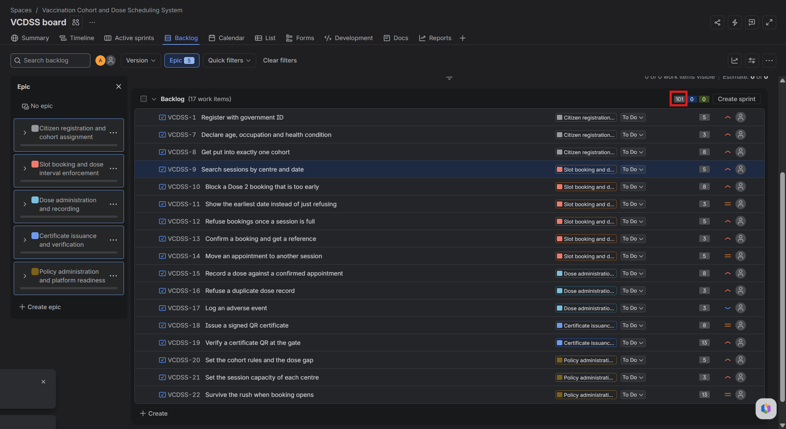
Figure 1: Jira backlog with the epic panel open and stories tagged to their epics

2. Story point estimation
Estimates use the Fibonacci scale. Declare age, occupation and health condition was the anchor at 3 points, since it is a plain form with nothing unknown about it, and the rest were sized against it. The largest is 13, for offline QR verification, which carries uncertainty rather than volume of work.
Figure 2: Story point values on the backlog rows, totalling 101 points

3. Sprint 1
Goal: a citizen can register, land in a cohort, and confirm a first booking with the dose gap enforced.
User story | Priority | Points
Set the cohort rules and the dose gap | High | 5
Set the session capacity of each centre | High | 3
Register with government ID | High | 5
Declare age, occupation and health condition | High | 3
Get put into exactly one cohort | High | 8
Search sessions by centre and date | High | 5
Block a Dose 2 booking that is too early | High | 8
Confirm a booking and get a reference | High | 3
Total |  | 40

The two administrator stories are at the top on purpose. The system cannot enforce a dose gap that nobody has configured, so they are dependencies rather than ordinary settings screens.
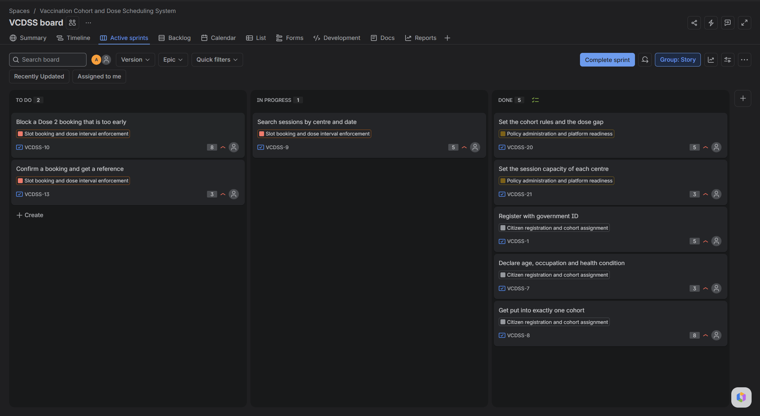
Figure 3: Sprint 1 active board, with work spread across To Do, In Progress and Done

4. Sprint 2
Goal: a booked citizen can be dosed at a centre and leave with a certificate that another officer can verify.
User story | Priority | Points
Show the earliest date instead of just refusing | Medium | 3
Refuse bookings once a session is full | High | 5
Record a dose against a confirmed appointment | High | 8
Refuse a duplicate dose record | High | 3
Issue a signed QR certificate | Medium | 8
Verify a certificate QR at the gate | High | 13
Total |  | 40

The dose record is what triggers the certificate, so recording had to be finished before issuing made any sense.
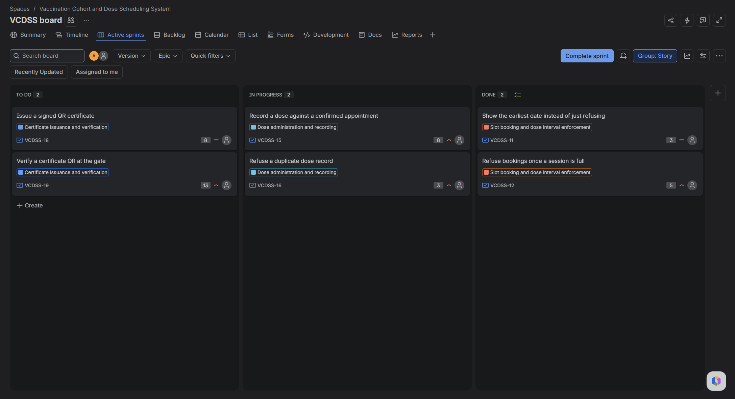
Figure 4: Sprint 2 active board

5. Stories left in the backlog
These three were left alone, which is closer to how a real sprint ends than a backlog that empties perfectly.
Story | Why it was not taken up
Move an appointment to another session | A citizen can cancel and book again, so this can wait
Log an adverse event | UC-10 only extends UC-04, so the main flow is complete without it
Survive the rush when booking opens | Needs load testing setup that does not exist until booking is stable

6. Burndown charts
Both sprints give the same shape. The red remaining line sits at zero, rises sharply to 40, then falls back. Every row of the event table reads Scope change, issue added to sprint.
The sprints were given backdated start dates so the chart would have more than one day on its axis, but the stories were added later. Jira therefore recorded each sprint as starting empty and then receiving all 40 as scope change.
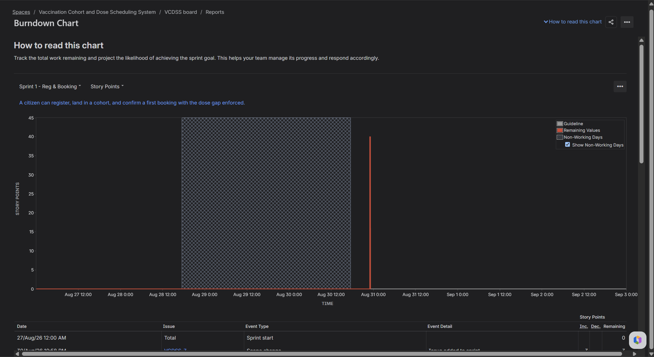
Figure 5: Burndown chart for Sprint 1
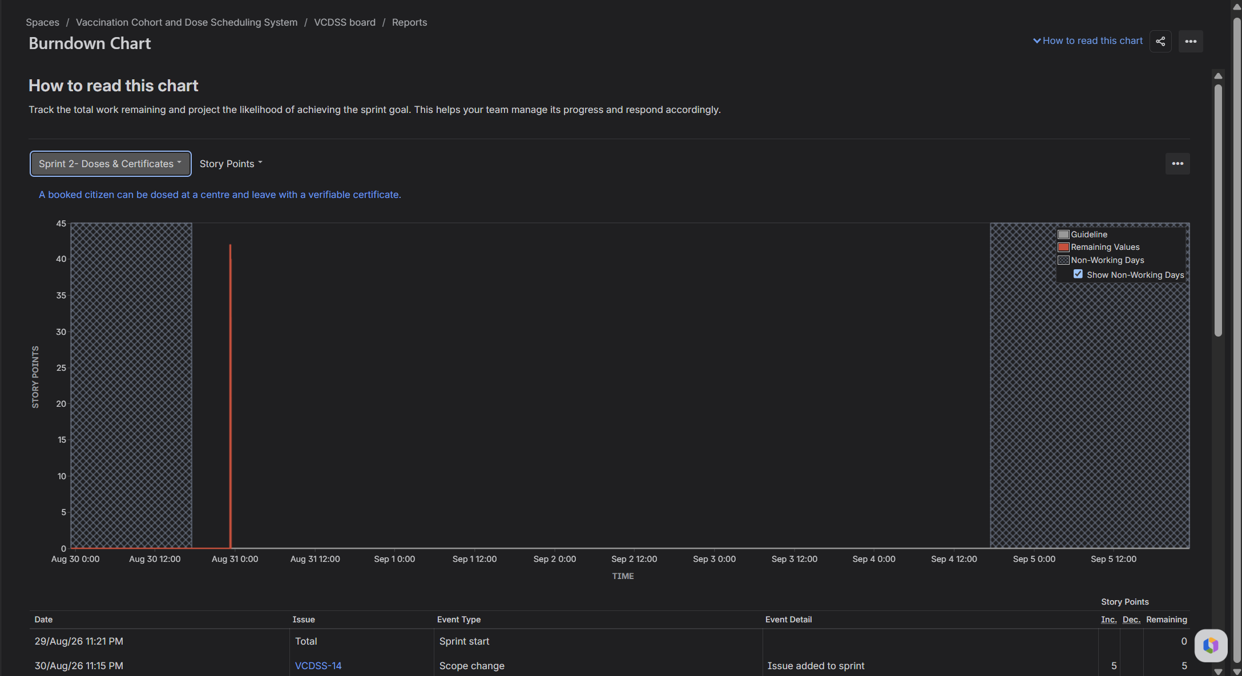
Figure 6: Burndown chart for Sprint 2

7. Sprint reports
Both sprints closed at 40 of 40 points with nothing pushed back to the backlog.
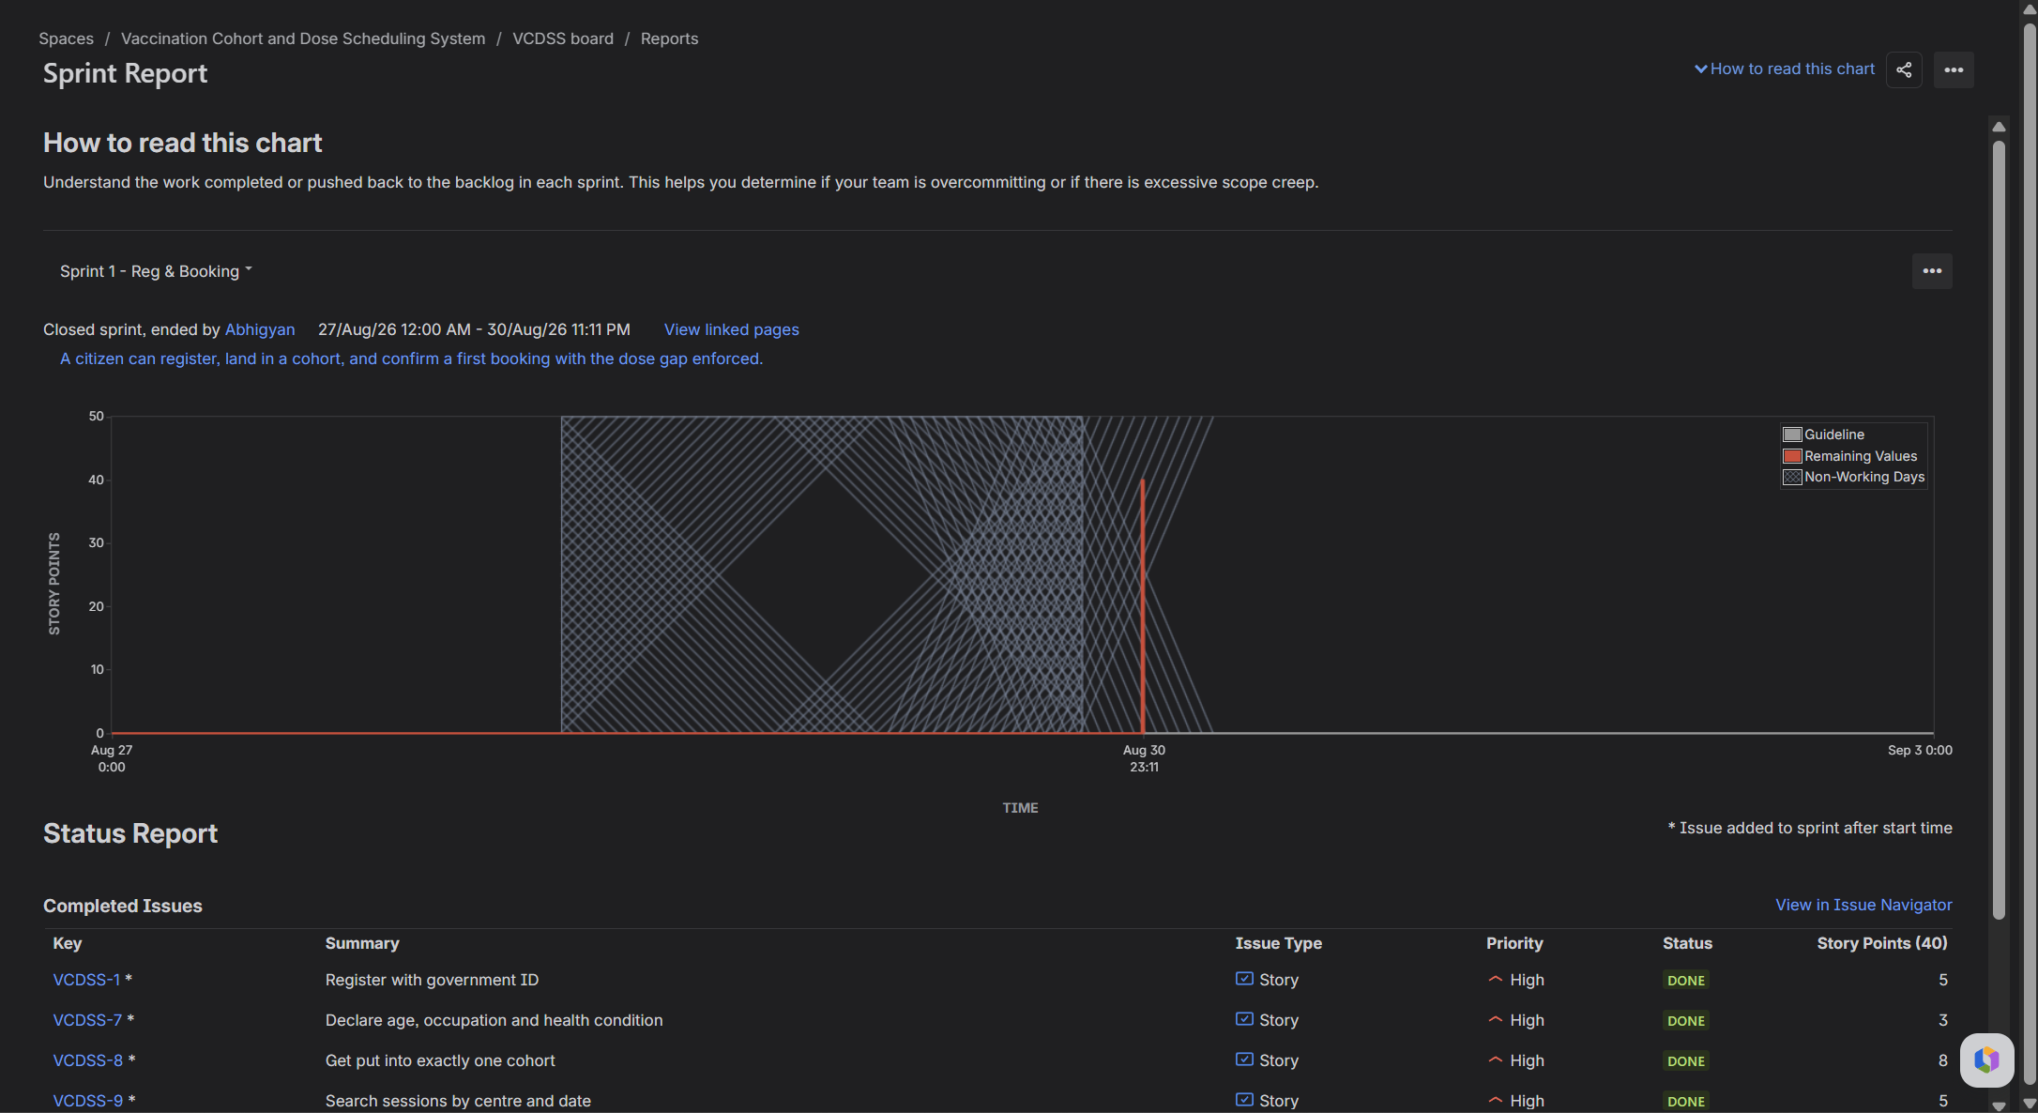
Figure 7: Sprint report for Sprint 1
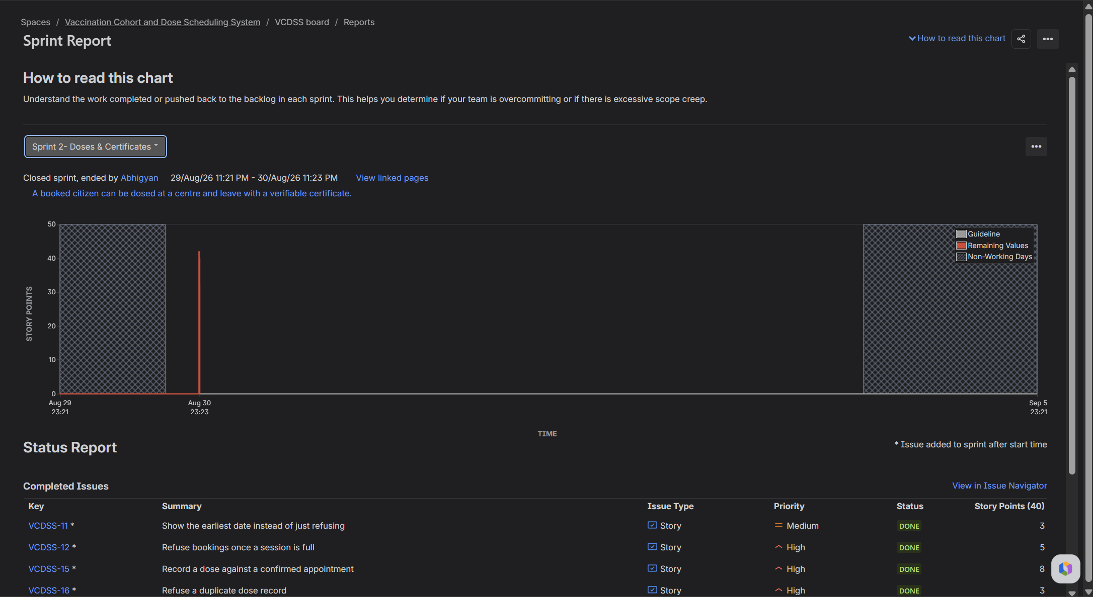
Figure 8: Sprint report for Sprint 2

8. Reflection
Did the estimates match the actual effort?
This exercise cannot really answer that. Nothing was built, so there is no actual effort to compare against, and both sprints closed at 40 of 40 only because I moved the cards.
What I can say is which ones I would change. The 13 on offline QR verification was carrying my uncertainty rather than the work, since it means getting the Certificate Authority key onto every device and rotating it, which is a distribution problem more than a coding one. Splitting it in two would have given two honest estimates instead of one large number hiding a question I never answered. The 8 on cohort assignment is too high, because the rule is a lookup and the hard part sits in a different story.
Was the backlog well prioritised?
Mostly. Priority was set by user impact, and here impact means medical safety before convenience. The dose gap, capacity and duplicate record stories are all High even though no citizen would ask for them, because they are the rules that stop the system doing harm.
The part I am less happy with is logging an adverse event, marked Low and dropped from both sprints. That follows from UC-10 only extending UC-04, but a reaction that never gets logged is a patient safety gap. It is Low because it is optional to the flow, not because it does not matter.
How did the simulated sprint match the plan?
On paper it matched exactly, both sprints planned at 40 and closed at 40. That is not evidence of good planning. It is what happens when one person drags every card across in a single sitting and nothing can slip.
Two things did go wrong. I changed statuses from the backlog rows before starting the sprint, assuming that dragging stories in had started it. It had not, and Jira records nothing in a burndown before a sprint starts, so I reset those stories and redid the moves on the board. The backdated start dates also did not line up with when the stories were added, which produced the odd burndown shape.
The sprint goals held up better. Sprint 1 delivers one connected slice rather than a scatter of half finished features, and Sprint 2 finishes the journey to a verifiable certificate.
What did the burndown chart show about capacity?
Read as a shape rather than a record of my clicking, it says work arrived after the sprint began and was finished in one lump. The handout notes that a sharp drop suggests work was not estimated or broken down properly, and that burndowns show scope creep. Both fit, and the 13 point story is the kind of item that causes the first for real.
Two sprints is nowhere near enough to claim a velocity, and these two are worth less still because the completions are simulated. Forty points a sprint is a starting assumption, not a measured number. The one honest signal is that 21 points were left in the backlog rather than pulled forward to make the numbers look complete.

