Software Engineering Lab 7: Fuzz Testing
Finding and fixing input validation bugs with Hypothesis
Name: Abhigyan Dutta
SRN: PES2UG24CS019
Class: 5A, CSE
Date: 6 November 2026
Assigned repo: L6_L7_17_electricity_bill (Lab 7 folder)
My repo: github.com/UltraBot05/se-ps17-vaccination-scheduling, folder lab7-fuzz
1. The program
The handout calls the files processor.py and test_processor.py. In my repo they are electricity_bill.py and test_electricity_bill.py. The module has three functions that read text typed by the user:
- units_consumed("1200:1350") gives the units used between two meter readings
- daily_average("5,7,6") gives the average of the daily units
- tariff_rate("DOM-A") gives the rate per unit for a category and a slab
None of them checked their input.
2. Running the original program
Normal input works. But 500:100 (the meter going backwards) gives -400 units without any complaint, and 5,,6 crashes the whole program.
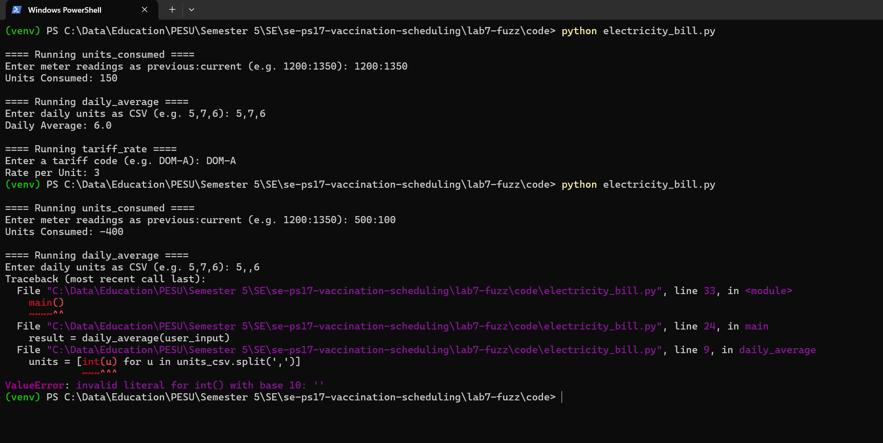
Figure 1: the original program, a normal run and then a run with bad input
3. Fuzz tests
Before writing the tests I had to decide what "not crashing" means. I chose this rule: a function either returns a correct answer or raises ValueError with a reason. Any other exception counts as a crash, and so does an answer that cannot be right, like negative units.
The test file has the three _no_crash tests from the starter, using st.text() | st.none(). I added a third strategy to each one that builds half valid strings out of numbers, blanks and junk, like -5::12 or DOM--b, because purely random text rarely looks like a meter reading. Then I added four property tests that build valid input and check the answer itself: units for two readings, the mean of a list, negative daily units being rejected, and every valid tariff code in any case with spaces around it.
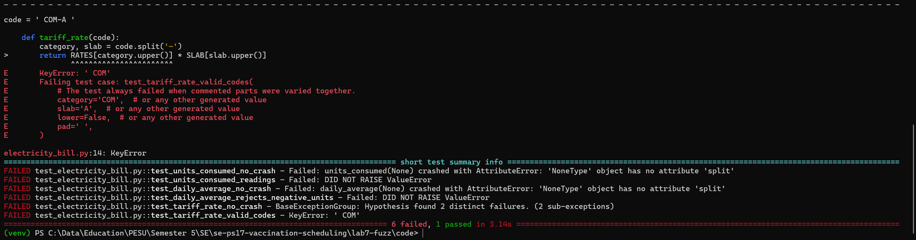
Figure 2: fuzz tests against the original code, 6 failed and 1 passed
Hypothesis shrank each failure to a small input:
Input | Original | Fixed
None | AttributeError in all three functions | ValueError: must be text
500:100 | returns -400 units | ValueError: current reading is lower than previous
5,,6 | crash on int('') | ValueError: must be a whole number
-3 (daily) | averaged as -3.0 | ValueError: cannot be negative
XYZ-A | KeyError: 'XYZ' | ValueError: unknown category
COM-A | KeyError: ' COM' | accepted, rate 6
DOM-A-B | ValueError from unpacking, no clear reason | ValueError: must look like DOM-A
The one test that passed was test_daily_average_matches_mean. For clean input the arithmetic was already right, so it shows that the fix did not change any correct answers.
4. Fixing the code
- Each function first checks that it got text, then splits it and checks it has exactly the right number of parts.
- Every number goes through one helper that turns a bad int() into a clear ValueError and rejects negative values.
- units_consumed rejects a current reading lower than the previous one. daily_average rejects empty input and catches overflow for very large numbers. tariff_rate strips spaces, uppercases, and checks the code against RATES and SLAB before looking it up.
- main() catches ValueError and prints Invalid input: <reason> instead of a traceback.
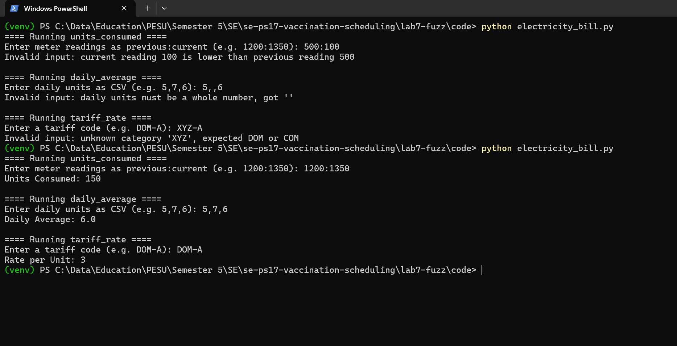
Figure 3: the fixed program, bad input first and then a normal run
5. Re-running the tests
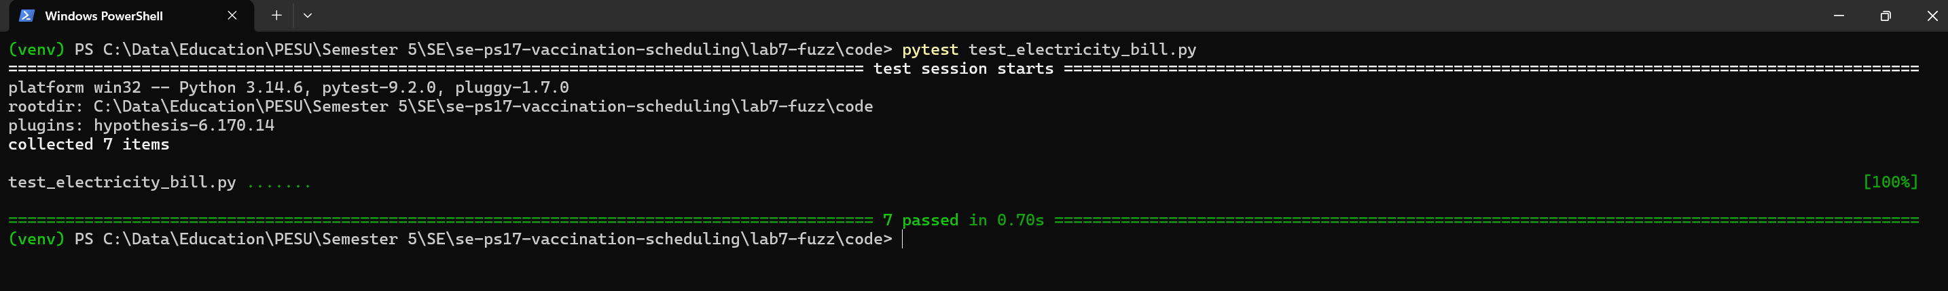
Figure 4: fuzz tests against the fixed code, 7 passed
By default Hypothesis tries 100 inputs per test. Before submitting I also ran the tests with 5000 inputs each, so 35,000 in total, and they still passed.
6. What I noticed
Most of the failures came from None and from a few characters in the wrong place, which a person typing tests by hand would probably skip. The KeyError for a code with a space around it is the kind of thing a real user would hit on day one.
Some decisions were mine and not the fuzzer's. A meter can roll over from 99999 back to 0, and my fix rejects that as a backwards reading, because the code has no idea of a maximum. Python's int() also accepts things like 1_000 and Arabic digits, so those still work. I left them in because they are real numbers, but a stricter version could allow only plain digits.

