Software Engineering Lab 6: Code and Branch Coverage
Writing tests to reach full line and branch coverage with coverage and pytest
Name: Abhigyan Dutta
SRN: PES2UG24CS019
Class: 5A, CSE
Date: 1 November 2026
Assigned repo: L6_L7_17_electricity_bill (Lab 6 folder)
My repo: github.com/UltraBot05/se-ps17-vaccination-scheduling, folder lab6-code-branch-coverage
1. The module
electricity_bill.py has three functions:
- energy_charge(units, connection) charges 3 per unit up to 100, 5 per unit up to 300 and 8 above that. Commercial connections pay double, then a fixed charge is added. Bad input raises ValueError.
- late_fee(bill_amount, days_late) gives 0 if paid on time, 50 up to 15 days late, and 100 after that, plus 5% of the bill if it is above 2000.
- subsidy(units, is_senior, has_solar) gives 50 to seniors using 100 units or less and 100 for solar, but the solar subsidy is removed above 300 units.
The starter file test_electricity_bill.py had two tests. They gave 38% line coverage and 31% branch coverage.
2. Code coverage
I added 10 tests in CodeCoverageTest_PES2UG24CS019_electricity_bill.py, each one aimed at lines the starter tests never reached: the two ValueError cases, the middle and top slabs, the commercial doubling, both kinds of late fee, and the three subsidy cases. With the 2 starter tests that makes 12.
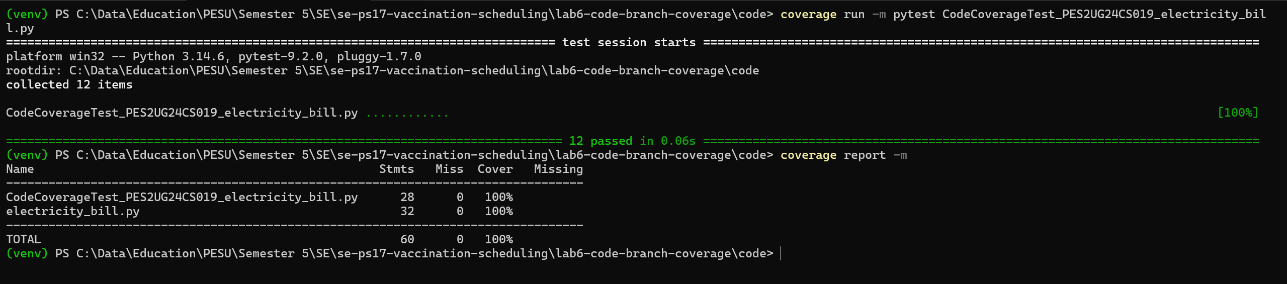
Figure 1: 12 tests pass, electricity_bill.py at 100% line coverage
Every line ran. But when I ran the same file with --branch it showed 98%, with one branch missing, 27->29. In late_fee, once a bill is more than 15 days late, my only test used a bill of 3000. So if bill_amount > 2000 was never false. There is no else line there, so line coverage had nothing to report as missed.
3. Branch coverage
BranchCoverageTest_PES2UG24CS019_electricity_bill.py keeps all 12 tests and adds 16. Only one of them was needed for the percentage, late_fee(500, 16). The rest test the values where each decision flips, since that is where a wrong < or <= would hide:
Decision | Values tested | Expected
Slab edges | 0, 100, 101, 300, 301 units | 50, 350, 355, 1350, 1358
Commercial, top of slab 2 | 300 units | 2750
Days late | -3, 15, 16 | 0, 50, 100
Bill above 2000 | 2000 and 2001, 20 days late | 100 and 200
Senior subsidy | 100 and 101 units | 50 and 0
Solar subsidy | 300 units, senior with solar, no subsidy | 100, 150, 0
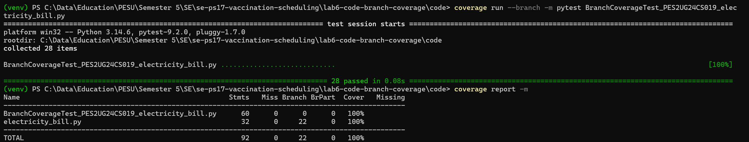
Figure 2: 28 tests pass, electricity_bill.py at 100% with all 22 branches taken
4. What I noticed
Line coverage told me my first file was done when it was not. The missed case is a real one: most late bills are small, and that was exactly the case I had not tested. Branch coverage caught it straight away.
100% branch coverage still does not mean every combination was tested. In subsidy, a senior with solar above 300 units cannot happen, because the senior rule needs 100 units or less. Path coverage would count that path, but coverage.py only measures lines and branches. Coverage also only checks that code ran, not that the answer was right. That part comes from the expected values in each assert, which I worked out by hand from the slab rules.
The TOTAL row in the reports also counts the test file itself, which is always 100%. The row that matters is electricity_bill.py.
5. Commits
- Lab 6: code coverage tests, 100% line coverage (module, starter test, code coverage file, Figure 1)
- Lab 6: branch coverage tests, 100% branch coverage (branch coverage file, Figure 2)
- A third commit with the README files and this document

