Software Engineering Practice, Lab 1
Requirements Engineering and UML Use Case Modelling
Name: Abhigyan Dutta
SRN: PES2UG24CS019
Class: 5A, CSE
Problem Statement 17: Vaccination Cohort and Dose Scheduling System
Domain: Healthcare and Telemedicine
1. About the system
This is a public health platform used to run a vaccination drive for a whole district. Citizens sign up on it, get sorted into priority cohorts, and book a slot at a centre near them. At the centre the officer records the dose that was actually given, and the platform then issues a QR certificate that anyone can verify later.
The part that makes this different from an ordinary booking app is the dose gap. A second dose cannot be taken too early, and the software is the only realistic place where that rule can be enforced, since a citizen could otherwise just walk into a different centre. Most of the requirements below are built around that idea, along with centre capacity and certificate trust.
2. Actors
The problem statement names two actors. I have added one more human actor and two system actors, because somebody has to configure the cohort rules in the first place, and the ID check and the signing of certificates are clearly done by outside services rather than by this system itself.
Actor | Kind | What it does in this system
Citizen Registrant | Primary, human | Registers on the platform, books and reschedules slots, downloads the certificate
Vaccination Officer | Primary, human | Records the dose at the centre, scans and verifies QR certificates, notes down adverse events
Health Administrator | Primary, human | Sets the cohort rules, the dose gap and the capacity of each centre
National ID Service | Secondary, system | Confirms that the government ID given at registration is genuine
Certificate Authority | Secondary, system | Signs the certificate payload and validates it when someone scans the QR
3. Requirements
Five functional and two non-functional requirements are listed below. Every description is written in the shall form, and the acceptance criteria are written as a pass and fail pair so that a tester can decide the result without arguing about it.
Req ID | Type | Description | Priority | Acceptance Criteria | Rationale
FR-001 | Functional | The system shall not allow a citizen to confirm a Dose 2 booking until the minimum gap set by the administrator (28 days by default) has passed since the recorded Dose 1 date. | High | Pass: with Dose 1 recorded on day 0, a Dose 2 booking on day 27 is rejected with the message “interval not completed”, and the same booking on day 28 goes through. Fail: any booking confirmed before day 28. | The vaccine works properly only if the gap is followed, and the software is the only place where this can actually be checked.
FR-002 | Functional | The system shall place every registered citizen into exactly one priority cohort, based on age group, job category and any health condition the citizen declares. | High | Pass: a 68 year old with a declared health condition gets exactly one cohort, which is shown on the dashboard and saved in the record. Fail: no cohort assigned, or more than one cohort assigned. | Slots are opened one cohort at a time, so a citizen sitting in two cohorts would break the order of the rollout.
FR-003 | Functional | The system shall reject a booking when the selected centre, date and session already holds its maximum number of confirmed appointments. | High | Pass: for a session with capacity 50 and 50 confirmed bookings, the 51st request is rejected and the session is shown as Full. Fail: the 51st booking is confirmed. | A centre can handle only a fixed number of people per session. Extra bookings mean crowding and wasted vaccine.
FR-004 | Functional | The system shall let a vaccination officer save a dose record containing the dose number, vaccine batch number, date and time, and officer ID against the citizen’s confirmed appointment. | High | Pass: after saving, the record shows all four values with status Administered, and a second save for the same appointment is rejected. Fail: any value stored empty, or a duplicate record accepted. | Batch numbers are needed if a batch is later recalled, and this record is what triggers the certificate.
FR-005 | Functional | The system shall create a digitally signed QR certificate within 2 minutes of a dose record being saved. | Medium | Pass: the certificate is available within 2 minutes, the signature checks out against the CA public key, and it carries name, masked ID, vaccine, batch, dose number, date and centre. Fail: certificate missing, late, unsigned, or a field left out. | Citizens need proof that other people can verify, and the signature makes a fake certificate easy to spot.
NFR-001 | Non-functional | The system shall check a signed certificate QR code in under 150 ms, both online and offline. This is a performance and security requirement. | High | Pass: in a 1000 request test on the reference machine the p95 time stays at or below 150 ms in both modes, and every edited QR code is rejected. Fail: p95 above 150 ms, or any edited QR accepted. | Checks happen at the centre gate where the queue keeps moving, and there is often no internet at rural centres.
NFR-002 | Non-functional | The system shall handle 5000 booking requests at the same time with a p95 response time of 2 seconds or less, and shall not give one slot to two citizens. This is a scalability requirement. | Medium | Pass: a load test with 5000 users at once gives p95 of 2 s or less, error rate under 1 percent, and no slot booked twice. Fail: any one of these limits is crossed. | Booking opens at a fixed hour every day, so almost everybody arrives together in the first few minutes.
A few more requirements came up while brainstorming but are kept out of the table so that the count stays at exactly five and two. These were cancelling a certificate when its batch is recalled, support for more than one language, and encryption of personal data at rest.
4. Use case diagram
The diagram was drawn in draw.io and is placed below. Its own colours have been left as they are. Blue ovals are the ones a citizen touches, green ovals belong to the officer and the administrator, and grey ovals are the ones that only exist because another use case pulls them in.
Use cases in the diagram
ID | Use case | Actor or relationship
UC-01 | Register citizen | Citizen Registrant, with the National ID Service
UC-02 | Book vaccination slot | Citizen Registrant
UC-03 | Reschedule appointment | Citizen Registrant
UC-04 | Record dose administration | Vaccination Officer
UC-05 | Verify certificate QR | Vaccination Officer, with the Certificate Authority
UC-06 | Set cohort and interval policy | Health Administrator
UC-07 | Assign priority cohort | Included by UC-01
UC-08 | Verify dose interval | Included by UC-02 and UC-03
UC-09 | Issue digital certificate | Included by UC-04
UC-10 | Log adverse event | Extends UC-04
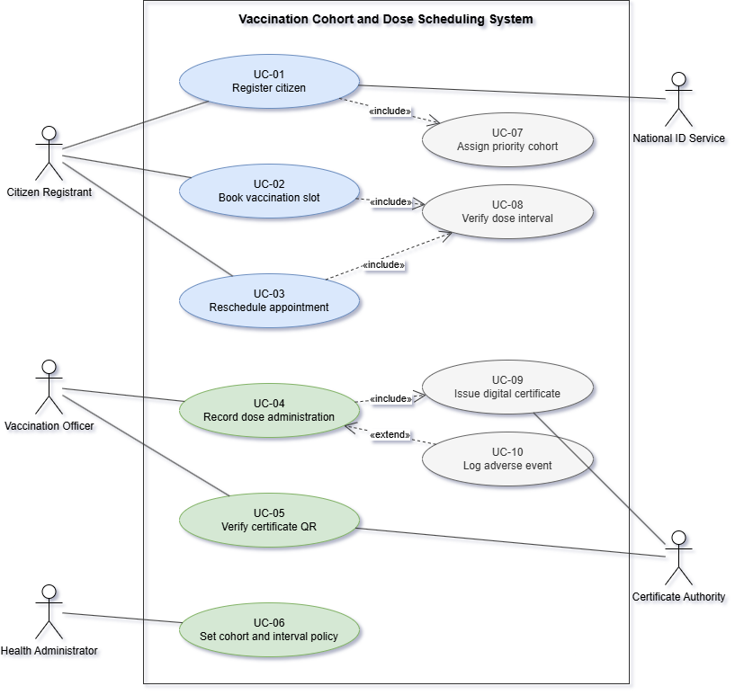
Figure 1: Use case diagram for the Vaccination Cohort and Dose Scheduling System
Why include and extend are used the way they are
Include is used when the smaller use case runs every single time. Booking a slot always checks the dose gap, so UC-02 includes UC-08. Registering always ends in a cohort being assigned, so UC-01 includes UC-07. Saving a dose always leads to a certificate, so UC-04 includes UC-09. The arrow points from the bigger use case towards the one it needs.
Extend is used when the behaviour is optional. An adverse event is logged only if the citizen actually reacts to the injection, so UC-10 extends UC-04. Here the arrow points backwards, from the optional use case into the one it adds to. UC-04 is still a complete use case without it.
5. Use case flow for UC-02, Book vaccination slot
I picked this use case because the dose gap rule, the capacity rule and the include relationship all show up in the same flow, so one specification ends up covering three different requirements.
Use case | UC-02 Book vaccination slot
Primary actor | Citizen Registrant
Secondary actor | Notification Service, which sends the confirmation message
Includes | UC-08 Verify dose interval
Trigger | The citizen clicks Book slot on the dashboard
Preconditions | The citizen is registered and ID verified, is logged in, and has exactly one cohort assigned. That cohort is open in the current phase of the rollout. If this is Dose 2, a Dose 1 record already exists.
Postconditions on success | The appointment is saved with status Confirmed, the session capacity is reduced by one, a booking reference is created, the confirmation message is sent, and an audit entry is written.
Postconditions on failure | No appointment is created and the session capacity stays as it was.
Main success scenario
1. The citizen clicks Book slot. The system shows which dose is due and the cohort status.
2. The system checks the dose interval. This is where UC-08 is included.
3. The system asks for a district or centre and a preferred date range.
4. The citizen fills in the district and the date range.
5. The system lists the sessions that still have room, along with how many places are left in each.
6. The citizen picks one session and confirms it.
7. The system checks the capacity once more, reduces it by one, and saves the appointment with status Confirmed.
8. The system creates a booking reference and sends the confirmation message.
9. The system shows the reference along with the centre, date and time slot. The use case ends successfully.
Alternate flow 2a, the dose gap is not over yet
2a1. The system works out the earliest allowed date as the Dose 1 date plus the required gap.
2a2. The booking is blocked and the message Dose 2 booking opens on the given date is shown.
2a3. The system offers a reminder for that date, and the use case ends with no appointment created.
Alternate flow 7a, the session fills up while the citizen is choosing
7a1. The capacity check in step 7 finds that there are no places left.
7a2. The message This slot just got full is shown and the flow goes back to step 5 with a fresh list. This is the case behind NFR-002, where two citizens click the last slot at the same moment.
6. Requirement traceability matrix
This is extra, added to check that no requirement is left without a use case behind it.
Req ID | Realised mainly by | Also touches | Checked by
FR-001 | UC-08 Verify dose interval | UC-02, UC-03, UC-06 | Alternate flow 2a of UC-02
FR-002 | UC-07 Assign priority cohort | UC-01, UC-06 | Precondition check of UC-02
FR-003 | UC-02 Book vaccination slot | UC-03 | Step 7 and alternate flow 7a
FR-004 | UC-04 Record dose administration | UC-10 | Main flow of UC-04
FR-005 | UC-09 Issue digital certificate | UC-04 | Postcondition of UC-04
NFR-001 | UC-05 Verify certificate QR | UC-09 | Benchmark test on reference machine
NFR-002 | UC-02 Book vaccination slot | UC-03 | Load test with 5000 users

