eTriops User Guide
v.0.9b

Introduction:
Welcome to eTriops, the desktop virtual pet based on the real-life aquatic creatures known as “triops.” Modeled after the classic hand held virtual pets that were popular in the mid-90’s, eTriops strives to be a relatively simple toy/game that lives on your PC to be interacted with casually throughout your day. The goal is straightforward: take care of your triops and raise it from a hatchling, trying to give it the longest life possible and afford it the opportunity to lay the most eggs it can. Much like their real-world counterparts, if you take good care of your eTriops it should easily live for several months.

The Interface:
The interface for eTriops is deliberately minimalistic and straightforward. The window is dominated by the main view screen, where you are presented with an animated image of your eTriops. Directly underneath the viewer is the dashboard, where the eTriop’s name and overall status is displayed. At the bottom of the window are the interaction buttons that allow you to care for your pet.

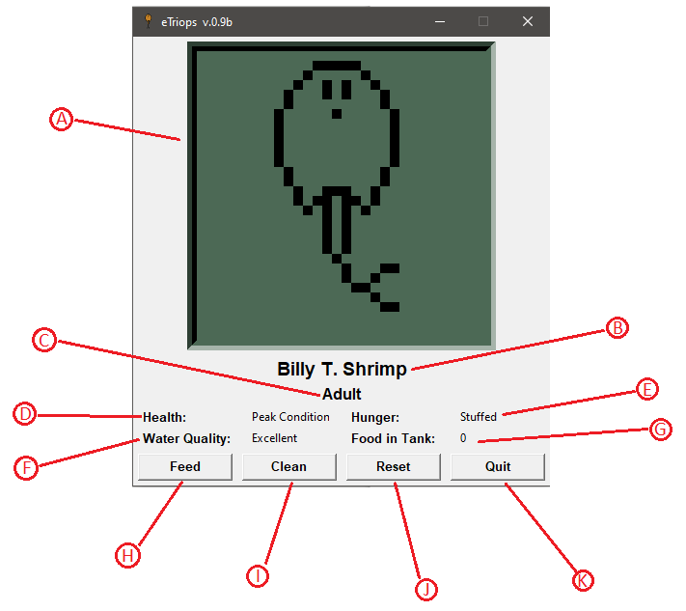
- Main View Screen – See what your eTriops is doing!
- Name Plate – Your eTriops’ name, set when it first hatches.
- Growth Stage – What phase of life your eTriops is in.
- Health – Describes the overall health of your pet.
- Hunger – See if your eTriops needs to eat.
- Water Quality – Shows how dirty the tank water currently is.
- Food in Tank – See how many uneaten food pellets are floating around.
- Feed Button – Give your eTriops food pellets!
- Clean Button – If the tank water gets too dirty clean it out here.
- Reset Button – Start the game over with a new hatchling. This will PERMANENTLY ERASE your current eTriops!
- Quit Button – Closes the game. Your eTriops will be saved in a file so you can load it back up later.

Starting, Stopping, Saving, and Resetting:
When you start the eTriops program it will automatically look for its save file (etriops.sav) in your user home directory. If the file exists it will load the save data and immediately resume the game from the point it was last saved. If there is no save file then it will prompt you to create a new hatchling by asking you to choose a name for it. Once a name is chosen a fresh save file will be created and the game will begin.
To quit the game, simply press the “Quit” button at the bottom of the window or click the “X” in the upper right-hand corner. In both cases the program will automatically save your game to file before closing out. It’s important to note that your eTriops will make no progress while the program isn’t running – the next time you start the game it will resume from the point you left off.
In addition to quitting, the game will also automatically perform a save every 30 minutes to hopefully prevent a loss of game due to program crashes, power outages, etc.
If you choose to start a new game you may do so by clicking the “Reset” button at the bottom of the window. Please note that eTriops only maintains ONE save file – if you choose to reset then your current eTriops will be completely and permanently ERASED. Also note that manually deleting or moving the etriops.sav file from your home directory has the same effect – your current pet will be GONE and will be permanently replaced with a new one.

Feeding your eTriops:
Like all animals, your eTriops needs food to survive. If you don’t feed it on a regular basis it could starve and die! To check on how hungry your eTriops is, you just need to look at the “Hunger” section of the dashboard. As you get to know your pet you will learn what the various hunger descriptions mean, but if you see the description become yellow or red your eTriops is in danger and you should consider feeding it as soon as possible!
To feed your eTriops, click on the “Feed” interaction button or press the “f” key on your keyboard. You will be prompted to enter the number of food pellets you want to put in the tank – choose wisely! If you don’t add enough pellets then your pet may not receive enough food to completely restore its hunger, but if you add too many pellets then they may sit uneaten in the tank, contributing to poor water quality.
NOTE: For the first 3 or so days of your eTriops’ life it is too small to eat food pellets and instead subsists on invisible microbes in the tank. Just like a real triops, you should not feed your eTriops any food during this stage! If you do, all of the pellets will sit uneaten and cause poor water quality.

Water Quality and Cleaning the Tank:
Similar to their real-world counterparts, eTriops’ health will suffer if their environment is not kept clean. The water your eTriops lives in will slowly build up toxic chemicals over time due to your pet’s waste. If you overfeed your eTriops then uneaten food will also add to water toxicity. High water toxicity will hamper your pet’s health and prevent it from reaching its full potential. In severe cases, poor water quality could leave your eTriops too weak to cope with other health hazards, such as molting. In order to prevent this, you’ll need to periodically clean the tank to keep its toxicity in check.
To know when you need to clean the tank keep an eye on the “Health” and “Water Quality” sections of the dashboard. You’ll get a feel for the various descriptions over time, but suffice it to say if you see the “Water Quality” indicator turn yellow or red then you should consider cleaning the tank immediately! Likewise, if you notice the “Health” description getting low and you can’t find another explanation for low health (such as a recent molt), then it’s very likely that poor water quality is the cause.
Cleaning the tank is simple: just click the “Clean” interaction button or press the “c” key on your keyboard. An animation will play, all uneaten food pellets will be removed from the tank, and your water quality will greatly improve. It’s important to know that cleaning only REDUCES water toxicity – it is impossible to remove it entirely. For this reason, you may need to perform several cleanings before the water quality is back to a healthy level.

Health and Healing:
Maintaining high health is key to ensuring your eTriops lives a long and productive life. Health can be monitored from the “Health” section of the dashboard – you will learn the various descriptions with experience, but as always a yellow or red listing is cause for immediate concern. If health gets too low then your eTriops will die, and the game will end. In addition to risking death, low health will also impact other factors in your eTriops’ life, such as its ability to lay eggs.
There are several hazards which may cause your eTriops’ health to falter. Certain events, such as molting, cause an instantaneous hit to an eTriops’ health. After such an event an eTriops’ will naturally recover on its own and will be back to its old self after several minutes (assuming no other hazards come along during that time).
Other events, such as starvation or water toxicity, are chronic issues which cause long-term detriment to an eTriops’ health. Such events require your help to fix the problem before your eTriops has any hope of starting recovery.

Stages of Growth:
Your eTriops’ will progress through many stages of growth throughout its life. These stages will impact your pet in various ways, from its physical appearance, its ability to perform certain tasks, and its vulnerability to health hazards.
Growth Stage | Appearance | Age Range | Description
Hatchling | 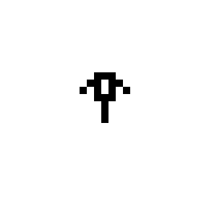 | 0-3 days | Your eTriops is a newborn! It doesn’t require feeding, can’t lay eggs, and molts easily.
Juvenile | 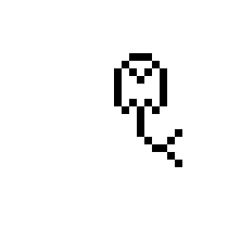 | 3-10 days | As a young child, your eTriops will start needing food. It still can’t lay eggs and molts easily.
Young Adult | 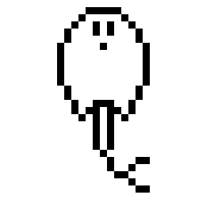 | 10-14 days | Your eTriops is finally at an adult size and appearance, but is still too young to lay eggs. Molting is easy.
Adult |  | 14-30 days | The eTriops is finally mature enough to potentially lay eggs! Molting is still relatively easy.
Middle Aged |  | 30-60 days | Molting becomes more difficult, but isn’t too risky if you pay close attention to your eTriops’ overall health.
Senior |  | 60-80 days | Molting becomes very risky – your eTriops’ health is paramount.
Elder |  | 80-90 days | Molting is extremely risky.
??? | ??? | 90+ days | ???

Molting:
In the real world triops have to shed their exoskeletons every few days in a process known as “molting”. While molting is a very important, natural process for a triops’ overall health and growth, it is physically strenuous and gets increasingly harder as the triops ages. Failing to molt results in death.
ETriops are no different. Throughout its life your eTriops will occasionally molt. When it does so an animation will play and your eTriops’ health will take a hit (which it will gradually recover from over the course of several minutes). The older your eTriops gets, the harder its health will be impacted by molting. A young hatchling will barely be affected, but a Senior or Elder eTriops would be in serious danger.
The exact times your eTriops will molt are determined at random, but the odds are calibrated in such a way that, on average, you can expect a molt once every 3 days or so.

Laying Eggs:
Once your eTriops reaches full maturity at around 14 days old it will gain the ability to occasionally lay eggs. When it happens, an animation will play showing your eTriops digging a nest in the sand and laying the eggs there. The software will keep track of the number of eggs your eTriops lays over its lifetime and will present the grand total to you upon its death, serving as a sort of “Final Score”.
Much like with molting the times your eTriops lays eggs are determined at random but odds are calibrated so that it happens every 3 or so days on average.
The exact number of eggs your eTriops lays is also ultimately random, however odds are impacted by its overall health. If your pet’s health is low it will result a lower number of eggs on average. If health is extremely poor your eTriops may not be able to lay any eggs at all.

