Sample-Efficient PPO for CarRacing-v3 Using Road-Mask Ray Features
Joe | Student ID: 1103820
Abstract--This project studies a sample-efficient reinforcement-learning pipeline for Gymnasium CarRacing-v3, where an agent receives 96 x 96 RGB observations and outputs continuous steering, gas, and brake actions. Instead of training PPO directly on pixels, the implemented wrapper converts each frame into an HSV road mask, casts nine road-distance rays from a calibrated origin, and appends previous controls, speed, and a curvature proxy. Four consecutive 14-dimensional observations are stacked into a 56-dimensional vector and trained with Stable-Baselines3 PPO using MlpPolicy for 500,000 timesteps. Evaluation reloads the saved model and VecNormalize statistics, then tests fixed COMPARE5 seeds and deterministic RANDOM10 seeds. The final artifact reaches several high-reward seeds near 900, with best raw reward 929.7, while RANDOM10 mean raw reward is 614.1 with high variance. Low-reward failure seeds remain, especially when the car drifts off road and cannot recover. The method is therefore sample-efficient and promising, but not uniformly robust. RL Baselines3 Zoo is configuration context only, not a measured baseline.
Index Terms--reinforcement learning, PPO, CarRacing-v3, MLP policy, HSV road mask, ray features

1. Introduction
Gymnasium CarRacing-v3 is a pixel-based continuous-control benchmark. The observation is a 96 x 96 RGB image, and the action is a continuous three-value vector for steering, gas, and brake [1]. A raw-pixel PPO agent must learn perception and control at the same time, which is expensive under a limited course or Colab training budget.
This project reduces that burden with a deterministic image-processing wrapper. The wrapper crops the frame, converts it to HSV, masks grass-like pixels, inverts the mask into an approximate road representation, and extracts nine ray distances. PPO itself is not modified; the main design choice is the observation representation.
The environment also has a reporting challenge. A single episode can look strong for many frames and then fail abruptly after a corner, off-road drift, or poor recovery. For that reason, this report does not rely on a single best video. It reports fixed seed sets, summary statistics, seed-level tables, reward charts, and qualitative success/failure examples.
The design is intentionally conservative. It does not add a custom PPO implementation, a new neural network architecture, or a learned perception model. The method uses deterministic preprocessing, a standard PPO learner, saved artifacts, and disk-based evaluation. This makes the final report easier to audit because each important value can be traced to notebook constants, CSV files, figures, or artifact files.
The research question is whether HSV road-mask ray features can make PPO more sample-efficient for CarRacing-v3 under limited training. The final model is trained for 500,000 timesteps with MlpPolicy. The compact input lets the policy learn from a 56D vector instead of raw pixels.
The final result is mixed but useful. The best raw reward is 929.7 and several seeds are near 900, but RANDOM10 mean raw reward is 614.1 with high variance. Seeds 599310825 and 440213415 fail near raw rewards of 55 and 56. The correct conclusion is therefore conservative: the method is promising and sample-efficient, but not solved or uniformly robust.
RL Baselines3 Zoo is used only as public configuration context because it publishes a CarRacing-v3 PPO setup using CnnPolicy, image input, and a larger training budget [5]. That baseline was not re-run here with the same seed list and evaluation harness, so this report does not make a direct performance claim against RL Zoo.
The contribution is therefore narrow but complete: a road-mask ray wrapper, the exact observation definition, a reproducible PPO training/evaluation workflow, and a conservative interpretation of both strong and weak seeds. This scope is appropriate for a course final project because it prioritizes a working, inspectable method over speculative claims.

2. Related Work
Proximal Policy Optimization (PPO) is a policy-gradient algorithm that stabilizes updates by clipping the policy ratio in the surrogate objective [2]. This makes PPO a practical baseline for continuous-control tasks because it can optimize stochastic policies while avoiding very large destructive policy updates.
Stable-Baselines3 provides the PPO implementation, model saving, vectorized environment support, and evaluation utilities used by this project [3]. It also distinguishes policy architectures by observation type. CnnPolicy is intended for image observations, while MlpPolicy is intended for vector observations [4]. Since this project converts images into engineered vectors, MlpPolicy is the appropriate choice.
The policy distinction is central to the project. CnnPolicy can learn from images, but it must discover useful visual features during training. MlpPolicy is smaller and easier to optimize, but it depends on the input vector already containing useful state information. This project deliberately accepts that tradeoff and asks whether road-mask ray features are informative enough for driving.
RL Baselines3 Zoo provides public hyperparameter configurations for Stable-Baselines3 tasks [5]. Its CarRacing-v3 PPO configuration uses CnnPolicy, image preprocessing, frame stacking, reward normalization, 8 environments, and 4e6 timesteps. This report uses that configuration as training-scale context only, not as a matched score comparison.
The preprocessing method uses HSV color thresholding. HSV is commonly used for color-based segmentation because hue and saturation can be easier to threshold than raw RGB channels [6]. Here, grass-like pixels are detected and inverted to approximate a road mask. This is simple and transparent, but it is also environment-specific.
Classical masking is less flexible than learned visual perception, but it gives two advantages in this setting. First, the resulting features are interpretable: a long ray means open road in that direction, while a short ray suggests nearby boundary or off-road pixels. Second, the representation is easy to debug visually, which is useful when evaluating failure cases.
This project is best understood as feature engineering for reinforcement learning. A deterministic visual front end provides a compact local road-geometry vector, and PPO learns the control policy from that vector. The benefit is interpretability and shorter training; the cost is dependence on the hand-built mask and ray design.

3. Proposed Method

3.1 Pipeline Overview
Figure 1 summarizes the implemented pipeline. It is a schematic based on notebook constants, not an experimental screenshot. The wrapper receives the RGB frame, crops the dashboard area by keeping the top 84 rows, converts the crop to HSV, thresholds grass-like pixels using [28, 35, 35] to [92, 255, 255], and inverts the grass mask to approximate the road.
From origin (48, 70), the wrapper casts nine rays at angles -70, -52.5, -35, -17.5, 0, 17.5, 35, 52.5, and 70 degrees. Ray length adapts to speed: max_len = 45.0 + 35.0v. Ray angles are squeezed by 1 - 0.18v at higher speed, which makes the geometry slightly more forward-looking without changing the input size.
The crop removes the dashboard region and keeps the road area most relevant to steering. The HSV threshold detects grass-like pixels, not road pixels directly. Inverting the grass mask is a simple way to approximate drivable road because road is the dominant non-grass region in this benchmark. This choice is not a universal segmentation solution, but it is reproducible and matched to CarRacing-v3.
The ray origin is calibrated near the car's forward position in the cropped image. Left and right rays estimate lateral clearance, while center rays estimate forward openness. The policy receives these distances rather than the mask image itself, so perception is compressed before learning begins.
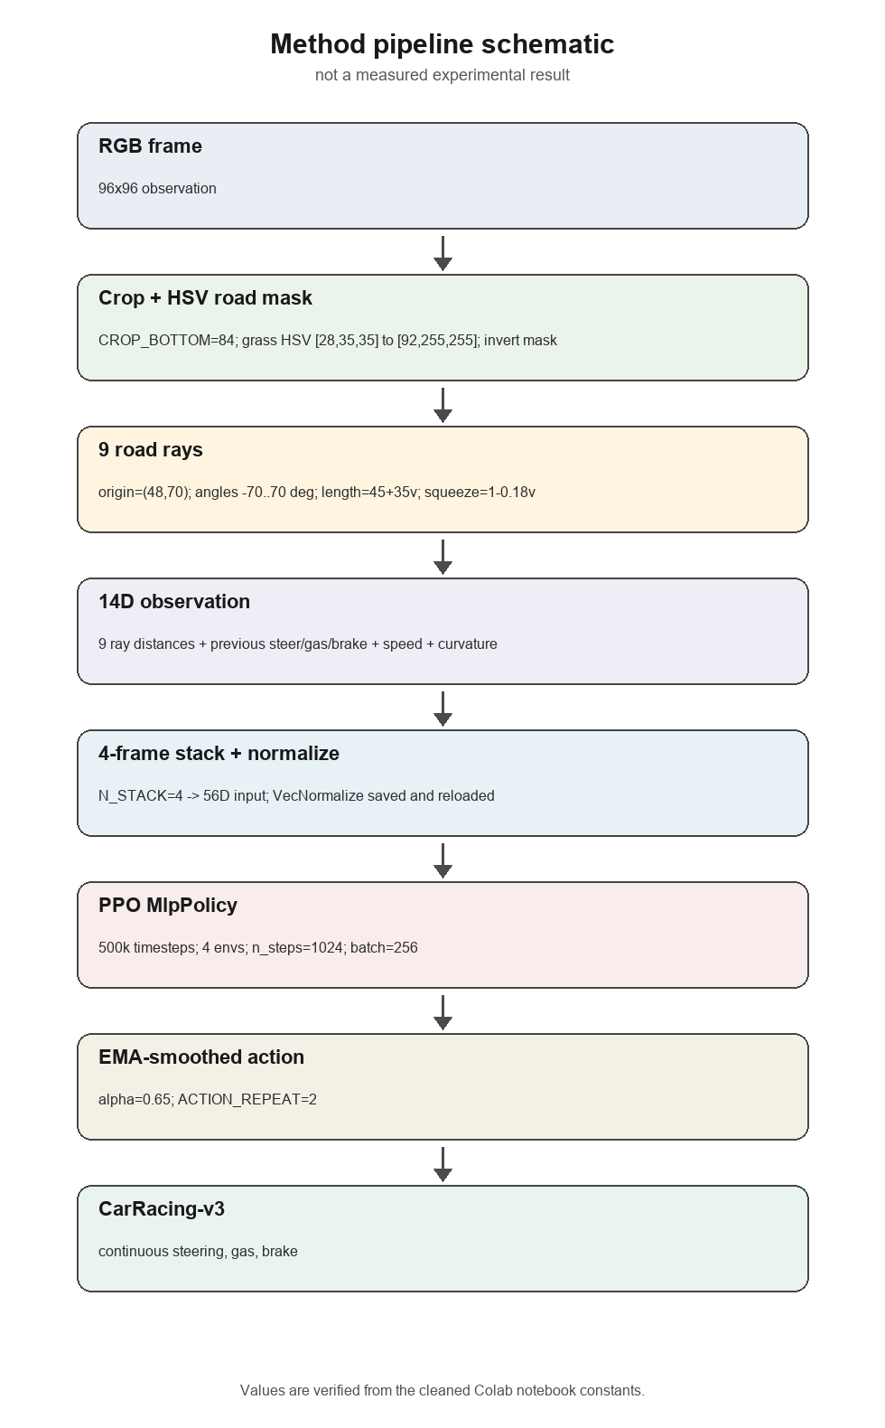
Figure 1. Schematic of the implemented wrapper and PPO pipeline; not a measured experimental result.

3.2 Observation, Stacking, and Normalization
Each base observation has 14 values: nine normalized ray distances, three previous smoothed controls, normalized speed, and a curvature proxy. Four consecutive base observations are stacked, so the policy receives a 56D vector. VecNormalize is paired with the saved model and must be reloaded during evaluation.
Previous-action features are included because CarRacing has inertia. The same ray geometry can require different correction depending on whether the car is already steering, accelerating, or braking. The curvature proxy gives the policy a compact signal about left-right road imbalance without increasing the input to an image-like representation.
o_t = [d_1,...,d_9, steer_{t-1}, gas_{t-1}, brake_{t-1}, v_t, c_t] in R^14
s_t = [o_{t-3}, o_{t-2}, o_{t-1}, o_t] in R^56
L^CLIP(theta) = E_t[min(r_t(theta) A_t, clip(r_t(theta), 1-epsilon, 1+epsilon) A_t)]
Table 1. Verified wrapper constants.
Item | Value
Environment | Gymnasium CarRacing-v3
Crop | CROP_BOTTOM = 84
HSV grass bounds | [28, 35, 35] to [92, 255, 255]
Ray origin | (48, 70) in cropped image
Ray angles | -70 to 70 degrees, 9 rays
Dynamic ray length | 45.0 + 35.0v
Angular squeeze | 1 - 0.18v
Action smoothing | EMA_ALPHA = 0.65
Action repeat | 2
Stacking | 4 frames; 14D base to 56D input

Table 2. Base observation layout.
Component | Count | Meaning
Ray distances | 9 | local road clearance from left to right
Previous smoothed action | 3 | steering, gas, and brake history
Speed estimate | 1 | movement proxy used by adaptive rays
Curvature proxy | 1 | road-shape signal from ray imbalance

3.3 Wrapper Algorithm and Training Settings
Algorithm 1 gives the wrapper procedure in compact form. The environment action remains continuous steering, gas, and brake. The policy output is clipped, smoothed by EMA, and repeated for two environment steps.
Action smoothing is an engineering choice rather than a learning algorithm. It reduces frame-to-frame control jitter, but it can also delay emergency recovery. This tradeoff is one reason the report recommends an ablation rather than assuming smoothing is always beneficial.
Algorithm 1. Road-mask ray wrapper pseudocode.
Step | Operation
1 | Receive RGB frame from CarRacing-v3
2 | Crop to top 84 rows and convert RGB to HSV
3 | Detect grass-like pixels and invert to road mask
4 | Compute speed-adaptive ray length and angular squeeze
5 | Cast nine rays from origin (48, 70)
6 | Build 14D observation and four-frame 56D stack
7 | Normalize with VecNormalize and feed PPO MlpPolicy
8 | Smooth action by EMA and repeat for two steps

Table 3. PPO training settings.
Item | Value
Algorithm | Stable-Baselines3 PPO
Policy | MlpPolicy
Network | 256 x 256 MLP
Total timesteps | 500,000
Parallel environments | 4
n_steps / batch size | 1024 / 256
gamma / GAE lambda | 0.99 / 0.95
Entropy coefficient | 0.01
Value-function coefficient | 0.5
Max gradient norm | 0.5
Use SDE | False

Table 4. Reward-shaping terms used during training.
Term | Weight | Purpose
Off-road penalty | 0.50 | discourage road departure
Steering jitter penalty | 0.04 | reduce abrupt steering
Gas while off road | 0.10 | avoid accelerating off road
Steering guide | 0.15 | follow open-road direction
Speed bonus | 0.02 | reward controlled movement
Curve braking bonus | 0.08 | encourage safer turns
Front-danger penalty | 0.20 | avoid near frontal boundary
Anti-spin penalty | 0.30 | reduce unstable control

Reward shaping is used only during training. It encourages road following, stable steering, and safer corner behavior within the 500,000-timestep budget. Because shaping changes the training objective, raw environment reward remains the headline metric in the final evaluation.

4. Experimental Setup
The final model is trained for 500,000 timesteps on Gymnasium CarRacing-v3 using four parallel environments and MlpPolicy. The notebook is a Colab-oriented workflow, but final evaluation is artifact-based rather than dependent on live notebook state.
This separation matters because notebooks can accidentally mix old runtime state with current cells. The final evaluation path reloads artifacts from disk, including the model and VecNormalize statistics. The cleaned notebook has zero outputs and zero execution counts, so the report is based on saved evidence rather than hidden cell state.
Evaluation reloads the saved PPO model together with saved VecNormalize statistics. This pairing is required because the policy was trained on normalized 56D observations. The evaluation records raw reward, shaped reward, frame count, termination reason, first-frame hash, and control statistics such as steering delta, steering magnitude, gas mean, and brake mean.
COMPARE5 uses seeds 42, 123, 777, 999, and 2026. RANDOM10 is generated deterministically from master seed 42. Raw reward is the headline metric because it is the original environment reward; shaped reward is a training aid and is not used as the main score.
Termination labels are included because reward alone can hide different behaviors. A high-reward off-road timeout can still indicate strong track progress, while a low-reward timeout indicates early failure. First-frame hashes and control statistics are retained in the CSVs as reproducibility diagnostics.
Table 5. Evaluation protocol.
Item | Protocol
Artifact source | saved PPO model plus VecNormalize statistics
Primary metric | raw CarRacing reward
Stored diagnostics | shaped reward, frames, termination, first-frame hash, control statistics
COMPARE5 seeds | 42, 123, 777, 999, 2026
RANDOM10 source | deterministic list from master seed 42
Retraining for report | none
Baseline rerun | none; RL Zoo is context only

Table 6. RL Zoo configuration context versus this project.
Item | RL Zoo context | This project
Role | public configuration | measured artifact
Policy | CnnPolicy | MlpPolicy
Input | image input | engineered 56D ray-feature stack
Timesteps | 4e6 configured | 500,000 trained
Parallel envs | 8 | 4
Status | not re-run here | evaluated here

5. Experimental Analysis and Results
Figure 2 shows the PPO evaluation reward during training, regenerated from the saved evaluation artifact. It is a diagnostic curve, not a final benchmark. The final judgment comes from the reloaded model evaluated on COMPARE5 and RANDOM10.
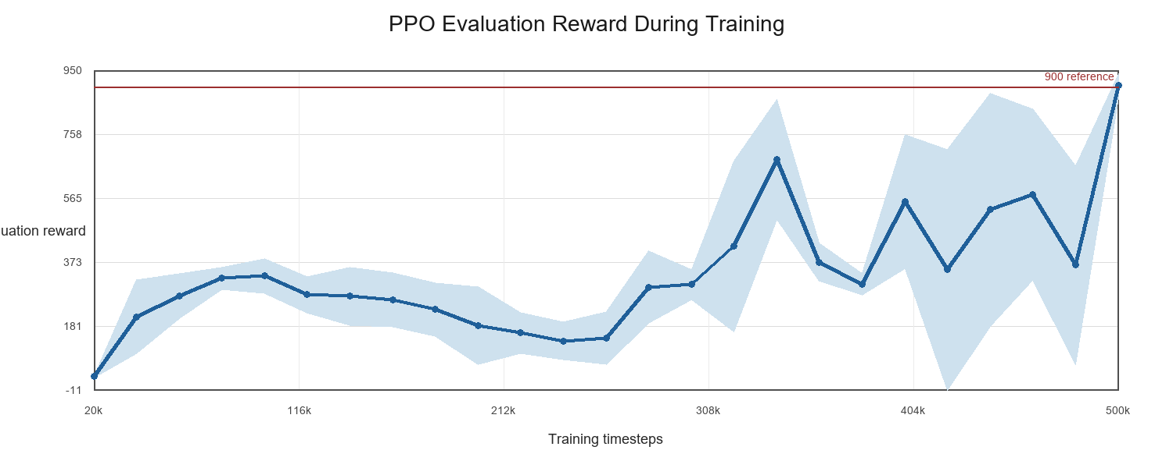
Figure 2. PPO evaluation reward during training, regenerated from saved evaluation data.
Table 7. Final raw reward summary.
Split | n | Mean | Std. | Min | Max
COMPARE5 | 5 | 609.1 | 348.2 | 210.8 | 896.0
RANDOM10 | 10 | 614.1 | 347.8 | 55.5 | 929.7

The summary table shows the central result. COMPARE5 mean raw reward is 609.1, while RANDOM10 mean raw reward is 614.1. The best raw reward is 929.7, but the RANDOM10 minimum is 55.5. The method can produce strong driving episodes, but robustness is incomplete.
COMPARE5 and RANDOM10 have similar mean and standard deviation, which suggests the RANDOM10 split does not contradict the smaller comparison set. However, both splits are high-variance. The high mean should not hide the failure seeds, and the failure seeds should not hide the fact that multiple runs are near the common 900-point success region.
Table 8. COMPARE5 seed-level evaluation.
Seed | Raw | Shaped | Frames | Result
42 | 250.42 | 219.05 | 232 | offroad timeout
123 | 210.82 | 191.5 | 126 | offroad timeout
777 | 895.95 | 853.35 | 393 | offroad timeout
999 | 795.11 | 761.96 | 359 | offroad timeout
2026 | 893.33 | 888.57 | 500 | env done

Table 9. RANDOM10 seed-level evaluation.
Seed | Raw | Shaped | Frames | Result
478163327 | 902.76 | 872.19 | 402 | offroad timeout
107420369 | 892.03 | 871.86 | 500 | env done
1181241943 | 900.1 | 848.51 | 388 | offroad timeout
1051802512 | 458.8 | 445.09 | 206 | offroad timeout
958682846 | 929.7 | 934.32 | 352 | env done
599310825 | 55.51 | 19.98 | 85 | offroad timeout
440213415 | 56.17 | 34.84 | 64 | offroad timeout
373399426 | 554.4 | 521.07 | 273 | offroad timeout
1812140441 | 898.35 | 859.69 | 403 | offroad timeout
136505587 | 492.75 | 466.16 | 195 | offroad timeout

The seed-level evidence shows why the conclusion must be balanced. Several RANDOM10 seeds reach approximately 900 raw reward, including seed 958682846 at 929.7. However, seeds 599310825 and 440213415 fail early near 55 and 56 raw reward. A robust conclusion must include both outcomes.
The qualitative video strips explain what the numeric outcomes look like. In the success strip, the car remains aligned through visible road curvature. In the failure strip, the car drifts off road and recovery is weak. These visuals support interpretation, but they are secondary to the CSV-backed reward tables and charts.
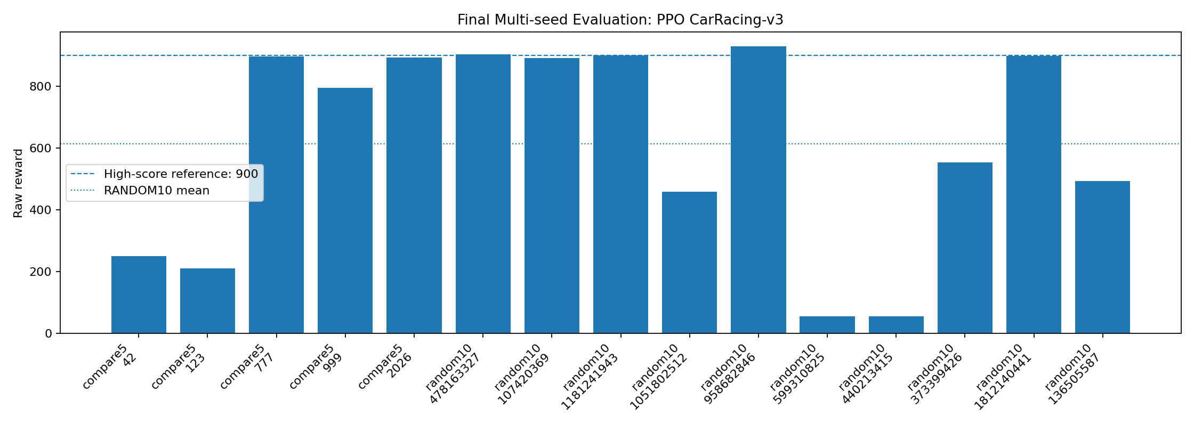
Figure 3. Final raw rewards for COMPARE5 and RANDOM10 seeds.
Figure 4 provides qualitative evidence from exported videos. The success strip shows seed 2026 continuing through visible road curvature. The failure strip shows seed 599310825 drifting off road and failing to recover. These frames are qualitative only; the CSV-backed tables and reward chart are the quantitative evidence.
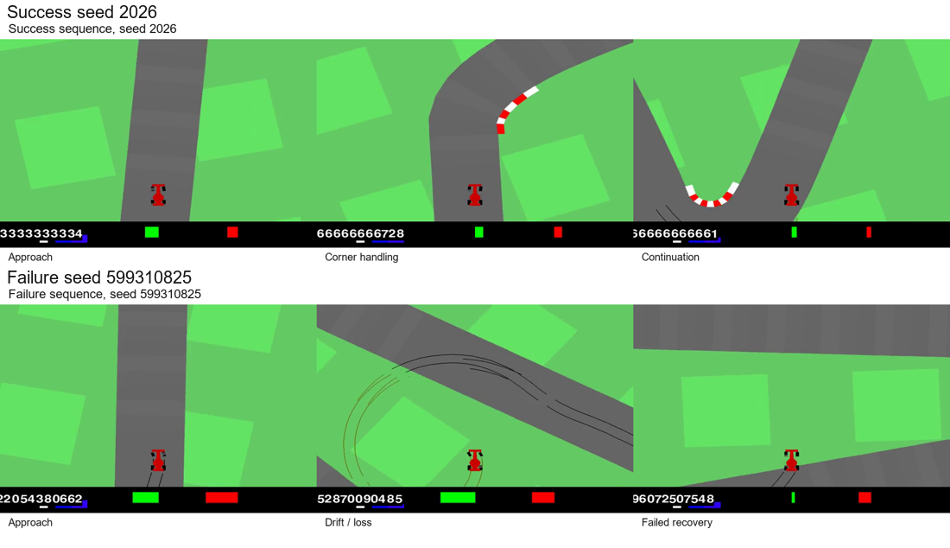
Figure 4. Success and failure examples from real exported videos; qualitative evidence only.

6. Discussion and Limitations
The main advantage is dimensionality reduction. A 96 x 96 x 3 RGB frame contains 27,648 pixel values, while the final stacked observation contains 56 values. This makes the policy smaller and easier to train, and it makes the input more interpretable.
The first limitation is the missing matched RL Zoo baseline. RL Zoo is useful configuration context, but it was not re-run under the same environment version, seed list, and evaluation script. Therefore, the report does not claim a direct baseline victory.
This limitation matters scientifically because the two systems trade off different strengths. A CnnPolicy may need more timesteps but preserve more visual information for recovery. The engineered ray policy trains with a much smaller input, but may lose information needed after the car is already off road.
The second limitation is the small evaluation sample and single final training run. COMPARE5 and RANDOM10 are useful evidence, but they are not independent training-seed statistics. A stronger study would repeat training with multiple seeds and evaluate more tracks.
The third limitation is HSV threshold dependence. The method assumes the CarRacing-v3 visual appearance is stable. A different renderer, texture set, or domain randomization could change the mask quality and reduce performance.
Mask dependence is also a reproducibility risk. If a future environment version changes colors or rendering, the same HSV thresholds may no longer identify grass reliably. The first debugging step for a reproduction should be inspecting the road mask before changing PPO settings.
The fourth limitation is local recovery. Rays describe nearby road geometry, not a global route back to the track. When the car leaves the road or points away from the drivable region, the local ray features may not provide enough information for recovery. EMA action smoothing can also delay emergency correction.
Future work should test ablations: no action smoothing, fixed ray length, no previous-action features, no curvature proxy, no reward shaping, and a matched RL Zoo CnnPolicy run. These experiments should be reported as future work, not as completed results.
The most urgent ablation is recovery behavior. The high-reward seeds show that normal road following can work, but the low-reward seeds suggest the weak point is returning to the track after a bad position. Future experiments should measure recovery separately instead of only optimizing best-case reward.

7. Conclusion
This project implemented a compact PPO pipeline for CarRacing-v3 using HSV road-mask rays. The RGB observation is converted into a 14D base observation, stacked into a 56D vector, normalized with VecNormalize, and trained with Stable-Baselines3 PPO using MlpPolicy.
The final artifact demonstrates promising sample efficiency. Several seeds score near 900 and the best raw reward is 929.7. At the same time, RANDOM10 mean raw reward is 614.1 with high variance, and low-reward failure seeds remain. The method is promising, but not uniformly robust.
The next step is a matched baseline and ablation study. RL Zoo remains configuration context only until both pipelines are trained and evaluated under the same protocol.

8. Data Availability and Reproducibility
The GitHub repository has not been created yet, so no repository URL is included as evidence in this report. The link should be added after the repository is created.
The package contains the cleaned Colab notebook, README, DATASET note, requirements file, report DOCX/PDF, slides, result CSVs, figures, and artifact zip. The dataset is generated by Gymnasium CarRacing-v3 during training and evaluation; no external dataset is required.
The most important reproducibility requirement is pairing the PPO model with saved VecNormalize statistics. The final notebook includes artifact reload and disk-based evaluation paths so the final results can be reproduced without relying on hidden notebook state.
Table 10. Reproducibility package contents.
File or folder | Purpose
README.md | project overview, setup, and reproduction path
DATASET.md and requirements.txt | environment data description and Python packages
notebooks/ | cleaned Colab notebook with training and evaluation code
report/ and slides/ | DOCX report source, PDF export, LaTeX reference, and final deck
tables/ and figures/ | CSV results, training curve, reward chart, method schematic, qualitative cases
artifact zip | saved model-related files and evaluation artifacts

References
[1] Farama Foundation, "CarRacing-v3," Gymnasium documentation. https://gymnasium.farama.org/environments/box2d/car_racing/
[2] J. Schulman, F. Wolski, P. Dhariwal, A. Radford, and O. Klimov, "Proximal Policy Optimization Algorithms," arXiv:1707.06347, 2017.
[3] Stable-Baselines3 Developers, "PPO," Stable-Baselines3 documentation. https://stable-baselines3.readthedocs.io/en/master/modules/ppo.html
[4] Stable-Baselines3 Developers, "Custom Policy Network," Stable-Baselines3 documentation. https://stable-baselines3.readthedocs.io/en/master/guide/custom_policy.html
[5] DLR-RM, "RL Baselines3 Zoo PPO hyperparameters," https://raw.githubusercontent.com/DLR-RM/rl-baselines3-zoo/master/hyperparams/ppo.yml
[6] OpenCV Developers, "Changing Colorspaces," OpenCV documentation. https://docs.opencv.org/4.x/df/d9d/tutorial_py_colorspaces.html

