Image Processing Project: Feature-Based Image Processing and Reinforcement Learning for CarRacing-v3
Joe / 1103820
Abstract
This report presents the final updated submission for Image Processing Project. The project studies a compact visual feature representation for Gymnasium CarRacing-v3. Instead of treating reinforcement learning as an end-to-end raw-pixel task, each RGB frame is converted into an image-processing-derived road representation: crop and preprocessing, HSV-based road-mask extraction, ray/radar-style geometric features, and stacked observations for downstream control. Stable-Baselines3 PPO and SAC are then used as evaluation methods for the feature pipeline. The completed PPO baseline (V9) reached 938.87 +/- 7.86 at the 500,000-step final evaluation, with a best parsed checkpoint of 939.53 +/- 4.09 at 480,000 steps. The SAC fast-result branch (V11.1) reached 938.51 +/- 4.88 at its validated 400,000-step checkpoint and is not treated as a completed 500K run. The evidence supports a conservative conclusion: compact image-processing features can support high-reward CarRacing-v3 behavior in this package, but the project does not claim a solved environment, algorithm superiority, or compute-equivalent PPO/SAC comparison.
Keywords - image processing, HSV road mask, visual feature extraction, CarRacing-v3, Gymnasium, Stable-Baselines3, PPO, SAC.
Submission item | Final status
Project identity | Image Processing Project
Main contribution | Image-processing-derived compact visual feature representation
Downstream evaluation | PPO and SAC on Gymnasium CarRacing-v3
Primary evidence | V2 logs, CSV tables, notebooks, figures, and video manifest
Claim boundary | No solved-environment, algorithm-victory, or compute-equivalent claim
Table A. Final submission snapshot.

I. Introduction
CarRacing-v3 is a continuous-control driving environment with procedurally generated tracks and RGB visual observations. A raw image-input policy must learn visual interpretation and control behavior together, which is expensive under a limited notebook or course-project budget. This submission instead asks whether a compact image-processing feature representation can make the downstream control problem easier to inspect and evaluate.
The final project identity is Image Processing Project. Reinforcement learning is the evaluation task, not the main contribution. The central contribution is the deterministic visual feature pipeline that converts road appearance into compact geometry before PPO or SAC receives the observation vector.
The report is deliberately conservative. PPO is presented as the completed 500K baseline. SAC is presented as a partial 400K best-checkpoint / fast-result branch. The package does not include a raw image-input CNN policy and does not claim that CarRacing-v3 is solved.
This framing also matches the course requirement. The public repository should communicate a coherent image-processing project, not a collection of notebook experiments. For that reason, the final submission foregrounds how road pixels are converted into compact visual features and treats the policies as downstream tests of that representation.
II. Image Processing and Feature Design
The processing path is: RGB frame -> crop/preprocess -> HSV road mask -> ray/radar features -> stacked observation -> PPO/SAC policy. The crop removes low-value dashboard and border content, while HSV thresholding separates grass-like regions from the road surface. The road mask is then interpreted by forward-biased rays that summarize free road geometry around the car.
Stage | Purpose | Output
Crop/preprocess | Remove non-road interface regions | Focused driving view
HSV road mask | Separate road-like pixels from background | Binary visual mask
Ray/radar scan | Summarize local road geometry | Distance-style features
Feature stack | Add short-term motion context | Compact policy input
Table I. Image-processing stages used before downstream policy evaluation.
The feature representation is compact and interpretable. It preserves road direction, local distance cues, previous control context, speed, and a curvature-like signal while avoiding the full 96 x 96 x 3 tensor. Four consecutive feature vectors are stacked so the policy sees short-term motion context as well as the current frame.
The design intentionally keeps the representation hand-auditable. A human can inspect the road mask, ray geometry, and feature values more easily than the hidden activations of a raw-pixel convolutional policy. This is useful for a course project because the visual feature design can be discussed, debugged, and related to failure modes without needing to infer every visual concept from learned filters.
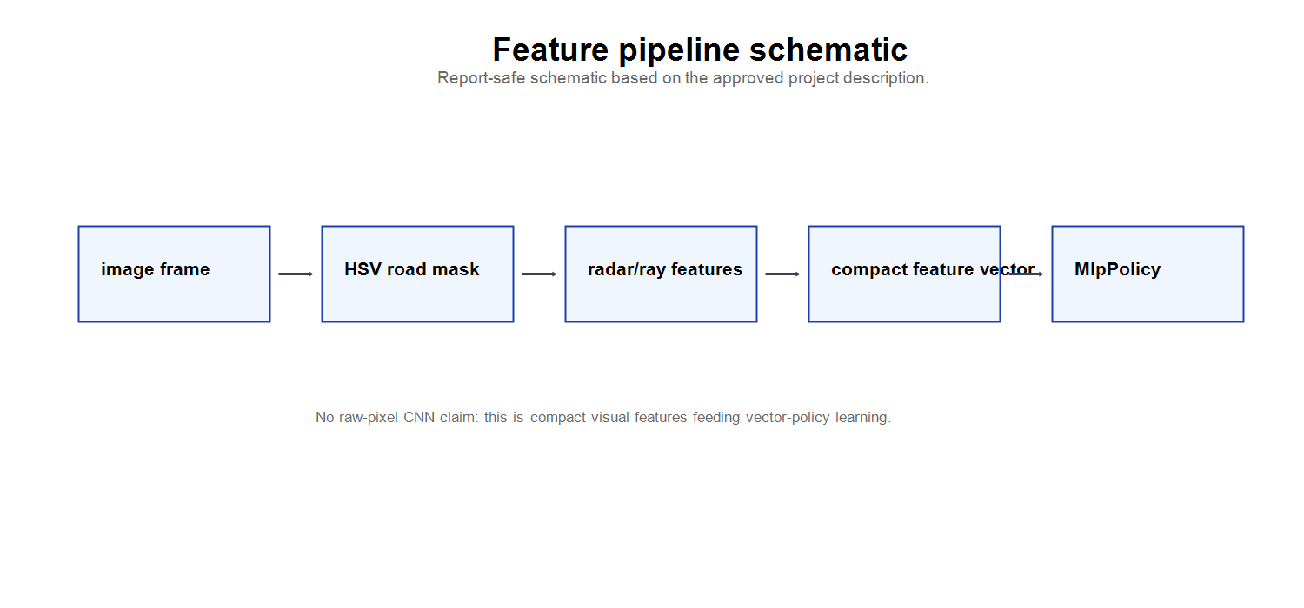
Fig. 1. Image-processing pipeline from rendered frame to compact visual features.
This representation does not attempt to replace deep visual learning in general. It is a course-project design choice: expose useful road geometry through deterministic processing, then test whether standard control algorithms can exploit the compact state.
The expected tradeoff is narrow but important. Compact features reduce the burden on the policy network and make evaluation faster, but they also discard information. If the road mask is wrong, or if the local rays do not capture the recovery direction, the controller receives a misleading state. The report therefore treats the feature pipeline as promising rather than universally robust.
III. Reinforcement Learning Setup
PPO and SAC are used off the shelf through Stable-Baselines3. PPO is the completed 500K baseline and uses vectorized rollouts. SAC is a speed-oriented fast-result branch with a validated 400K checkpoint. Because the validated budgets differ, the comparison is informative but not compute-equivalent.
Branch | Role | Validated status | Evidence
PPO baseline (V9) | Completed baseline | 500,000-step final eval | V9 log, result table
SAC fast-result branch (V11.1) | Partial fast-result branch | 400,000-step checkpoint | V11.1 log, result table
Table II. Downstream evaluation branches and validated status.
Both branches evaluate the same overall idea: image-processing-derived compact visual features can serve as the policy input. Neither branch modifies PPO or SAC theory, and neither result is used to claim algorithm superiority.
The policy inputs are therefore best understood as a compact visual state, not as a new reinforcement-learning algorithm. PPO contributes a stable on-policy baseline under the planned budget. SAC contributes an off-policy fast-result branch that reached a strong checkpoint before a validated 500K evaluation was available.
IV. Experimental Setup
The evidence package includes logs, CSV tables, notebooks with retained output evidence, figures, and demo videos. The final report uses checkpoint results from logs and tables as headline evidence, while notebook multi-seed outputs and videos provide secondary qualitative and generalization context.
Evidence item | Used for | Status
Training logs | Checkpoint means and standard deviations | Headline source
CSV result tables | Structured result verification | Headline source
Notebooks | Retained output evidence and context | Secondary source
Figures | Visual explanation and trend inspection | Report source
Demo videos | Qualitative behavior review | Visual evidence
Table III. Evidence hierarchy used in the final package.
The notebooks are report/evaluation oriented by default. Training is disabled unless explicitly enabled by a human operator, and this packaging step did not run training or execute long notebook cells.
This separation matters because notebook state can otherwise mix old outputs, partially executed cells, and one-off paths. The final package treats saved logs, tables, and exported figures as the reproducibility record. Notebook outputs are useful for inspection, but they are not allowed to override the structured evidence files.
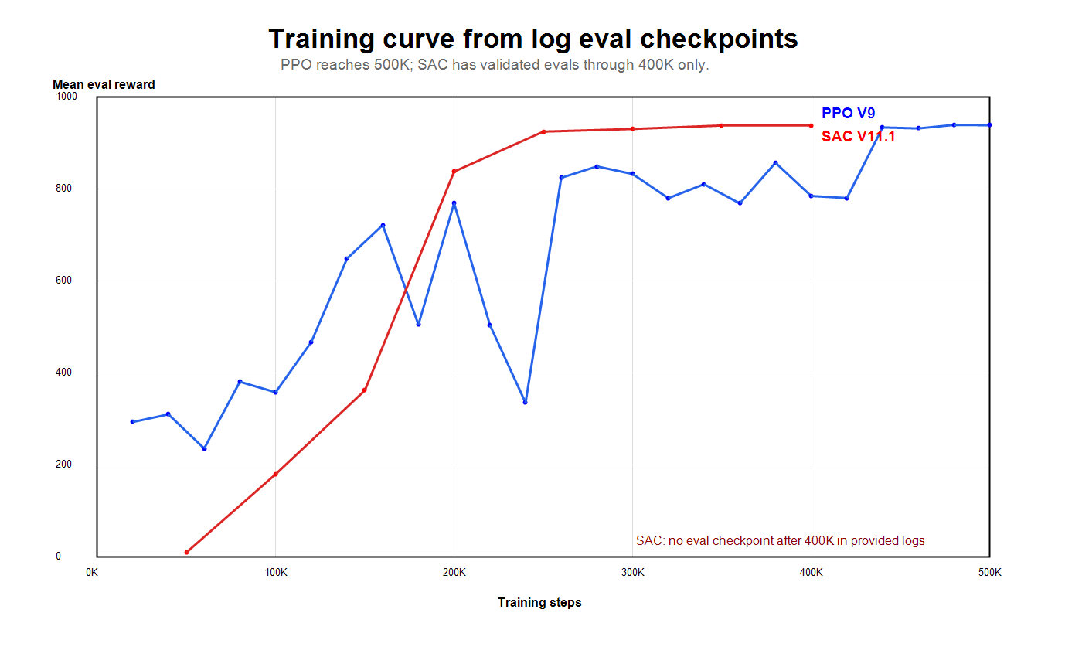
Fig. 2. Log-derived checkpoint evaluation curves for PPO and SAC.
V. Results
Branch | Status | Validated eval | Best eval
PPO baseline (V9) | completed 500K baseline | 938.87 +/- 7.86 @ 500,000 | 939.53 +/- 4.09 @ 480,000
SAC branch (V11.1) | 400K best-checkpoint / partial-run fast-result | 938.51 +/- 4.88 @ 400,000 | 938.51 +/- 4.88 @ 400,000
Table IV. Headline results verified from V2 logs and result tables.
The PPO baseline has the cleanest final-package claim because it completed the planned 500K run and has a final evaluation checkpoint at 500,000 steps. SAC reaches a similar checkpoint reward band earlier, but it remains a partial 400K best-checkpoint branch and is not a completed 500K result.
The difference between the two branches should be read as an evidence-status difference, not a winner/loser result. PPO provides the final completed baseline. SAC provides a strong partial checkpoint that motivates future work, but a fair algorithm comparison would require matched training budgets, repeated runs, and identical evaluation handling.
Branch | Secondary evidence | Mean +/- std | 95% CI
PPO baseline (V9) | fixed-seed evaluation | 924.6 +/- 6.8 | not found in provided files
PPO baseline (V9) | randomized multi-seed evaluation | 926.4 +/- 7.3 | not found in provided files
PPO baseline (V9) | bootstrap | 925.8 +/- 6.7 | [922.2, 929.0]
SAC branch (V11.1) | fixed-seed evaluation | 923.3 +/- 7.7 | not found in provided files
SAC branch (V11.1) | randomized multi-seed evaluation | 925.3 +/- 8.2 | not found in provided files
SAC branch (V11.1) | bootstrap | 924.6 +/- 7.5 | [920.7, 928.2]
Table V. Notebook-output secondary evidence for tested-seed behavior.
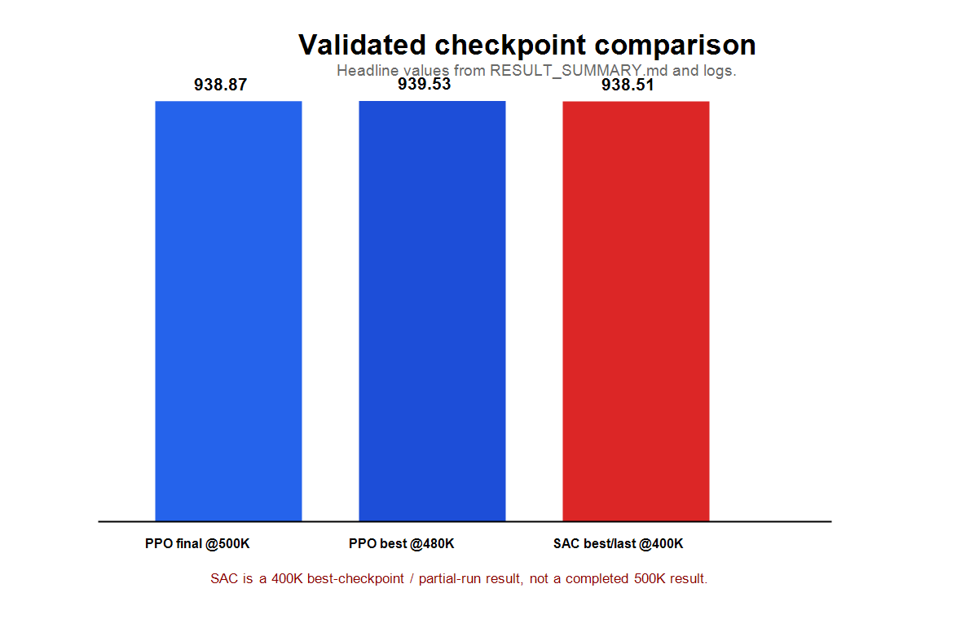
Fig. 3. Checkpoint comparison derived from the V2 evidence package.
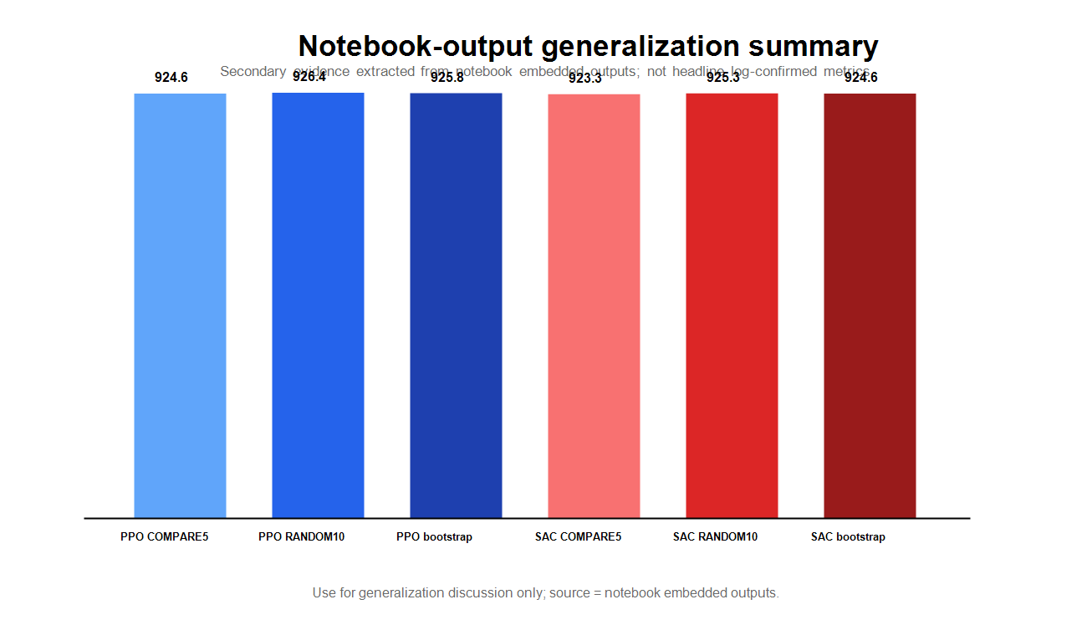
Fig. 4. Multi-seed summary used as secondary evidence.
VI. Discussion and Limitations
The main interpretation is that the compact visual representation is useful: the mask/ray/radar pipeline gives the control algorithm a lower-dimensional and more interpretable input than raw pixels. This does not prove that the representation is universally robust, and it does not remove the need for careful evaluation under unseen track seeds.
The qualitative videos support this reading. They show that the trained policies can follow the road under tested seeds, but they are not additional evaluation runs and are not counted as new quantitative evidence. They are included to make the behavior inspectable for a course audience.
The most important limitation is budget mismatch. PPO has a completed 500K baseline. SAC has a validated 400K checkpoint and no later validated evaluation checkpoint in the supplied logs. Therefore the comparison should be read as a course-project evidence summary, not as a compute-equivalent algorithm benchmark.
A second limitation is that no raw image-input CNN policy was trained in this V2 package. The project can explain why compact visual features are appealing, but it cannot claim direct performance superiority over a raw-pixel CNN under a matched protocol. A fair benchmark would require training both pipelines under the same runtime, seed list, evaluation harness, and reporting policy.
A third limitation is perceptual dependency. HSV-style road-mask extraction can be sensitive to rendering, lighting, and track appearance assumptions. Failure modes should be expected when the visual preprocessing no longer matches the road surface or when local rays do not describe the recovery path after off-road drift.
A fourth limitation is scope. The final package is a polished evidence package for the submitted feature-based approach. It does not include full hyperparameter ablations, multiple independent training repeats, or a matched raw-pixel baseline. These would be appropriate next steps, but adding them here without new verified evidence would weaken the submission.
VII. Conclusion
This final submission packages an image-processing-centered feature representation for CarRacing-v3 and evaluates it with standard PPO and SAC controllers. The completed PPO baseline (V9) reaches 938.87 +/- 7.86 at 500,000 steps, while the SAC fast-result branch (V11.1) reaches 938.51 +/- 4.88 at its validated 400,000-step checkpoint. The result is promising for compact visual features, but the correct claim remains narrow: the project demonstrates a useful image-processing-derived representation and a coherent evidence package, not a solved environment or an algorithm victory.
For submission, the important artifacts are the GitHub repository, the final report, the final presentation, the notebooks, the result tables, the figures, and the demo-video manifest. These materials together document both the image-processing method and the conservative evidence boundary.
References
[1] Farama Foundation, Gymnasium CarRacing-v3 environment documentation.
[2] OpenCV documentation, color-space conversion and HSV masking.
[3] J. Schulman et al., Proximal Policy Optimization Algorithms, arXiv:1707.06347, 2017.
[4] A. Raffin et al., Stable-Baselines3: Reliable Reinforcement Learning Implementations, 2021.
[5] T. Haarnoja et al., Soft Actor-Critic: Off-Policy Maximum Entropy Deep Reinforcement Learning with a Stochastic Actor, ICML, 2018.
[6] Image Processing Project V2 evidence package: training logs, CSV result tables, notebooks, figures, and video manifest, 2026.

Appendix: Selected Checkpoint Evidence
Branch | Step | Mean reward | +/- std
PPO baseline (V9) | 20000 | 293.54 | 146.56
PPO baseline (V9) | 40000 | 310.22 | 89.79
PPO baseline (V9) | 60000 | 236.05 | 79.57
PPO baseline (V9) | 80000 | 381.07 | 69.73
PPO baseline (V9) | 100000 | 358.19 | 132.66
PPO baseline (V9) | 120000 | 467.53 | 211.29
PPO baseline (V9) | 140000 | 648.81 | 243.53
PPO baseline (V9) | 160000 | 721.70 | 135.85
PPO baseline (V9) | 180000 | 505.19 | 296.11
PPO baseline (V9) | 200000 | 769.12 | 223.36
PPO baseline (V9) | 220000 | 505.04 | 355.49
PPO baseline (V9) | 240000 | 335.40 | 109.84
PPO baseline (V9) | 260000 | 824.59 | 182.66
PPO baseline (V9) | 280000 | 849.36 | 173.34
PPO baseline (V9) | 300000 | 832.78 | 204.18
PPO baseline (V9) | 320000 | 780.22 | 211.17
PPO baseline (V9) | 340000 | 810.58 | 233.17
PPO baseline (V9) | 360000 | 768.91 | 211.34
PPO baseline (V9) | 380000 | 857.28 | 104.10
PPO baseline (V9) | 400000 | 784.98 | 178.68
PPO baseline (V9) | 420000 | 780.46 | 317.26
PPO baseline (V9) | 440000 | 934.05 | 6.67
PPO baseline (V9) | 460000 | 931.94 | 2.33
PPO baseline (V9) | 480000 | 939.53 | 4.09
PPO baseline (V9) | 500000 | 938.87 | 7.86
SAC branch (V11.1) | 50000 | 9.67 | 8.98
SAC branch (V11.1) | 100000 | 179.94 | 28.69
SAC branch (V11.1) | 150000 | 362.34 | 53.22
SAC branch (V11.1) | 200000 | 838.10 | 151.24
SAC branch (V11.1) | 250000 | 924.99 | 4.55
SAC branch (V11.1) | 300000 | 930.68 | 6.09
SAC branch (V11.1) | 350000 | 938.33 | 2.42
SAC branch (V11.1) | 400000 | 938.51 | 4.88
Table VI. Full checkpoint evidence from V2 CSV tables.
Package component | Final-facing role
Final report | Technical description and conservative evidence interpretation
Final slides | Course presentation and professor-facing summary
PPO/SAC notebooks | Inspection of retained outputs and safe report/evaluation mode
Logs and tables | Source for headline result verification
Figures | Pipeline, checkpoint, and generalization visuals
Media manifest | Index of qualitative demo videos
Table VII. Final repository materials and their role in the submission.
Branch | Demo type | Seed | Reward | Video file
PPO baseline (V9) | lower-reward selected | 599310825 | 911.2 | PPO_V9_worst_seed599310825_r911_clean.mp4
PPO baseline (V9) | lower-reward selected | 123 | 913.4 | PPO_V9_worst_seed123_r913_clean.mp4
PPO baseline (V9) | lower-reward selected | 1051802512 | 918.4 | PPO_V9_worst_seed1051802512_r918_clean.mp4
PPO baseline (V9) | higher-reward | 107420369 | 932.9 | PPO_V9_best_seed107420369_r933_clean.mp4
PPO baseline (V9) | higher-reward | 1181241943 | 933.0 | PPO_V9_best_seed1181241943_r933_clean.mp4
PPO baseline (V9) | higher-reward | 136505587 | 936.0 | PPO_V9_best_seed136505587_r936_clean.mp4
SAC branch (V11.1) | lower-reward selected | 599310825 | 908.7 | SAC_V11_1_worst_seed599310825_r909_clean.mp4
SAC branch (V11.1) | lower-reward selected | 123 | 911.0 | SAC_V11_1_worst_seed123_r911_clean.mp4
SAC branch (V11.1) | lower-reward selected | 1051802512 | 914.4 | SAC_V11_1_worst_seed1051802512_r914_clean.mp4
SAC branch (V11.1) | higher-reward | 1181241943 | 931.1 | SAC_V11_1_best_seed1181241943_r931_clean.mp4
SAC branch (V11.1) | higher-reward | 107420369 | 933.3 | SAC_V11_1_best_seed107420369_r933_clean.mp4
SAC branch (V11.1) | higher-reward | 136505587 | 933.7 | SAC_V11_1_best_seed136505587_r934_clean.mp4
Table VIII. Demo-video manifest used for qualitative inspection.

