Feature-Based Reinforcement Learning
for CarRacing-v3
PPO Baseline and SAC Fast-Result Analysis
Student: Joe
Date: June 24, 2026
Abstract
This report studies feature-based visual reinforcement learning in the randomized Gymnasium CarRacing-v3 environment. The system converts each RGB frame into a compact road-mask and ray/radar-style feature representation, then trains multilayer-perceptron controllers with PPO and SAC. The completed PPO V9 baseline reached 938.87 ± 7.86 at the 500,000-step final evaluation, with a best parsed checkpoint of 939.53 ± 4.09 at 480,000 steps. The SAC V11.1 branch reached 938.51 ± 4.88 at its last validated 400,000-step checkpoint; no later SAC evaluation checkpoint is available in the evaluation logs. A fixed 5-seed evaluation, a randomized 10-seed evaluation, and bootstrap summaries provide secondary evidence for tested-seed generalization. The results support a conservative conclusion: compact visual features can support high-reward CarRacing-v3 control in this project setting, while SAC should be interpreted as a resource-constrained fast-result checkpoint rather than a completed equal-budget comparison or an algorithm-superiority claim.
Keywords: CarRacing-v3, reinforcement learning, PPO, SAC, visual features, road-mask perception, ray-based perception, generalization.
I. Introduction
CarRacing-v3 is a continuous-control environment in which an agent must steer, accelerate, and brake on procedurally generated tracks [1]. Because the track changes across seeds, the task provides a useful small-scale setting for studying road-following behavior and tested-seed generalization.
This project addresses randomized visual control under practical notebook and Colab constraints. Instead of training directly on raw image tensors, the final system extracts compact road-mask and ray/radar-style features before policy learning. This choice reduces the training burden and makes the policy input easier to inspect, while limiting the claim to feature-based visual control rather than raw-pixel image learning.
The report asks three questions. First, can a compact mask/ray/radar feature pipeline support high-reward CarRacing-v3 control? Second, how does a completed PPO baseline compare with a SAC fast-result checkpoint when the difference in validated budgets is disclosed? Third, what tested-seed generalization evidence is available from fixed and randomized seed evaluations?
II. Background
The implementation uses Stable-Baselines3 as the reinforcement-learning library context [2]. PPO is an on-policy policy-gradient method that uses a clipped surrogate objective to stabilize policy updates [3]. SAC is an off-policy actor-critic method that combines replay-buffer learning with entropy regularization [4]. PPO was selected as a stable on-policy reference baseline, while SAC was selected to examine whether off-policy replay and update reuse could provide faster convergence under limited runtime.
These algorithmic differences motivate the comparison, but they do not make this experiment a perfectly controlled ablation. PPO is treated as the completed reference baseline because it has a validated 500K final evaluation. SAC is treated as a fast-result branch because it reached the high-reward range earlier but lacks a validated evaluation checkpoint beyond 400K in the available logs.
The report does not evaluate an end-to-end convolutional policy. All main claims concern a compact feature-based representation derived from road masks and ray/radar-style geometry, passed to MLP policies.
III. Methodology
A. Feature-Based Perception Pipeline
The final wrapper crops the lower portion of each RGB observation, applies HSV road-mask extraction, optionally uses connected-region cleanup, and casts nine forward-biased rays from a fixed origin. The audited constants include CROP_BOTTOM = 84, PERCEPTION_MODE = v6_full_mask, RAY_ORIGIN = (48, 70), and ray angles from -70 degrees to +70 degrees. Ray length is normalized and dynamically adjusted by the previous speed term.
The resulting base observation has 16 dimensions: nine ray features, three smoothed action components, normalized speed, curvature, front-ray change, and left-right asymmetry. A four-frame stack produces a 64-dimensional input to an MlpPolicy. The policy output is the continuous CarRacing action vector: steering in [-1, 1], gas in [0, 1], and brake in [0, 1].
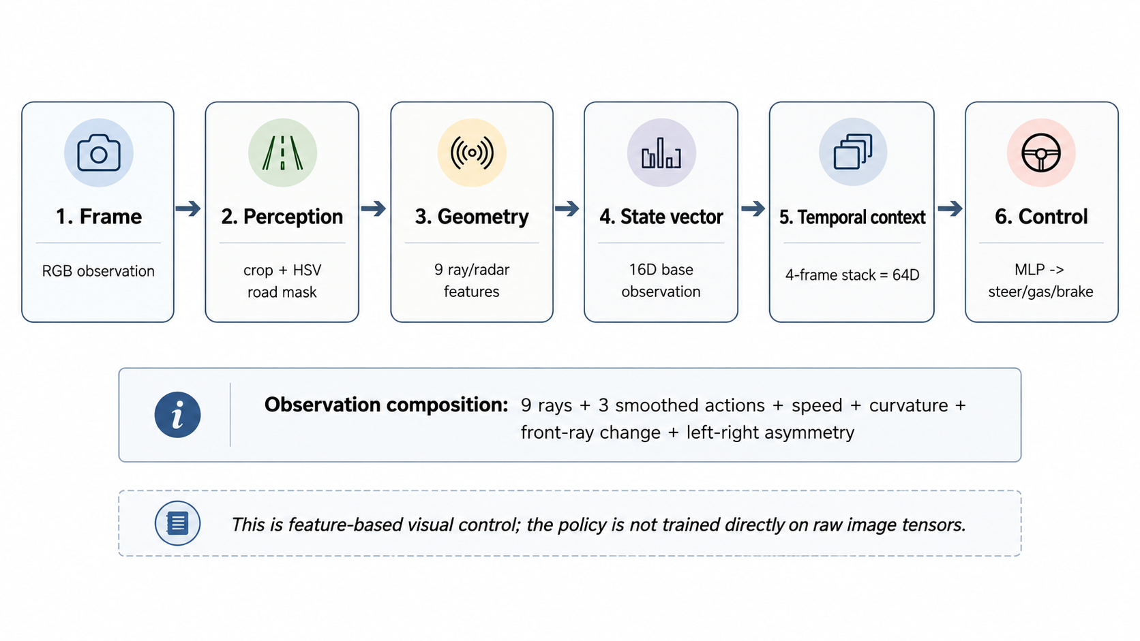
Fig. 1. Compact feature-based perception and control pipeline. The policy consumes a stacked feature vector rather than raw image tensors.
Component | Role in observation
9 ray distances | Normalized road-distance features from forward-biased angles (-70 to +70 degrees).
3 smoothed actions | EMA-smoothed steering, gas, and brake values from recent control history.
Speed | Normalized speed from the environment vehicle state.
Curvature | Road-geometry cue derived from left/right ray imbalance when on road.
Front-ray change | Temporal change in the center ray value.
Left-right asymmetry | Mean right-ray distance minus mean left-ray distance.
Frame stack | 16D base observation × 4 frames = 64D MlpPolicy input.
Table I. Observation composition used by the final feature-based policy.
B. Action and Reward Handling
The wrapper uses the standard continuous CarRacing action structure and applies exponential moving-average smoothing to the action vector before stepping the environment. The learning reward includes shaping terms for tile progress, steering guidance, speed, front danger, steering jitter, off-road behavior, and early termination penalties. The notebook also records raw_reward and shaped_reward in evaluation information. The headline metrics in this report are not recomputed; they are taken from the provided logs and result summaries.

C. Algorithm Settings
Setting | PPO V9 | SAC V11.1
Policy | MlpPolicy, net_arch [256, 256] | MlpPolicy, net_arch [256, 256]
Observation | 16D base × 4-frame stack = 64D | 16D base × 4-frame stack = 64D
Environment count | 4 vectorized environments | 1 environment
Planned budget | 500,000 steps, completed | 500,000 planned; validated through 400,000
Learning rate | linear schedule 3e-4 to 1e-5 | 3e-4 constant
Discount | gamma = 0.99 | gamma = 0.99
PPO-specific | n_steps 512; batch 128; epochs 6; clip 0.20 to 0.10; ent_coef 0.01; gae_lambda 0.95 | N/A
SAC-specific | N/A | buffer 200,000; learning_starts 10,000; batch 256; tau 0.005; train_freq 8 steps; gradient_steps 1; ent_coef auto
Evaluation | every 20,000 env steps; 5 episodes | every 50,000 env steps; 5 episodes
Table II. Audited algorithm settings. N/A indicates that a setting does not apply to the corresponding algorithm.
The environment-count difference is an important practical limitation. PPO used four vectorized environments to improve rollout throughput, whereas the SAC fast-result profile used one environment together with an off-policy replay buffer. This difference reflects implementation and Colab resource constraints rather than a controlled experimental variable. For this reason, the PPO/SAC comparison is interpreted as a budget-disclosed performance comparison, not as a compute-equivalent ablation.
IV. Experimental Setup
The evidence is separated into two levels. Headline claims use the training logs and result summaries, which record completion status, validated evaluation checkpoints, elapsed time, throughput, and last observed step. Notebook-output values are used only for fixed-seed, randomized-seed, and bootstrap evaluation summaries.
PPO V9 was trained and validated as the completed 500K baseline. SAC V11.1 was planned for a 500K training budget, but the available Colab/runtime window and project deadline made completion of the full planned budget impractical. Because the evaluation logs contain validated evaluation checkpoints only through 400K, this report treats the 400K checkpoint as the last validated SAC result. Since SAC had already reached the high-reward range by 350K–400K, it is discussed as a strong fast-result checkpoint under resource constraints, not as a completed 500K run.
A fixed set of five evaluation seeds is used to test deterministic performance across known seeds, while a randomized set of ten evaluation seeds is used to provide a broader tested-seed evaluation. Bootstrap summary metrics are derived by resampling the available seed-evaluation rewards with replacement for 10,000 bootstrap replicates, estimating a 95% confidence interval for the mean reward across the tested evaluation episodes. These secondary results support a tested-seed generalization discussion; they do not replace multi-seed retraining or a matched-budget ablation.
Evidence source | Use in this report
Training logs | Primary checkpoint and completion evidence.
Result summaries | Curated headline metrics and conservative interpretation.
Notebook outputs | Method details and secondary seed-evaluation summaries.
Generated figures and tables | Visual summaries generated from existing evidence only.
Table III. Evidence sources used in the academic report.
V. Results
The headline comparison shows that PPO V9 completed the full 500K baseline and stabilized in the high-reward range. SAC V11.1 reached the same high-reward range by the last validated 400K checkpoint, but no SAC evaluation checkpoint after 400K is available in the evaluation logs. This budget distinction is central to the interpretation.
Branch | Status | Validated eval | Best eval | Last observed step
PPO V9 | completed 500K baseline | 938.87 ± 7.86 @ 500,000 | 939.53 ± 4.09 @ 480,000 | 501,760
SAC V11.1 | 400K best-checkpoint / partial run | 938.51 ± 4.88 @ 400,000 | 938.51 ± 4.88 @ 400,000 | 418,697
Table IV. Headline comparison from result summaries and training logs.
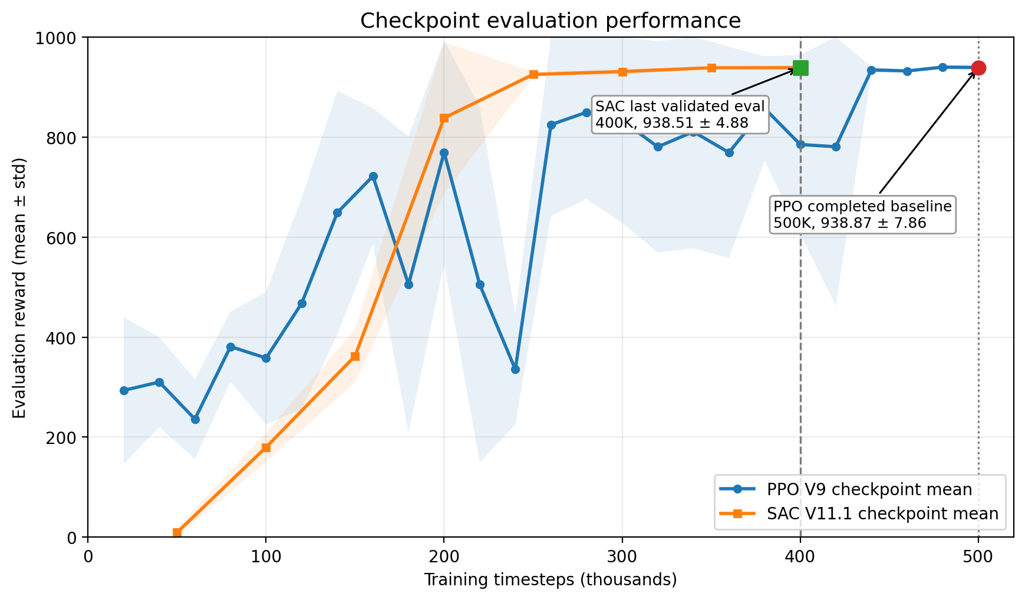
Fig. 2. Log-derived checkpoint evaluation curves. PPO is shown through 500K; SAC is shown only through the last validated 400K evaluation checkpoint.
The secondary seed-based evidence is intentionally separated from the headline log-confirmed results. The fixed-seed and randomized-seed summaries indicate that both policies remain in a similar high-reward range on the tested seed sets, but they do not prove universal generalization across all randomized tracks.
Branch | Evaluation | Mean ± std | Min / max | 95% CI | Evidence level
PPO V9 | Fixed 5-seed evaluation | 924.6 ± 6.8 | N/A | N/A | secondary evidence
PPO V9 | Randomized 10-seed evaluation | 926.4 ± 7.3 | 911.2 / 936.0 | N/A | secondary evidence
PPO V9 | Bootstrap summary | 925.8 ± 6.7 | 911.2 / 936.0 | [922.2, 929.0] | secondary evidence
SAC V11.1 | Fixed 5-seed evaluation | 923.3 ± 7.7 | N/A | N/A | secondary evidence
SAC V11.1 | Randomized 10-seed evaluation | 925.3 ± 8.2 | 908.7 / 933.7 | N/A | secondary evidence
SAC V11.1 | Bootstrap summary | 924.6 ± 7.5 | 908.7 / 933.7 | [920.7, 928.2] | secondary evidence
Table V. Seed-based evaluation evidence from notebook outputs. N/A indicates unavailable values in the provided evidence.
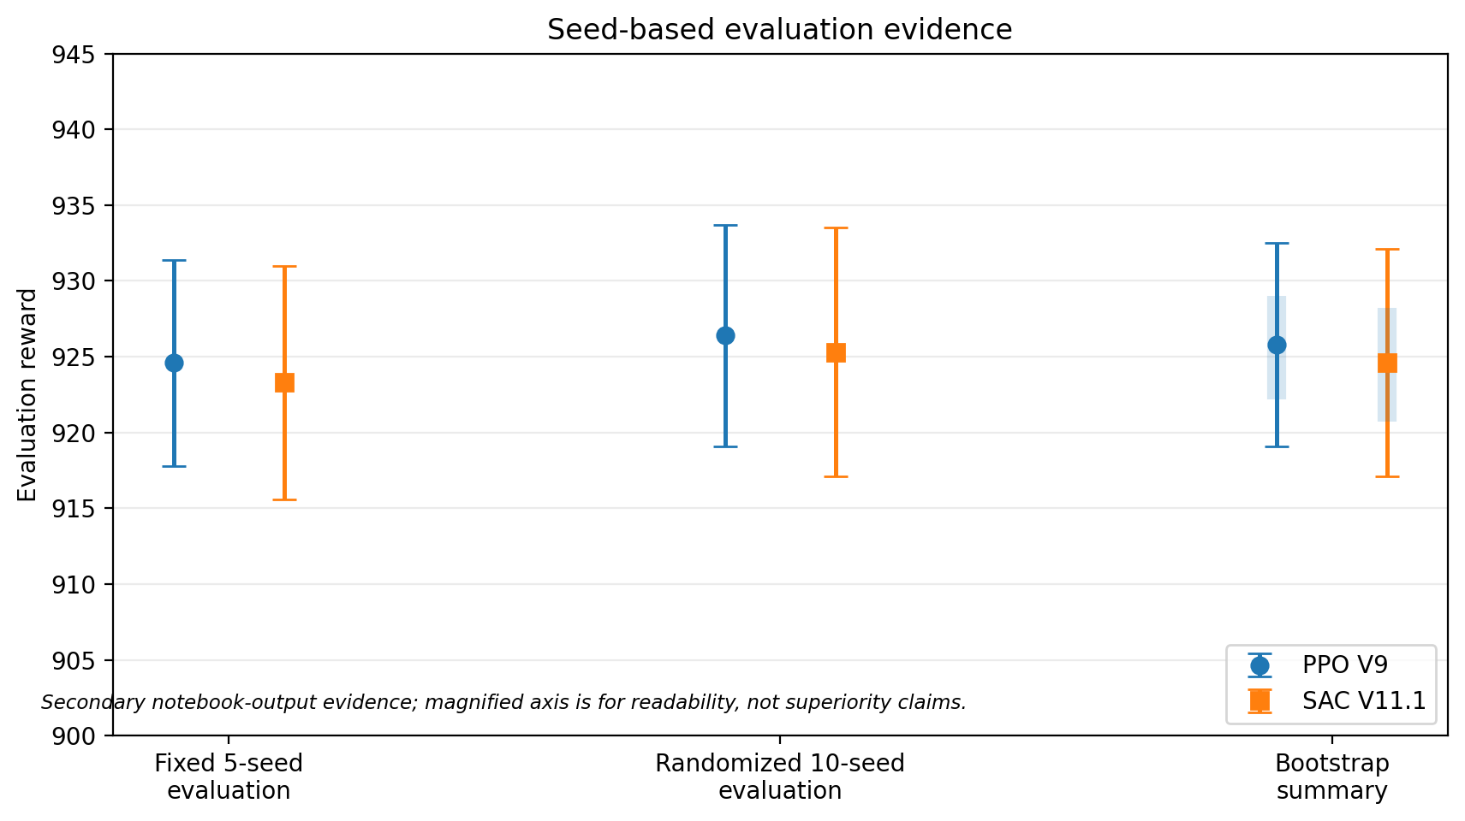
Fig. 3. Seed-based evaluation evidence. The magnified axis improves readability and should not be interpreted as an algorithm-superiority claim.
VI. Discussion
PPO remains the stronger completed baseline because it has a validated 500K final evaluation and a sequence of late checkpoints that remain in the high-reward range. Its best parsed checkpoint, 939.53 ± 4.09 at 480K, and final checkpoint, 938.87 ± 7.86 at 500K, show that the completed run stabilized near the top of the observed performance range.
SAC is scientifically interesting because it reached 938.51 ± 4.88 by its validated 400K checkpoint. Since SAC is off-policy and uses replay-buffer updates, reaching the high-reward range with a smaller validated step budget is consistent with the hypothesis that the feature-based representation and SAC update structure support faster convergence. However, the experiment does not establish an algorithm win because the validated budgets, environment counts, and update densities differ.
The ray/radar-style feature design likely helps convergence by exposing control-relevant road geometry, recent action history, speed, and road-asymmetry cues to an MLP policy. This is a practical engineering choice under Colab constraints. It also narrows the scope of the conclusion: the report supports feature-based visual control, not raw-pixel image-policy generality.
The fixed-seed and randomized-seed evaluations support a cautious generalization claim across the tested seeds. They do not prove complete generalization across all possible CarRacing-v3 tracks, and they do not substitute for independent multi-seed training runs.

VII. Limitations
• SAC V11.1 is a 400K best-checkpoint / partial-run result in the provided evidence, whereas PPO V9 is a completed 500K baseline.
• The validated budgets, environment counts, and update densities differ, so the comparison is not a perfectly compute-equivalent ablation.
• Each algorithm is represented by one main training trajectory rather than independent multi-seed training runs.
• Fixed-seed, randomized-seed, and bootstrap metrics are notebook-output evidence and remain secondary to the training logs and result summaries.
• The feature-based perception pipeline limits conclusions about raw-pixel CNN policies or end-to-end image learning.
• Future work should include matched-budget PPO/SAC runs, multiple independent training seeds, broader seed distributions, and direct comparison to a pixel-based baseline.
VIII. Conclusion
This report supports a conservative but meaningful conclusion: compact mask/ray/radar visual features can support high-reward CarRacing-v3 control in this project setting. PPO V9 provides the completed 500K baseline. SAC V11.1 provides a strong validated 400K fast-result checkpoint under Colab/runtime constraints. The result is best interpreted as evidence that a feature-based perception pipeline can make high-reward control feasible and inspectable, while stronger algorithmic claims require matched-budget and multi-seed follow-up experiments.
References
[1] Farama Foundation, "CarRacing-v3," Gymnasium documentation. https://gymnasium.farama.org/environments/box2d/car_racing/
[2] Stable-Baselines3 Contributors, "Stable-Baselines3 documentation." https://stable-baselines3.readthedocs.io/
[3] J. Schulman, F. Wolski, P. Dhariwal, A. Radford, and O. Klimov, "Proximal Policy Optimization Algorithms," arXiv:1707.06347, 2017.
[4] T. Haarnoja, A. Zhou, K. Hartikainen, G. Tucker, S. Ha, J. Tan, V. Kumar, H. Zhu, A. Gupta, P. Abbeel, and S. Levine, "Soft Actor-Critic Algorithms and Applications," arXiv:1812.05905, 2018.

Appendix
A. PPO Evaluation Checkpoints
Step | PPO mean | PPO std
20,000 | 293.54 | 146.56
40,000 | 310.22 | 89.79
60,000 | 236.05 | 79.57
80,000 | 381.07 | 69.73
100,000 | 358.19 | 132.66
120,000 | 467.53 | 211.29
140,000 | 648.81 | 243.53
160,000 | 721.70 | 135.85
180,000 | 505.19 | 296.11
200,000 | 769.12 | 223.36
220,000 | 505.04 | 355.49
240,000 | 335.40 | 109.84
260,000 | 824.59 | 182.66
280,000 | 849.36 | 173.34
300,000 | 832.78 | 204.18
320,000 | 780.22 | 211.17
340,000 | 810.58 | 233.17
360,000 | 768.91 | 211.34
380,000 | 857.28 | 104.10
400,000 | 784.98 | 178.68
420,000 | 780.46 | 317.26
440,000 | 934.05 | 6.67
460,000 | 931.94 | 2.33
480,000 | 939.53 | 4.09
500,000 | 938.87 | 7.86
Table A1. PPO V9 evaluation checkpoints parsed from the 500K training log.
B. SAC Evaluation Checkpoints
Step | SAC mean | SAC std
50,000 | 9.67 | 8.98
100,000 | 179.94 | 28.69
150,000 | 362.34 | 53.22
200,000 | 838.10 | 151.24
250,000 | 924.99 | 4.55
300,000 | 930.68 | 6.09
350,000 | 938.33 | 2.42
400,000 | 938.51 | 4.88
Table A2. SAC V11.1 validated evaluation checkpoints. No evaluation checkpoint after 400K is present in the provided logs.
C. Evidence Hierarchy
Primary headline evidence: result summaries and training logs.
Secondary evidence: notebook-output values for fixed 5-seed evaluation, randomized 10-seed evaluation, bootstrap summaries, and diagnostic outputs.
SAC 500K final artifacts are not available or not validated in the provided evidence. The report uses the validated 400K best-checkpoint result instead.

