# 使用ConstraintLayout

## Failed to load AppCompat ActionBar with unknown error

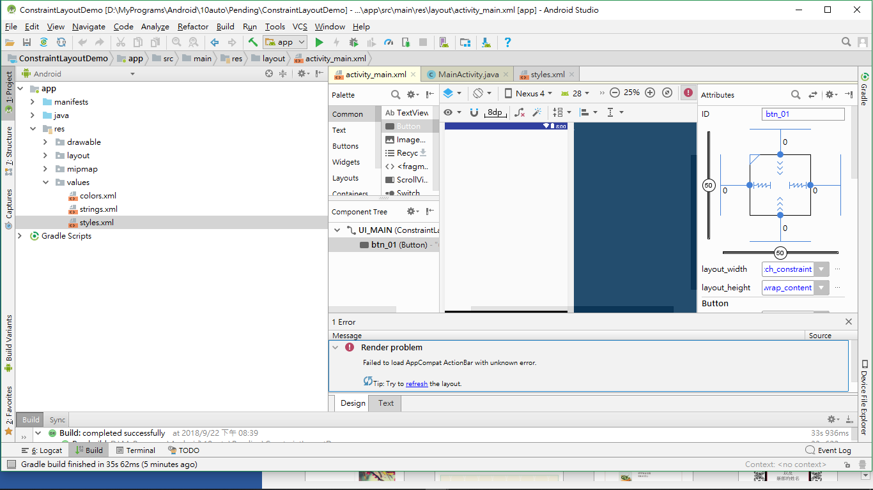

Open Styles.xml

add "Base." before "Theme.AppCompat.Light.DarkActionBar"

