**Overview.**

1. **About our team.**

|  |  |  |  |
| --- | --- | --- | --- |
| **Name** | **Student ID** | **Email** | **Role** |
| Yerkegul Assaiyn | 201069 | [201069@astanait.edu.kz](mailto:201069@astanait.edu.kz) | Development of the Menu page |
| Arailym Bakenova | 201184 | [201184@astanait.edu.kz](mailto:201184@astanait.edu.kz) | Filling out the documentation |
| Ansar Yertaev | 201138 | [201138@astanait.edu.kz](mailto:201138@astanait.edu.kz) | Development of the Reservation page |
| Aslan Nurlybekov | 201610 | [201610@astanait.edu.kz](mailto:201610@astanait.edu.kz) | Development of the Home page |
| Sanzhar Khamitov | 201330 | [201330@astanait.edu.kz](mailto:201330@astanait.edu.kz) | Working on media files |

**Communication strategy –** Online and offline group meetings.

1. **Motivation:** The number of Astana IT University students is growing every year as well as the demand for a website for the university canteen where student will be able to see the menu, book a table, and so on.
2. **High-level project scope**– A brand new website, aiming a minimum of 10,000 unique visitors per month.
3. **Target audience/market** – Target audience is formed from students, teachers and university workers.

**Project goals and team interests.**

1. **Project goals**

* Creating a beautiful and convenient website for Astana IT University canteen.
* Improve the efficiency of the university canteen.
* Integrate canteen reservation system.
* Attract more visitors with convenient access to canteen data in the form of menus or promotions/sales.

1. **Team interests**

* Understand HTML tags and CSS by building website of university canteen.
* Establish a solid understanding of website design principles
* Improve team working skills by collaborating with different members of the group

**Phases:**

* **Phase 1** – Basic Astana IT University website with HTML
* **Phase 2** – Add reservation form made in Mailchimp
* **Phase 3** – Add styles to improve the appearance and thus draw wider audience
* **Phase 4** – Combine all the parts worked out by each member of the group into one complete project

**Content structure:**

**Site map**

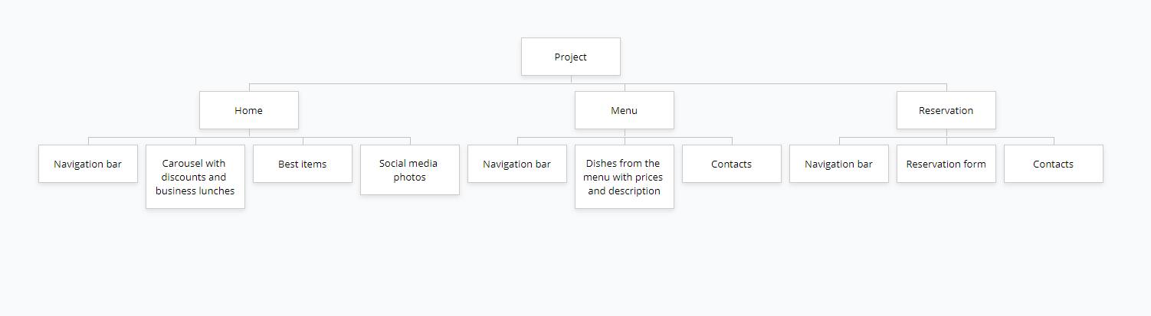

**Content types**

Home page:

* Posts of promotions in the canteen
* Posts of best items
* Contacts

Menu:

* Dishes in The Canteen with description and prices
* Contacts

Reservation:

* Form To Fill Out
* Contacts

**Design**

* Reference links: <https://codepen.io/partisan1991/pen/yrwmA>, <https://codepen.io/Jhonierpc/pen/MWgBJpy>, <https://getbootstrap.com/docs/4.6/getting-started/introduction/>
* Image files:
* https://cutt.ly/Ekbg47v
* https://cutt.ly/7kbhYUL
* https://cutt.ly/QkbhAke
* https://cutt.ly/VkbgG4j
* https://cutt.ly/ykbsIls
* Colors: #89d10e, #52b622, #4FC452, #68975f, #fff
* Typography rules: font-family: 'Montserrat', sans-serif
* Animations: transition
* Grid systems: Bootstrap, CSS
* Spacing: auto

**Functionality**

We have our own functionality on each page of the site.

On the home page, we see a carousel with promotions.

On the menu page, we see different positions of dishes, and when user hover over them with the cursor, the product description window pops up.

And on the last page of the reservation, an error appears if the email input is incorrect or the entered date does not match the current date. This page also has protection from bots, on this page you are asked to check the box if you are not a robot. Then, after the client has submitted their data, a window pops up where they have the choice to go to the home page or send you a notification by email.

Also on each of the pages, there is a navigation bar that takes the user to any of the pages he wants.

**Hosting**

After logging into the GitHub, we clicked on “new repository”, wrote the repository name (in our case aitucanteen), clicked on “public”. Checked the “add a readme file checkbox”, clicked “create repository”, then clicked on add file -> upload file, renamed the main page to index.html for the site to accept file and clicked on “commit changes”. We went to settings, look for the GitHub pages section ---> source, clicked on the none button, clicked on “main”, saved and went back to the GitHub page section and instead of “roots” we have placed “docs”, saved it and got the link where our site was. At the end we checked if everything was done in the right way.

**Accessibility**

Making website accessible should be a priority. All content on our website is easily accessible and readable. Moreover, each section is designed so that it will be impossible to get confused in it. The general color does not interfere with the user, but disposes to itself. In addition, the site using the grid system makes it possible to use the site on all possible devices.

**Deadlines**

* Phase 1 – February 2, 14:00
* Phase 2 – February 4, 16:00
* Phase 3 – February 6, 18:00
* Phase 4 – February 7, 23:59

**Summary:**

We have definitely achieved both project and group goals. Having a beautiful, and most importantly, easy-to-use website, our knowledge of the HTML and CSS languages ​​has significantly improved. That is, using Bootstrap, CSS grid and the whole CSS framework in practice helped to consolidate our knowledge.

The site consists of three pages: Home, Menu and Reservation. Each page was written according to the Must Have Elements requirement presented by the teacher. Hence the main difficulty that arose during the work, namely that three pages were created so that elements such as navigation bar and footer were repeated and minor changes had to be remembered and taken into account adhering to a certain style. However, the difficulty was naturally eliminated.

In conclusion, we would like to note that the second group has done a large amount of work in a short time and in its own way has reached some heights.