**Overview.**

1. **About our team.**

|  |  |  |  |
| --- | --- | --- | --- |
| **Name** | **Student ID** | **Email** | **Role** |
| Yerkegul Assaiyn | 201069 | [201069@astanait.edu.kz](mailto:201069@astanait.edu.kz) | Development of the About team page |
| SaltanatYensebaeva | 201111 | [201111@astanait.edu.kz](mailto:201111@astanait.edu.kz) | Developing Express.js |
| AnsarYertaev | 201138 | [201138@astanait.edu.kz](mailto:201138@astanait.edu.kz) | Developing JavaScript code |
| Aslan Nurlybekov | 201610 | [201610@astanait.edu.kz](mailto:201610@astanait.edu.kz) | Development of the Home page |
| BalnurSatybaldy | 201548 | [201548@astanait.edu.kz](mailto:201330@astanait.edu.kz) | Filling out the documentation |

**Communication strategy –** Online and offline group meetings.

1. **Motivation:** As we know, football is a very interesting and exciting game. With this site, we will have the opportunity to have fun and show your skills in the front end and back-end development, mastered in this course.
2. **High-level project scope**– A brand new website, aiming a minimum of 10,000 unique visitors per month.
3. **Target audience/market** – Target audience is formed from students, adults and other people who are interested in football.

**Project goals and team interests.**

1. **Projectgoals**

* Creating a beautiful and convenient website for people interested in football.
* Attract more people to football using beautiful site design.

1. **Teaminterests**

* Understand HTML tags, CSS, Bootstrap, JavaScript and using Express.js by building website of football match’s all possible scoring outcomes.
* Establish a solid understanding of back-end development principles.
* Establish a solid understanding of front-end development principles.
* Improve team working skills by collaborating with different members of the group.

**Phases:**

* **Phase 1** – Basic website with HTML and add CSS to improve the appearance and thus draw wider audience.
* **Phase 2** – Add JavaScript to our website.
* **Phase 3** – Using Express.js (back-end JavaScript) to our website.
* **Phase 4** –Combine all the parts worked out by each member of the group into one complete project.

**Content structure:**

**Site map**

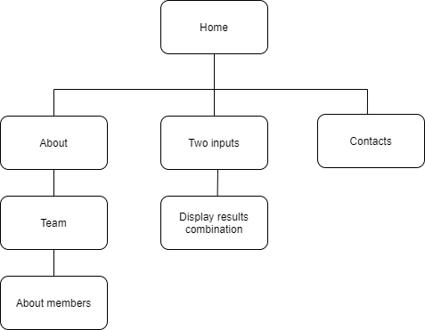

**Content types**

Home page:

* Navigation bar
* Team 1 inputs
* Score list (displaying winner)
* Team 2 inputs
* Contacts

About page:

* Navigation
* Information about our team with group photo.
* Contacts

**Design**

* Reference links: <https://codepen.io/partisan1991/pen/yrwmA>, <https://getbootstrap.com/docs/4.6/getting-started/introduction/>
* Colors: #4c8a32; #405341; white; black; #82ad84;
* Typography rules: font-family: Montserrat', sans-serif;
* Gridsystems: Bootstrap, CSS
* Animation: transition
* Spacing: auto

**Functionality**

We have our own functionality on each page of the site.

On the home page, we see an input for team 1 and team 2, body div to display the winner and the score list.

On the about page, we see body div with information about your team and the group photo. Here we use the Bootstrap grid.

Also, on each of the pages, there is a navigation bar that takes the user to any of the pages he wants and footer with contacts.

**Hosting**

After logging into the GitHub, we clicked on “new repository”, wrote the repository name, clicked on “public”. Checked the “add a readme file checkbox”, clicked“create repository”, then clicked on add file -> upload file,renamed the main page to index.html for the site to accept file and clicked on “commit changes”. We went to settings, look for the GitHub pages section ---> source, clicked on the none button, clicked on “main”, saved and went back to the GitHub page section and instead of“roots” we have placed“docs”, saved it and got the link where our site was. At the end we checked if everything was done in the right way.

**Accessibility**

Making website accessible should be a priority.All content on our website is easily accessible and readable. Moreover, each section is designed so that it will be impossible to get confused in it. The general color does not interfere with the user but disposes to itself. In addition, the site using the grid system makes it possible to use the site on all possible devices.

**Deadlines**

* Phase 1 – March 15, 14:00
* Phase 2 – March 15, 22:00
* Phase 3 – March 16, 14:00
* Phase 4 – March 16, 23:00

**Summary:**

We have definitely achieved both project and group goals. Having a beautiful, and most importantly, easy-to-use website, our knowledge of the HTML and CSS languages ​​has significantly improved. That is, using Bootstrap, CSS grid and the whole CSS framework in practice helped to consolidate our knowledge. Also, we use our knowledge from lections about Node.js, Express,js and JavaScript functions, arrays and so on.

The site consists of three pages: Home and About. Each page was written according to the Must Have Elements requirement presented by the teacher. Hence the main difficulty that arose during the work, namely that two pages were created so that elements such as navigation bar and footer were repeated and minor changes had to be remembered and taken into account adhering to a certain style. However, the difficulty was naturally eliminated.

In conclusion, we would like to note that the second group has done a large amount of work in a short time and in its own way has reached some heights.