Multi-Organ Anatomy-Preserving Speckle Reduction and Texture Enhancement in Ultrasound Images Using Semantic-Guided Latent Diffusion with Pixel Refinement
Aravind RK, Saran Hiruthik M, Shruti Shri A, V Sanjana, and Suchithra M
Department of Computer Science and Engineering, Amrita Vishwa Vidyapeetham, Coimbatore, India

Abstract— Handheld ultrasound imaging enables point-of-care imaging, but small forms factors result in images with speckle, poor resolution and blurred boundaries, while enhancement techniques that over-smooth or hallucinate can cause loss or hallucinate can cause loss or creation of important structure. We propose an anatomy-aware enhancement peipeline that processesing on five organs (breast, carotid artery, kidney, liver, thyroid) using a single model. Compressed images using a frozen variational autoencoder are then restored by a latent diffusion denoiser that takes inputs the degraded latent representation of the image, as well as cross-attented patch tokens from a frozen ViT-B/16 architecture for semantically-guided image reconstruction. An additional residual refinement stage that is trained on the sampler output restores details, while a region-of-interest gate excludes the input outside the imaging region. For 123 held-out image pairs from USenhance2023, mean PSNR increases from 18.77 dB to 22.10 dB (22.71 dB with the gate) and mean SSIM from 0.632 to 0.695 (0.756 with the gate). A seperate 210-pair test partition, evaluated without retraining, confirms these gains: PSNR increases from 18.73 dB to 22.15 dB (22.64 dB with the gate) and SSIM increase from 0.643 to 0.700 (0.747 with the gate). In the absense of region-of-interest gate, SSIM improves on all five organs except kidney and liver; removing the semantic backbone results in PSNR dropping by 1.4 dB, while the classifier acheives 95.9% accuracy (91.9% on the test partition). LPIPS changes are minimal. Backbone is initialized on ImageNet-21k rather than ultrasound data, evaluation is performed on image-level on one of datasets; this is a research prototype, not a clinical application.
Index Terms—ultrasound image enhancement, speckle reduction, latent diffusion, cross-attention, vision transformer, multi-task learning, multi-organ imaging.
I. INTRODUCTION
Ultrasound is one of the most widely used imaging modalities because it is non-invasive, radiation-free, real-time and inexpensive. Handheld devices extend it to bedside, emergency and resource-limited settings, but miniaturised transducers and electronics produce images with stronger speckle, weaker contrast and reduced visibility of fine structures [1], [2]. Software enhancement is therefore an attractive complement to hardware improvement.
Enhancement is not the same as smoothing. Speckle is a granular interference pattern, yet part of the texture it produces reflects tissue microstructure and may carry diagnostic information. Classical despeckling filters such as speckle-reducing anisotropic diffusion [3] depend on hand-set parameters and can erase small structures together with noise. Convolutional networks learn restoration from examples [1], [2], but their local receptive fields and per-organ training can over-smooth high-frequency detail. Adversarial translation [4] can produce convincing images, yet realism does not guarantee fidelity to the scanned anatomy. Diffusion models [5], [6] give a stable generative restoration framework and have recently been applied to ultrasound with auxiliary semantic pathways [7], while ultrasound foundation models [8] offer reusable semantic features. These strands leave several gaps that motivate our work: (i) most methods treat all pixels alike and are not evaluated across organs; (ii) the trade-off between noise suppression and detail preservation remains unresolved; (iii) generative methods risk hallucinating structure; and (iv) enhancement, classification and segmentation are usually separate pipelines.
We study a unified framework for five organs that combines latent diffusion, transformer-derived semantic conditioning and auxiliary anatomical tasks. We emphasise honest evaluation: all metrics are computed per image on a held-out split, every pipeline stage is reported separately, and limitations are stated explicitly. Our contributions are:
- A single multi-organ latent-diffusion enhancer whose denoiser is conditioned on frozen ViT-B/16 patch tokens through cross-attention and trained jointly with organ-classification and weakly supervised region-of-interest (ROI) heads.
- A train/inference-consistent two-stage design: a DDIM sampler without latent clipping, and a residual pixel refiner trained on cached outputs of that sampler applied to low-quality inputs rather than on reconstructions of noised high-quality latents.
- An ROI gate, evaluated as a separate pipeline stage, that retains the input outside the imaging sector, together with an analysis of how much of the gain it accounts for.
- A five-organ held-out and test-partition evaluation using PSNR, SSIM, LPIPS and entropy, with a stage-wise breakdown, per-image robustness statistics, a semantic-guidance ablation and auxiliary-task results.
The remainder of this paper is organised as follows: Section II reviews related work; Section III describes the method; Section IV the experimental setup; Section V the results; Section VI discusses limitations; and Section VII concludes.
II. RELATED WORK
A. CNN-based and classical despeckling
Speckle-reducing anisotropic diffusion [3] modulates smoothing by local gradient statistics and remains a standard baseline. US-Net [1] is a lightweight U-Net-style [9] network that suppresses speckle and enhances texture simultaneously using residual learning and a feature-refinement attention block. A texture-compensated multi-resolution CNN [2] first suppresses speckle with a densely connected U-Net-like network and then restores resolution and texture with multi-resolution dilated convolution blocks, using physics-informed augmentation. These networks are efficient, but they are trained for a single enhancement task and carry no explicit semantic or organ information.
B. Adversarial and diffusion-based enhancement
CycleGAN-style unpaired translation [4] removes the need for registered pairs but optimises distribution-level realism. Denoising diffusion models [5] and their latent-space variants [6] instead learn to reverse a gradual noising process. DiffusionClusNet [7] couples a VAE-based latent diffusion enhancer with an auxiliary classification pathway whose clustering-derived features are fused by cross-attention and which uses an SSIM loss. Diffusion sampling can, however, be sensitive to the starting noise level and number of steps [10], [11], which we examine in Section III-G.
C. Foundation-model features
USFM [8] is a ViT-style foundation model [12] pretrained by spatial–frequency masked image modelling on more than two million ultrasound images and evaluated on segmentation, classification and enhancement. Using such features as conditioning for restoration is attractive because they carry semantic context beyond local intensity. Our implementation uses a general-purpose ViT-B/16 encoder as a stand-in (Section III-D); we do not claim to reproduce USFM. Table I positions our approach among the closest methods.
TABLE I
POSITIONING AMONG CLOSELY RELATED METHODS
Method | Paradigm | Key mechanism | Semantic / auxiliary task
US-Net [1] | CNN | U-Net style; residual learning; feature-refinement attention | None
MRCB-CNN [2] | CNN, 2-stage | Dense U-Net-like despeckling; multi-resolution dilated blocks | None
CycleGAN [4] | GAN | Adversarial + cycle-consistency, unpaired | None
DiffusionClusNet [7] | Latent diffusion | VAE + U-Net denoiser; cross-attention fusion; SSIM loss | Clustering-based classification
USFM [8] | Foundation model | Spatial–frequency masked image modelling, >2M images | Downstream seg., cls., enhancement
This work | Latent diffusion + refiner | ViT-token cross-attention; cached-sampler refiner; ROI gate | Organ classification; weak ROI segmentation

III. PROPOSED METHOD
A. Overview
The registered pair of low quality image ILQ and high quality reference image IHQ of a known organ is a training sample. Please refer to Fig. 1 for the pipeline. (1) Both images are encoded to latents by a frozen VAE. (2) The frozen ViT-B/16 backbone transforms ILQ into patch tokens F for an organ-classification head, an ROI-segmentation head, and also serves as keys and values in the cross-attention layers of the denoiser. (3) The denoiser predicts the noisy latent, the low-quality latent and the timestep, to predict the noise added to the high-quality latent. At inference, the low-quality latent is partially noised and denoised using DDIM which can be then decoded to a base image B. The pixel refiner (5) adds ILQ and B to the final image, with the optional ROI gate restoring the input outside of the imaging sector. Only ILQ is needed at inference.

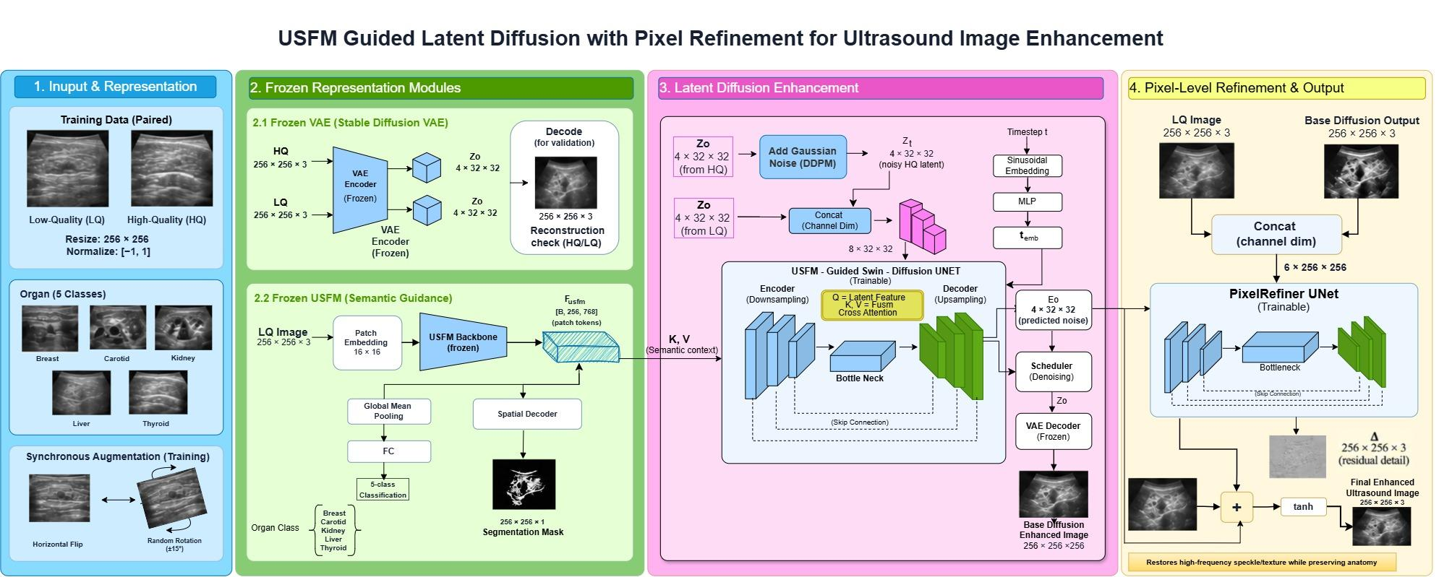
Fig. 1. Architecture of the proposed framework: (1) paired input and synchronised augmentation; (2) frozen VAE and frozen semantic backbone with classification and segmentation heads; (3) latent diffusion denoiser with cross-attention to the backbone tokens; (4) pixel refiner producing the final image. The optional ROI gate (Section III-H) is a post-processing step and is not drawn. The backbone block is labelled “USFM” in the figure; in our experiments its weights are an ImageNet-21k ViT-B/16 initialisation (Section III-D).

B. Data and preprocessing
We adopt the aligned dataset from USenhance2023 in this work, which consists of low- and high-quality paired images of five organs. We found 840 pairs (Table II) with the data loader. Images are resized to 256 × 256 and normalised to [−1, 1]. Horizontal flips and flips by 0 to 15° (by 0.5) are applied to each image of a pair, and the same amount of flips are applied to both images during training. 85% of the images of each organ are allocated for training use, 15% for held-out validation use; validation images are not augmented or used in any training step (including refiner).
C. Latent representation
Diffusion works in the latent space of the frozen latent space of the autoencoder [15] (VAE [16]) which is for an image dimensions of 3 × 256 × 256 with a latent space of 4 × 32 × 32, an 8× spatial reduction as in latent diffusion [6]. The training process is based on latent samples and the inference is based on the posterior mean. As the decoder is not specifically sonographic, this loss of information in the round trip can't be recovered by later stages (as quantified in Table IV).
D. Semantic backbone and auxiliary heads
The backbone is a ViT-B/16 [12] trained with the timm library [17] with weights from ImageNet-21k [18]. It is run at the native 256 × 256 resolution, with positional embeddings resampled to a 16 × 16 grid, so that it outputs F ∈ ℝB×256×768. The 85.8 M encoder parameters are stored and can't be changed. The classification head applies the mean of the class token(s), LayerNorm and a linear layer to predict one of five organs. The segmentation head consists of the following 4 stages: a transposed-convolution decoder that outputs a 256 × 256 mask. Both heads (3.81 M parameters) are trainable. On start-up, it looks for an ultrasound-pretrained USFM checkpoint and logs what it has loaded; during our experiments it was the same as the initialisation of ImageNet, meaning that the backbone is not ultrasound-pretrained. Henceforth we call it a “USFM-style” semantic backbone.
USenhance2023 does not provide segmentation masks, and the segmentation head is supervised using a pseudo-ROI mask of the imaging sector which is smoothed with a 5 × 5 average filter, thresholded at τ = 0.06 and then morphologically closed with a 15 × 15 window (Fig. 2). This is a weak target that helps delineate the field of view, rather than clinical structures.
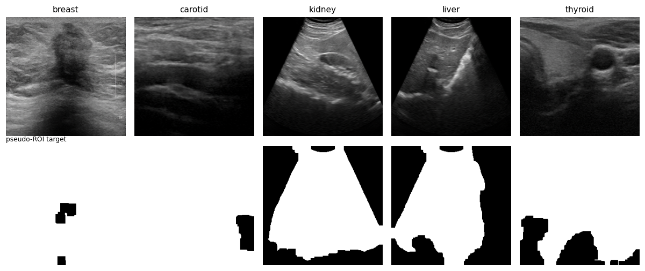
Fig. 2. Pseudo-ROI targets (bottom) derived from high-quality images (top) for the five organs.
E. Guided denoising network
The denoiser is a hierarchical U-Net [9] that contains 8.64 M parameters. The input is a concatenation of the noisy high-quality latent zt, and the low-quality latent zLQ (8 channels) with a sinusoidal embedding and MLP. It's actually a 3 × 3 stem (64 channels), followed by a 64 channels to 128 channels encoder block, then a stride-2 convolution, then an encoder block (128 channels to 256 channels), then a bottleneck block, then a stride-2 transposed-convolution upsampling, then two decoder blocks (256 channels to 128 channels and another 192 channels to 64 channels), with skip connections between them, and then a 1 × 1 convolution to 4 noise channels. Convolution and group normalisation, a cross-attention layer (8 heads, head dimension 64, pre-LayerNorm, residual), whose queries are formed from a flattened feature map, and whose keys and values are formed from F, and a second convolution with residual connection:
Attn(Q, K, V) = softmax( QK^{T} / √d_{k} ) V (1)
Although the block is named “Swin-diffusion” in our code and figures, it does not implement shifted-window self-attention [19]; it is a convolutional U-Net with cross-attention conditioning. The forward process follows the standard DDPM formulation [5] with 1000 steps:
z_{t} = √(ᾱ_{t}) z₀ + √(1 − ᾱ_{t}) ε, ε ~ N(0, I) (2)
F. Training objective
The network is trained to predict the injected noise, jointly with the two auxiliary heads:
L_{enh} = ‖ ε − ε̂_{θ}(z_{t}, z_{LQ}, t, F) ‖₁ (3)
L = λ_{enh} L_{enh} + λ_{cls} L_{cls} + λ_{seg} L_{seg} (4)
where L_{cls} is the cross-entropy against the true organ label and L_{seg} is binary cross-entropy against the pseudo-ROI mask; (λ_{enh}, λ_{cls}, λ_{seg}) = (1.0, 0.01, 0.05). One model is trained on all organs together, so the batches contain mixed organs and the classification head receives a genuine multi-class signal. We use AdamW [20] and mixed-precision training [21]; Table III lists all settings.
G. Inference: bounded latent denoising
If you start from "pure noise," you will be discarding the input in the beginning of a full reverse chain. Like SDEdit [11] we convert ILQ to zLQ, add noise to this, and then execute the rest of the deterministic DDIM steps [10]. We choose to start from index 35 (timestep 280, √ᾱ ≈ 0.67), and then move forward 15 denoising steps conditioned on zLQ and F, which is then decoded to the base image B. The default DDIM scheduler bounds the predicted clean latent to [−1, 1] to prevent it from going out of bounds, but since the latents of the VAE are unbounded we use clip_sample = False (default = True).
H. Pixel refiner and ROI gate
The refiner is a four-level U-Net (32–256 channels, 1.93 M parameters) with batch normalisation. It receives the 6-channel concatenation of I_{LQ} and B and predicts a residual Δ_{φ}:
Î = tanh( B + Δ_{φ}(I_{LQ}, B) ) (5)
and is trained with L1 + 5·(1 − SSIM) for 100 epochs. To avoid a train/test mismatch, the training inputs B are produced by the actual inference sampler applied to the low-quality training images (two noise draws per image, cached once), and flips and rotations are applied jointly to the (I_{LQ}, B, I_{HQ}) triplets. An earlier variant trained the refiner on one-step reconstructions of noised high-quality latents; those inputs contain high-quality information that is unavailable at test time.
In sector shaped scans (kidney, liver) the areas outside the sector are large black areas, and if there is any trace of the texture in these areas, it will be heavily penalized by SSIM. The optional ROI gate operates on the sector mask M predicted by the segmentation head (thresholded at 0.5, dilated with a 9 × 9 window and feathered with a 9 × 9 average filter) by retaining the input outside of it.
Ī = M ⊙ Î + (1 − M) ⊙ I_{LQ} (6)
The gate is post-processing, not a learned enhancement, so we always report it as a separate stage.
TABLE II
DATASET PARTITION (IMAGE PAIRS)
Organ | Total | Train | Held-out
Breast | 161 | 137 | 24
Carotid | 229 | 195 | 34
Kidney | 98 | 84 | 14
Liver | 119 | 102 | 17
Thyroid | 233 | 199 | 34
All | 840 | 717 | 123

TABLE III
IMPLEMENTATION SETTINGS
Item | Setting
Input / latent | 3×256×256 / 4×32×32
Backbone | ViT-B/16, ImageNet-21k init., frozen (85.8 M)
Trainable parts | Denoiser 8.64 M; heads 3.81 M; refiner 1.93 M
Optimiser | AdamW; lr 1×10⁻⁴ (refiner 2×10⁻⁴)
Batch / epochs | 16 / 100 (denoiser), 100 (refiner)
Loss weights (enh, cls, seg) | 1.0, 0.01, 0.05
Diffusion steps / noise sched. | 1000 / linear β (DDPM default)
Sampler | DDIM, 50-step schedule, start index 35, 15 steps, η = 0, no clipping
Refiner cache | 2 noise draws per training image
Gradient clipping / precision | 1.0 / fp16 autocast
Seed / split | 42 / 85% – 15% per organ
Training cost | ≈77 s/epoch (denoiser), ≈9 s/epoch (refiner); ≈2.5 h total on one cloud GPU

IV. EXPERIMENTAL SETUP
A. Data and protocol
Table II shows the data split. The held-out set constains123 pairs (14–34 per organ). The loader’s counts are the number of pairs found in the training directory of the aligned dataset and must not be taken as the size of the original public dataset. A separate test split with high-quality references containing 210 pairs, neither contained in the training split nor in the held-out split, is reported in Section V-F. All results reported in the table below are obtained after a single training run with one random seed.
B. Metrics
Full-reference quality is assessed via PSNR and SSIM [22] on the images normalized to [0, 1], and perceptual difference via LPIPS [23] (AlexNet backbone; the lower is better). In addition, we meausre the Shannon entropy of the grey-level histogram that has no favoured direction, and compare it with the entropy of the high-quality target. Metrics are computed for each image and averaged seperately for each organ; the “Average” row shows the average across the five organs without any weighting. We also report the fraction of individual for which there is an improvement over the input image; this gives an additional robustness check that might hide in the means.
For every held-out image we consider four stages: the low-quality input (LQ), the base diffusion output (B), the refined output Î ("Refined"), and the gated output Ī ("+Gate"). Training curves are shown in Fig. 4.
TABLE IV
VAE ROUND-TRIP FIDELITY OF HIGH-QUALITY IMAGES
Organ | PSNR (dB) | SSIM
Breast | 27.19 | 0.6281
Carotid | 28.64 | 0.7400
Kidney | 28.92 | 0.7895
Liver | 28.97 | 0.7903
Thyroid | 28.71 | 0.7324

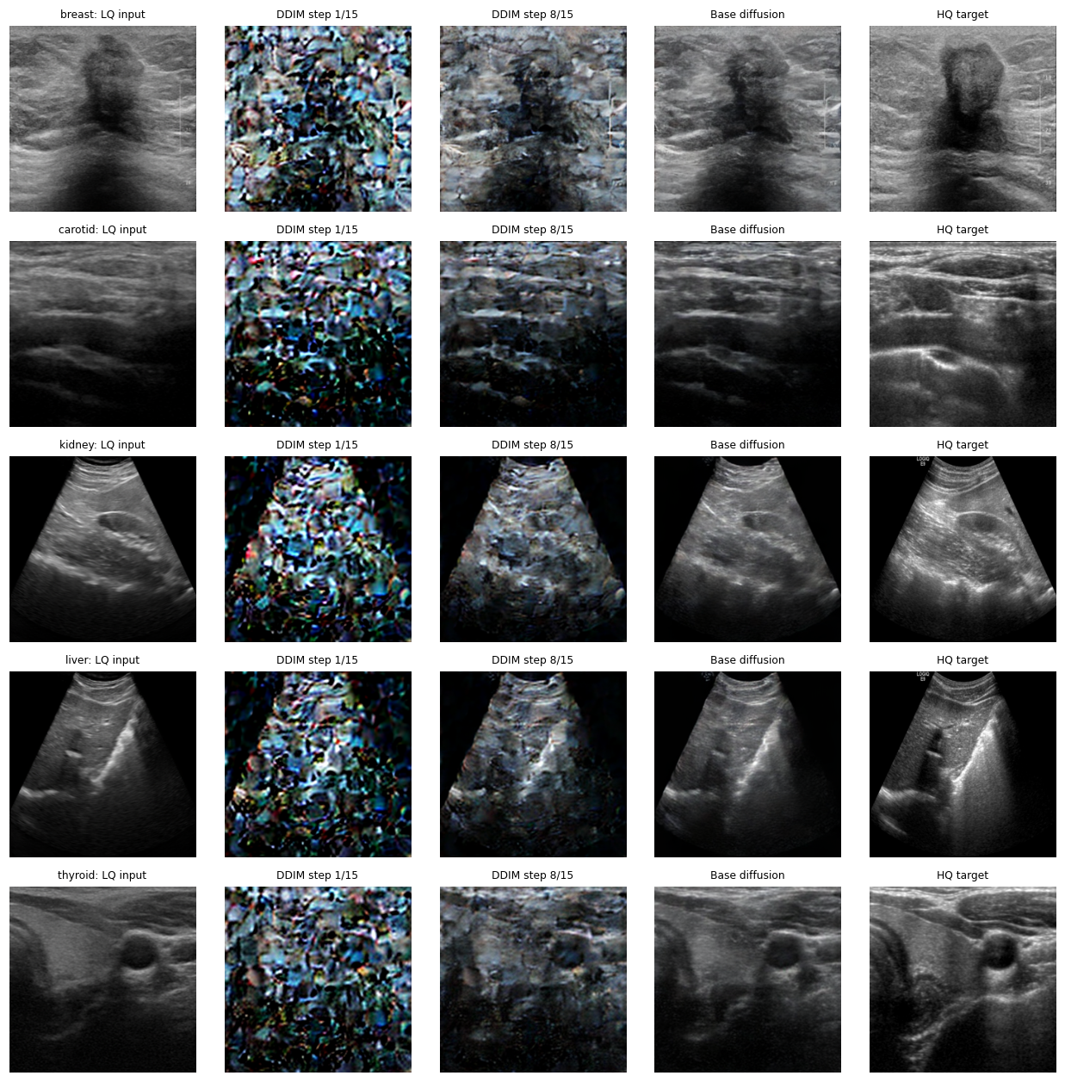
Fig. 3. Denoising trajectory on a held-out image per organ (columns: LQ input, DDIM step 1/15, step 8/15, base diffusion output, HQ target).

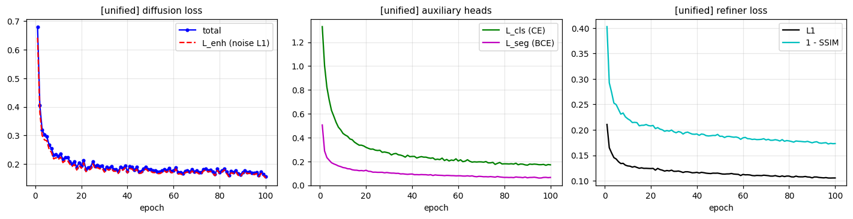
Fig. 4. Training curves of the unified model: denoiser total and noise-prediction loss (left), auxiliary classification and ROI losses (middle), and refiner L1 and (1 − SSIM) terms (right).

V. RESULTS
A. Latent-space ceiling
As Table IV indicates, the frozen autoencoder generates high-quality images with 27.2–29.0 dB PSNR but only 0.63–0.79 SSIM, with breast being the lowest. Since every image generated in the base-diffusion stage is decoded using this VAE, there is a natural round-trip limit on how much this stage can do, especially with respect to structural similarity.
B. Main quantitative results
Table V gives quantitative results for the four stages for each organ. The sole output of the base diffusion output is not yet a good image: its SSIM (0.523 on average) is lower than the input (0.632) for all organs, and its PSNR is within ±1 dB of the input. The refiner is responsible for most of the improvement, bringing PSNR from up from 18.77 dB to 22.10 dB and SSIM from 0.632 to 0.695. Using the ROI gate yeilds further PSNR gains up to 22.71 dB and SSIM up to 0.756 (Fig. 5).
However the refined output is not uniformly better on both metrics to the input: for kidney and liver, PSNR increases (+2.95 dB and +2.09 dB), but SSIM decreases (0.677→0.586 and 0.688→0.592), and not a single held-out kidney or liver image has increased SSIM (Table VI). Moreover, entropy of the refined output of kidney and liver (6.79 and 6.72 bits) is substantially higher than entropy of the high-quality target images (5.44 and 5.41; Table VII); this is likely due to faint textures in the black background, observable in the qualitative results (Fig. 6). ROI gating brings it down significantly (6.18 and 6.11 bits), and raises SSIM to 0.738 and 0.737; hence, it improves SSIM of all five organs and all held-out images (100%, Table VI). This is because the gate simply copies the input pixel in the background, and a good part of the gains of the refiner for kidney and liver is due to background restoration; PSNR of the interior sector interior was not computed separately.
Results on perceptual metrics are somewhat mixed. LPIPS decreases only slightly from 0.272 (input) to 0.277 (refined) and 0.265 (gated), i.e., there is no meaningful improvement. LPIPS improves for 73.5% of images after applying the gate but does not improve any of the breast images (0.273 to 0.361, despite increasing PSNR and SSIM); hence, we do not make claims on perceptual-quality.

TABLE V
HELD-OUT RESULTS PER ORGAN AND PIPELINE STAGE (MEAN OVER IMAGES; BEST IN BOLD)
Organ | n | PSNR (dB) ↑ |  |  |  | SSIM ↑ |  |  |  | LPIPS ↓
 |  | LQ | Base | Refined | +Gate | LQ | Base | Refined | +Gate | LQ | Base | Refined | +Gate
Breast | 24 | 17.27 | 16.86 | 20.04 | 20.03 | 0.6452 | 0.4316 | 0.7525 | 0.7522 | 0.2730 | 0.3201 | 0.3599 | 0.3607
Carotid | 34 | 16.87 | 16.75 | 21.03 | 21.00 | 0.5121 | 0.3988 | 0.7646 | 0.7644 | 0.3295 | 0.3443 | 0.2785 | 0.2948
Kidney | 14 | 20.77 | 21.70 | 23.72 | 25.20 | 0.6773 | 0.6447 | 0.5859 | 0.7377 | 0.2397 | 0.1758 | 0.2484 | 0.2133
Liver | 17 | 21.78 | 22.66 | 23.87 | 25.43 | 0.6876 | 0.6475 | 0.5920 | 0.7371 | 0.2467 | 0.1819 | 0.2575 | 0.2191
Thyroid | 34 | 17.16 | 17.62 | 21.83 | 21.91 | 0.6395 | 0.4925 | 0.7794 | 0.7904 | 0.2719 | 0.2823 | 0.2396 | 0.2357
Average | 123 | 18.77 | 19.12 | 22.10 | 22.71 | 0.6323 | 0.5230 | 0.6949 | 0.7564 | 0.2722 | 0.2609 | 0.2768 | 0.2647

TABLE VI
GAIN OVER THE LQ INPUT AND ROBUSTNESS (REFINED / +GATE)
Organ | n | ΔPSNR (dB) |  | ΔSSIM |  | ΔLPIPS (↓ better) |  | % images SSIM ↑
 |  | Refined | +Gate | Refined | +Gate | Refined | +Gate | Refined | +Gate
Breast | 24 | +2.78 | +2.76 | +0.107 | +0.107 | +0.087 | +0.088 | 100 | 100
Carotid | 34 | +4.16 | +4.13 | +0.253 | +0.252 | −0.051 | −0.035 | 100 | 100
Kidney | 14 | +2.95 | +4.43 | −0.092 | +0.060 | +0.009 | −0.026 | 0 | 100
Liver | 17 | +2.09 | +3.65 | −0.096 | +0.050 | +0.011 | −0.028 | 0 | 100
Thyroid | 34 | +4.67 | +4.75 | +0.140 | +0.151 | −0.032 | −0.036 | 97.1 | 100
Average | 123 | +3.33 | +3.94 | +0.063 | +0.124 | +0.005 | −0.008 | 59.4 | 100

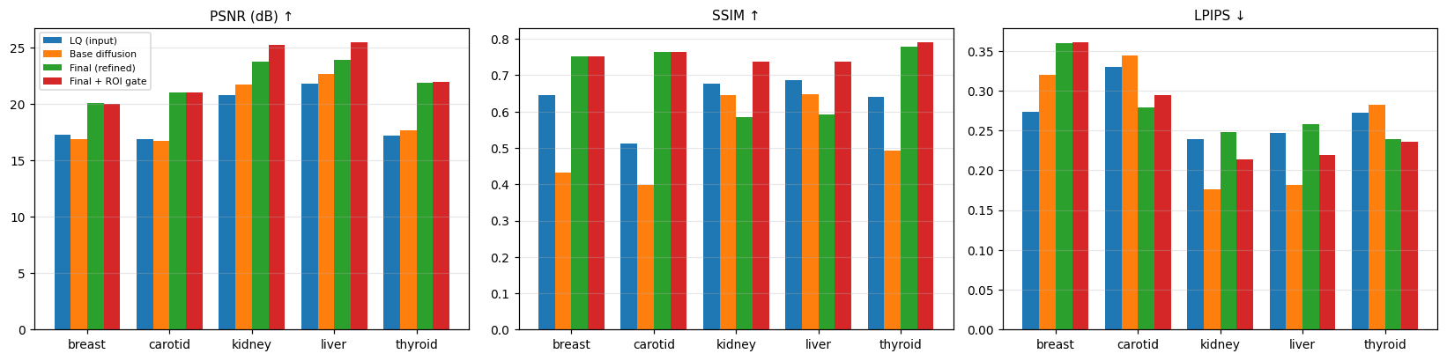
Fig. 5. Per-organ PSNR, SSIM and LPIPS of the four pipeline stages on the held-out images.
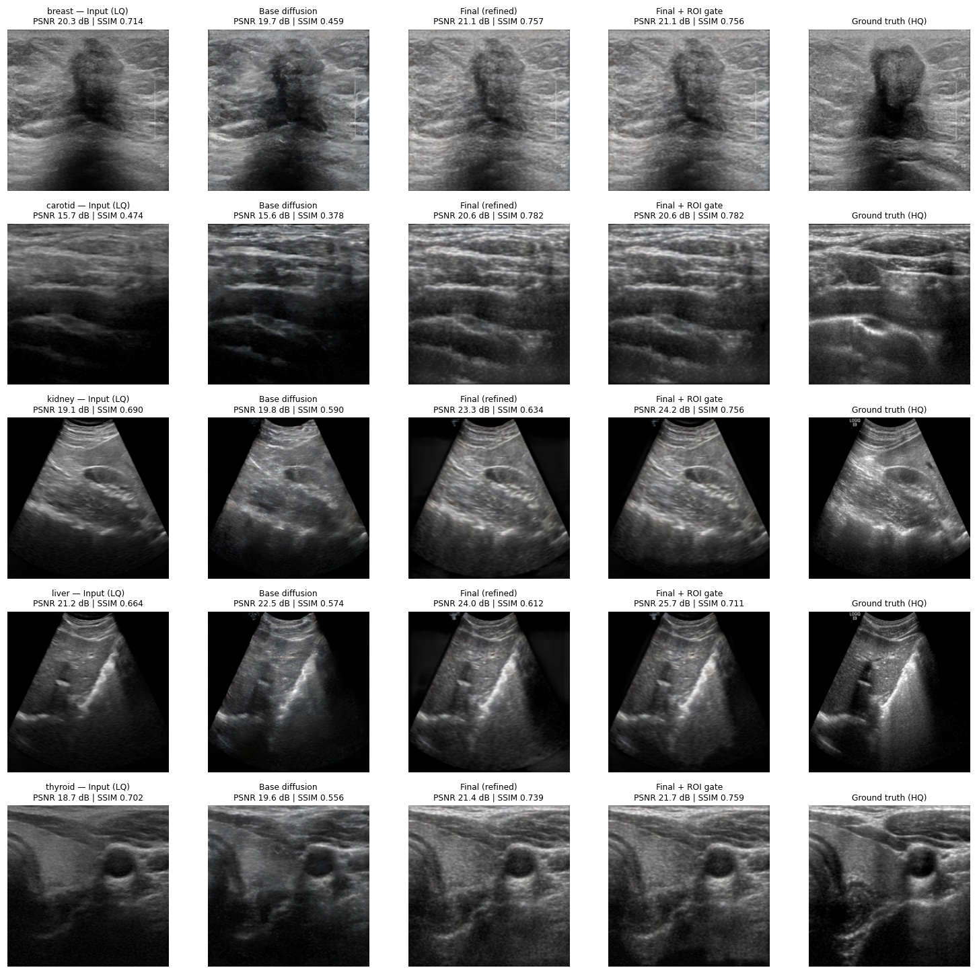
Fig. 6. Qualitative results on one held-out image per organ (rows: breast, carotid, kidney, liver, thyroid). Columns: LQ input, base diffusion, refined, refined + ROI gate, ground-truth HQ, with per-image PSNR/SSIM.

TABLE VII
MEAN GREY-LEVEL ENTROPY (BITS)
Organ | LQ | Base | Refined | +Gate | HQ target
Breast | 7.220 | 7.278 | 7.204 | 7.219 | 7.313
Carotid | 6.439 | 6.543 | 7.162 | 7.237 | 7.290
Kidney | 5.831 | 5.635 | 6.789 | 6.183 | 5.438
Liver | 5.773 | 5.722 | 6.715 | 6.114 | 5.408
Thyroid | 6.726 | 6.899 | 7.272 | 7.295 | 7.312
Average | 6.398 | 6.415 | 7.028 | 6.810 | 6.552

TABLE VIII
SEMANTIC-GUIDANCE ABLATION (REFINED OUTPUT, NO GATE)
Organ | PSNR (dB) |  |  | SSIM
 | True | Zero | Wrong | True | Zero | Wrong
Breast | 20.04 | 19.59 | 19.80 | .7525 | .7362 | .7498
Carotid | 21.03 | 19.84 | 19.89 | .7646 | .7361 | .7543
Kidney | 23.72 | 21.60 | 23.57 | .5859 | .5225 | .5823
Liver | 23.87 | 21.78 | 22.28 | .5920 | .5287 | .5432
Thyroid | 21.83 | 20.58 | 21.28 | .7794 | .7481 | .7637
Average | 22.10 | 20.68 | 21.37 | .6949 | .6543 | .6787

TABLE IX
AUXILIARY TASKS ON HELD-OUT IMAGES
Organ | n | Classification acc. | Dice vs. pseudo-ROI
Breast | 24 | 1.000 | 0.996
Carotid | 34 | 0.971 | 0.965
Kidney | 14 | 0.857 | 0.951
Liver | 17 | 0.882 | 0.935
Thyroid | 34 | 1.000 | 0.966
Overall | 123 | 0.959 | —

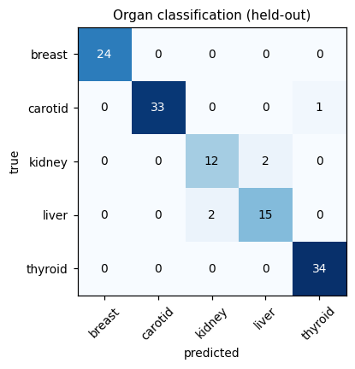
Fig. 7. Organ-classification confusion matrix on the held-out images.
C. Role of the semantic guidance
To validate the importance of the cross-attention conditioning, we re-trained the improved piepline on the held-out images with the backbone tokens set to zeros or those of the images of a different organ (Table VIII). Exclusion of the guidance results in a decrease in mean PSNR from 22.10 to 20.68 dB and mean SSIM from 0.695 to 0.654; wrong-organ guidance decreases them to 21.37 dB and 0.679. The ordering true > wrong-organ > zero is observed for all organs in both metrics, indicating that the denoiser uses organ-specific semantic information instead of a conditioning signal only. The figures are single-run averages without confidence intervals; no estimates for the magnitudes of the differences relative to run-to-run variation calculated.
D. Auxiliary tasks
The classification head trained along with the denoiser, assigns 95.9% of held-out images to the correct organ (Table IX, Fig. 7); among organs, the lowest performance is seen for the kidney (85.7%) and liver (88.2%), the organs having the fewest number of training images. The agreement betwe-en the segmentation head and the pseudo-ROI is very good (Dice 0.94–1.00); however, due to the fact that the target is a binary image, the result indicates learning the field of view rather than anatomy segmentation.
E. Convergence and cost
The total loss of the denoiser decreases from 0.681 at epoch 1 to 0.156 at epoch 100 (from 0.642 to 0.151 for the noise-prediction part; Fig. 4), while the loss of the refiner decreases from 2.22 to 0.97. The training of the unified model took about 2.5 hours in total on a single cloud GPU, of which only 15 minutes is needed for the training of the refiner due to the use of cached triplets.
F. Evaluation on the test partition
The aligned dataset also provides a separate test partition. We evaluated the saved final checkpoints on it without any retraining. It contains 210 low-/high-quality pairs (breast 41, carotid 57, kidney 24, liver 30, thyroid 58), and every image was matched to its high-quality reference by file name. Preprocessing, the four pipeline stages, the sampler seed and the metrics are identical to Section IV. Tables X and XI and Fig. 8 give the results, and Fig. 9 shows examples.
On the test partition the refined output raises mean PSNR from 18.73 dB to 22.15 dB and mean SSIM from 0.643 to 0.700; with the ROI gate the means are 22.64 dB and 0.747 (Table X). The pattern matches the held-out results. The base diffusion output alone does not improve structure: its mean SSIM (0.533) is below that of the input for every organ, and the refiner supplies most of the PSNR gain. For kidney and liver, the refined SSIM again falls (0.689→0.584 and 0.691→0.576) while PSNR rises, and the gate lifts SSIM to 0.737 and 0.730. With the gate, SSIM is above the input’s on all five organs and, averaged over organs, on 98.0% of images; PSNR improves on 94.2% (Table XI).

TABLE X
TEST-PARTITION RESULTS PER ORGAN AND PIPELINE STAGE (MEAN OVER IMAGES; BEST IN BOLD)
Organ | n | PSNR (dB) ↑ |  |  |  | SSIM ↑ |  |  |  | LPIPS ↓
 |  | LQ | Base | Refined | +Gate | LQ | Base | Refined | +Gate | LQ | Base | Refined | +Gate
Breast | 41 | 16.29 | 15.85 | 20.53 | 20.29 | 0.6355 | 0.4253 | 0.7663 | 0.7583 | 0.2601 | 0.3246 | 0.3446 | 0.3521
Carotid | 57 | 16.74 | 16.58 | 21.03 | 21.00 | 0.5433 | 0.4249 | 0.7897 | 0.7348 | 0.3119 | 0.3328 | 0.2680 | 0.2896
Kidney | 24 | 20.73 | 21.61 | 23.48 | 24.59 | 0.6886 | 0.6501 | 0.5839 | 0.7374 | 0.2410 | 0.1732 | 0.2448 | 0.2189
Liver | 30 | 21.93 | 22.49 | 23.42 | 25.02 | 0.6912 | 0.6615 | 0.5762 | 0.7304 | 0.2352 | 0.1756 | 0.2540 | 0.2213
Thyroid | 58 | 17.97 | 18.30 | 22.29 | 22.30 | 0.6569 | 0.5055 | 0.7819 | 0.7728 | 0.2434 | 0.2700 | 0.2250 | 0.2180
Average | 210 | 18.73 | 18.96 | 22.15 | 22.64 | 0.6431 | 0.5334 | 0.6996 | 0.7468 | 0.2583 | 0.2552 | 0.2673 | 0.2600

TABLE XI
TEST-PARTITION GAIN OVER THE LQ INPUT (AVERAGE ROW: UNWEIGHTED MEAN OVER ORGANS)
Organ | n | ΔPSNR (dB) |  | ΔSSIM |  | ΔLPIPS (↓ better) |  | % images improved (+Gate)
 |  | Refined | +Gate | Refined | +Gate | Refined | +Gate | PSNR ↑ | SSIM ↑ | LPIPS ↓
Breast | 41 | +4.24 | +4.00 | +0.1308 | +0.1229 | +0.0845 | +0.0920 | 92.7 | 97.6 | 0
Carotid | 57 | +4.29 | +4.26 | +0.2464 | +0.1915 | −0.0439 | −0.0223 | 98.2 | 100 | 70.2
Kidney | 24 | +2.75 | +3.86 | −0.1047 | +0.0488 | +0.0038 | −0.0221 | 91.7 | 95.8 | 100
Liver | 30 | +1.49 | +3.09 | −0.1150 | +0.0392 | +0.0188 | −0.0139 | 90.0 | 96.7 | 86.7
Thyroid | 58 | +4.32 | +4.33 | +0.1250 | +0.1159 | −0.0184 | −0.0254 | 98.3 | 100 | 79.3
Average | 210 | +3.42 | +3.91 | +0.0565 | +0.1036 | +0.0090 | +0.0016 | 94.2 | 98.0 | 67.2

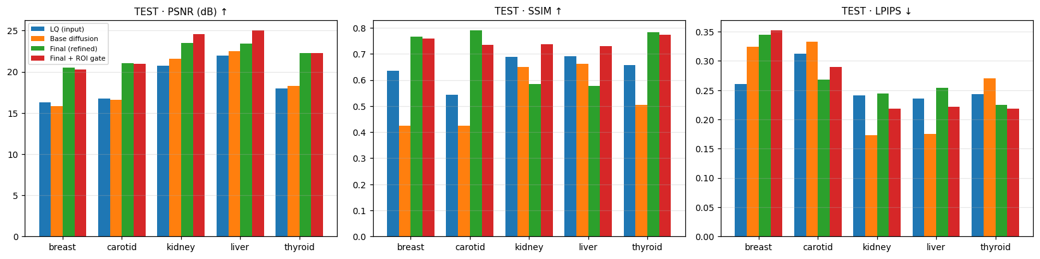
Fig. 8. Per-organ PSNR, SSIM and LPIPS of the four pipeline stages on the test partition.
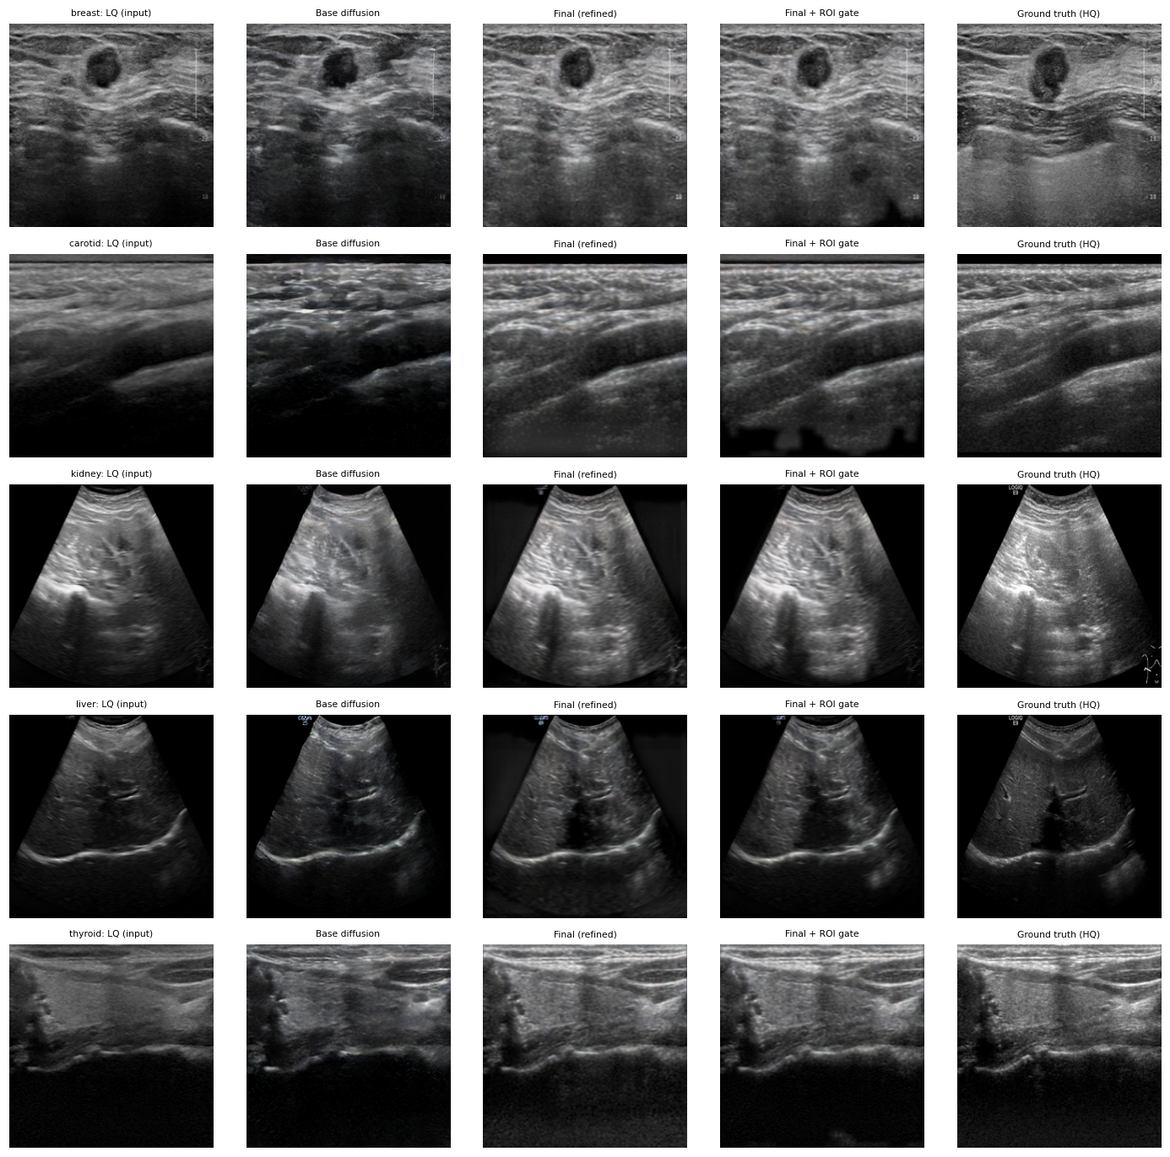
Fig. 9. Qualitative results on one test image per organ (rows: breast, carotid, kidney, liver, thyroid). Columns: LQ input, base diffusion, refined, refined + ROI gate, ground-truth HQ.

Two results differ from the held-out split. First, the gate is no longer neutral for the organs imaged over the full frame: relative to the refined output it lowers SSIM for carotid (0.790→0.735), breast (0.766→0.758) and thyroid (0.782→0.773), whereas on the held-out images it was neutral or slightly positive for these organs (Table V). In the breast and carotid examples of Fig. 9 the gated output contains dark patches in the lower part of the image; we did not investigate whether imperfect masks are the cause. Second, the perceptual picture is again mixed: mean LPIPS is 0.258 for the input, 0.267 refined and 0.260 gated, and with the gate it worsens for breast (0.260→0.352, improving on none of the breast images) while improving for the other four organs. We therefore still do not claim a perceptual gain. The entropy of the refined kidney and liver outputs (6.84 and 6.70 bits) again exceeds that of the high-quality targets (5.43 and 5.27 bits) and the gate reduces it (6.07 and 5.92 bits), consistent with the background-texture explanation given above.
The auxiliary heads generalise less well than the enhancer. Organ classification reaches 91.9% overall on the test images (Table XII, Fig. 10), against 95.9% on the held-out split. Kidney is weakest (70.8%; 7 of 24 images predicted as liver), followed by carotid (91.2%; 5 predicted as thyroid) and thyroid (93.1%; 4 predicted as carotid). Agreement of the segmentation head with the pseudo-ROI drops to 0.65–0.95 (held-out: 0.94–1.00), lowest for liver (0.650) and kidney (0.680), the sector-shaped organs on which the gate is most useful.
TABLE XII
AUXILIARY TASKS ON THE TEST PARTITION
Organ | n | Classification acc. | Dice vs. pseudo-ROI
Breast | 41 | 1.000 | 0.949
Carotid | 57 | 0.912 | 0.869
Kidney | 24 | 0.708 | 0.680
Liver | 30 | 0.967 | 0.650
Thyroid | 58 | 0.931 | 0.836
Overall | 210 | 0.919 | —

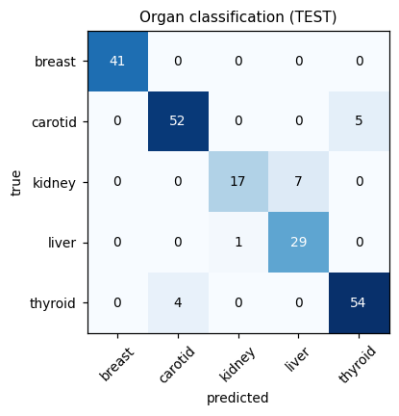
Fig. 10. Organ-classification confusion matrix on the test partition.
Overall, the enhancement gains on the test partition are close to the held-out ones (refined: +3.4 dB PSNR and +0.057 SSIM against +3.3 dB and +0.063; gated: +3.9 dB and +0.104 against +3.9 dB and +0.124). The same caveats apply: one training run, one seed, 24–58 images per organ, an image-level split in which patient overlap between partitions cannot be excluded, and no external dataset.
VI. DISCUSSION AND LIMITATIONS
What the results support. On held-out images of five organs, the unified pipeline improves mean PSNR by 3.3 dB (3.9 dB with the gate) and mean SSIM by 0.06 (0.12 with the gate), the semantic guidance contributes measurably, and a single frozen-backbone model can classify organs with high accuracy while enhancing them. On the separate 210-image test partition the enhancement gains are similar (mean PSNR +3.4 dB, +3.9 dB with the gate; SSIM +0.06 and +0.10), whereas organ-classification accuracy (91.9%) and mask agreement are lower than on the held-out split.
What they do not support. (i) The gate drives the kidney/liver SSIM result. Without it, kidney and liver SSIM decrease; on the test partition the gate in turn lowers SSIM for carotid, breast and thyroid (Section V-F). (ii) No perceptual gain is shown: LPIPS is unchanged on average and worse for breast. (iii) The base diffusion stage does not by itself improve structure; it is bounded by the VAE round trip (Table IV) and relies on the refiner, a point we attribute to the latent bottleneck but have not isolated experimentally. (iv) Not a foundation-model result: the backbone is ImageNet-21k-initialised, so claims about ultrasound-specific pretraining do not apply; using the official USFM weights is an obvious next step. (v) Evaluation scope: the split is image-level; if several images of one patient fall on both sides, results may be optimistic, and patient-level splitting was not performed. The held-out and test sets are small (14–34 and 24–58 images per organ), a single seed was used, and no external dataset was evaluated. (vi) No benchmark comparison: we did not re-implement or run US-Net, DiffusionClusNet or other published methods, so no superiority claim is made. (vii) Weak supervision: the ROI head is trained on a heuristic mask. (viii) Clinical validity: PSNR, SSIM and LPIPS are proxies; no reader study or downstream-diagnosis experiment was performed, and the system must be regarded as a research prototype.
Two implementation choices deserve emphasis. First, disabling latent clipping and training the refiner on the sampler’s own outputs are consistency fixes motivated by analysis of the pipeline; we did not ablate each separately. Second, the unified refiner, which has no organ input, may favour the texture statistics of the more numerous organs; per-organ refiners or an organ-conditioned refiner are natural extensions that reuse the trained denoiser.
VII. CONCLUSION
We presented a multi-organ ultrasound enhancement framework that conditions a latent diffusion denoiser on frozen ViT-B/16 tokens through cross-attention, adds organ-classification and ROI heads, and finishes with a residual pixel refiner and an optional ROI gate. On held-out and separate test data from five organs it improves PSNR and SSIM over the low-quality input, with the semantic guidance providing a measurable benefit, while perceptual gains remain unproven and the improvement for sector-shaped organs depends on the ROI gate. Future work includes ultrasound-pretrained USFM weights, patient-level splits and external validation, shifted-window attention in the denoiser, clinically annotated masks, organ-conditioned refinement, perceptual-quality improvements, a disease-prediction head on enhanced images, and a web application for point-of-care use.
REFERENCES
[1] P. Monkam, W. Lu, S. Jin, W. Shan, J. Wu, X. Zhou, B. Tang, H. Zhao, H. Zhang, X. Ding, H. Chen, and L. Su, "US-Net: A lightweight network for simultaneous speckle suppression and texture enhancement in ultrasound images," Comput. Biol. Med., vol. 152, Art. no. 106385, 2023.
[2] M. Moinuddin, S. Khan, A. U. Alsaggaf, M. J. Abdulaal, U. M. Al-Saggaf, and J. C. Ye, "Medical ultrasound image speckle reduction and resolution enhancement using texture compensated multi-resolution convolution neural network," Front. Physiol., vol. 13, Art. no. 961571, 2022, doi: 10.3389/fphys.2022.961571.
[3] Y. Yu and S. T. Acton, "Speckle reducing anisotropic diffusion," IEEE Trans. Image Process., vol. 11, no. 11, pp. 1260–1270, Nov. 2002.
[4] J.-Y. Zhu, T. Park, P. Isola, and A. A. Efros, "Unpaired image-to-image translation using cycle-consistent adversarial networks," in Proc. IEEE Int. Conf. Comput. Vis. (ICCV), 2017, pp. 2223–2232.
[5] J. Ho, A. Jain, and P. Abbeel, "Denoising diffusion probabilistic models," in Proc. Adv. Neural Inf. Process. Syst. (NeurIPS), vol. 33, 2020, pp. 6840–6851.
[6] R. Rombach, A. Blattmann, D. Lorenz, P. Esser, and B. Ommer, "High-resolution image synthesis with latent diffusion models," in Proc. IEEE/CVF Conf. Comput. Vis. Pattern Recognit. (CVPR), 2022, pp. 10684–10695.
[7] N. Chen, Y. Zhang, C. Fan, W. Zhao, C. Wang, and H. Wang, "DiffusionClusNet: Deep clustering-driven diffusion models for ultrasound image enhancement," IEEE Trans. Consum. Electron., vol. 71, no. 1, 2025, doi: 10.1109/TCE.2025.3540502.
[8] J. Jiao, J. Zhou, X. Li, M. Xia, Y. Huang, L. Huang, N. Wang, X. Zhang, S. Zhou, Y. Wang, and Y. Guo, "USFM: A universal ultrasound foundation model generalized to tasks and organs towards label efficient image analysis," Med. Image Anal., vol. 96, Art. no. 103202, 2024, doi: 10.1016/j.media.2024.103202.
[9] O. Ronneberger, P. Fischer, and T. Brox, "U-Net: Convolutional networks for biomedical image segmentation," in Proc. Med. Image Comput. Comput.-Assist. Interv. (MICCAI), 2015, pp. 234–241.
[10] J. Song, C. Meng, and S. Ermon, "Denoising diffusion implicit models," in Proc. Int. Conf. Learn. Represent. (ICLR), 2021.
[11] C. Meng, Y. He, Y. Song, J. Song, J. Wu, J.-Y. Zhu, and S. Ermon, "SDEdit: Guided image synthesis and editing with stochastic differential equations," in Proc. Int. Conf. Learn. Represent. (ICLR), 2022.
[12] A. Dosovitskiy et al., "An image is worth 16×16 words: Transformers for image recognition at scale," in Proc. Int. Conf. Learn. Represent. (ICLR), 2021.
[13] "Ultrasound image enhancement challenge 2023 (USenhance 2023)," Grand Challenge. [Online]. Available: https://ultrasoundenhance2023.grand-challenge.org/
[14] "USenhance2023_Aligned dataset," Hugging Face. [Online]. Available: https://huggingface.co/datasets/Jason0411202/USenhance2023_Aligned
[15] "stabilityai/sd-vae-ft-mse," Hugging Face model card. [Online]. Available: https://huggingface.co/stabilityai/sd-vae-ft-mse
[16] D. P. Kingma and M. Welling, "Auto-encoding variational Bayes," in Proc. Int. Conf. Learn. Represent. (ICLR), 2014.
[17] R. Wightman, "PyTorch image models," GitHub repository, 2019, doi: 10.5281/zenodo.4414861.
[18] A. Steiner, A. Kolesnikov, X. Zhai, R. Wightman, J. Uszkoreit, and L. Beyer, "How to train your ViT? Data, augmentation, and regularization in vision transformers," Trans. Mach. Learn. Res., 2022.
[19] Z. Liu, Y. Lin, Y. Cao, H. Hu, Y. Wei, Z. Zhang, S. Lin, and B. Guo, "Swin Transformer: Hierarchical vision transformer using shifted windows," in Proc. IEEE/CVF Int. Conf. Comput. Vis. (ICCV), 2021, pp. 10012–10022.
[20] I. Loshchilov and F. Hutter, "Decoupled weight decay regularization," in Proc. Int. Conf. Learn. Represent. (ICLR), 2019.
[21] P. Micikevicius et al., "Mixed precision training," in Proc. Int. Conf. Learn. Represent. (ICLR), 2018.
[22] Z. Wang, A. C. Bovik, H. R. Sheikh, and E. P. Simoncelli, "Image quality assessment: From error visibility to structural similarity," IEEE Trans. Image Process., vol. 13, no. 4, pp. 600–612, Apr. 2004.
[23] R. Zhang, P. Isola, A. A. Efros, E. Shechtman, and O. Wang, "The unreasonable effectiveness of deep features as a perceptual metric," in Proc. IEEE/CVF Conf. Comput. Vis. Pattern Recognit. (CVPR), 2018, pp. 586–595.

