**Sunstate Equipment Information Management System**



Group 1

1552749 刘书良

1552780 顾沛益

1552661 王一同

Instructor 黄杰

2018/6/23

Contents

[1、Background of the Project 4](#_Toc517794168)

[1.1 Critical issue to resolve 4](#_Toc517794169)

[1.2 Scope management 4](#_Toc517794170)

[1.3 Stakeholders and resources 4](#_Toc517794171)

[2、Objectives of the Project 5](#_Toc517794172)

[2.1 Development objectives 5](#_Toc517794173)

[2.1.1 Social objectives 6](#_Toc517794174)

[2.1.2 Economic objects 7](#_Toc517794175)

[2.2 Immediate objectives 8](#_Toc517794176)

[2.2.1 Improvement of work efficiency 8](#_Toc517794177)

[2.2.2 The improvement of customer satisfaction 9](#_Toc517794178)

[2.2.3 The reduction of human error 9](#_Toc517794179)

[2.2.4 The improvement of enterprise image 10](#_Toc517794180)

[2.2.5 More profits 10](#_Toc517794181)

[2.2.6 Service extension 10](#_Toc517794182)

[2.2.7 Experience application 10](#_Toc517794183)

[2.2.8 The introduction of new technology and knowledge 11](#_Toc517794184)

[3、Expected results of the Project 11](#_Toc517794185)

[3.1 The overall results 11](#_Toc517794186)

[3.1.1 Functional requirements 11](#_Toc517794187)

[3.1.2 Functional component description 17](#_Toc517794188)

[3.1.3 Characteristics of software 17](#_Toc517794189)

[3.2 Challenges 18](#_Toc517794190)

[3.2.1 Market risks 18](#_Toc517794191)

[3.2.2 Delay risk 19](#_Toc517794192)

[3.2.3 Requirements change 19](#_Toc517794193)

[3.2.4 Technical backwardness risk 20](#_Toc517794194)

[3.2.5 Management risk 20](#_Toc517794195)

[3.2.6 Natural disaster risk 21](#_Toc517794196)

[3.2.7 Political risk 21](#_Toc517794197)

[3.3 Response plan 22](#_Toc517794198)

[3.3.1 Market risk solutions 22](#_Toc517794199)

[3.3.2 Delay risk solutions 23](#_Toc517794200)

[3.3.3 Requirements change solutions 24](#_Toc517794201)

[3.3.4 Technical backwardness risk solutions 25](#_Toc517794202)

[3.3.5 Management risk solutions 25](#_Toc517794203)

[3.3.6 Natural disasters risk solutions 26](#_Toc517794204)

[3.3.7 Political risk solutions 26](#_Toc517794205)

[3.4 Quantitative project results 26](#_Toc517794206)

[4、PROJECT IMPLEMENTATION & MANAGEMENT PLAN 27](#_Toc517794207)

[4．1 Project activities and work plan 27](#_Toc517794208)

[4．2 Project Beneficiaries 32](#_Toc517794209)

[4．3 Implementing team management of project 35](#_Toc517794210)

[4.3.1 Main roles of the project 35](#_Toc517794211)

[4.3.2 Effective coordination arrangements 35](#_Toc517794212)

[4．4 Project Life cycle model 41](#_Toc517794213)

[4．5 Project monitoring & Quality control 41](#_Toc517794214)

[4.5.1 Reasons that we monitor the project 42](#_Toc517794215)

[4.5.2 Mechanisms and procedures for monitoring 42](#_Toc517794216)

[4.5.3 Monitor objects 43](#_Toc517794217)

[4.5.4 Levels of monitoring 44](#_Toc517794218)

[5、Software Measurement and Improvement 45](#_Toc517794219)

[5.1 Software Measurement 45](#_Toc517794220)

[5.2 Measurement-driven Improvement 46](#_Toc517794221)

[5.3 Process-driven Improvement 48](#_Toc517794222)

[5.3.1 SPI framework 48](#_Toc517794223)

[5.3.2 Maturity Model 49](#_Toc517794224)

[5.3.3 The Implement of CMM 50](#_Toc517794225)

[5.3.4 SPI Return on Investment 52](#_Toc517794226)

[6、Budget 53](#_Toc517794227)

[6.1 Work plan budget 53](#_Toc517794228)

[6.2 Estimate cost 54](#_Toc517794229)

[6.3 Budget source 54](#_Toc517794230)

[7、 Financial Evaluation 55](#_Toc517794231)

[7.1 12 Months Profit and Loss Projection 55](#_Toc517794232)

[7.2 Four Years Profit and Loss Projection 55](#_Toc517794233)

[7.3 12 Months Cash Flow WorkSheet 56](#_Toc517794234)

[7.5 Break-Even Analysis 58](#_Toc517794235)

[7.6 Price Strategy 60](#_Toc517794236)

[Reference 61](#_Toc517794237)

# 1、Background of the Project

## 1.1 Critical issue to resolve

Since 1977, Sunstate Equipment (https://www.sunstateequip.com/) has provided construction, industrial, and special event companies with rental tools and equipment. Their reliable service and dedication have helped clients get their job done efficiently and safely.

Renting a full line of quality, well-maintained equipment, from hand tools to heavy equipment, they have continued to grow from their Arizona home base. With the trend for users to outsource their equipment needs, the company has successfully competed against the changing face of its competitors for over four decades. Currently, the company has locations in California, Nevada, Utah, Colorado, Arizona, New Mexico, Oklahoma and Texas.

Due to the exponential expending of the business, the current manual operations to create customer information (records), to update equipment inventory data, to assign jobs to trucks/drivers, and to update job statuses can no longer meet the daily business demands. The management of the company realizes that it is necessary to build a web-based dispatching system to conduct their dispatching operations more effectively.

## 1.2 Scope management

In this project, we provide a web-based dispatching system for Sunstate Equipment. The system should be able to provide real time information on customers’ needs, the inventory and the availability of the equipment, the available suitable trucks and drivers to perform either pickup or delivery tasks.

## 1.3 Stakeholders and resources

This project has many beneficiaries and stakeholders, such as customers who rental equipment, truck drivers, dispatchers, Sunstate Equipment managers, software developers and so on.

In addition, stakeholders and other organizations will provide the following resources: equipment, infrastructure, human resources, finance and so on.

# 2、Objectives of the Project

## 2.1 Development objectives

The equipment leasing and financing Association (ELFA), representing $1 trillion in equipment financing, announced the ten major purchasing trends of equipment in 2017. Considering that American companies, non-profit organizations and government departments will spend more than 1 trillion and 500 billion dollars this year to buy means of production or make fixed business investments (including software), most of these assets are financing, and these trends have a great impact on the US economy. With the changing economic and regulatory environment helping to improve the business environment, enterprises will find a positive driving force for investment in equipment.

ELFA president and CEO Ralph Petta said, “Equipment procurement continues to drive the supply chain of manufacturing and service industries in the United States. Equipment leasing provides funds for most American businesses to obtain the productive assets they need for their development and operation. We are pleased to provide ten major equipment procurement trends every year to help enterprises understand the market and formulate their purchasing strategies.”

ELFA refer to recent survey data, including equipment leasing and financing fund's equipment leasing and financing in 2017, US economic outlook, the professional views of the industry participants and the views of the members of the ELFA meeting, to sort out ten major trends. The project responds to the trend of the US leasing industry in the following ways：

### 2.1.1 Social objectives

The following are the social objectives of the project and how this project helps to achieve these social goals:

•A stable employment rate and an increase in income：

After negative growth in the US leasing industry in 2016, equipment and software investment will improve in 2017. Stable employment rate, revenue growth and higher business confidence will drive a new round of enthusiasm for owners' capital investment.

This project provides many employment opportunities not only for Sunstate Equipment, including equipment dispatchers, system maintainers, system developers, system testers, etc, but also for society including truck drivers. As customers' outsourced demand for their equipment grows, the demand for this project increases. This project requires more human resources to maintain the normal operation of the system, so the more opportunities are provided to society. Therefore, more people are willing to join the industry, ensuring a stable employment rate, as well as increasing the income of truck drivers, system developers and others.

•Increase the flexibility and convenience of the customer：

Increasing the convenience and flexibility of the leasing process can lead to more investment. And electronic transaction is the rising trend of equipment leasing industry.。

The project is a scheduling system based on WEB. So it is easy to use and has extensible external interfaces. Customers and truck drivers can accomplish their own needs through smart phones, increasing their flexibility and convenience.

•Stable supply of equipment：

When considering equipment leasing decisions, most enterprises will be aware of potential "universal cards". Although there are many favorable factors for equipment leasing, American enterprises will pay close attention to many aspects of development. The influence of geopolitical transformation such as Britain falls out of the EU and other groups against the free market international order may have devastating effects on finance, politics and even military affairs. Therefore, most enterprises will carefully consider enterprises that can provide stable leasing equipment.

The project will provide a stable supply of equipment. The project will expand its business to the whole of the United States in the future, and have equipment warehouses in various market areas to provide equipment for all types of enterprises.

### 2.1.2 Economic objects

The following are the economic objectives of the project and how this project helps to achieve these economic goals:

•Help the growth of other industries：

Many key equipment industries will benefit from the positive driving force of the project, which is good news for many previously underperforming equipment industries. The project will not only have a positive impact on investment in oil and mining, but also have a positive impact on railway, material handling and industrial equipment. Increased personal consumption and infrastructure spending will stimulate the growth of Sunstate Equipment. Meanwhile, the Sunstate Equipment's excellent equipment will stimulate the development of other infrastructure industries.

•The growth of leasing equipment business is more than that of equipment purchase：

Due to the increase in tenancy tendency, the growth of equipment and software purchases this year will lag behind the growth of equipment leasing. More companies choose to lease equipment, and market data show that equipment leasing and leasing industry is coming out of a slow growth period, pointing to higher investment.

The project provides different kinds of equipment for different companies, including airborne equipment, air compressors, concrete equipment, dirty equipment and so on. Customers can rent a full line of quality, well-maintained equipment, from hand tools to heavy equipment. Sunstate Equipment faces different industries and different companies who encourages more companies to rent equipment instead of buying equipment at higher price.。

•More business：

A commercial friendly federal policy will support business investment and economic growth. The new Trump administration and Congress pledged infrastructure spending, tax relief, and reduced regulatory burdens and other restrictions, which will further lead enterprises to invest in capital investment. These fiscal and regulatory policies will be conducive to the U.S. economy moderately strong growth, also helps equipment and software investment slightly higher growth.

This project adapted to the financial and regulatory policies of the US Congress, and stimulated the development of the infrastructure industry. Sunstate Equipment will obtain more business which can stimulate the development of economy of the U.S.

## 2.2 Immediate objectives

In the short term, the successful operation of the project can also create wealth for the stakeholders and achieve the goals they want. These goals include increased income, increased efficiency and the social and international impact of Sunstate Equipment.

### 2.2.1 Improvement of work efficiency

Through this project, Sunstate Equipment can accomplish daily affairs through the software system. After handling different types of information, each truck driver can get the latest data. The truck driver can download his timetable, check his route and finish his work through smart phone. The whole process is simple and fast, which greatly improves the efficiency of truck drivers.

For dispatchers, they can query the equipment inventory data of the system, the availability of equipment required for the identification and update the inventory data. At the same time, the dispatcher can inquire the contract information, create the scheduling operation, and update the completion status of the driver according to the driver's work. The system greatly improves the efficiency of dispatchers, and the staff can accomplish the above complex tasks only by performing simple operations at the WEB end.

For financial managers, financial data can be obtained from the new system, including rental income and related costs, especially artificial costs, traffic costs, warehousing costs, etc. Financial managers can make statistics at department level or contract level. It improves the efficiency of financial work and shortens the time of calculation and statistics.

### 2.2.2 The improvement of customer satisfaction

The system enables customers to view their contract information at any time. By doing so, customers can arrange the receiving plan according to the delivery status of the goods. Information system makes the whole distribution process transparent, and the whole rental process is convenient and quick, which is conducive to improving customer satisfaction.

### 2.2.3 The reduction of human error

Sunstate Equipment is a large leasing company. With the increase of demand, business data will also become larger and larger. If the company manages data in an inflexible way, it will cause great danger to the entire company and the dispatching system. By using this system, the company can reduce more human errors, such as computation or record loss.

### 2.2.4 The improvement of enterprise image

The system can help Sunstate Equipment improve its corporate image greatly and help to expand its business to the United States and even the world to gain more business opportunities because of the convenient and fast leasing process, the perfect system, and the stability of the excellent equipment.

### 2.2.5 More profits

The system reduces the operation cost of Sunstate Equipment, including human resources, equipment maintenance resources and so on. At the same time, through these recent goals, we can greatly expand the company's business and bring more profits.

### 2.2.6 Service extension

The system greatly improves the efficiency of leasing process and reduces the cost of the company. So companies can expand their businesses to other areas with savings. A web-based renting service system will not increase the cost due to regional differences, and the system will provide more stable services for more areas, so that the company will get more business opportunities.

### 2.2.7 Experience application

The system can make complex workflow more efficient and concise. Therefore, the operation and maintenance experience of the system can be applied to other departments, such as the personnel department. Sunstate Equipment can also use the WEB based personnel management system to manage staff scheduling, salary and other issues. The experience of the system applied to other departments can also improve the efficiency of other departments and reduce the cost of work.

### 2.2.8 The introduction of new technology and knowledge

The system is based on the WEB side, and it also needs to expand the business to smart phones. Therefore, the requirements for system developers and system operators are high. The use of the system will introduce new WEB technology and knowledge for the company, and help the employees to understand and grasp the new technology and knowledge. In this way, staffs can adapt to the technology and operation of the Internet more quickly in the future work.

# 3、Expected results of the Project

## 3.1 The overall results

When this project is completed, it will include seven functional components, including login in, contract creation, inventory management, business data inquiry, job assignment , financial statistics and report. These functional components will implement the services required by the company.

### 3.1.1 Functional requirements

After the end of the project development cycle, a web-based dispatching system shall be able to provide real time information on customers’ needs, the inventory and the availability of the equipment, the available suitable trucks and drivers to perform either pickup or delivery tasks. According to the business needs of scheduling operations, a complete scheduling system will achieve the following functions:

•Allows a counter person to enter the information for a customer to create a contract record in the database on condition that a customer has an account in the dispatching system. The contract record includes the contact person’s name, the street address, city name, zip code, state. The contract information also contains the data on required equipment, the length of rental, the date and time to get the required equipment. Sometimes the contract is actually to return a piece of equipment.

•Allows a dispatcher to query the equipment inventory data, i.e., identify the availability of required equipment, update the inventory data. For instance, when a specific piece of equipment is rented from a specific location, the number of available pieces of that equipment at that location shall be reduced correspondingly. Sunstate owns several locations where equipment can be stored in southwest US marketing place.

•Allows the dispatcher to query contract information in order to create dispatching jobs.

•Allows the dispatcher to assign a job (to deliver a piece of equipment or to pick up a piece of equipment) to a proper available truck/driver. A truck to deliver or pick up a piece of equipment must have the capability of carrying this equipment. When a truck/driver is assigned with a job, the availability of the truck/driver will be updated to “busy”.

•Allows the dispatcher to update the job completion status upon driver’s commitments and update truck/driver availability properly.

•Allows the registered customer to inquiry the information of previous contracts in recent 3 years.

•Allow the financial manager to get the financial figures from the new system, these figures include rental income and relevant cost esp. labor costs, traffic costs, warehousing costs etc., and to do statistics in department level or in contract level.

•Allow the general manager to get the reports about the transaction, revenue, costs and net income from the different depots in every week.

Here is a list of function points.

|  |  |  |  |  |
| --- | --- | --- | --- | --- |
| **ILF (internal logic file)** | **RET (record element type)** | **DET (data element type)** | **complexity** | **FP** |
| **contract information** | 11 | 5 | low | 9 |
| **finicial information** | 6 | 6 | low | 4 |

|  |  |  |  |  |
| --- | --- | --- | --- | --- |
| **EIF (external interface file)** | **RET (record element type)** | **DET (data element type)** | **complexity** | **FP** |
| **driver information** | 2 | 4 | low | 2 |
| **counter information** | 1 | 4 | low | 1 |

|  |  |  |  |  |
| --- | --- | --- | --- | --- |
| **EO (external output)** | **FTR (file type referenced)** | **DET (data element type)** | **complexity** | **FP** |
| **query contract information** | counter,driver,contract | 18 | high | 19 |
| **query finicial information** | counter,driver,contract | 14 | high | 16 |

|  |  |  |  |  |
| --- | --- | --- | --- | --- |
| **EI (external input)** | **FTR (file type referenced)** | **DET (data element type)** | **complexity** | **FP** |
| **add contract information** | counter,driver,contract | 16 | high | 5 |
| **remove contract information** | counter,driver,contract | 16 | high | 6 |
| **update contract information** | counter,driver,contract | 16 | high | 5 |
| **add finicial information** | counter,driver,contract | 12 | high | 6 |
| **remove finicial information** | counter,driver,contract | 12 | high | 4 |
| **update finicial information** | counter,driver,contract | 12 | high | 2 |

|  |  |  |  |  |
| --- | --- | --- | --- | --- |
| **EQ (external inquery)** | **FTR (file type referenced)** | **DET (data element type)** | **complexity** | **FP** |
| **financial review** | counter, contract | 14 | high | 10 |

| **Component** | **Functional description** |
| --- | --- |
| sign up | sign up for a customer |
| login | |  |  | | --- | --- | | customer | log in as customer | | counter | log in as counter | |  |  | |  |  | | driver | log in as driver | | manager | log in as manager | |
| contract creation | creating contract information for future dispatching jobs |
| contract review | review the contract information |
| contract update | update contract for some reasons |
| contract delete | remove mistake contract |
| equipment check | check the equipment base information |
| equipment inventory check | check how many equipments are in the inventory and check which inventory they are in |
| equipment number automaticly management | equipment number changes with the contract and job update |
| job assignment | assigning job (pickup or delivery) to a proper truck/driver,updating truck/driver’s status, updating job status |
| drvier state check | check what the drivers’ states are.(busy idle working) |
| business data inquiry | identifying equipment availability and new contract for adispatching job |
| divers state management | counters can update the drivers’ state |
| contract review for customer | allow the customer to review his own contract in the past three years |
| financial statistics | doing statistics about business and financial status |
| report | generating reports about business and financial issues |

### 3.1.2 Functional component description

When the scheduling system is completed, it is expected to contain the following functional components.

|  |  |
| --- | --- |
| **Component** | **Functional Description** |
| Log in | Validating users and assigning proper privilege |
| Contract creation | Creating contract information for future dispatching jobs |
| Inventory management | Creating and updating equipment inventory data |
| Business data inquiry | Identifying equipment availability and new contract for a  dispatching job |
| Job assignment | Assigning job (pickup or delivery) to a proper truck/driver,  updating truck/driver’s status, updating job status |
| Financial statistics | Doing statistics about business and financial status. |
| Report | Generating reports about business and financial issues. |

### 3.1.3 Characteristics of software

Compared with other systems, the functional component of the project has the following characteristics:

•Running on an internet-based environment

•Web service based application

•Having a centralized database

•Having authentication functionality

•Scalable and extendable, e.g. extend Mobile APP

•Reasonable external interface, e.g. add new interface for PayPal

•User-friendly UI and easy to use

•The driver should be able to download his working schedule, see the routes, and commit the work when he is done via his smart phone

## 3.2 Challenges

The project may encounter many risks and challenges, including the following categories:

### 3.2.1 Market risks

From a market perspective, the decline of the rental market will cause huge losses to the project. The system is mainly for the convenience of the Sunstate Equipment’s leasing service, and when the leasing industry is slump, the system will become useless.

According to the environment generated by leasing risk, it can be divided into static risk and dynamic risk. Static risk, also known as pure risk, refers to the risk that only loss is possible and no profit opportunity exists. Such risks can not be avoided under any social and political or economic conditions. Dynamic risk refers to both the possibility of loss and the risk of profit. Identifying different types of market risks is the first step in leasing risk management.

•Exchange rate risk refers to the possibility that the exchange rate of currencies between countries may lead to economic losses in a certain international trade. It occurs mainly in multinational leasing or leasing business. Exchange rate risk includes commercial risk and financing risk.

Commercial risk refers to the exchange rate risk taken by importers and exporters in import and export trade. It usually takes 3 months or longer for leasing business from sign lease contract to payment for equipment. In this period, the exchange rate of settlement currency changes, although the price of contract is unchanged.

•Interest rate risk is the loss caused by the fluctuation of interest rate to the borrowers. In today's international financial market, floating interest rates are widely used, and interest rates vary with the changes in the supply and demand of funds in the financial market. Most of the loans made by leasing companies from international financial markets are small and short-term.

The main factor affecting rent in leasing business is the interest rate except the price of the leased goods. For example, in the leasing business, leasehold companies use floating interest rates from overseas loans and leases. For the lessee, if the interest rate is on the rise, the rent paid by the lessee will increase. If the lessee has a fixed interest rate to the lessor in order to facilitate the control of the total investment and financial budget of the project, the Lessor will take the risk of increasing interest rates.

•Tax risk refers to the adverse effects arising from changes in tax provisions or tax rates. In the leasing business, the income tax will be reduced if the business tax and additional or income tax are increased. In addition, the increase in import leasehold duties or the tax increase of the lessee will also have adverse effects on the economic performance of the lessee, so that the rent repayment will be difficult.

### 3.2.2 Delay risk

In the process of project development, there may be needs, personnel changes, and various kinds of risks to be solved, so it is impossible to guarantee the project to complete the corresponding work according to the time node. Delays in development progress are not impossible. Due to various uncertainties, schedule delays will occur at any time, so the project development team must be prepared to deal with this risk.

### 3.2.3 Requirements change

There are many ways of changing requirements, such as boss changes ideas temporarily, increasing or decreasing project budgets, and changing requirements of customers. In IT projects, changes may come from the project service providers, customers or product suppliers, and may also come from within the project group. Although the manifestations of requirements change vary widely, there are no more than the following reasons:

•The scope without delineation begins to refine:

Refinement is done by the demand analyst. Refinement is generally refined on the basis of the descriptive and summary words proposed by the user to extract one of the functions and describe (the description of the normal execution and the description of the accident). When the system is designed to a certain extent, the scope will change, and the description of the detail use case may have many changes.

•No baseline for specified requirements:

The baseline of demand refers to whether or not the boundary line of demand change is allowed. Along with the progress of the project, the baseline of demand is changing. Whether the change is allowed based on the contract and the impact on the cost, such as the overall structure of the software will not change because of the change the scope of the requirement.

### 3.2.4 Technical backwardness risk

In the process of software project development and construction, strategic management technology factor is a very important factor. The project team must choose the appropriate and mature technology in accordance with the actual requirements of the project. Do not ignore the actual situation of the project and choose some technology which is advanced but not necessary and unfamiliar with the project. If the technical items required by the project are not available or insufficient, the risk factors need to be focused.

### 3.2.5 Management risk

Management risk refers to the effect that enterprises fail to achieve the desired result because of defects or mistakes in management and management activities. For lessors, management risk is reflected in internal management. Management risks include there is no scientific assessment of the feasibility of leasing projects or scheduling operations, business decision error, risk control has not been standardized, failure to comply with the purchase contract and the lease contract and so on. On the other hand, it is manifested in the external business environment, such as the failure of the lessee to pay the rent, resulting in the loss of the lessor.

For the lessee, business risk may occur in both internal management and external environment. The management risk in the internal management of enterprises is characterized by imperfect internal control system and ineffective execution, and lack of effective means of operation. In the external business environment, the prices of raw materials, auxiliary materials, power, transportation and other prices are rising or insufficient, the price of products or services is declining, the demand is poor, and the supplier or the lessor defaults, these risks will adversely affect the economic performance of the lessee.

### 3.2.6 Natural disaster risk

The risk of natural disasters refers to the adverse effects of fire, lightning, storm, tornado, torrential rain, flood, tsunami, earthquake, snowstorm, avalanche, hail and debris flow on the production and management of enterprises. It belongs to pure risk. Once these disasters occur, it will impede the transportation, installation and use of leases, affect the production and operation of the lessee, and thus affect the performance of the lease contract.

### 3.2.7 Political risk

Political risk refers to the political environment of the normal operating activities of the lessor and the lessee, as well as the changes in the government's policies, laws and regulations, and the possibility of economic losses. There are three types of political risks:

1．The risk of ownership is different from the definition and approval of the local authorities on the ownership of the leased property, which leads to the legal risk of the lessor's recovery of the lease in order to recover the loss.

2. The risk of identifying the nature of the leasing industry by regulatory authorities.

3．The risk of enterprise operation is the risk brought by the government's intervention in the production and operation of enterprises. In addition, labor risks, disturbances, coups, ethnic conflicts, wars and policy changes will also lead to political risks.

## 3.3 Response plan

For the many challenges and risks listed in 3.2, there are several ways to solve them.

### 3.3.1 Market risk solutions

From a market perspective, the main risks come from exchange rate, interest rate and tax.

•The solution of tax risk:

Generally speaking, tax policy can embody the orientation of macroeconomic policy. Therefore, the parties concerned with the leasing business should analyze the current situation of the country's macro-economy, the current situation and the trend of the industry, take measures to avoid the adverse effects caused by the change of tax policy. In order to remedy the loss of its own tax risk, leasing companies in the United States generally adds a change in the tax rate to the lease contract.

•The solution of interest rate risk:

For the lessor of the leasing business, the interest rate risk mainly appears in the fund-raising stage. Therefore, the borrower's choice of borrowing interest rate is extremely important. The generally available loan interest rates are interbank lending rate, commercial bank preferential interest rate, export credit interest rate, mixed loan interest rate, government loan interest rate, international financial organization loan interest rate and so on. The lessor should strive for lower interest rate as much as possible. Or we can just ignore it because the company cannot control the interest rate.

•The solution of exchange rate risk：

In order to avoid losses caused by exchange rate risk, the following measures should be taken:

1．Correctly choose the currency used in the transaction. Exports should be priced in a currency that tends to appreciate (or hard currency), and imports should strive to use a devalued currency (or soft currency), or two currencies at the same time.

2．The method of transfer and liquidation is adopted. The method of transfer and liquidation refers to the agreement between the parties of the transaction. In a certain period of time, the economic exchanges between the two sides are priced in the same currency, and the amount of each transaction is only allocated on the books to be liquidated to the specified time limit. In this way, most of the volume of bilateral transactions can be exchanged with each other to avoid losses caused by exchange rate fluctuations.

3．Use the way of swap. It means selling or buying forward foreign exchange while buying or selling spot foreign currency.

4．Use of foreign exchange protection clause. That is to say, the exchange rate will be fixed on the date of signing the contract, and the exchange rate will still be used when the actual payment is made.

5．Use forward foreign exchange transactions, foreign exchange futures trading and foreign exchange options trading to maintain value.

### 3.3.2 Delay risk solutions

Develop detailed and milestones for product delivery. We should deliver products in stages, increase the frequency and intensity of project monitoring, and apply more feasible methods to ensure the quality of work and avoid rework. In the time progress management of project implementation, we should take full account of various potential factors and make room for them. The task decomposition should be detailed and easy to be examined. In the execution process, we should emphasize the important items that the project carries out according to the schedule, and when considering any problems, we should keep the progress as a prerequisite.

Moderately pessimistic on schedule, moderately optimistic in project implementation, pessimistic and not negative, optimism is not careless. The blind increase of personnel in the project may result in half the effort, so there is an optimal combination between the three tasks, manpower and time, which deserves the attention of the project leader. It should be avoided: a person in one aspect is not in place, or in the case of a number of projects, a person in a certain aspect is drawn to other projects, or more than one project, or in other projects that can not be put into the project.

In the formulation of the plan, the total progress target and the progress target of the project must be determined. In the whole process of project progress, we compare the schedule with the actual progress, find the deviation in time, take timely measures to correct or prevent, and coordinate the progress relationship among the participants.

### 3.3.3 Requirements change solutions

The way to prevent this risk is the need for teamwork and close collaboration among team members. We should carefully distribute the work of team members when we need analysis. The requirements analysis phase of the team is carried out according to the typical matrix structure in project management. This structure can project the effective utilization of resources and reduce conflict compartmentalized, increase communication and coordination opportunities, reduce the cost of implementation of the project, can give full play to the enthusiasm of the project manager and a group of personnel, and by using some incentive mechanism, ensure the project members have full sense of responsibility and sense of achievement.

Effectively curb changes in requirements. Software requirement change is the biggest enemy of software project development and implementation, and may occur at all stages of software project. The later the requirement changes, the greater harm will be done to the project. So software requirement change control runs through all stages of software implementation.

### 3.3.4 Technical backwardness risk solutions

The way to prevent this risk is to select the technology necessary for the project. Before the application of technology, carry out technical training for relevant personnel. First of all, do a good job of technical review at all stages. Ensure the feasibility of the technology adopted by the project and the correctness of the technical solution through collective wisdom. Secondly, we should be cautious about the use of new technologies. Step by step, try to adopt mature technology solutions to complete software development. Thirdly, balance between technological innovation and technological risks, and do research and experiment on innovative technology. The various technologies used in the software project need to be evaluated.

### 3.3.5 Management risk solutions

First, the asset liability ratio management of leasing companies should set up monitoring indicators. For example, total capital should not be less than 10% of total venture assets. The financing balance of the same lessee (that is, lease and loan) shall not exceed 15% of the total capital of the financial leasing company. The working capital loan provided to the lessee shall not exceed 60% of the amount of the lease contract. The total amount of long-term investments (excluding long-term treasury bonds and policy financial bond investments) shall not exceed 30% of the total capital. The proportion of leased assets (including entrusted leasing and transferring leased assets) shall not be less than 60% of the total assets.

Second, financial leasing companies should establish corresponding monitoring indicators for their business operations. Financial leasing companies should establish and improve the internal control system. The company should establish a regular audit system, and the board of directors or the board of supervisors should entrust a qualified accounting firm at the beginning of the year to conduct an audit of the company's operating activities for the last year.

### 3.3.6 Natural disasters risk solutions

The lessee should first do a good job of prevention. In case of natural disasters, rescue should be carried out immediately to minimize losses. In addition, the lessor or lessee must choose different risks according to the actual situation. The uncertain loss of the leased property is converted into a fixed insurance cost, and the insurance premium can be included in the lessee's cost or the person's rent. In case of natural calamities or accidents, the lessor may claim compensation from the insurance company on the basis of the insurance accident manual provided by the lessee.

### 3.3.7 Political risk solutions

The political risk should be based on prevention. In the international financial leasing business, we should fully understand the social system, policies, laws and regulations, labor relations, ethnic issues, political situations, and the political parties in the countries where the parties are located so as to avoid cooperation with the leasehold objects of the unstable countries, such as political situation and policy.

## 3.4 Quantitative project results

1.Completion of the project from 2018.4 to 2018.8

2.Control the cost within the expected scale of ¥82,000,000 within 4 years

3.Make net profit of ¥120,000,000(After taxes) within 4 years

4.The number of contracts reached 7000 in one year

5.Extension of the company's business to the United States in two years

# 4、PROJECT IMPLEMENTATION & MANAGEMENT PLAN

## 4．1 Project activities and work plan

To have a better organization and presentation of our project activities and work plan, we use Microsoft Project Professional to manage and monitor them.

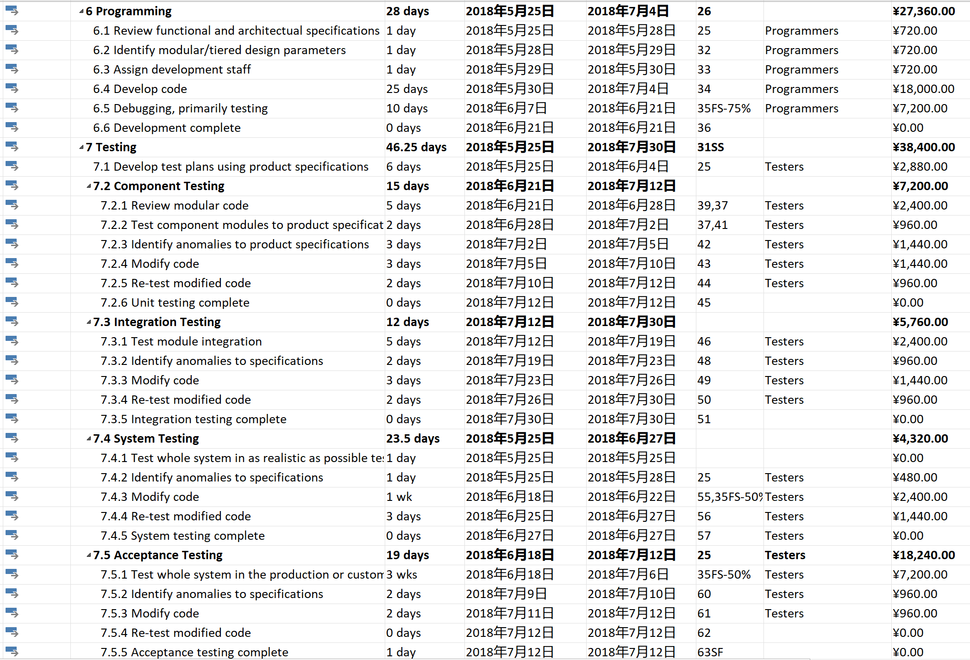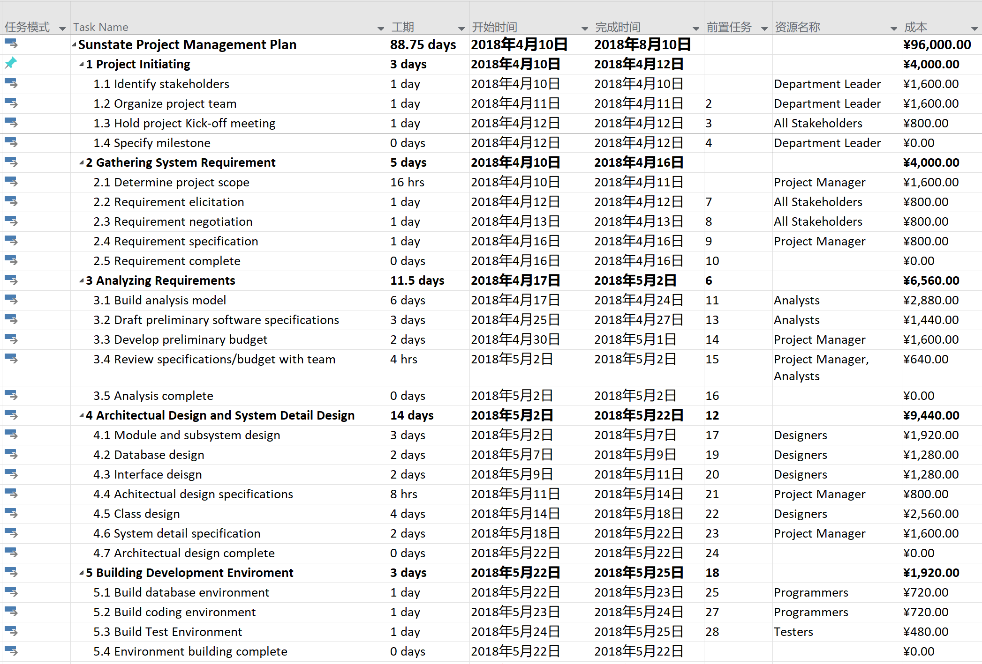For detailed information of the whole activities and plan, we have a task schedule chart which shows all of the arrangement and management.

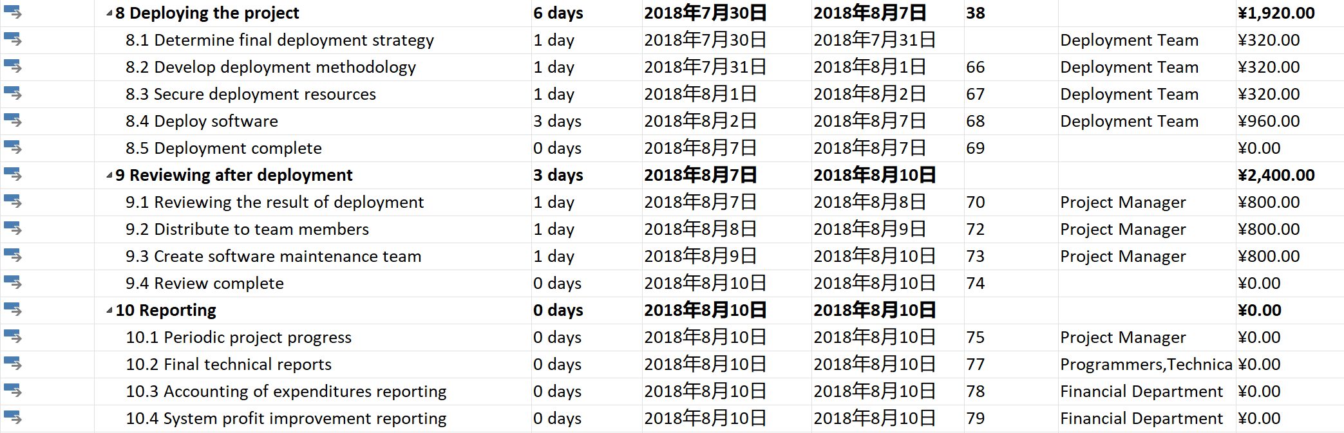

And to provide a more detailed activities schedule information and resources distribution, we draw some Gantt charts. A Gantt chart lists the tasks to be performed on the vertical axis, and time intervals on the horizontal axis. The width of the horizontal bars in the graph show the duration of each activity. Gantt charts illustrate the start and finish dates of the terminal elements and summary elements of our project. Terminal elements and summary elements constitute the work breakdown structure of the project.

First of all, considering the limited resources allocation in the whole development process, we draw a normal Gantt chart to show the resources distribution of every activities in different period of the development of the project.

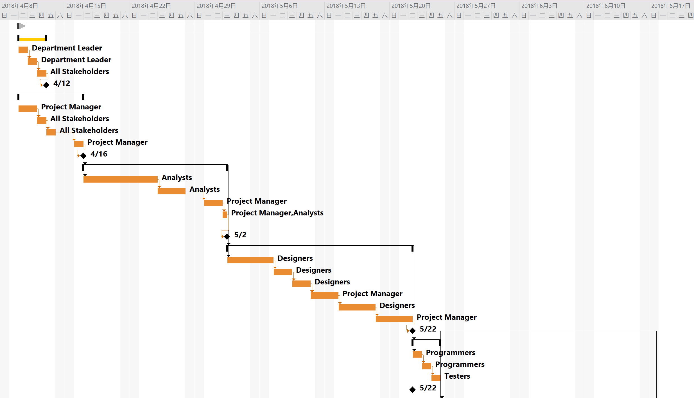

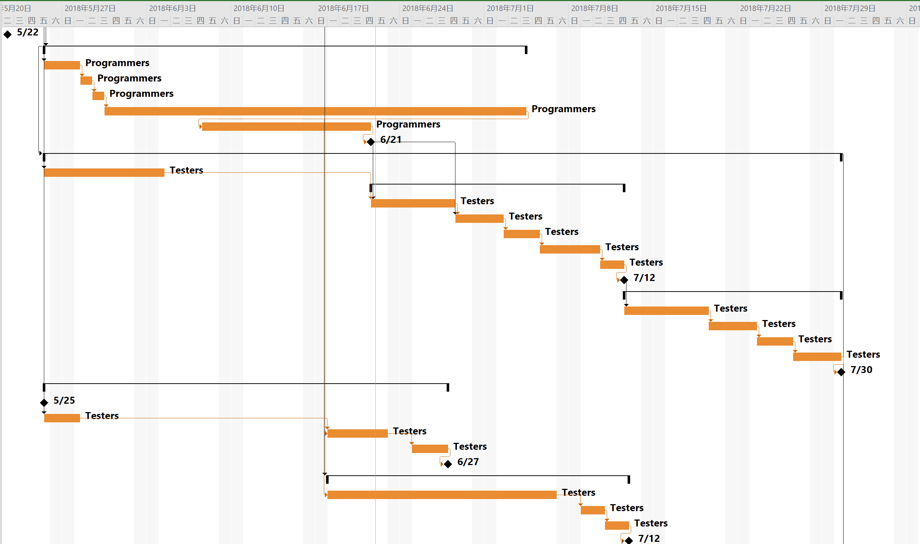

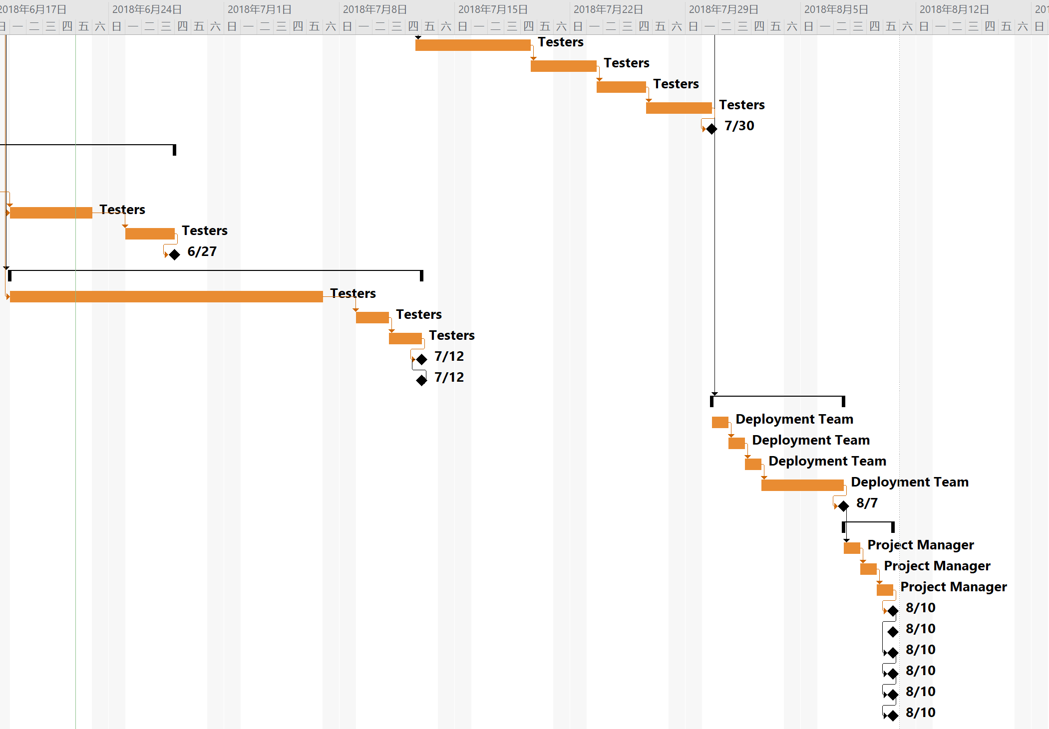

And then we draw a detailed Gantt chart to show the time consumption and detailed plan of every activities, which provides a clear and efficient way to check out the process of the project.

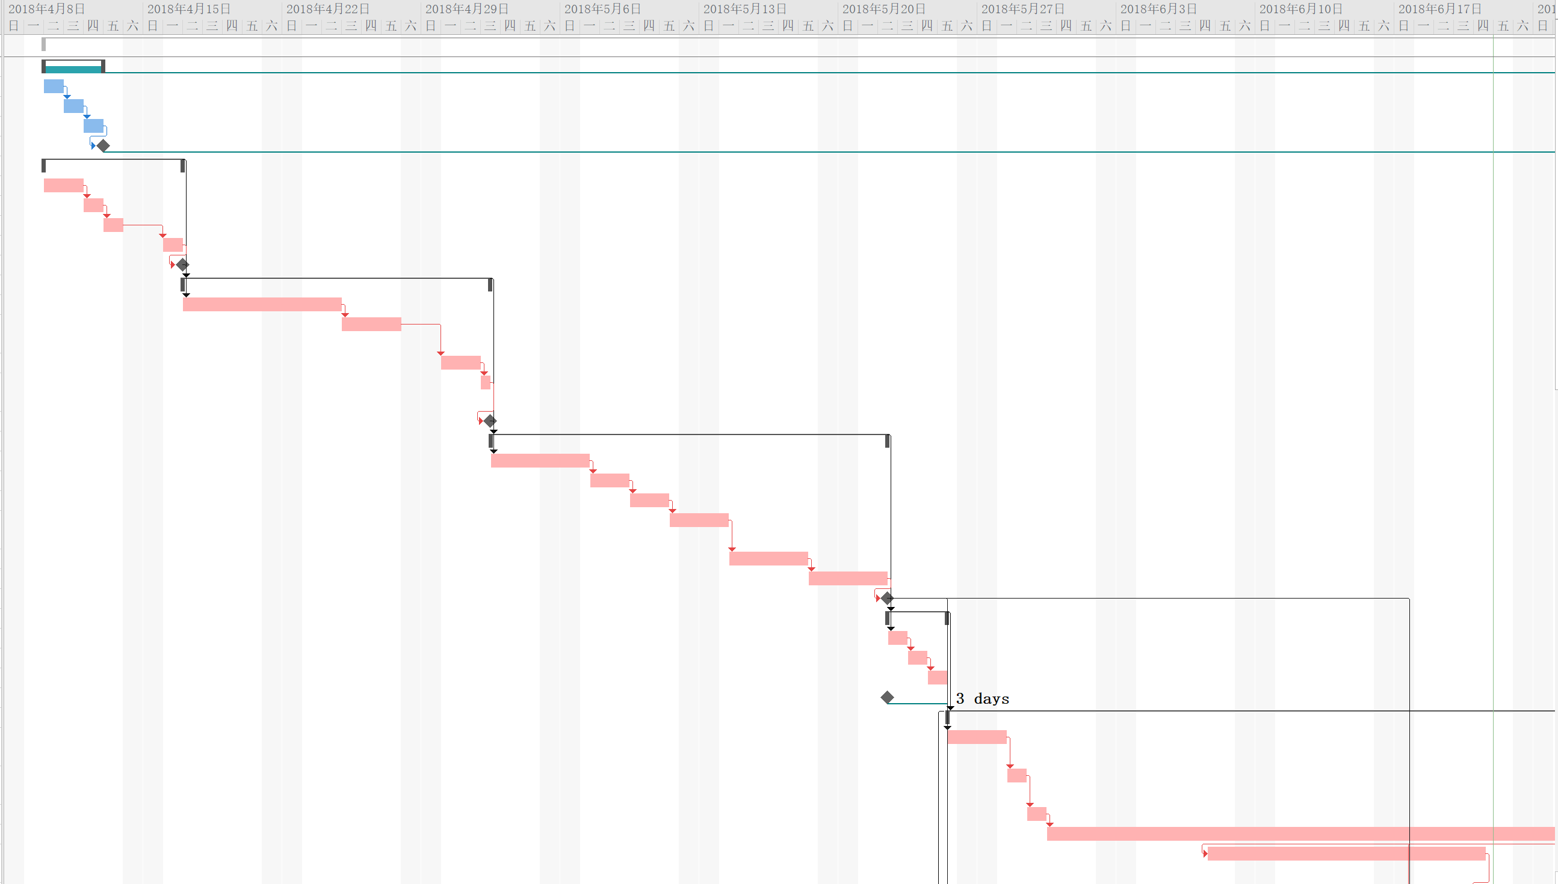

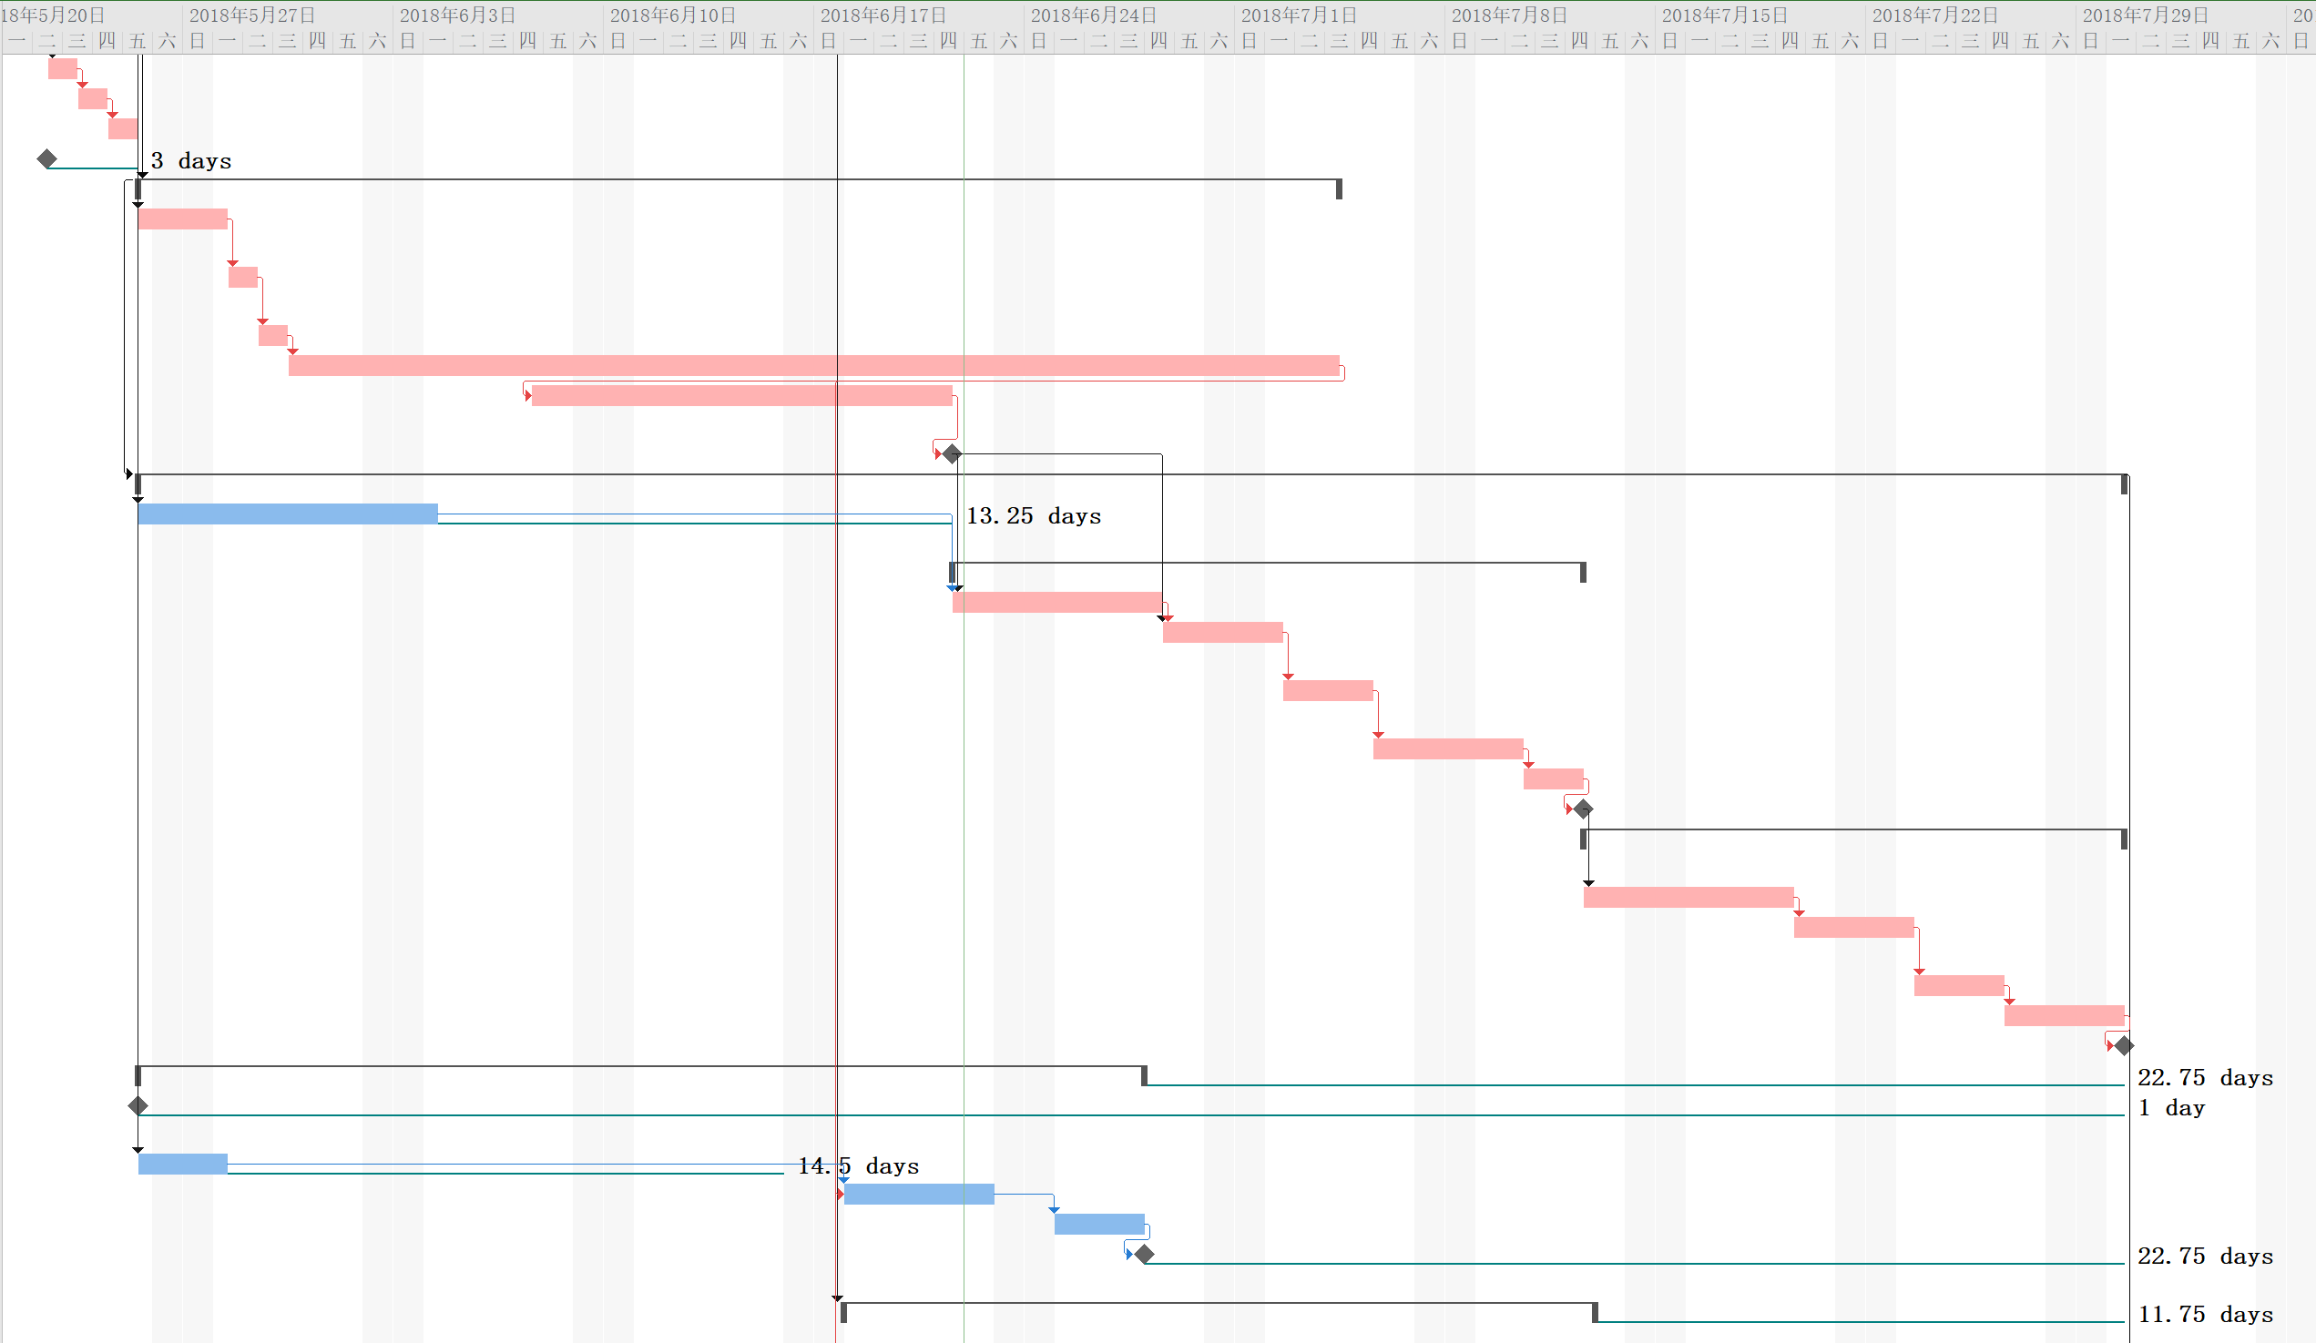

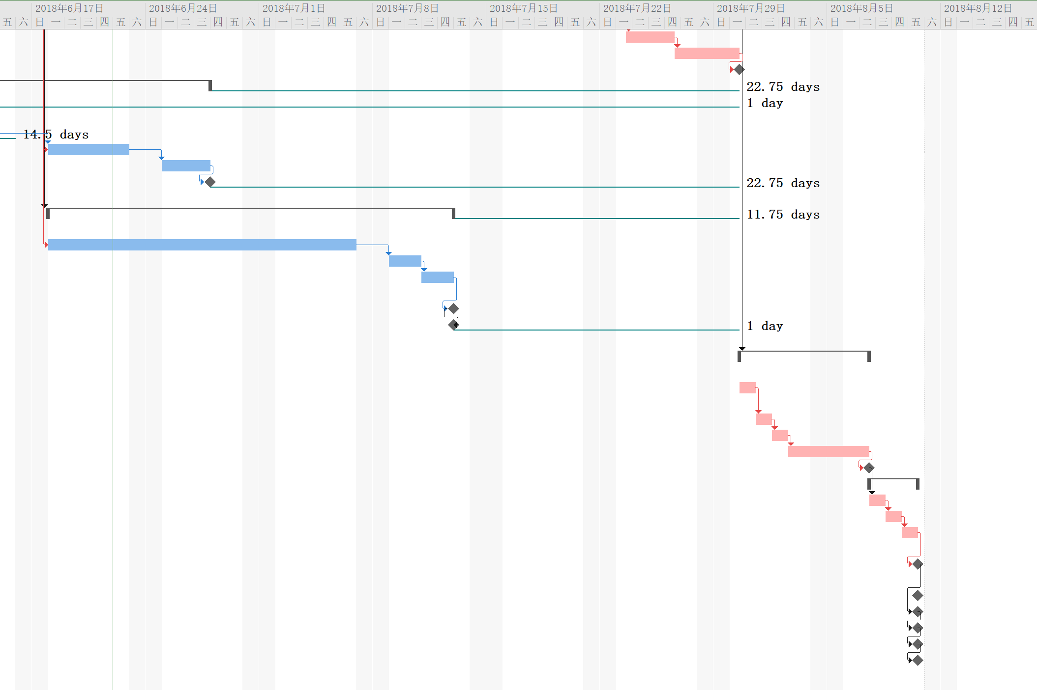

Finally, we draw a following Gantt chart to show every time section’s focus, which represents an activity in the above schedule chart.

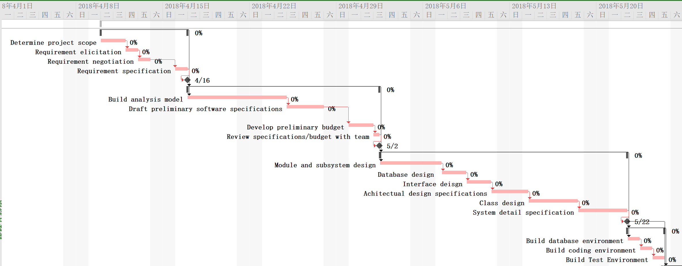

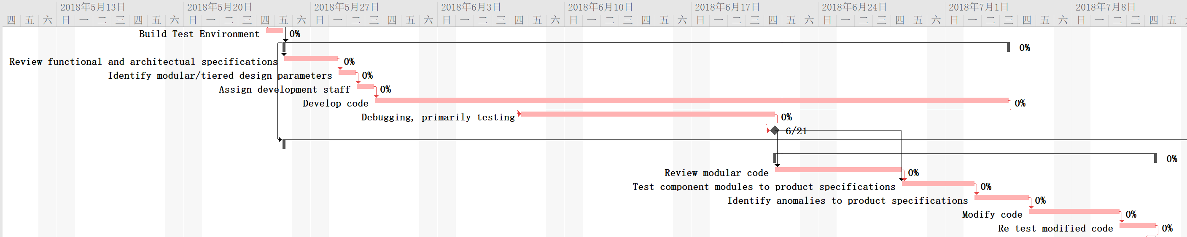

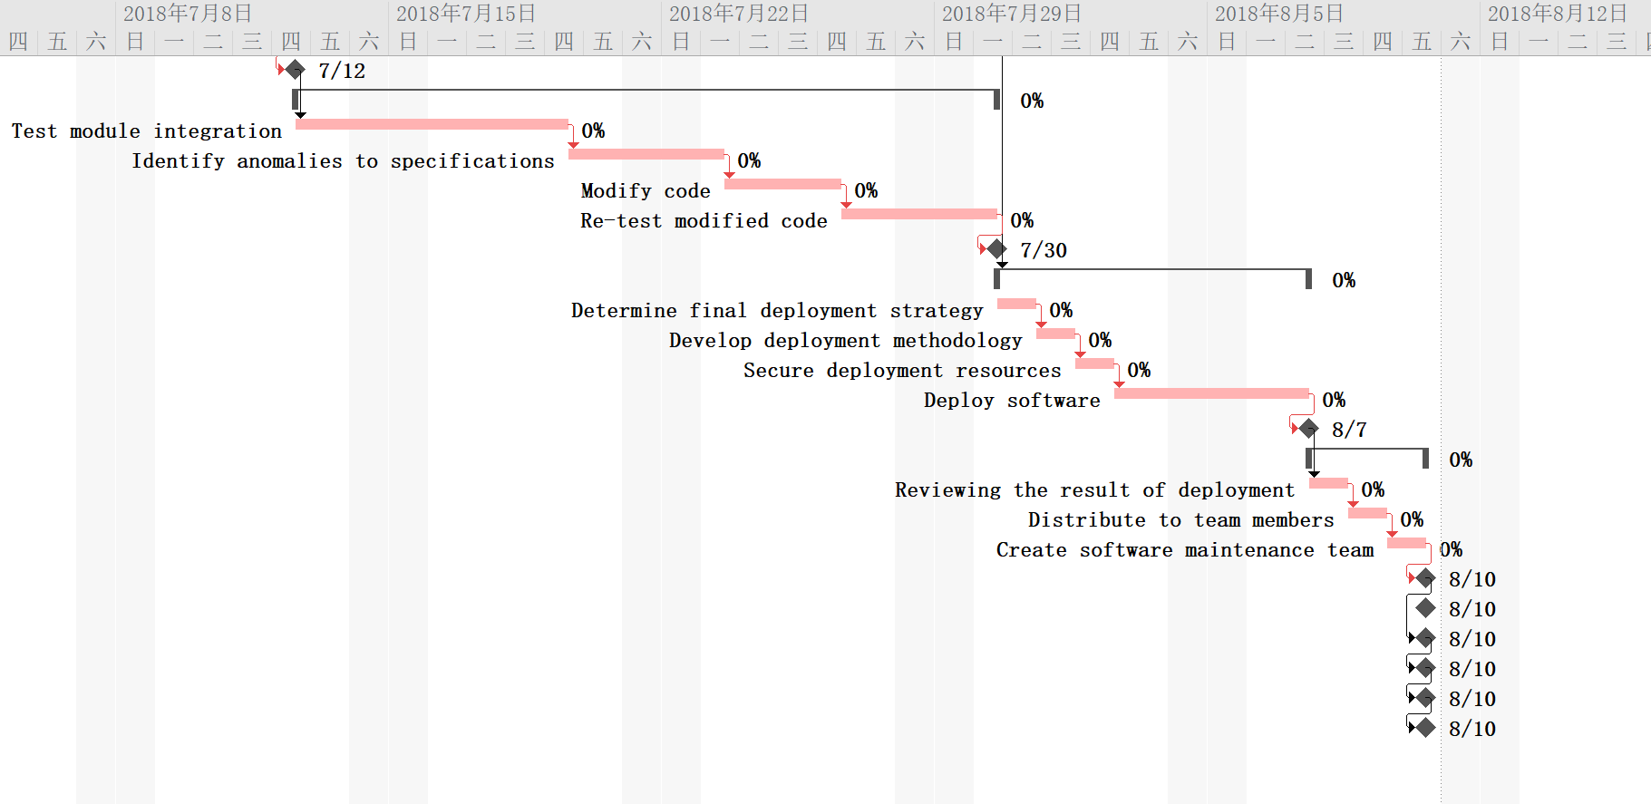

To see more detailed information, please check [Sunstate Project Management Plan.mpp](Sunstate%20Project%20Management%20Plan.mpp).

## 4．2 Project Beneficiaries

To better explain the role and all of the responsibilities of beneficiaries directly benefiting from the project in the project implementation and evaluation, we divide the original project schedule chart by different roles and resources, and get the beneficiaries distribution chart as following.

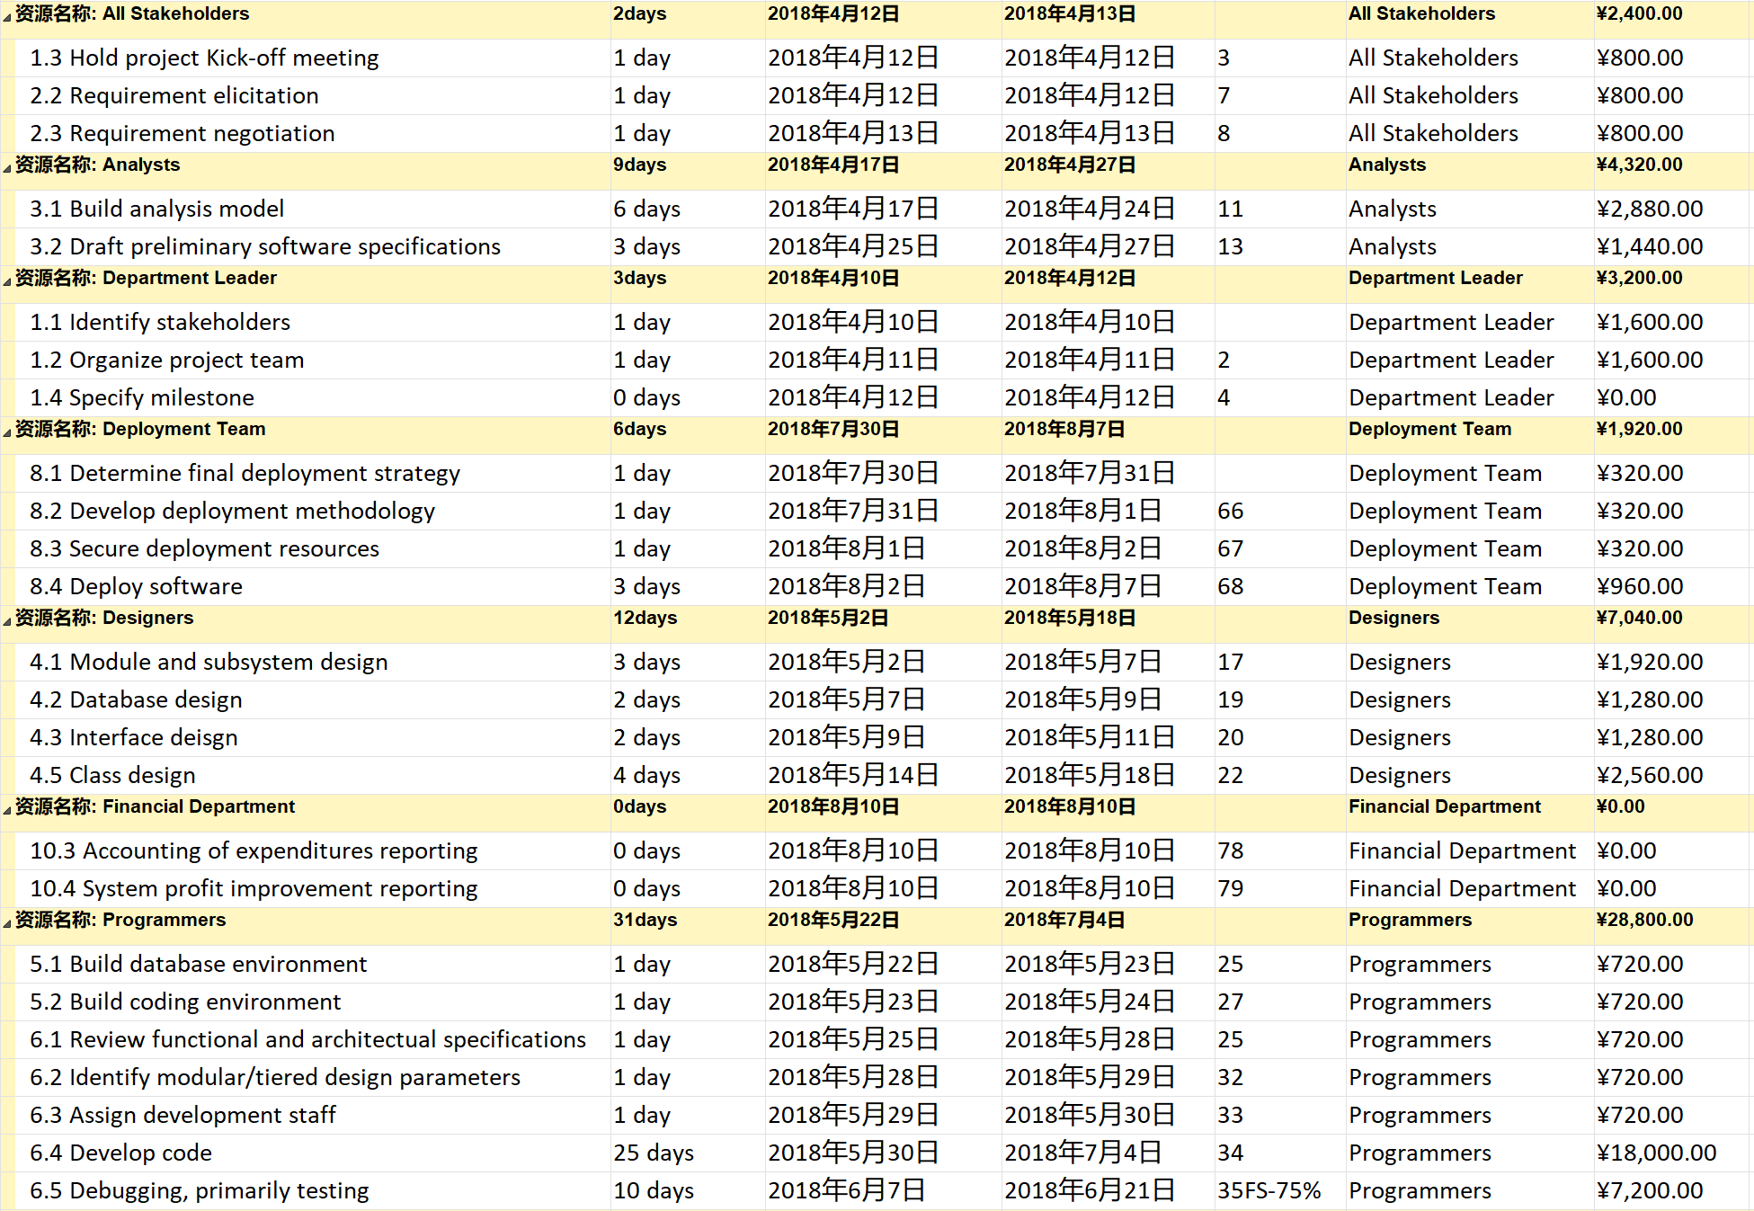

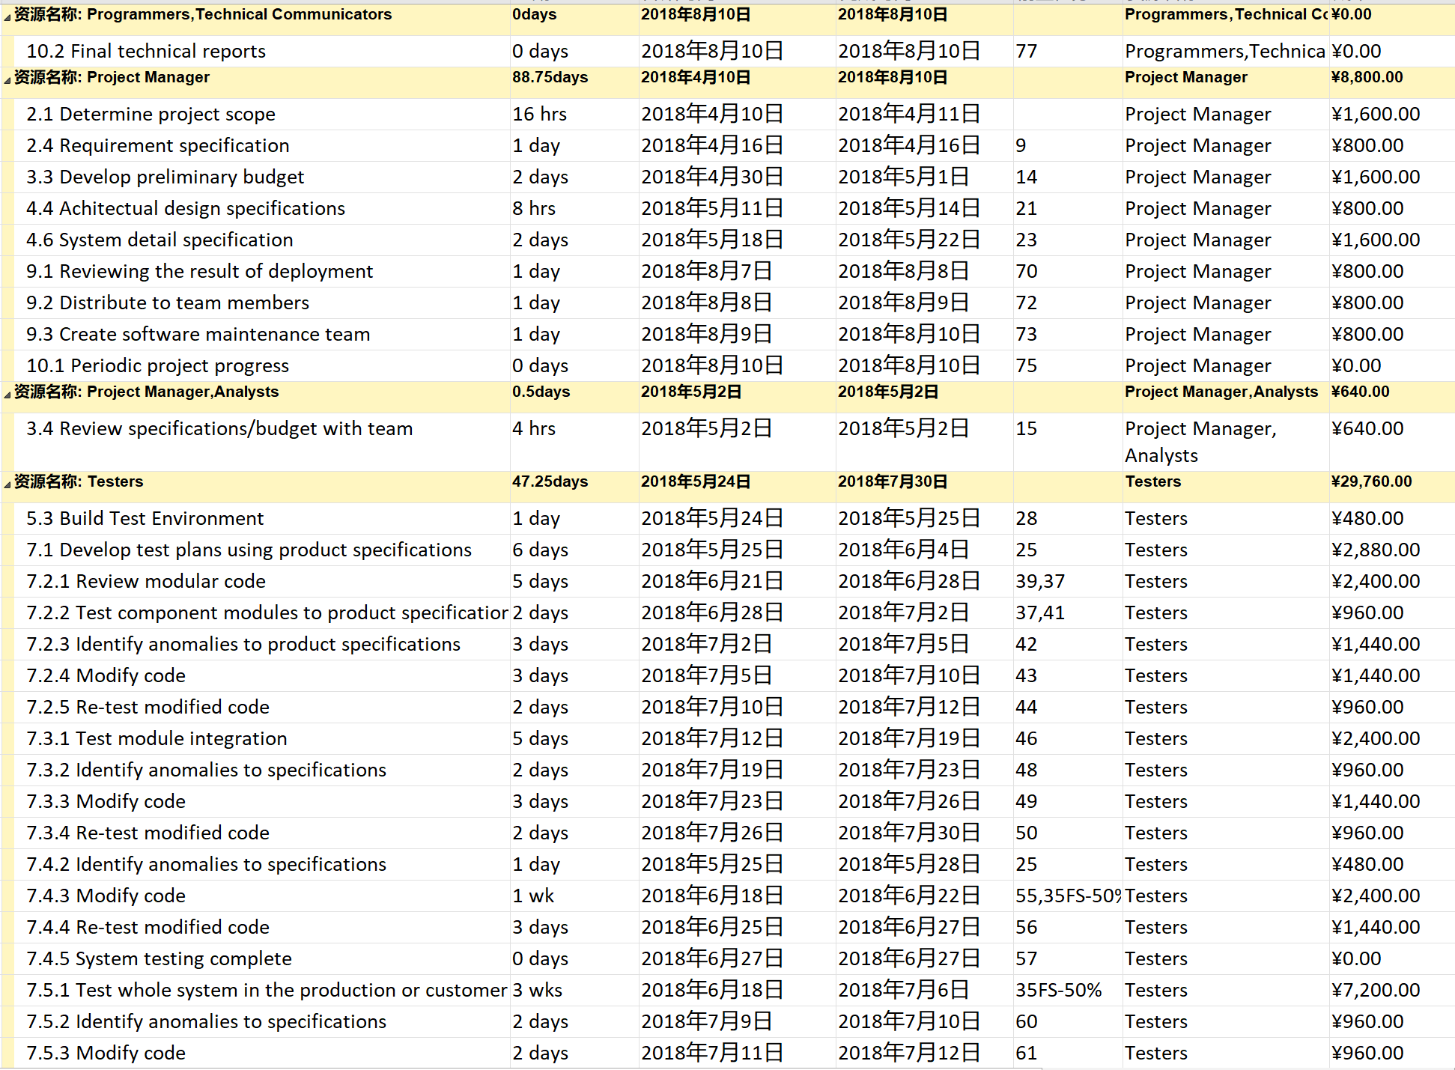 And we draw a beneficiaries’ work schedule Gantt chart to show the time arrangement of every stakeholder.

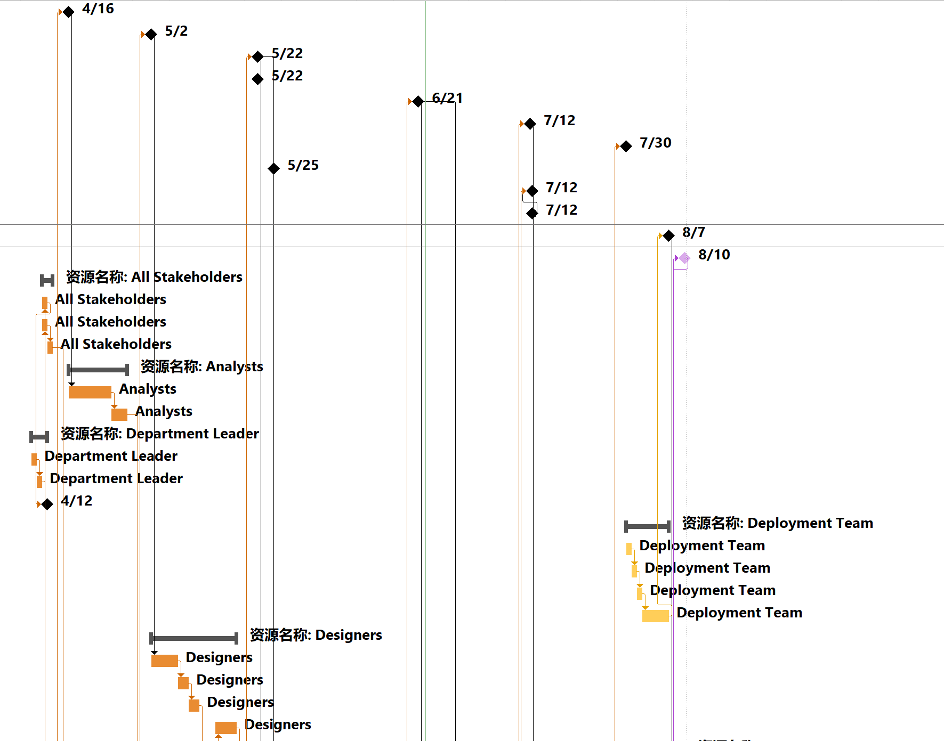

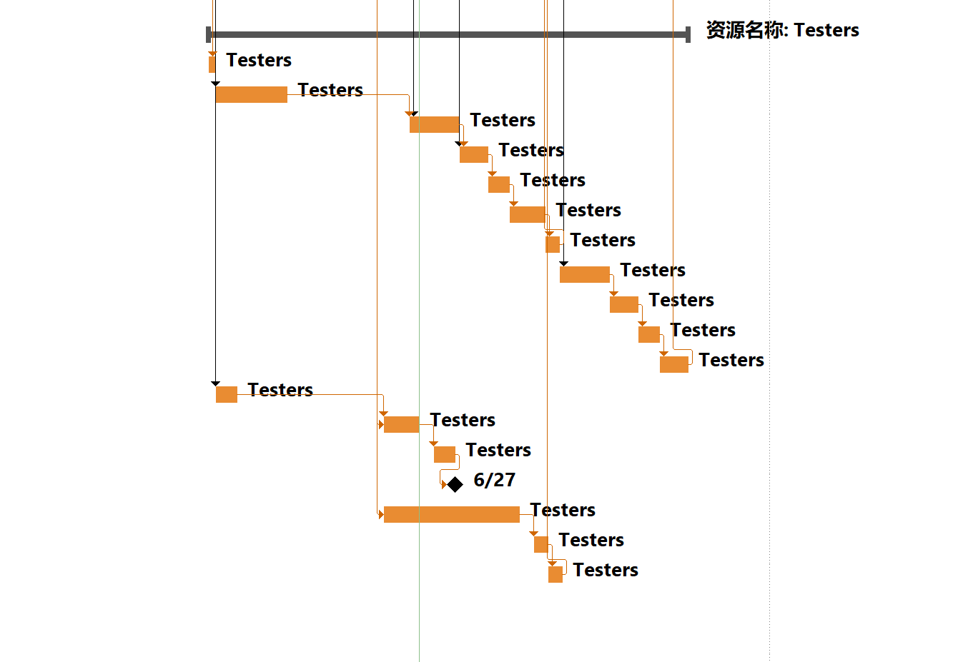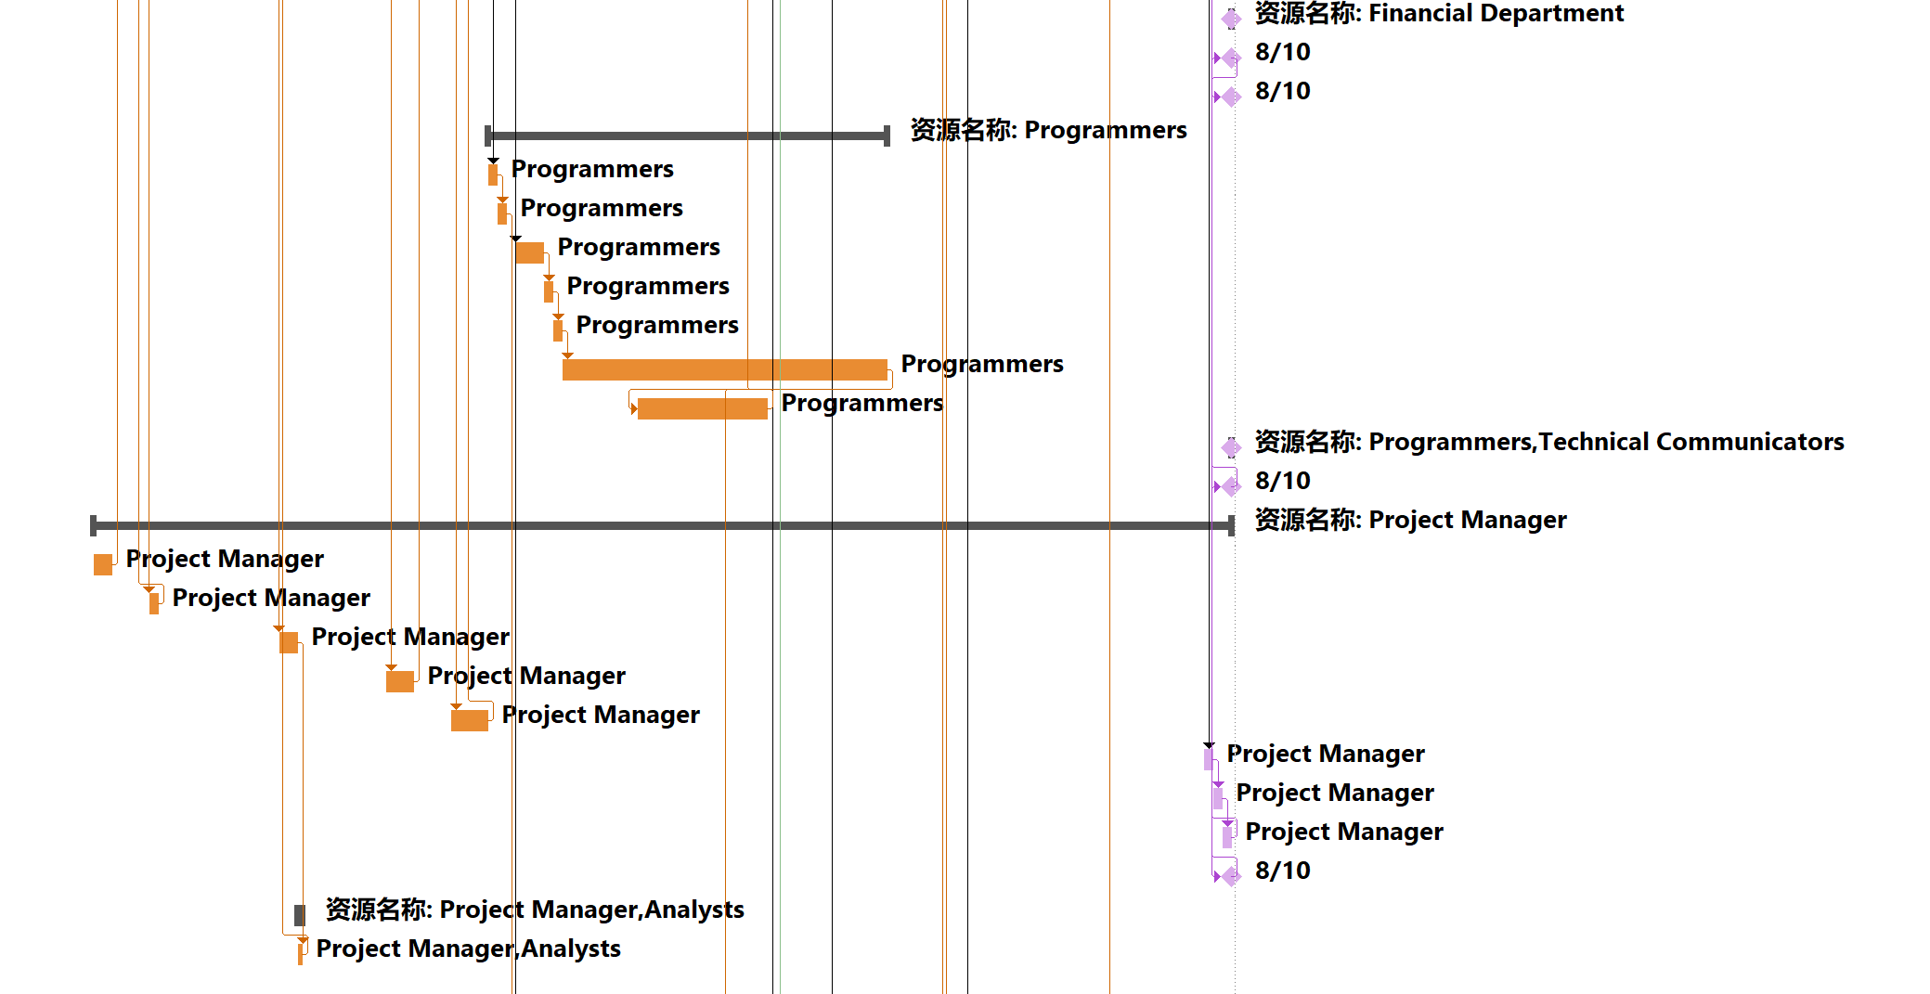 Finally, we list all of the beneficiaries and its role in the following chart to give a profile of our project’s beneficiaries.

|  |  |
| --- | --- |
| Beneficiaries | Role of the project |
| Department Leader | Developer of the project |
| All Stakeholders | Benefit from project |
| Project Manager | Developer of the project |
| Analysts | Developer of the project |
| Designers | Developer of the project |
| Programmers | Developer of the project |
| Testers | Developer of the project |
| Deployment Team | Developer of the project |
| Financial Department | Manager of the project’s financial affair |
| Other Department of the company | Project collaborators |
| Customer | User of the project |
|  |  |

## 4．3 Implementing team management of project

### 4.3.1 Main roles of the project

The project manager is responsible for the planning and management of the project, while the department leader is mainly responsible for the team building, organization structure and project scope analysis.

Other bodies and organizations associated with the project mainly include other departments of the Sunstate company, express company and customers.

Other departments of the Sunstate company cooperate with the project development department to improve the whole company’s efficiency and performance. And project manager is the key person that communicates with these departments and finishes the tasks that need different departments’ joint efforts.

Express company is the role that transport the equipment of Sunstate to customers, which ensure the business be correctly and smoothly carried out. Choosing the best express company and the communication and cooperation agreement with express company can be much important for Sunstate company to earn more profits. So department leader take responsibility for the communication with express company.

Customers are the users of our project, and all of our profits come from customers, so customers are the most important part of all of the other bodies and organizations associated with the project. So we must pay much attention to the demands and experience of customers and change our projects’ focus according to the customers’ reflection. And project manager is the best person responsible for collecting that information.

### 4.3.2 Effective coordination arrangements

Our project must see some added value from participating in the coordination process and the benefits must outweigh the costs – and there are costs to coordination, as it requires time and dedicated resources. As a consequence, coordination is far from a sure thing. Our coordinating organization, must establish a coordination process based on certain qualities. To achieve the best possible coordination outcomes the process should be:

* Participatory: Coordination occurs through the legitimacy derived from involvement. The tasks of coordination must occur within a structure and process agreed to and supported by the actors in the DG OFFICE. The coordinator must secure and maintain the confidence of the others, fostering an atmosphere of respect and good will. Organizations need to participate in deciding the policies, procedures, strategies and plans that will affect them.
* Impartial: The coordination process should not be seen to favour one department/ program over another, but rather to identify the distinctive competencies of each. Coordination should advocate the principle of impartiality, provided by the ORG most likely to achieve the desired outcomes.
* Transparent: Coordination requires trust and trust requires transparency – the willing flow of information, open decision-making processes and publicly stated, sincere and honest rationales for decisions. This will include the need to admit failure, or at least falling short of objectives.
* Useful: The coordination process must produce, share and disseminate useful products, processes and outcomes. These may include a platform for decision-making, an opportunity to use shared resources, a venue for donor recognition and support, or a comfortable place to share frustrations and try out new ideas

Practicing certain skills of coordination will help facilitate the coordination process. The following are techniques and approaches that we use in achieving coordination and circumventing common coordination barriers likely to be encountered.

* 1. Promote an understanding of collaborating organizations

The coordinator must first get to know the players. Only by understanding the mandates of various organizations, their intentions and their capacities (resources both material and personnel), can the team involve them appropriately and have reasonable expectations of their performance variations. Start a database with contacts and activities. These files will need to be updated regularly and online solutions or similar format where stakeholders can be encouraged to enter and update their own information is recommended.

* 1. Establish a purpose

The challenge in any coordination process is to ensure a comprehensive approach to the design of the coordination mechanism, based on a mutual understanding of an overall purpose of the coordination activities. In a hierarchical structure, the establishment of common goals is usually defined in a top-down process. In a multi-organizational response environment the definition of common goals will often require a much more participatory process. Only with a clearly defined and agreed purpose (i.e., why we need to coordinate this way) will it be possible to define the required coordination functions to support the process and determine the activities (i.e., what we need to do to achieve the purpose)

* 1. Clarify coordination parameters

Taking a little bit of the mystery out of coordination will go a long way in ensuring that it happens. Coordination will be avoided if organizations feel that it will be just a waste of time in endless meetings or that the coordination effort will result in a veto of their plans and activities. The best way to clarify the coordination parameters is to have frank and open discussions about the goals expected to be reached through the coordination efforts and the needs of the various organizations for coordination. It is often useful to jointly remind about or specify the objectives for the humanitarian operations given the time following the start of the crisis and the phase of the humanitarian programme cycle

* 1. Define an agile coordination structure

Coordination is most effective if built around an organized established structure. When handling large-scale agency with multi-agency participation, however, it may not be feasible to base coordination on existing coordination structures because these would not be able to handle the additional, situational requirements. There may be a need to either enhance structures or establish additional structures. To be successful the coordination structure must strive towards a high level of agility to be able to facilitate multi-organizational coordination. What might have worked last time, may not work this time and everything has to be adjusted to the situation at hand. In a fast changing environment established organizations more often than not are working in structures without the necessary flexibility to adapt to situational requirements.

* 1. Ensure proximity

The coordinator has a unique opportunity to affect the coordination process when choosing and establishing the site for the coordination process. Several of the functions initially taken care of by the coordinator will very soon, or simultaneously, be filled by other stakeholders, The coordinator should ensure that these entities establish themselves inside, or as close as possible to, the coordination centre. This will provide a “one-stop-shop” a situation where it will be easier to achieve tasks. The coordination focal should be like a lighthouse or a pivotal point that the operations and planning turn around. Other agencies may even want to establish their own focal point in close proximity  that may develop into a compound for the longer-term operation where all the key partners and/or agencies work out of the same place. This will be a great advantage for the coordination process as people will have easy access to each other and there will be more opportunities for informal networking.

* 1. Promote transparency and inclusiveness

When an organization’s actions are transparent, it is possible to see how and why decisions are being made. The reluctance to transparency resides in fear – fear of disapproval, that ideas will be stolen or resources monopolized, or that freedom of action or the ability to change course will be circumscribed. By promoting transparency without negative consequences the coordination structure may be able to reduce the natural tendency to hide organizational decision-making processes. And, of course, transparency begins at home. Thus, the coordinator must model transparency in its own processes. One way to do this is to periodically evaluate how the coordination process is going and how it might be improved. Clarifying how the coordinator can do his job better and then making those changes will improve operations at the same time that transparency is increased. Strive to involve and integrate partners and other stakeholders in the coordination mechanism, aiming to create one whole where the output is larger than the sum of its parts. Avoid silo-thinking and organizational ego-behaviours; be self-effacing. You yourself are unimportant, like a sports referee that is never visible, yet never loses oversight or control of the game. By avoiding one’s own agenda, and clearly showing that the team does not have one, it will be easier to achieve trust.

* 1. Develop trust

In a multi-organizational environment trust is essential to create the good working relationships needed to collaborate. The need for funding may create a competitive environment where development networks get hampered by a business approach. Stakeholders may become drawn between loyalties and have to choose between options that are equally unattractive. Trust has to be understood in relation to the context in which the organizations are operating. To build trust and cooperation amongst organizations in the development environment it may be an advantage to start with some less controversial functions such as elementary information sharing, before moving into more controversial domains. One should try to keep things simple to begin with and build on networks very similar to social networks, tied together by common interests or, as in this environment, by sectoral operational interests. Rallying around the development of a common or joint strategic development plan or funding appeal is often a good way to build cooperation.

* 1. Build on linkages and networks

When meeting the organizations, it will be important to identify with whom, in particular, organizations should liaise. This may be determined by any number of variables such as sector, geographical area of operation, government or opposition coordinating agent, etc. The coordinator should ensure that the linkages have been made. In many cases this will involve contacting the parties, organizing a meeting, facilitating the introductions of the organizational representatives and producing and sharing information products such as contact lists, etc. Some important and helpful personal relationships may already be operating. The development community knowing each other or having worked with one another is quite high. These pre-existing relationships can greatly aid the linkage process. Of course, the opposite may also be true where an unsatisfactory prior relationship will impede the current effort. Nevertheless, networks based on pre-existing relationships have immense value in development work. Very often information sharing and collaboration takes place outside the formal coordination structures and is conducted inside a previously established network. Such networks should be utilized in the coordination process, as it will be easier for people to connect and work together. Organizations are made up of people, building relationships in advance of development program can greatly improve coordination efforts during implementation

* 1. Facilitate an enabling environment

The environment around the coordination process should be enabling, allowing all actors to communicate, share information and collaborate with each other. In an enabling environment, stakeholders take the initiative to become involved, take on responsibilities and move from reactive to proactive. To achieve an enabling environment it is necessary to facilitate coordination by managing the process and avoid directing it. In a coordination process it should be easy for participating organizations to become an active partner. One should try to instill an attitude that coordination is a shared responsibility and not something someone else does on behalf of others.

* 1. Start with the needs of others

In promoting coordination it is tempting to say,“we need this information to be able to coordinate”. Thus, the need for coordination resides not in the other participating organizations. This is the wrong approach. The team should first ask how they can help the agencies. By starting by meeting some of the agencies’ needs, the coordinator is committing to service first and earning significant credibility. As part of the effort of identifying the needs of others it will become clearer not only what coordination should seek to accomplish but also how organizations may be induced to participate. Adopt a marketing approach where you try to find out their needs and meet them, as opposed to selling them what you have to offer. What do the operational organizations need? Identify it and find ways of providing it. This could be everything from the key to a functioning toilet to the right information to base strategic decisions on. The needs are often basic tools and services, such as contact lists, meeting spaces, baseline information and common resources such as Internet access and printers. Reliable and timely information management products are usually the service most wanted in a development situation. Information management is the bread and butter of the coordination process

* 1. Provide useful information and services

In part this will occur if you practice the technique of asking others what they need. Even so, some types of information will always be useful to almost everyone. If the team is the repository of useful information, people will want to come to it. Maps, for instance, often seem to be in short supply. Further, the coordination focal should be a good place to get a copy made, get a weather report, check what might be going on somewhere, get a security update or just see a smiling and congenial coordinator willing to take a few moments to listen.

* 1. Keep the ball rolling

Momentum in coordination is essential to maintain interest and commitment. One way to do this is to ensure rapid reporting of new or updated information. Decisions made in the coordination process must be documented in the form of minutes or reports and made available. Even more important is to ensure follow-up and follow-through on decisions. Failure to implement conclusions will cause cynicism about the process to develop and ultimately destroy the team’s credibility. Part of keeping momentum is keeping people in touch with one another and keeping channels of communication open. This may involve going out of your way to make the right connections.

* 1. Respect people’s time and schedules

Don’t let the coordination meetings become just another meeting. Ensure that the meetings need to occur and that there is vital and important work to be done. Don’t be afraid to cancel a standing meeting if the agenda is not compelling enough. Publish an agenda for the meeting and stick to the schedule, including beginning and ending meetings on time. Practice good meeting facilitation skills. Ensure that everyone has a chance to say what is on their mind and that a small group or individuals don’t dominate the conversation.

* 1. Write it down

Some of the results of the coordination process, both from large group and bilateral discussions will be concrete enough to be developed into a document. Such items might include a preparedness plan or plan of operations. Certainly all such agreements will require updating and, even in the best of cases, represent an intention to act or an agreement, in principle, subject to change as situations change. Regardless, writing conclusions/ agreements down provides a record for follow-up and accountability.

* 1. Address small problems before they grow

A small problem, be it a misunderstanding, a hurt feeling or a perception of insensitivity, may grow and fester resulting in a much bigger barrier to communication. Part of the role of facilitating productive relationships may involve engaging in active conflict management or relationship confidence building, usually outside the formal coordination process. Starting small is generally a good idea in any situation as confidence builds in the coordination process. As always, ORG should be leading by example.

* 1. Build on strengths

It is important to ask people to do things they can do. Too often people agree to a task that they can’t or won’t perform under the threat of consensus or as part of wanting to be a team player. Therefore, ask people to do things they can easily accomplish, especially at first. Don’t be afraid to ask them over and over whether they are sure they want to take on the task. Once the relationship is strong, it may be possible to ask them to engage in more difficult tasks

* 1. No surprises

Nobody likes to go to a meeting and be embarrassed because they don’t know something they should or that other people know. The team will need to meet and brief people outside of the formal meeting process to keep them updated on current or fast changing events, shifts in resources or important visitors.

* 1. Hand over functions to others

It is an old cliché, but try to work yourself out of a job. If a coordination focal is going to need to function for a long time period, it will be best if as many functions as possible are handled either by the other agencies or by local staff. If someone else can and is willing to do the job, give them the chance. In almost every situation there is more to do than can be done. Giving jobs to others can only help in freeing you up to take on another task.

* 1. Thank people and acknowledge their contribution

Rewarding participation is an important technique in building commitment to the coordination process. When organizations have done good work, changed their program or otherwise gone out of their way to put other’s needs ahead of their own they need to be thanked and acknowledged, publicly. Few things will inspire more participation in coordination than the feeling of being a valued contributor.

* 1. Use the informal time

There is a minimum amount of “down-time” during an ORG mission, but there are always opportunities to interact with the response community during off-duty periods like meals or after-hours socializing. Don’t miss the chance to build effective relationships at these times. Sharing information on hobbies, favourite sports teams, family, etc., all contribute to building the personal regard that will encourage people to want to associate with the coordination process

## 4．4 Project Life cycle model

We use iterative and incremental model to develop our project.

The main objective of iterative development is to build the system incrementally, starting from basic partial system features and gradually adding more features until the entire system is completed. Compared to waterfall, iterative development allows flexibility in accommodating new requirements or changes thereof. It also provides room for improvement in succeeding iterations based on lessons learned from previous iterations.

And it is obviously reflected in our work plan schedule that we use the incremental model.

Iterative and Incremental Development Phases

Incremental development slices the system functionality into increments (portions). In each increment, a slice of functionality is delivered through cross-discipline work, from the requirements to the deployment. The Unified Process groups increments/iterations into phases: inception, elaboration, construction, and transition.

* Inception identifies project scope, requirements (functional and non-functional) and risks at a high level but in enough detail that work can be estimated.
* Elaboration delivers a working architecture that mitigates the top risks and fulfills the non-functional requirements.
* Construction incrementally fills-in the architecture with production-ready code produced from analysis, design, implementation, and testing of the functional requirements.
* Transition delivers the system into the production operating environment.

Each of the phases may be divided into 1 or more iterations, which are usually time-boxed rather than feature-boxed. Architects and analysts work one iteration ahead of developers and testers to keep their work-product backlog full.

## 4．5 Project monitoring & Quality control

Obviously, project manager should take the responsibility preparing periodic project progress and for final technical reports and financial department should be responsible for the accounting of expenditures.

### 4.5.1 Reasons that we monitor the project

To monitor a project is to routinely gather information pertaining to all aspects of the project, and observe and record all activities occurring in it. Monitoring involves a systematic and purposeful observation of all ongoing processes in the project. It also includes giving meaningful feedback to the investors and project owners regarding the project status and how the milestones are likely to be achieved over time so informed decisions can be made by them.

Monitoring does not involve just staring at a computer monitor spewing out data from analytics tools and generating reports for the management and team members. The project manager or the process-in-charge needs to understand the metrics and forecast where the project is heading in accordance to the efforts put in by the team and how well the team is performing at the moment. Moreover, other constrains such as budget availability, short staffing, project deadlines and other issues popping up in day-to-day activities also need to be considered as to how they’re likely to affect the success and sustenance of the ongoing project.

Monitoring provides information as to what the status of a particular program, project or policy is at any moment, or is going to be over time, and how well the functioning of various processes in the project, including the resources allotted for it relate to targets and deliverables. Its focus should also be on optimum utilization of the resources made available for the project. The objective is to track the gap between what was originally planned and what is actually happening now.

### 4.5.2 Mechanisms and procedures for monitoring

**Monitoring Information**

At the execution stage when the actual tasks of the project are in progress, it is vital to monitor information in order to keep track of what is being accomplished. The project manager can facilitate the project by communicating with team members and clients. Through hands-on monitoring, the team leader can make sure that individual participants stay with the original plan for the project and remain focused on predetermined goals. The project manager takes careful notes to follow all aspects of the project and address any problems that come up.

**Monitoring Progress**

Time management monitoring is executed by the project manager to make sure deadlines are being met as the project moves forward. Time sheets are used to monitor the time individual team members spend on tasks within the project. The team leader can identify and resolve any time management issues that arise.

**Monitoring the Budget**

Cost management is executed by the project manager to make sure the project comes in at or under budget. Costs within the project are identified and expenses are approved before a purchase is made. The project manager keeps a central record of all costs incurred by the project. He can then determine if expenses are adequately budgeted, and if not, grant special approval for necessary expenditures.

**Monitoring Quality**

To monitor quality effectively as the project progresses, the team and the project manager must set up quality guidelines before the execution phase. Once the team leader knows how quality is to be measured, he can take action to measure the quality of the output of the team, identify any quality issues and make any necessary improvements.

### 4.5.3 Monitor objects

The nature of the project, its goals and objectives, and its deliverables primarily indicate what parameters should be ideally monitored and in what manner. It can be difficult to generalize the “what” aspect since it may differ from project to project. Generally, the key performance indicators (KPIs) used for monitoring the progress levels in a project are set up collectively by the client and project manager based upon their project related needs and deliverables. Some of the important aspects to monitor in a project can be:

**Objectives and needs of the client**

Is the client’s project vision fulfilled and are the project’s milestones successfully met?

**Efficiency level of the team**

Is the team working as per the development plan and are enough efforts put in to meet the deadlines?

**Collaboration and communication levels**

Is the team working together in a harmonious manner and pursuing the goals collectively with a single focus?

**Business value and work monetization**

Is the work delivered by the team monetizable?

**Risk mitigation**

What are the risks involved in the project? Can they be identified in time? Can they be resolved?

### 4.5.4 Levels of monitoring

A project should be ideally monitored at three main levels to get a clear insight regarding its current status so corrective measures can be taken well in time.

**1. Activity level monitoring**

It is done to ensure that each activity defined in the project schedule is carried out in a proper manner and within the time box allotted for it. It can be done by holding daily meetings with the team, or alternately the project manager can check the status of all tasks scheduled to be carried out for the day. Typically, the daily tasks to be carried out by team members are listed on paper and their completion status is checked at the end of the day to identify any pending work remaining on that particular day. This level of monitoring is basic to all project management processes since it makes the team accountable for the work assigned to it. It is to ascertain that the project proceeds as per plan and delivery deadlines can be met successfully.

**2. Project status reporting**

Usually generated once a week, project status reports often contain a summary of all tasks completed successfully by the team in the week gone by against the actual activities planned for that week. The idea is to identify how much of work is completed in the project, how much of it is still pending, and whether the deliverables can be produced by the team considering its current rate of delivering work. It also helps to identify the causes of delays logged by the team and pinpoint any pitfalls hampering team productivity.

**3. Milestone analysis**

Analysis is done every few weeks to make sure whether milestones supporting the project vision are, or can be, achieved within the time duration allotted for its completion, and to find out how much of efforts are actually put in by the entire team over time to achieve the proposed milestones. When plotted on a graph, it helps to identify any deviations occurring in the proposed “line” of project completion versus time. If the deviation is severe or more and objectives are not met with time, project managers need to identify and understand the root causes and undertake corrective measures in time to correct the deviation so milestone deadlines can be met successfully.

# 5、Software Measurement and Improvement

## 5.1 Software Measurement

This project belongs to WebAPP project. Measures used for traditional software engineering projects are difficult to translate directly to WebApps. Among the measures that can be collected are the following:

•Number of static Web pages:

These pages represent low relative complexity and generally require less effort to construct than dynamic pages. This measure provides an indication of the overall size of the application. The number of static Web pages of this project is about 20.

•Number of dynamic Web pages:

These pages represent higher relative complexity and require more effort to construct than static pages. This measure provides an indication of the overall size of the application and the effort required to develop it. The number of dynamic Web pages of this project is about 30.

•Number of internal page links:

This measure provides an indication of the degree of architectural coupling within the WebApp. As the number of page links increase, the effort expended on navigational design and construction also increase. The number of internal page links of this project is about 65.

•Number of persistent data objects:

As the number of persistent data objects grows, the complexity of the WebApp also grows and the effort to implement it increases proportionally. The number of persistent data objects of this project is about 12.

•Number of external systems interfaced:

As the requirement for interfacing grows, system complexity and development effort also increase. The number of external systems interfaced of this project is about 10.

•Number of static content objects:

These objects represent low relative complexity and generally require less effort to construct than dynamic pages. The number of static content objects of this project is about 6.

•Number of dynamic content objects:

These objects represent higher relative complexity and require more effort to construct than static pages. The number of dynamic content objects of this project is about 13.

•Number of executable functions:

As the number of executable functions increases, modeling and construction effort also increase. The number of executable functions of this project is about 7.

## 5.2 Measurement-driven Improvement

The PSM(Practical Software Measurement) model is an information-driven software metrics process aimed at the unique technology and business objectives of software organizations. This metric that is widely used by the US Department of Defense, government agencies, industry, and software companies, as proposed by the PSMSC (US Utility Software and System Measurement Support Center). It consists of two models: the Measurement Information Model (MIM) and the Measurement Process Model (MPM).

The measurement process model defines three activities: clipping metrics, implementing metrics, and evaluating metrics, as shown in the following figure:

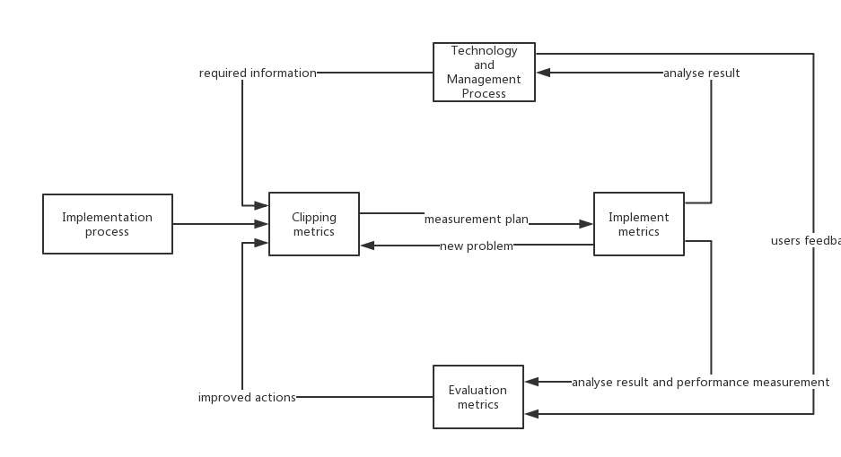

The cutting measurement activity determines the priority of the current project problem based on the risk management information and budget information of the project, as well as project information that needs improvement and newly discovered project issues. Then select the measurement item and specify the specification. Finally combine with technical process and management process to generate measurement plan. The main tasks of the metric's evaluation activities are: evaluating metrics and indicators, evaluating metrics, updating the database of experiences and process baselines, identifying and implementing improvement activities, and so on. The metric information model (MIM) is shown in the following figure:

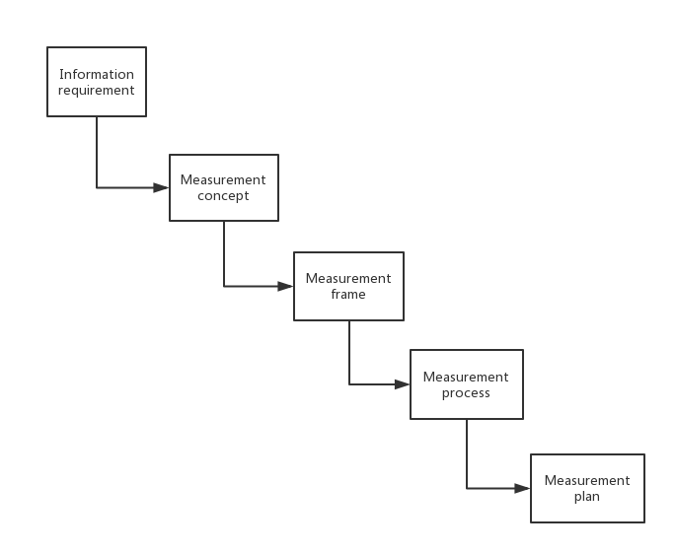

## 5.3 Process-driven Improvement

### 5.3.1 SPI framework

The following picture is the SPI framework of this software project:

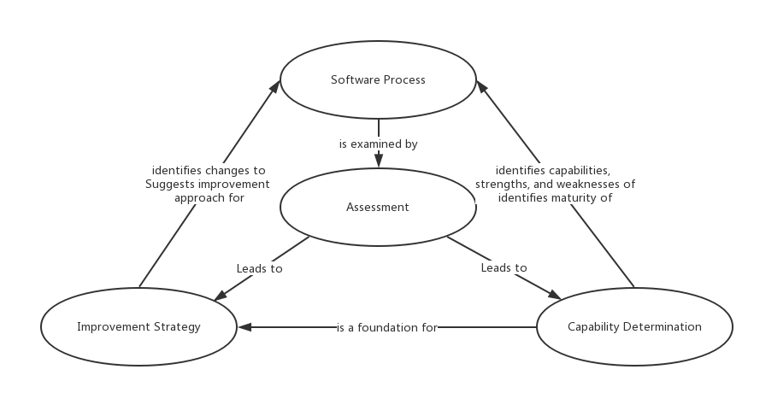

The software process defines a set of characteristics that must be present if an effective software process is to be achieved, including functional points from functional requirements, delivery of a project as scheduled, no bug for the project and so on. The assessment defines a method for assessing whether those characteristics are present. The capability determination defines a mechanism for summarizing the results of any assessment. And the improvement strategy defines a strategy for assisting a software organization in implementing those process characteristics that have been found to be weak or missing. The detail of the framework will be discussed in following sections.

### 5.3.2 Maturity Model

Our maturity model of this project is CMM(Capability Maturity Model for Software). It is a description of the development stages of software organizations in the practice of defining, implementing, measuring, controlling and improving their software processes. The core of CMM is to view software development as a process, and to monitor and study the process of software development and maintenance based on this principle, so that it can be more scientific, standardized and enable enterprises to achieve business goals better. And here are five levels of CMM:

•Initial:

Features: The lack of software engineering management system. The lack of definition of the process, chaotic disorder. Often due to lack of management and planning lead to time, cost overruns, management methods are reactive, mainly used to deal with the crisis, the process is unpredictable and difficult to repeat.

Improvement: Establish project process management, establish various plans, and carry out QA activities.

•Repeatable:

Features: Based on the experience of similar projects, a basic project management system was established and some resource control measures were adopted. Managers can find problems and take countermeasures in time.

Improvement: Introduce demand management, project management (including project tracking and monitoring), sub-contract management, software configuration management and quality management (including quality quantification and monitoring).

•Defined:

Features: The software process is documented and standardized. The development process can be improved according to requirements. The assessment method is used to ensure the software quality. Case management tools are introduced to improve the quality and efficiency.

Improvement: Organization process definition, focus, training outline, software integration management, organization coordination, expert review etc.

•Managed:

Features: All processes establish corresponding measures and clear metrics. Measurements are detailed and can be used to understand and control software processes. Quantitative control will make software development truly an industrial production activity.

Improvement: Quantitative software process management and product quality management, the ability to prevent and circumvent deficiencies, technological innovation capabilities, and continuous process improvement.

•Optimizing:

Features: Feedback from the implementation process can be used to improve the next step in the implementation process, optimize the execution steps (based on statistical quality and process management tools, continuous improvement of the software process), and steadily improve quality and efficiency.

Improvement: Defect prevention management (including prevention and response to disaster recovery measures), process change management (work flow), and technology change management.

Obviously, the goal of maturity level of this project is level five. The detail to achieve this goal will be discuss in the following sections.

### 5.3.3 The Implement of CMM

In developing the implement of CMM for this project, the company needs to address the following key implementation factors:

1. Development Process:

Sunstate Equipment needs a set of development practices that would make their activities more tractable, visible, and understandable. The company needs to create documents that track development artifacts: designs, source code, test plans and so on.

1. System Architecture:

Sunstate Equipment needs to manage the contract they created. The company needs central servers to centralize data access. If a programmer makes an mistake, undoing the change and reverting to an earlier version was difficult. The company also needs a flexible network to ensure that programmers and analysts could access the data form anywhere in the company.

So the project needs a centralize server which facilities the distribution of information among employees primarily as a configuration management and process assert library(PAL).

1. Recognition of key aspects:

The management team needs to understand the differences among system architecture, software architecture and supporting organizational and development processes. The company needs to make organizational changes such as committing resources to complete the project, creating a PAL, and establishing process definition standards and terminology.

1. Process Asset Library:

The company needs to spend time and effort to create a process assets repository for organizational and project information that the process improvement efforts generated to communicate the process assets to the organization.

1. Periodic Reviews:

The company needs to institute monthly meetings to review the status of projects and changes. These reviews provide a forum for key personnel to spread the word about process improvement and to implement the defined practices. Participants use the PAL to access data at these meetings (action items, agenda, minutes, work products), which lends credibility to this information’s value. Management can review, approve, and baseline the defined practices during these reviews. Through participation in periodic reviews, the company president is able to demonstrate support of the process improvement initiative and communicates the effort’s status and importance.

1. Terminology and process definition standards:

Key personnel needs to understand the need to use consistent terms and definitions and document them in a glossary. Staffs in the company need to understand the basic components of the process information that they needed before implementing a best practice, including basic process definition, process flow, templates, guidelines and criteria, and roles.

### 5.3.4 SPI Return on Investment

In order to ensure that improved process will result in the implementation of better-quality work, better control of change and less technical rework, these qualitative benefits need to be translated into quantitative results. And the classic return on investment(ROI) equation is:

IMG_256

The benefits and costs are listed in the final chapter. And the result of ROI for the first year is 31.32%.

# 6、Budget

We have attached the detailed cost and budget estimation in the PROJECT IMPLEMENTATION & MANAGEMENT PLAN section and the detailed budget chart is listed in the Project activities and work plan section.

So in this section, we will display the budget in a higher level.

## 6.1 Work plan budget

|  |  |  |  |  |  |
| --- | --- | --- | --- | --- | --- |
| Project Stage | Working days | Cost | Person | Schedule(month) | Effort(Man-month) |
| Project Initiating | 3 days | ¥4,000.00 | 1 | 0.100 | 0.100 |
| Gathering System Requirement | 5 days | ¥4,000.00 | 1 | 0.167 | 0.167 |
| Analyzing Requirements | 11.5 days | ¥6,560.00 | 2 | 0.383 | 0.767 |
| Architectual Design and System Detail Design | 14 days | ¥9,440.00 | 2 | 0.467 | 0.933 |
| Building Development Enviroment | 3 days | ¥1,920.00 | 2 | 0.100 | 0.200 |
| Programming | 28 days | ¥27,360.00 | 5 | 0.933 | 4.667 |
| Testing | 46.25 days | ¥38,400.00 | 4 | 1.542 | 6.167 |
| Component Testing | 15 days | ¥7,200.00 | 1 | 0.500 | 0.500 |
| Integration Testing | 12 days | ¥5,760.00 | 1 | 0.400 | 0.400 |
| System Testing | 23.5 days | ¥4,320.00 | 1 | 0.783 | 0.783 |
| Acceptance Testing | 19 days | ¥18,240.00 | 1 | 0.633 | 0.633 |
| Deploying the project | 6 days | ¥1,920.00 | 2 | 0.200 | 0.400 |
| Reviewing after deployment | 3 days | ¥2,400.00 | 1 | 0.100 | 0.100 |
| Reporting | 0 days | ¥0.00 | 1 | 0.000 | 0.000 |
| Total | 88.75 days | ¥96,000.00 | 25 | 6.308 | 15.817 |

## 6.2 Estimate cost

|  |  |  |  |  |  |  |
| --- | --- | --- | --- | --- | --- | --- |
| Budget line item | Personnel | Subcontracts | Staff Training | Equipment | Miscellaneous | Total |
| Cost | ￥100000 | ￥15000 | ￥8800 | ￥35000 | ￥23000 | ￥18100 |

## 6.3 Budget source

|  |  |  |  |  |  |  |
| --- | --- | --- | --- | --- | --- | --- |
| Source | Sunstate Grants | Investment | Stakeholders | Government | Ourselves | Total |
| Amount | ￥110000 | ￥32000 | ￥23000 | ￥30000 | ￥35000 | ￥230000 |

# Financial Evaluation

## 7.1 12 Months Profit and Loss Projection

To get detail data, please jump to [12-monthProfit and Loss Projection.xls](12-monthProfit%20and%20Loss%20Projection.xlsx)

## 7.2 Four Years Profit and Loss Projection

To get detail data, please jump to [4 Year Profit and Loss Projection.xlsx](4%20Year%20Profit%20and%20Loss%20Projection.xlsx)

## 7.3 12 Months Cash Flow WorkSheet

To get detail data, please jump to [12 Months Cash Flow WorkSheet.xls](12%20Months%20Cash%20Flow%20WorkSheet.xls)

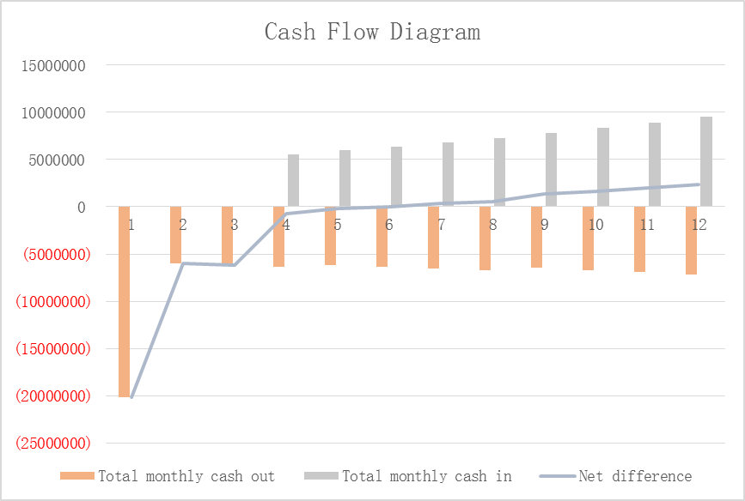

**7.4 Four Years Cash Flow WorkSheet**

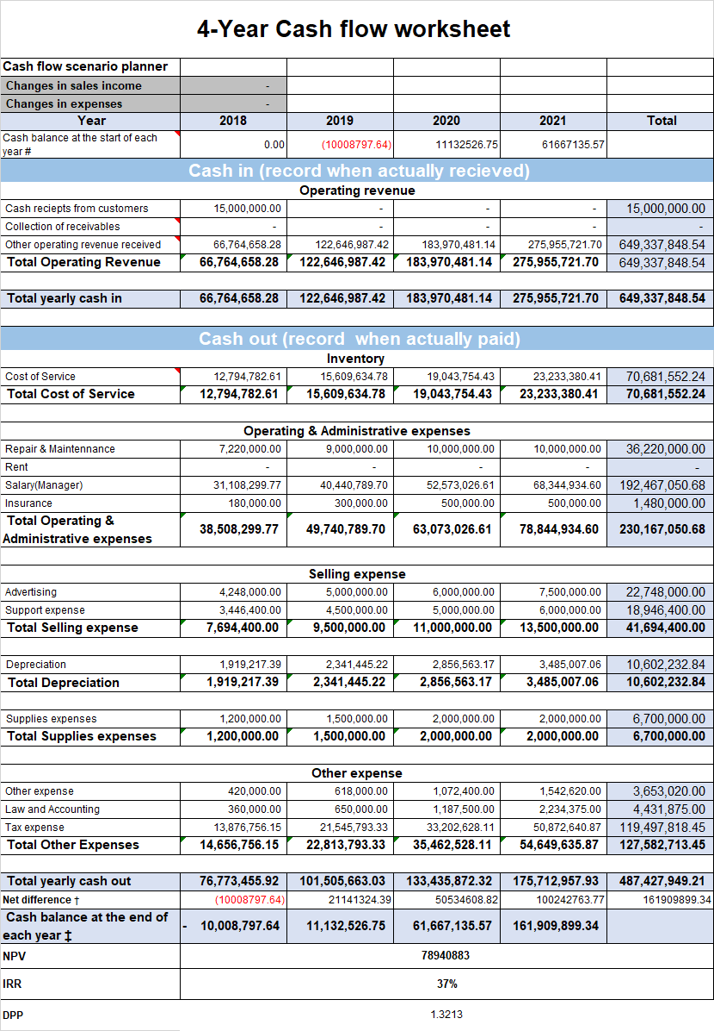

To get detail data, please jump to [4-Year Cash flow worksheet .xlsx](4-Year%20Cash%20flow%20worksheet%20.xlsx)

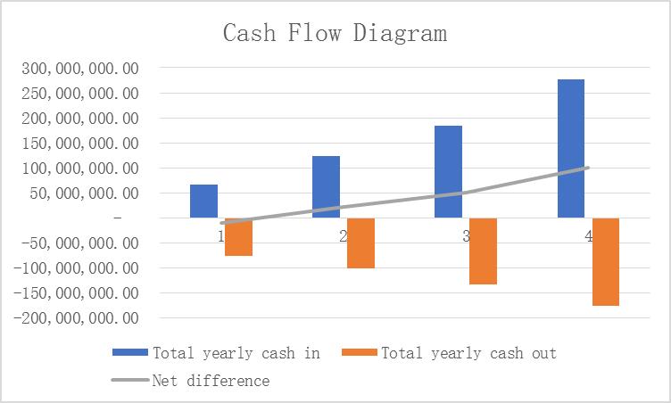

## 7.5 Break-Even Analysis

If we want has profit in first year:

Business volume = Total Fixed Cost ÷ (Income - Variable cost) = 14714000 ÷ (8139 - 6198) = 7580 (contracts)

|  |  |
| --- | --- |
| Break-even Cart | |
| Fixed Cost | Amount |
| Equipment Cost | ¥1,200,000.00 |
| Loan Cost | ¥1,200,000.00 |
| Depreciation Cost | ¥240,000.00 |
| Transport Cost (road toll) | ¥10,874,000.00 |
| Server Cost | ¥1,200,000.00 |
| Total Fixed Cost | ¥14,714,000.00 |
| Average Variable Cost | ¥6198 per contract |
| Average Income | ¥8139 per contract |

If we want has profit in four years:

Total Fixed Cost(four years) = 14714000 + 14714000 × (1+22%) + 14714000 × (1+22%) × (1+22%) + 14714000 × (1+22%) × (1+22%) × (1+22%) = ¥81,283,784

Average Variable Cost per contract = ¥ 10133

Average Income per contract = ¥16522

Business volume = 81283784 ÷ (16522 - 10133) = 12722 (contracts)

|  |  |
| --- | --- |
| Break-even Cart | |
| Fixed Cost | Amount |
| Total Fixed Cost(four years) | ¥81,283,784 |
| Average Variable Cost | ¥ 1,0133 per contract |
| Average Income | ¥1,6522 per contract |

## 7.6 Price Strategy

We are a subsidiary company under the Sunstate Equipment company. Our software provides services directly to the company. But if we want to sell our services to other companies, we need to set the price of this software.

In order to set the price of this software. Firstly, we need to determine which demand is less elastic. The substitute of this software is purchasing equipment directly whose price is higher. So it has little impact on the price of this software and this demand is less elastic.

Next, we need to estimate costs. Fixed costs of this software includes equipment cost, loan cost, depreciation cost, transport cost(road toll) and server cost. Variable costs of this software includes salary expenses, payroll taxes, after-sale service, supplies(office and operating), repair and maintenance, advertisement, driver expense, law expense, communication expense(telephone), insurance, utility(office supplies), taxes(real estate), accounting, misc(unspecified). The amount of each cost can be found from the ‘Profit and Loss Projection’.

And then we need to analyze competition. We need to consider whether our price of this software is more reasonable than competitors and customers possible price reactions.

Then, we adopt markup pricing as pricing method. The reason why we use this method as follows:

1. The seller can make more affirmation about cost than demand. When prices are combined with costs, sellers can simplify their own pricing tasks; when demand changes, they do not have to adjust prices frequently.
2. When all enterprises in the industry use this pricing method, their prices will tend to be similar. So the price competition will be reduced to a minimum. If they pay attention to changes in demand when pricing, then price competition cannot be reduced to a minimum.
3. When the buyer's demand becomes urgent, the seller does not take advantage of this favorable condition to seek additional benefits and still get fair investment remuneration.

Costs of this software for the first year is ￥82842210.6. And our expected profit for this software for the first year is 20%. According to markup pricing, the formula for calculating the pricing is ***COST /( 1 - PROFIT)***. So the price of this software is ￥103552763.

# Reference

1. Hao Teng，Xiaobo Huang，Changman Yan “Analysis of the main points and effects of US government leasing accounting standards”， 《*Finance and Accounting Monthly》，* pp. 141-142, 2018(3).
2. Hao Teng，Xiaobo Huang “A brief analysis of the main points of the new American lease criteria and the treatment for the new lease”， 《*Finance and Accounting Monthly》，*2017(4).
3. Market Structure as Determinant:the Case of Leasing in Banking Industry Transforma-tion in Central and South Eastern Europe. Elisabeth Kichler,Peter Haiss. the8th Global Conference on Business&.Economics . 2008
4. Roger Pressman, “Software Engineering A Practitioner's Approach 8th Edition”, 2014
5. Kathy Schwalbe, “Information Technology Project Management 6th”
6. Jack Gido, “Successful Project Management 5th”
7. HAROLD KERZNER, “Project Management\_A Systems Approach 10th Edition”, 2009
8. The State of the Leasing Industry:Review of developments and trends. Vinod Kothari. . 2009
9. Captive Finance Firms in a Challenging Economy. Cameron Krueger,Steven Byrnes,Christine Williams. Journal of Equipment Lease Financing .
10. Drivers of Success in the U.S.Equipment Lease and Financing Industry. Sarah J.Marsh. Journal of Equipment Lease Fi-nancing .
11. A Perspective on Captive Leasing:Where It Has Been,Where It Could Go. Allan Essenfeld. Journal of Equipment Lease Fi-nancing .