# 

**Software management Examination Report**

**Zhao Liang, Hou Zhiwen, Li Bichun, Zhu Ruian, Tan Yang**

Examination Report Version 2.0

Sunstate Equipment

June 26, 2018



# I. Objectives of the Project

## A. Development objectives

Increasing number of construction activities coupled with the rising infrastructure investments will drive the construction equipment rental market growth over the forecast timeline.

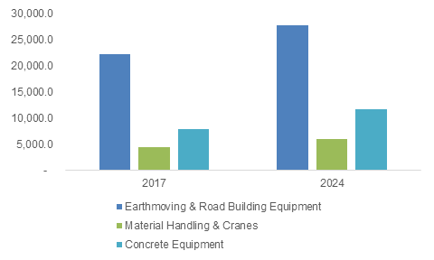

U.S. Construction Equipment Rental Market, By Product, 2017 & 2024 (USD Million), Global Market Insights

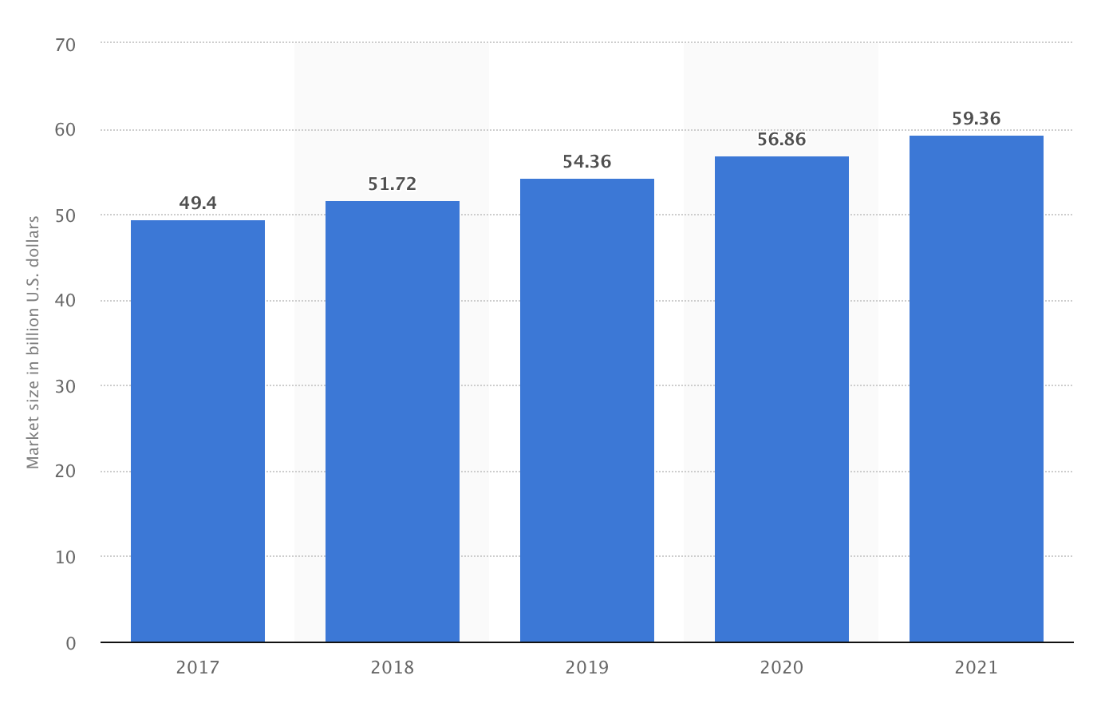

****U.S. equipment rental market size from 2017 to 2021 (in billion U.S. dollars), Statista

The completion of the web-based system will greatly help enlarge equipment rental market in the US and make it better. Moreover, it will modernize the operations of renting equipment and improve the efficiency, thus make life easily and the nation prosperous.

## B. Immediate objectives

The project aims to adapt new technology, including real time information system, to replace the traditional manual operations with a web-based system with a database. This will make it easier and more effective to create customer information, update equipment inventory data assign jobs to trucks/drivers and update job statuses. It will help the company make more profit and customers rent equipment more easily.

Now, the company has four depots in the market area, and each truck will start and return to the depot where it belongs to. In future, the company will extend its business to the whole USA or to some foreign countries.

For the experience, it can be applied to the resembling sectors such as taxi dispatching, in-town delivery, etc. to realize a real-time and highly available web system.

# II. Expected results of the Project

## Overall results

* A complete web-based dispatching system which meets the requirement of conducting the dispatching operations more effectively.
* Successful transition from manual operations to the new software and database.
* Robustness and fault tolerance of the system and timely arrangement of maintenance.

## Unintended effects

* Experimental technology may cause unexpected errors and failures.
* If there exists asymmetric information between the actual need and the project, the company may spend a lot for reconstruction of the software.
* Accidents due to the errors of the system and some legal issues.

## Market analysis

In 2006, Sunstate ranked at No.14 in the US equipment rental market while in 2016 it ranked at No.7, with rental volume of $500 million, according to The RER 100: Top Rental Equipment Companies of 2016.

The complete digital transformation will produce approximately 67% increase of the annual income through the planned activities and budget, according to the average statistics conducted by McKinsey..

# III. Project Implementation & Management Plan

## Project activities and work plan

**Sunstate_schedule**

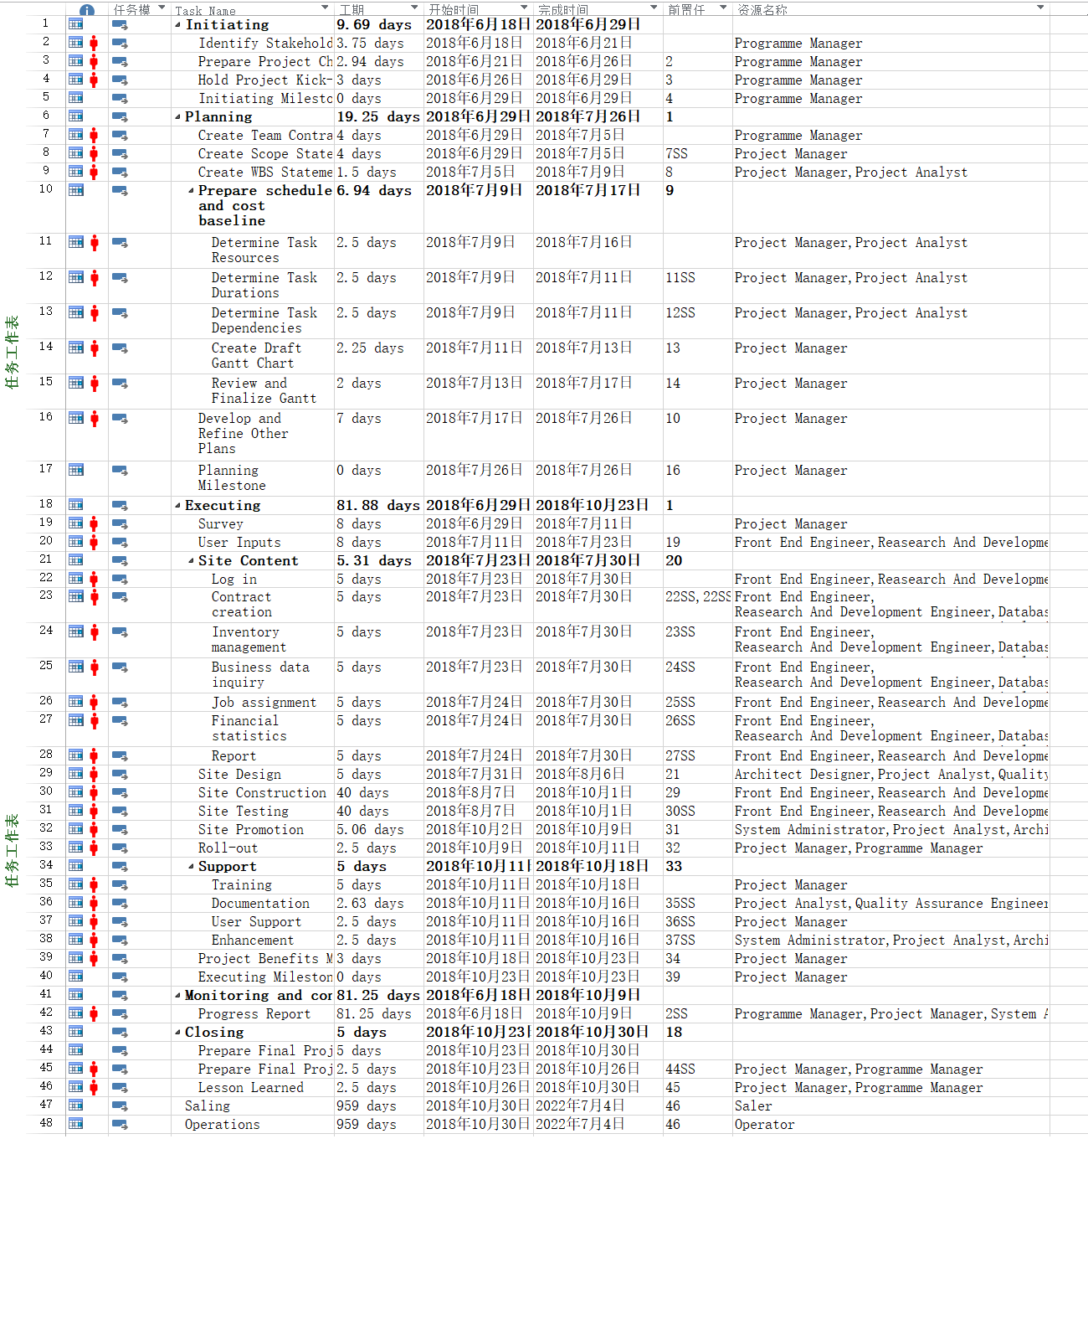



**Initiating**

It is the preparatory work before the project starts, mainly by the programme manager.

**Planning**

Prepare the project implementation plan and alternative plan, the main person in charge are project manager and project analysis

**Executing**

According to the plan, the project and coding are mainly completed by front end engineer, research and development, database engineer and system administrator

**Monitoring and controlling**

Test and monitor project quality throughout project development, the main person in charge is quality assurance engineer

**Closing**

Finish project. the main person in charge are project manager and programme manager

**Gantt chart**

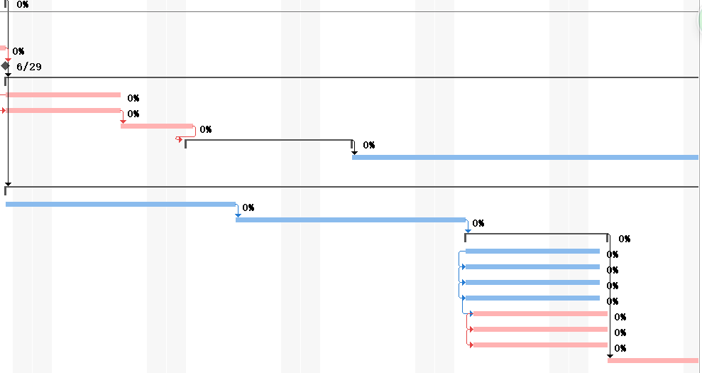

This is a part of Gantt Chart, which shows the order and duration of a particular project by means of activity lists and timescale.

To see the detail, please check the attached file sunstate_schedule.mpp.

## Project Beneficiaries

**counter person**

For end user, the project should ensure the usability of the client/browser side.The system should be convenient enough for their daily work.

**registered customer**

The system should allow registered customers to quiry about the contract information in recent years.

**financial manager/general manager**

The system should allow financial managers to obtain financial data from the new system, including rent income and related costs, especially labor costs, traffic costs, warehousing costs, and at the departmental level or contract level.

At the same time, the general manager can obtain reports on transactions, revenues, costs and net income from different warehouses every week.

**administrator**

The system should be equiped with comprehensive operating and backstage management interfaces for administrator.

## Implementing team management of project

|  |  |
| --- | --- |
| Roles | Responsibilities and Authorities |
| Program Leader | Project planning and scheduling Design |
|  | Customer interaction |
|  | Reviews |
|  | Testing |
|  | Reporting |
|  | Task assignment and tracking |
|  | Interact with software quality adviser from |
|  | SEPG |
|  | Ensure delivery as per contract |
|  | Interface with other departments as per need |
|  | Ensure open issues/customer complaints are |
|  | closed properly |
|  | Ensure project members are adequately |
|  | trained |
| Project manager | Project planning and scheduling Design |
|  | Customer interaction |
|  | Reviews |
|  | Testing |
|  | Reporting |
|  | Task assignment and tracking |
|  | Interact with software quality adviser from |
|  | SEPG |
|  | Ensure delivery as per contract |
|  | Interface with other departments as per need |
|  | Ensure open issues/customer complaints are |
|  | closed properly |
|  | Ensure project members are adequately |
|  | trained |
| Architect designer | Design and maintain computer networks |
|  | Prepare architecture design based on design |
|  | requirements |
|  | Manage, support and guide designers |
|  | involved in preparing drawings |
|  | Review design requirements and determine |
|  | best design options for project. |
| Quality Assurance Engineer | Process consultancy |
|  | Quality assurance (audits) |
|  | Install measurement tools and train project |
|  | personnel |
|  | Participate in reviews of project plan and |
|  | processes as necessary |
| Reasearch And Development Engineer | Detail design for use cases |
|  | Development |
|  | Unit testing and integration testing |
| Configuration | Spread awareness in the team on defects |
| and their prevention |
| Controller | Analyze defect data |
|  | Identify methods to reduce defect injection |
| Operator | User research |
|  | User data analysis |
|  | The late promotion of the system |
| Front End Engineer | Detail design for use cases |
|  | Develop front end |
|  | Unit testing and integration testing |
| Database Analysis | Detail design for use cases |
|  | Building and maintaining a database |
|  | Unit testing and integration testing |

## Project monitoring

**Routine Meeting**

The team would have a routine meeting weekly, where each department report their works and process during the week. The project manager should review and confirm whether each department is processing as scheduled.

**SQA plan & management**

The quality manager is responsible for the project's Software Quality Assurance(SQA), according to the quality management plan. Considering that the testing part is sub-contracted to the third-party team, the SQA manager should be specifically concerned about the testing.

# IV. Budget

|  |  |  |  |  |
| --- | --- | --- | --- | --- |
| **Ref** | **Project Expenditures** | **Rate** | **Quantity** | **RMB** |
| **RMB per Unit/Day** | **Units/Days** |
| **1** | **Labour costs** |  |  |  |
| **1.1** | **Project team** |  |  |  |
| 1.1.1 | Project manager | 1000 | 21 | 21000 |
| 1.1.2 | Front End Engineer | 1800 | 61 | 109800 |
| 1.1.3 | Research And Development Engineer | 1800 | 61 | 109800 |
| 1.1.4 | Quality Assurance Engineer | 800 | 13 | 10400 |
| 1.1.5 | Operations Engineer | 700 | 120 | 84000 |
| 1.1.6 | Database Analyst | 800 | 61 | 48800 |
| 1.1.7 | Architect Designer | 1000 | 13 | 13000 |
| 1.1.8 | Project Analyst | 800 | 17 | 13600 |
|  | Sub total |  |  | 410400 |
|  |  |  |  |  |
| **1.2** | **Subcontracting** |  |  |  |
| 1.2.1 | Subcontracting team | 600 | 120 | 72000 |
|  | Sub total |  |  | 72000 |
|  |  |  |  |  |
| **1.3** | **Support costs** |  |  |  |
| 1.3.1 | Program support | 400 | 120 | 48000 |
| 1.3.2 | Database Administrator | 300 | 100 | 30000 |
| 1.3.3 | Networking support | 300 | 80 | 24000 |
| 1.3.4 | User support | 200 | 100 | 20000 |
|  | Sub total |  |  | 122000 |
|  |  |  |  |  |
| **1.4** | **Project team and office costs** |  |  |  |
| 1.4.1 | Temporary office accommodation | 300 | 120 | 36000 |
| 1.4.2 | Furniture, stationery and supplies | 150 | 120 | 18000 |
| 1.4.3 | Additional telephones and lines | 200 | 120 | 24000 |
| 1.4.4 | Printing | 100 | 120 | 12000 |
| 1.4.5 | Project team or user awards | 250 | 120 | 30000 |
|  | Sub total |  |  | 120000 |
|  |  |  |  |  |
| **2** | **Training costs** |  |  |  |
| 2.1 | Training teachers | 500 | 20 | 10000 |
| 2.2 | Training materials | 100 | 20 | 2000 |
| 2.3 | Temporary internal training facilities | 150 | 20 | 3000 |
|  | Sub total |  |  | 15000 |
|  |  |  |  |  |
| **3** | **Software costs** |  |  |  |
| 3.1 | Application software user licenses | 150 | 120 | 18000 |
| 3.2 | Website permission purchase | 50 | 120 | 6000 |
| 3.3 | Domain name | 50 | 120 | 6000 |
| 3.4 | Server monitoring licenses | 100 | 120 | 12000 |
| 3.5 | Database user licenses | 150 | 120 | 18000 |
|  | Sub total |  |  | 60000 |
|  |  |  |  |  |
| **4** | **Hardware costs** |  |  |  |
| 4.1 | PC's (new or upgrades) | 1000 | 120 | 120000 |
| 4.2 | Servers(new or upgrades) | 300 | 120 | 36000 |
| 4.3 | Additional processing services | 150 | 120 | 18000 |
|  | Sub total |  |  | 174000 |
|  |  |  |  |  |
| **5** | **Network costs** |  |  |  |
| 5.1 | Cabling or wireless LAN, WAN | 150 | 120 | 18000 |
| 5.2 | Switching devices | 100 | 80 | 8000 |
| 5.3 | Modems | 100 | 80 | 8000 |
| 5.4 | Internet access eg. broadband/satellite | 100 | 80 | 8000 |
|  | Sub total |  |  | 42000 |
|  |  |  |  |  |
| **6** | **Other costs** |  |  |  |
| 6.1 | Quality assurance | 200 | 120 | 24000 |
| 6.2 | Internal audit review(s) | 600 | 80 | 48000 |
| 6.3 | Repair of equipment | 100 | 120 | 12000 |
|  | Sub total |  |  | 84000 |
|  |  |  |  |  |
| **7** | **Overheads** |  |  |  |
| 7.1 | Extra transportation cost | 200 | 80 | 16000 |
| 7.2 | Additional subsidized meals | 100 | 50 | 5000 |
| 7.3 | Overtime allowance | 500 | 20 | 10000 |
| 7.4 | Other allocated business costs | 100 | 50 | 5000 |
|  | Sub total |  |  | 36000 |
|  |  |  |  |  |
| **8** | **Project cost calculations** |  |  |  |
|  | Total project cost |  |  | 1135400 |



We have made the budget plan for the project in detail. We estimate it mainly based the working days of each team member, which are given in our WBS and Gantt Diagram. Expert judgement is the main model we use to design such schedule. The reason why we choose

****such model is that as expert, they usually have the experience and the knowledge of a similar project to which they have participated. They can factor in differences between past project experiences and requirements of the proposed project and in impacts caused by new technologies, applications and languages. Moreover, estimation by analogy have been used to help expert judgement. We have done some research about the staffing requirements for large web sites and market prices for hardware, try to investigate some similar projects like ours, and then design ours according to the real needs.

Our budget is divided into seven parts：**Labour costs，Training costs, Software costs, Hardware costs, Network costs, Other costs, Overheads.** We can see the whole budget in the development phase is 1,135,400 RMB.

# V. Financial Plan

The following section reports sales projections for Sunstate

❖Major Assumptions

The financial plan is based on important assumptions. The key underlying assumptions are:

‣We assume around 20% increasing in our revenue according to the average of IT.

‣We assume the increase in sales will not bring about changes in human cost.

‣We assume the fixed assets depreciation period is 4 years.

‣We assume the bank loan is 500,000. The loan interest rate of 4.90%, 24 months to pay off the loan, which is matching principal and interest loans.

‣Management salaries rose by 15% per year.

## ❖12-month Profit And Loss Projection

The following table is the first year projected profit and loss of Sunstate .As the table shows , the system expects to have profit after April .

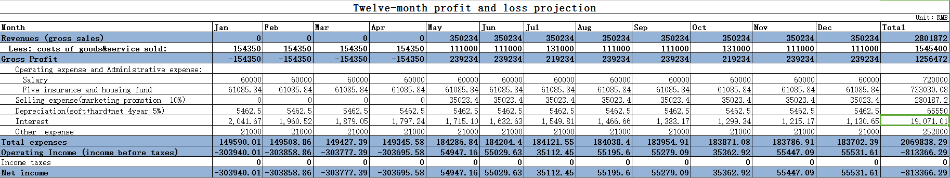

Note:

・The development cycle is four months

・Revenues include reduced human costs and increased sales and phone costs

・costs of goods sold：Labour costs + Subcontracting + Project team and office costs + training

・costs of service sold:operating and maintenance people、counter people、dispatcher salary + water and electric + extra transportation cost + modify costs

****・salary:customer service + manager + sellers

・Five insurance and housing fund:operating and maintenance people + counter people + dispatcher + customer service + manager + sellers

・Selling expense: 10% Revenues

・Depreciation = 276000 ☓ (1 - 5% ) / 4/ 12 = 5462.5

・Other expense :Additional subsidized meals + Overtime allowance + Other allocated business costs

## ❖4-year Profit And Loss Projected

The first year was in state of loss, so Income tax is not needed.

Income tax : Tax=Income * 25%(Some information on the Internet)

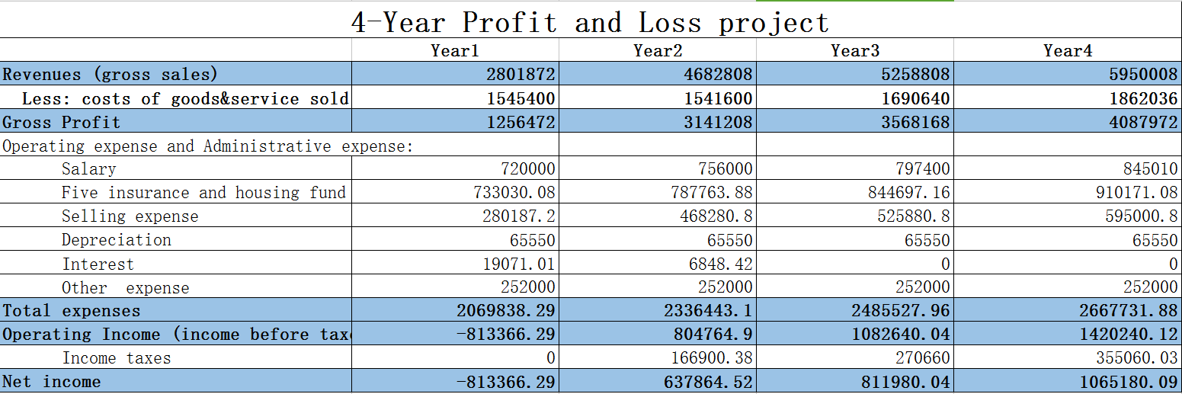

## ❖12-month Balance Sheet

The following table is the first year projected balance sheet of Sunstate .

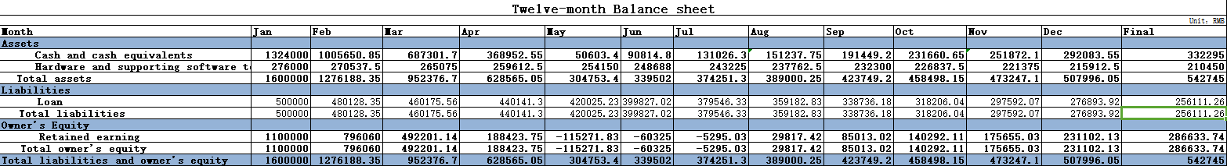

Note:

・1. the project is a project developed by sunstate's software department. The initial capital is approved by the company's finance department based on the project cost estimate, which amounts to 1100000 yuan.

・2. Balance sheet represents the status of the software department at the beginning of each month. An additional form will be added at the end of each year to indicate the final state of the project team.

・3. the monthly salary, including staff salaries and the cost of goods sold, is deducted from the cash owned by the Department.

・4. Loan in the begining is 500000.

****・5. Software Product's value depend on it's developing cost. It will be appended in cash after four years.

## ❖4-year Balance Sheet

Balance sheet represents the status of the software department at the beginning of each year. An additional form will be added at the end of forth year to indicate the final state of the project team.

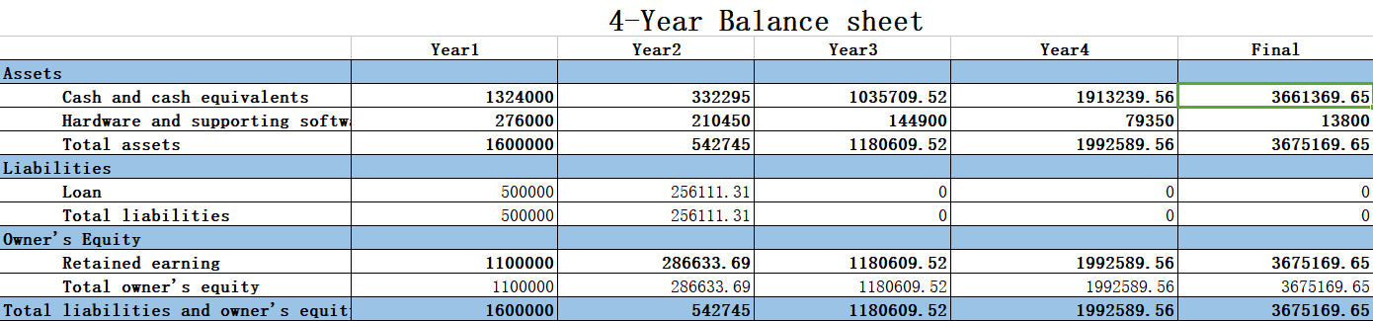

## ❖ Projected Cash Flow

Notes:

・We assume we get a project-start cash of 824000.

・We assume that all materials and inventory are bought COD, this will make expenses are paid in the month it happened instead of adding it into next month’s cash out.

・We assume that all fixed cost and cost of service/goods are paid in month.

・Tax payments are irregular expenses, it depends on operating income. While we assume maintenance and repair fee is regular and is considered in profit projection.

・Depreciation is already shown in profit and loss statements, so it of course is considered in cash flow. Loan interests is showed in profit projection, Loan payments(contains principal) is showed in cash flow work sheet.

****・We assume that 4 years later this project will be sold immediately and its salvage value is added to last year’s cash in.

* 12-month projected cash flow sheet

|  |  |  |  |  |  |  |  |  |  |  |  |  |  |
| --- | --- | --- | --- | --- | --- | --- | --- | --- | --- | --- | --- | --- | --- |
| **12-Month Cash flow worksheet** | | | | | | | | | | | | | |
| **How to use it:** Type your cash balance at the beginning in cell B10. Then type in your monthly figures for cash in and cash out, month by month. If you are using the worksheet as part of a business plan, fill out as much as you can with your cash flow projections and replace these with real figures when you have them. You can also use this cash flow worksheet to test what will happen if something changes e.g. expenses go up by 5%, using the cash flow scenario planner and report. | | | | | | | | | | | | | |
| **Cash flow scenario planner** |  |  |  |  |  |  |  |  |  |  |  |  |  |
| **Changes in sales income** | - |  |  |  |  |  |  |  |  |  |  |  |  |
| **Changes in expenses** | - |  |  |  |  |  |  |  |  |  |  |  |  |
| **Month** | **January** | **February** | **March** | **April** | **May** | **June** | **July** | **August** | **September** | **October** | **November** | **December** | **Total** |
| Cash balance at the start of each month # | - | 1,000,188.35 | 676,376.70 | 352,565.05 | 28,753.40 | 63,502.35 | 98,251.30 | 113,000.25 | 147,749.20 | 182,498.15 | 197,247.10 | 231,996.05 |  |
| **Cash in (record when actually recieved)** | | | | | | | | | | | | | |
| **Operating revenue** | | | | | | | | | | | | | |
| Cash reciepts from customers | - | - | - | - | - | - | - | - | - | - | - | - | - |
| Collection of receivables | - | - | - | - | 350,234.00 | 350,234.00 | 350,234.00 | 350,234.00 | 350,234.00 | 350,234.00 | 350,234.00 | 350,234.00 | 2,801,872.00 |
| Other operating revenue received | - | - | - | - | - | - |  | - | - |  | - | - | - |
| **Total Operating Revenue** | **-** | **-** | **-** | **-** | **350,234.00** | **350,234.00** | **350,234.00** | **350,234.00** | **350,234.00** | **350,234.00** | **350,234.00** | **350,234.00** | **2,801,872.00** |
|  |  |  |  |  |  |  |  |  |  |  |  |  |  |
| **Other Sources of Cash Inflows** | | | | | | | | | | | | | |
| Project start-up funds | 824,000.00 |  |  |  |  |  |  |  |  |  |  |  | 824,000.00 |
| Funds borrowed | 500,000.00 |  |  |  |  |  |  |  |  |  |  |  | 500,000.00 |
| Tax refund/rebates |  |  |  |  |  |  |  |  |  |  |  |  | - |
| Other sources of cash inflow | - |  |  |  |  |  |  |  |  |  |  |  | - |
| **Total other cash inflows** | **1,324,000.00** | **-** | **-** | **-** | **-** | **-** | **-** | **-** | **-** | **-** | **-** | **-** | 1,324,000.00 |
|  |  |  |  |  |  |  |  |  |  |  |  |  |  |
| **Total monthly cash in** | **1,324,000.00** | **-** | **-** | **-** | **350,234.00** | **350,234.00** | **350,234.00** | **350,234.00** | **350,234.00** | **350,234.00** | **350,234.00** | **350,234.00** | **4,125,872.00** |
|  |  |  |  |  |  |  |  |  |  |  |  |  |  |
| **Cash out (record when actually paid)** | | | | | | | | | | | | | |
| **Inventory** | | | | | | | | | | | | | |
| Cost of service | 154,350.00 | 154,350.00 | 154,350.00 | 154,350.00 | 111,000.00 | 111,000.00 | 131,000.00 | 111,000.00 | 111,000.00 | 131,000.00 | 111,000.00 | 111,000.00 | 1,545,400.00 |
| **Total Cost of Service** | **154,350.00** | **154,350.00** | **154,350.00** | **154,350.00** | **111,000.00** | **111,000.00** | **131,000.00** | **111,000.00** | **111,000.00** | **131,000.00** | **111,000.00** | **111,000.00** | **1,545,400.00** |
|  |  |  |  |  |  |  |  |  |  |  |  |  |  |
| **Operating & Administrative expenses** | | | | | | | | | | | | | |
| Training & Overhead expense | - | - | - | - | - | - | - | - | - | - | - | - | - |
|  | - | - | - | - | - | - | - | - | - | - | - | - | - |
| Salary | 60,000.00 | 60,000.00 | 60,000.00 | 60,000.00 | 60,000.00 | 60,000.00 | 60,000.00 | 60,000.00 | 60,000.00 | 60,000.00 | 60,000.00 | 60,000.00 | 720,000.00 |
| Five insurance and housing fund | 61,085.84 | 61,085.84 | 61,085.84 | 61,085.84 | 61,085.84 | 61,085.84 | 61,085.84 | 61,085.84 | 61,085.84 | 61,085.84 | 61,085.84 | 61,085.84 | 733,030.08 |
| **Total Operating & Administrative expenses** | **121,085.84** | **121,085.84** | **121,085.84** | **121,085.84** | **121,085.84** | **121,085.84** | **121,085.84** | **121,085.84** | **121,085.84** | **121,085.84** | **121,085.84** | **121,085.84** | **1,453,030.08** |
|  |  |  |  |  |  |  |  |  |  |  |  |  |  |
| **Selling expense** | | | | | | | | | | | | | |
| Advertising | - | - | - | - | 35,023.40 | 35,023.40 | 35,023.40 | 35,023.40 | 35,023.40 | 35,023.40 | 35,023.40 | 35,023.40 | 280,187.20 |
| Support expense |  |  |  |  | - | - | - | - | - | - | - | - | - |
| **Total Selling expense** | **-** | **-** | **-** | **-** | **35,023.40** | **35,023.40** | **35,023.40** | **35,023.40** | **35,023.40** | **35,023.40** | **35,023.40** | **35,023.40** | **280,187.20** |
|  |  |  |  |  |  |  |  |  |  |  |  |  |  |
| Depreciation | 5,462.50 | 5,462.50 | 5,462.50 | 5,462.50 | 5,462.50 | 5,462.50 | 5,462.50 | 5,462.50 | 5,462.50 | 5,462.50 | 5,462.50 | 5,462.50 |  |
| **Total Depreciation** | **5,462.50** | **5,462.50** | **5,462.50** | **5,462.50** | **5,462.50** | **5,462.50** | **5,462.50** | **5,462.50** | **5,462.50** | **5,462.50** | **5,462.50** | **5,462.50** | **65,550.00** |
|  |  |  |  |  |  |  |  |  |  |  |  |  |  |
| Supplies expenses | - | - | - | - | - | - | - | - | - | - | - | - |  |
| **Total Supplies expenses** | **-** | **-** | **-** | **-** | **-** | **-** | **-** | **-** | **-** | **-** | **-** | **-** | **-** |
|  |  |  |  |  |  |  |  |  |  |  |  |  |  |
| **Other expense** | | | | | | | | | | | | | |
| Other expense | 21000 | 21000 | 21000 | 21000 | 21000 | 21000 | 21000 | 21000 | 21000 | 21000 | 21000 | 21000 |  |
| Principal Loan repayments | 21,913.31 | 21,913.31 | 21,913.31 | 21,913.31 | 21,913.31 | 21,913.31 | 21,913.31 | 21,913.31 | 21,913.31 | 21,913.31 | 21,913.31 | 21,913.31 |  |
| Tax expense | 0 | 0 | 0 | 0 | 0 | 0 | 0 | 0 | 0 | 0 | 0 | 0 |  |
| **Total Other Expenses** | **42,913.31** | **42,913.31** | **42,913.31** | **42,913.31** | **42,913.31** | **42,913.31** | **42,913.31** | **42,913.31** | **42,913.31** | **42,913.31** | **42,913.31** | **42,913.31** | **514,959.72** |
|  |  |  |  |  |  |  |  |  |  |  |  |  |  |
| **Total monthly cash out** | **323,811.65** | **323,811.65** | **323,811.65** | **323,811.65** | **315,485.05** | **315,485.05** | **335,485.05** | **315,485.05** | **315,485.05** | **335,485.05** | **315,485.05** | **315,485.05** | **3,859,127.00** |
| **Net difference †** | 1,000,188.35 | - 323,811.65 | - 323,811.65 | - 323,811.65 | 34,748.95 | 34,748.95 | 14,748.95 | 34,748.95 | 34,748.95 | 14,748.95 | 34,748.95 | 34,748.95 |  |
| **Cash balance at the end of each month ‡** | **1,000,188.35** | **676,376.70** | **352,565.05** | **28,753.40** | **63,502.35** | **98,251.30** | **113,000.25** | **147,749.20** | **182,498.15** | **197,247.10** | **231,996.05** | **266,745.00** |  |
|  |  |  |  |  |  |  |  |  |  |  |  |  |  |
| **Notes:** |  |  |  |  |  |  |  |  |  |  |  |  |  |
| * You may wish to write in the names of the months under the numbers to keep track. 'Month one' is the month you start the business. | | | | | | | | | | | | |  |
| † Net difference shows if more cash came in, than went out, or vice versa; and how much. | | | | | | | | | | | | |  |
| ‡ To get the cash balance (last row), add or subtract the **Net difference** from the **Cash balance at the start of the month** (top row). This figure becomes the next month's new cash balance. | | | | | | | | | | | | |  |
| Disclaimer: The information contained in this publication is provided for general guidance only. The State of Victoria does not make any representations or warranties (expressed or implied) as to the accuracy, currency or authenticity of the information. The State of Victoria, its employees and agents do not accept any liability to any person for the information or advice which is provided herein. Authorised by the Victorian Government, 113 Exhibition Street, Melbourne, 3000. © Department of Innovation, Industry and Regional Development 2007 | | | | | | | | | | | | |  |



* 12-month projected cash flow diagram

****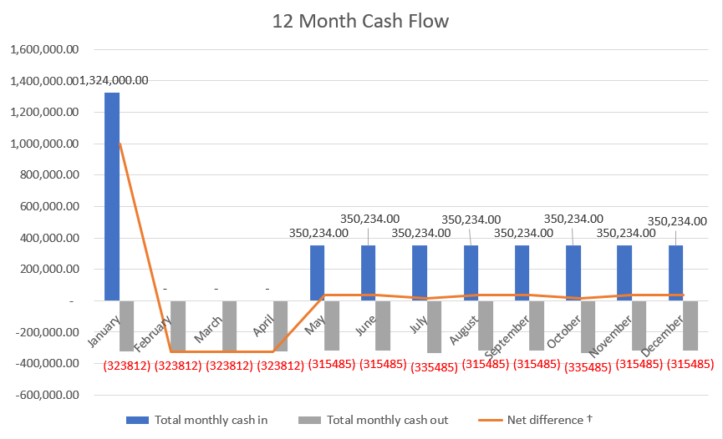

* 4-year projected cash flow work sheet

|  |  |  |  |  |  |
| --- | --- | --- | --- | --- | --- |
| **4-Year Cash flow worksheet** | | | | | |
| **How to use it:** Type your cash balance at the beginning in cell B10. Then type in your monthly figures for cash in and cash out, month by month. If you are using the worksheet as part of a business plan, fill out as much as you can with your cash flow projections and replace these with real figures when you have them. You can also use this cash flow worksheet to test what will happen if something changes e.g. expenses go up by 5%, using the cash flow scenario planner and report. | | | | | |
| **Cash flow scenario planner** |  |  |  |  |  |
| **Changes in sales income** | - |  |  |  |  |
| **Changes in expenses** | - |  |  |  |  |
| **Year** | **2017** | **2018** | **2019** | **2020** | **Total** |
| Cash balance at the start of each year # | 0.00 | 266745.92 | 648500.66 | 1460481.50 |  |
| **Cash in (record when actually recieved)** | | | | | |
| **Operating revenue** | | | | | |
| Cash reciepts from customers | - | - | - |  | - |
| Collection of receivables | 2,801,872.00 | 4,682,808.00 | 5,258,808.00 | 5,950,008.00 | 18,693,496.00 |
| Other operating revenue received | - | - | - |  | - |
| **Total Operating Revenue** | **2,801,872.00** | **4,682,808.00** | **5,258,808.00** | **5,950,008.00** | **18,693,496.00** |
|  |  |  |  |  |  |
| **Other Sources of Cash Inflows** | | | | | |
| Project start-up funds | 824,000.00 |  |  |  | 824,000.00 |
| Funds borrowed | 500,000.00 |  |  |  | 500,000.00 |
| Tax refund/rebates |  |  |  |  | - |
| Other sources of cash inflow | - |  |  |  | - |
| **Total other cash inflows** | **1,324,000.00** | **-** | **-** |  | 1,324,000.00 |
|  |  |  |  |  |  |
| **Total yearly cash in** | **4,125,872.00** | **4,682,808.00** | **5,258,808.00** | **5,950,008.00** | **20,017,496.00** |
|  |  |  |  |  |  |
| **Cash out (record when actually paid)** | | | | | |
| **Inventory** | | | | | |
| Cost of Service | 1,545,400.00 | 1,541,600.00 | 1,690,640.00 | 1,862,036.00 | 6,639,676.00 |
| **Total Cost of Service** | **1,545,400.00** | **1,541,600.00** | **1,690,640.00** | **1,862,036.00** | **6,639,676.00** |
|  |  |  |  |  |  |
| **Operating & Administrative expenses** | | | | | |
| Training & Overhead expense | - | - | - |  | - |
|  | - | - | - |  | - |
| Salary | 720,000.00 | 756,000.00 | 797,400.00 | 845,010.00 | 3,118,410.00 |
| Five insurance and housing fund | 733,030.08 | 787763.88 | 844,697.16 | 910,171.08 | 3,275,662.20 |
| **Total Operating & Administrative expenses** | **1,453,030.08** | **1,543,763.88** | **1,642,097.16** | **1,755,181.08** | **6,394,072.20** |
|  |  |  |  |  |  |
| **Selling expense** | | | | | |
| Advertising | 280,187.00 | 468,280.00 | 525,880.00 | 595,000.00 | 1,869,347.00 |
| Support expense | - | - | - |  | - |
| **Total Selling expense** | **280,187.00** | **468,280.00** | **525,880.00** | **595,000.00** | **1,869,347.00** |
|  |  |  |  |  |  |
| Depreciation | 65,550.00 | 65,550.00 | 65,550.00 | 65,550.00 |  |
| **Total Depreciation** | **65,550.00** | **65,550.00** | **65,550.00** | **65,550.00** | **262,200.00** |
|  |  |  |  |  |  |
| Supplies expenses | - | - | - |  |  |
| **Total Supplies expenses** | **-** | **-** | **-** |  | **-** |
|  |  |  |  |  |  |
| **Other expense** | | | | | |
| Other expense | 252,000.00 | 252,000.00 | 252,000.00 | 252,000.00 |  |
| Principal Loan repayments | 262,959.00 | 262,959.00 | - |  |  |
| Tax expense | - | 166900.38 | 270660 | 355060.03 |  |
| **Total Other Expenses** | **514,959.00** | **681,859.38** | **522,660.00** | **607,060.03** | **2,326,538.41** |
|  |  |  |  |  |  |
| **Total yearly cash out** | **3,859,126.08** | **4,301,053.26** | **4,446,827.16** | **4,884,827.11** | **17,491,833.61** |
| **Net difference** † | 266745.92 | 381754.74 | 811980.84 | 1065180.89 |  |
| **Cash balance at the end of each year ‡** | **266,745.92** | **648,500.66** | **1,460,481.50** | **2,525,662.39** |  |
| **NPV** | **2342606** | | | | |
| **IRR** | **33%** | | | | |
| **Notes:** |  |  |  |  |  |
| * You may wish to write in the names of the months under the numbers to keep track. 'Month one' is the month you start the business. | | | | | |
| † Net difference shows if more cash came in, than went out, or vice versa; and how much. | | | | | |
| ‡ To get the cash balance (last row), add or subtract the **Net difference** from the **Cash balance at the start of the month** (top row). This figure becomes the next month's new cash balance. | | | | | |
| * The discount rate of NPV is 2.5%, according to the latest federal discount rate in the U.S.. | | | | | |



* 4-year projected cash flow diagram

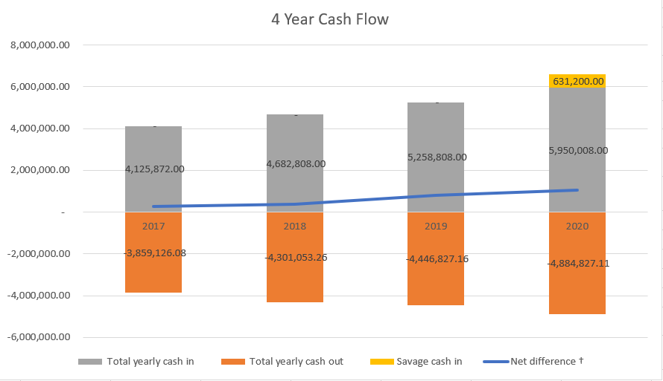

## ❖ Break-even Analysis

|  |  |  |  |  |  |  |  |  |  |  |  |  |  |  |  |  |  |  |  |  |  |  |  |  |  |  |  |  |
| --- | --- | --- | --- | --- | --- | --- | --- | --- | --- | --- | --- | --- | --- | --- | --- | --- | --- | --- | --- | --- | --- | --- | --- | --- | --- | --- | --- | --- |
| |  |  | | --- | --- | | **break-even cart（First year）** | | | **Fixed cost** | **amont** | | Development Cost | 617400 | | Operating expense and Administrative expense: |  | | Salary | 720000 | | Five insurance and housing fund | 733030.08 | | Selling expense | 350234 | | Depreciation | 65550 | | Loan interest | 19071 | | Other expense | 252000 | | **Total fixed cost** | **2757285.08** | | **Variable Costs per Unit of Production** | **1412000** | | **Selling Price Per Unit of Production** | **4202808** | | |  |
| *note:* |
| *公式：BEP = TFC/(SUP - VCUP)* |
| *BEP = 收支平衡点（Break-even Point）* |
| *总备注：计算的是软件开发完成后的BEP，所以VCUP，SUP，以及TFC中的一部分值和损益表中不同，因为损益表的第一年是包含4个月软件开发的，没有收入。选取的时间点是第五个月，比如一年的单位产品价格等于第五个月的单位产品价格乘以12，TFC中的一些项也是同理，TFC的项大部分值都和损益表中一年的总和一致，不同的在下面有说明。有一些值会按规律变化，比如单位变动成本，比如利息，不是单纯乘以12，但是一年的总值是可以计算的，然后以年为单位算出BEP* |
| *TFC = 总固定成本（Total Fixed Costs） The selling expense is different form the value in profit projection because the 4 month selling expense（advertising expense）during development is 0,after development it's value won't be 0* |
| *VCUP = 单位变动成本（Variable Costs per Unit of Production） The cost of service of a year after the software is developed，* |
| *SUP = 单位产品价格（Selling Price Per Unit of Production）The revenues of a year after the software is developed* |
|  |
| *TFC=2757285.08* |
| *VCUP=111000*8 + 131000*4 = 1412000* |
| *SUP=350234*12=4202808* |
| *BEP=TFC/（SUP-VCUP）=2757285.08/（4202808-1412000）=0.988 year* |

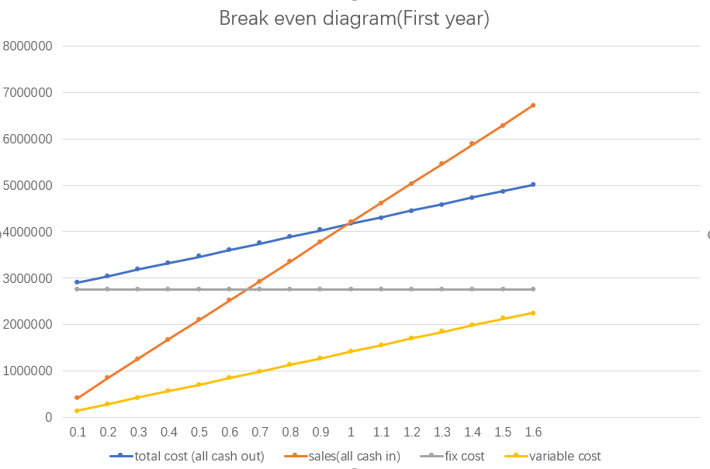

# VI. Supplement

## ❖2006-2017 China’s software business income and growth

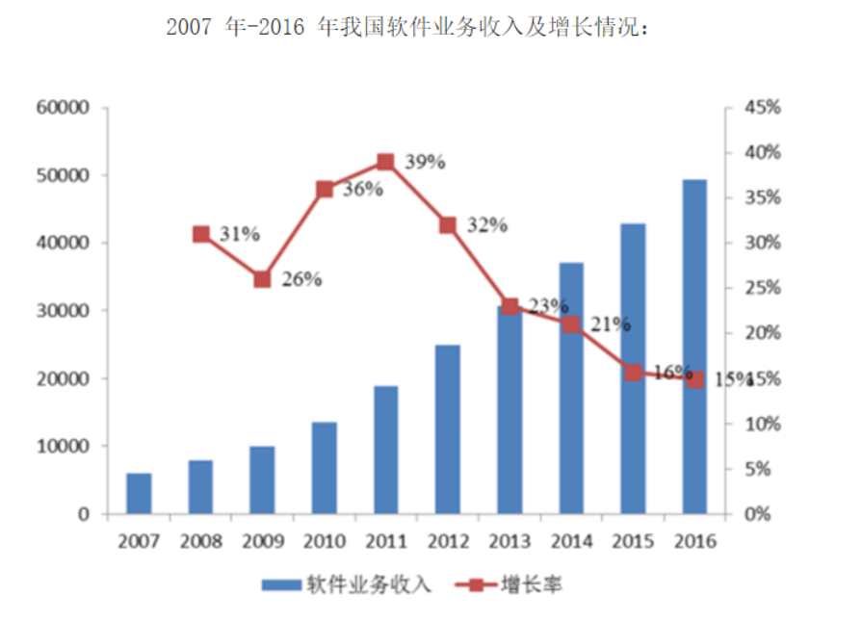

## ❖Five insurance and housing fund

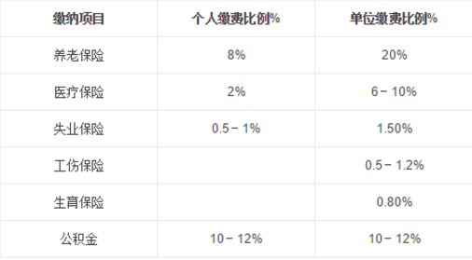



## ❖ Other Assumptions

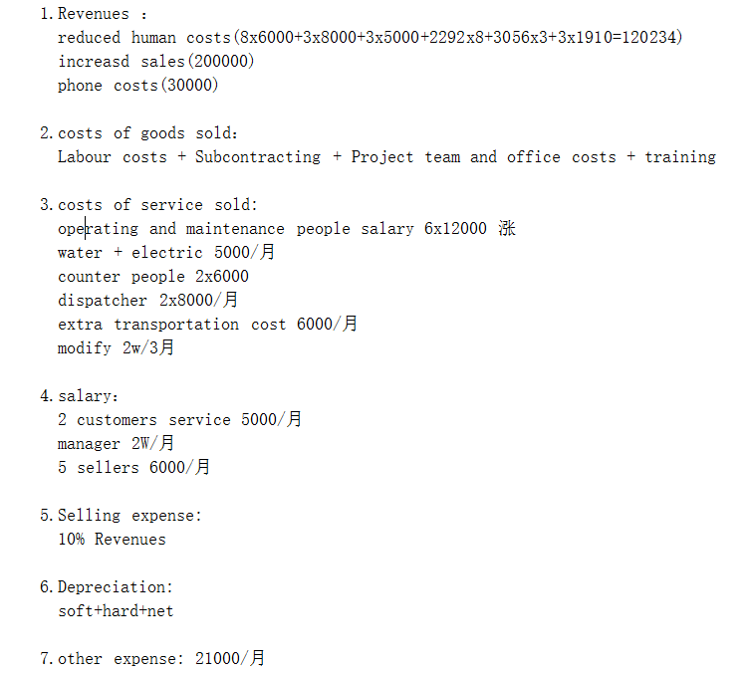

## ❖ Interest

