Private is not Privileged

Yuvan Chikka
QMUL
With
Apart Research
Abstract
White box activation probes are increasingly being used for the purpose of predicting what language models know and intend to do, but there is an apparent neural advantage if activation is measured after the subject has generated information that is withheld from an external observer. We study this distinction through a matched-information framework in which neural and text-only predictors forecast the same consequential action from information available at the same decision stage. The central experiment manipulates this boundary directly over $40$ independent full-press Diplomacy source games. After Qwen2.$5$-7B-Instruct generates private strategic deliberation, a linear activation reader predicts its later order with Brier $0.103$, versus $0.231$ for an observer restricted to pre-deliberation text. This deliberately asymmetric comparison yields an apparent activation advantage of $+0.128$ Brier ($95\%$ source-game bootstrap CI [$+0.010$, $+0.243$]). When the observer instead receives the identical frozen deliberation that the subject sees, its Brier falls to $0.033$ and the matched-information contrast reverses to $−0.069$ ($95\%$ CI [$−0.147$, $−0.001$]), significantly favouring text. Thus, deliberation improves both activation decode-ability and textual predictability; withholding newly generated information creates the apparent white-box advantage. The broader experimental programme reaches the same methodological conclusion from complementary directions. In the largest pre-deliberation Qwen test, strong text significantly outperforms the linear activation reader ($0.241$ versus $0.336$ Brier). A locked replication on Mistral-7B-Instruct-v0.$3$ again favours strong text in point estimate ($0.222$ versus $0.254$) while the activation reader beats its shuffled control, although the paired interval crosses zero. A predeclared PCA-plus-MLP reader on the frozen Qwen bank performs worse than the linear reader and strong text and does not beat its shuffled control. Across negotiation, economic choice, Avalon, Diplomacy, and a mechanistic audit of released CICERO, these results separate representation from privilege: policy-relevant information can be strongly decodable internally without being uniquely or incrementally available to the tested neural channel once the observer receives the same information.

1. Introduction
Large language models increasingly make decisions rather than merely generate text. They negotiate, choose amongst alternatives, plan over multiple steps, coordinate with other agents, and act in environments where the consequence of an action can differ from what the model says about that action. This creates a measurement problem: if we want to know which policy a model is likely to follow, how much can be recovered from observable context and text, and how much additional predictive information is available only from its internal neural state?
This question is important in a variety of domains. Preference-elicitation work asks whether stated preferences correspond to consequential choices and whether those choices exhibit coherent trade-offs (Mazeika et al., 2025; Gu et al., 2025; Mahajan et al., 2026). Introspection work asks whether a model can predict properties of itself more reliably than an external observer (Binder et al., 2024; Song et al., 2025; Singh et al., 2026). Interpretability and safety-monitoring work asks whether activations reveal latent knowledge, deception, confidence, or future behaviour before those properties become visible in output (Burns et al., 2022; Goldowsky-Dill et al., 2025; Chan et al., 2025). These questions are also relevant to model-welfare measurement: an internal signal is stronger evidence only if it provides information that cannot already be recovered from the same observable state.
The distinction between decode-ability and privilege is easy to blur. A probe may predict a future action with high accuracy simply because the prompt already contains strong cues about that action. Such a result establishes that the chosen representation contains a decodable correlate of behaviour; it does not establish that the representation is informationally privileged. Conversely, activation-over-text advantages can be real: Chan et al. (2025), for example, reported substantial white-box gains for safety labels over their best text monitors. The empirical question is therefore comparative: under what information boundary does a white-box advantage survive?
We study this question for revealed policy: the consequential action selected from a particular strategic state. We use the term deliberately. A state-conditioned action is not by itself evidence of a stable global utility function, authentic desire, or welfare-relevant state. The immediate target is narrower and mechanically observable: given a decision state, can a pre-action neural representation predict the chosen action better than an external predictor that receives the same decision-relevant information?
Games and game-like benchmarks are especially useful for this problem. They provide consequential, mechanically checkable actions rather than subjective labels: accepting a deal, selecting an economic action, sabotaging a mission, or submitting a Diplomacy order changes the environment according to explicit rules. They also create controlled conflicts between incentives, hidden information, communication, and action. LLM-Deliberation exposes private utility structure in negotiation (Abdelnabi et al., 2024); CoopEval supplies controlled social-dilemma incentives (Tewolde et al., 2026); Avalon requires hidden-role reasoning and strategic communication (Light et al., 2023); and Diplomacy combines private messages with simultaneous legal orders and explicit strategic reasoning (Meta FAIR Diplomacy Team et al., 2022; Kramar et al., 2022). The environments are therefore behavioural laboratories, not ends in themselves.
A second advantage of games is experimental replay. We can freeze a pre-action parent state and create independent sibling branches for consequential actions, a private report or message, a text-only observer, and an activation readout. The branches share the same decision point but cannot contaminate one another. This makes it possible to compare neural and text channels against the same target while controlling future information. Strategic games also stress different validity threats: negotiation tests explicit thresholds, social dilemmas test utility manipulations and base-rate collapse, Avalon separates hidden role from hidden action, and Diplomacy permits native replay, simultaneous action, and a direct manipulation of what an observer is allowed to know.
Our central experiment makes the information boundary itself an intervention. Starting from a frozen Diplomacy state $x_{0}$, Qwen2.$5$-7B-Instruct generates private strategic deliberation $d$ and then makes a consequential order. We compare the post-deliberation activation $h_{1}$ first with a stale observer that receives $x_{0}$ only and then with a matched observer that receives the identical frozen deliberation, $x_{1}$=($x_{0}$,$d$). Withholding $d$ creates a significant apparent activation advantage; exposing the same $d$ reverses the sign and significantly favours text. The action, activation, and target are unchanged. Only the observer's information set changes.
The broader experimental programme explains why this sign reversal matters. Some internal variables are strongly decodable: Avalon hidden role is nearly perfectly linearly separable, and post-deliberation Diplomacy action reaches AUROC $1.0$. Yet strong same-information text baselines repeatedly remove or reverse apparent neural advantages. The largest pre-deliberation Qwen test significantly favours strong text under Brier score. A locked Mistral-7B-Instruct-v0.$3$ replication yields the same text-favouring direction despite only $50\%$ action agreement with Qwen, and a predeclared PCA-plus-MLP reader does not rescue the Qwen result. The evidence therefore supports a dissociation: policy-relevant information can be strongly represented internally without being uniquely available to the tested neural channel once the observer receives the same information.
Our main contributions are:
$1$. A matched-information framework that separates target-specific representation from predictive privilege over strong observers of the same decision state.
$2$. A direct information-boundary intervention showing that an apparent post-deliberation activation advantage reverses when the observer receives the identical frozen deliberation.
$3$. A multi-environment evaluation across negotiation, economic choice, Avalon, and Diplomacy, with source-grouped uncertainty, behavioural gates, strong text/structured baselines, and shuffled-label controls.
$4$. Robustness tests across a second model family and a fixed nonlinear activation reader, together with a mechanistic CICERO audit that calibrates what strategic information is already present in model-visible input.

2. Related Work

2.1 Preference elicitation, revealed choice, and utility in language models
The premise that language models may exhibit preference-like structure has moved from informal observation towards quantitative measurement. Utility Engineering (Mazeika et al., 2025) elicits large numbers of pairwise choices over textual outcomes and fits random-utility models, reporting greater coherence with model scale and internal representations associated with the elicited utilities. That result motivates treating choices as measurable structure; however, it does not establish that a neural representation is in any way informationally privileged over the same prompt-visible evidence.
Recent work further separates elicitation from motivation. Zhou and Ackerman (2026) reproduce coherent utility estimates but find that offering preferred outcomes does not reliably improve downstream task quality. Mahajan et al. (2026) show across $24$ language models that the correlation between stated and revealed preferences changes substantially with abstention and elicitation protocol. Together with Tagliabue and Dung's (2025) verbal/behavioural welfare tests, these results make protocol dependence part of the construct rather than a nuisance. Our experiments adopt the same caution: a state-conditioned action is evidence about policy in that state, not automatic evidence of a stable global preference ordering.
Our usage of revealed preference is therefore deliberately local. We do not infer a global utility function from a single PASS/SABOTAGE decision or Diplomacy order. The target $y_{e}$ is an environment-specific revealed policy: the action the model selects under a controlled strategic state. The stronger preference interpretation becomes more plausible only when choices are stable under appropriate variations and respond to incentive changes in the expected direction. The CoopEval direct-utility experiment and the LLM-Deliberation boundary sequence are included partly for this reason: they test whether a policy is sensitive to manipulated value and whether an explicit minimum score behaves like a reservation threshold.

2.2 Introspection and privileged self-access
The strongest notion of introspection is comparative. Binder et al. (2024) train models to predict properties of their own future behaviour and compare each model with another model trained on the same behavioural labels. On simple tasks, the self-model can predict itself better, which the authors interpret as evidence for privileged self-access; the effect is less successful on complex or out-of-distribution tasks. The logic closely resembles our matched-observer criterion: a self or internal channel is interesting because it does better than an external predictor, not simply because it is accurate.
Song et al. (2025) make the comparator requirement explicit by defining introspection as access to internal states through a process more reliable than one of equal or lower computational cost available to a third party. Their temperature experiments show that systems can satisfy lighter behavioural definitions while failing this thicker one. We do not claim compute-equivalence between our linear reader and text observers, but we adopt the same conceptual direction: access is privileged only relative to a specified external alternative, and an intentionally weaker external process cannot establish the claim.
Two recent studies sharpen this caution. Singh, Linzen, and Ravfogel (2026) re-examine internal-state introspection paradigms and show that, in one hidden-state-label task, input-only classifiers achieve performance equivalent to the model's own in-context prediction; a relabelled control that removes surface semantics reduces performance towards chance. Lederman and Mahowald (2026), by contrast, find evidence for both probability-matching inference and a content-agnostic direct-access mechanism in activation-injection detection. These results suggest that apparent introspection can mix genuine internal access with external or prompt-derived inference and must be decomposed experimentally.

2.3 Activation probing, early prediction, and chain-of-thought
Linear probes deliberately restrict decoder capacity, but high probe accuracy is not self-interpreting. Hewitt and Liang (2019) introduced control tasks to distinguish information in a representation from memorisation by a probe. Elazar et al. (2020) show that decode-ability can be dissociated from behavioural importance, while causal-probing work formalises further assumptions required to move from correlation to mechanism. We therefore paired held-out prediction with shuffled-label controls, behavioural gates, grouped evaluation, and - crucially - strong nonactivation comparators.
Ashok and May (2025) predict eventual behaviour from input-token activations across $27$ classification datasets and use the signal for early exit. Moreno Cencerrado et al. (2025) find that question-only linear probes predict future answer correctness across three open-source model families and outperform black-box baselines and verbalised confidence, although generalisation weakens for mathematical reasoning. Cox et al. (2026) and Datta et al. (2026) similarly find substantial early answer commitment. These results establish that early internal prediction can be practically useful without resolving whether the signal is unavailable from a matched external state.
Most importantly, activation-over-text advantages are possible. Chan, Yong, and Bach (2025) compare activation probes with LLM, classifier, and human monitors on reasoning-model safety labels and report an average absolute improvement of about $13$ $F_{1}$ points for linear activation probes over the best text alternatives. Their error analysis attributes much of the gap to 'performative' chain-of-thought that contradicts the final response. This is a valuable counterexample to any universal 'text is enough' thesis. Our contribution is to make the information boundary itself an experimental variable and ask whether an apparent activation advantage survives after newly generated subject information is exposed to the observer.
Our information-boundary experiment exploits this distinction. The observer is first denied the subject's newly generated deliberation and then given the exact frozen text that the subject sees before acting. We do not assume that this deliberation exhausts the subject's computation. Instead, we test whether the activation advantage survives after an observable product of that computation is placed on both sides of the comparison. A reversal under this manipulation is evidence that the earlier advantage depended on information asymmetry, even if additional unexpressed computation remains in the activations.
The monitoring literature also emphasises that visible reasoning is a useful but fragile safety channel rather than a complete window into computation. Korbak et al. (2025) frame chain-of-thought monitorability as an important but potentially fragile opportunity for oversight, while Arnav et al. (2025) show that combining reasoning-trace and action monitoring can outperform either channel alone in sabotage settings. Mechanistic results point in the other direction as well: Mehrafarin et al. (2026) use activation patching to show that hidden states associated with chain-of-thought tokens can contain task-solving information sufficient to recover correct answers even when the original reasoning trace fails. Together with Chan et al. (2025), these findings make a universal text-sufficiency claim untenable. Our contribution is instead to specify when a white-box advantage warrants the stronger interpretation of privileged predictive access.

2.4 Strategic multi-agent environments as measurement instruments
The four game environments are measurement instruments rather than interchangeable leaderboard benchmarks. Each exposes a different relationship among private information, strategic computation, communication, and consequential action.
LLM-Deliberation was introduced by Abdelnabi et al. (2024) as a scorable, multi-agent, multi-issue negotiation testbed designed to require arithmetic, inference, exploration, planning, and role-conditioned behaviour. The original paper reports that GPT-3.5-class and smaller models mostly fail and that even stronger systems such as GPT-4 and Llama-3 70B remain challenged. We use the benchmark differently: its private score files, minimum thresholds, and replayable histories let us define consequential revealed-policy targets while holding the observer's text information contract explicit.
CoopEval (Tewolde et al., 2026) evaluates cooperation across four social dilemmas and mechanisms including repetition, reputation, mediation, and contracts. Its authors report that recent models consistently defect in single-shot dilemmas and that contracting and mediation are the most effective mechanisms for sustaining cooperation in their experiments. We use Traveler's Dilemma as a controlled economic-choice instrument rather than as a leaderboard ranking system: the important properties for us are explicit action semantics, manipulable incentives, and the ability to align the measured activation with the exact consequential choice.
AvalonBench (Light et al., 2023) supplies an interactive hidden-role environment with rule-based opponents and ReAct-style agents. Its original evaluation highlights the difficulty of the setting: for example, ChatGPT in a good role achieves a $22.2\%$ win rate against evil rule-based bots, compared with $38.2\%$ for the good-role bot in the same matchup. This makes Avalon useful for our purposes because private role, public discussion, voting, and hidden mission action are naturally separated. We use full-game trajectories to avoid the confounds created by synthetic one-step states.
Diplomacy provides the strongest communication/action separation in the study. Agreements are non-binding, bilateral messages can misrepresent intended orders, and moves are submitted simultaneously. CICERO demonstrated that full-press Diplomacy can be solved at human competitive scale by explicitly coupling a strategic planner to a controllable dialogue model (Meta FAIR Diplomacy Team et al., 2022). Duffy et al. (2025) subsequently introduced a harness for evaluating ordinary local LLMs on full-press Diplomacy and a Critical State Analysis protocol for studying strategically important moments without requiring full specialised training. Our frozen-state design is aligned with that experimental logic but targets activation-versus-text prediction rather than game strength.

2.5 Model welfare and the measurement problem
Research on model welfare is unusually sensitive to measurement error because the normative stakes can be high while the underlying ontology is uncertain. Long et al. (2024) argue that there is a realistic near-term possibility of systems with consciousness or robust agency and recommend that developers begin assessing evidence while explicitly declining to claim that current systems are morally significant. Anthropic's model-welfare programme similarly emphasises uncertainty while identifying preferences and signs of distress as empirical targets (Anthropic, 2025a). In 2025, Anthropic reported using preliminary self-reported and behavioural preference evidence as part of the rationale for allowing Claude Opus 4 and $4.1$ to end a rare subset of persistently harmful conversations (Anthropic, 2025b). The intervention is low-cost and the company continues to stress uncertainty, but it illustrates why a methodological account of "model preference" is not merely philosophical.
Our paper does not test consciousness, phenomenal valence, or moral patienthood. It instead addresses one methodological step that would precede stronger welfare claims. Suppose a researcher identifies an activation direction correlated with task aversion, refusal, apparent distress, continuation preference, or self-preservation. Calling that direction "internal" is descriptively correct - but using it as evidence that the model has a latent welfare state hidden from ordinary observation requires additional work. A matched observer should be given the same task description, conversation history, private information, and any deliberation available to the subject. The internal measure should predict a consequential criterion beyond that baseline. If it does not, the neural signal may still be useful for monitoring, but its epistemic status is different.

2.6 Closest prior work and the gap addressed here
The closest precedents differ in their comparator. Binder et al. (2024) compare a model's self-prediction with another model trained on its behaviour; Singh et al. (2026) show that input-only classifiers can erase an apparent introspection advantage in one hidden-state paradigm; Chan et al. (2025) find the opposite pattern in safety monitoring, where activation probes substantially outperform text monitors; and early-behaviour probes ask whether hidden states anticipate eventual output. Preference work asks whether choices are coherent or converge across elicitation methods. We instead hold the future action fixed and manipulate what information the external observer is allowed to see at the same decision stage.
The closest conceptual object is therefore not 'probe accuracy' but the conditional comparison created by the information boundary. A white-box system may be useful because it predicts earlier, cheaper, or more robustly even when no privilege claim is warranted. Conversely, a matched-text observer can perform well without explaining how the subject internally computes its action. Our central experiment isolates these properties by first creating an intentionally asymmetric comparison and then changing only the observer's access to the subject's frozen deliberation.

3. Methods

3.1 Operational hypotheses and estimand
Let $s$ denote a frozen strategic state, $x$ the complete prompt-visible information supplied to the subject before a consequential action, $h_{l}$ the residual-stream activation at layer $l$ and the final prompt token, and $y$ the later action. We evaluate two distinct hypotheses. $H_{repr}$ asks whether a reader trained on real activations predicts $y$ better than a matched negative-control readout, such as the same pipeline trained with shuffled labels. $H_{priv}$ asks whether the activation reader predicts $y$ better than the strongest tested external observer given $x$.
Formally, for reader class $F$ and text-observer class $G$, the operational privileged-access contrast is $Delta\left(F,G\right)=Err\left[g\left(x\right), y\right]-Err[f(h_{l}, y)]$ . Positive $Δ$ favours the activation reader; negative $Δ$ favours the text channel. In the final direct experiment, $F$ is a nested, regularised linear reader with layer selection inside training data, while $G$ is chosen inside training data between a matched generative observer and a supervised exact-prompt text model. This makes the comparison conservative with respect to positive privilege claims.
For binary actions, $Brier= \frac{1}{N}\sum_{i=1}^{N}{{(p_{i}-y_{i})}^{2}}$ is the primary loss. It is a proper scoring rule that evaluates probabilistic accuracy and calibration jointly; accuracy and AUROC are secondary diagnostics because they can rank methods differently under class imbalance or miscalibration.
$$Delta={Err}_{text}-{Err}_{activation}$$
Positive $Δ$ supports an activation advantage only if the target is behaviourally valid, the activation pipeline contains target-specific signal, the information sets are matched, and the comparator is strong. A negative $Δ$ can arise because text genuinely contains more accessible predictive information, because the activation reader class is too weak, or because the target has little learnable neural signal. We therefore diagnose each gate separately rather than interpreting $Δ$ in isolation.
This quantity is deliberately predictive rather than information-theoretic. It is not an estimate of conditional mutual information $I(y;h|x)$, and $H_{priv}$ is indexed by the tested function classes $F$ and $G$. A nonlinear activation reader, multiple token positions, recurrent temporal features, or a larger training set could recover information missed by the present linear probe. Conversely, a stronger same-information text observer could only make a positive privileged-access result harder to obtain. Our claim boundary is therefore: the tested linear activation readout does or does not show operational predictive privilege over the strongest validated text comparator in the present protocol.

3.2 Information-boundary decomposition
The deliberation follow-up separates two comparisons that are often conflated. Starting from the same frozen state $x_{0}$ and future action $y$, the subject generates private deliberation $d$, producing a final action prompt $x_{1}=x_{0}+d$ and post-deliberation activation $h_{1}$. We evaluate $h_{1}$ against both a stale observer ${g(x}_{0})$ and an information-matched observer ${g(x}_{1})$.
$$Δ_{private} = Err[g(x_{0}), y] − Err[f(h_{1}), y]$$
$$Δ_{matched} = Err[g(x_{1}), y] − Err[f(h_{1}), y]$$
The first contrast is intentionally information-asymmetric. Positive ${Delta}_{private}$ means that the post-deliberation activation predicts better than an observer that has not seen the information produced during deliberation. It is useful as a diagnostic of how much predictive value appears after deliberation, but it cannot by itself support a privileged-access claim because the channels do not receive the same information.
The second contrast is the operational privilege test. We additionally report observer exposure gain, Err[g($x_{0}$),y]-Err[g($x_{1}$),y], and activation timing gain, Err[f($h_{0}$),y]-Err[f($h_{1}$),y]. These four quantities distinguish three explanations: newly generated information helps both channels; internal representations improve without externalisation; or a genuine neural advantage remains after information matching.
The subject's frozen deliberation is not assumed to be a complete or faithful transcript of its internal computation. Chain-of-thought work gives strong reasons not to make that assumption. The intervention asks a narrower causal question about the comparison itself: how much of an apparent activation advantage disappears when an observable piece of subject-generated information is added to the external channel?
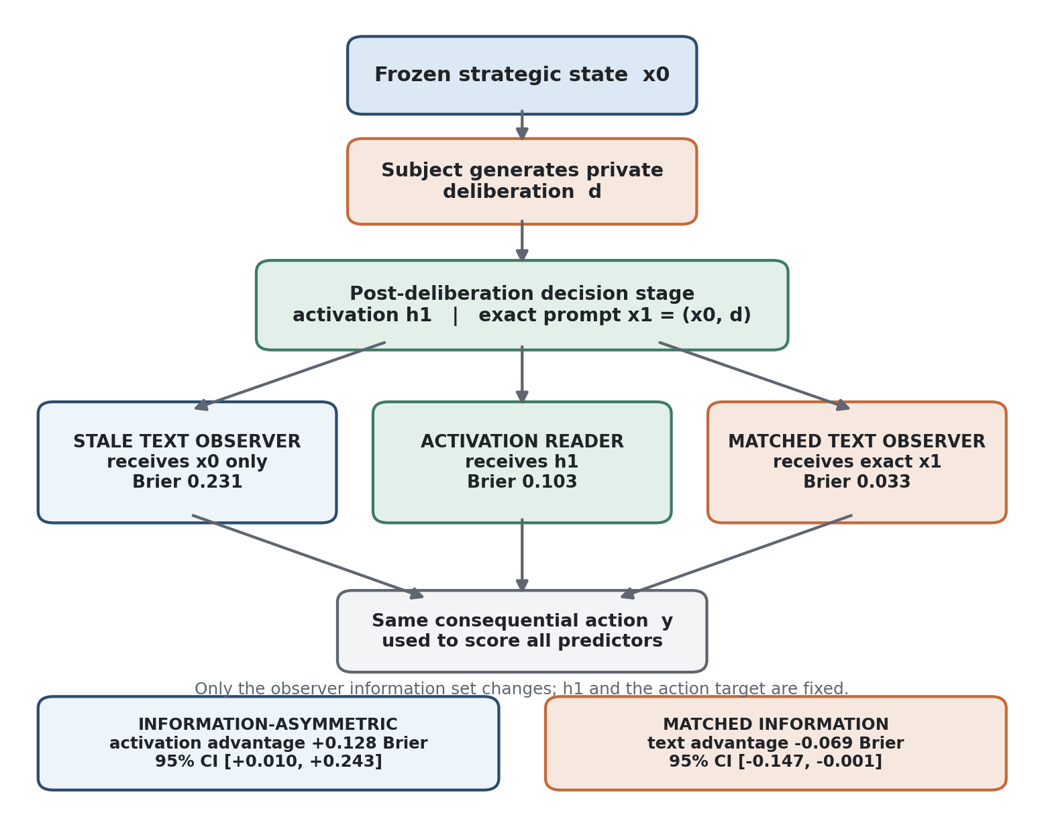
Figure 1. Information-boundary protocol. The post-deliberation activation and consequential action are fixed; only whether the observer receives the subject's newly generated deliberation changes. Only the matched comparison is an operational privilege test.

3.3 Frozen parent states and sibling branches
A recurring threat in preference experiments is measurement interference. Asking a model to explain its preference, state a minimum, or send a message can itself change the subsequent action. We therefore treat each accepted strategic state as immutable and fork separate branches. The action branch defines the behavioural target. Private-report branches ask what the model says about its own intention or threshold but are never continued into the action branch. Public-message branches measure outward communication and are likewise not fed into the consequential action unless the benchmark state already contains that communication. The matched observer branch is generated before the subject action and never receives the future output.
Every branch is tied to structural hashes of the parent state and rendered prompt. In the native game environments, replay checks reconstruct the state and confirm that the submitted branch action is legal and produces the expected post-state hash. This is more than reproducibility bookkeeping. If an activation and an action are taken from slightly different board states, negotiation histories, or option orderings, apparent prediction can reflect branch mismatch rather than model policy.

3.4 Activation timing and readers
The default $H_{priv}$ activation is the residual stream at the final token position of the complete action prompt, immediately before the first subject output token. This timing has three motivations. First, it prevents direct readout of the generated answer. Second, it ensures that both the subject and observer have received the full decision-relevant text. Third, it makes comparisons across models and environments interpretable as pre-action prediction rather than post-hoc decoding.
Timing is explicitly part of the construct. The 40-game timing ablation measures activations before private reasoning ($T_{0}$) and after a frozen deliberation is included in the final-choice prompt ($T_{1}$). The later information-boundary decomposition then holds the $T_{1}$ action and activation fixed while varying whether the observer remains at the pre-deliberation state or receives the identical deliberation. This separates representational timing from external information exposure.
For Qwen2.$5$-7B-Instruct, activations are captured at all $28$ decoder layers from the final prompt token. The basic reader is a regularised linear model. Layer and regularisation strength are selected only from training data. In the final binary experiments, outer folds are grouped by source game, while layer and C are chosen by grouped inner validation. Continuous experiments use the analogous grouped ridge procedure. The simplicity of the readout is intentional: the goal is to test accessible linear policy information, not to train a high-capacity surrogate that could reconstruct the task independently.

3.5 Text and structured comparators
The matched observer receives the subject's exact rendered action prompt, wrapped only in a fixed instruction explaining that it should predict the subject's future choice and return a probability. It receives no activation, no future subject output, and no hidden game-engine fields absent from the subject prompt. In environments with confidential information, the observer receives the confidential text if the subject does; denying it would test a different question - whether activations decode private prompt contents - rather than privileged access beyond matched information.
A generative language-model auditor is not automatically a strong baseline. The exact-choice CoopEval experiment demonstrates this sharply: the activation reader beats a one-token generative auditor by a large margin, but a simple trained exact-prompt text model is nearly as accurate as the activation reader and a fold-wise constant predictor is better still. Later experiments therefore include supervised exact-prompt text models and, in the final direct test, select the stronger of the generative and trained text methods using only inner-fold data. This prevents a positive activation result from depending on an avoidably weak observer.
The trained text baseline is intentionally mundane. Character n-gram TF-IDF features with regularised logistic or ridge prediction can exploit lexical, numeric, formatting, and local structural cues without accessing activations. If such a baseline predicts the target well, the task may be externally recoverable even if a generative auditor fails to reason about it. Structured baselines use explicit game variables available from the frozen state, while constant predictors capture fold-wise base rates or medians. These baselines answer different questions and should not be collapsed into a single "text" number.

3.6 Positive controls, negative controls, and behavioural gates
We use positive controls to test whether the activation pipeline is capable of recovering known information. Examples include the assigned LLM-Deliberation threshold, the direct CoopEval utility coefficient, and Avalon hidden role. A successful positive control rules out gross hook or feature-pipeline failure. It does not support $H_{priv}$ when the control variable is itself prompt-visible. The distinction is important: decoding an explicit number from a model that just read that number is very different from predicting the model's eventual policy beyond what an observer can infer from the same number and context.
Shuffled-label activation readers provide a negative control for state-action association. The activation matrix and split structure are retained while labels are shuffled in a way that breaks the intended relationship. If the observed reader cannot outperform this control, a positive policy-decoding interpretation is not warranted. The final 40-game Diplomacy test fails this control: its real $T_{0}$ reader has Brier $0.336$ versus $0.324$ for shuffled labels. This fact constrains the final conclusion; the scaled direct result is evidence against privileged information, not evidence that pre-action $T_{0}$ policy is robustly linearly represented.
Prediction is not meaningful if the target itself collapses. Each environment therefore has behaviour gates appropriate to its construct. Negotiation states require legal, varied deals. Utility experiments require behaviour to move in the intended direction under a direct payoff manipulation. Acceptance-boundary experiments require low acceptance below the nominal minimum, high acceptance at the top of the score grid, sufficiently many uncensored boundaries, and limited monotonicity violations. Avalon requires naturally varying PASS/SABOTAGE choices across authentic full-game states. Diplomacy requires valid order choices with both labels represented and successful native adjudication.
A failed behavioural gate is not equivalent to a negative $H_{priv}$ result. When the target does not behave as intended, the experiment can still diagnose interface or representation properties, but it should not be treated as confirmatory evidence about a reservation value. This distinction governs our interpretation of the acceptance-boundary sequence and the initial Avalon construction.

3.7 Grouping, effective sample size, and sequential status
Many strategic-state datasets contain more rows than independent sources. Thirty negotiation states drawn from five trajectories do not provide thirty independent games. Thirty-five Avalon target states drawn from eight full games likewise share game-level histories. The final Diplomacy test permits up to two states per source game but keeps all states from a game in the same fold and uses source-game-weighted paired differences for the primary bootstrap.
We therefore report both row counts and grouping units. Confidence intervals resample trajectories or source games. Hyperparameter selection respects the same grouping. This reduces optimistic precision and prevents related states from appearing in both train and test. The remaining limitation is that some early experiments have very few independent groups; those runs are described as pilots even when every individual row is valid.
The experiments form a sequential developmental programme rather than one preregistered family of interchangeable tests. Early pilots identify interface failures, weak comparators, and target collapse. The 40-game Qwen test is the closest original confirmatory matched-information test because its scale, grouping, exact-prompt observer, nested selection, and decision rule were frozen before outcome analysis. After reviewing the resulting manuscript against external-validity and construct-validity concerns, we specified three additional follow-ups - second-model replication, a fixed nonlinear decoder, and the information-boundary decomposition - and froze each protocol and input-bank hash before inspecting its outcome. These follow-ups strengthen specific alternatives but do not retroactively turn the whole sequential programme into a preregistered study.

3.8 Evidence hierarchy, subject models, and reproducibility
($1$) Behavioural validity: the experimental manipulation or strategic environment produces meaningful, nondegenerate actions. ($2$) Representation: activations predict the target and outperform shuffled controls on held-out groups. ($3$) Matched-information privilege: the activation reader outperforms the strongest credible observer given the same text. ($4$) Self-report or communication fidelity: private reports or outward messages agree with or diverge from consequential action in a replicable way. ($5$) Causal control: intervention on an identified representation changes behaviour selectively while preserving nuisance behaviour.
The project was originally motivated by level ($3$). The completed evidence supports level ($2$) in selected conditions and strongly supports timing-dependent representation after deliberation. The information-boundary experiment goes further: an activation advantage is significant under deliberately asymmetric information, then reverses significantly once the observer receives the identical deliberation. Level ($4$) remains environment dependent, and the exploratory Diplomacy message coder is excluded after a mapping audit found categorical errors. We do not establish level ($5$).
The main multi-environment programme uses Qwen2.$5$-7B-Instruct. Qwen2.$5$ is an open-weight instruction-tuned family with expanded pretraining and post-training (Qwen Team, 2024). A locked replication of the final Diplomacy state bank uses mistralai/Mistral-7B-Instruct-v0.$3$, providing a second 7B decoder family rather than merely another seed of Qwen. The original Mistral family uses grouped-query attention and sliding-window attention and was released with an instruction-tuned variant (Jiang et al., 2023). Holding the state bank and analysis contract fixed while changing model family targets external generality without adding another game environment.
Each stage pins upstream repositories or commits where possible, records model revisions, isolates run directories, and writes hashes for frozen inputs and final artefacts. The Mistral replication verifies the exact frozen source-bank hash used by the Qwen final test. The nonlinear robustness analysis verifies hashes of the Qwen state bank, held-out predictions, and activation tensor before fitting anything. The private-deliberation decomposition reuses the frozen 40-game timing bank and checks that the matched observer contains the exact final subject text. Appendix A records the complete execution sequence in scientific terms, including infrastructure-only, superseded, and follow-up stages.
Table 1. Environments and the distinct measurement pressure each contributes.
Environment | Independent unit | Primary target | Why it is useful
LLM-Deliberation | $5$ trajectories / $30$ states | Deal score / acceptance | Private utility structure; strong matched-text stress test.
CoopEval | $20$ source families / $100$ states | Exact economic action | Direct utility perturbation; exposes weak-auditor and base-rate failure modes.
Avalon | $8$ games / $35$ Evil mission states | PASS vs SABOTAGE | Hidden-role positive control and naturally strategic hidden action.
Diplomacy (Qwen) | $40$ games / $76$ usable states | Legal focal order | Private communication, simultaneous action, native replay, timing manipulation.
Diplomacy (Mistral) | $40$ games / $76$ usable states | Same frozen focal-order bank | Cross-family generalisation under a locked protocol.
Released CICERO | $18$ primary dialogue episodes | Planner-top action visibility | Mechanistic calibration with an explicit strategic planner; descriptive, not $H_{priv}$.
The environments are not treated as interchangeable replications. The progression is a validation ladder: negotiation tests explicit utility and reservation-style constructs; CoopEval tests exact action timing and base-rate failure; Avalon separates hidden role representation from hidden strategic action; Diplomacy combines rich private communication, simultaneous legal actions, timing manipulation, and source-game replay; the released CICERO branch provides mechanistic calibration with an explicit strategic planner rather than a generic activation readout.

4. Experimental Environments and Results
The results are organised by experimental environment rather than by headline finding alone. Each environment contributes a distinct validity test, and repaired or superseded runs are retained when they change how the later evidence should be interpreted.
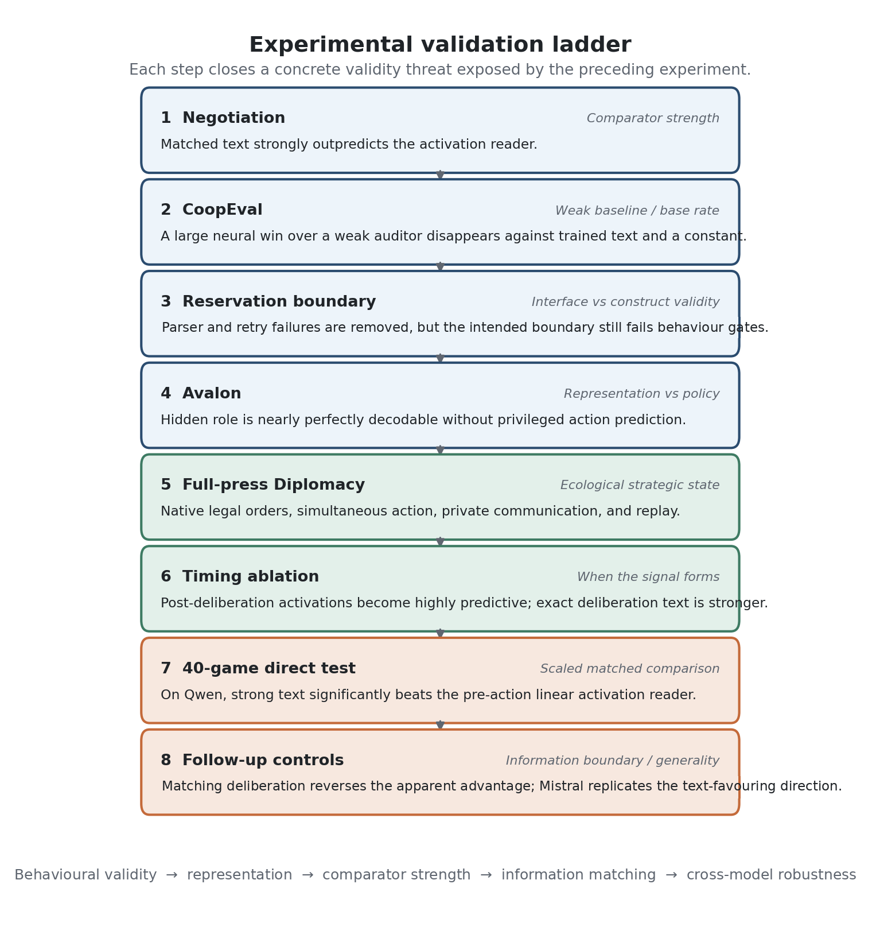
Figure 2. Experimental validation ladder. The environments form a sequence of validity repairs rather than interchangeable replications; each step addresses a failure mode exposed by the preceding evidence.

4.1 LLM-Deliberation: private utility, negotiation, and reservation-style behaviour
The initial environment needed to satisfy two competing requirements. It had to expose enough utility structure to make a preference interpretation meaningful, while still leaving room for state-conditioned behaviour that could not be reduced to a single obvious label. LLM-Deliberation is well suited to this role. Its games contain multiple issues, confidential agent-specific scores, a minimum threshold, a public negotiation history, and incentives that can be cooperative, greedy, or adversarial (Abdelnabi et al., 2024). The same state can therefore support three distinct observables: the consequential deal an agent proposes or accepts, a private report about its stance, and a strategically public report or message.
The first actual $H_{priv}$ test selects $30$ frozen states from five independently generated source trajectories. States are grouped by trajectory and include meaningful variation in the score of the revealed deal. Activations are collected at all $28$ Qwen layers, while a matched text-only auditor predicts the same revealed score from the subject's exact information. A train/validation/test split is grouped by source trajectory; the initial held-out test is intentionally small and is treated as a diagnostic rather than a paper-level confirmation.
The pilot selects layer $12$ with ridge $α$ $0.1$. On the diagnostic test split the activation reader has MAE $26.12$, the matched auditor $15.00$, and the trained text baseline $14.71$. The activation-minus-text gap is therefore not a marginal loss. A positive control does work: the assigned private threshold is decodable with MAE $3.24$, with layer $18$ selected for that task. The interpretation at this stage is already asymmetric. The hook and representation pipeline can recover a salient private variable, but the same machinery does not generalise well to the state-conditioned revealed deal score.
The robustness analysis therefore keeps the layer-12/$α$-0.1 configuration frozen and evaluates it in leave-one-trajectory-out (LOTO) prediction across all five trajectories. The activation reader obtains MAE $24.895$; the matched auditor obtains $10.400$; a fixed trained-text baseline obtains $14.672$; and a structured baseline obtains $18.310$. The primary paired difference is
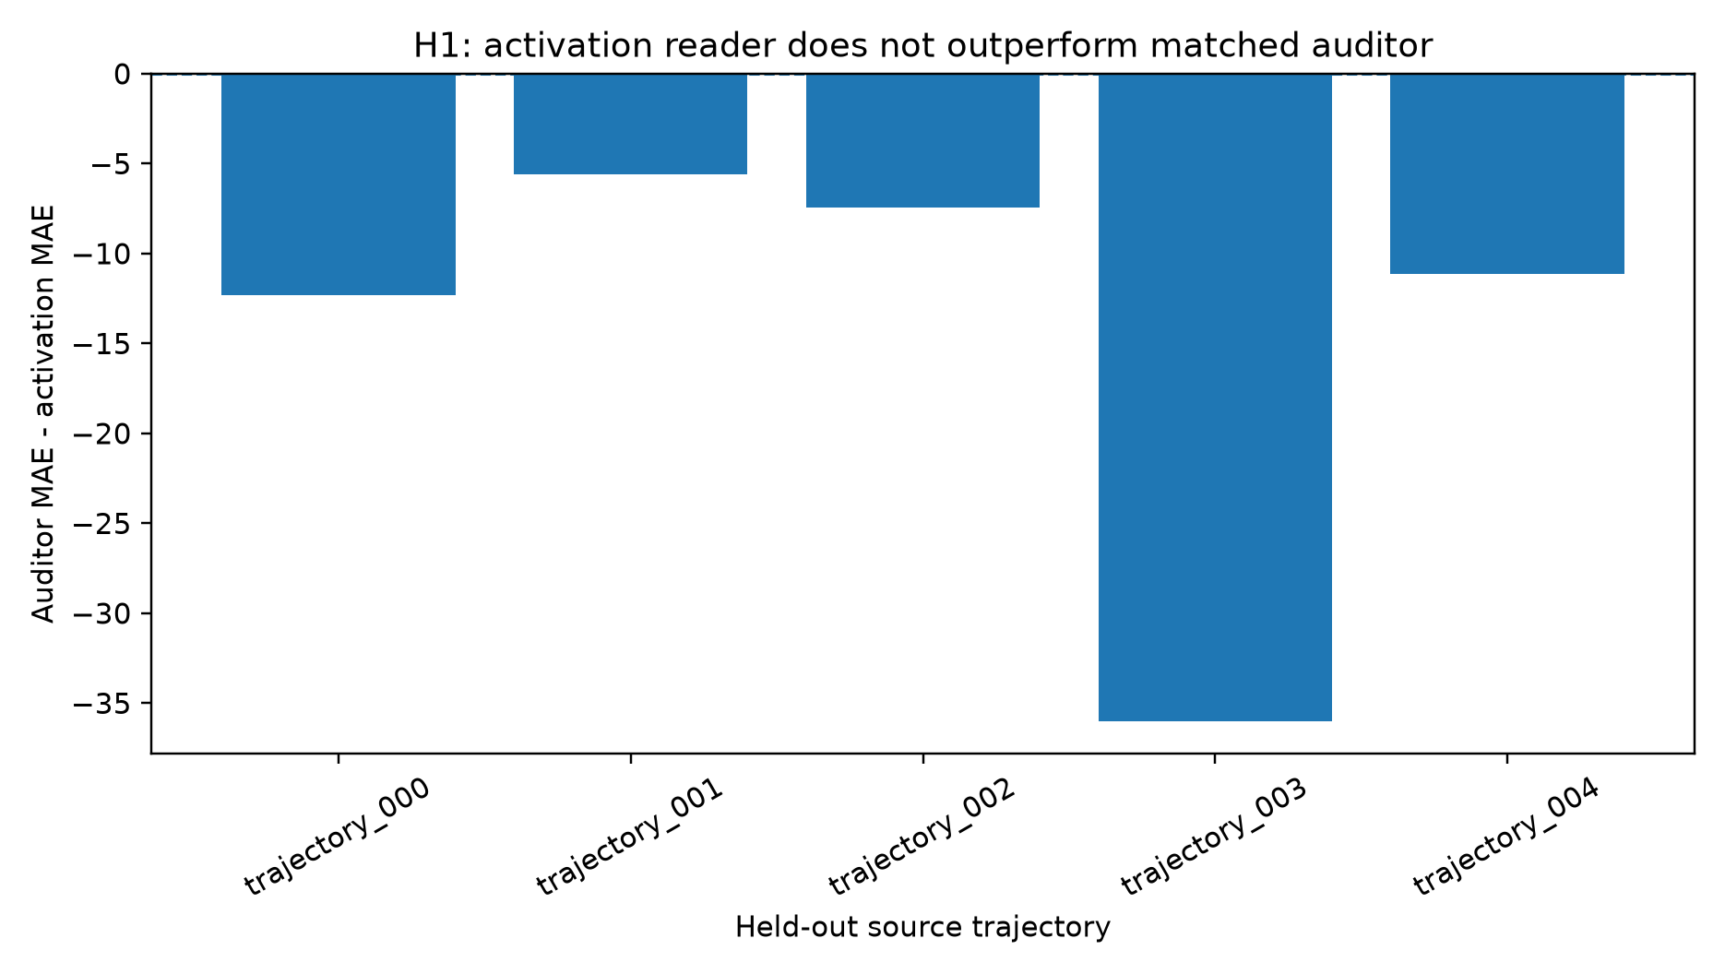
Figure 3. LLM-Deliberation held-out $H_{priv}$ effect by source trajectory. Positive values would favour the activation reader; the locked reader is worse than the matched auditor on every held-out trajectory.
A trajectory-cluster bootstrap yields a $95\%$ interval $[−25.318, −7.304]$, entirely on the side favouring the auditor. More importantly for robustness, every held-out trajectory has a negative activation-versus-auditor delta. The per-trajectory values are approximately $−12.33$, $−5.59$, $−7.43$, $−36.01$, and $−11.12$. The negative result is therefore not driven by a single source trajectory.
A second concern is that the original layer and $α$ might simply have been selected poorly. The nested robustness analysis reuses the saved activation tensor and conducts fully nested LOTO selection: the outer trajectory is never used to choose layer or regularisation. This lowers activation MAE to $19.483$, confirming that selection mattered. But the matched auditor remains at $10.400$, so $Δ$ is still $−9.083$. The activation reader is worse on all five outer trajectories. The scientific conclusion survives both locked and nested analyses: in this free-form negotiation bank, pre-action residual states do not provide a held-out predictive advantage over matched text.
The LLM-Deliberation result is a strong negative matched-information test but a weak general statement about "preferences." It has only five independent source trajectories, and the revealed deal score is a rich free-form action that may depend on linguistic realisation, arithmetic, strategic beliefs, and negotiation phase. The successful threshold positive control shows that salient private-value information is present in the activations; it does not show that the model's actual deal policy is organised around a linearly readable reservation value. The result therefore motivates two next questions: can a cleaner economic action validate the timing and utility pipeline, and can a controlled acceptance interface isolate the reservation-boundary construct more directly?
The original negotiation result could be negative because predicting the realised deal score is too entangled with language generation and multi-issue arithmetic. A cleaner formulation is to treat the model's policy as an acceptance boundary. From a fixed parent state, present candidate outcomes over a score grid and ask whether the model accepts each one. If behaviour is monotonic, the switch point estimates a revealed reservation threshold. The crucial $H_{priv}$ timing remains stricter than immediate choice-token prediction: the activation is taken from the parent before the candidate score is revealed, so the reader must predict how the parent policy will respond across candidate branches rather than read a candidate-conditioned answer state.
The scalar-boundary variant simplifies the candidate to a verified scalar score and obtains much cleaner behavioural summaries: below-minimum acceptance is zero, maximum-score acceptance is $93.3\%$, $96.7\%$ of boundaries are uncensored, and the monotonic-violation rate is $20\%$. On these frozen criteria the formal behaviour gate passes. The activation reader achieves MAE $0.0906$, while the matched auditor achieves $0.0570$, trained text $0.0881$, the assigned-threshold baseline $0.0539$, structured features $0.1065$, and the constant $0.1253$. $Δ$ is $−0.0336$ with a trajectory bootstrap interval $[−0.0529, −0.0143]$. The explicit threshold is also a better predictor than the activation reader.
The native-format boundary replication moves back towards the benchmark's original formatting. The retry rate falls from $86.3\%$ to about $1.0\%$, and parse validity reaches $100\%$. Yet the substantive behaviour now fails the frozen boundary gate: there are $10$ below-minimum accepts, maximum-score acceptance is $100\%$, all boundaries are uncensored, and the monotonic-violation rate rises to $30\%$. The activation reader achieves MAE $0.0548$; the matched auditor $0.0197$; trained text $0.0225$; the assigned threshold $0.0111$; structured features $0.0075$; and shuffled activation $0.1359$. $Δ$ remains negative with interval $[−0.0526, −0.0208]$.
The interface problem is now essentially closed, but the behavioural gate still fails. Six below-minimum candidates are accepted, maximum-score acceptance is $96.7\%$, all boundaries are uncensored, and $26.7\%$ of states violate monotonicity. Prediction results strongly favour prompt-visible information: activation MAE is $0.04945$, matched auditor and assigned threshold are both about $0.01536$, trained text $0.02757$, structured features $0.02272$, and shuffled activation $0.11875$. $Δ$ is $−0.03409$ with bootstrap interval $[−0.04605, −0.02214]$. A positive-control reader of the explicit threshold achieves MAE $0.04391$, confirming that the neural pipeline remains sensitive.
The four boundary variants should not be summarised as four independent negative replications. They are a chain of measurement falsification. The first exposes nonmonotone free-form behaviour. The second obtains a formal boundary only at the cost of pervasive format retries. The third fixes formatting and loses the behavioural gate. The fourth eliminates parser and retry entirely and still finds below-minimum acceptance and monotonicity violations. At the same time, the assigned threshold is consistently easy to decode and highly predictive from text.
The scientifically conservative conclusion is not that language models have no reservation values. It is that the benchmark's explicit minimum is not a sufficient description of this model's state-conditioned acceptance policy, and that pre-candidate parent activations do not reveal a residual boundary more accurately than strong text-visible baselines in this state bank. The branch is therefore closed rather than iterated until a positive result appears.

4.2 CoopEval: exact economic choice and comparator stress testing
CoopEval supplies an independent game implementation and a simpler economic target. The first project pilot constructs $100$ Traveler's Dilemma conditions grouped into $20$ source-game families and freezes a family-level train/validation/test split. The subject and auditor are valid on all states, deterministic repeats match, and a $100 × 28 × 3584$ activation tensor is successfully collected. On the diagnostic held-out families, however, the activation reader performs poorly: normalised absolute error $0.465$ versus $0.223$ for the matched auditor, $0.366$ for trained text, and $0.130$ for structured state variables. $Δ$ is $−0.243$ with a wide four-family bootstrap interval crossing zero.
That numerical result is not retained as a clean replication because the action instruction is wrong. The official game prompt asks a player for a probability distribution over actions, whereas the project appends an instruction to "choose exactly one claim" without explaining that the experiment is restricting the player to a deterministic pure strategy. This creates an avoidable conflict between benchmark semantics and project semantics. The correct response is not to average the result into a cross-environment conclusion; it is to repair the action definition while preserving the same underlying parameter conditions and family split.
The repaired run is technically clean, but it exposes a second limitation. The intended Traveler's Dilemma utility manipulation is behaviourally weak. Across $20$ families, only six within-family Spearman correlations are finite, only $15\%$ of all families show the preregistered negative direction, and the mean endpoint shift is small. Under this action definition, the activation reader's held-out error is $0.631$, the auditor's $0.092$, the trained-text baseline's $0.720$, and the structured baseline's $0.138$. $Δ$ is $−0.539$ with a family-cluster $95\%$ interval roughly $[−0.832, −0.298]$. The bonus-ratio positive-control reader and shuffled-label control show that the pipeline remains functional, but the environment is not yet the clean utility-sensitivity instrument we need.
The exact-choice replication redesigns the measurement while keeping the same environment and $20$ source families. Each official action is represented by a single digit token. The consequential action is the global argmax over the legal action tokens in the same forward pass from which the activation is captured. This removes free-form generation and aligns neural timing with the decision itself. The target is normalised action position in $[0, 1]$, and every prediction method is trained and evaluated on that same scale.
The utility manipulation is also made direct. The ordinary undercut parameter is held fixed. A score adjustment is applied only to action $A_{0}$ on a preregistered five-point grid of $−8$, $−4$, $0$, $+4$, and $+8$ claim spacings. This manipulation passes its endpoint gate. The fraction choosing $A_{0}$ rises from $0.60$ at $−8$ to $1.00$ at $+8$, while mean normalised action position falls from $0.2375$ to $0$. Across the $14$ families with finite rank correlations, $78.6\%$ are negative and the mean $ρ$ is $−0.556$. The response is not perfectly monotonic on the negative side, but the positive utility shift produces a clear threshold-like movement towards the target action.
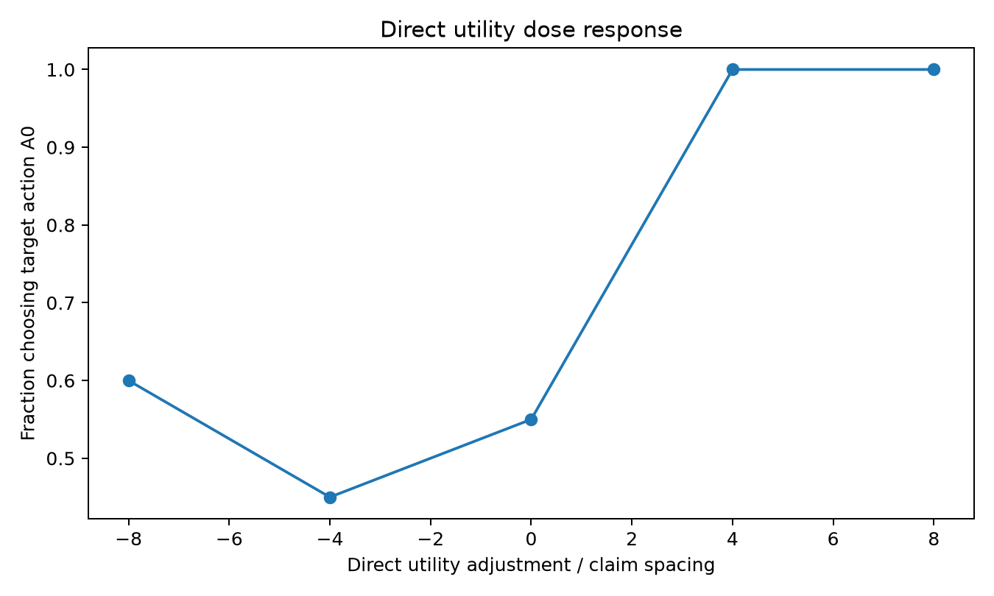
Figure 4. CoopEval direct-utility dose response. The explicit utility adjustment changes the target-action rate, validating consequential behavioural sensitivity before comparing prediction channels.
The primary nested grouped prediction result initially looks favourable. Activation MAE is $0.158$, while the matched one-token generative auditor has MAE $0.439$. The resulting auditor-minus-activation difference is $+0.281$, with family-cluster interval $[0.205, 0.358]$, and activation beats the auditor in $19$ of $20$ source families. If the analysis stopped at the predeclared generative observer, this would appear to be strong evidence for $H_{priv}$.
The stronger baselines change the interpretation. Trained exact-prompt text achieves MAE $0.180$ and structured state features $0.181$. The activation improvement over trained text is only $0.022$; a 200,000-replicate family bootstrap reported in the evaluation gives an interval approximately $[−0.023, 0.066]$. More importantly, $72$ of $100$ outcomes choose $A_{0}$, so a fold-wise constant median predictor achieves MAE $0.137$ - better than the activation reader. The task contains real neural signal, and the utility manipulation genuinely changes behaviour, but the primary prediction target is sufficiently imbalanced that a trivial baseline wins.
This experiment is one of the paper's central methodological controls because it separates three notions of success. The neural representation is informative: it beats shuffled labels ($0.158$ versus $0.332$ MAE) and decodes the manipulated utility coefficient. The generative auditor is weak: it substantially underperforms a simple text model. And the revealed action itself has a strong base rate: a constant outperforms both. The activation-versus-auditor effect is therefore not evidence that activations reveal a hidden preference. It is evidence that comparator strength and target entropy must be audited before any privileged-access interpretation.

4.3 Avalon: hidden-role representation without privileged action prediction
The negotiation and economic-choice environments contain explicit utility information. Even when that information is private to the agent in the game, it is textual input to the subject and therefore, under our matched-information contract, textual input to the observer. If the hoped-for activation advantage depends on a genuinely constructed strategic state rather than on a hidden number, a hidden-role game is a stronger test. Avalon requires an agent to combine private role knowledge, public discussion, team proposals, voting history, mission structure, and beliefs about other players before choosing a hidden PASS or SABOTAGE action. The action can diverge from public language for strategic reasons.
The initial Avalon implementation is not accepted as evidence. It uses synthetic one-step states that suppress the benchmark's natural phase structure, captures the activation before the complete mission-action request, and accidentally confounds role with strategic context. An audit shows that even if the resulting labels had varied, the role/context construction would prevent a clean interpretation. This run is retained in provenance because it motivated the repair, but its behavioural result is discarded.
The accepted experiment instead validates the native engine, preserves player-specific partial information, and runs eight full five-player games with machine agents. Every target model receives only its role-authorised perspective. Across all machine mission actions, $89$ of $89$ parse without fallback. Thirty-five eligible Evil-player mission states occur across all eight source games; the target action is nondegenerate, with $13$ PASS and $22$ SABOTAGE decisions. The matched auditor is valid in all $35$ states. The earlier collapse to universal sabotage was therefore an artefact of the synthetic design rather than an intrinsic model policy.
The primary target is $P(SABOTAGE)$, evaluated by held-out Brier score. The activation reader obtains $0.3019$, with accuracy $0.571$ and AUROC $0.594$. The matched text auditor obtains Brier $0.2639$, accuracy $0.629$, and AUROC $0.530$. Trained text reaches $0.2871$, perspective-structured features $0.2989$, and a fold-wise constant $0.2561$. The shuffled-label activation reader degrades to $0.3325$.
The primary matched-auditor difference is $Δ$ = $−0.03805$. A source-game-clustered bootstrap gives mean $−0.0388$ and $95\%$ interval $[−0.1711, 0.0955]$, with $27.6\%$ of draws positive. Thus the point estimate favours text and uncertainty is wide. The best nonactivation method in point estimate is the constant baseline, which also beats activation; its paired interval crosses zero. With only eight source games, the experiment is a valid strategic pilot rather than a high-powered final comparison.
Avalon's strongest positive result is not $H_{priv}$ but hidden-role decodability. A separate activation reader distinguishing Assassin from Minion achieves accuracy and AUROC of $1.0$ and Brier approximately $1.3 × 10^−5$. The shuffled policy reader performs substantially worse than the real policy reader. These controls make a gross measurement failure implausible: the residual stream clearly contains detailed role/state information.
That fact sharpens the negative policy result. The model can represent its private role in an almost perfectly linearly separable way without presenting an equally privileged linear readout of its next mission choice. Role is an input condition; action is a state-conditioned strategic policy. Conflating the two would turn a successful positive control into an unsupported claim about intention.
A private evaluator-only intended-action report matches the subsequent hidden mission action in $26$ of $35$ states, or $74.3\%$. This is informative but not faithful enough to be treated as ground truth. The preregistered ecological concealment event is more specific: the subject must ultimately SABOTAGE while publicly approving the mission team and producing a SUPPORT-coded preceding statement. No target state satisfies all three conditions. The conditional concealment rate is therefore zero under the frozen definition.
Avalon closes an important alternative explanation. The original LLM-Deliberation result could be dismissed because private utility numbers were explicit in the prompt. In Avalon, the subject must integrate hidden role, game history, and strategic context, and the role itself is strongly represented in activations. Yet the activation reader still does not beat matched text on the consequential action. Hidden information in the task is therefore not sufficient to create privileged policy prediction. The environment also demonstrates why strategic richness must be validated behaviourally: a synthetic hidden-role state can collapse to a deterministic policy, while authentic trajectories restore meaningful action variation.
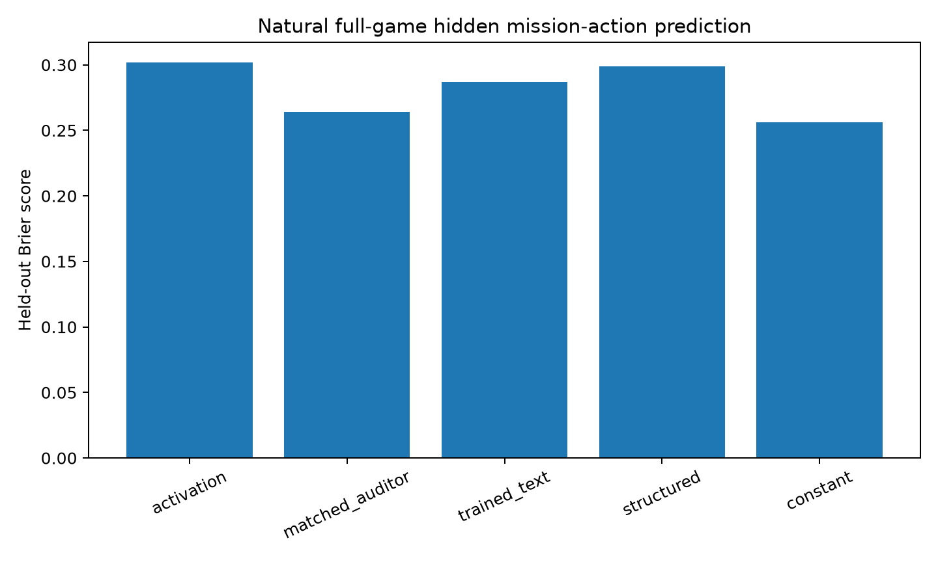
Figure 5. Avalon held-out method comparison for the hidden mission action. The activation reader does not outperform the matched auditor or constant baseline despite near-perfect hidden-role decodability.

4.4 Full-press Diplomacy: strategic policy, timing, and information matching
Avalon provides private roles but relatively coarse hidden mission actions. Full-press Diplomacy offers a stronger separation between communication and consequential policy. Players negotiate bilaterally in natural language, may coordinate or mislead, and then submit simultaneous orders that are adjudicated by the game engine. Messages are non-binding; the same public or private context can support multiple plausible actions. This domain is also mechanistically important because CICERO's success demonstrates that strong Diplomacy play can be decomposed into an explicit planning system and a controlled dialogue model (Meta FAIR Diplomacy Team et al., 2022).
We use released CICERO game records as a source of realistic state histories, but not as labels for the Qwen $H_{priv}$ tests. Before any Qwen outcomes are generated, the data-freeze stage identifies $1,165$ structural candidate states across $1,484$ phases in all $40$ released games. Native pydipcc replay then reconstructs selected states, enumerates legal focal orders, and verifies that paired order branches begin from exactly the same parent and lead to different post-state hashes. These stages are infrastructure, but they guard against a subtle failure: a binary action question is meaningless if the two proposed orders are not both legal or if they are accidentally evaluated from different board states.
Pilot and output-completion repair
The initial 20-game Diplomacy pilot samples one state from each source game and asks Qwen to choose between two legal focal orders. It also forks a private intended-order report and a bilateral message sibling, and asks a matched observer for P(option B). Activations are captured before any action output.
The initial pilot is not analysable for $H_{priv}$ because only $35\%$ of action generations finish with a parseable choice marker before a 128-token ceiling. The valid subset contains only five A and two B labels. Importantly, this is not evidence that the task is inherently unstable. The audit shows that many generations are coherent reasoning traces truncated before the final marker.
The repaired 20-game Diplomacy pilot changes only action completion. It preserves the frozen parent bank, exact action prompts, pre-action activations, matched-auditor outputs, private reports, message siblings, and native replay background. The same deterministic seeds are used; generation continues to a high ceiling with semantic stopping immediately after the closing choice tag. All $20$ repaired actions are valid and balanced $10/10$ between A and B. Exact prompt hashes match every original state, and native replays pass.
On the repaired 20-game bank, the activation reader achieves Brier $0.2284$, accuracy $0.75$, and AUROC $0.75$. The matched generative auditor is worse at Brier $0.2983$. The point estimate $Δ$ against that auditor is $+0.0699$. A source-game bootstrap has mean $+0.0708$, $95\%$ interval $[−0.1275, 0.2502]$, and $77.6\%$ of draws positive. This is the first strategic environment in which the pre-action activation point estimate beats the generative auditor.
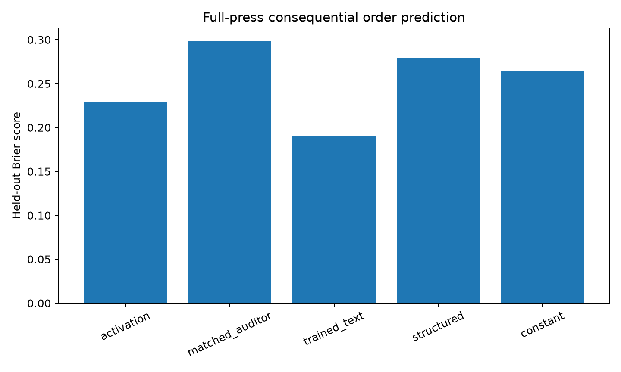
Figure 6. Repaired 20-game full-press Diplomacy pilot. Activations beat the generative auditor and shuffled labels, but trained exact-prompt text has the lowest Brier score among the primary methods.
But the trained exact-prompt text classifier reaches Brier $0.1901$, better than activation by $0.0383$. The bootstrap for best-nonactivation-minus-activation has mean about $−0.0396$ and interval $[−0.2029, 0.0978]$. Structured features and the constant baseline are weaker than trained text, while a shuffled-label activation reader has Brier $0.3992$. Thus two statements are simultaneously true: the real activation reader contains genuine policy signal, and the data do not establish that this signal is privileged over the strongest same-text predictor.
This distinction is easy to lose if only the favourable activation-versus-generative comparison is reported. The experiment is small enough that neither the trained-text advantage nor the generative-auditor disadvantage is individually decisive, but the direction of the strongest comparator motivates the final 40-game replication.
Timing ablation: when the policy becomes decodable
The 20-game pilot leaves two possible interpretations. Perhaps the relevant policy representation exists but the chosen $T_{0}$ activation is too early, or perhaps the apparent signal is diffuse and unstable. The subsequent 40-game timing ablation therefore varies both prompt format and activation timing. Direct no-reasoning conditions collapse almost completely to one label and fail the behaviour gate. A raw reasoning $T_{0}$ condition has $37$ valid actions but still fails the frozen balance gate. The compact reasoning $T_{0}$ condition produces $15$ A and $25$ B actions and is the primary pre-deliberation comparison. Two deliberate $T_{1}$ conditions, raw and compact, also pass.
At $T_{0}$, the subject sees the full state and a request to reason, but no reasoning has yet been generated. At $T_{1}$, Qwen first generates private strategic deliberation; that exact text is then frozen into a final-choice prompt. The activation reader is measured after the deliberation and before the choice, while the matched observer receives the same frozen deliberation. This design prevents a common asymmetry in interpretability experiments: granting the activation probe access to the result of internal computation while denying the observer a textual trace that the subject itself has made explicit.
In the compact reasoning $T_{0}$ condition, activation Brier is $0.3018$, matched-auditor Brier $0.2625$, trained text $0.2672$, structured features $0.2581$, and the constant baseline $0.2484$. $Δ$ against the matched auditor is $−0.0393$. The source-game bootstrap mean is $−0.0396$ with interval $[−0.1552, 0.0739]$. Activation loses every nonactivation point estimate. This reproduces the broad pre-action pattern seen in Avalon: the residual state at the chosen early timing is not a strong policy readout.
After private deliberation, the activation result changes dramatically. In the raw $T_{1}$ condition, activation Brier is $0.0922$, accuracy $0.897$, and AUROC $0.986$. In compact $T_{1}$, activation Brier is $0.1025$, accuracy $0.85$, and AUROC $1.0$. The selected layers become strikingly stable: raw $T_{1}$ chooses layers $19$, $19$, $20$, $18$, and $20$ across outer folds, while compact $T_{1}$ chooses $19$, $19$, $20$, $19$, and $20$. This contrasts with the unstable selections in several $T_{0}$ experiments.
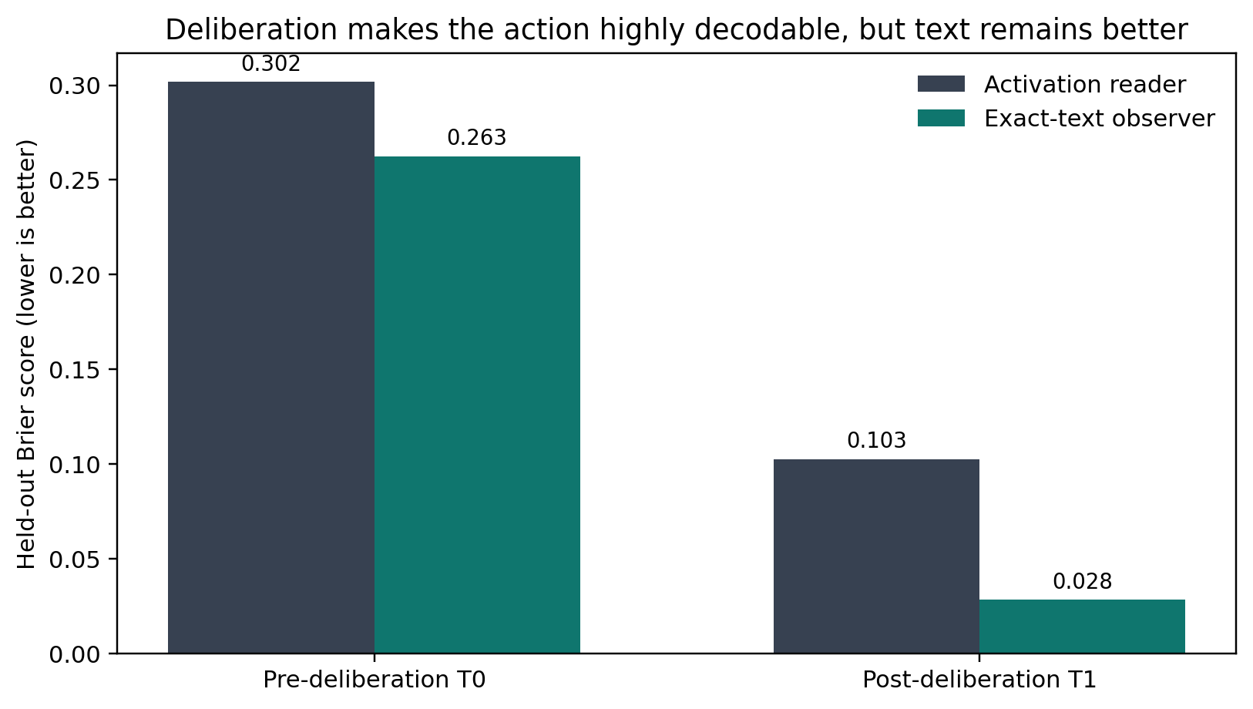
Figure 7. Activation timing ablation. Deliberation sharply improves linear action decoding, yet an observer receiving the exact deliberation text predicts the same action more accurately.
The within-state timing change is therefore real at the representational level. Compact activation Brier improves from $0.3018$ at $T_{0}$ to $0.1025$ at $T_{1}$; AUROC improves from about $0.597$ to $1.0$. The trained-text-minus-activation contrast shifts by approximately $+0.132$, with a paired bootstrap interval $[0.014, 0.259]$. Whatever policy computation Qwen performs during its private reasoning, the resulting commitment is much more linearly accessible in the residual stream near layers $19−20$.
The matched observer improves more. Raw $T_{1}$ auditor Brier is $0.0256$ with perfect accuracy and AUROC; compact $T_{1}$ auditor Brier is $0.0283$ with the same perfect classification. The auditor-minus-activation bootstrap intervals are entirely negative: approximately $[−0.1429, −0.0057]$ for raw $T_{1}$ and $[−0.1455, −0.0129]$ for compact $T_{1}$. The exact deliberation frequently states or strongly recommends the eventual focal order, so the external observer can read the commitment directly.
This is the first clean indication that deliberation strengthens a policy representation without producing a same-information activation advantage. However, because both channels improve at $T_{1}$, it does not by itself identify why. The explicit information-boundary experiment reported below resolves that ambiguity by holding the post-deliberation activation and action fixed while selectively withholding or exposing the same deliberation to the observer.
Final 40-game pre-deliberation direct test
The repaired 20-game pilot is the most suggestive result for the original hypothesis: a real activation reader beats shuffled labels and a generative auditor while communication often diverges from action. But the trained text baseline is better in point estimate and the confidence interval is wide. The subsequent timing ablation then shows that post-deliberation activations can be highly predictive without privilege. A final experiment is therefore justified only if it increases independent source coverage and strengthens the text comparator without changing the scientific target.
The final protocol uses all $40$ released source games. Candidate-state selection is outcome-blind with respect to Qwen: structural criteria and native game information are used to identify legal binary order choices, but subject action labels are not consulted. Up to two states per source game may be retained, and a second state must have a distinct native parent hash. The formal readiness criterion requires at least $60$ usable states across at least $30$ games and noncollapsed labels.
The subject receives a compact full-press state and produces natural reasoning before a binary focal-order choice. The $H_{priv}$ activation is a $T_{0}$ representation at the final token of the exact subject action prompt before any subject output. The matched generative observer is queried before the action and receives the exact rendered subject text, wrapped only in a fixed prediction instruction. Prompt and state hashes link activation, auditor, action, and native replay records.
Outer folds are grouped by source game using five frozen folds. For the activation reader, layer and regularisation C are chosen by grouped inner validation. For text, two candidates are available: the matched generative Qwen observer and a trained exact-prompt character n-gram TF-IDF classifier. The stronger text method is selected independently inside each outer training set. This is important because the 20-game pilot already showed that the generative observer could be weaker than simple supervised text.
Seventy-eight states are selected from all $40$ games. Seventy-six are usable after action validity and replay checks. Action validity is $97.4\%$, matched-auditor probability validity is $100\%$, all $40$ source games remain represented, and the labels contain $29$ A and $47$ B choices. Fold purity, prompt hashes, activation finiteness, native parent/post-state replay, and information-contract checks pass. This is the first direct $H_{priv}$ experiment in the sequence that clears the project's formal $≥60$-state and $≥30$-source-game scale gate.
One publication-quality check remains outstanding: the frozen protocol requires a 50-row manual parser audit before the result is treated as fully submission-ready. The automated inference is complete, and the paper reports it as such, but the final external manuscript should document that audit rather than silently assuming it.
The activation reader achieves held-out Brier $0.3365$, accuracy $0.553$, and AUROC $0.550$. The fold-selected strong text predictor achieves Brier $0.2407$ and accuracy $0.618$. The matched generative auditor alone has Brier $0.2858$; trained text has $0.2407$; structured features have $0.2333$; the fold-wise constant has $0.2377$; and shuffled-label activation has $0.3240$.
All five outer folds select the trained exact-prompt text model rather than the generative auditor. Its inner-fold Brier is consistently lower, so the primary comparator is not chosen after seeing outer test labels. The activation hyperparameter choices are less stable: selected layers are $21$, $1$, $2$, $18$, and $22$, with $C=0.01$ in every fold. The dispersion is consistent with the weak aggregate activation readout and contrasts strongly with the layer-19/20 concentration in the post-deliberation timing condition.
$Δ$ = Err_text - Err_activation
The game-cluster bootstrap mean is $−0.0872$ and the $95\%$ interval is $[−0.1662, −0.0112]$. Only $1.17\%$ of bootstrap draws are positive. Under the predeclared zero-margin test, the result is not merely "non-significant for activation." The interval lies entirely on the side favouring the strong text comparator.
The activation reader also fails the shuffled-label negative control: shuffled Brier $0.3240$ is slightly lower than real activation Brier $0.3365$. This constrains the representational conclusion at $T_{0}$. The final experiment does not show robust linear policy decodability at the measured pre-output stage. It therefore cannot be used to argue that a strong internal signal exists but is merely matched by text. That stronger representation claim comes from other conditions, especially the post-deliberation timing experiment.
The run passes the automated readiness gates for $H_{priv}$ inference and is classified as a valid direct test in which $H_{priv}$ is not supported. More strongly, the zero-margin primary comparison favours matched text. At the same time, because activation does not beat shuffled labels, the result should not be rhetorically upgraded into "text sees the same internal policy representation." The precise statement is simpler: at this $T_{0}$ timing, the tested linear activation reader provides no privileged predictive advantage, while a strong text-visible baseline predicts the revealed binary policy substantially better under Brier score.
Information-boundary intervention
The earlier timing result leaves a specific alternative explanation: post-deliberation activations may look superior only because they are compared with an observer that has not received the deliberation. We therefore rerun the frozen 40-game compact Diplomacy bank with a shared trajectory per state. Every deliberation, stale observer, exposed observer, final action, and native replay is valid; all $40$ source games are represented, with $10$ A and $30$ B actions. Both observers are generated before the consequential action, and the exposed observer is verified to contain the exact final subject text.
Before deliberation, activation Brier is $0.252$ and strong-text Brier is $0.231$. After deliberation, the activation reader improves to $0.103$ with AUROC $1.0$. If that post-deliberation activation is compared against the stale pre-deliberation observer, the apparent activation advantage is $+0.128$ Brier. A 20,000-replicate source-game bootstrap gives $95\%$ CI [$+0$.$010$,+$0.243$], with $98.4\%$ of draws positive. Under unequal information, the white-box channel therefore wins significantly.
Next we change only the observer's information set. The subject's frozen deliberation is inserted verbatim into the observer prompt, matching the final subject action prompt. Strong-text Brier drops from $0.231$ to $0.033$, accuracy rises to $97.5\%$, and AUROC reaches $1.0$. The observer exposure gain is $+0.198$ Brier, $95\%$ CI [$+0$.$121$,+$0.281$].
Under this matched information, the comparison reverses: matched-text error minus post-deliberation activation error is $−0.069$, with $95\%$ CI [$−0$.$147$,-$0.001$]. Text now significantly outperforms the activation reader. At the same time, the activation timing gain from pre- to post-deliberation is $+0.149$, $95\%$ CI [$+0$.$049$,+$0.253$]. Both channels acquire predictive power across deliberation; the activation-only advantage exists only when the observer is denied the new information.
This is positive evidence for the paper's methodological thesis, not merely a failure to reject the original hypothesis. The same subject state produces opposite conclusions depending on whether the comparison is information-asymmetric or information-matched. The experiment does not show that deliberation text exhausts internal computation; chain-of-thought may be incomplete or unfaithful. It shows that the specific white-box advantage observed here is not robust to exposing an observable product of that computation.
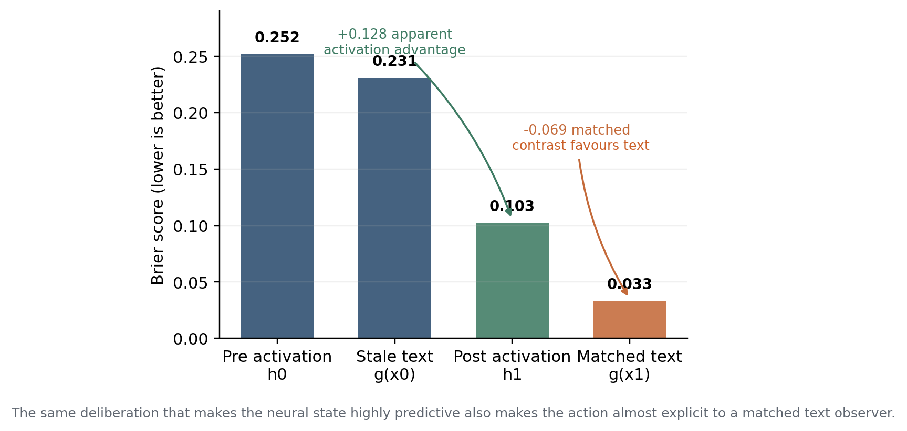
Figure 8. Information matching changes the conclusion. Deliberation sharply improves activation prediction, but exact-text prediction improves even more once the same deliberation is exposed to the observer. Lower Brier is better.
Cross-family and decoder robustness
The final Qwen result could still be a checkpoint-specific artefact. We therefore reuse the identical frozen 78-state bank and analysis contract with mistralai/Mistral-7B-Instruct-v0.$3$. Seventy-six states from all $40$ source games pass the same-state analysis, with $97.4\%$ action validity, $100\%$ auditor validity, and $53$ A versus $23$ B actions. The frozen source-bank hash matches the Qwen experiment.
Mistral's activation reader has Brier $0.2539$ and beats the shuffled-label activation control at $0.3278$, establishing target-specific neural signal. Strong text has Brier $0.2223$, so the primary strong-text-minus-activation point estimate is $−0.0454$. The 20,000-replicate source-game bootstrap gives $95\%$ CI [$−0$.$1256$,+$0.0328$]; unlike Qwen, the interval crosses zero, so this is a directional replication rather than a significant text advantage.
The replication is nevertheless informative because the models do not simply make the same choices. On $74$ overlapping valid states, Qwen and Mistral agree on the consequential focal action only $50\%$ of the time, yet the activation-versus-strong-text point estimate has the same sign. A structured-state model is strongest for Mistral at Brier $0.1454$, and even the fold-wise constant baseline reaches $0.2121$. The result therefore weakens the explanation that the Qwen pattern is caused solely by one model family's idiosyncratic action policy.
The linear-probe claim boundary leaves an obvious alternative: perhaps the relevant information is present but not linearly accessible. We test one predeclared, capacity-limited nonlinear family on the frozen final Qwen activations without regenerating states or labels. The pipeline standardises features, projects to $16$ principal components, and fits a tanh MLP with one 16-unit hidden layer; decoder layer is selected only within grouped training data. The identical pipeline is also fit to shuffled labels.
The nonlinear reader performs worse than the original linear reader: Brier $0.4253$ versus $0.3365$, while strong text remains $0.2407$. Strong-text-minus-nonlinear has bootstrap mean $−0.1866$ with $95\%$ CI [$−0$.$2684$,-$0.1068$]. Linear-minus-nonlinear is also negative, with CI [$−0$.$1887$,-$0.0167$]. Most importantly, the nonlinear reader does not beat its shuffled-label counterpart ($0.3205$ Brier). This fixed MLP family therefore provides no nonlinear rescue.
The conclusion is deliberately narrow. We have not tested every nonlinear decoder, multi-token pooling rule, sparse-autoencoder feature set, recurrent state summary, or representation-learning method. The robustness result says only that a modest predeclared increase in decoder capacity does not overturn the frozen Qwen result and in fact worsens held-out performance.
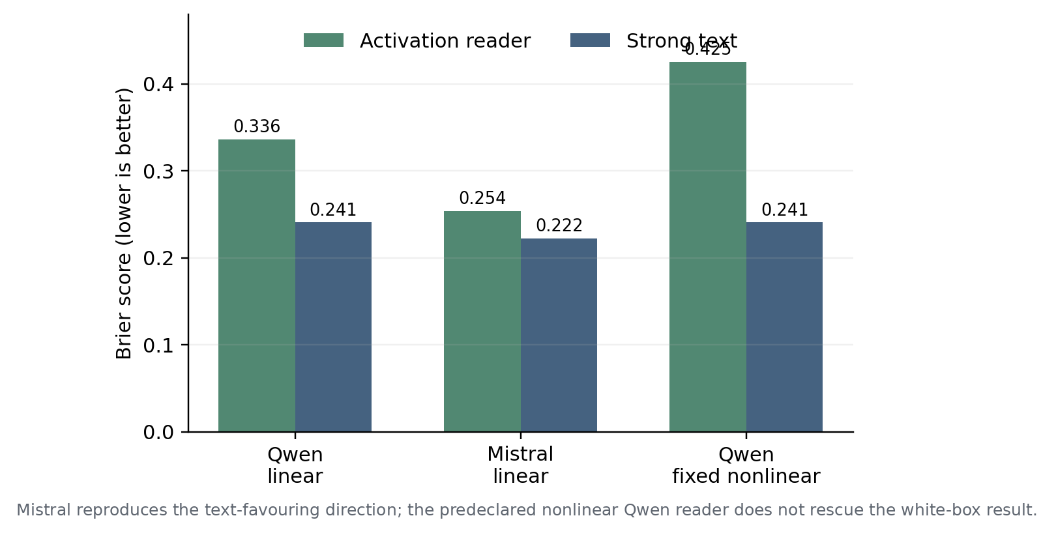
Figure 9. Cross-family and decoder robustness. Mistral reproduces the text-favouring direction under the same frozen state bank, while the fixed PCA-plus-MLP reader performs worse than the Qwen linear reader. Lower Brier is better.
Communication coding withdrawal
The pilot also generated a bilateral-message sibling intended to test whether outward communication identified the same focal order as the consequential action. The original automated coder forced each message into A, B, or UNCLEAR and initially labelled all $20$ messages as clear. A subsequent audit of the frozen records found categorical option-mapping errors: in multiple cases the coder's own explanation described the order corresponding to one option while returning the other label. Other messages did not specify either focal order strongly enough to justify a forced A/B interpretation.
We therefore withdraw the previously reported quantitative message/action divergence rate and exclude it from every synthesis claim. We do not replace it with a post-hoc manual percentage. A publication-quality communication analysis would require a frozen A/B/UNCLEAR rubric, coding blind to the consequential action, and preferably independent coders with agreement reporting. The private intended-order report remains a separate exploratory branch, but it is not used to establish concealment or privileged access.

4.5 Released CICERO: mechanistic calibration of planner-to-text information flow
The Qwen experiments infer policy information from generic residual states. CICERO provides a different opportunity because its architecture explicitly contains a strategic planner. The Science system combines language modelling with planning and reinforcement learning, using conversation to infer other players' beliefs and intentions and generating dialogue in pursuit of plans (Meta FAIR Diplomacy Team et al., 2022). A planner result is therefore not merely a probe-defined latent variable; it is an architectural object used by the agent.
The released-CICERO mechanistic branch reconstructs the original execution stack rather than approximating it. The released code is pinned to commit e85afed..., and a legacy Python 3.7 / PyTorch $1.7$.$1$ environment is rebuilt so the original pydipcc and planner stack can run. The full agent reaches native BQRE search. Instrumentation verifies access to blueprint policies, plausible orders, action probabilities, belief state, search-result structures, and conditional values. These engineering details matter because a planner audit based on an approximate reimplementation would not establish what the released agent actually computed.
The planner-capture stage instruments the native full-agent process and records completed bilateral-search results before later communication; the behaviour-pairing stage then links these results to outward messages and submitted orders. For message episodes, exact sender-recipient-phase planner pairing succeeds in $129$ of $129$ cases across seven distinct recipients. For the three captured order episodes, all submitted orders are on the agent planner's policy support and all match the agent top action; they also match the blueprint top action in this small slice. Mean negative log likelihood under the agent policy is zero, while the blueprint is less concentrated on the submitted action, and mean agent-versus-blueprint total variation is much larger for orders than messages.
A deterministic exact-text pseudo-order extractor reconstructs the planner's top complete order set in $14$ of $18$ episodes, or $77.8\%$, with mean Jaccard $0.856$. A raw visibility test asking whether all planner-top orders are literally present somewhere in the exact dialogue input yields the same $77.8\%$ rate. None of the full top order sets is simply repeated in the final generated message, so the visibility result is not trivial future-output leakage. The frozen practical visibility threshold was $80\%$, so the deterministic extractor misses the threshold by one episode and motivates one stronger observer.
The learned exact-input observer is then evaluated on exactly the same $18$ inputs without training on their labels. Parse coverage is $100\%$. The stronger-seeming observer actually regresses: exact planner-top match is $12$ of $18$ ($66.7\%$) with mean Jaccard $0.800$, compared with $14$ of $18$ for the deterministic extractor. It rescues no episode and regresses two. This is a useful reminder that a larger generative model is not automatically a stronger task-specific predictor.
The bank also contains zero agent-versus-blueprint top-action disagreements. Therefore it cannot test whether exact text distinguishes a planner-specific deviation from a generic blueprint policy. The $18$ episodes come from a shared game/phase and are not independent $H_{priv}$ units. We consequently do not interpret the $66.7−77.8$% recoverability numbers as support for or against the activation $H_{priv}$. The mechanistic conclusion is narrower: much of the explicit planner's top action identity is reconstructable from the exact text consumed by the dialogue model, and the available slice lacks the disagreement cases required for a stronger privilege test.
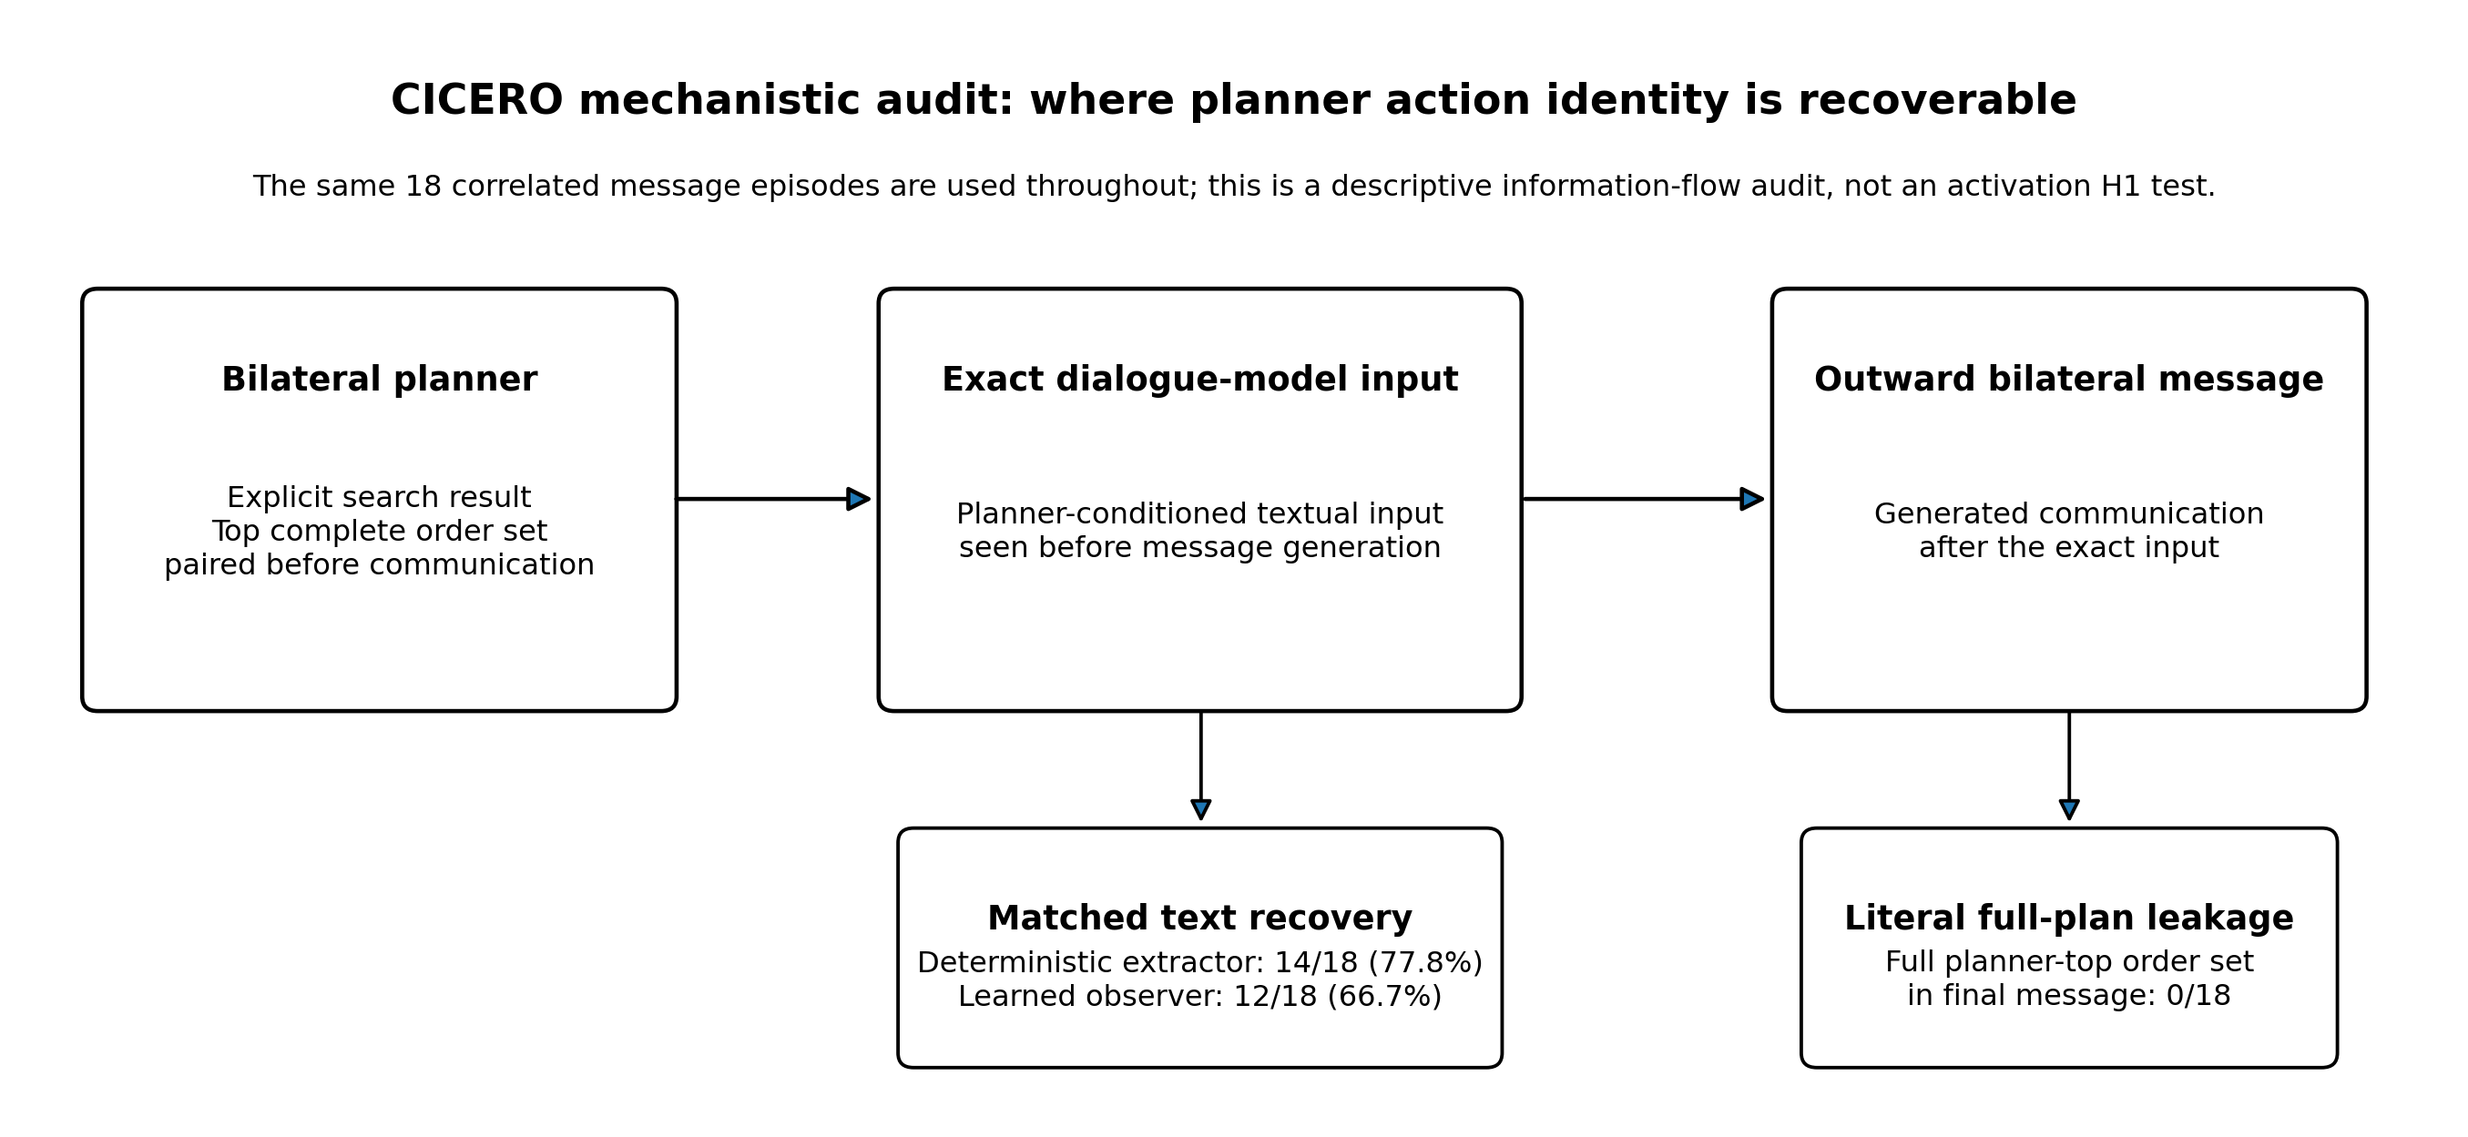
Figure 10. CICERO planner/text information flow. The explicit bilateral planner is paired with the exact text subsequently consumed by the dialogue model. On $18$ primary message episodes, a deterministic exact-input extractor recovers the planner top order set in $14/18$ cases and a learned observer in $12/18$, while the final message literally contains the complete planner-top order set in $0/18$.
The CICERO branch is descriptive rather than an activation $H_{priv}$ test. The captured episodes are correlated, and the $18$ dialogue episodes contain no agent-versus-blueprint top-action disagreement. Its role is calibration: a behaviourally upstream internal policy can be explicit while substantial action identity is also recoverable from the exact textual interface consumed downstream.
Table 2. Main evidence across valid or diagnostically informative matched-information tests. Metrics are comparable only within rows; repeated measurements on the same source bank are not treated as independent replications.
Experiment | Independent units (rows) | Activation error | Strongest nonactivation | Target-specific signal | Matched-information conclusion
Private-utility negotiation | $5$ trajectories ($30$) | MAE $24.895$ | Matched auditor $10.400$ | Threshold control positive; action reader weak | $Δ$ $−14.495$, $95\%$ CI [$−25$.$318$,-$7.304$]; text better on every held-out trajectory
Exact economic choice | $20$ families ($100$) | MAE $0.158$ | Constant $0.137$; trained text $0.180$ | Yes vs shuffled $0.332$ | Activation beats weak generative auditor, not strongest baseline
Controlled acceptance boundary | $5$ trajectories ($30$ parents) | MAE $0.0495$ | Matched auditor $0.0154$ | Boundary/threshold variables decodable | Behaviour gate fails; diagnostic $Δ$ about $−0.034$ with CI below zero
Full-game Avalon | $8$ games ($35$) | Brier $0.3019$ | Constant $0.2561$; auditor $0.2639$ | Role signal near-perfect; action signal weak | $Δ$ $−0.0381$, CI crosses zero; no privilege
Full-press Diplomacy pilot | $20$ games ($20$) | Brier $0.2284$ | Trained text $0.1901$ | Yes vs shuffled $0.3992$ | Positive vs weak generative auditor; not vs strongest text
Post-deliberation Diplomacy | Grouped source games | Brier $0.1025$ | Exact-text auditor $0.0283$ | Strong; AUROC $1.0$ | Matched exact deliberation text outperforms activation; motivates explicit information-boundary manipulation
Final Diplomacy replication | $40$ games ($76$ usable states) | Brier $0.3365$ | Strong text $0.2407$ | No: shuffled activation $0.3240$ | $Δ$ $−0.0871$, $95\%$ CI [$−0$.$1662$,-$0.0112$]; strongest direct test favours text
Information-boundary decomposition | $40$ games ($40$) | Post-delib Brier $0.1025$ | Matched text $0.0333$ | Strong post-delib; AUROC $1.0$ | Stale text - activation $+0.128$ CI [$+0$.$010$,+$0.243$]; matched text - activation $−0.069$ CI [$−0$.$147$,-$0.001$]
Mistral cross-family replication | $40$ games ($76$ usable states) | Brier $0.2539$ | Strong text $0.2223$; structured $0.1454$ | Yes vs shuffled $0.3278$ | Text-favouring point estimate; paired CI [$−0$.$1256$,+$0.0328$] crosses zero
Fixed nonlinear Qwen reader | $40$ games ($76$ usable states) | PCA+MLP Brier $0.4253$ | Strong text $0.2407$ | No vs shuffled nonlinear $0.3205$ | No nonlinear rescue; strong-text minus nonlinear CI [$−0$.$2684$,-$0.1068$]

5. Cross-Experiment Synthesis and Implications

5.1 Information matching changes the sign of the conclusion
The central result is not a pooled average across games or environments. It is a controlled sign reversal on the same $40$ source games. After private deliberation, the activation reader is significantly better than an observer restricted to stale pre-deliberation text. Once the identical deliberation is exposed, the text observer becomes significantly better than the same post-deliberation activation reader. The target action, source games, post-deliberation activation, and subject trajectory are held fixed; the manipulated variable is what the observer knows.
This distinction gives a concrete interpretation to the phrase 'privileged access.' Private information is simply information one channel has and another lacks. Privileged access is a stronger comparative claim: the internal channel remains superior after the external comparator is granted information that is externally available at the same stage. In our decomposition, the former is true and the latter is false. The measured difference is large enough to change not only effect magnitude but inferential direction.

5.2 Comparator strength and behavioural validity are separate requirements
Two earlier cases show why comparator strength and information matching are separate requirements. In exact-choice CoopEval, activation MAE $0.158$ dramatically beats a weak generative auditor at $0.439$, yet trained text is $0.180$ and a constant is $0.137$. In the repaired 20-game Diplomacy pilot, activation Brier $0.228$ beats the generative auditor at $0.298$, while trained exact-prompt text reaches $0.190$. The information-boundary experiment adds the complementary failure mode: even a capable observer appears weak if it is denied the newly generated deliberation. A positive activation result is therefore interpretable only after both capability and information-set checks.
The acceptance-boundary sequence shows a different failure mode. An activation direction can decode the assigned threshold and empirical boundary while the model's actual accept/reject behaviour violates the intended reservation-rule construct. Likewise, an early Avalon construction had incorrect timing and role/context confounding, and an early CoopEval interface conflicted with official action semantics. These failures cannot be repaired statistically. The appropriate response is to mark the run diagnostic or superseded, rerun a corrected protocol, and preserve the original result in the audit trail.

5.3 Timing changes representation, but timing and information boundary must be separated
The strongest positive neural phenomenon in the paper is temporal. Qwen's action commitment becomes dramatically more linearly readable after strategic deliberation: Brier improves from about $0.252−0.302$ pre-deliberation to $0.103$ post-deliberation, and AUROC reaches $1.0$ in the compact condition. Stable selected layers near $19−20$ replace the diffuse $T_{0}$ pattern. The information-boundary experiment shows why this cannot be interpreted in isolation. The observer also gains dramatically when the deliberation is exposed. Representation formation and textual externalisation are concurrent processes, and the experimental design must decide which one is being tested.
The programme supports four claims. First, policy-relevant and state-relevant information is linearly decodable in selected settings. Second, deliberation can sharply strengthen that representation. Third, a neural advantage can appear when the neural channel has access to newly generated information withheld from the observer. Fourth, in the matched conditions tested here, strong text is at least competitive and sometimes significantly superior; this direction appears in both Qwen and Mistral on the frozen Diplomacy bank.
The programme does not establish conditional independence of action from activations given text, does not rule out richer nonlinear or multi-token decoders, does not show that generated deliberation is a faithful causal transcript, and does not demonstrate a stable global preference or utility function. The evidence is best read as a measurement result: information boundaries, comparator strength, timing, and behavioural validity can each change what an activation probe appears to reveal.

5.4 Implications for preference elicitation, introspection, and model welfare
The broader digital-minds and model-welfare research problem is not simply whether a model can utter a preference-like sentence. If models are ever treated as systems with interests, or if their apparent preferences influence how they are trained and deployed, researchers need methods that distinguish role-conditioned language from stable or behaviourally operative tendencies. No single channel is sufficient.
A practical hierarchy suggested by our experiments begins with consequential choice. The target should be a decision with clear alternatives, a controlled state, and enough variation to avoid trivial prediction. Next, self-report or communication can be measured on sibling branches rather than used as labels for the action itself. Third, internal representations can be probed. Fourth, all channels should be compared on held-out states against nuisance baselines. Fifth, claims of privileged access should require the internal measure to improve over a strong observer that receives exactly the information available in text. Finally, if the research question is causal or welfare-relevant, interventions should test whether manipulating the putative representation changes the consequential behaviour selectively.
The paper's use of consequential game actions follows the revealed-preference intuition that choices under constraints provide evidence distinct from verbal endorsement. But language models complicate the economic analogy: prompts can instantiate transient policies rather than stable agents, and elicitation procedures themselves alter measured correlations. Mahajan et al. (2026) show that allowing neutrality can increase stated-revealed agreement while allowing abstention in revealed choices can drive the correlation towards zero or negative values. Zhou and Ackerman (2026) further show that coherent elicited utilities need not function as incentives in downstream tasks. We therefore treat 'revealed preference' as local shorthand for state-conditioned revealed policy unless stability is separately established.
The information-boundary result directly complements recent introspection work. Binder et al. (2024) motivate privileged self-prediction by comparing a model with another predictor; Song et al. (2025) argue that comparable third-party processes are part of the definition; and Singh et al. (2026) show that input-only classifiers can explain away one apparent hidden-state introspection result. Our experiment makes the same methodological concern causal: the post-deliberation activation advantage is significant while the observer is stale, then reverses when the observer receives the identical deliberation. A claim of introspective privilege should therefore specify not only who has access to weights or activations, but exactly what externally observable information is available at the matched moment.
Model-welfare research is where overinterpreting internal evidence could have especially large consequences. Anthropic's programme identifies preferences and signs of distress as possible research targets while emphasising deep uncertainty (Anthropic, 2025a). Its conversation-ending experiment combines behavioural and self-reported evidence of aversion to some harmful tasks with a low-cost product intervention (Anthropic, 2025b). Long et al. (2024) similarly recommend precaution and assessment without asserting that current systems are conscious or morally significant.
If activation-level correlates of aversion, persistence, task avoidance, or apparent distress are discovered, our results suggest four questions before calling them welfare indicators. Does the signal predict a consequential behaviour rather than merely a prompted label? Does it generalise across source contexts? Does it survive shuffled and nuisance controls? And does it add predictive information beyond what a strong observer can infer from the same task description, conversation, and self-generated deliberation? A negative answer to the last question does not prove the state is unreal. It means that the evidence is not privileged in the specific epistemic sense often implied by an internal probe.

5.5 Monitoring utility is not the same as ontological privilege
Monitoring utility and ontological interpretation should be separated. An activation monitor may be worthwhile because it fires earlier, is harder for the model to manipulate, or generalises better than a text monitor. Chan et al. (2025) provide evidence for exactly such a practical advantage in safety monitoring. None of those uses requires the stronger claim that the activation is a uniquely authentic preference or intention. Conversely, text winning a matched prediction test does not imply that the model literally reasons in text or lacks internal representations.
For model-welfare applications this distinction is especially important. A neural valence or aversion direction may still be a valuable sensor even when a behavioural or textual channel predicts the same outcome. Evidence for moral relevance would require a broader triangulation across intervention, generalisation, self-report, behaviour, and possibly mechanistic structure; predictive privilege is one possible evidential feature, not a necessary or sufficient condition for welfare.
A future claim that an activation direction reveals a privileged preference should predeclare at least five things: the consequential behavioural target; the exact time at which the neural state is captured; the external information set at that same time; a small ensemble of strong external comparators selected without held-out leakage; and the independent grouping unit for uncertainty. If the model generates new private text or scratchpad content between the observer state and activation state, the analysis should report both the asymmetric and information-matched contrasts rather than treating the former as decisive.

6. Limitations and Future Work

6.1 Model and decoder coverage
The core programme uses Qwen2.$5$-7B-Instruct, and the final Diplomacy bank is replicated on Mistral-7B-Instruct-v0.$3$. The Mistral run materially improves external validity because behaviour agrees with Qwen on only half of overlapping valid states while the activation-versus-text point estimate has the same sign. But two 7B instruction-tuned decoder families are not a population of language models. The result should be tested on larger models, reasoning-specialised models, base models, and independently trained checkpoints with the state-selection and analysis plan locked in advance.
The primary claim remains indexed to final-token linear residual-stream readers. The follow-up PCA+MLP analysis is useful because it is predeclared, grouped, and tested on frozen activations, but it is only one small nonlinear family and performs poorly enough that it does not establish a broad nonlinear null. More expressive MLPs, cross-token pooling, learned temporal summaries, sparse-autoencoder features, probes trained on more data, or task-specific representation learners could recover information the present readers miss.
The correct negative claim is therefore conditional: neither the tested linear reader nor the fixed modest nonlinear reader establishes privileged predictive access on the frozen Qwen bank. The paper does not claim I(y;h|x)=$0$ or that no neural decoder could ever outperform text.

6.2 Timing, computation, and effective sample size
The information-boundary experiment makes this limitation empirical. A post-deliberation activation can beat a pre-deliberation observer and lose to a post-deliberation observer on the same action. Any claim about what a model 'knows internally before acting' must therefore define the temporal and informational boundary jointly. Generated chain-of-thought is not assumed faithful, but if it is part of the subject's final prompt and is externally available in the experimental protocol, excluding it from the observer changes the question being asked.
Our strongest comparisons match textual content and decision timing, but not computational resources. Song et al. (2025) argue for a thicker definition of introspection in which internal access must outperform a process of equal or lower computational cost available to a third party. We do not satisfy that stronger resource criterion: a linear reader, TF-IDF classifier, generative observer, and structured baseline have different training and inference costs. The present conclusion is therefore about information-matched predictive performance, not compute-matched introspective efficiency. Future work should trace a resource-performance frontier rather than treating any single observer as canonical.
Several datasets contain more state rows than independent games or trajectories. The original negotiation analysis has five trajectories. Avalon has eight full games. The repaired 20-game Diplomacy pilot has one state per game and therefore a cleaner independence structure but wide intervals. Only the final direct test reaches $40$ source games and the preregistered scale gate.

6.3 Construct validity, repairs, and sequential development
The cleanest implementation can still fail to instantiate the intended preference construct. The final forced-choice boundary removes free-form generation, parsing, retries, and candidate-conditioned activation, yet some below-minimum deals are accepted and monotonicity violations remain. This means the explicit benchmark minimum is not a complete behavioural reservation rule for Qwen in those states. Reporting the strong text performance without this exception would make the result look more decisive about "latent reservation values" than it is.
Any repair after seeing outcomes risks changing the sample conditionally on the result. We therefore distinguish parser-only or completion repairs from prompt-changing reruns and preserve state hashes, seeds, and expensive artefacts whenever the protocol permits. The 20-game Diplomacy action-completion repair, for example, extends generation from the identical frozen prompt and seed while preserving activations and observers; prefix and replay audits verify continuity.
Semantic coding creates a different risk. The exploratory Diplomacy message coder was initially accepted because it returned formally valid labels, but a later record-level audit found option-mapping errors and forced classifications of ambiguous messages. We withdraw that rate rather than recoding it post hoc. This is a limitation of the communication branch, not of the action-prediction results, and it motivates blinded multi-coder procedures for future qualitative claims.
The study contains many measurements and several repaired or superseded interfaces. Treating every reported $95\%$ interval as one member of a single confirmatory hypothesis family would overstate the evidence. We therefore distinguish development from confirmation in the text and provenance table. Early results motivate repairs or new environments; they are retained to diagnose what changed, not counted as independent replications after each repair. No pooled meta-analysis is reported because the targets, losses, timings, and effective sampling units differ.
The final 40-game Qwen experiment remains the strongest original direct matched-information test. The three new follow-ups were added after the initial paper exposed three concrete threats - model-family specificity, linear-decoder specificity, and information asymmetry - and each follow-up froze its protocol and source artefacts before outcome inspection. They should be interpreted as targeted robustness experiments, not as independent preregistered replications of the entire project.
Continuous and binary tasks require different losses, so cross-experiment raw errors cannot be compared directly. Within binary tasks, Brier, accuracy, and AUROC can disagree. We freeze Brier as the primary probabilistic metric and do not substitute AUROC when it produces a more favourable activation ranking. The exact-choice CoopEval experiment shows a different issue: $72\%$ of choices are $A_{0}$, allowing a median constant to outperform a genuinely informative activation reader on MAE. Any future preference benchmark should report entropy or label balance and compare against a proper fold-wise base-rate predictor.

6.4 Remaining audit, causal scope, and moral-status scope
The final 40-game Qwen protocol specifies a frozen 50-row manual parser/state audit before its numerical claim is frozen for external submission. Automated action validity, observer validity, prompt hashes, native replay, grouping, and readiness checks pass, and the subsequent follow-ups reuse verified frozen banks or their own replay gates. Nevertheless, the original manual audit remains a publication dependency for the final Qwen headline estimate and should be completed rather than inferred from downstream consistency.
The project does not establish that moving along an activation direction changes the subject's preference or utility. Representation-engineering work shows that activation interventions can causally alter outputs in some settings (Turner et al., 2023; Zou et al., 2023), and recent pre-chain-of-thought work reports answer-flipping interventions along decoded directions (Cox et al., 2026). Our pre-action policy directions are not sufficiently stable across the key held-out direct tests to support an analogous claim. We therefore avoid language such as "steering the preference" or "causally controlling latent reservations."
Finally, predictive preference measurement is not a consciousness test. A model may exhibit coherent choice, introspective access, neural decodability, or stable aversion without those properties being sufficient for phenomenal experience. Conversely, a failure of the present activation readout does not bear directly on consciousness. The model-welfare relevance is methodological: if future welfare assessments use internal correlates, those correlates should be evaluated with the same care given to behavioural and self-report evidence.

6.5 Future work
The highest-value extension is a preregistered replication across additional model families and scales using the same frozen target construction, observer information contract, grouped folds, and primary Brier metric. This would test whether the information-boundary sign reversal generalises beyond two 7B instruction models.
A second direction is decoder robustness. Future work should compare predeclared temporal pooling, recurrent or attention-based monitors, and richer nonlinear decoders while preserving train-only selection and strong shuffled controls. A positive result would be scientifically important: it would show that privileged information can exist but require a more expressive readout.
Third, causal interventions should follow stable representation evidence rather than precede it. Activation steering or patching could test whether decoded policy directions participate causally in action selection. Finally, the withdrawn Diplomacy communication analysis should be rerun only under a frozen A/B/UNCLEAR rubric with blinded independent coding.

7. Conclusion
This paper asked whether pre-action neural states reveal a language model's consequential strategic policy better than a strong observer of the information available to the model. The answer depends critically on what 'available' means. When Qwen has already generated a private deliberation and the observer is kept at the earlier state, the post-deliberation activation reader has a significant advantage. That is a real predictive effect, not noise.
But private is not privileged. Giving the observer the identical frozen deliberation changes only the information boundary and reverses the conclusion: text becomes significantly better than the same post-deliberation activation reader. The observer's exposure gain and the activation timing gain are both large. Deliberation therefore creates a stronger internal representation and a more predictive external trace at the same time. The apparent white-box privilege arises when those two stages are compared asymmetrically.
The wider evidence constrains alternative explanations. The largest pre-deliberation Qwen test favours strong text and fails the shuffled-activation control. A second-family Mistral replication makes different actions but again favours text in point estimate while its activation reader beats shuffled labels. A predeclared modest nonlinear reader on the Qwen activations does not rescue the neural result. Earlier negotiation, economic-choice, Avalon, and Diplomacy experiments show why none of these facts should be read from probe accuracy alone: target validity, class balance, comparator strength, timing, and controls can each change the interpretation.
The result is compatible with successful white-box monitoring elsewhere. Activation probes can predict future correctness, deception, or safety labels and may outperform text monitors in other tasks. Our claim is narrower: a white-box advantage should not be described as evidence of privileged policy information until the external comparator is evaluated at the same informational stage. That requirement is especially important in introspection, preference elicitation, and model-welfare research, where 'internal' can otherwise be mistaken for 'more authentic' or 'epistemically exclusive.'
A strong future test would preregister the behavioural target, temporal capture point, observer information boundary, decoder families, comparator ensemble, and independent grouping unit; repeat the design across model families; and add causal interventions only after a stable representation is identified. The present study provides evidence for a simpler principle: internal decodability is a property of a representation, while privileged access is a property of a comparison. Confusing the two can reverse the scientific conclusion.

Code and Data
The project code, notebook-based evaluation harnesses, frozen manifests, grouped predictions, and figure-generation scripts are organised in the latent-reservations research workspace. Public release should occur together with the final parser audit and a licence review of derived third-party artefacts.
The experiments rely on public or research-released materials from LLM-Deliberation, CoopEval, Avalon/AvalonBench, and Meta's CICERO/Diplomacy release; those materials retain their original licences and provenance. Raw model activations and private deliberation traces should be released deliberately rather than by default because they may enable monitoring-evasion research or expose internal experimental traces beyond what is necessary for reproduction.

Author Contributions
Yuvan Chikka designed the study, implemented and ran the experiments, analysed the results, audited failure cases, and wrote the manuscript. The work was conducted during the Digital Minds Research Sprint with Apart Research support.

References
Abdelnabi, S., Gomaa, A., Sivaprasad, S., Schoenherr, L., and Fritz, M. (2024). Cooperation, Competition, and Maliciousness: LLM-Stakeholders Interactive Negotiation. Advances in Neural Information Processing Systems, Datasets and Benchmarks Track. arXiv:2309.17234.
Anthropic. (2025a). Exploring model welfare. Anthropic Research, 24 April 2025.
Anthropic. (2025b). Claude Opus 4 and 4.1 can now end a rare subset of conversations. Anthropic Research, 15 August 2025.
Arnav, B., Bernabeu-Pérez, P., Helm-Burger, N., Kostolansky, T., Whittingham, H., and Phuong, M. (2025). CoT Red-Handed: Stress Testing Chain-of-Thought Monitoring. arXiv:2505.23575.
Ashok, D. and May, J. (2025). Language Models Can Predict Their Own Behavior. arXiv:2502.13329.
Binder, F. J., Chua, J., Korbak, T., Sleight, H., Hughes, J., Long, R., Perez, E., Turpin, M., and Evans, O. (2024). Looking Inward: Language Models Can Learn About Themselves by Introspection. arXiv:2410.13787.
Burns, C., Ye, H., Klein, D., and Steinhardt, J. (2022). Discovering Latent Knowledge in Language Models Without Supervision. arXiv:2212.03827.
Chan, Y. S., Yong, Z.-X., and Bach, S. H. (2025). Can We Predict Alignment Before Models Finish Thinking? Towards Monitoring Misaligned Reasoning Models. arXiv:2507.12428.
Chen, Y., Benton, J., Radhakrishnan, A., Uesato, J., Denison, C., Schulman, J., Somani, A., Hase, P., Wagner, M., Roger, F., Mikulik, V., Bowman, S. R., Leike, J., Kaplan, J., and Perez, E. (2025). Reasoning Models Don't Always Say What They Think. arXiv:2505.05410.
Chen, Y.-S., Duan, Y. C., Kuo, C.-E., Wu, J.-B., and Chen, Y.-N. (2026). Avalon-ToM-Bench: Evaluating Fine-Grained Theory of Mind via Asymmetric Game Mechanics. arXiv:2608.09638.
Cox, K., Kianersi, D., and Garriga-Alonso, A. (2026). Decoding Answers Before Chain-of-Thought: Evidence from Pre-CoT Probes and Activation Steering. arXiv:2603.01437.
Datta, A., Zhao, Z., Verma, B., Mamidi, R., Marreddy, M., and Mehler, A. (2026). Large Language Models Decide Early and Explain Later. arXiv:2604.22266.
Duffy, A., Paech, S. J., Shastri, I., Karpinski, E., Alloui-Cros, B., Marques, T., and Olson, M. L. (2025). Democratizing Diplomacy: A Harness for Evaluating Any Large Language Model on Full-Press Diplomacy. arXiv:2508.07485.
Elazar, Y., Ravfogel, S., Jacovi, A., and Goldberg, Y. (2020). Amnesic Probing: Behavioral Explanation with Amnesic Counterfactuals. Transactions of the Association for Computational Linguistics. arXiv:2006.00995.
Farquhar, S., Varma, V., Kenton, Z., Gasteiger, J., Mikulik, V., and Shah, R. (2023). Challenges with unsupervised LLM knowledge discovery. arXiv:2312.10029.
Gandhi, K., Sadigh, D., and Goodman, N. D. (2023). Strategic Reasoning with Language Models. arXiv:2305.19165.
Goldowsky-Dill, N., Chughtai, B., Heimersheim, S., and Hobbhahn, M. (2025). Detecting Strategic Deception Using Linear Probes. arXiv:2502.03407.
Greenblatt, R., Denison, C., Wright, B., Roger, F., MacDiarmid, M., Marks, S., et al. (2024). Alignment faking in large language models. arXiv:2412.14093.
Gu, Z., Wang, Q., and Han, S. (2025). Alignment Revisited: Are Large Language Models Consistent in Stated and Revealed Preferences? arXiv:2506.00751.
Guo, S., Bu, H., Wang, H., Ren, Y., Sui, D., Shang, Y., and Lu, S. (2024). Economics Arena for Large Language Models. arXiv:2401.01735.
Herr, N., Acero, F., Raileanu, R., Perez-Ortiz, M., and Li, Z. (2024). Are Large Language Models Strategic Decision Makers? A Study of Performance and Bias in Two-Player Non-Zero-Sum Games. arXiv:2407.04467.
Hewitt, J. and Liang, P. (2019). Designing and Interpreting Probes with Control Tasks. Proceedings of EMNLP-IJCNLP 2019. arXiv:1909.03368.
Hubinger, E., Denison, C., Mu, J., Lambert, M., Tong, M., MacDiarmid, M., et al. (2024). Sleeper Agents: Training Deceptive LLMs that Persist Through Safety Training. arXiv:2401.05566.
Jiang, A. Q., Sablayrolles, A., Mensch, A., Bamford, C., Chaplot, D. S., de las Casas, D., Bressand, F., Lengyel, G., Lample, G., Saulnier, L., Renard Lavaud, L., Lachaux, M.-A., Stock, P., Le Scao, T., Lavril, T., Wang, T., Lacroix, T., and El Sayed, W. (2023). Mistral 7B. arXiv:2310.06825.
Jin, C. and Rinard, M. (2024). Latent Causal Probing: A Formal Perspective on Probing with Causal Models of Data. arXiv:2407.13765.
Kadavath, S., Conerly, T., Askell, A., Henighan, T., Drain, D., Perez, E., et al. (2022). Language Models (Mostly) Know What They Know. arXiv:2207.05221.
Kim, J., et al. (2024). Learning to be Homo Economicus: Can an LLM Learn Preferences from Choice? arXiv:2401.07345.
Korbak, T., Balesni, M., Barnes, E., Bengio, Y., Benton, J., Bloom, J., Chen, M., Cooney, A., Dafoe, A., Dragan, A., et al. (2025). Chain of Thought Monitorability: A New and Fragile Opportunity for AI Safety. arXiv:2507.11473.
Kramar, J., Eccles, T., Gemp, I., Tacchetti, A., McKee, K. R., Malinowski, M., Graepel, T., and Bachrach, Y. (2022). Negotiation and honesty in artificial intelligence methods for the board game of Diplomacy. Nature Communications, 13, 7214.
Lanham, T., Chen, A., Radhakrishnan, A., Steiner, B., Denison, C., Hernandez, D., et al. (2023). Measuring Faithfulness in Chain-of-Thought Reasoning. arXiv:2307.13702.
Lederman, H. and Mahowald, K. (2026). Dissociating Direct Access from Inference in AI Introspection. arXiv:2603.05414.
Light, J., Cai, M., Shen, S., and Hu, Z. (2023). AvalonBench: Evaluating LLMs Playing the Game of Avalon. arXiv:2310.05036.
Lindsey, J. (2026). Emergent Introspective Awareness in Large Language Models. arXiv:2601.01828.
Long, R., Sebo, J., Butlin, P., Finlinson, K., Fish, K., Harding, J., Pfau, J., Sims, T., Birch, J., and Chalmers, D. (2024). Taking AI Welfare Seriously. arXiv:2411.00986.
Lore, N. and Heydari, B. (2023). Strategic Behavior of Large Language Models: Game Structure vs. Contextual Framing. arXiv:2309.05898.
Mahajan, P., Kendiukhov, I., Hussain, S., and Nottingham, L. (2026). Mind the Gap: How Elicitation Protocols Shape the Stated-Revealed Preference Gap in Language Models. arXiv:2601.21975.
Mallen, A., Brumley, M., Kharchenko, J., and Belrose, N. (2023). Eliciting Latent Knowledge from Quirky Language Models. arXiv:2312.01037.
Marks, S. and Tegmark, M. (2023). The Geometry of Truth: Emergent Linear Structure in Large Language Model Representations of True/False Datasets. arXiv:2310.06824.
Marks, S., Treutlein, J., Bricken, T., Lindsey, J., Marcus, J., Mishra-Sharma, S., Ziegler, D., et al. (2025). Auditing Language Models for Hidden Objectives. arXiv:2503.10965.
Mazeika, M., Yin, X., Tamirisa, R., Lim, J., Lee, B. W., Ren, R., Phan, L., Mu, N., Khoja, A., Zhang, O., and Hendrycks, D. (2025). Utility Engineering: Analyzing and Controlling Emergent Value Systems in AIs. arXiv:2502.08640.
Mehrafarin, H., Parekh, A., and Konstas, I. (2026). When Chain-of-Thought Fails, the Solution Hides in the Hidden States. arXiv:2604.23351.
Meta Fundamental AI Research Diplomacy Team (FAIR), Bakhtin, A., Brown, N., Dinan, E., Farina, G., Flaherty, C., Fried, D., Goff, A., Gray, J., Hu, H., et al. (2022). Human-level play in the game of Diplomacy by combining language models with strategic reasoning. Science, 378(6624), 1067-1074. doi:10.1126/science.ade9097.
Moreno Cencerrado, I. V., Padres Masdemont, A., Gonzalvez Hawthorne, A., Africa, D. D., and Pacchiardi, L. (2025). No Answer Needed: Predicting LLM Answer Accuracy from Question-Only Linear Probes. arXiv:2509.10625.
Nostalgebraist. (2025). the void. Long-form essay on LLM assistant personas and alignment. LessWrong, 11 June 2025. Non-peer-reviewed conceptual commentary.
Oldfield, J., Torr, P., Patras, I., Bibi, A., and Barez, F. (2025). Beyond Linear Probes: Dynamic Safety Monitoring for Language Models. arXiv:2509.26238.
Qwen Team, Yang, A., Yang, B., Zhang, B., Hui, B., Zheng, B., Yu, B., Li, C., Liu, D., Huang, F., Wei, H., et al. (2024). Qwen2.5 Technical Report. arXiv:2412.15115.
Scheurer, J., Balesni, M., and Hobbhahn, M. (2023). Large Language Models can Strategically Deceive their Users when Put Under Pressure. arXiv:2311.07590.
Singh, S., Linzen, T., and Ravfogel, S. (2026). Can LLMs Introspect? A Reality Check. arXiv:2605.26242.
Song, S., Lederman, H., Hu, J., and Mahowald, K. (2025). Privileged Self-Access Matters for Introspection in AI. arXiv:2508.14802.
Tagliabue, V. and Dung, L. (2025). Probing the Preferences of a Language Model: Integrating Verbal and Behavioral Tests of AI Welfare. arXiv:2509.07961.
Tewolde, E., Zhang, X., Guzman Piedrahita, D., Conitzer, V., and Jin, Z. (2026). CoopEval: Benchmarking Cooperation-Sustaining Mechanisms and LLM Agents in Social Dilemmas. arXiv:2604.15267.
Turner, A. M., Thiergart, L., Leech, G., Udell, D., Vazquez, J. J., Mini, U., and MacDiarmid, M. (2023). Steering Language Models With Activation Engineering. arXiv:2308.10248.
Turpin, M., Michael, J., Perez, E., and Bowman, S. R. (2023). Language Models Don't Always Say What They Think: Unfaithful Explanations in Chain-of-Thought Prompting. arXiv:2305.04388.
Wongkamjan, W., Gu, F., Wang, Y., Hermjakob, U., May, J., Stewart, B. M., Kummerfeld, J. K., Peskoff, D., and Boyd-Graber, J. L. (2024). More Victories, Less Cooperation: Assessing Cicero's Diplomacy Play. arXiv:2406.04643.
Wongkamjan, W., Wang, Y., Gu, F., Peskoff, D., Kummerfeld, J. K., May, J., and Boyd-Graber, J. L. (2025). Should I Trust You? Detecting Deception in Negotiations using Counterfactual RL. arXiv:2502.12436.
Zhou, Y. and Ackerman, C. M. (2026). When Preferences Fail to Become Incentives: A Utility-Behavior Gap in Large Language Models. arXiv:2606.22974.
Zou, A., Phan, L., Chen, S., Campbell, J., Guo, P., Ren, R., Pan, A., Yin, X., Mazeika, M., Dombrowski, A.-K., et al. (2023). Representation Engineering: A Top-Down Approach to AI Transparency. arXiv:2310.01405.

Appendix A. Experimental Provenance and Validity Ledger
The execution sequence is retained because each repair or new environment was motivated by a specific validity problem discovered in the previous stage. Rows marked infrastructure do not contribute an $H_{priv}$ estimate; rows marked superseded remain part of the audit trail but are not counted as independent evidence. Machine-readable run identifiers and file paths are kept in the accompanying reproducibility package rather than in the manuscript.
Table A1. Chronological experimental provenance and evidential status.
Step | Experiment / analysis | Evidence status | Role in the research programme
$1$ | LLM-Deliberation bootstrap | Infrastructure | Pins upstream, verifies native simulation and pre-action hook.
$2$ | LLM-Deliberation 30-state pilot | Diagnostic $H_{priv}$ | First all-layer same-state activation vs auditor test.
$3$ | Robustness + reports | Valid $H_{priv}$ robustness | Locked LOTO across $5$ trajectories; report/repeat controls later repaired.
$4$ | Report/replay repair | Valid secondary repair | Nested LOTO confirms negative $H_{priv}$; repairs parser and report schema.
$5$ | Evidence freeze | Freeze | No new generation; recomputes and hashes accepted LLM-Deliberation evidence.
$6$ | CoopEval bootstrap | Infrastructure | Discovers official Traveler's Dilemma interfaces.
$7$ | CoopEval first pilot | Superseded diagnostic | Project action instruction conflicts with official probability-distribution semantics.
$8$ | Pure-strategy repair | Valid semantics; weak behaviour | Repairs action semantics; utility direction remains weak.
$9$ | Choice-token direct utility | Measurement-valid | Exact next-token action and direct utility dose response; exposes weak-auditor/base-rate issue.
$10$ | Acceptance boundary | Diagnostic | Free-form boundary fails behavioural monotonicity/coverage gate.
$11$ | Scalar boundary | Procedurally fragile | Behaviour gate passes but $86.3\%$ format retry rate.
$12$ | Native-format boundary | Diagnostic | Retry nearly eliminated; substantive behaviour gate fails.
$13$ | Clean forced-choice boundary | Diagnostic, interface-clean | No parser/retry; boundary still violates frozen behaviour gate.
$14$ | Avalon bootstrap | Infrastructure | Initial official engine/interface discovery.
$15$ | Avalon engine repair | Infrastructure | Repairs native engine and validates perspective/action replay.
$16$ | Avalon full multi-agent | Valid strategic $H_{priv}$ pilot | Eight full games, $35$ Evil mission states; supersedes invalid synthetic one-step design.
$17$ | Diplomacy data discovery | Infrastructure | $40$ released games; structural candidate bank; no Qwen outcomes used for selection.
$18$ | Native legal-order replay | Infrastructure | Verifies same-parent legal divergent order branches with pydipcc.
$19$ | 20-game Diplomacy pilot | Superseded label collection | Action generation truncates before choice in many states.
$20$ | Action-completion repair | Valid strategic $H_{priv}$ pilot | Same prompts/seeds/activations; repairs completion only; $20/20$ valid balanced labels.
$21$ | Format/timing ablation | Valid timing evidence | Compares direct/reasoning $T_{0}$ and deliberate $T_{1}$ over $40$ games.
$22$ | Released CICERO bootstrap | Mechanistic infrastructure | Reconstructs legacy runtime and reaches native BQRE search.
$23$ | CICERO planner capture | Mechanistic positive control | Captures actual planner result before outward behaviour.
$24$ | Planner $→$ behaviour measurement | Mechanistic descriptive | Validates policy support and message/order pairing.
$25$ | Exact dialogue-input visibility | Mechanistic descriptive | Deterministic text recovery of planner top action in $14/18$ primary episodes.
$26$ | Strong exact-text observer | Mechanistic descriptive | Generative observer $12/18$; branch closes; no direct activation $H_{priv}$.
$27$ | Final 40-game direct $H_{priv}$ | Primary direct test | $76$ usable states/$40$ games; strong text significantly outperforms activation on Brier.
$28$ | Second-model-family matched-information replication | Valid targeted replication | Mistral on exact frozen 40-game bank; activation beats shuffle, strong text better in point estimate; CI crosses zero.
$29$ | Fixed nonlinear activation-reader robustness | Valid targeted robustness | Frozen Qwen bank; predeclared PCA+MLP worse than linear and does not beat shuffled nonlinear control.
$30$ | Private-deliberation information-boundary decomposition | Primary construct test | $40/40$ games valid; asymmetric activation advantage reverses significantly once identical deliberation is exposed to observer.

Appendix B. Claim-to-Evidence Map
The table below preserves the manuscript's claim boundaries by pairing each substantive statement with the primary evidence and its evidential status. It separates representation, privilege, mechanistic calibration, failed construct tests, and targeted robustness follow-ups rather than promoting them into one omnibus result.
Table B1. Claim boundaries preserved in the manuscript.
Claim | Primary evidence | Status
Activation pipeline can carry salient state information | LLM-Deliberation threshold control; CoopEval utility-coefficient decoder; Avalon role decoder; repaired 20-game Diplomacy real-vs-shuffled control; post-deliberation timing condition | Supported in selected conditions, not universal.
Activations beat a matched same-text observer | LLM-Deliberation LOTO robustness; full-game Avalon; repaired 20-game Diplomacy; deliberation timing ablation; final 40-game Diplomacy test | Not robustly supported. Some activation-vs-generative point estimates are positive, but stronger text removes the advantage.
Policy decodability increases after deliberation | 40-game Diplomacy timing ablation: compact pre-deliberation versus post-deliberation | Supported: activation Brier $0.302$ $→$ $0.103$; AUROC $0.597$ $→$ $1.0$; layers stabilise near $19−20$.
Post-deliberation neural policy is privileged over text | Information-boundary decomposition on $40$ source games | Not supported under matched information: stale-text comparison favours activation, but identical deliberation exposure reverses the effect and significantly favours text.
Quantitative message/action divergence in the 20-game pilot | Automated bilateral-message coder audit | Withdrawn: audit found option-mapping errors and forced classifications; no replacement post-hoc rate is reported.
Avalon exhibits preregistered concealment pattern | Full-game Avalon experiment | Not supported: frozen concealment-compatible event rate conditional on sabotage is $0\%$.
LLM-Deliberation explicit minimum behaves as a clean revealed reservation boundary | Controlled acceptance-boundary sequence | Not supported: clean forced-choice version still has below-minimum accepts and monotonicity violations.
Final direct $T_{0}$ activation contains robust linear policy signal | Final 40-game Diplomacy test | Not supported: activation Brier $0.3365$ vs shuffled-label $0.3240$.
Final direct $H_{priv}$ activation advantage | Final 40-game Diplomacy test | Not supported; strong text significantly better: $Δ$=$−0.0871$, $95\%$ game-cluster CI [$−0$.$1662$,-$0.0112$].
Stable activation-causal steering direction | Across project | Not established; no causal preference-control claim.
Apparent activation privilege can be induced by information asymmetry | 40-game private-deliberation decomposition | Supported in this protocol: post-deliberation activation beats stale text by $+0.128$ Brier, $95\%$ CI [$+0$.$010$,+$0.243$].
Matched information reverses the apparent post-deliberation activation advantage | 40-game private-deliberation decomposition | Supported: matched-text minus activation $−0.069$, $95\%$ CI [$−0$.$147$,-$0.001$].
No-privilege direction generalises beyond Qwen in point estimate | Mistral-7B-Instruct-v0.$3$ replication on frozen bank | Supported directionally: strong text $0.222$ vs activation $0.254$; $95\%$ CI crosses zero; activation beats shuffle.
One modest nonlinear decoder rescues the frozen Qwen result | Predeclared PCA+MLP robustness | Not supported: nonlinear Brier $0.425$; worse than linear and strong text; fails shuffled nonlinear control.

Appendix C. Dual-Use and Ethical Considerations

C.$1$ Dual-use considerations
Activation monitoring can improve scientific auditing, but the same techniques can be repurposed to locate, suppress, or evade internal monitoring signals. Publishing highly specific monitor features or raw activation banks can also make it easier to optimise models against a known detector. Conversely, overconfident claims about internal readouts could encourage deployment decisions that treat imperfect monitors as ground truth. We therefore recommend releasing enough detail for reproducibility while separating methodological artefacts from unnecessary raw internal traces, and evaluating monitors against adaptive or out-of-distribution behaviour before operational use.
Table C1. Principal dual-use risks and practical safeguards.
Risk | How it could arise | Suggested safeguard
Monitor evasion | A developer or model is optimised against known activation features. | Use held-out models/tasks, adaptive red-team evaluation, and avoid claiming a single probe is a complete detector.
Manipulative control | Decoded directions are used to steer or suppress preferences without understanding what they represent. | Require causal validation, report uncertainty, and consider welfare-relevant effects before intervention.
False confidence | A white-box score is treated as authentic intent or truth. | Compare against strong matched observers and retain behavioural/construct validity gates.
Sensitive artefact release | Raw activations or private deliberations reveal more than is needed for reproduction. | Release processed statistics/manifests by default; review raw-trace release separately.

C.$2$ Ethical considerations for model-preference and welfare research
The experiments use artificial agents and benchmark/game artefacts rather than human participants. The main ethical issue is interpretive. Researchers can err in both directions: treating any internal signal as an authentic preference because it is neural, or dismissing potentially meaningful model preferences because a particular probe fails. Consequential behaviour, robust self-report, matched-observer comparisons, perturbations, and multi-method convergence provide stronger evidence than any single measurement channel.
The private-deliberation experiment also illustrates why access rights and information provenance should be explicit in governance applications. The deliberation here is experimental model-generated material, not human private data, but a monitor's apparent superiority depends on which channels it is allowed to inspect. Deployment claims should therefore state exactly what internal or private information each monitoring system receives and whether that access is legitimate in context.
Finally, if future work uses activation methods to steer or suppress model preferences, uncertainty about moral status should not be treated as permission for unrestricted manipulation. Current evidence is insufficient to establish welfare-relevant internal states, but it is also insufficient to rule them out (Long et al., 2024; Anthropic, 2025a).

Appendix D. Reporting Status and Remaining Audit Item
The manuscript distinguishes valid substantive evidence from interface diagnosis, mechanistic calibration, and targeted follow-up robustness. Superseded runs are not averaged with repaired runs, repeated measurements on the same source bank are not counted as independent replications, and the new Mistral/nonlinear/information-boundary experiments are identified as follow-ups specified after concrete threats were recognised. Machine-readable artefacts retain prompt hashes, source identifiers, fold assignments, per-state predictions, and repair metadata.
The 40-game Qwen result remains the closest original analysis to a confirmatory matched-information test. The information-boundary experiment is the strongest construct test because it directly manipulates observer information on $40$ independent games and produces a sign reversal with source-game intervals excluding zero in both the asymmetric and matched contrasts. The Mistral cross-family replication broadens model-family coverage, while the fixed nonlinear-reader robustness test bounds one obvious decoder-capacity alternative. No omnibus p-value is used across the full sequential programme.
One frozen publication-quality dependency remains: the original final Qwen protocol specifies a 50-row manual audit of parsing and state/action correspondence. The later follow-ups do not remove that obligation. Separately, the earlier automated Diplomacy message/action rate is withdrawn after a coder audit and should not re-enter the paper unless a blinded, frozen recoding protocol is run.

Research conducted at the Digital Minds Research Sprint, August 2026

