Robert Uhren
WEB-289
April 24, 2026

Image Documentation

Generated by ChatGPT (includes all sub files, e.g. recipe-placeholder.webp also covers recipe-placeholder-270.webp):
- All sample recipe images
- logos.png which was cropped to make favicon.ico, full-logo.png and compact-logo.png. Logo pngs were converted to svgs using Inkscape.
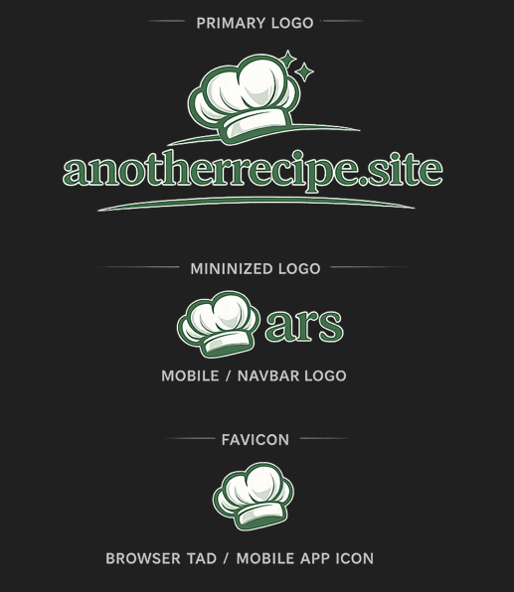
- recipe-placeholder.webp

- hero-food-bg.webp
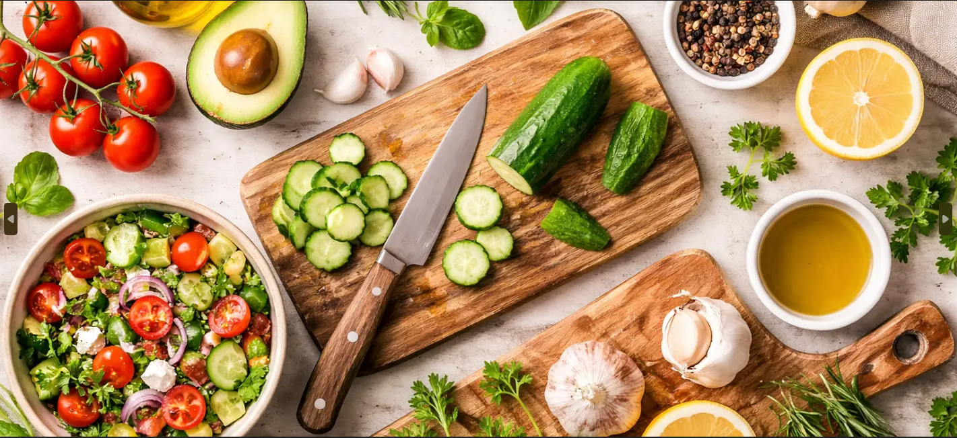

From Icons8.com via their free Universal Multimedia License Agreement (link to Icons8 in footer on all pages):
- clock.svg
- search.svg

- user-login.png

- user-login-hover.png

- user-signup.png

- user-signup-hover.png


