The description of our products

The Details

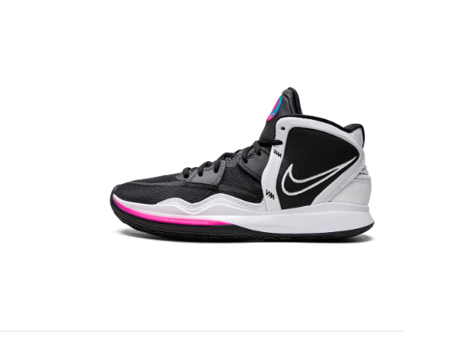

[**Nike**](https://www.farfetch.com/uz/shopping/men/nike/items.aspx)

Kyrie Infinity sneakers

Nike's Kyrie Infinity now appears dressed in a black and white colour scheme. This pair upper uses mesh and leather detailed with a graphic pattern placed on the majority of the upper, Kyrie logos on the tongue and heels. Underneath a rubber outsole adds comfort and traction to the shoe.

**Composition**

Leather 100%

Sole: Rubber 100%

Lining: Fabric 100%

Outer: Mesh 100%

**Product IDs**

FARFETCH ID: 19377587

Brand style ID: CZ0204

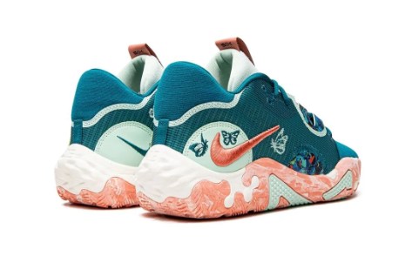

The Details

[**Nike**](https://www.farfetch.com/uz/shopping/men/nike/items.aspx)

PG 6 NRG "Valentine's Day" sneakers

In a special edition for Valentine's Day, this Nike PG 6 NRG is decorated with multiple butterfly embroideries. This high-top pair arrives in a dark green and light green hue, highlighted by a contrasting Swoosh logo on the sides, and sits atop a rubber sole for comfort.

**Composition**

Sole: Rubber 100%

Outer: Fabric 100%

Lining: Fabric 100%

**Product IDs**

FARFETCH ID: 18728712

Brand style ID: DH8446

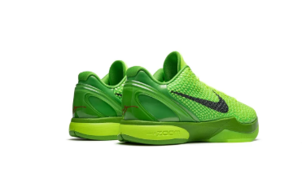

[**Nike**](https://www.farfetch.com/uz/shopping/men/nike/items.aspx)

Kobe 6 Protro "Grinch" sneakers

These Nike Kobe 6 Protro 'Grinch' sneakers were originally released in 2010 for a legendary matchup between Kobe Bryant and LeBron James on Christmas day. Unsurprisingly, this low-top silhouette features a vibrant 'apple green' colourway with crimson and black accents to the Swoosh and tongue. This iteration is updated with an improved Zoom Air cushioning system and slightly less traction for enhanced performance.

**Composition**

Sole: Rubber 100%

Outer: Fabric 100%

Lining: Fabric 100%

**Product IDs**

FARFETCH ID: 19827250

Brand style ID: CW2190