**The University of Arizona Student Union Memorial Center BANNER POLICIES & REQUEST FORM**

|  |  |
| --- | --- |
| Please submit completed requests to:  [sueventplanning@email.arizona.edu](mailto:sueventplanning@email.arizona.edu)  **OR**  Room 348 of the Student Union Memorial Center  (520) 621-1414 | Student Union Memorial Center Event Services  1303 E. University Blvd.  P.O. Box 210017  Tucson, AZ 85721-0017 |

**POLICIES**

Only banners promoting a specific function or event taking place in the Student Union Memorial Center (SUMC) may be posted in available SUMC banner spaces. Any banners hung outside of the approved spaces will be removed and the club, organization or department may forfeit their posting privileges. The Arizona Student Unions reserve the right to dispose of any unauthorized banners and are not responsible for lost, stolen or damaged banners.

1. Banner requests must be submitted to the Event Services Office a minimum of 14 days prior to the start date of the requested reservation.
2. All banners must be approved by the Arizona Student Unions’ Event Services Office prior to being displayed.
3. Banners must be in good taste, clean, neat, use correct grammar, and contain no commercial comment other than a small endorsement or acknowledgement.
4. University groups displaying banners must be recognized campus organizations or departments and include their organization/department name on their banner.
5. No outside vendors or agencies may utilize banner spaces unless they have scheduled the use of facilities in the SUMC.
6. Banners will be hung by Arizona Student Unions’ staff ONLY.
7. Banners can only be displayed on 1 of the 7 approved banner spaces in the SUMC. *Please see diagram on back of form.*
8. Banners must be delivered to the Event Services Office at least 1 day prior to the start of the reservation.
9. Banners must be picked up from the Event Services Office within 2 business days after the conclusion of the reservation. Any banners not picked up within this time frame will be disposed of.

*Please initial to acknowledge understanding of banner policies:* _______________

**PRICING**

Charges are applied on the 1st day of the reservation and every 7th day thereafter.

1. University Rate: $50.00
2. Non-University Rate: $100.00

**BANNER SPECIFICS**

1. Banners must be 3ft tall x 8ft wide in size. *Please initial to acknowledge size restrictions:* _______________
2. Banners must be vinyl and have grommets every 2 feet. *Please initial to acknowledge banner requirements:* _______________

**CLIENT INFORMATION**

|  |  |
| --- | --- |
| DEPARTMENT/ORGANIZATION | |
| ADVISOR NAME | CONTACT NAME |
| ADVISOR PHONE NUMBER | CONTACT PHONE NUMBER |
| ADVISOR EMAIL | CONTACT EMAIL |

**BILLING INFORMATION**

|  |  |  |  |
| --- | --- | --- | --- |
| DEPARTMENT/ORGANIZATION | | | CONTACT NAME |
| ADDRESS | | CONTACT PHONE NUMBER | |
| CITY | | CONTACT EMAIL | |
| STATE | ZIP | FRS ACCOUNT NUMBER | |

**EVENT INFORMATION**

|  |  |  |
| --- | --- | --- |
| TITLE OF EVENT | TYPE OF EVENT | EVENT LOCATION |

**BANNER INFORMATION**

|  |  |
| --- | --- |
| BANNER TO BE HUNG ON THE *MORNING* OF: | BANNER TO COME DOWN ON THE *EVENING* OF: |
| BANNER CONTENT (WHAT DOES IT SAY?) | PREFFERED BANNER LOCATION(S) **IN ORDER OF PREFFERENCE**  (PLEASE SEE DIAGRAM ON BACK OF FORM)  1.)  2.)  3.) |

**CERTIFICATION**

|  |  |
| --- | --- |
| I agree to abide by the rules as set out in the University of Arizona SUMC Banner Policy. Failure to comply may result in termination of banner placement and may prevent future banner privileges. | |
| LESSEE NAME (PLEASE PRINT) | LESSEE SIGNATURE  I have read and agree to the policies, pricing, and banner specifics on this form. |
| **DATE** |

**Student Union Memorial Center 3rd Floor Breezeway Banner Locations**

**North facing North (NN1 and NN2)**: Located on the North breezeway, facing North, overlooking the circle/roundabout

**North facing South (NS1 and NS2)**: Located on the North breezeway, facing South, overlooking the Bookstore’s main entrance

**South facing North (SN1)**: Located on the Central breezeway, facing North, overlooking the Bookstore’s main entrance

**South facing South (SS1 and SS2)**: Located on the South breezeway, facing South, overlooking the mall

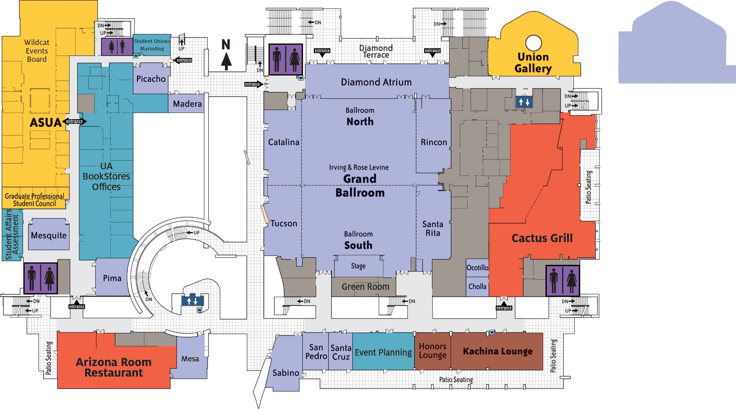

**NN1 and NN2**

**NS1 and NS2**

**SN1**

**SS1 and SS2**