Student Name: Luyang Ye

Student ID : z5280537

**Lab 1**

**Task1**

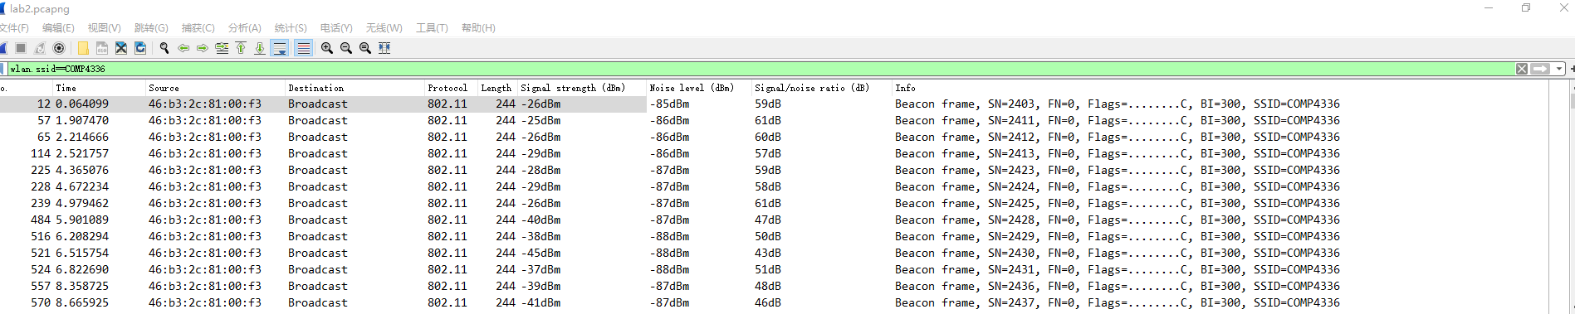

Graph1.1(screenshot of filter and data)

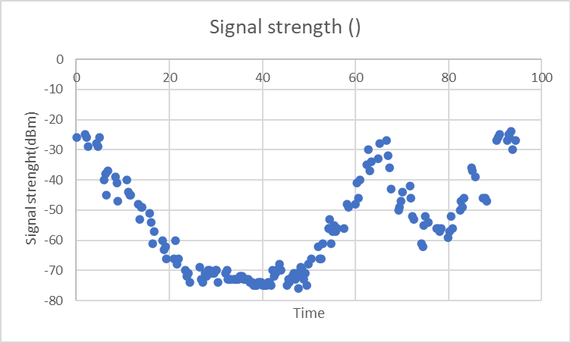

Graph1.2(graph for signal strength)

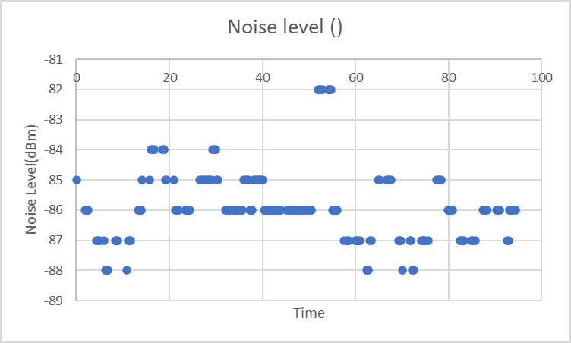

Graph1.3(graph for noise level)

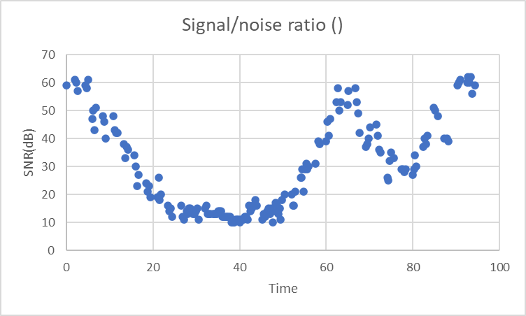

Graph1.4(graph for SNR)

According to above graphs, we can find that the signal strength and the SNR ratio are highest at beginning, and slowly reduce until lowest, then slowly return to highest. The noise level seems not have a clear trend. Since the mobile phone was moved away from the laptop and then moved back to it again and move away once again, we can say that the signal strength and the SNR ratio will become lower while the distance increase, and become higher as the distance decrease.Since there is not a clear trend for noise level, I would say the noise level will not be significantly influenced by the distance.

Task2

Cannot read SSID from the trace file produced by Microsoft Network Monitor, using the data with filter “wlan” to create the following graph.

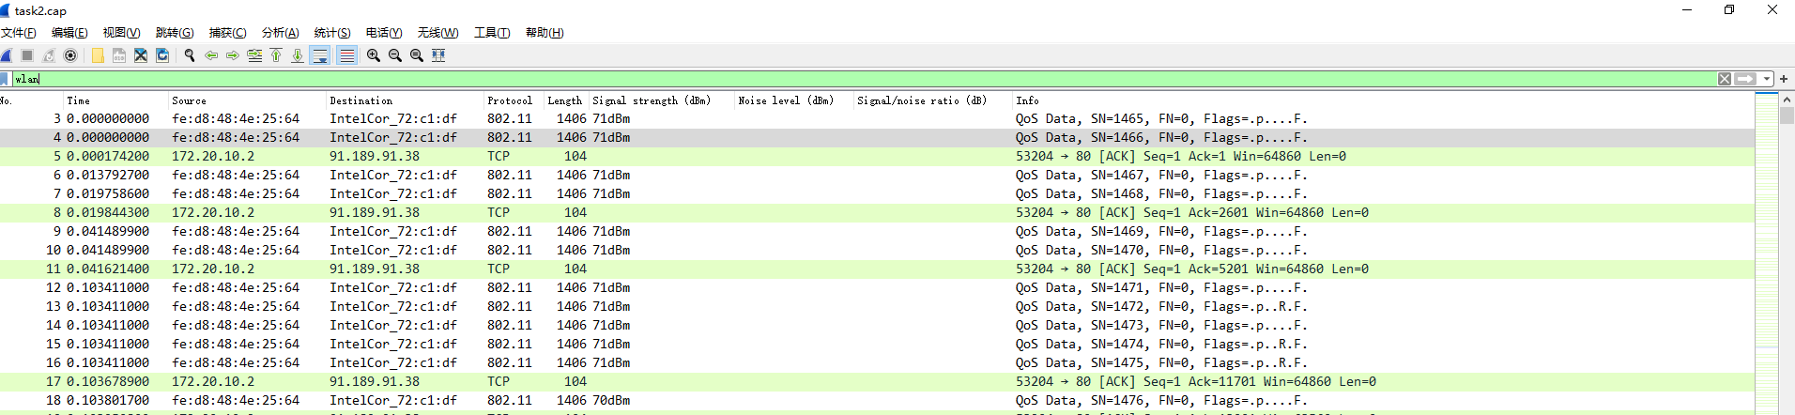

Graph2.1(screenshot of filter and data)

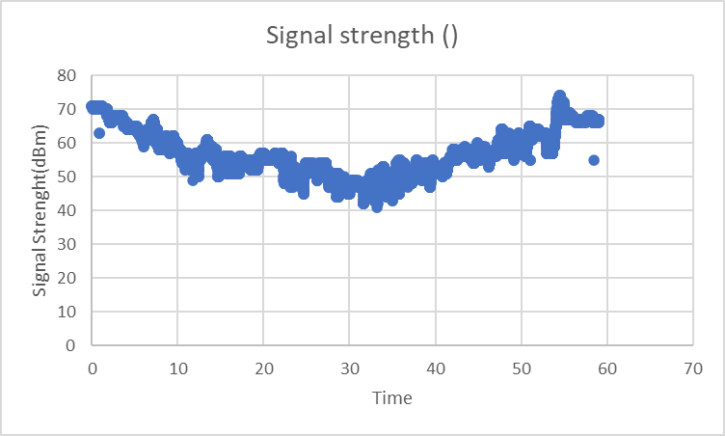

Graph2.2(graph for signal strength)

As shown in graph 2.1, I can only get data of signal strength by using Microsoft Network Monitor, so there is just one graph here.

According to the above graph, although it’s not perfect, we can still see that the signal strength is around 70 at the beginning, and slowly decrease until about 30 seconds. After that, the signal strength starts to slowly increase, and it return to 70 again at about 57 seconds.

Therefore, it is reasonable to say that the signal strength will become lower while the distance increase, and become higher as the distance decrease.