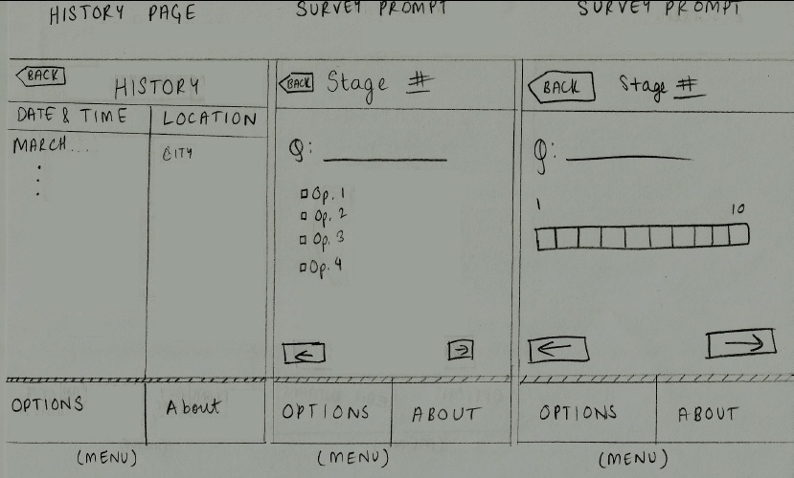

History Page

Survey Prompt

BACK

History

City, State

…

Chicago, IL

Date & Time

Location

March 23, 2012

….

Nov. 18, 2012

Options

Stage #2

About

About

Q #4: How many cigarettes have you smoked?

Less than one

One

More than one

More than five

BACK

Options

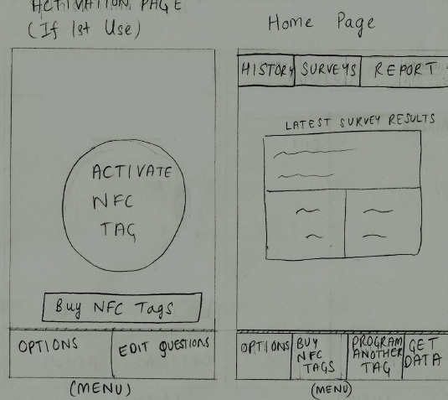

Activation Page Home Page

(if 1st use)

Report

Surveys

History

Options

5 questions were answered on

November 18, 2012 at 5:32 p.m.

Latest Survey Results

Get Data

Options

Buy Tags

Program Another Tag

Activate NFC Tag!

Buy NFC Tags

Edit Questions