

IQRA UNIVERSITY
Department of Engineering / Computer Science

OPERATING SYSTEMS LAB

PROJECT REPORT
Project Title: OS Process Manager

Submitted By (Group Members):

Student Name | Registration ID
Muhammad Umer Ahmed | IU05-0125-0092
Abdul Rehman | IU05-0125-0022
Muhammad Faheem Khan | IU05-0125-0035
Muhammad Muzammil  Instructor: Muhammad Ahmed | IU05-0125-0002

- Objective and Description of the Project:

• Project Objective: To design and implement a professional, desktop-based graphical user interface (GUI) application capable of monitoring, analyzing, and managing operating system processes in real-time. The project bridges theoretical operating systems concepts—such as process states, scheduling priorities, resource allocation, and CPU/IO bounds—with practical software engineering.
• Project Description: The OS Process Manager is a cross-platform desktop utility developed using Python, the PySide6 framework (Qt for Python), and the psutil systems library. It provides deep visibility into system-wide and per-process metrics, featuring a live metrics dashboard, dynamic resource classification, interactive search and filter mechanisms, and an advanced process inspector. By offloading heavy background polling to an asynchronous worker thread, the application ensures high responsiveness without freezing the primary GUI event loop

- Detailed Explanation Of Components Used:

The project adopts a clean, modular architecture separating concerns across dedicated files and directories to ensure high maintainability, scalability, and code readability:
- main.py (Application Entry Point): Initializes the QApplication context, sets the application name, instantiates the root window, and safely handles the event loop execution lifecycle.
- config.py (Configuration Management): Centralizes global application constants, such as UI refresh intervals (REFRESH_MS), threshold limits for CPU usage (CPU_THRESHOLD) and disk I/O rates (IO_THRESHOLD), privileged system user lists, system path prefixes, and OS-specific nice-value mappings (PRIORITY_LEVELS).
- utils.py (Heuristics & Pure Logic): Houses standalone helper functions. is_system_process() checks process usernames, executable file paths, and low process IDs (PID: 4) to accurately categorize background kernel tasks versus user-space applications. classify () evaluates CPU percentages and I/O rates against established thresholds to designate processes as CPU-bound, I/O-bound, or Balanced.
- worker.py (Asynchronous Polling Thread): Implements ProcessWorker, a subclass of QThread. It runs an isolated background loop that queries psutil every second, pre-warms CPU metric baselines, calculates precise byte deltas for disk read/write throughput over elapsed time intervals, and safely emits data packets via custom Qt Signals (results_ready and system_stats_ready).
- ui/ Package (Graphical Interface Modules):
  - main_window.py (ProcessManagerWindow): Acts as the primary orchestrator for the UI. It manages the master process table, interactive search fields, system/user combo-box filters, status bar metrics summaries, and right-click context menus for process control operations.
  - dashboard.py (DashboardPanel & DashboardBar): Renders top-level visual telemetry widgets utilizing custom-styled progress bars to display overall CPU utilization, memory consumption percentage/volumes, and aggregate disk read/write rates in MB/s.

  - inspector.py (ProcessInspectorDialog): Provides an in-depth modal inspection dialog for any selected process, exposing fine-grained metrics including thread counts, open file descriptors, OS process status, exact creation timestamps, recursive child processes, and command-line execution arguments.

3.Working Methodology of the Project:

• Application Bootstrapping: Executing python main.py triggers the creation of the QApplication framework and mounts the ProcessManagerWindow layout container onto the desktop.
• Background Telemetry Polling: Upon startup, the ProcessWorker thread initiates, cycling through psutil.process_iter() to query process attributes (PID, name, user, memory info, executable paths) without blocking user interactions.
• Metric Computation & Error Resilience: The worker calculates CPU percentages and evaluates delta bytes against previous tracking loops to determine live MB/s throughput. Throughout collection, exception blocks robustly catch NoSuchProcess, AccessDenied, and ZombieProcess exceptions to prevent runtime crashes caused by volatile operating system states.
• Thread-Safe Signal Communication: Raw data arrays and overall system statistics are transmitted to the main thread via Qt's thread-safe signal-slot mechanism, updating the table rows and dashboard bars instantaneously.
• Interactive Management & Control: Users can filter rows dynamically, sort columns, review detailed properties via double-click inspection, or invoke system actions (such as suspend(), resume(), priority adjustments via .nice(), terminate() via SIGTERM, or kill() via SIGKILL) through the context menu interface.

4.Project Setup (Images):

os_process_manager/
├── main.py # Entry point of the application
├── config.py # Global constants and configurations
├── utils.py # Helper logic (process classification)
├── worker.py # Background QThread for data polling
└── ui/ # Package containing all UI components
├── __init__.py
├── dashboard.py # Dashboard components (bars, panels)
├── inspector.py # ProcessInspectorDialog
└── main_window.py # Core UI (tables, menus, layouts)
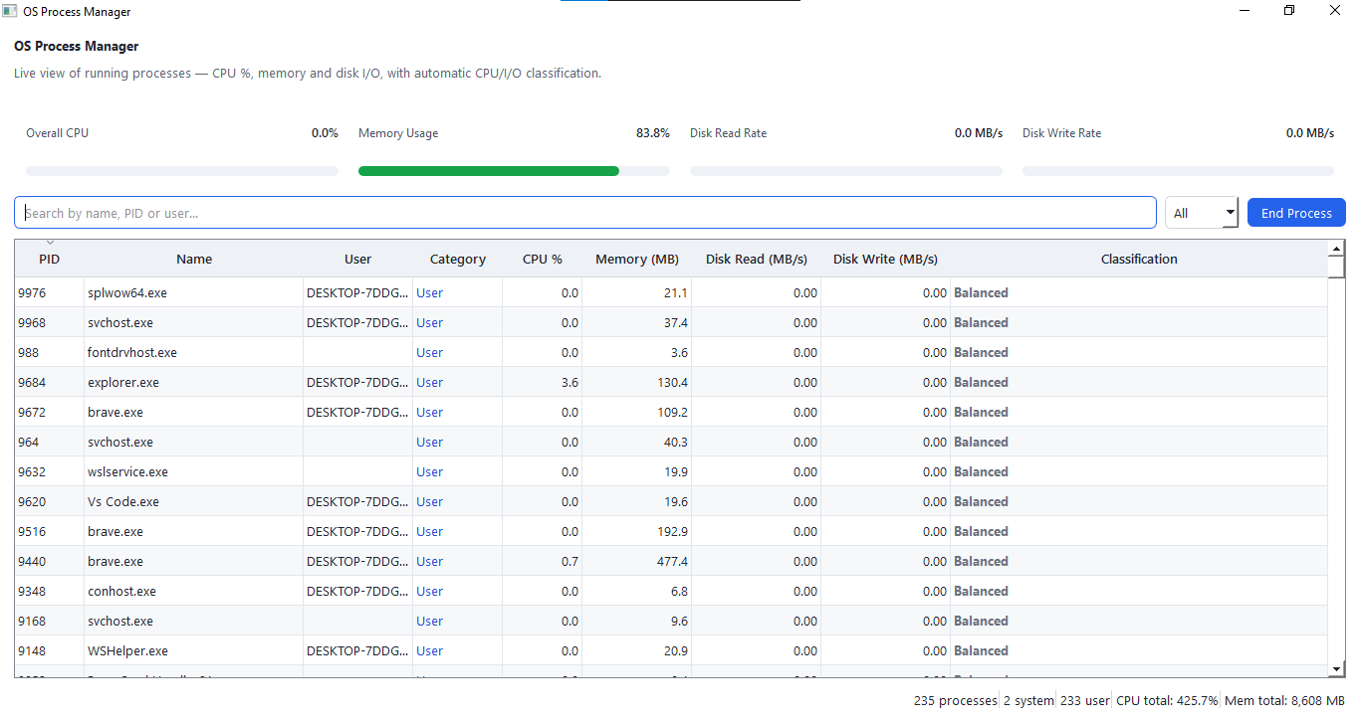

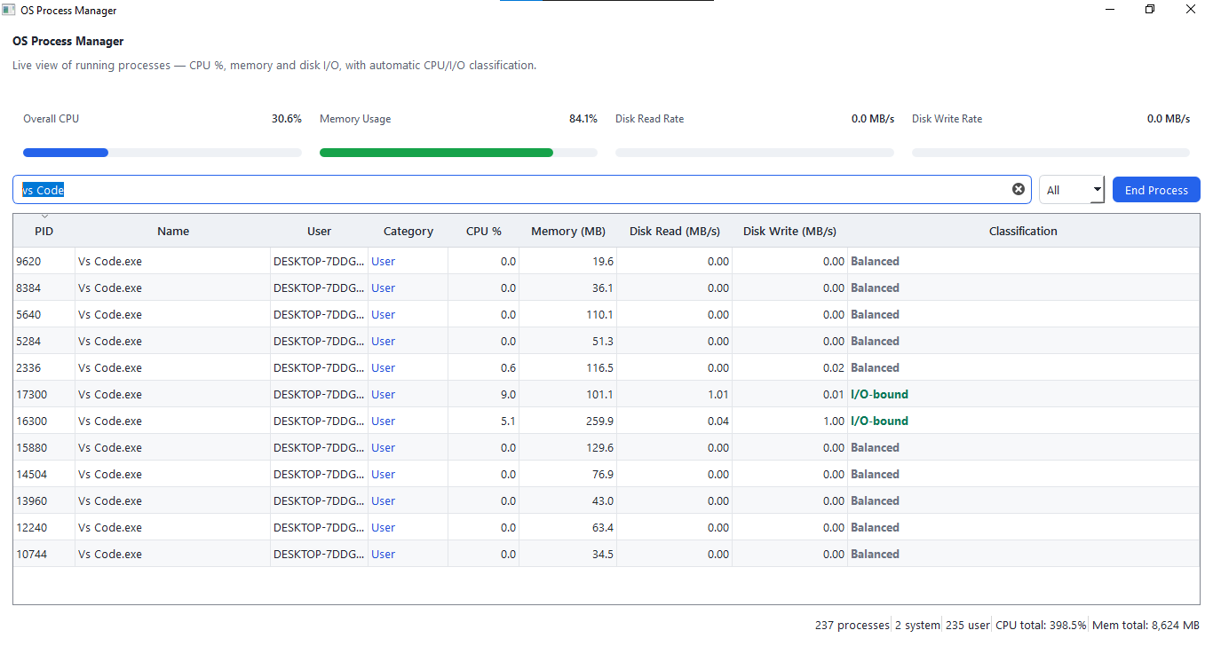
-------------------------------------------------------------------------------------------------------------------------------------
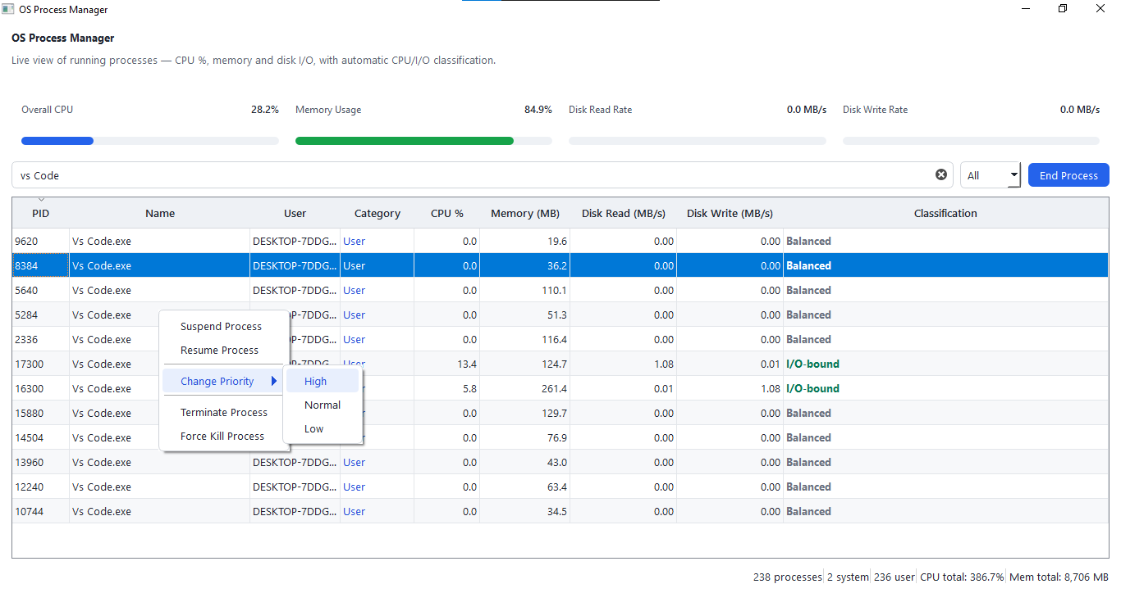

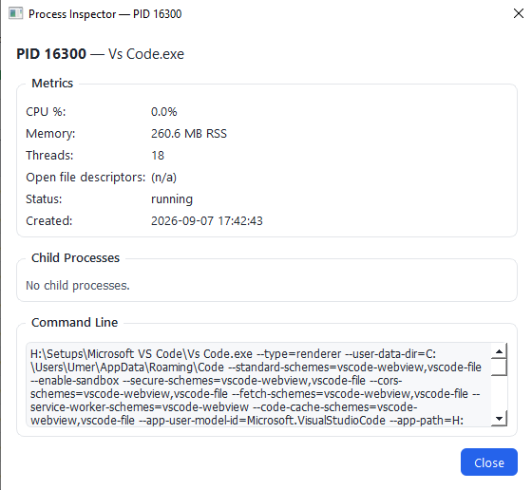

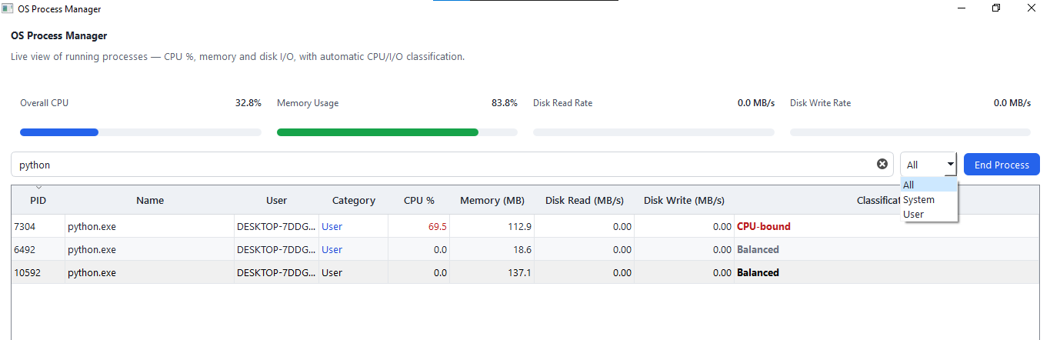

Conclusion:

The OS Process Manager project successfully demonstrates core operating system principles by programmatically interfacing with kernel-level metrics through Python. By implementing multi-threading (QThread), signal-slot architecture, and defensive programming against system access restrictions, the application achieves enterprise-grade stability and responsiveness. The clean, modular segregation into configuration, worker, utility, and interface layers highlights best practices in modern software engineering and desktop application design.

