OPERATING SYSTEM LAB Task 08

UNIX/Linux File Permissions, Access & Ownership using Git Bash
Muhammad Umer Ahmed
IU05-0125-0092

Instructions: Execute each command separately in Git Bash. After every command, take a screenshot showing the command and its output and paste it into the Word file. Write 1–2 lines explaining the command below each screenshot.

Task 1 — Create a Directory
Command 1
mkdir testdir
Explanation: mkdir is used to create a new directory. This command creates a directory named testdir.

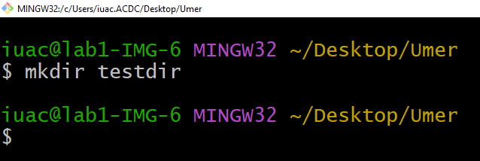
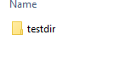

Task 2 — View Directory Permissions
Command 1
ls -ld testdir
Explanation: ls -ld displays detailed information about the directory, including its permissions, owner, group, and modification time.

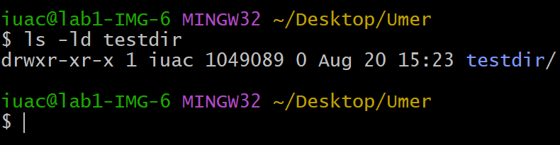

Task 3 — Understand Permission Modes
Command 1
ls -ld testdir
Explanation: The permission string is divided into three sections: owner, group, and others. The characters r, w, and x represent read, write, and execute permissions.

Task 4 — Change Permissions to 700
Command 1
chmod 700 testdir
Explanation: chmod is used to change permissions. Permission 700 gives the owner read, write, and execute permissions while group and others have no permissions.
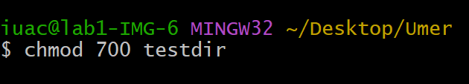
Command 2
ls -ld testdir
Explanation: This command verifies the permissions that were applied to testdir.

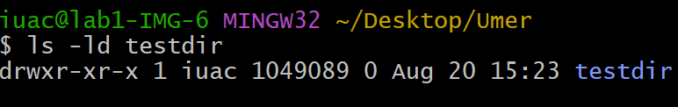Task 5 — Change Permissions to 755
Command 1
chmod 755 testdir
Explanation: Permission 755 gives the owner full permissions and gives group and others read and execute permissions.
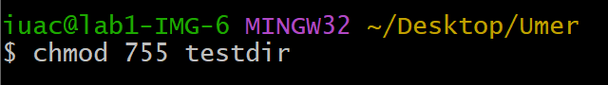Command 2
ls -ld testdir
Explanation: This command displays the updated permissions of testdir after using chmod 755.

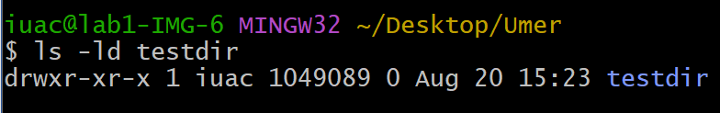

Task 6 — File Permissions
Command 1
touch sample.txt
Explanation: touch creates an empty file named sample.txt. The file will be used to practice file permission management.
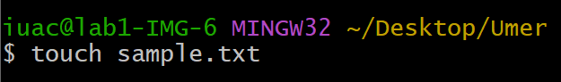

Command 2
ls -l sample.txt
Explanation: ls -l displays detailed information about the file, including its permissions, owner, group, and size.
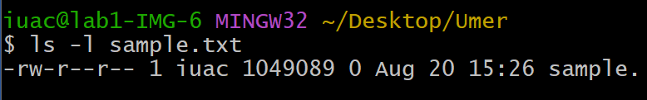

Task 7 — Change File Permission to 600
Command 1
chmod 600 sample.txt
Explanation: Permission 600 gives the owner read and write permissions. Group and others have no permissions.
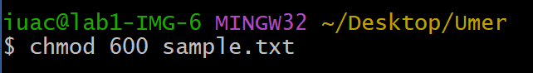Command 2
ls -l sample.txt
Explanation: This command verifies that the permission of sample.txt has been changed to 600.

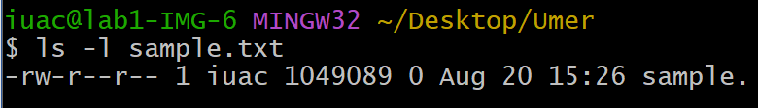Task 8 — Symbolic Permissions
Command 1
chmod u+x sample.txt
Explanation: u represents the owner, while +x adds execute permission. This command adds execute permission for the file owner.
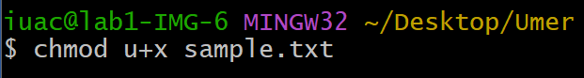Command 2
ls -l sample.txt
Explanation: This command displays the updated permissions and allows the added execute permission to be verified.

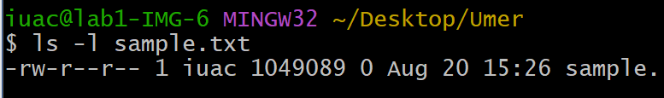

Task 9 — Permission Comparison
Command 1
chmod 644 sample.txt
Explanation: Permission 644 gives the owner read and write permissions, while group and others have read-only permission.
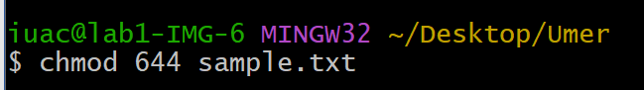Command 2
chmod 777 sample.txt
Explanation: Permission 777 gives read, write, and execute permissions to the owner, group, and others.

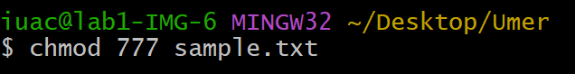

Task 10 — Final Ownership and Permission Check
Command 1
ls -l sample.txt
Explanation: This command displays the final permission, owner, and group information of sample.txt.
